NATIONAL MEASUREMENT, REPORTING AND VERIFICATION (MRV) FRAMEWORK

DRAFT VERSION (17th December 2020)

Ministry of Environment, Solid Waste Management and Climate Change

2020

CONTENTS

Acronyms and Abbreviations 6
Introduction 8
1. Key elements of the MRV Framework 9
1.1. Key elements at the international level 9
1.2. Key elements at domestic level 10
2. National (domestic) MRV system 13
2.1. Key activity 1: Review current MRV activities 13
2.2. Key activity 2: Establish institutional arrangements 14
2.3. Key activity 3: Assess data gaps and needs 17
2.4. Key activity 4: Establish data management processes 17
2.5. Key activity 5: Build MRV capacity 17
2.6. Key activity 6: Improve the MRV system over time 18
3. Domestic MRV system in RoM 19
3.1. Government structure relevant to MRV 19
3.2. How the system is presently functioning 20
3.3. MRV for GHG Inventory System 21
3.4. MRV of mitigation actions 26
3.5. MRV of support needed and support received 27
4. Prioritised actions to develop an MRV system 28
4.1. Prioritised actions for MRV system in RoM 29
References 30
Annexes 31
Annex 1: Confidentiality Agreement 32
Annex 2: Memorandum of Understanding (MoU) template 37
Annex 3: Institutional arrangements template 40
Annex 4: Method and data documentation template 46
Annex 5: QA/QC procedures template 50
Annex 6: Archiving system template 59
Annex 7: Key Categories Analysis template 66
Annex 8: National inventory improvement plan template 71
Annex 9: Parameters needed for the MRV mitigation actions 77

Tables
Table 1. Improvements required for the GHG Inventory 24
Table 2. Prioritised actions 28
Table 3. Prioritised actions* 29
Table 4. Designated Inventory Agency 40
Table 5. National Inventory Management Team 40
Table 6. Energy Sector Institutional Arrangements 42
Table 7. Industrial Processes Sector Institutional Arrangements 42
Table 8. Agriculture Sector Institutional Arrangements 42
Table 9. LULUCF Sector Institutional Arrangements 43
Table 10. Waste Sector Institutional Arrangements 43
Table 11. Other Sector Institutional Arrangements [Optional] 43
Table 12. Potential Improvements in Management Structure of National Inventory System 44
Table 13. Category Information template 46
Table 14. Methodology for [category name], template 47
Table 15. [Category name] Activity Data, template 47
Table 16. [Category name] Emission/carbon-stock change Factors, template 48
Table 17. Uncertainty Estimates Calculated for Categories 48
Table 18. Comments on Estimates for Categories 49
Table 19. Improvements to the Methodology and Data Documentation Analysis 49
Table 20. Personnel Responsible for QA/QC Activities 51
Table 21. General (Tier 1) QC Activities 53
Table 22. Category-specific (Tier 2) QC Procedures 56
Table 23. External Reviewers 58
Table 24. Improvements to the QA/QC Plan 58
Table 25. Archive Tasks, Responsibilities, and Schedule for RoM 63
Table 26. Improvements to the Inventory Archive System 65
Table 27. Key Categories Based on Contribution to Total National Emissions inRoM (e.g., 1994) 67
Table 28. Key Categories Based on Contribution to Total National Emissions in RoM (e.g., 1990) 67
Table 29. Key Categories Based on Contribution to Overall Trend in National Net Emissions 68
Table 30. Improvements to the key category analysis 70
Table 31. Priority Actions for RoM´s National Inventory System 71
Table 32. Key Categories for RoM 73
Table 33. Potential Improvements for Categories 73
Table 34. Potential Improvements to QA/QC procedures 74
Table 35. Potential Improvements to the Archive System 74
Table 36. Improvements to National Inventory System 75
Table 37. National Inventory Improvement Priorities 76
Table 38. Potential Projects for Improving the National Inventory System 76
Table 39. Parameters needed for the MRV of the mitigation scenarios of the Energy Industries. 77
Table 40. Parameters needed for the MRV of the mitigation scenarios of the Land Transport. 78
Table 41. Parameters needed for the MRV of the mitigation scenarios of the Solid Waste sector. 79
Table 42. Parameters needed for the MRV of the mitigation scenarios of the Forestry sector. 80
Table 43. Parameters needed for the MRV of the mitigation scenarios of the Livestock management. 82

Figures
Figure 1. Key elements of the MRV framework 9
Figure 2. Information on the domestic MRV of domestically supported NAMAs 11
Figure 3. Key elements of the guidelines for domestic MRV 11
Figure 4. Elements of national MRV frameworks 13
Figure 5. Key steps of the domestic institutional arrangements for MRV 14
Figure 6. Sustained institutional arrangement for Biennial Update Report 20
Figure 7. Government structure relevant to MRV 21
Figure 8. Institutions involved in the preparation of GHG Inventory 22
Figure 9. Inventory Cycle 45

Acronyms and Abbreviations
AAP | Africa Adaptation Programme
AD | Activity Data
AFOLU | Agriculture, Forestry and Other Land Use (2006 IPCC Guidelines)
Annex I | Parties included in Annex I to the United Nations Framework Convention on Climate Change
AR4 | Fourth Assessment Report
BAU | Business as Usual
BESS | Battery Energy Storage System
BUR | Biennial Update Report
CCIC | Climate Change Information Centre
CDM | Clean Development Mechanism
CEB | Central Electricity Board
CER | Certified Emission Reduction
CPEIR | Climate public expenditure and institutional review
DOWA | Deep Ocean Water Application
EE | Energy Efficiency
EEBCCS | Energy Efficiency Building Code Compliance Scheme
EF | Emission Factor
EST | Environmentally Sound Technologies
GCF | Green Climate Fund
GDP | Gross Domestic Product
GEF | Global Environment Facility
GHG | Greenhouse Gas
GNI | Gross National Income
GVA | Gross Value Added
GWP | Global Warming Potential
ICT | Information and Communication Technology
ICZM | Integrated Coastal Zone Management
IEF | Implicit Emission Factor
IOC | Indian Ocean Commission
IPCC | Intergovernmental Panel on Climate Change
IPM | Integrated Pest Management
IPPs | Independent Power Producers
IPPU | Industrial Processes and Product Use
JCA | Japan International Cooperation Agency
LNG | Liquified Natural Gas
LPG | Liquid Petroleum Gas
LTO | Landing and Take-Offs
LULUCF | Land Use, Land-Use Change and Forestry
MIC | Upper-middle-income Country
MoESWMCC | Ministry of Environment, Solid Waste Management and Climate Change
MEPU | Ministry of Energy and Public utilities
MRC | Mauritius Research Council
MRC | Mauritius Research Council
MRV | Measurement, Reporting and Verification
MSDG | Medium-Scale Distributed Generation
MUR | Mauritian Rupee
NAI | National Accounts and Investment
NAMA | Nationally Appropriate Mitigation Action
NCV | Net Calorific Value
NDC | Nationally Determined Contributions
NDRRMC | National Disaster Risk Reduction and Management Centre
NIR | National Inventory Report
NIS | National Inventory System
Non-Annex I | Parties not included in Annex I to the United Nations Framework Convention on Climate Change
NTA | National Transport Authority
ODS | Ozone Depleting Substances
OEP | Outline Energy Policy
PV | Photovoltaic
QA | Quality Assurance
QC | Quality Control
R&D | Research and Development
RCMRD | Regional Centre for Mapping of Resources for Development
RE | Renewable Energy
RoM | Republic of Mauritius
SIDS | Small Island Development States
SLM | Sustainable Land Management
TAP | Technology Action Plans
TEU | Twenty-foot Equivalent Unit
TNA | Technology Needs Assessment
TNC | Third National Communication
UNEP | United Nations Environment Program
UNFCCC | United Nations Framework Convention on Climate Change
USD | United States Dollar
WB | World Bank
WTE | Waste-to-Energy

Introduction
The United Nations Framework Convention on Climate Change (UNFCCC) laid the foundation for the current system of reporting climate information. Article 12, paragraph 4 of the Convention mandates all Parties to communicate actions they have taken or envisage to take to implement the Convention to the Conference of the Parties (COP), through the Secretariat. This includes information on greenhouse gas (GHG) emissions by sources, removals by sinks, as well as on the actions that Parties are taking to mitigate and adapt to climate change.
The arrangements for national reporting under the Convention have since evolved over the subsequent COP meetings. The Kyoto Protocol, which implements the framework Convection, helped to put in place a comprehensive MRV framework which remains up to now the most detailed and comprehensive set of rules and also the reflection of best practices regarding MRV and setting up national systems under the Convention. The set of rules for reporting information under the Convention were further detailed to include guidance on the content and frequency of National Communications (NC), provisions for Biennial Update Reports (BUR) and Biennial Reports along with the process of international consultation and analysis (ICA) and respectively International Assessment of these reports.
The term MRV originally came from the Bali Action Plan, the negotiating text of the UNFCCC in Bali, Indonesia at the end of 2007. The basic understanding of the Bali Action Plan is that climate change mitigation actions – mainly Greenhouse Gas (GHG) emissions reduction – shall be implemented in a “measurable, reportable and verifiable” manner, and this idea has brought significant implications for international negotiations since then.
The key function of MRV is enhancing transparency through the tracking of national GHG emission levels, the tracking of climate finance flows received or the impact of mitigation actions. MRV facilitates sharing information and lessons learnt and allows assessing whether set targets have been achieved. This creates transparency and shows the continuity of a country's actions, which internationally strengthens trust of climate finance donors and other investors. Transparent MRV approaches can improve comparability at national and international level thus supporting coherence between domestic and international MRV systems where detailed reporting on MRV approaches takes place, as in National Inventory Reports under the UNFCCC, this enhances the identification of best practice examples.
For developing country Parties, the current MRV framework under the Convention includes submitting NCs every four years and BURs every two years, undergoing ICA, and setting up domestic MRV. Moreover, it includes undertaking MRV of the Reducing Emissions from Deforestation and Forest Degradation (REDD+) activities for the purpose of obtaining and receiving results-based incentives.
Measurement, reporting, and verification (MRV) is given a central place under the Paris Agreement, thus enhancing the requirements existing already under the UNFCCC. The Paris Agreement makes it clear that all developing countries must be provided with support in order to be able to put in place the institutional structures needed to support compliance with the transparency obligations.
This document contains an MRV Framework for RoM, and it is shaped by 4 sections. The first one explains, from a theoretical point of view, the key elements which an MRV framework should contains. The second one describes the key activities to be considered during the design and implementation of a domestic MRV system. Third section describes the current status of the domestic MRV system of RoM. Last section contains a list with prioritized actions to be developed by RoM to continue implementing its domestic MRV system.

Key elements of the MRV Framework

Key elements at the international level
The existing framework for MRV under the Convention for developing country Parties consists of several elements, which have been put in place gradually through a set of decisions by the COP over the period 2004–2013.
Some of these elements are implemented at the international level and others at the national level. At the international level, the MRV framework for non-Annex I Parties includes:
- Guidance on reporting through national communications and BURs;
- Guidance on setting up domestic MRV frameworks;
- A process for consideration of information submitted by non-Annex I Parties in their BURs through ICA;
For those non-Annex I Parties that voluntarily implement REDD-plus activities and wish to take the opportunity of a results-based payment, international guidance on MRV for REDD-plus activities applies.
At the national level, Parties are expected to implement the international guidelines for domestic MRV frameworks and to prepare and report information according to the guidance on reporting through national communications and BURs, including information on GHG emissions and removals by sinks, mitigation actions and their effects, and support needed and received.
Figure 1. Key elements of the MRV framework
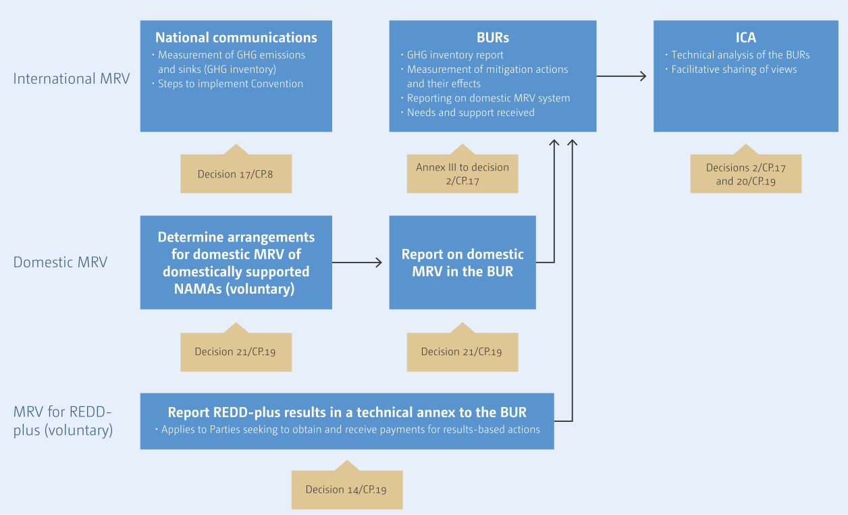
Source: Handbook on MEASUREMENT, REPORTING AND VERIFICATION FOR DEVELOPING COUNTRY PARTIES
Measurement for non-Annex I Parties applies both to efforts to address climate change and to the impacts of these efforts, including the level of GHG emissions by sources and removals by sinks, emission reductions and other co-benefits. Such measurement occurs at the national level. Initially, it referred to the measurement of GHG emissions by sources and removals by sinks through the national GHG inventories, which are reported in national communications. Based on the decisions adopted at COP 16 and 17, non-Annex I Parties now need to measure the specific effects of national mitigation actions as well as the support needed and received, and to provide this information, including a national inventory report, as part of their BURs. The methodologies for measurement are not defined by the Convention; therefore, in undertaking measurement Parties rely on methodologies developed externally, including by the Intergovernmental Panel on Climate Change (IPCC) and other organizations, as discussed in more detail below. However, where possible, the COP identifies and endorses the methodologies that Parties should use, at a minimum.
Reporting for non-Annex I Parties is implemented through the national communications and BURs. Parties are required to report on their actions to address climate change in their national communications, which include information on the GHG inventories, adaptation, mitigation actions and their effects, constraints and gaps, support needed and received, and other information considered relevant to the achievement of the objective of the Convention. National communications are to be submitted every four years and prepared following the guidance contained in the revised guidelines for the preparation of national communications from non-Annex I Parties contained in the annex to decision. BURs are to be submitted every two years, providing an update of the information presented in national communications, in particular on national GHG inventories, mitigation actions, constraints and gaps, including support needed and received.
Verification is addressed at the international level through ICA of BURs, which is a process to increase the transparency of mitigation actions and their effects, and support needed and received. National communications are not subject to ICA. At the national level, verification is implemented through domestic MRV mechanisms to be established by non-Annex I Parties, general guidelines for which were adopted at COP 19 in 2013. Provisions for verification at the domestic level that are part of the domestic MRV framework are to be reported in the BURs.

Key elements at domestic level
In the BURs, Parties should provide information on domestic MRV. COP 19 adopted the general guidelines for domestic MRV of domestically supported NAMAs by developing country Parties.
Figure below presents the information on domestic MRV of domestically supported NAMAs that needs to be reported in the BUR as laid out in the guidelines.
When reporting on their domestic MRV in the BURs, non-Annex I Parties are encouraged to provide information on three key elements, including:
- A description of the overall institutional arrangements, whether based on existing or new processes and systems. This includes information on the key domestic MRV processes, systems and arrangements, including institutional structures, legal and administrative framework, relevant information, methodologies and experts to be engaged.
- A description of the approach used to measure domestically supported NAMAs. This should include information on the systems for collection and management of relevant data and on how methodologies are being documented. Similar to the information on mitigation programmes being submitted as part of the national communication, this section should describe the institutional arrangements in place to collect information and manage quality assurance (QA) and quality control (QC) through documentation of the methodologies and data sources used;
- Finally, it should describe the approach used to conduct domestic verification of the information, including a description of experts engaged in the verification and the mechanisms of verification. This may include information on how the experts involved in the independent evaluation of information/verification are being selected and appointed (e.g. is there an accreditation process involved, and if so, what does it entail).
Figure 2. Information on the domestic MRV of domestically supported NAMAs
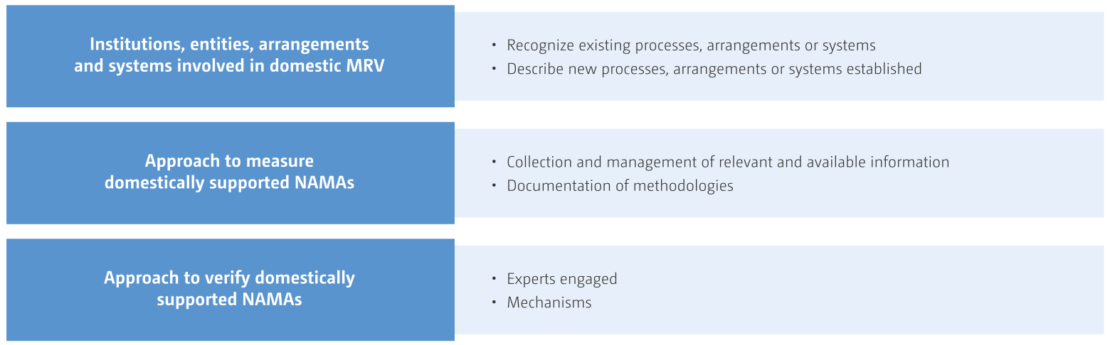
Source: Handbook on MEASUREMENT, REPORTING AND VERIFICATION FOR DEVELOPING COUNTRY PARTIES
Figure 3. Key elements of the guidelines for domestic MRV
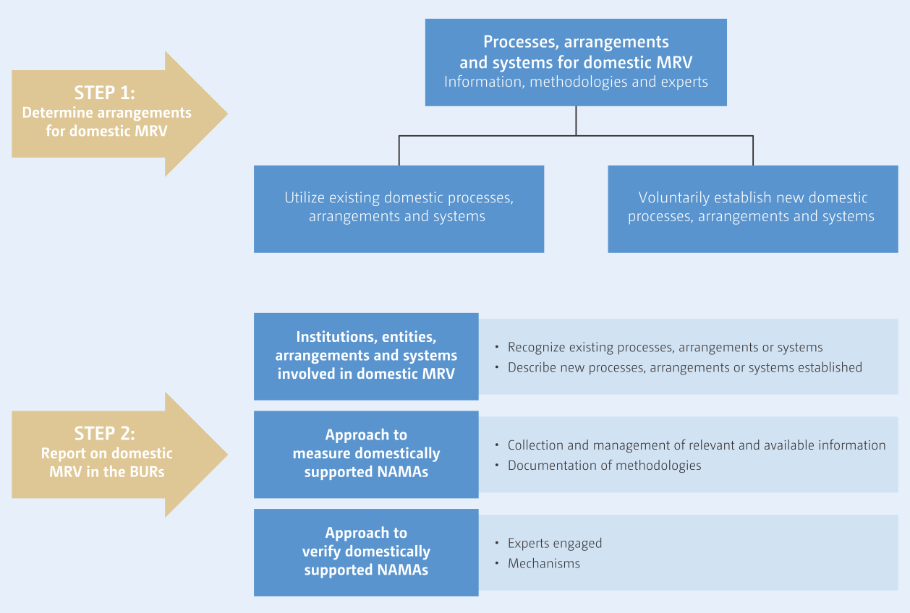
Source: Handbook on MEASUREMENT, REPORTING AND VERIFICATION FOR DEVELOPING COUNTRY PARTIES
Figure above presents the approach to domestic MRV of domestically supported NAMAs laid out in the guidelines. The first step in setting up the domestic MRV framework is to determine the key processes, systems and arrangements, including institutional structures, relevant information, methodologies and experts to be engaged.
There are no specific guidelines on the detailed institutional set-up for MRV, since it will depend on the national circumstances and existing institutional arrangements and capacities of a particular country.
Based on the experience to date, sustainable institutional arrangements for MRV include the following key elements:
- Establishing national legal/formal arrangements;
- Choosing and maintaining an appropriate coordination body;
- In-country institutional and technical capacity-building;
- Mechanism for stakeholder involvement.
Such institutional arrangements should ensure representation and effective involvement of all key sectors and stakeholders.
As the second step, when reporting on their domestic MRV in the BURs, developing country Parties are encouraged to provide information on three key elements, including a description of the:
- Overall institutional arrangements, whether based on existing or new processes and systems
- Approach used to measure domestically supported NAMAs. This should include information on the systems for collection and management of relevant data and on how methodologies are being documented;
- Approach used for domestic verification of the information, including a description of the experts that are engaged in the verification and the mechanisms for verification.
Both internationally and domestically supported NAMAs may be subjected to the domestic MRV and can be reported as a part of the mitigation actions within the BURs.

Once introduced the key elements of the MRV framework, the chapter 2 focuses on the elements of a domestic MRV and the key activities that a Party might follow to establish its domestic MRV systems.

National (domestic) MRV system
The national MRV systems is formed by three different elements: MRV of emissions, MRV od NAMAs and MRV of support. The interactions among the various elements of the national MRV framework and the key information that is provided under each of the elements is presented in the figure below.
Figure 4. Elements of national MRV frameworks
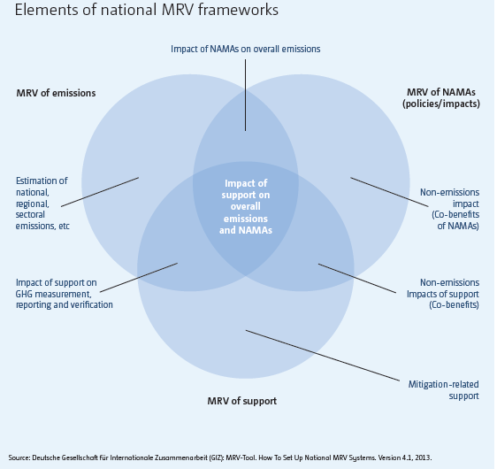

Key activities required to set up the domestic MRV system are listed below:

Key activity 1: Review current MRV activities
Review recent Biennial Update Reports submissions, identifying how data (e.g. mitigation, adaptation, climate finance) were generated for these reports, the frequency of data collection and who is involved (e.g. statistical offices, sectoral ministries and their affiliated institutions).

Key activity 2: Establish institutional arrangements
Figure 5. Key steps of the domestic institutional arrangements for MRV
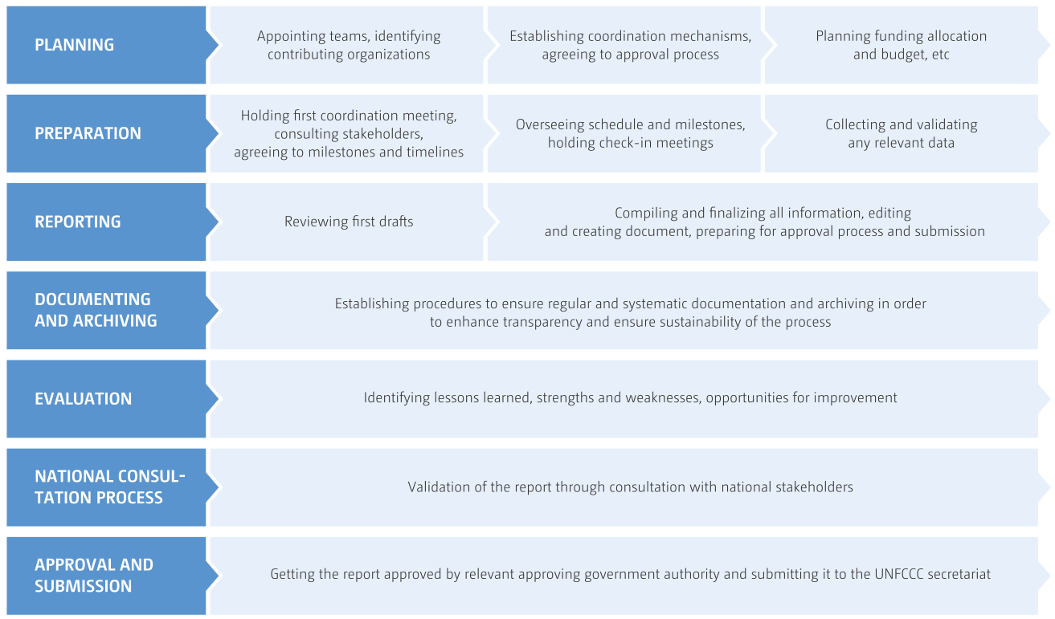
Source: Handbook on MEASUREMENT, REPORTING AND VERIFICATION FOR DEVELOPING COUNTRY PARTIES
It is recommended that a single body be designated as responsible for the overall coordination and management of the BUR preparation process.
The main responsibility of this body is to perform the overall coordination for the preparation of BURs, with key tasks being to:
- Plan and conduct all coordination and consultation activities with governmental and, if appropriate, non-governmental stakeholders;
- Identify all institutions and teams that will be involved in the preparation of the BUR, and establish any formal working arrangements required;
- Allocate responsibilities for all components of the BUR, ensuring there is a clear lead for each section, and establish a formal approval process;
- Develop and monitor a timeline and schedule for BUR preparation, including specific milestones and dates for deliverables.
In addition, the national coordinating body is responsible for the following elements:
- Identify constraints and gaps, and related financial, technical and capacity building needs, including a description of support needed and received;
- Keep any management committees and working groups informed of progress and emerging issues;
- Develop and implement Quality Assurance and Quality Control strategies for the entire BUR;
- Manage the overall budget for the preparation of the BUR;
- Compile and integrate all sections of the BUR into a cohesive document;
- Develop and maintain an archiving system to ensure institutional memory and to fully and systematically document all the activity data and the methods used;
- Collect and maintain statistical records;
- Conduct an evaluation exercise to identify key lessons learned and areas for improvement;
- Consider results of the International Consultation and Analysis (ICA) process.
Countries may consider using a variety of tools to organize and define their institutional arrangements. One example of the tools that Parties can use to build sustainable institutional arrangements is a series of predefined templates. These templates were originally developed to assist national teams in assessing and documenting the strengths and weaknesses of existing institutional arrangements to ensure continuity and integrity, promote institutionalization and facilitate prioritization of future improvements. In particular, the templates:
- Focus on documenting essential information in a concise format;
- Standardize tasks;
- Ensure roles and responsibilities of all stakeholders are clearly defined;
- Accommodate varying levels of national capacity;
- Provide an objective and efficient system for identifying priorities for future improvements;
- Allow for the presentation of information in a consistent, transparent, complete and timely manner;
- Serve as a starting point for future teams;
- Create transparency in a Party’s institutional arrangements.
It may be helpful to establish a MoU, or other formal agreement or legal act, between the coordinating body and other national institutions involved in the BUR process to define responsibilities, allocate tasks and so forth. A possible structure for the MoU is available at Annex 2
There are key elements that need to be considered when stablished the institutional arrangements:

Establishing National Legal or Formal Arrangements
A legal or formal mandate may enhance the coordination and supervisory role and high-level authority of the appointed institutions by designating the formal coordinating body and other implicated institutions.
A legal or formal mandate may facilitate the various stages of the approval process. A legal or formal mandate can help to facilitate the appointment of the coordinating body, in particular appointing focal points and permanent representatives among concerned stakeholders.
A legal or formal mandate is, of course, effective only if it is implemented.

Choosing an appropriate Coordinating Body
The location of the national coordinating body within the government has been a key factor influencing the effectiveness of institutional arrangements and, in particular, the strength of the body’s mandate and its ability to conduct interministerial coordination.
The location is important because it influences the extent to which the BUR is integrated into broader climate change planning processes.
The location of the national coordinating body will differ from country to country. The coordinating body has typically been located in the ministry responsible for climate change and/or environmental issues, or within a specific organization or agency responsible for coordinating the climate change policy.

Engaging Stakeholders
Engaging a broad range of stakeholders is important to the BUR process.
Given the increased frequency, BUR preparation can help to establish greater continuity and institutionalization of the report development process as well as processes of collaboration and information exchange.
It is important that clear roles and responsibilities are defined throughout a multistakeholder process to ensure it produces effective results and provides useful knowledge to those involved.
Identifying incentives for continuous participation of stakeholders is recommended.
Countries are increasingly engaging NGO groups, including the private sector, which provides access to information and raises awareness of reporting activities.

Building In-Country Institutional and Technical Capacity
Developing countries have often relied on consultants and external experts to assist in preparing their NCs and/or BURs and this has:
- Impeded archiving and institutional capacity-building;
- Resulted in loss to the ministry and Party in question the learning that emerges from the reporting process as well as the information and data gathered and the improvement of specific capacities.
Developing internal capacity could help avoid this reliance and instead encourage stability of institutions and their staff.
As BURs will likely require the establishment, over time, of permanent coordination teams, there is now an opportunity to ensure that Parties invest in internal institutional and technical capacity-building and the elaboration of institutional memory.
Institutional ownership is a key factor for the sustainability of the entire NC and BUR development process.

Maintaining a Motivated and Stable Coordinating Body
Continuity of staff and succession planning of the national coordinating body is essential to avoid loss of experience, skills, information and institutional memory.
Although recruiting and maintaining staff for reporting processes proved difficult for NCs, for BURs it may be important to retain dedicated staff given the increased frequency of reporting.
It is important to ensure there are dedicated and skilled national staff appointed to the coordinating body with clearly assigned roles and responsibilities and sufficient time to coordinate inputs and activities of all stakeholders.

Reporting on Institutional Arrangements within BURs
While developing countries are required to describe their institutional arrangements in their BURs and NCs, there is flexibility to determine the level of information to be provided.
Beyond meeting reporting requirements, describing Parties’ institutional arrangements in their BURs and NCs is also important for sharing information and best practices in establishing institutional arrangements.
Parties may consider providing the following information on their institutional arrangements:
- Overall description, including location, coordination and engagement processes, covering government and non-government stakeholders;
- Relationship to broader climate change development process and other institutional arrangements related to the Convention;
- Any lessons learned or recommended practices, including recruiting and maintaining a permanent national coordinating body;
- A description of adjustments or changes made to existing or new institutional arrangements as a result of BURs;
- Cost implications;
- Capacity-building that needs to be undertaken as part of the institutional arrangements;
- Constraints and gaps, and related financial, technical and capacity-building needs, including a description of support needed and received.

Key activity 3: Assess data gaps and needs
For the assessment of data and needs, these two tasks are necessary:

Assess and prioritise data gaps
  - Identify the scope of data required across mitigation, adaptation, finance and other areas to track NDC implementation. As part of this process, it may be useful to reflect on the overall international MRV requirements for climate change, in order to set out what data are needed and by when.
  - It may be useful to consider MRV requirements for SDG reporting, for example the incorporation of gender-specific benchmarks and indicators to track gender equity within climate change actions.
  - Having mapped existing national processes, consider potential data gaps, for example, data which are not yet collected, not available, not in the right format or frequency, or not of the required quality.
  - Prioritise addressing these data gaps, based on their relative importance for domestic and international reporting.

Identify how existing MRV systems can be extended to address data gaps
  - Consider how existing data flows, responsibilities and processes might be adjusted and extended to build a system which can collect the required data.
  - This could include exploring complementary MRV systems, and considering options for integrating gender considerations into the MRV system (e.g. gender-specific benchmarks and indicators to assess the effectiveness of gender mainstreaming initiatives).
  - Consider how any existing MRV systems can be complemented and refined over time.

Key activity 4: Establish data management processes
For establishing the data management processes, these four tasks are necessary:

Develop systems to improve data quality
This can include a number of approaches, from the robust independent verification of data, to internal data audits and quality checks, and consultation with stakeholders.

Develop data management systems
There should be clear and transparent archiving of data. Consider making online data systems accessible to all or to certain individuals through password-controlled access.

Address data gaps
These could, at least in the short term, be filled by using generic factors or international benchmarks, until the data can be improved.

Develop data improvement plans
Develop plans for improving data sets as necessary, with suggested responsibilities, timings and resource requirements. This could be part of the wider NDC implementation plan or a stand-alone plan.

Key activity 5: Build MRV capacity
Assess capacity-building needs for the design and implementation of each element. Capacities of subnational and local governments should be enhanced to coordinate cohesive tracking of development plans.
The following areas might require capacity-building support, both within the central MRV team and across stakeholders involved in the implementation of the MRV system:
- compiling and improving the national greenhouse inventory, and understanding IPCC guidelines
- M&E of the impacts of mitigation and adaptation actions, and their developmental co-benefits
- MRV of support
- data management issues, including robust quality assurance and archiving
- reporting to the UNFCCC, in particular keeping abreast of guidance being developed by the Ad Hoc Working Group on the Paris Agreement
- the ability to draft memoranda of understanding, legal requirements and other mechanisms that ensure the provision of relevant, long-term data
- the translation of technical data into messages for policy-makers; see the governance module for more information.

Key activity 6: Improve the MRV system over time
For the improvement of the systems over time, these two tasks are necessary:

Ensure MRV reports are relevant
Establish a mechanism to ensure that the outputs from the MRV systems can inform regular updates of the mitigation, adaptation and climate finance planning processes, and lessons learned can be integrated into subsequent actions.

Consider options for continuous improvement
Evaluate the effectiveness of the MRV system in collating and reporting relevant data, and adjust the implementation plan and the systems according to any lessons learned.
Engage with stakeholders to seek feedback on the working and effectiveness of the MRV system. Work with countries with similar MRV needs to share lessons learned and best practice.

Domestic MRV system in RoM

Government structure relevant to MRV
In order to integrate the MRV system in the organizational structure of Mauritius Government, an institutional arrangement must be developed to ensure assigned responsibilities, enough capacity and manpower, as well as a smooth connection and regular exchange of information between the administrations/institutions involved in MRV activities.
In this context, a sustained institutional arrangement for Biennial Update Reports is proposed to create an appropriate working framework. This working framework should cover management and coordination of the parties involved in the MRV system. In addition, sectoral experts should be part of the working framework to provide technical knowledge and data.
The Climate Change Committee under the forthcoming Climate Change Bill will be coordinating the preparation of greenhouse gas inventories to monitor and control emissions in various key sectors. Therefore, it is proposed that such a Climate Change Committee coordinates the implementation of activities for the MRV system.
National sectoral experts must be involved in this working framework. Consequently, a Technical Committee divided in six main pillars has been setting up: Energy Industries Sub-TWG, Transport Sub-TWG, Energy Other Sector Sub-TWG, Industrial Processes and Product Use Sub-TWG, Agriculture, Forestry and Other Land Use (AFOLU) Sub-TWG and Waste (Solid and Liquid) Sub-TWG. These pillars represent the Technical Working Groups (TWG) for the First BUR.
The Climate Change Division leads the process of institutional reorganization and, depending on the sector to which the GHG relates, involves one of the following institutions to provide experts for the review of the monitoring plan:
- Ministry of Environment, Solid Waste Management and Climate Change (MoESWMCC)
- Ministry of Energy and Public Utility (MEPU)
- Ministry of Agro Industry and Food Security
- Ministry of Land Transport and Light Rail
- Ministry of National Infrastructure and Community Department
- Ministry of Blue Economy, Marine Resources, Fisheries and Shipping
- Ministry of Commerce and Consumer Protection
- Ministry of Industrial Development, SMEs and Cooperatives
- Ministry of Housing and Land Use Planning
- Ministry of Health and Wellness
These Ministries will be involved in the whole process of institutional arrangement to provide technical resources to shape the sectoral technical working groups
Figure 6. Sustained institutional arrangement for Biennial Update Report
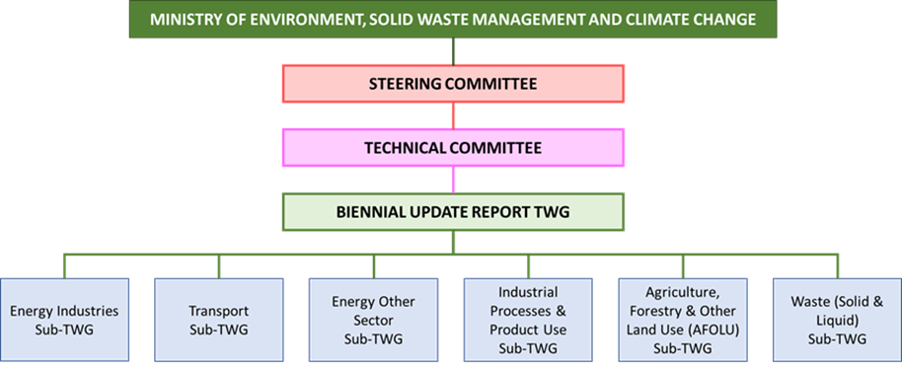

How the system is presently functioning
To date, RoM has relied upon a system of temporary, ad hoc institutional arrangements to undertake National Communications and their associated inventories, whereby ministries and other institutions have supplied staff members to technical working groups for limited periods of time. This has led to coordination challenges (over 75 such institutions are usually involved), as well as limited institutional memory (as it is rarely the same staff members who work on successive National Communications), a lack of systematic data archiving and a heavy reliance upon short-term consultants. There is a need to develop a sustainable solution for archiving the data collected; currently, data is fragmented across multiple computers, is not readily accessible and is difficult to reconstruct for the purposes of building time-series.
Presently, the Climate Change Division (CCD) is responsible for coordinating data collection. Input of data into the 2006 IPCC inventory Software is either undertaken by Consultants. Data processing – i.e. converting data into the form required for the IPCC Software – is a laborious process that varies from sector to sector according to data availability and individual institutional capacities.
The result is an increasingly stressed MRV system that is struggling, and will continue to struggle, in the face of growing demands, notably the increasing frequency of reporting (BURs) and the growing need for GHG data to inform national policies and to track NDC progress.

Figure 7. Government structure relevant to MRV
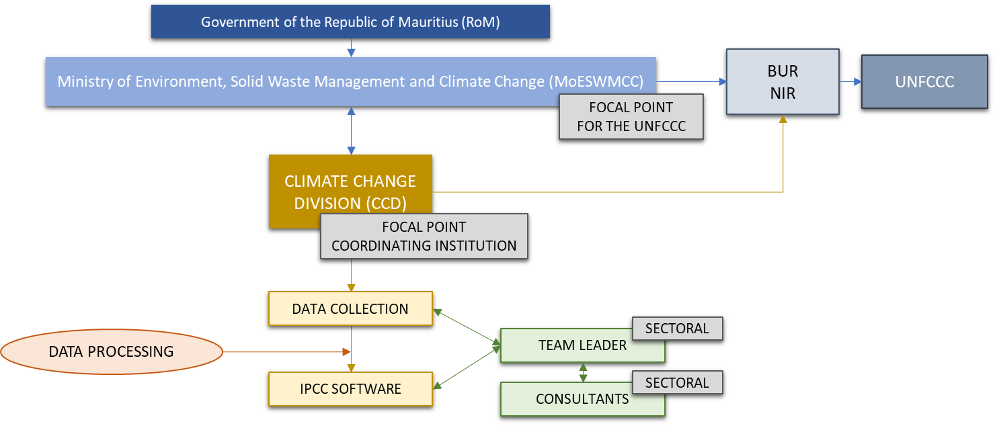

MRV for GHG Inventory System
RoM has an obligation to submit BUR as well as NC on a regular basis, including GHG emissions inventory. It is vital that the process be strengthened, and a system is developed and maintained in a robust manner to ensure that it functions on a continuous basis to meet Republic’s reporting requirements. There is a need to strengthen the existing institutional arrangements or establish new ones to ensure that national capacity is available to yield more technically robust reports and meet the frequency of submissions.
CCD together with the support of the MoESWMCC, acting like leader for GHG inventory, is responsible for coordinating the activities related to data collection, identification of relevant stakeholders, and the organisation of capacity building exercises. The data collection is led by the Team Leader (TL) of each sectoral working group, under the guidance of consultants.
The MoESWMCC is the focal point for the UNFCCC and is responsible for the coordination of the BUR and NIR development. The CCD, as responsible for the coordination of data collection and responsible for the formulation of Low Carbon Development Strategy and a Nationally Appropriate Mitigation Actions (NAMAs) for RoM, should support the MoESWMCC in the development of the documents to be reported to the UNFCCC.
Institutional arrangements for a sustainable development of GHG inventories
The institutional arrangements used for the elaboration of the GHG emission inventory for the first Biennial Update Report are in line with the institutional arrangements used for the NIR. Six sub-technical working groups formed by assigned experts have been established to oversee the technical implementation of data collection, quality control and GHG Inventory.
The CCD, as focal point of the data collection is responsible for the data gathering from the responsible data providers. For this request of information, it is necessary the development of a correct institutional arrangement. The institutional arrangement should assure the smooth and regular development of the GHG Inventory. In addition, it is recommendable to stablish a responsible for each of the data that has to be collected for the development of the national inventory. This responsible should have identified the different responsible from whom data must be requested.
Figure 8. Institutions involved in the preparation of GHG Inventory
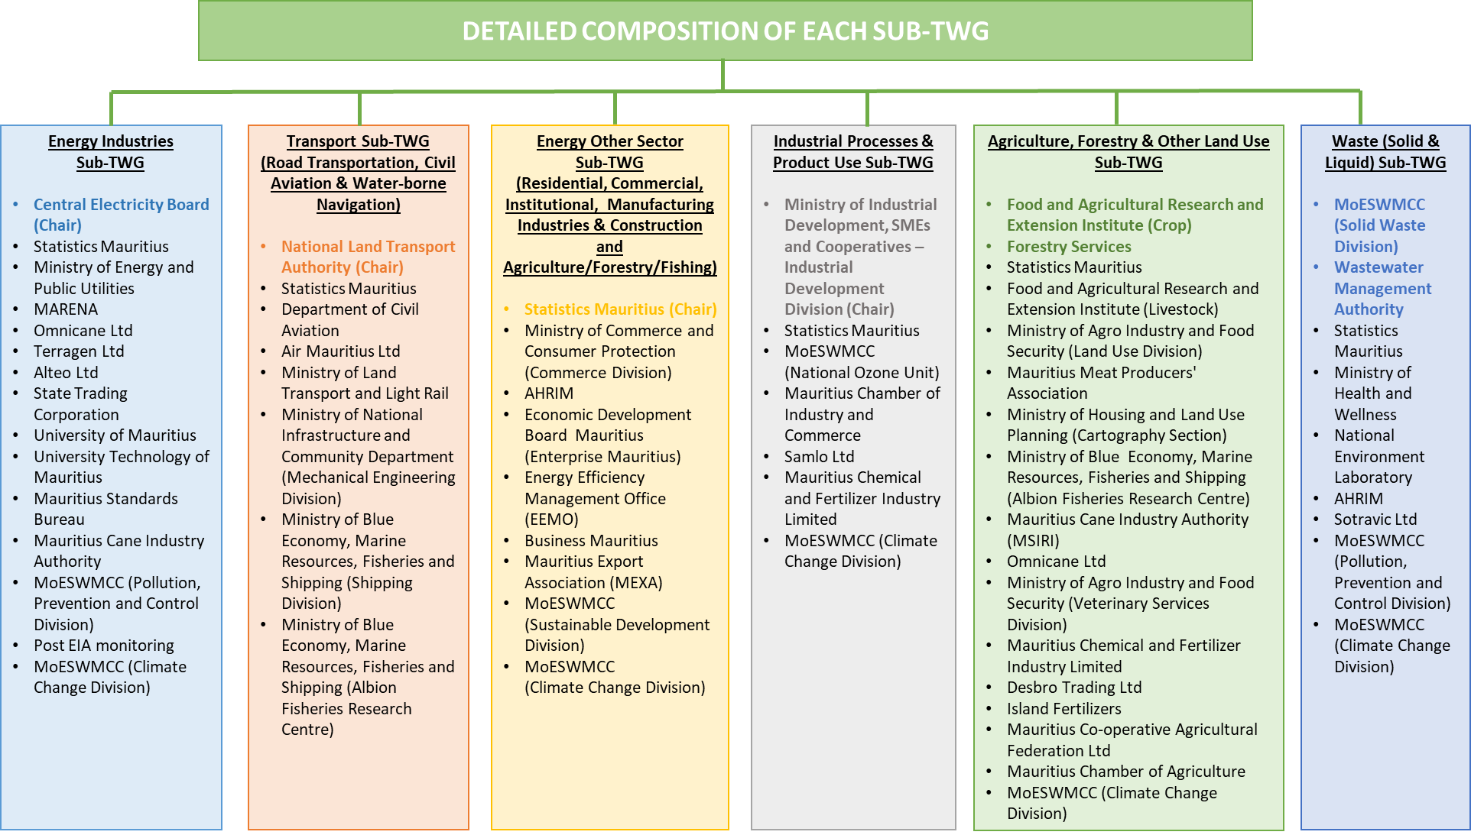
Proper institutional arrangements need to consider the aspects as described in Annex 3: Institutional arrangements template.
For the data request it is necessary to sign a Memorandum of Understanding and Confidentiality Agreement with the data provider. A template for the CA and MoU are reported in Annex 1: Confidentiality Agreement and Annex 2: Memorandum of Understanding (MoU) template.
Before and during the turning of the data collected in the Inventory, it is necessary to gather and report as much information as possible on the data collected, such as contact of the data provider, methodology used, data processing (if applicable), calculations, assumptions (if any), recalculations (if any), etc. All this information should be collected as shown in the Annex 4: Method and data documentation template.
It is also important at this stage to consider the QA/QC procedures during the data collection, for that end, QA/QC procedure proposal is reported in the Annex 5: QA/QC procedures template of this document.
Proposed archiving system
One of the most important procedures to be considered in the Inventory System is the data archiving. An Archiving System helps make a national inventory transparent and reproducible and facilitates development of subsequent inventories by future inventory staff and category leads. All information used to create the inventory should be archived in a single location in both electronic and/or hard copy (paper) storage so that future inventory managers can reference all relevant files to respond to reviewer feedback including questions about methodologies.
Main features:
- Information should be stored in a single location: Climate Change Division seems the more appropriate location. Other options could be the cloud or the IT department.
- Both electronic and paper storage
- Include all emission factors, activity data, and documentation of how these factors and data have been generated and used
- Documentation of QA/QC procedures, reviews, key categories, and planned inventory improvements (e.g. use QA/QC template)
- Multiple copies, including frequent backups.
Content:
- List and Copies of References
- Expert Judgment (Documentation, Contact Information)
- Key Category Analysis
- Uncertainty Analysis
- QA/QC Measures
- Changes and Recalculations
- Improvement Plan
- Archiving Plan
- Review Findings and Responses
- Templates for Future Work
- Results, Analyses, Plans, Measures
Instructions for archiving relevant information:
- Books, Databases or Large Reports:
  - Print and scan cover/title page
  - Print and scan relevant pages of the book/report or screenshots of the database showing the actual source data
- Small Reports, Websites, Spreadsheets:
  - Print and scan entire report, full website, or spreadsheet ensuring all source data is included
- Personal Communications/Interviews with Experts:
  - Create a log listing the expert, interview date, mode of communication (email, in person interview, phone), and the experts contact information
  - Include as much detail as possible from the expert source, including all source data
  - Print and scan the log

A proposal for the archiving system can be consulted in the Annex 6: Archiving system template of this document.
The archiving template will assist:
- Assess past archiving System
- Guidance to develop an archiving system (e.g. procedures)
- Establish roles/responsibilities /procedures consistent with inventory schedule
- Future improvements
Applying and completing the template will help the inventory team:
- Access previous records
- Easily reproduce and review estimates
- Ensure credibility
- Respond to inquiries
- Safeguard against loss of data/information

As Mauritius moves towards more frequent reporting, in the form of BURs and the upcoming Forth National Communication (FNC), there is a greater need for institutional continuity and systematic procedures, including deeper engagement with civil society and the private sector. There is a pressing need to build internal capacities for data collection and GHG estimation to improve data supply and quality in the national GHG Inventory.
Several improvements required for the GHG Inventory that have been identified, are provided in the table below.
Table 1. Improvements required for the GHG Inventory
Sector | Adopted GHG Estimation Approach | Improvements Required
Energy | Tier 1 approaches were adopted for all energy sub-sectors, using IPCC default emission factors. Fugitive emissions from fuels were not estimated. | The adopted approach is the simplest Tier 1 but with country-specific net calorific values.
Energy Industries | Tier 1 approach but with country-specific net calorific values (NCVs), which were derived from the energy statistics maintained by Statistics Mauritius. Mass and volume data on fuel imports were provided by the State Trading Corporation (STC). Consumption data was obtained from CEB, IPPs and Statistics Mauritius. Default emission factors from the 2006 IPCC guidelines were used. | The activity data used for Energy Industries are quite detailed and obtained at plant level. However, this is not the case for EFs. It would be useful for the carbon content of fuels to be tested, so that country-specific carbon emission factors could be used rather than default ones from the 2006 IPCC guidelines.
Manufacturing Industry and Construction | The activity data comprised the fuel used for the Manufacturing Sector in the Energy Statistics produced by Statistics Mauritius. The split among the manufacturing sub-categories required the estimations of fuels used in boilers based on the proportions of boilers available in each of the sub-categories. | The approach adopted was Tier 1 since not enough country specific EFs were available.
Transport | Tier 1 approach has been used. The NTA maintains a vehicle database containing information on types of vehicle (including light-duty and heavy-duty split into fuel-types), age of vehicle, and use of catalyst and fuel-injection technology. Fuel consumption and vehicle km travelled estimated from sample surveys of large vehicle fleet operators. | The lack of country specific EFs prevented use of Tier 2 or Tier 3 for CO₂ emissions.  Need for data related to vehicle kilometres (surveys), vehicle emissions (tests) and country specific emission factors.
Energy Other Sectors | Tier 1 approach has been adopted. Activity data, primarily use of LPG by households and the commercial sector, was obtained from the national energy statistics. | The activity data used for this category was sufficiently detailed. Improved development of sub-sector EFs will ensure more accuracy.
Industrial Processes and Product Use (IPPU) | Source categories covered by the inventory are Mineral Products (primarily Metal Production – Iron and Steel) and ODS substitutes. A Tier 1 approach was used. | Although Iron and Steel Production is a key category within IPPU, its contribution to GHG emissions is only minor.  Following 2006 IPCC guidelines, since IPPU is not a key category, not much time and effort was put to develop higher-tier methods for this category.
Agriculture, Forestry and Other Land Use (AFOLU) | GHG sources include enteric fermentation, manure management, agricultural soils and field burning. | It is recognised that this sector needs improvement and data gap analysis activity need to be performed.
Agriculture | Most agricultural activity data was obtained locally, but EFs used were Tier 1 default factors drawn from the IPCC 2006 Guidelines. | Some activity data and EFs had to be estimated by using expert knowledge. It is proposed to empower FAREI to improve collection of livestock population data and develop local EFs to reduce the uncertainty level. Change in the agriculture
Forestry | Removals in the forestry sector were estimated using local activity data, data from statistics Mauritius and default Tier 1 removal factors (gain-loss method). Above-ground biomass and the soil carbon pools were considered. | Most of the country-specific factors were not available (basic wood density, biomass expansion factors, root-to-shoot ratio, amongst others). The removal factors utilised were mostly default values.  The major data gaps identified were lack of data and maps for general land cover changes and land uses for the past 10 years and lack of data on private forest lands.  Limited data on privately-owned forests, trees along rivers and roadsides; and on natural forests (types of trees, age distribution, annual increment).  Land use pattern and its GIS map need to be developed to assess the changes in land use and cropping pattern.
Waste | GHG emissions for waste sector were generally calculated using the measurement and monitoring records from the waste management plant and records from site office. Other statistical methods used were (e.g. amount of waste landfilled, population connected to the sewer network and per capita generation rate etc.) and emissions were calculated using Tier 1 approach | The Waste Sector measurement, reporting and verification is dependent upon accurate and regularly updated data on solid waste composition.  The calculation will be more transparent if there are country specific Emission factors. The activity data for liquid wastes needs to be studied with a view to develop country specific EFs and hence it is deemed to use EF’s from IPCC.
Solid Waste | The IPCC waste model was used to estimate CH₄ emissions from the Mare Chicose sanitary landfill. A fraction of the biogas is captured and used to generate electricity, for which reasonable source of data exists; the inventory quantifies the CH₄ emissions that are vented without capture and without oxidation in the cover of the landfill. Composting and waste incineration (clinical waste only) are minor emissions sources, for which default IPCC EFs are used. | Mauritius has country-specific and accurate [municipal solid waste] data.  Insufficient work on EF development for emissions from waste and previous data record is from the year 2000 does not meet the standard QA/QC. UNFCCC Model correction factor is applied
Liquid Waste | Activity data were provided and sourced from treatment plants metered water statistics supplied and coordinated by from Wastewater Management Authority, Mauritius. Wastewater characteristics were determined using laboratory analyses as provided by WWMA, Mauritius. Default CH₄ emission factors were used. | There is lack of effective and verifiable data on the quantity of wastewater generated its source types.  Comprehensive survey on number of households, commercial establishment and other wastewater generation source shall be identified and measured for Integrated Wastewater Management Framework for the purpose of MRV.  The WWMA needs to identify and improve the monitoring of the types of storm water and sewage network, including wastewater from residential, commercial and Industrial sector for accurate calculations. Also, WWMA may need to conduct the survey of catchment area for  Waste characterisation and chemical analysis need to be carried out to have more accurate data for percentage of waste (paper, garden and others).  Lack of actual measured data on different sources of wastewater emissions at treatment plants and records of population connected. More country specific

MRV of mitigation actions
A Measuring, Reporting and Verification (MRV) System is required for GHG mitigation/sequestration actions to support NAMAs and the regular submission of BURs.
There is no completed formal recording system for tracking mitigation actions within the RoM institutions, which would be used to report conveniently about the status and progress of activities implemented. Nevertheless, RoM is in the process of developing a framework which ensures MRV approaches for individual mitigation actions are developed using a uniform process, using common sectoral assumptions to provide comparability with existing projections, are aligned with data and emission factors in the national GHG inventory where feasible, avoid double counting and are reported using standardized reports on implementation and impacts. The reported data will provide quality information for political decision-making and reporting on implementation of mitigation action at the national level as well as input for next Biennial Update Reports (BUR) compilation.
RoM continues to build and improve its system for measuring, reporting and verifying mitigation actions and their effects while tracking support received in implementing these. The institutional arrangements follow closely those described above for the GHG inventory, involving many of the same institutions collaborating for the MRV of emissions but with somewhat different responsibilities for the MRV mitigation and support systems. The Mitigation Working Groups (MWG), with representatives responsible for collecting and reporting data, should have well-developed procedures and these arrangements must be reviewed and upgraded to be fully operational and to deliver for meeting reporting standards.
For making the appropriate linkages on funding, the Ministry of Finance, Economic Planning and Development may be fully fledged member of the MRV mitigation and support systems. Ministries/Institution/Agencies implementing mitigation actions will automatically join the mitigation working group to provide data collected.
First step for developing an MRV of the mitigation actions proposed is reported in Annex 9: Parameters needed for the MRV mitigation actions.

MRV of support needed and support received
The MRV of support will not completely be dissociated from the MRV of mitigation. However, the operational framework will have to be different from the one proposed for MRV of mitigation due to the different roles and responsibilities of various ministries.
Therefore, the responsibility of the MRV of support could be taken by the Ministry of Finance in close collaboration with the Environment and Sustainable Development Division or the institutional body responsible for the Environmental Funds.
The main ministries and institutions identified to be part of the MRV of support are:
- Ministry of Finance, Economic Planning and Development
- Ministry of Energy and Public Utility (MEPU)
- Ministry of Agro Industry and Food Security
- Ministry of Land Transport and Light Rail
- Central Electricity Board (CEB)
Climate Change Division is in the process of developing user-friendly templates that the Ministries and other organizations will complete once annually, and send back for analysis, compilation and reporting. RoM is in the process of design but the information collected could be handed over to Statistics Mauritius for databasing and archiving. Then, Statistics Mauritius would send back a copy of the quality-controlled data to Climate Change Division for storage. However, this is something to be agreed at the topmost managerial level for appropriate action to guarantee a consistent system for the MRV of support.

Prioritised actions to develop an MRV system
This section includes the priority actions to further develop the MRV systems. Links are presented in table below to the key activities as described above and the templates included in the annex in this report.
Some of these prioritized actions can be develop in parallel, even some have a strong relation between them so carried out some of them at the same time, developing them organically, could be required and/or advantageous. This table links the suggested prioritized actions with the key activities (KA) previously mentioned in section 2 of this MRV Framework, and with the related Annex/es.
Table 2. Prioritised actions
Prioritised action | KA1 | KA2 | KA3 | KA4 | KA5 | KA6 | Template
Update / Review / Establish / Officialize the coordinating body and technical working groups |  |  |  |  |  |  | Annex 3
Identification of necessary/required data and information for the appropriate (accurate, transparent, consistent, comparable, complete) development of the inventory of emissions, mitigation actions and other required parameters for the national MRV system. Identification of all relevant stakeholders required to achieve all this information |  |  |  |  |  |  | Annex 3 Annex 4
Define and sign institutional agreements with identified stakeholders |  |  |  |  |  |  | Annex 1 Annex 2
Design and agreement between working groups and stakeholders of the templates and contents of the required information |  |  |  |  |  |  | Annex 5
Design and registration of the archiving system |  |  |  |  |  |  | Annex 6
Analysis de gaps and constraints and needs identification to request the appropriate international support from a financial and capacity building point of view

Prioritised actions for MRV system in RoM
This section includes the prioritized actions to further develop the MRV system in ROM. Based on the current situation of the MRV system in RoM, there are some activities/tasks which require attention and improvements. Depending on the activity/task, the resources required (in terms of time, staff or capacity) to finally achieve the complete implementation will vary. The implementation of the MRV system is an iterative process: it will evolve in different steps and will need to adapt the changes in, for example, institutions or reporting needs. Table 3 shows, by using the colour coding system described below, the current status of the different activities/tasks of the MRV system in RoM.
- Green: Implemented
- Orange: In progress
- Red: Not implemented
Table 3. Prioritised actions*
Key activities/tasks | Status
Key activity 1: Review current MRV activities: Not applicable until 2nd BUR
Key activity 2: Establish institutional arrangements

Establishing National Legal or Formal Arrangements

Choosing an appropriate Coordinating Body
Engaging Stakeholders
Building In-Country Institutional and Technical Capacity
Maintaining a Motivated and Stable Coordinating Body
Reporting on Institutional Arrangements within BURs
Key activity 3: Assess data gaps and needs

Assess and prioritise data gaps
Identify how existing MRV systems can be extended to address data gaps
Key activity 4: Establish data management processes
Develop systems to improve data quality
Develop data management systems
Address data gaps
Develop data improvement plans
Key activity 5: Build MRV capacity
Key activity 6: Improve the MRV system over time
Ensure MRV reports are relevant
Consider options for continuous improvement
*Key activities and tasks follow the scheme in section 2. National (domestic) MRV system
Based on the current status, and also considering the resources required to continue improving each of these activities/tasks of the MRV system, RoM will identify which activities/tasks need to be prioritised in the short, medium and long term.
As it has previously mentioned, some of these prioritized actions can be developed in parallel, even some have a strong relation between them so the simultaneous implementation, developing them organically, will use their synergists and enhance cost-effectiveness.

References
- Climate & Development Knowledge Network (CDKN)
https://www.cdkn.org/ndc-guide/book/planning-for-ndc-implementation-a-quick-start-guide/measuring-reporting-and-verification/
- Deutsche Gesellschaft für Internationale Zusammenarbeit (GIZ) GmbH: “MRV Measurement, Reporting, Verification. How To Set up National MRV Systems. Draft 4.2”
- NIRAS - European Commission, DG Climate Action: “GUIDELINES FOR DESIGNING CAPACITY BUILDING PROJECTS ON CLIMATE MRV. Input to NDC, BUR and mitigation actions in developing countries”
- UNDP “MRV IN PRACTICE – CONNECTING BOTTOM-UP AND TOP-DOWN APPROACHES FOR DEVELOPING NATIONAL MRV SYSTEMS FOR NDCS”
- World Resources Institute “UNDERSTANDING MEASUREMENT, REPORTING, AND VERIFICATION OF CLIMATE CHANGE MITIGATION”
- Republic of Mauritius (2016). Third National Communication: Report to the United Nations Framework Convention on Climate Change. Republic of Mauritius, Port Louis

Annexes

Annex 1: Confidentiality Agreement

CONFIDENTIALITY AGREEMENT

This confidentiality agreement (“Agreement”) made as of the [date] day of [Month], [Year], is by and between [Organization A] of [Address] (“[Short Organization name if applicable]”), and [Organization B] of [Address] (“[Short Organization name if applicable]”). [Short name of Organization A, if applicable] and [Short name of Organization B, if applicable] are at times referred to herein individually as a “Party” and collectively as the “Parties.” This agreement considers data provided by [Organization A] to be treated as confidential and will not be shared beyond the purposes of national GHG inventory estimates.

AGREEMENT

WHEREAS, each party to this Agreement possesses certain confidential and/or proprietary information that it proposes to disclose to the other party solely for the purposes of compiling confidential business information required to [insert the purpose of obtaining the information and how it will be used in the greenhouse gas inventory], all such disclosures are subject to the terms and conditions set forth below.

NOW, THEREFORE, in consideration of the foregoing and the promises and agreements herein set forth, the Parties agree as follows:

- APPLICABLE LAW
  - This Agreement shall be governed by the laws of the [Name of Country, other political jurisdiction, or Ministry], without regard to [Name of Country, other political jurisdiction, or Ministry]’s conflict of laws principles; provided, however, that the determination of whether any Confidential Information (as such term is defined below) qualifies as a trade secret shall be made solely by reference to the law of the jurisdiction in which such Confidential Information is maintained by the Disclosing Party and not by reference to the laws of the [Name of Country, other political jurisdiction, or Ministry referred to above].
- DEFINITIONS
  - For the purposes of this Agreement, the term, “Confidential Information,” shall mean confidential and/or proprietary information under the ownership or control of one of the parties. The term, “Confidential Information,” expressly excludes information that:
    - was in the public domain at the time it was disclosed or falls within the public domain, except through a breach of this Agreement; or
    - is or becomes known by the Receiving Party or any of its associated companies from a source other than the Disclosing Party without breach of this Agreement by the Receiving Party; or
    - was furnished to a third party by the Disclosing Party without restrictions on the third party’s rights similar to those contained in this Agreement; or
    - to the extent that such disclosure shall be required by law by the Receiving Party, but only after the Disclosing Party has been notified in writing by the Receiving Party and has been provided a reasonable opportunity to take appropriate action to protect its legal interest in the Confidential Information.
  - If only a portion of any Confidential Information falls within any one of the exceptions listed above, the remainder of such Confidential Information shall continue to be subject to this Agreement.
  - For the purposes of this Agreement, the term, “Disclosing Party,” shall mean the party owning or controlling Confidential Information and making such Confidential Information available to the other party.
  - For the purposes of this Agreement, the term, “Receiving Party,” shall mean the party who receives Confidential Information from the Disclosing Party.
- LIMITATION ON USE OF CONFIDENTIAL INFORMATION
  - The parties agree that, as between them, the asserted Confidential Information disclosed under this Agreement: (a) as it relates to Confidential Information disclosed by [Short name of Organization A if applicable], derives independent economic value, actual or potential, from not being generally known to, and not being readily ascertainable through proper means by other persons who can obtain economic value from its disclosure or use, and (b) as it relates to Confidential Information disclosed by [Short name of Organization B if applicable], derives independent economic value, actual or potential, from not being generally known to the public or to other persons who can obtain economic value from its disclosure or use.
  - All rights, title, and interest in Confidential Information disclosed pursuant to this Agreement are reserved by the Disclosing Party, and the Receiving Party will not use such Confidential Information disclosed to it by the Disclosing Party to benefit itself or others, except for the limited purposes for which the Confidential Information is disclosed within the context of this Agreement. The Receiving Party will not disclose such Confidential Information to any third party unless and until expressly authorized in writing to do so by the Disclosing Party.
- PROTECTION OF CONFIDENTIAL INFORMATION
  - The Receiving Party shall exercise at least the same standard of care to prevent the disclosure or misuse of the Confidential Information as it exercises to prevent the disclosure or misuse of its own Confidential Information, but in no event shall the Receiving Party exercise less than reasonable care [for example, the Receiving Party could ensure data are protected by locking spreadsheets with a password]. The Receiving Party shall limit dissemination of such Confidential Information to those persons within its organization who have a need to know such information to fulfill the purpose of this Agreement and who agree to be subject to the restrictions of this Agreement. Both parties agree not to disclose the fact or content of any negotiations between them to third parties (other than outside counsel) without the written consent of the other party.
  - The Receiving Party shall aggregate all data disclosed, and emissions estimates will be aggregated with other data provided for the source category. Specific activity data for the Disclosing Party will not be presented or published in the National Inventory, and only the aggregated emissions estimates will be presented.
- TERM OF AGREEMENT
  - This Agreement shall take effect as of the date written above and shall terminate [amount of time, e.g., one year] from the effective date of this agreement.
  - The respective obligations of the parties relating to limitations on the use and/or disclosure of Confidential Information under this Agreement shall survive termination of this Agreement.
- RETURN OF CONFIDENTIAL INFORMATION
  - All Confidential Information and copies thereof shall be returned to the Disclosing Party at the time this Agreement expires, or earlier at the initiation of the Receiving Party or upon the Receiving Party’s receipt of a written request from the Disclosing Party for the return of such Confidential Information.
  - The Receiving Party may retain one (1) copy of such Confidential Information for its legal archives, subject to the ongoing restrictions on the use and/or disclosure of the Confidential Information.
- SPECIFIC PERSONS TO RECEIVE INFORMATION
  - The following persons are designated as the respective parties’ team leaders to receive and/or disclose the Confidential Information exchanged pursuant to this Agreement
For [Organization A]: [Name(s)]
For [Organization B]: [Name(s)]
- MARKING OF CONFIDENTIAL INFORMATION
  - Confidential Information developed or disclosed by either party under this Agreement shall be clearly labeled and identified as Confidential Information by the Disclosing Party at the time of disclosure. When written identification of Confidential Information is not feasible at the time of such disclosure, the Disclosing Party shall provide such identification in writing promptly thereafter.
- APPLICATION OF [COUNTRY] SECURITIES LAWS
[Short name of Organization A if applicable] acknowledges that (a) [Short name of Organization B if applicable] considers the Confidential Information to be material, non-public information about [Short name of Organization B if applicable], and (b) it is aware, and it will advise persons within its organization, that the [Country] securities laws prohibit any person who has material, non-public information about a company from purchasing or selling securities of such company, or from communicating such information to any other person under circumstances in which it is reasonably foreseeable that such person is likely to purchase or sell such securities in reliance upon such information.
- RELATIONSHIP OF THE PARTIES
  - The parties are independent contractors. This Agreement does not create a partnership, joint venture, agency or other similar relationship between the parties. Neither party is authorized solely by means of this Agreement to make any representation, contract or commitment on behalf of the other party, or to otherwise bind the other party in any respect whatsoever.
- ENTIRE AGREEMENT
  - Both parties acknowledge that they have read this Agreement, understand it, and agree to be bound by its terms, and further agree that it is the entire agreement between parties hereto which supersedes all prior agreements, written or oral, relating to the subject matter hereof. No modification or waiver of any provision shall be binding unless in writing signed by the party against whom such modification or waiver is sought to be enforced.
NOW THEREFORE, the parties hereto have caused this Agreement to be duly executed in their names by officials who are duly authorized as of the effective date set forth above.

FOR: [ORGANIZATION A] |  | FOR: [ORGANIZATION B]
SIGNATURE |  | SIGNATURE
NAME (TYPED) |  | NAME (TYPED)
DATE |  | DATE

AMENDMENT NO. 1

CONFIDENTIALITY AGREEMENT

This Amendment no. 1 (“Amendment”), is made and entered into this [Date] (“Amendment Effective Date”), by and between [Organization A], with its principal place of business at [Address] (“[Short Organization name if applicable]”), and [Organization B], with offices at [Address] (“[Short Organization name if applicable]”). [Short name of Organization A, if applicable] and [Short name of Organization B, if applicable] are at times referred to herein individually as a “Party” and collectively as the “Parties.”
RECITALS:
- The Parties signed the Confidentiality Agreement (as so amended, the “Agreement”), on [Date].
NOW IT IS HEREBY AGREED as follows:
- [Description of the first matter amended].
- [Description of the second matter amended, as applicable].
- [Etc.]
IN WITNESS WHEREOF, the Parties intending to be bound hereby execute and deliver this Amendment by their duly authorized representatives as of the Amendment Effective Date.

[Organization A] |  | [Organization B]
By: |  | By:
Print Name: |  | Print Name:
Print Title: |  | Print Title:
Date: |  | Date:

Annex 2: Memorandum of Understanding (MoU) template

MEMORANDUM OF UNDERSTANDING
between
___________[MINISTRY X]___________
and
___________ [MINISTRY Y]___________
on
The National Greenhouse Gas Inventory and Program B, C, etc…
- OBJECTIVES
The objectives of this Memorandum of Understanding (MOU) between [Ministry X] and [Ministry Y] are:

Examples:
- To develop a system of data sharing between Ministry X and Ministry Y, to support the development of the National Greenhouse Gas Inventory (for UN reporting obligations (e.g. National Communication, BUR and/or national policy purposes)). Ministry X has been tasked under [degree, law, act, etc.] to coordinate development of the national GHG inventory.
- To commit to work together to develop and jointly implement a program to slow the growth of greenhouse gas emissions.
- AUTHORITIES AND RELATED ACTIVITES
Nothing in this agreement alters, or is intended to alter, the legal and regulatory authorities of Ministry X and Ministry Y. This agreement is solely intended to facilitate the fulfillment of legal requirements and cooperative efforts.

- The National Greenhouse Gas Inventory

- The Program
Provide a description of the program in question and context for the program in this MOU.
.
- Authorities
Provide descriptions for the national authorities that are relevant to this MOU.
Example from the USA: EPAct Section 1605 (b) (4) allows reporting entities to use information reported through the voluntary reporting system to demonstrate achieved reductions of greenhouse gases.
- Program B (If necessary)

- The Program
Provide a description of the program in question and context for the program in this MOU.
- Authorities
Provide descriptions for the national authorities that are relevant to this MOU.
- PROVISIONS
A. The National Greenhouse Gas Inventory
It is mutually agreed:
- to…;
- to…
Ministry X agrees:
- to continue to consult with DOE on preparation of the greenhouse gas inventories to meet the RoM´s commitments under the UNFCCC;
- to ensure that this inventory will undergo full interagency review, and that any outstanding issues will be raised to the Office on Environmental Policy or its Monitoring, Evaluation, and adjustment Task Force for final resolution; and,
- to forward the inventory to the Department of State for submission by the RoM Government under the UNFCCC.
Ministry Y agrees:
- to make available supporting technical reports, models, and data that may form the basis of the guidelines; and,
- to provide, in advance, a schedule for review of draft and final materials which includes, to the extent possible, adequate time for review and comment.
B. Program B (If necessary)
It is mutually agreed:
Ministry X agrees:
Ministry Y agrees:
- MEETINGS AND CORRESPONDENCE (optional)
To accomplish the goals and activities set forth in this MOU, Ministry X and Ministry Y will to the fullest extent possible:
- Regularly meet for the purposes of program planning and monitoring and evaluating outcomes;
- Respond to correspondence by telephone or email in a manner and timeframe that promotes efficiency and the timely progress or completion of objectives and tasks consistent with the goals and activities described above; and,
- Agree to specific meeting or call times and dates as far as possible in advance of the appointed occasion.
- POINTS OF CONTACT
The points of contact for the MOU on The National Greenhouse Gas Inventory are:
Ministry X | Ministry Y
Position | Position
Points of contact may be re-designated by the signatories.
- DURATION OF THE AGREEMENT
This MOU may be amended by written agreement between Ministry X and Ministry Y. The agreement becomes effective on the date of signature by both parties. It shall remain in effect for a ____ year term from the effective date. This MOU may be terminated by mutual written agreement of X and Y or by either party with ____ days notice to the other party.

This memorandum of understanding is entered into
On the ____ day of ____ in the year ____.

Signatures:

____________________ | ____________________
Name | Name
Position | Position
Ministry X | Ministry Y
Date of Signature | Date of Signature

Annex 3: Institutional arrangements template

Overview of Current Inventory Management Team
STEP 1: The inventory management team coordinates the development of the national GHG inventory. In STEP 1, list the lead agency and identify inventory management team members. Information for additional contacts for each sector can be listed in STEP 2. The status of the institutional arrangements can be noted in the “Comments” column.
Table 4. Designated Inventory Agency
Designated National GHG Inventory Preparation Agency/Organization | UNFCCC Focal Point (Name) and UNFCCC Focal Point Agency | Describe the arrangements or relationship between Inventory Agency/Organization and UNFCCC Focal Point Agency, if different.
Table 5. National Inventory Management Team
Role | Name | Organization | Contact Information | Comments
Inventory Director/Coordinator
Energy Sector Lead
Industrial Processes Lead
Agriculture Sector Lead
LULUCF Sector Lead
Waste Sector Lead
Archive (Data and Document) Manager/Coordinator
QA/QC coordinator
Uncertainty Analysis coordinator
Other: e.g., GHG Policy Specialist who tracks capacity building efforts and IPCC processes
Sectoral Roles and Arrangements
STEP 2: In this step, list more specific information about contacts/experts for inventory development for each sector.
One table is provided for each sector to document existing arrangements for obtaining, compiling and reviewing inventory data. In each table, identify the role, organization, and contact information for those providing relevant data for estimating emissions. Use the examples provided as a guide for the type of information required.
In the “Comments” section, provide information on the status of the institutional arrangement, or any additional information not included within the table.
Insert as many rows within the table below as necessary to provide the detailed information for each category.
In the comments column of each table, explain in detail how the arrangements were established. For example, the data provider listed provides the statistics that will be used in the inventory. Describe for each sector the strategies that were used to collect the necessary inventory data from an organization. In this description, address the following questions and add additional comments as necessary:
  - Is there a formal legal contract between the organizations?
  - Was there a meeting with the experts, data providers, and other key contributors explaining the background and purpose of the inventory?
  - Is it an informal arrangement (e.g., written or verbal communication with staff)?
  - How was the request for data made?
  - At what level of management was the request made?
  - How was the organization motivated to share its data and information with the inventory agency?
Table 6. Energy Sector Institutional Arrangements
Role | Organization | Contact(s) [Name] | Contact Information  [E-Mail, Phone, etc.] | Participated in meetings on GHG inventory development?  [Yes/No] | Comments
Technical coordinator
Consultant compiling estimates
Expert reviewer
Data provider
Other
Table 7. Industrial Processes Sector Institutional Arrangements
Role | Organization | Contact(s) [Name] | Contact Information  [E-mail, Phone, etc.] | Participated in meetings on GHG inventory development?  [Yes/No] | Comments
Table 8. Agriculture Sector Institutional Arrangements
Role | Organization | Contact(s) [Name] | Contact Information  [E-mail, Phone, etc.] | Participated in meetings on GHG inventory development?  [Yes/No] | Comments

Table 9. LULUCF Sector Institutional Arrangements
Role | Organization | Contact(s) [Name] | Contact Information  [E-mail, Phone, etc.] | Participated in meetings on GHG inventory development?  [Yes/No] | Comments
Table 10. Waste Sector Institutional Arrangements
Role | Organization | Contact(s) [Name] | Contact Information  [E-mail, Phone, etc.] | Participated in meetings on GHG inventory development?  [Yes/No] | Comments
Table 11. Other Sector Institutional Arrangements [Optional]
Role | Organization | Contact(s) [Name] | Contact Information  [E-mail, Phone, etc.] | Participated in meetings on GHG inventory development?  [Yes/No] | Comments
Potential Improvements
STEP 3: Within each sector list where institutional arrangements to support preparing the inventory are well established, where data are collected and managed adequately, and where strengthening is not needed.
Given the key category analysis and existing institutional arrangements within each sector, identify what improvements are needed to enhance the institutional arrangements for each sector, and list these in Table below. In preparing this section, consider whether any important tasks for inventory preparation have not been assigned or delegated, and determine whether they could be assigned.
Table 12. Potential Improvements in Management Structure of National Inventory System
Sector | Strengths in Management Structure of National Inventory System | Potential Improvements in Management Structure of National Inventory System
Energy
Industrial Processes
Agriculture
Waste
LULUCF
Other [Optional]
Inventory Cycle
STEP 4: The length of the inventory cycle depends on national circumstances and reporting requirements. The inventory cycle diagram in Figure below can be applied to annual, biennial, or longer-term completion cycles. In this step, use the diagram below to outline the overall inventory cycle as it exists in your country. Use the side boxes to note the length of time devoted to each phase or determine tentative completion dates for each phase. This cycle presents important information that should be considered and adopted to reflect institutional arrangements in your inventory development schedule. This cycle will help to communicate when and where in the process institutional coordination will need to occur. Data providers may have different schedules for the publication of relevant information and data. Therefore, adequate time should be scheduled for data collection or to adjust sector specific schedules as needed. Sometimes agencies may be able to provide preliminary estimates in advance of final estimates so that review and draft write-ups of estimates are not delayed.

Deadline:

Deadline:

Deadline:

Deadline:
Deadline:
Deadline:
Figure 9. Inventory Cycle
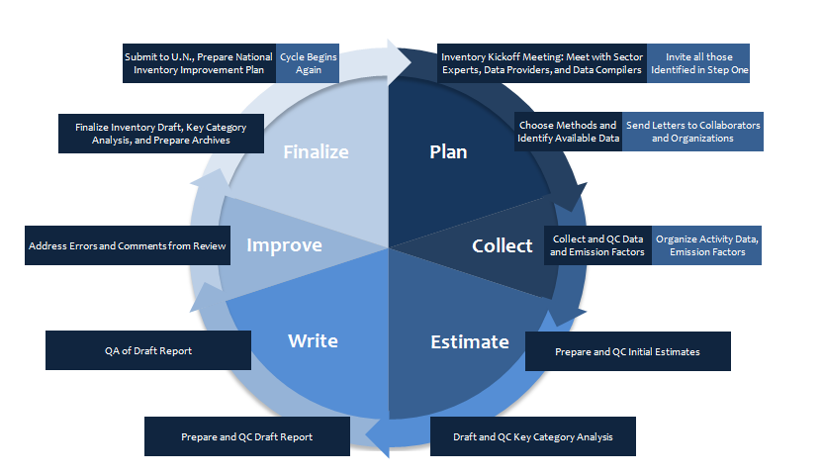
Deadline:

Deadline:

Deadline:

Deadline:

Deadline:

Deadline:

Deadline:

Deadline:

Deadline:
Deadline:

Annex 4: Method and data documentation template
Category Information
STEP 1: Provide information about each category, including the sector it belongs to, a description of the category, and details about emissions and removals from this category in your country including which GHGs are emitted. A standard description from existing documents is sufficient to describe the category.
In the Country Detail field, describe the importance of emissions/removals in RoM from the category. Provide the contribution to total net emissions and the historical context for emissions/removals in your country from this category (e.g., relative importance and trends).
Copy and paste tables below as necessary to provide detailed information for each key category, or alternatively, save each greenhouse gas category as a separate file.
Tables below include the relevant information about categories, including descriptions of each category as it pertains to RoM.
Table 13. Category Information template
Sector
Category
Key Category?
[Yes or No]
Category Description/Definition
Country Detail

Method Choice and Description
STEP 2: Provide information about the method used to estimate emissions/removals from each category. List the equation used and the reference (e.g., 2006 IPCC Guidelines), equation page number, etc.) for the equation. Describe the reason(s) that this methodology was chosen. If completing this template for key categories in the current inventory cycle, describe the methods likely to be used.
Copy and paste as many of the below tables as necessary to provide the detailed information for each category, or alternatively, save each category as a separate file.
Table below describes the methodology used to calculate greenhouse gas emissions and removals, including the equation used, its reference, and why this methodology was chosen.
Table 14. Methodology for [category name], template
Equation
(Describe variables for method used.)
Reference
Describe How and Why this Method Was Chosen
Activity Data
STEP 3: List the activity data used to estimate emissions and removals from each category, including the value, units, and year. Provide a reference for this data and other relevant information, such as when the data were obtained, and the contact name (if the data were supplied by a person) or a full citation (if the data were collected from a published source). If completing this template for categories in the current inventory cycle, identify the data likely to be used.
Copy and paste as many of the below tables as necessary to provide the detailed information for each key category.
Table below shows the activity data used with the methodology described above to calculate greenhouse gas emissions and removals for [category name]. Information in this table contributes to understanding the overall quality of the activity data chosen to this estimate.
Table 15. [Category name] Activity Data, template
Type of Activity Data | Activity Data  Value(s) | Activity Data Units | Year (s) of Data | Reference | Other Information (e.g., date obtained and data source or contact information) | Category QA/QC Procedure Adequate / Inadequate / Unknown | Are all data entered correctly into models, spreadsheets, etc.? Yes / No (List Corrective Action) | Checks with Comparable Data (e.g., At international level, IPCC defaults). Explain and show results.
Emission Factors
STEP 4: List emission factors and carbon-stock change factors used to estimate emissions and removals from each category, including the value and units. Provide a reference for this data and other relevant information, such as the date the factor was obtained, and either the contact name (if the data were supplied by a person) or a full citation (if the data were collected from a published source). If completing this template for categories in the current inventory cycle, identify the emission factors likely to be used.
Copy and paste as many of the below tables as necessary to provide the detailed information for each category.
Table 2.4 provides the emission factors used to calculate emissions from [category name]. Also included in table below are each emission and carbon-stock change factor’s reference, an explanation on how appropriate the emission factor is for calculation emissions from RoM, and more information on how the emission factor was obtained.
Table 16. [Category name] Emission/carbon-stock change Factors, template
Type of Factor | Emission/carbon-stock change Factor  Value | Emission/carbon –stock change Factor Units | Reference | Other Information (e.g., Date obtained and data source or contact information) | Category QA/QC Procedure Adequate / Inadequate / Unknown | Are all data entered correctly into models, spreadsheets, etc.? Yes / No (List Corrective Action) | Explain how this factor is appropriate to national circumstances. Provide sources.
Uncertainty (Optional)
STEP 5: List the current year’s emissions for each category for which an uncertainty estimate has been assigned. Also, include the assigned lower bound and upper bound uncertainty estimate and the resulting lower and upper bound estimate when the uncertainty bounds are applied to the current estimate.
Insert as many rows within the table below as necessary to provide the detailed information for each category.
Table below provides information on the uncertainty associated with several [key and non-key] category estimates.
Table 17. Uncertainty Estimates Calculated for Categories
Category | Key Category? [Yes or No] | Emissions Estimate  (Gg CO2 Eq.) | Relative Lower Bound Uncertainty (%) | Relative Upper Bound Uncertainty (%) | Lower Bound Emissions Estimate  (Gg CO2 Eq.) | Upper Bound Emissions Estimate  (Gg CO2 Eq.)
Provide Any Additional Information
STEP 6: Provide any other relevant information for each key category that would increase transparency of the estimates from this category. Examples include QA/QC activities performed, notes on reporting and documentation, and data quality.
Insert as many rows within the table below as necessary to provide the detailed information for each category.
Table below shows any additional relevant information pertaining to the estimate for [category name].
Table 18. Comments on Estimates for Categories
Category | Key Category?  [Yes or No] | Comments
Improvements to the Methodology and Data Documentation Analysis
STEP 7: Enter any suggested improvements to the Methodology and Data Documentation category-by-category Background Document Template in table below.
Insert as many rows within the table below as necessary to provide the detailed information for each improvement.
Table below provides a list of suggested improvements to the methodology and data documentation category-by-category analysis. These improvements will be incorporated into the template in future years.
Table 19. Improvements to the Methodology and Data Documentation Analysis
Improvement | Sector | Category | Potential Improvement

Annex 5: QA/QC procedures template
Background
Quality assurance and quality control measures are two distinct types of activities. The IPCC defines each as follows:
- Quality Assurance (QA) – a planned system of review procedures conducted by personnel not involved in the inventory development process.
- Quality Control (QC) – a system of routine technical activities implemented by the inventory development team to measure and control the quality of the inventory as it is prepared.
An effective QA/QC plan contains the following elements:
- Personnel responsible for coordinating QA/QC activities.
- General (Tier 1) QC procedures.
- Source-specific (Tier 2) QC procedures.
- QA review procedures.
- Reporting, documentation, and archiving procedures.
Each of these elements are described in more detail below.
QA/QC Plan
STEP 1: Fill out each subsection to document or develop the various elements of RoM’s QA/QC plan. Once developed, use the plan in subsequent inventory preparation. Modify the plan as necessary to reflect new processes.
A written QA/QC plan is a fundamental element of a QA/QC system. This plan outlines QA/QC activities performed, the personnel responsible for these activities, and the schedule for completing these activities. The following sections describe the QA/QC plan that RoM plans to follow to ensure a high quality national inventory.
QA/QC Personnel
STEP 2: List responsibilities for the QA/QC coordinator. Fill out table below with the names and contact information for appropriate staff person(s) responsible for each activity listed.
Insert as many rows within the table below as necessary to provide the detailed information for each activity listed.
The QA/QC coordinator is the main person responsible for implementing the QA/QC plan. In this role, the QA/QC coordinator:
- Clarifies and communicates QA/QC responsibilities to inventory members.
- Develops and maintains QA/QC checklists appropriate to various inventory team member roles
- Ensures the timely and accurate completion of QA/QC checklists and related activities. Develops an overall QA/QC timeline and when external reviews will occur.
- Manages and delivers documentation of QA/QC activities to the inventory lead and archive coordinator.
- Coordinates external reviews of the inventory document and ensures that comments are incorporated into the inventory.
In this role, the QA/QC coordinator communicates with several other inventory members.
Table 20. Personnel Responsible for QA/QC Activities
Title | QA/QC Responsibility | Name | Organization | Contact Information
Inventory Lead | All aspects of the inventory program, cross, cutting QA/QC
QA/QC Coordinator | Implementing the overall QA/QC plan
Category Lead(s) | Implementing category specific QA/QC procedures (Tier 1 and Tier 2 procedures listed in Table 3.2 and 3.3 below)
Outside Expert(s) | Expert review of the inventory
Communicating the QA/QC Plan
It is essential to communicate the contents of the QA/QC plan to inventory team members and outside experts so that the procedures can be effectively implemented, evaluated, and improved. The QA/QC coordinator for RoM will implement the following procedures for the QA/QC plan:
- Convene a meeting with all team members to develop a QA/QC plan.
- Write and distribute a QA/QC plan to all team members required to perform QA/QC.
- Conduct a “kick-off” meeting with all of those working on the inventory (including consultants, universities, etc), introduce plan and distribute QC checklists (this can be completed in conjunction with the inventory kick-off meeting)
- Send memos (written or electronic) reminding team members of their QA/QC responsibilities and overall schedule.
- List additional ways of communicating the QA/QC plan.
General (Tier 1) QC Procedures for Source/Sink Category Leads
STEP 3: As each item in table below is completed, enter the name or initials of the person completing the item and the date the item was completed.
Insert as many rows within the table below as necessary to provide the detailed information for QA/QC procedures.
According to the 2006 IPCC Guidelines, although general QC procedures are designed to be implemented for all categories and on a routine basis, it may not be necessary or possible to check all aspects of inventory input data, parameters and calculations every year. A representative sample of data and calculations from every category may be subjected to general QC procedures each year. In establishing criteria and processes for selecting sample data sets and processes, it is good practice for the inventory compiler to plan to undertake QC checks on all parts of the inventory over an appropriate period of time as determined in the QA/QC plan.
A minimum set of QC procedures are followed each year for all categories to ensure that basic standards of quality are met. These standards generally focus on the processing, handling, documenting, archiving, and reporting procedures common to all categories. Table below lists the specific Tier 1 QC activities performed by RoM, and a checklist for when these activities were completed.
Table 21. General (Tier 1) QC Activities
QC Activity | Procedures | Task Completed |  | Corrective Measure Taken
 |  | Name/  Initials | Date | Supporting Documents (List Document Name) | Date
Data Gathering, Input, and Handling Checks
Check that assumptions and criteria for the selection of activity data and emission factors are documented. | - Cross-check descriptions of activity data and emission factors with information on categories and ensure that these are properly recorded and archived.
Check for transcription errors in data input and reference. | - Confirm that bibliographical data references are properly cited in the internal documentation (MDD template report)  - Cross-check a sample of input data from each category (either measurements or parameters used in calculations) for transcription errors.  - Utilize electronic data where possible to minimize transcription errors.  - Check that spreadsheet features are use d to minimize user/entry error:  - Avoid hardwiring factors into formulas.  - Create automatic look-up tables for common values used throughout calculations.  - Use cell protection so fixed data cannot accidentally be changed.  - Build in automated checks, such as computational checks for calculations, or range checks for input data.
Check that emissions/removals are calculated correctly. | - Reproduce a representative sample of emissions/removals calculations.  - If models are used, selectively mimic complex model calculations with abbreviated calculations to judge relative accuracy.
Check that parameter and emission/removal units are correctly recorded and that appropriate conversion factors are used. | - Check that units are properly labeled in calculation sheets and (MDD template report)  - Check that units are correctly carried through from beginning to end of calculations.  - Check that conversion factors are correct.  - Check that temporal and spatial adjustment factors are used correctly.
Check the integrity of database files. | - Confirm that the appropriate data processing steps are correctly represented in the database.  - Confirm that data relationships are correctly represented in the database.  - Ensure that data fields are properly labeled and have the correct design specifications.  - Ensure that adequate documentation of database and model structure and operation are archived.
Check for consistency in data between categories. | - Identify parameters (e.g., activity data, constants) that are common to multiple categories and confirm that there is consistency in the values used for these parameters in the emissions/removals calculations.
Check that the movement of inventory data among processing steps is correct. | - Check that emissions/removals data are correctly aggregated from lower reporting levels to higher reporting levels when preparing summaries.  - Check that emissions/removals data are correctly transcribed between different intermediate products.
Data Documentation
Review of internal documentation and archiving. | - Check that there is detailed internal documentation to support the estimates and enable duplication of calculations.  - Check that every primary data element has a reference for the source of the data (via cell comments or another system of notation).  - Check that inventory data, supporting data, and inventory records are archived and stored to facilitate detailed review.  - Check that the archive is closed and retained in secure place following completion of the inventory  - Check integrity of any data archiving arrangements of outside organizations involved in inventory preparation.
Calculation Checks
Check methodological and data changes resulting in recalculations. | - Check for temporal consistency in time series input data for each category.  - Check for consistency in the algorithm/method used for calculations throughout the time series.  - Reproduce a representative sample of emission calculations to ensure mathematical correctness.
Check time series consistency | - Check for temporal consistency in time series input data for each category.  - Check for consistency in the algorithm/method used for calculations throughout the time series.  - Check methodological and data changes resulting in recalculations.  - Check that the effects of mitigation activities have been appropriately reflected in time series calculations.
Check completeness | - Confirm that estimates are reported for all categories and for all years from the appropriate base year over the period of the current inventory.  - For subcategories, confirm that the entire category is being covered.  - Proved clear definition of ‘Other’ type categories.  - Check that known data gaps that result in incomplete category emissions/removals estimates are documented, including qualitative evaluation of the importance of the estimate in relation to total net emissions (e.g. subcategories classified as ‘not estimated’).
Trend checks | - For each category, compare current inventory estimates to previous estimates, if available. If there are significant changes or departures from expected trends, re-check estimates and explain any difference. Significant changes in emissions or removals from previous years may indicate possible input or calculation errors.  - Check value of implied emission factors (aggregate emissions/removals divided by activity data) across time series. Are changes in emissions or removals being captured?  - Check if there any unusual or unexplained trends noticed for activity data or other parameters across the time series.
Category-specific (Tier 2) Procedures
STEP 4: List Key Categories after completing Template 5 (Key Category Analysis). Add or remove Tier 2 QC procedures from Table 3.3 as necessary.
In addition to the Tier 1 QC procedures outlined in the preceding section, RoM follows Tier 2 QC procedures for select key categories and, as resources allow, for other categories. These key categories are:
- [List key categories].
RoM conducts the Tier 2 QC procedures listed in table below.
Table 22. Category-specific (Tier 2) QC Procedures
QC Activity | Procedures | Task Completed |  | Corrective Measure Taken
 |  | Name/  Initials | Date | Supporting Documents (List Document Name) | Date
Assess the applicability of IPCC default factors | - Evaluate whether national conditions are similar to those used to develop the IPCC default factors  - Compare default factors to site or plant-level factors  - Consider options for obtaining country-specific factors  - Document results of this assessment
Review country-specific factors | - QC the data used to develop the country-specific factor  - Assess whether secondary studies used to develop country-specific factors used (at a minimum) Tier 1 QC activities  - Compare country-specific factors to IPCC defaults; document any significant discrepancies  - Compare country-specific factors to site or plant-level factors  - Compare to factors from other countries (using IPCC Emission Factor Database)  - Document results of this assessment
Review measurements | - Determine if national or international (e.g., ISO) standards were used in measurements  - Ensure measurement equipment is calibrated and maintained properly  - Compare direct measurements with estimates using a factor; document any significant discrepancies
Evaluate time series consistency | - Review significant (> 10%) changes in year-over-year estimates for categories and sub-categories  - Compare top-down and bottom-up estimates for similar orders of magnitude  - Conduct reference calculations that use stoichiometric ratios and conservation of mass and land
Review national level activity data | - Determine the level of QC performed by the data collection agency. If inadequate, consider alternative data sources such as IPCC defaults and international data sets. Adjust the relevant uncertainty accordingly.  - Evaluate time series consistency  - Compare activity data from multiple references if possible
Review site-specific activity data | - Determine if national or international (e.g., ISO) standards were used in estimates  - Compare aggregated site-specific data (e.g. production) to national statistics/data  - Compare data across similar sites  - Compare top-down and bottom-up estimates for similar orders of magnitude
QC uncertainty estimates | - Apply QC techniques to uncertainty estimates  - Review uncertainty calculations  - Document uncertainty assumptions and qualifications of any experts consulted
Verify GHG estimates | - Compare estimates to other national or international estimates at the national, gas, sector, or sub-sector level as available
QA Procedures
STEP 5: Complete table below 3.4 with a list of external experts who have reviewed the Inventory. If possible, these experts should be independent of the inventory agency, either from other national agencies, international organizations, or other relevant organizations with expertise. If third party reviewers are unavailable, staff from another part of the inventory agency not involved in the portion of the inventory under review can fulfill this role. Key categories should be given priority for review, as well as source categories where significant changes in methodology or data have been made.
Expert review offers the opportunity to uncover technical issues related to the application of methodologies, selection of activity data, and development and choice of emission factors. Because of their knowledge and experience in areas related to the inventory, the listed experts and/or organizations indicated in table below, have been included in the QA process. Their comments have been reviewed and addressed, as appropriate, prior to the submission of the Inventory.
Table 23. External Reviewers
Name | Organization | Area of Expertise | Contact Information | Comment Summary
Proposed QA/QC Plan Improvements
STEP 6: An important part of the QA/QC plan is continually improving the plan as appropriate (i.e., when changes in processes occur or on the advice of independent reviewers). Fill out table below with any planned QA/QC improvements.
Insert as many rows within the table below as necessary to provide the detailed information for each planned improvement.
To enhance the inventory process and accompanying emission estimates, RoM] plans to implement the improvements to the QA/QC plan listed in table below.
Table 24. Improvements to the QA/QC Plan
Improvement # | Sector | Category | Potential Improvement
 |  |  | QA | QC

Annex 6: Archiving system template
Background
Archives refer to a collection of records that have been created during the development of the inventory (references, methodological choice, expert comments, revisions, etc.), as well as document the location where these records are kept. The Archiving System is a critical component of the inventory development process and is important for sustaining any National Inventory System. An Archiving System helps make a national inventory transparent and reproducible, and facilitates development of subsequent inventories by future inventory staff and category leads (individuals responsible for developing estimates within a particular sector). Each new inventory cycle will benefit from effective data and document management during development of the previous inventory.
All information used to create the inventory should be archived in a single location in both electronic and/or hard copy (paper) storage so that future inventory managers can reference all relevant files to respond to reviewer feedback including questions about methodologies. Archived information should include all emission factors and activity data at the most detailed level, and documentation of how these factors and data have been generated and aggregated for the preparation of the inventory. This information should also include internal documentation on QA/QC procedures, external and internal reviews, documentation of annual key categories and key category identification, and planned inventory improvements. If possible, a copy of all archive documents should be kept in multiple locations to reduce the risk of losing all records due to theft or disaster (e.g., fire, earthquake, or flooding).
Assess Existing Archiving Program and Procedures
STEP 1: Describe any archiving procedures from the first inventory, as well as those currently in place. These questions below will help identify these procedures to include in the plan:
Previous Inventory:
  - What documents and files are available from the previous inventory?
    - Where are they located? Were they stored electronically or in hard copy?
    - Who has access?
    - Are both final and draft copies available?
    - Are contact names available in a list by category/sector?
Current Inventory:
  - Who has received data or documents from previous inventories that will be updated and used to compile the next inventory?
    - How are the data stored?
    - Where are the data stored?
    - Are they stored electronically or in hard copy? In both formats?
    - How are the files named?
    - How are the names/files changed to reflect updates?
  - Who is keeping the following templates while they are being completed, and where are they stored?
    - Institutional Arrangements Template
    - Methods and Data Documentation (MDD) Template
    - QA/QC Measures Template
    - Archiving System Template
    - Key Category Analysis Template
    - National Inventory Improvement Plan Template
Archive System Plan
The following sections describe the Archive System Plan that RoM plans to follow to ensure a high-quality national inventory based on an assessment of existing practices.
Archiving Coordinator Role and Responsibilities
The role of Archiving Coordinator will be designated at the beginning of the inventory process. The Archiving Coordinator is responsible for ensuring that all archiving procedures are performed for the inventory and all supporting documents and spreadsheets are retained appropriately. The Archiving Coordinator is also responsible for clarifying who is responsible for carrying out archive procedures at various levels, as well as for ensuring that all team members know their archiving responsibilities, including which documents should be archived. These responsibilities require that the Archiving Coordinator:
- Communicate archiving system plan, procedures, and responsibilities to other staff.
- Determine archiving tasks and assign tasks to staff, create a checklist of archiving procedures for team members to follow.
- Ensure that the archive procedures are carried out effectively.
- Serve as the keeper of the permanent archive and respond to future requests to view archive materials.
This task is the general responsibility of [e.g., the Inventory Coordinator, who is in charge of compiling the Inventory Chapter for the BURs for RoM. She/he is with X organization (e.g., Ministry, University, etc.).]
Archive Procedures
It is essential to outline each aspect of the archiving process so that these procedures can be effectively implemented. The archive plan developed by the Archive Coordinator for [Country] that takes into account the following:
STEP 2: Modify the following list according to proposed procedures.
Management of Files.
- Save files with IPCC category name and inventory year, and track the file version by including the date the file was last saved. For example, use a category-year naming convention such as "N2O soils 2000.23_0523_05_2001.xls" or "KEY-CO2 stat combus-2000.23_0505_2001.xls."
- Clearly establish and communicate the file management procedures and naming conventions for version control.
Data Retention.
Spreadsheets and other electronic files used to create inventory estimates should be provided to the Archiving Coordinator.
The following are essential components of the archive:
- Data and calculation spreadsheets and other electronic files for every category used to create inventory estimates.
- QA/QC plan with completed checklists.
- Key category analysis spreadsheets.
- Internal and external review comments and responses.
- Latest draft and final electronic versions of the inventory document (for use as a starting point to update the inventory in the future).
- Updated MDD templates, which should be used to list and check references (references provided in STEP 2 through STEP 4 in the MDD template).
- [List any additional components of the data retention archiving checklist.]
The files listed above are most easily archived by saving to a CD-ROM disk or other durable media, and should be given to the Archiving Coordinator. If it is not possible to store the data archive in electronic format, files should be printed, catalogued, and placed in the inventory archive. The contents of the CD-ROM disc should be clearly labeled for easy reference.
There are several types of numerical systems that can be used to catalogue archive items. One of these systems involves cataloguing by sector. For example, the data related to the first new source in the energy sector would be labeled "E-1-dat," the second source "E-2-dat," etc. The sources for waste would be "W-1-dat," "W-2-dat," etc. Dates should also be included in the labels for proper version control.
List any additional document retention procedures.
Document Retention.
Source documents and references used to create the inventory will be collected and provided to the Archiving Coordinator. Vital information from publications, contacts, and other sources must be included in the documents provided to the Archiving Coordinator. This information includes, at a minimum, the title page with the name of the author(s), pages of actual data used, pages explaining data used, and pages describing methodologies used.
These documents should include:
- All new reference documents for the current year's inventory records file. The files retained in storage from any given inventory year are known as the inventory archive. The Archiving Coordinator is responsible for reviewing the references cited in the inventory and collecting all new documents. It is not necessary to include duplicate copies of references that are already in the records file from the previous inventory cycle.
- Draft versions (either electronic or hard copy) used for major internal and external peer reviews, as well as the final submitted versions of the inventory.
- Final version of the National Systems Report (compilation of completed templates including Institutional Arrangements, QA/QC Plan, Description of Archiving System, Key Category Analysis Report, and National Inventory Improvement Plan).
- Documents created to address comments received during any official review periods (or from expert reviews). These documents typically include both, comments received verbatim, as well as the response and subsequent actions taken by the inventory staff.
- List any additional document types.
Storage Mechanisms.
Archived inventory files are stored in [insert location(s) of hard copy and electronic files here].
- The master copies of the archive files are stored in [insert location of master versions of hard copy and electronic files] by [insert name of person(s) in charge of master files].
- Duplicate copies of the archive files are stored in [insert location, address, etc.] by [insert name of person(s) in charge of copied files].
All archive materials should be duplicated (two copies of each document), catalogued and placed in the archive file. An index describing the contents of the archive should be placed at the front. The Archiving Coordinator will choose a centralized and secure location for the placement of the hard copy and electronic archive.
Overall Archive Procedures Checklist
To ensure a successful archiving system, the Archiving Coordinator should use a comprehensive checklist. Checklists help to ensure that all archiving procedures occur in a timely and complete manner.
The final archiving task list and schedule will show all archiving tasks, corresponding task leaders, and due dates. The Archiving Coordinator will ensure that all tasks are outlined prior to the start of any archive procedure. The Archiving Coordinator is also responsible for assigning task leaders to accomplish each archive task prior to the due date. Staffing for each task and date due will be completed by the Archiving Coordinator at the beginning of the inventory process. Table below provides the comprehensive checklist to be used by the Archiving Coordinator for RoM.
- The checklist below contains a list of proposed archiving activities for both the overall Archive coordinator and also category leads. Edit this list according to your country's circumstances and objectives. The "date due" column does not need to be completed for the purposes of describing and developing archive procedures in your national system report. When using the checklist below at the beginning of the next inventory cycle, develop due dates in accordance with the "Inventory Cycle" proposed in the Institutional Arrangements Template. Archive material should be collected when the material is first used for the inventory, to avoid searching for materials at a later date.
- Review table below carefully. As noted above, edit the tasks and responsibilities so that they accurately reflect those in your country's inventory system.
- Insert as many rows within the table below as necessary to provide the detailed information for each subtask.
Table 25. Archive Tasks, Responsibilities, and Schedule for RoM
Subtask | Date Due | Task Completed
 |  | Initials | Date
Archiving Coordinator
Create official archive located in [insert location of master versions of hard copy and electronic files].
Communicate archiving plan and set deadlines.
Collect copies of all data references.
Request missing references from category leads.
Compile electronic versions of spreadsheets used to estimate net emissions by sector.
Collect copies of draft versions of inventory document.
Collect copies of final versions of inventory document.
Compile electronic versions of final versions of inventory document.
Collect copies of expert review comment response documents from each category lead.
Collect copies of public review comment response documents from each category lead.
Catalogue all documents using a unique tracking number and index.
Collect completed Institutional Arrangements and Methods and Data Documentation templates.
Compile electronic versions of Key Category analyses. (Some files will be duplicated from the previous subtask.)
Compile electronic versions of QA/QC checklists.
Save all electronic files on archive CD-ROM.
Ensure all hard copy materials are present in official archive by reviewing contents against index.
Ensure all necessary electronic files are contained on CD-ROM and ensure that it is placed with other official archive materials.
Distribute electronic files at start of next inventory update.
[List additional tasks]
Category Lead
Send electronic versions of spreadsheets used to estimate net emissions to Inventory Coordinator (using naming convention).
Send final text documents for sector or category to Inventory Coordinator.
Send Methods and Data Documentation reports for category.
Create index of draft documents and files for electronic and hard copy storage.
Create index of final documents and files for electronic and hard copy storage.
Compile and send electronic versions of any Key Category analyses and documents to Inventory Coordinator (add "key" to naming convention).
Send summary or list of QA/QC steps and corrective actions (by category) to Inventory Coordinator.
Save all final electronic files on archive CD-ROM. Label as "FINAL" with name of category/sector, date, and contact information, and send copy to Inventory Coordinator.
[List additional tasks]
Improvements to the Inventory Archive System
STEP 3: Improvements to the Archiving System include improvements associated with staff roles and responsibilities and archiving procedures, including file management, file storage, and document and data retention.
Enter any suggested improvements to the inventory archive system in table below.
Insert as many rows within the table below as necessary to provide the detailed information for each improvement.
Table below provides a list of suggested improvements to the archive system. These improvements should be incorporated into the archive system in future years.
Table 26. Improvements to the Inventory Archive System
Improvement | Archive System Task | Potential Improvement

Annex 7: Key Categories Analysis template
Background
The concept of "key categories" was created by the IPCC as a way to help countries prioritize resources for improving national greenhouse gas inventories. Key categories have the greatest contribution to the overall level of national emissions. When an entire time series of emission estimates is prepared, key categories can also be identified as those categories that have the largest influence on the trend of emissions over time. In addition, when uncertainty estimates are incorporated into emission estimates, additional key categories are identified.
The results of the key category analysis provide a country with a list of their most important inventory categories. This list is a starting point from which a country can begin the process of improving their greenhouse gas inventory. To improve the national greenhouse gas inventory, it may be necessary to consider applying more accurate or higher tier methodologies, collect more detailed activity data, or develop country-specific emission factors. These activities all require additional resources, and it is not possible to make improvements for every inventory category. The inventory category list resulting from this analysis can provide a quantitative framework for the national greenhouse gas inventory team to develop an inventory improvement plan. The key category analysis also provides more complete and transparent information for the BUR and National Communication.
This report presents the results of the IPCC Approach 1 and Approach 2 methodologies for determining key categories (referred to as Tier 1 and Tier 2 throughout this template). In the Tier 1 methodology, key categories are identified using a pre-determined cumulative emissions threshold, where key categories are those that, when summed together in descending order of magnitude, add up to 95% of the total level. The Tier 2 methodology to identify key categories can be used if category uncertainties or parameter uncertainties are available. Under the Tier 2 key category methodology, source or sink categories are sorted or ranked according to their contribution to uncertainty, and emissions are weighted by their combined uncertainty, in addition to contribution to total emissions.
Tier 1 Current Year Level Analysis
Complete table below using the results from the key category analysis from IPCC software.
Insert as many rows within the table below as necessary to provide the detailed information for each category.
When inventory categories are sorted in order of decreasing GHG magnitude, those that fall at the top of the list and cumulatively account for 95% of emissions are considered key categories. They are those inventory categories that contribute the most to overall national total emissions.
Table below presents the results of the IPCC Tier 1 key category level analysis for the most recent or current year XXXX (e.g., 1994).
Table 27. Key Categories Based on Contribution to Total National Emissions inRoM (e.g., 1994)
IPCC Category Code | IPCC Category | Gas | Current Year Emissions  (Gg CO₂ Eq.) | Contribution to National Emissions | Cumulative Percent of National Emissions
Tier 1 Base Year Level and Trend Analyses
To be completed by those countries that have GHG inventories for more than one year. Complete table below 5.2 using the results from the key category analysis from IPCC software.
Insert as many rows within the table below as necessary to provide the detailed information for each category.
When inventory categories are sorted in order of decreasing GHG magnitude, those that fall at the top of the list and cumulatively account for 95% of emissions are considered key categories. They are those inventory categories that contribute the most to overall national total emissions.
Table below presents the base year level results of the IPCC Tier 1 key category level analysis for the base year XXXX (e.g., 1990).
Table 28. Key Categories Based on Contribution to Total National Emissions in RoM (e.g., 1990)
IPCC Category Code | IPCC Category | Gas | Base Year Emissions  (Gg CO₂ Eq.) | Contribution to National Emissions | Cumulative Percent of National Emissions
The second part of this step is to conduct the trend assessment using both the base year estimates and current estimates. Complete Table 5.3 using the results from the IPCC software.
Insert as many rows within the table below as necessary to provide the detailed information for each category.
The trend assessment identifies categories whose trend is different from the trend of the total inventory, regardless of whether category trend is increasing or decreasing, or is a sink or source. Categories whose trend diverges most from the total trend should be identified as key when this difference is weighted by the level of emissions or removals of the category in the base year. The inventory category trend is defined, by IPCC as the change in net emissions from the base year to the current year, as a percentage of current year net emissions from that inventory category. The total trend is the percentage change in total inventory net emissions from the base year to the current year.
Table below presents the results of the IPCC key category trend analysis for the years XXXX to XXXX (e.g., 1994-2000). The key categories are listed in order of decreasing contribution to the overall trend. Together they account for at least 95% of the overall trend in national total emissions.
Table 29. Key Categories Based on Contribution to Overall Trend in National Net Emissions
IPCC Category Code | IPCC Category | Gas | Base Year Emissions  (Gg CO₂ Eq.) | Current Year Emissions  (Gg CO₂ Eq.) | Contribution to Trend | Cumulative Contribution to Trend
Methodology
The methodologies used in this report are taken from IPCC Good Practice (2000) and 2006 IPCC Guidelines for National Greenhouse Gas Inventories. More detailed descriptions of the methodologies can be found in these documents.
Tier 1 Level Assessment
For a Tier 1 Level Assessment of key categories, calculate the contribution of each inventory category's emissions to the total national inventory level, according to Equation 1:
EQUATION 1
Key Category Level Assessment = |Source or Sink Category Estimate|
Total Contribution
$$L_{x,t}={|E_{x,t}|}/{\sum_{y}{|E_{y,t}|}}$$
where:
$L_{x,t}$ = the level assessment for source or sink category x in year t
$|E_{x,t}|$ = the absolute value of emission or removal estimate of source or sink category x in year t
$\sum_{y}{|E_{y,t}|}$ = the total contribution, which is the sum of the absolute values of emissions and removals in year t calculated using the aggregation level chosen by the country for key category analysis. Because both emissions and removals are entered with positive sign, the total contribution/level can be larger than a country’s total emissions less removals.
This equation determines the contribution of each inventory category's GHG emissions to the national total. Key categories are those that, when added together in descending order of magnitude, constitute at least 95% of the total emissions for a given year.
Tier 1 Trend Assessment
Countries that have emission inventories for more than one year and have conducted the Trend Assessment should include this section.
The contribution of each category's emission trend to the trend in the total inventory can be assessed if more than one year of inventory data are available, according to Equation 2:
EQUATION 2
$$T_{x,t}= \frac{|E_{x,0}|}{\sum_{y}{|E_{y,0}|}}×|\left[\frac{\left(E_{x,t}-E_{x,0}\right)}{\left|E_{x,0}\right|}\right]-\frac{(\sum_{y}{E_{y,t}-\sum_{y}{E_{y,0})}}}{|\sum_{y}{E_{y,0}|}}|$$
where:
$T_{x,t}$ = the trend assessment of source or sink category x in year t as compared to the base year (year 0)
$|E_{x,0}|$ = the absolute value of emission or removal estimate of source or sink category x in year 0
$E_{x,t}$ and $E_{x,0}$ = the real values of estimates of source or sink category x in years t and 0, respectively
$\sum_{y}{E_{y,t}}$ and $\sum_{y}{E_{y,0}}$= the total inventory estimates in years t and 0, respectively
The trend assessment for an individual source or sink category is the change in the category emission/removal over time, computed by subtracting the base year (year 0) estimate for source or sink category x from the current year (year t) estimate, and dividing by the current year estimate. The total trend is the change in the total inventory emissions over time, computed by subtracting the base year (year 0) estimate for the total inventory from the current year (year t) estimate, and dividing by the current year estimate.
The trend assessment will identify inventory categories that have a trend different from the trend of the overall inventory. As differences in trend are more significant to the overall inventory level for larger inventory categories, the result of the trend difference (i.e., the inventory category trend minus the total trend) is multiplied by the result of the level assessment from the base year (Lx,t from Equation 1) to provide appropriate weighting. Thus, key categories will be those where the inventory category trend diverges significantly from the total trend, weighted by the emission level of the inventory category.
This type of key category analysis is only applicable to those countries that have emission inventories for more than one year. Thus, key categories are those whose trend diverges significantly from the total trend, weighted by the level of emissions or removals of the category in the base year. Key categories are those that, when summed together in descending order of magnitude, add up to more than 95% of the total trend.
Improvements to the Key Category Analysis
Enter any suggested improvements to the key category analysis in table below.
Insert as many rows within the table below as necessary to provide the detailed information for each improvement.
Table below provides a list of suggested improvements to this template. These improvements shall be incorporated into the template in future years.
Table 30. Improvements to the key category analysis
Improvement # | Sector | Source Category | Potential Improvement
Provide Any Additional Information
RoM may add more detailed qualitative or quantitative results here, including the output tables from the IPCC software.
References
Add any additional references used in the analysis.
2006 IPCC Guidelines for National Greenhouse Gas Inventories (IPCC 2006). < http://www.ipcc-nggip.iges.or.jp/public/2006gl/index.html>
IPCC Good Practice Guidance (IPCC 2000). < http://www.ipcc-nggip.iges.or.jp/public/gp/gpgaum.htm>

Annex 8: National inventory improvement plan template
Objective
This National Inventory Improvement Plan (NIIP) presents actions that RoM has identified to improve its national GHG inventory systems. The NIIP will guide future efforts to increase the transparency, consistency, comparability, completeness, and accuracy of future inventories. The plan addresses many of the shortcomings of the previous inventory, and will inform future inventory teams of needed improvements. These improvements have been identified through documentation of existing institutional arrangements, category-by-category analyses of methods and data, QA/QC procedures, developing archiving systems, and an assessment of key categories in RoM.
STEP 1: List any additional ways in which you have identified improvements. Describe any further objectives that RoM may have in developing this plan.
Institutional Arrangement Priorities
STEP 2: Complete table below using information from Institutional Arrangements template. Provide any additional information on how institutional arrangement priorities were identified.
Insert as many rows within the table below as necessary to provide the detailed information for each sector’s institutional arrangements.
The National Inventory System involves all of the institutional, legal, and procedural arrangements made by a country for estimating anthropogenic emissions and removals, as well as the reporting and archiving of inventory information. Identified within a National Inventory System is the designated government agency responsible for producing a national greenhouse gas inventory, the key organizations that contribute data and methods, estimates, and the end-users of the inventory.
Preparing a comprehensive inventory requires establishing, identifying, and documenting all relevant contributors to the National Inventory. Assessing and documenting the status of existing institutional arrangements for inventory development will ensure continuity and integrity of the inventory, promote institutionalization of the inventory process, and facilitate prioritization of future improvements.
Provide additional comments that describe details on institutional priorities in your country, such as how priority actions were identified.
Table 31. Priority Actions for RoM´s National Inventory System
Sector | Strengths in Management Structure of National Inventory System | Potential Improvements in Management Structure of National Inventory System
Summary of Key Categories
STEP 3: Complete table below using the information of the completed Key Category Analysis template, as applicable. Include a short paragraph summarizing categories listed in this table. If your country has completed Table 5.1 through Table 5.3 in the Key Category Analysis template, include all key categories identified in these tables and note which assessment identifies each key category using the “key category assessment” column in Table 6.2. See additional instructions below. Insert as many rows within the table below as necessary to provide the detailed information for each category.
The concept of "key categories" was created by the IPCC as a way to help countries prioritize resources for improving national greenhouse gas inventories. Key categories have the greatest contribution to the overall level of national emissions. When an entire time series of emission estimates is prepared, key categories can also be identified as those categories that have the largest influence on the trend of emissions over time. In addition, when uncertainty estimates are incorporated into emission estimates, additional key categories are identified.
The results of the key category analysis provide a country with a list of their most important inventory categories. This list is a starting point from which a country can begin the process of improving their greenhouse gas inventory. To improve the national greenhouse gas inventory, it may be necessary to consider applying more accurate or higher tier methodologies, collect more detailed activity data, or develop country-specific emission factors. These activities all require additional resources, and it is not possible to make improvements for every inventory category. Therefore, RoM has identified the categories listed in table below as the most important categories contributing to national net emissions. Assessing the methods and data used to estimate emissions and/or removals from these key categories is integral to identifying priorities. These categories were identified through the Key Category Analysis, using IPCC software. A level assessment was conducted, identifying the largest categories accounting for at least 95% of the total estimate.
Provide additional information on other key category assessments if they were conducted (such as Tier 2 methodologies incorporating uncertainty estimates).
Table 32. Key Categories for RoM
Key Category Assessment* | IPCC Category Code | IPCC Category | Gas | Emissions  (Gg CO₂ Eq.) | Percent Contribution to National Net Emissions | Cumulative Percent of National Net Emissions

Potential Category-Improvements
STEP 4: Review the completed Methods and Data Document for each key category, and identify any improvements needed to improve emissions and/or removals estimates. These actions may include, but are not limited to, improving transparency, obtaining more complete activity data, using a higher-tiered methodology (e.g., IPCC Tier 2 instead of Tier 1), or using regional- or country-specific factors. Describe the problem and the potential improvement. Also, identify any other improvements needed to improve emissions and/or removals estimates for other categories in table below (e.g., estimating emissions for a category not included in past inventories).
Priority areas for improvement for these and other categories are identified using this documentation. Table below lists the problems and potential improvements for each category.
Include any additional information on process used to identify improvements for each category.
Insert as many rows within the table below as necessary to provide the detailed information for each category.
Table 33. Potential Improvements for Categories
Sector | Category | Describe Problem | Potential Improvement
Potential Improvements to QA/QC Procedures
STEP 5: Review the completed QA/QC template, and identify any improvement needed to improve QA/QC procedures.
Insert as many rows within the table below as necessary to provide the detailed information for each planned improvement.
Table 34. Potential Improvements to QA/QC procedures
Sector | Category | Describe Problem | Potential Improvement
 |  |  | QA | QC
Potential Archiving System Improvements
STEP 6: Review the completed Archiving template, and identify any improvements needed to improve inventory archiving procedures.
Insert as many rows within the table below as necessary to provide the detailed information for each planned improvement.
Table 35. Potential Improvements to the Archive System
Archive System Task | Describe Problem | Potential Improvement
Communication, Outreach, and Training Priorities
STEP 7: Communicating the purpose of the inventory and results to policymakers is important. In this section, you should include priorities based on your current activities or plans for raising awareness of GHG inventory efforts or for training staff on the inventory system or practices. These plans and activities may include any of the following:
  - Communicating to inventory results to data providers
  - Scheduling stakeholder meetings
  - Raising awareness with government, academia, and the public
  - Providing feedback to government and associated institutions
  - Training or hiring inventory staff
  - Developing a transition plan to ensure a smooth transfer of inventory capacity when needed
  - Improving relationships with institutions
Potential Improvements
STEP 8: Enter the improvements identified (and summarized from each template in sections above) in table below.
Insert as many rows within the table below as necessary to provide the detailed information for each improvement.
Table below provides a list of potential improvements across the national inventory system. These improvements should be incorporated into the national inventory system in future years.
Table 36. Improvements to National Inventory System
Improvement | Template | Sector  (if applicable) | Category  (if applicable) | Potential Improvement
Prioritized List of Potential Improvements
STEP 9: List up to 10 of the most important improvements identified above. Classify these improvements according to how critical they are: "High," "Medium," or "Low." For example, improvements to an agricultural category may be very important (High), while developing outreach materials may be a lower priority (Low). Insert a short paragraph discussing the highest priority items (see additional instructions below).
Insert as many rows within the table below as necessary to provide the detailed information for each improvement.
This section prioritizes the most critical improvements needed, based on an assessment of the relative importance of improvements identified for institutional arrangements, categories, QA/QC procedures, archiving systems, key categories, additional categories, and communication, outreach, and training identified in Steps 2 through 8, above. By addressing these issues, [Country] can move toward producing a more complete and higher-quality inventory. Table below lists these potential improvements, and identifies the level of priority associated with each (High, Medium, or Low).

Table 37. National Inventory Improvement Priorities
Priority Level | Improvement Needed
Propose Inventory Improvement Projects
STEP 10: Propose projects to address inventory improvement priorities listed in table below to strengthen the National Inventory System and improve the quality and completeness of GHG estimates. Use the text below as a general guide and list potential projects in table below.
Insert as many rows into the table below as necessary to provide the detailed information for each improvement.
Through an assessment of key categories, current methods and data, and institutional arrangements, we have identified [insert number] projects to address national inventory improvement priorities. Some of these improvements will require additional personnel, capital, or other resources to implement them.
Table 38. Potential Projects for Improving the National Inventory System
# | Potential Project | Estimated Personnel Needed | Estimated Cost ($) | Estimated Capital (equipment) Needed

Annex 9: Parameters needed for the MRV mitigation actions
Background
Below the main mitigation policies proposed in the country for GHG emission mitigation, including the parameters needed for the MRV of the mitigation actions.
Table 39. Parameters needed for the MRV of the mitigation scenarios of the Energy Industries.
 | Parameter | Units | Remarks
Grid Emission Factor | Share of Low Cost Must Run (LCMR) power plants/units in the electricity system in the past 5 years | % of total generation | All the parameters are as defined in the CDM Methodological Tool 07, version 5 – “Tool to calculate the emission factor of an electricity system” (UNFCCC, CDM, PA Methodologies, 2016)
 | Annual data from each power plant/unit on power generation | MWh | Data should be measured using calibrated meters and collected using the Quality Assurance System (QAS) established by the CEB.
 | Annual data from each power plant/unit on fuel type |  | The fuel type determines the fuels for which emission factors and net calorific values (NCV) are needed.
 | Annual data from each power plant on fuel/unit consumption | t | Data are recorded using the QAS established by the CEB.
 | NCV of each type of fuel used in power plants/units | GJ/tonne fuel | Uses laboratory data from CEB for fuel oil and kerosene, and IPPs for coal.
 | Emission factor of each type of fuel used in power plants/units | tCO₂/GJ | Uses IPCC default values.
 | Annual electricity generated from renewable energy sources | MWh | Data should be measured using calibrated meters and collected using the QAS established by the CEB
 | Avoided electricity through demand side management | MWh | - Reduction in electricity use against historical baseline  - Surveys carried out by EEMO  - Data collected during energy audits  - At the project level, the parameters defined in CDM Approved Small-Scale methodologies, such as AMS-II.C; II.D; II.E; II.J; II.L; II.N; II.O; II.Q; II.R; II.S need to be measured (UNFCCC, CDM, SSC Methodologies, 2016).
Source: Modified from the Third National Communication
Table 40. Parameters needed for the MRV of the mitigation scenarios of the Land Transport.
 | Parameter | Units | Remarks
Passenger Mobility | Average annual distance travelled by different types of passenger vehicles (e.g. two-wheelers, car, bus, DPV) and broken down by fuel type (e.g. LPG, gasoline, diesel, hybrid, electric) | km per year | This has to be carried out through sampling and is a parameter that may be collected by the road worthiness test centres.
 | Average occupancy of different types of passenger vehicles and broken down by fuel type | Number of passengers | Data should be measured through surveys.
 | Average fuel consumption of different types of passenger vehicles and broken down by fuel type | L fuel per 100km travelled | Data should be measured through surveys using methodology adopted by the Global Fuel Economy Initiative (GFEI) project.
 | Number of registered passenger vehicles and broken down by fuel type | Number of passenger vehicles | Although these data are not used in the model, they can nevertheless be used to carry out cross verification of the model output.
 | NCV of each type of fuel used in vehicles | GJ/tonne fuel | Uses IPCC default values or can use laboratory data from national authorities (preferred).
 | Emission factor of each type of fuel used in passenger vehicles | tCO₂/GJ | Uses IPCC default values or can use Tier 2 factors when available.
Freight Mobility | Average annual distance travelled by freight vehicles (diesel or gasoline) | Km per year | This has to be carried out through sampling and is a parameter that may be collected by the road worthiness test centres. Although not used in the model, it will be useful to collect data by categorising freight vehicles by tare or maximum load.
 | Average load of freight carried by vehicles | t | Data should be measured through surveys.
 | Average fuel consumption of freight vehicles | L fuel per 100km travelled | Data should be measured through surveys using methodology adopted by the Global Fuel Economy Initiative (GFEI) project. Data can also be collected for different types of freight vehicles classified by tare.
 | Number of registered freight vehicles by fuel type and size of vehicles (e.g. tare or maximum load) | Number of freight vehicles | Although these data are not used in the model, they can nevertheless be used to carry out cross verification of the model output.
 | Net calorific value (NCV) of each type of fuel used in vehicles | GJ/tonne fuel | Uses IPCC default values or can use laboratory data from national authorities (preferred).
 | Emission factor of each type of fuel used in passenger vehicles | tCO₂/GJ | Uses IPCC default values or can use Tier 2 factors when available.
Aggregate fuel statistics | Quantity of total annual fuel consumed in land transport by fuel type | t per year | This data are already available at Statistics Mauritius. It is used in the model for carrying out the energy balance and for tracking overall national GHG emissions.
Source: Modified from the Third National Communication
Table 41. Parameters needed for the MRV of the mitigation scenarios of the Solid Waste sector.
Parameter | Units | Remarks
Population (annual) | Number of persons | Population given by Mauritius Statistical Department
Per capita waste generated | Kg/person/year | This value is calculated by dividing the total quantity of MSW generated (tonne) in a year by the population in that year. The Solid Waste Management Division, MoESWMCC, compiles the quantity of total waste generated/collected.
Composition of waste | % | The total waste is disaggregated into its various components such as food, garden, paper, wood, inert, etc. The data is taken from the Republic of Mauritius records, Fitchner for Year 2000-2008; Gamma for Year 2009-2013 and University of Mauritius for Year 2014
Quantity of MSW generated | Kg (or equivalent) | Mauritius Statistical Department Republic of Mauritius (ROM)
Quantity of industrial waste | Kg (or equivalent) | Statistics of Mauritius
Quantity of waste diverted from landfill for alternative uses (e.g. recycling, composting and waste-to-energy) | Kg (or equivalent) | These quantities are recorded and are available at the Solid Waste Management Division, MoESWMCC.
LFG capture (either for flaring or electricity generation) | Kg CH₄ (or equivalent units) | Data are recorded and available at the Solid Waste Division, MoESWMCC
Degradable Organic Carbon (DOC) in various types of solid waste | Dimensionless | Uses IPCC default values.
Fraction of DOC (DOCf) | Dimensionless | Uses IPCC default values.
Emission factor | Dimensionless | Uses IPCC default values
Source: Modified from the Third National Communication
Table 42. Parameters needed for the MRV of the mitigation scenarios of the Forestry sector.
 | Parameter | Units | Remarks
carbon stocks and change in  carbon stocks | Carbon fraction of tree biomass (CFtree) | t C t⁻¹d.m. | A value of 0.5 shall be used unless transparent and verifiable  information can be provided to justify a different value
 | Carbon fraction of litter biomass (CFLI) | t C t⁻¹ d.m. | IPCC default value of 0.37 t C t⁻¹ d.m. may be used
 | Basic wood density for species j (D_{J}) | t d.m. m⁻³ | Values from Table 3A.1.9 of IPCC GPG-LULUCF 2003 are used  unless transparent and verifiable information can be provided to  justify different values
 | Conservative default factor expressing carbon stock in dead wood as  a percentage of carbon stock in tree biomass (DF_{DW}) | Per cent (%) | Defaults conservatively derived from Delaney et al. 1997, Smith et  al. 2006, Glenday 2008, Keller et al. 2004, Eaton and Lawrence  2006, Krankina and Harmon 1995, and Clark et al 2002:15
 | Default factor for the relationship between carbon stock in litter and  carbon stock in living trees (DF_{LI}) | Per cent (%) | Defaults conservatively derived from sources cited above
 | Root-shoot ratio for species j (R_{J}) | Dimensionless | The value of Rj shall be calculated as: R = exp[-1.085+0.9256xln(A)]/A, where A is above-ground biomass  (t d.m. ha⁻¹) [Source: Table 4.A.4 of IPCC GPG-LULUCF 2003]  unless transparent and verifiable information can be provided to justify a different value
 | Area of stratum i (Ai) | Ha | Field measurement [Standard operating procedures (SOPs) prescribed under national  forest inventory are applied. In the absence of these, SOPs from published handbooks, or from the IPCC GPG LULUCF 2003, may be applied]
 | Total area of sample plots in stratum i (A_{plot,i}) | Ha | Field measurement [Standard operating procedures (SOPs) prescribed under national  forest inventory are applied. In the absence of these, SOPs from published handbooks, or from the IPCC GPG LULUCF 2003, may be applied]
 | Diameter at breast height of a tree (DBH) | cm or any unit of length as specified | Field measurements in sample plots,  Measurement methods -Standard operating procedures (SOPs) prescribed under national  forest inventory are applied. In the absence of these, SOPs from  published handbooks, or from the IPCC GPG LULUCF 2003, may be  applied
 | Height of tree (H) | m or any other unit of length as specified | Field measurements in sample plots  Measurement Procedures- Standard operating procedures (SOPs) prescribed under national forest inventory are applied. In the absence of these, SOPs from published handbooks, or from the IPCC GPG LULUCF 2003, may be applied
 | Time period elapsed between two successive estimations of carbon  Stock (T) | year | If the two successive estimations of carbon stock are carried out at different points of time in year t2 and t1, (e.g. in the month of April in year t1 and in the month of September in year t2), then a fractional value shall be assigned to T
GHG emissions attributable to displacement of pre-project agricultural activities | Area of a sample plot; area of a stratum (A_{plot}, A_{shrub}, A_{i}) | Ha | Field measurement  Measurement Procedures- Standard operating procedures (SOPs) prescribed under national forest inventory are applied. In the absence of these, SOPs from published handbooks, or from the IPCC GPG LULUCF 2003, are applied
 | Crown cover of shrubs in shrub biomass stratum i (CCshrub) | Dimensionless | Field measurement  [Considering that the biomass in shrubs is smaller than the biomass in trees, a simplified method of measurement may be used for estimating shrub crown cover. Ocular estimation of crown cover may be carried out or any other method such as the line transect method or the relascope method may be applied]
Afforestation and reforestation (sequestration scenarios) | Crown cover of trees in the baseline stratum I (CC_{tree_BSL,i}) | Dimensionless | Field measurement,  Measurement Procedures- Considering that the biomass in trees in the baseline is smaller compared to the biomass in trees in the project, a simplified method of measurement may be used for estimating tree crown cover. Ocular estimation of tree crown cover may be carried out or any other method such as the line transect method or the relascope method may be applied
 | Area of land from which agricultural activity is being displaced in year t (Adisp,t) | Ha | Field measurement  [Standard operating procedures (SOPs) prescribed under national forest inventory are applied. In the absence of these, SOPs from published handbooks, or from the IPCC GPG LULUCF 2003, are applied]
 | Baseline net GHG removals by sinks in year t | t CO2-e | Calculations of baseline emissions
 | Density Overbark of tree stem for tree species (Dj) | t d.m. m⁻³ | Calculation of carbon stocks and changes in carbon stock
Source: Modified from the Third National Communication
Table 43. Parameters needed for the MRV of the mitigation scenarios of the Livestock management.
 | Parameter | Units | Remarks
GHG Mitigation measures and manure management systems | Number of animal heads per year by livestock type | No. of heads | The livestock types covered in the analyses are: dairy cow, other cattle (calves, heifers, local and imported bulls), sheep, goats, horses, swine, poultry and deer).  Purpose: Calculation of baseline and project emissions
 | volatile solids (VS) degradation factor (RV_{S,n}) | Fraction | Animal Manure Management- GHG mitigation – CDM methodologies
 | N2O emission factors (direct and indirect emissions), EF_{N2O, D,j,} EF_{N2O,ID,j} | kg N2O-N/ kg N and kg N₂O-N/ kg NH₃-N and NO_{X}-N | Default values in IPCC 2006 Guidelines may be used because country specific or region-specific data are not available
 | Fraction of N lost due to volatilization, F_{gasm} | Fraction | Default values in IPCC 2006 Guidelines may be used because country  specific or region-specific data are not available.
 | N2O emission factor from soil and runoff water (EF) | kg N₂O-N/ kg N for EF | Default values in IPCC 2006 Guidelines may be used because country  specific or region-specific data are not available.
 | Methane conversion factor for leakage calculation assumed to be equal to 1 (MCFd) | t/m³ | CDM methodologies ACM 0010
 | Amount of biogas collected at the digester outlet in year y (Q_{biogas,y}) | Nm³ biogas | The volumetric flow measurement should always refer to the actual pressure and temperature. Instruments with recordable electronic signal (analogical or digital) are required
 | Average chemical oxygen demand (COD) of the liquid digestate in  year y (PCOD,y) | t COD / m³ | Samples should be collected based on the “2005 Standard Methods for the Examination of Water and Wastewater, 21st. American Public Health Association, Water Environment Federation and American Water Works Association” or any other equivalent national or international standard
 | Amount of liquid digestate stored anaerobically in year y (Qstored,y) | m³ | Using flow meters - “Determining LE _{storage, y} for liquid digestate”
 | Combined margin emission factor for the grid in year y (EF_{grid,CM,y}) | t CO2/MWh | Calculate the combined margin emission factor, using the procedures in the latest approved version of the “Tool to calculate the emission factor for an electricity system”. As per the “Tool to calculate the emission factor for an electricity system”
 | Quantity of electricity generated and supplied by the project power  plant to the grid in year y  Quantity of electricity generated and supplied by the project power  plant to the consumers/electricity consuming facility i in year y (EG_{PJ,grid,y} or EG_{PJ,facility,I,y}) | MWh/yr | Direct measurement or calculated based on measurements from more than one electricity meters.  [Use electricity meters installed at the grid interface for electricity export to grid and for supply to captive consumers use electricity meters installed at the entrance of the electricity consuming facility].
 | Oxidation factor (reflecting the amount of methane from SWDS that is  oxidized in the soil or other material covering the waste) (OX) | 0.1 | Based on an extensive review of published literature on this subject,  including the IPCC 2006 Guidelines for National Greenhouse Gas  Inventories.  When methane passes through the top-layer, part of it is oxidized by methanotrophic bacteria to produce CO2. The oxidation factor represents the proportion of methane that is oxidized to CO2 This should be distinguished from the methane correction factor (MCF) which is to account for the situation that ambient air might intrude into  the SWDS and prevent methane from being formed in the upper layer of SWDS
 | Fraction of methane in the SWDS gas (volume fraction) [F] | 0.5 | IPCC 2006 Guidelines for National Greenhouse Gas Inventories [Upon biodegradation, organic material is converted to a mixture of  methane and carbon dioxide]
 | Methane correction factor (MCF_{default}) | - | IPCC 2006 Guidelines for National Greenhouse Gas Inventories  [MCF accounts for the fact that unmanaged SWDS produce less methane from a given amount of waste than managed SWDS, because a larger fraction of waste decomposes aerobically in the top layers of unmanaged SWDS. In case of a water table above the bottom of the SWDS, a larger proportion of the SWDS is anaerobic]
 | Fraction of degradable organic carbon in the waste type j (weight  fraction) (DOCj) | - | IPCC 2006 Guidelines for National Greenhouse Gas Inventories  (adapted from Volume 5, Tables 2.4 and 2.5)
 | Decay rate for the waste type j (kj) | 1/yr | IPCC 2006 Guidelines for National Greenhouse Gas Inventories  (adapted from Volume 5, Table 3.3)
Source: Modified from the Third National Communication

These key activities have been obtained from “CDKN Planning for NDC implementation: A Quick-Start Guide” (https://www.cdkn.org/ndc-guide/book/planning-for-ndc-implementation-a-quick-start-guide/measuring-reporting-and-verification/)
The 1996 IPCC Guidelines refer to “key source categories” which has been revised in subsequent IPCC Guidelines to “key categories” since sinks are also included in the analysis.

