Ministry of Environment, Solid Waste Management and Climate Change

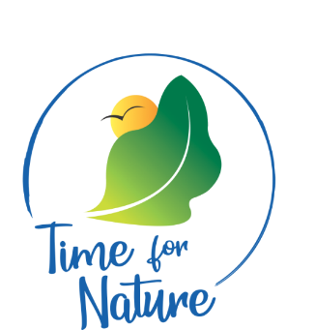

Environmental Awards

2024

Information Note – Tourism Sector

Introduction

To commemorate the World Environment Day 2024 which will be held on the 5 June, the Ministry of Environment, Solid Waste Management and Climate Change is pleased to launch the second edition of the Environmental Awards 2024. The Awards Ceremony will be held on 05 June 2024. This year’s Environment Awards is inviting entries for 12 thematic sectors as follows: -
- Manufacturing industry;
- Retail outlets;
- Media;
- Non-Governmental Organisations;
- Waste management and resource recovery;
- Banking/finance sector;
- Tourism industry;
- Local authorities;
- Public sector;
- Transport sector;
- Best environmental initiatives in educational institutions; and
- Other Environmental Recognitions.

Participation for the tourism sector
The Tourism Authority will shortly launch its 3rd edition of Sustainable Tourism Mauritius Awards whereby entrants will be assessed on sustainability criteria such as social, economic and environmental. As such, to avoid duplication, the Ministry of Environment, Solid Waste Management and Climate Change is working in close collaboration with the Tourism Authority. Hotels and Tourist Accommodations in Mauritius who will register in the two categories of the Sustainable Tourism Awards 2024, namely Hotel and Tourism Accommodation will automatically compete for the Environmental Awards in the two categories and rewarded during the ceremony of the ‘Environmental Awards' scheduled for 05 June 2024.

For more information and application in the Hotels and Tourist Accommodations categories, stakeholders are encouraged to visit and register on the website of the Tourism Authority.

