

**National Inventory Report (NIR) to the United Nations Framework Convention on Climate Change**

**DRAFT VERSION (17th December 2020)**

**Ministry of Environment, Solid Waste Management and Climate Change**

**2020**

**CONTENTS**

Tables 5

Figures 8

Acronyms and Abbreviations 10

1 Executive Summary 12

2 Introduction 15

2.1 National Circumstances 15

2.2 Commitment under UNFCCC for GHG Reporting 15

2.3 Involvement and Participation of Stakeholders 15

2.4 Inventory Preparation 18

3 Trends of Greenhouse Gas (GHG) Emissions 23

3.1 Emission trend by sector 23

3.2 Summary of GHG Emission Trends per Gas 38

3.3 Key Category Analysis 40

4 Energy Sector 41

4.1 Overview 41

4.2 Energy Industries (Category 1A1) 44

4.3 Manufacturing Industries (Category 1A2) 49

4.4 Transport (Category 1A3) 55

4.5 Other Sectors (Category 1A4) 65

4.6 Non-Specified Sector (Category 1A5) 70

4.7 Memo Items 74

4.8 Reference Approach 78

5 Industrial Processes and Product Use (IPPU) 80

5.1 Overview 80

5.2 Mineral Industry – Lime Production (Category 2A2) 81

5.3 Metal Industry – Iron and Steel Production (Category 2C1) 84

5.4 Non-Energy Products from Fuels and Solvent Use as Lubricant Use (Category 2D1) 88

5.5 Product Uses as Substitutes for Ozone Depleting Substances (Category 2F) 91

6 Agriculture, Forestry and Other Land Use (AFOLU) 96

6.1 Overview 96

6.2 Land (Category 3B) 106

6.3 Aggregate Sources and non-CO2 Emissions Sources on Land (3.C) 116

7 Waste 122

7.1 Overview 122

7.2 Solid Waste Disposal – Managed Waste Disposal Sites (Category 4A1) 123

7.3 Biological Treatment of Solid Waste (Category 4B) 133

7.4 Incineration and Open Burning of Waste – Waste Incineration (Category 4C1) 136

7.5 Wastewater Treatment and Discharge (Category 4D) 140

8 Improvement Plan 152

8.1 Strategies for Long Term Improvement in the National Inventory System 152

8.2 Planned Improvement on the Methodology 153

9 References 154

Appendix 1: Key Category Analysis 155

Appendix 2: Uncertainty Assessment 168

Appendix 3: National Inventory 184

Appendix 3.1: GHG Emissions Inventory for the Time Series 2000 – 2016 185

Appendix 3.2: Summary report for GHG emissions inventory 200

Appendix 4: QC Category-specific Procedures 224

Appendix 5: Quality Assurance Procedures 226

# Tables

Table 1. GWP values for 100-year time horizon according to the Second Assessment Report of IPCC 18

Table 2. Completeness of the 2000-2016 National GHG Emission Inventory 20

Table 3. Total GHG Emissions by Sector from 2000 to 2016 (Gg CO2eq) 23

Table 4. Total GHG Emissions for Energy Sector from 2000 to 2016 (Gg CO2eq) 25

Table 5. Total GHG Emissions for Energy Industries, 2000 – 2016 (Gg GHG/year) 26

Table 6. Total GHG Emissions from Manufacturing Industries Category, 2000 – 2016 (Gg GHG/year) 27

Table 7. Total GHG Emissions from Transport Sector, 2000 – 2016 (Gg GHG/year) 28

Table 8. Total GHG Emissions from Other Sectors, 2000 – 2016 (Gg GHG/year) 29

Table 9. Total GHG Emissions from Non-Specified Sectors, 2000 – 2016 (Gg GHG/year) 31

Table 10. Total GHG Emissions from Memo Items, 2000 – 2016 (Gg GHG/year) 32

Table 11. Total GHG Emissions from IPPU Sector, 2000 – 2016 (Gg CO2eq/year) 33

Table 12. GHG emissions from enteric fermentation of Livestock and manure management, 2014 – 2016 34

Table 13. GHG Sequestration by AFOLU sector (Gg CO2eq/year) 35

Table 14. Direct and indirect emissions of N2O (Gg N2O) 36

Table 15. Total GHG Emissions from Waste Sector, 2000 – 2016 (Gg CO2eq/year) 37

Table 16. Key Categories analysis from 2016 IPCC Software – Level Assessment 40

Table 17. Key Categories analysis from 2016 IPCC Software – Trend Assessment 40

Table 18. Methodology used for the Energy sector 43

Table 19. Effective Plant Capacity, Peak Demand and Electricity Generation 2000 – 2018 45

Table 20. Fuel consumed for electricity generation, 2000 – 2016 (Gg Fuel) 46

Table 21. Country Specific Net Calorific Values (NCV) for fuels consumed in Energy Industries (TJ/Gg) 46

Table 22. Country Specific Net Calorific Values (NCV) for fuels consumed in Energy Industries (TJ/Gg) 47

Table 23. Emissions Factors for the fuel used for the energy industries (kg GHG/TJ) 47

Table 24. GHG Emissions from Energy Industries from 2000 to 2016 (Gg CO2eq) 48

Table 25. Uncertainty Analysis of the Energy Industry category (1.A.1) for the period 2000 – 2016 48

Table 26. Fuel consumed by Manufacturing Industries and Construction, 2000 – 2016 (Gg Fuel) 50

Table 27. Country Specific Net Calorific Values for fuel consumed in Manufacturing Industries and Construction (TJ/Gg) 51

Table 28. Country Specific Net Calorific Values for fuel consumed (coal and bagasse) in Manufacturing Industries and Construction (TJ/Gg) 51

Table 29. Emissions factors for the fuel used for the manufacturing industries (kg GHG/TJ) 51

Table 30. GHG Emissions from Manufacturing Industries, 2000 – 2016 (Gg CO2eq) 52

Table 31. Uncertainty Analysis from the Manufacturing Industry category (1.A.2) for the period 2000 – 2016 53

Table 32. Number of vehicles by type and fuel used matriculated in the Island of Mauritius, 2014 – 2016 57

Table 33. Number of vehicles by type and fuel used matriculated in the Island of Rodrigues, 2014 – 2016 57

Table 34. Total number of vehicles in the RoM, 2000 – 2016 58

Table 35. Country Specific Density Values for fuels consumed in road transport (L fuel/ton fuel) 58

Table 36. Country Specific Net Calorific Values for fuels consumed in road transport (TJ/Gg) 58

Table 37. Average distance travelled in the Road Transport for the period 2000 – 2013 58

Table 38. Average fuel consumption in the Road Transport for the period 2000 – 2013 59

Table 39. Total fuel consumption in road transport in the RoM, 2000 – 2016 (Gg fuel). 59

Table 40. Fuel consumed by Civil aviation, 2000 – 2016 (Gg fuel) 60

Table 41. Fuel consumed by Water-borne navigation, 2000 – 2016 (Gg fuel) 60

Table 42. Country Specific Net Calorific Values for fuels consumed in aviation and water-borne navigation (TJ/Gg) 60

Table 43. Emissions factors for the fuel used for the road transport (kg GHG/TJ) 61

Table 44. Emissions factors for the fuel used for civil aviation (kg GHG/TJ) 61

Table 45. Emissions factors for the fuel used for water-borne navigation (kg GHG/TJ) 61

Table 46. GHG Emissions from Transport Sector, 2000 – 2016 (Gg CO2eq) 62

Table 47. Uncertainty Analysis of the Transport category (1.A.3) for the period 2000 – 2016 62

Table 48. Fuel consumed by Energy Other Sectors, 2000 – 2016 (Gg Fuel) 66

Table 49. Country Specific Net Calorific Values for fuels consumed in Energy Other Sectors (TJ/Gg) 66

Table 50. Emissions factors for the fuel used for the Commercial/Institutional sector from Energy Other Sectors (kg GHG/TJ) 67

Table 51. Emissions factors for the fuel used for the Residential (kg GHG/TJ) 67

Table 52. Emissions factors for the fuel used for the Agriculture/Forestry/Fishing sector from Energy Other Sectors (kg GHG/TJ) 67

Table 53. GHG Emissions from Energy Other sectors, 2000 – 2016 (Gg CO2eq) 68

Table 54. Uncertainty Analysis of Other sectors category (1.A.4) for the period 2000 – 2016 68

Table 55. Fuel consumed by Non-Specified Sectors, 2000 – 2016 (Gg Fuel) 71

Table 56. Country Specific Net Calorific Values for fuels consumed in Non-Specified Sector (TJ/Gg) 71

Table 57. Emissions factors for the fuel used for Non-Specified Sectors (kg GHG/TJ) 71

Table 58. GHG Emissions from Non-Specified Sector, 2000 – 2016 (Gg CO2eq) 72

Table 59. Uncertainty Analysis of Non-Specified sector category (1.A.5) for the period 2000 – 2016 73

Table 60. Fuel consumed by Memo Items (International Aviation and Water-borne Navigation, 2000 – 2016 (Gg Fuel) 74

Table 61. Country Specific Net Calorific Values for fuels consumed in aviation and water-borne navigation (TJ/Gg) 75

Table 62. Emissions factors for the fuel used for civil aviation (kg GHG/TJ) 75

Table 63. Emissions factors for the fuel used for water-borne navigation (kg GHG/TJ) 75

Table 64. GHG Emissions from Memo Items, 2000 – 2016 (Gg CO2eq) 76

Table 65. Uncertainty Analysis of Memo Item category (1.A.3.a.i and 1.A.3.d.i) for the period 2000 – 2016 76

Table 66. Methodology used for the IPPU sector 80

Table 67. Lime production in RoM (2000 – 2016) 81

Table 68. GHG Emissions (Gg CO2-eq) from Lime Production, 2000 – 2016. 82

Table 69. Uncertainty Analysis of Lime Production category (2.A.2) for the period 2000 – 2016 83

Table 70. Metal Industry Companies 84

Table 71. Iron and Steel Production (2000 – 2016) 85

Table 72. GHG Emissions (Gg CO2-eq) from Iron and Steel Production 86

Table 73. Uncertainty Analysis of Iron and Steel Production category (2.C.1) for the period 2000 – 2016 87

Table 74. Consumption (Gg) of lubricants in RoM (2011 – 2016) 88

Table 75. Parameters used for the estimation of CO2 emissions from lubricant use 88

Table 76. GHG Emissions (Gg CO2-eq) from Non-Energy Products 89

Table 77. Uncertainty Analysis of Non-Energy Products category (2.D.1) for the period 2000 – 2016 89

Table 78. Net Consumption (ton) of ODS Substitute in RoM for Refrigeration and Stationary Air Conditioning (1990 – 2016) 91

Table 79. Net Consumption (ton) of ODS Substitute in RoM for Mobile Air Conditioning (1990 – 2016) 92

Table 80. Parameters for GHG Emission estimation for Product Uses as Substitutes for ODS 93

Table 81. GHG Emissions (Gg CO2eq) from Product Uses as Substitutes to ODS 94

Table 82. Uncertainty Analysis of Product Uses as Substitutes for ODS category (2.F.1) for the period 2000 – 2016 94

Table 83. Area harvested and production in agricultural crops, 2014 – 2016 97

Table 84. Methodology used in the AFOLU sector 98

Table 85. Livestock population 102

Table 86. Default emissions factors for Livestock sub-category as per IPCC 2006 103

Table 87. Methane Emission from Livestock for the period 2014 – 2016 104

Table 88. Land Cover Change of RoM 110

Table 89. Harvest of Round Wood and Fuel Wood Gathering 111

Table 90. GHG removals in AFOLU sector 114

Table 91. Harvested Area and Production in 2016 116

Table 92. Agricultural crops – Area harvested and production, 2014 – 2016 118

Table 93. Summary N Inorganic Fertiliser used on Cropland for the whole Island 118

Table 94. Emission Factors used to calculate Direct and Indirect N2O Emissions from Managed Soil 119

Table 95. GHG Emissions (Gg CO2eq) from Agricultural Soils 120

Table 96. Methodology used for the Waste sector 122

Table 97. Activity data for Solid waste disposal in Mauritius 124

Table 98. Activity data for Solid waste disposal in Rodrigues 125

Table 99. Total activity data for Solid waste disposal in RoM 127

Table 100. Composition of Solid waste disposed at landfills in RoM. Data in percentage (%) 128

Table 101. DOC values 130

Table 102. Other parameters assumed for solid waste disposal emissions estimates 130

Table 103. Methane generation rate (*k*) values considered 130

Table 104. Landfill gas (LFG) and CH4 data from solid waste disposal sites (2000 – 2016) 130

Table 105. CH4 recovered, flared and energy recovery data from solid waste disposal sites (2000 – 2016) 130

Table 106. GHG Emissions from solid waste disposal (Gg CO2eq) 131

Table 107. Uncertainty Analysis of Solid waste disposal category (4.A) for the period 2000 – 2016 132

Table 108. Activity data for composting 133

Table 109. GHG Emissions from composting (Gg CO2eq) 134

Table 110. Uncertainty Analysis of Biological treatment of solid waste category (4.B) for the period 2000 – 2016 135

Table 111. Activity data for clinical waste incineration 137

Table 112. CO2 emission factor parameters for clinical waste incineration 137

Table 113. GHG Emissions from clinical waste incineration (Gg CO2eq) 138

Table 114. Uncertainty Analysis of Waste Incineration category (4.C) for the period 2000 – 2016 139

Table 115. Activity data for wastewater treatment in RoM 141

Table 116. Disaggregation of domestic/commercial wastewater by type of treatment in Mauritius (data in %) 141

Table 117. Disaggregation of domestic/commercial wastewater by type of treatment in Rodrigues (data in %) 142

Table 118. Disaggregation of domestic/commercial wastewater by type of treatment in RoM (data in %) 142

Table 119. MCF values considered for domestic/commercial wastewater treatments 143

Table 120. Amount of CH4 recovered and flared in RoM 143

Table 121. Amount of tourist visiting RoM 144

Table 122. RoM population and annual per capita protein consumption (kg/person/year) 145

Table 123. Parameters assumed for N2O emissions estimates (default values) 145

Table 124. Activity data for sugar industry 146

Table 125. Activity data for poultry industry 147

Table 126. Activity data for beer industry 147

Table 127. Disaggregation of industrial wastewater treated by type of treatment 148

Table 128. GHG Emissions from domestic/commercial wastewater (Gg CO2eq) 149

Table 129. GHG Emissions from industrial wastewater (Gg CO2eq) 149

Table 130. GHG Emissions from total wastewater (domestic/commercial + industrial) (Gg CO2eq) 150

Table 131. Uncertainty Analysis of Wastewater Treatment and Discharge category (4.D) for the period 2000 – 2016 150

Table 132. Key Category Analysis using Approach 1 Trend Assessment method from IPCC 2006 Guidelines for the National Inventory for the period 2000 – 2016. 156

Table 133. Key Category Analysis using Approach 1 Level Assessment method from IPCC 2006 Guidelines for the National Inventory for the period 2000 – 2016. 162

Table 134. Uncertainty Assessment in trend 2000 – 2016 of the National Inventory 169

Table 135. GHG Emissions Inventory (Gg CO2eq). time series 2000 – 2007 185

Table 136. GHG Emissions Inventory (Gg CO2eq). time series 2008 – 2016 192

Table 137. Summary Report for GHG Emissions Inventory. Year 2000 200

Table 138. Summary Report for GHG Emissions Inventory. Year 2005 204

Table 139. Summary Report for GHG Emissions Inventory. Year 2010 208

Table 140. Summary Report for GHG Emissions Inventory. Year 2014 212

Table 141. Summary Report for GHG Emissions Inventory. Year 2015 216

Table 142. Summary Report for GHG Emissions Inventory. Year 2016 220

Table 143. QC Procedures 224

Table 144. Cross-Cutting Checks for Overall Inventory Quality 226

Table 145. Detailed Checklist for Inventory Document 228

# Figures

Figure 1. Total GHG Emissions by Sector from 2000 to 2016 (CO2eq) 12

Figure 2. GHG Emissions from Energy Sector 2000 – 2016 (Gg CO2eq) 13

Figure 3. GHG Emissions from IPPU Sector, 2000 – 2016 (Gg CO2eq/year) 13

Figure 4. GHG Emissions from AFOLU Sector, 2000 – 2016 (Gg CO2eq/year) 14

Figure 5. GHG Emissions from Waste Sector, 2000 – 2016 (Gg CO2eq/year) 14

Figure 6. Proposed sustained institutional arrangement for Biennial Update Report 15

Figure 7. Government structure 16

Figure 8. Institutions involved in the preparation of NIR/BUR 17

Figure 9. Total GHG Emissions by Sector from 2000 to 2016 (CO2eq) 23

Figure 10. GHG Emissions from Energy Sector 2000 – 2016 (Gg CO2eq) 24

Figure 11. Share of GHG Emissions for Energy Sector 2000, 2005, 2010 and 2016 (%CO2eq) 25

Figure 12. GHG Emission trend for Energy Industry Category, 2000 – 2016 (Gg CO2eq/year) 26

Figure 13. GHG Emission trend from Manufacturing Industry Category, 2000 – 2016 (Gg CO2eq/year) 27

Figure 14. GHG Emission trend from Transport Sector, 2000 – 2016 (Gg CO2eq/year) 28

Figure 15. GHG Emission share from Transport Sector 2000, 2010 and 2016 (Gg CO2eq) 28

Figure 16. GHG Emission trend from Other Sector, 2000 – 2016 (Gg CO2eq/year) 29

Figure 17. GHG Emission share for Other Sectors 2000, 2010 and 2016 (Gg CO2eq) 30

Figure 18. GHG Emission trend from Non-Specified Sector, 2000 – 2016 (Gg CO2eq/year) 30

Figure 19. GHG Emission trend from Memo Items, 2000 – 2016 (Gg CO2eq/year) 31

Figure 20. GHG Emissions from IPPU Sector, 2000 – 2016 (Gg CO2eq/year) 33

Figure 21. Share of GHG Emissions from IPPU Sector 2000, 2005, 2010 and 2016 (%CO2eq) 33

Figure 22. Emissions from enteric fermentation of livestock and manure management, 2014 – 2016 34

Figure 23. GHG Trend of GHG Removals from Forest Land (Gg CO2eq) 35

Figure 24. GHG Emissions from Waste Sector, 2000 – 2016 (Gg CO2eq/year) 36

Figure 25. GHG Trend of CO2 emissions in the RoM (Gg CO2) 38

Figure 26. GHG Trend of CH4 emissions in the RoM (Gg CH4) 38

Figure 27. GHG Trend of N2O emissions in the RoM (Gg N2O) 39

Figure 28. GHG Trend of HFC emissions in the RoM (Gg CO2eq) 39

Figure 29. Primary energy requirement in 2018 (% of required energy in terms of TJ) in the RoM 41

Figure 30. Percentage of primary energy requirement locally produced and imported in 2018 (% of TJ of energy required) 42

Figure 31. Distribution of Energy consumption by sector in 2018 (% of the total TJ of energy consumed) 42

Figure 32. Distribution of the Primary Electricity Generation by Fuel type in 2018 44

Figure 33. Evolution of the Electricity Mix (2000 – 2018) 45

Figure 34. Evolution of the GHG Emissions from Energy Industries from 2000 to 2016 (Gg CO2eq) 47

Figure 35. Evolution of the GHG Emissions from Manufacturing Industries and Construction, 2000 – 2016 (Gg CO2eq) 52

Figure 36. Evolution of the GHG Emissions from Transport Sector, 2000 – 2016 (Gg CO2eq) 61

Figure 37. Evolution of the GHG Emissions from Other Sectors, 2000 – 2016 (Gg CO2eq) 67

Figure 38. Final Energy consumption by sector in 2016. 70

Figure 39. Evolution of the GHG Emissions from Non-Specified Sectors, 2000 – 2016 (Gg CO2eq) 72

Figure 40. Evolution of the GHG Emissions from Non-Specified Sectors, 2000 – 2016 (Gg CO2eq) 76

Figure 41. Evolution of the GHG Emissions from Lime Production, 2000 – 2016 (Gg CO2eq) 82

Figure 42. Evolution of the GHG Emissions from Iron and Steel Production (Gg CO2eq) 86

Figure 43. Evolution of the GHG Emissions from Non-Energy Products (Gg CO2eq) 89

Figure 44. Evolution of the GHG Emissions from Product Uses as ODS (Gg CO2eq) 93

Figure 45. Share of Agriculture in the Economy in the Republic of Mauritius, 2016 96

Figure 46. GHG emissions from AFOLU sector, 2013 – 2016 104

Figure 47. CO2 emission from Manure management and enteric fermentation 104

Figure 48. Timber local production 107

Figure 49. Land Cover of Mauritius (Circa 2010) 109

Figure 50. Portion of the scanned 1:25,000 scale map. Circled area shows mountains and wasteland (see text) 109

Figure 51. GHG removals in AFOLU sector, 2013 – 2016 114

Figure 52. Solid waste composition over the Inventory period 129

Figure 53. Evolution of the GHG Emissions from Solid waste disposal (Gg CO2eq) 131

Figure 54. Evolution of the GHG Emissions from Composting (Gg CO2eq) 134

Figure 55. Evolution of the GHG Emissions from clinical waste incineration (Gg CO2eq) 138

Figure 56. Evolution of the GHG Emissions from domestic/commercial wastewater (Gg CO2eq) 148

Figure 57. Evolution of the GHG Emissions from industrial wastewater (Gg CO2eq) 149

# Acronyms and Abbreviations

|  |  |
| --- | --- |
| AD | Activity Data |
| AFOLU | Agriculture. Forestry and Other Land Use (2006 IPCC Guidelines) |
| Annex I | Parties included in Annex I to the United Nations Framework Convention on Climate Change |
| BAU | Business as Usual |
| BESS | Battery Energy Storage System |
| BUR | Biennial Update Report |
| CCIC | Climate Change Information Centre |
| CEB | Central Electricity Board |
| CPEIR | Climate public expenditure and institutional review |
| DOWA | Deep Ocean Water Application |
| EE | Energy Efficiency |
| EF | Emission Factor |
| FAREI | Food and Agricultural Research & Extension Institute |
| GCF | Green Climate Fund |
| GDP | Gross Domestic Product |
| GEF | Global Environment Facility |
| GHG | Greenhouse Gas |
| GNI | Gross National Income |
| GVA | Gross Value Added |
| GWP | Global Warming Potential |
| ICT | Information and Communication Technology |
| IEF | Implicit Emission Factor |
| IPCC | Intergovernmental Panel on Climate Change |
| IPPs | Independent Power Producers |
| IPPU | Industrial Processes and Product Use |
| LNG | Liquified Natural Gas |
| LPG | Liquid Petroleum Gas |
| LTO | Landing and Take-Offs |
| LULUCF | Land Use. Land-Use Change and Forestry |
| MIC | Upper-middle-income Country |
| MRC | Mauritius Research Council |
| MRV | Measurement. Reporting and Verification |
| MSDG | Medium-Scale Distributed Generation |
| MUR | Mauritian Rupee |
| NAI | National Accounts and Investment |
| NAM | National Accounts of Mauritius |
| NAMA | Nationally Appropriate Mitigation Action |
| NCV | Net Calorific Value |
| NDC | Nationally Determined Contributions |
| NIR | National Inventory Report |
| NIS | National Inventory System |
| Non-Annex I | Parties not included in Annex I to the United Nations Framework Convention on Climate Change |
| NTA | National Transport Authority |
| ODS | Ozone Depleting Substances |
| OEP | Outline Energy Policy |
| PV | Photovoltaic |
| QA | Quality Assurance |
| QC | Quality Control |
| R&D | Research and Development |
| RE | Renewable Energy |
| RoM | Republic of Mauritius |
| SAR | Second Assessment Report |
| SIDS | Small Island Development States |
| TEU | Twenty-foot Equivalent Unit |
| TNC | Third National Communication |
| UNEP | United Nations Environment Program |
| UNFCCC | United Nations Framework Convention on Climate Change |
| USD | United States Dollar |
| WB | World Bank |
| WTE | Waste-to-Energy |

# Executive Summary

RoM submitted its first inventory of GHG as part of its Initial National Communication in April 1999. Then, an improved national GHG inventory was developed by RoM during the preparation of the Second and Third National Communications.

RoM has an obligation to submit its Biennial Update Report (BUR) as well as NC on a regular basis. It is vital that the process be strengthened, and a system is developed and maintained in a robust manner to ensure that it functions on a continuous basis to meet RoM reporting requirement. There is a need to strengthen the existing institutional arrangements or establish new ones to ensure that national capacity is available to yield more technically robust reports and meet the frequency of submissions. An attempt has been made to establish a sustainable team of experts and data flows in the context of the preparation of the BUR.

To meet the UNFCCC reporting requirements, the GHG national inventory is divided into 4 main sectors (Energy, IPPU, AFOLU and Waste) and each of which are further subdivided into sub-categories.

The methodology followed for the development of the national inventory is recommended by IPCC in their 2006 Guidelines for GHG emission estimation to be in line with Good Practices.

The National GHG Emission Inventory has been developed for the time period 2000 – 2016. In the following figures the trend of GHG emissions by gas and sector has been represented.

The trend of the CO2eq emissions is clearly rising along the last 16 years, from 2000 to 2016. The biggest emitter is the energy sector, which represents the 81.4% of the total emissions of the country in 2016, followed by the waste sector with the 11.5% of the emissions, the IPPU sector with the 6.1% of the total emissions and the AFOLU sector with the 1% of total emissions in 2016. The total amount of GHG emissions increased in 75.4% from 2000 to 2016.

Figure 1. Total GHG Emissions by Sector from 2000 to 2016 (CO2eq)

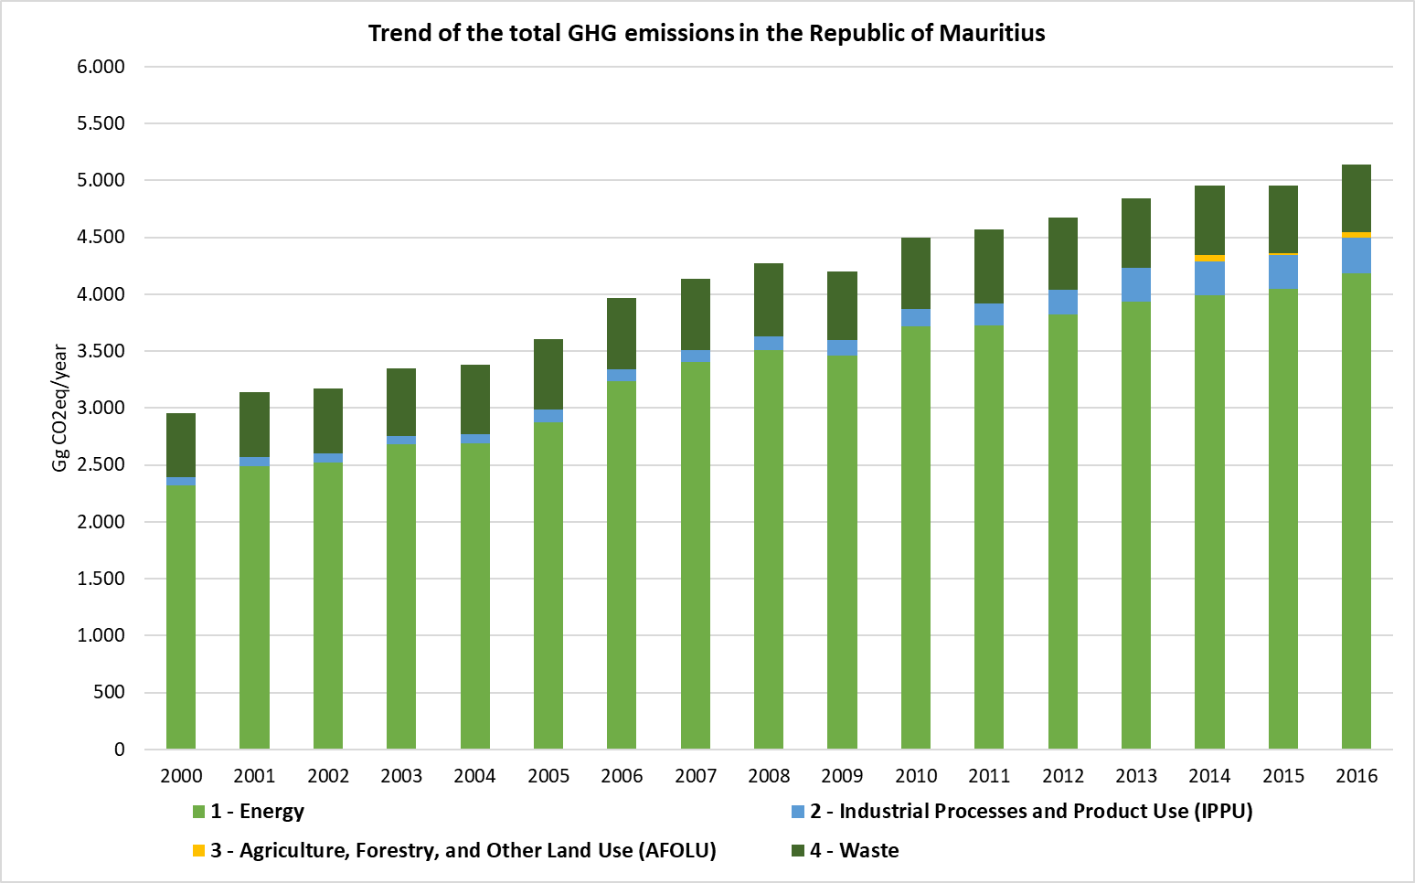

The following figure shows the trend of the emissions in the RoM for the period 2000 – 2016. The biggest emitter of the energy sector corresponds to the energy industries category, representing the 57.9% of the total emissions in the sector in the year 2016. The category is followed by the emissions from transport sector which represents the 28% of the total energy emissions, the manufacturing industries and construction represent the 8.2% of the total emissions and the energy other sectors the 5.9% of the total emissions in the energy sector by 2016.

Figure 2. GHG Emissions from Energy Sector 2000 – 2016 (Gg CO2eq)

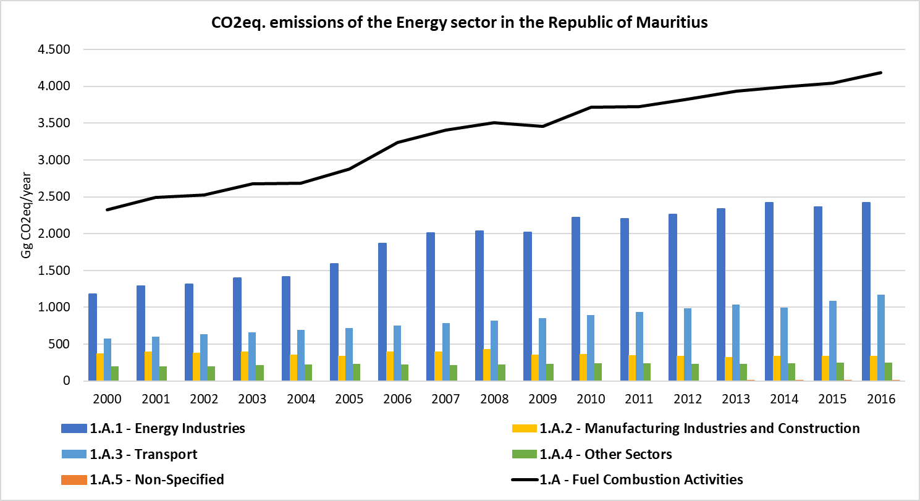

GHG emissions from IPPU Sector has experiment an increase along the time series from 2000 to 2016.

The most significant category, in terms of GHG emissions, that represent the IPPU sector is the Product Use as Substitutes of Ozone Depleting Substances (ODS), represented by stationary refrigerant and air conditioning and mobile air conditioning.

GHG emissions of this sector have increase annually, more moderately between 2000 and 2004 (15.54%) and more pronounced from 2004 to 2016 (283%). The category that most contribute to the increase of the emissions in the last 10 years is the product uses as substitutes for ODS.

Product Uses as Substitutes for ODS represent the 90.7% of the total GHG emissions of the sector in 2016, corresponding to the Refrigeration and Air conditioning category, stationary and mobile.

Figure 3. GHG Emissions from IPPU Sector, 2000 – 2016 (Gg CO2eq/year)

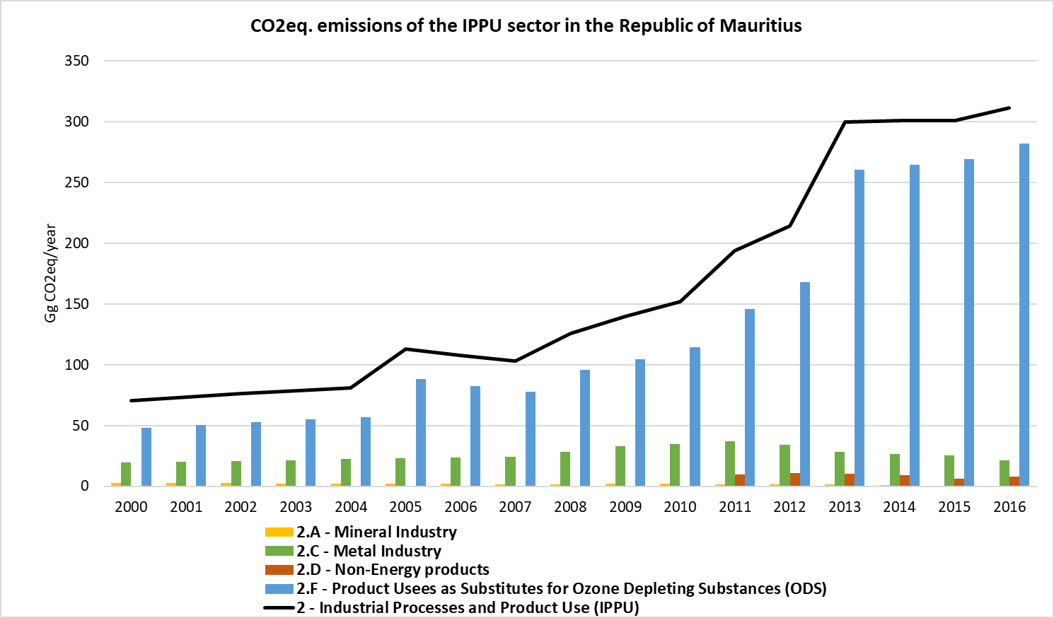

GHG emissions from AFOLU sector have been calculated for the period 2014 – 2016, as shown in the figure below, the total emissions show a decrease of 11.5% between 2014 and 2016.

The most representative categories in this sector are the Aggregate sources and non-CO2 emissions sources (including direct and indirect emissions from land) which contributes to the 90.5% of the total GHG emissions in the sector, while the Livestock category contribute to the remaining 9.5% in 2016.

Figure 4. GHG Emissions from AFOLU Sector, 2000 – 2016 (Gg CO2eq/year)

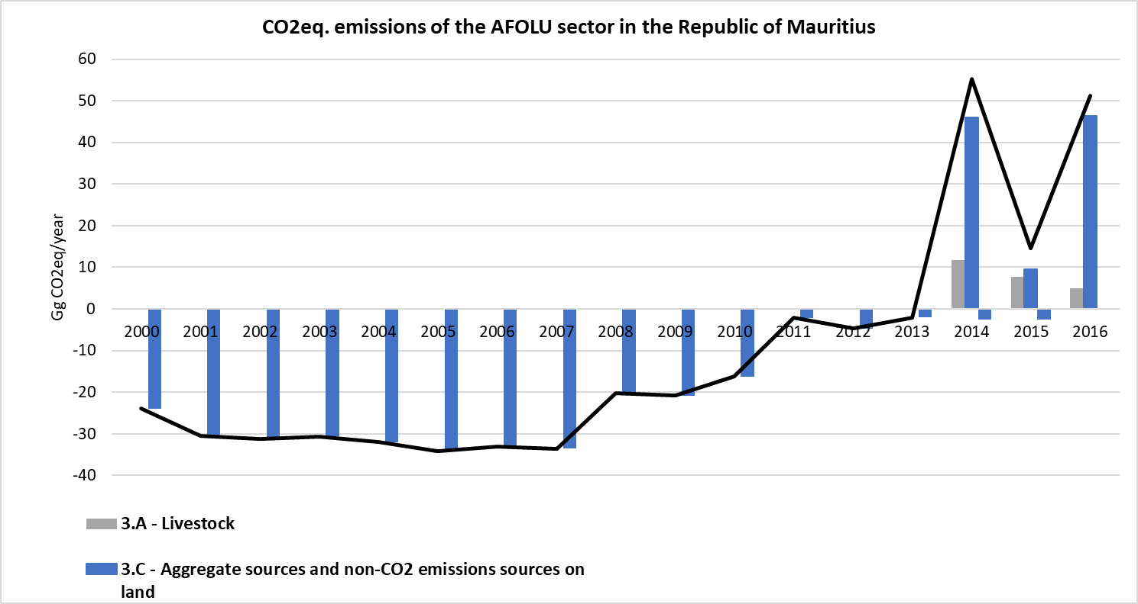

Waste sector’s GHG total emissions show a slightly ascendant trend along the time period 2000 – 2016. The increase of emissions from 2000 to 2016 is estimated in 5.8%, and the most representative categories inside the sector according to their emissions are the Solid Waste Disposal (68.03% of the total Waste sector emissions in 2016), followed by the Wastewater treatment and discharge (30.82% of the total waste emissions in 2016), the emissions from biological treatment of solid waste corresponds to the 1.02% of the total emissions of waste sector and the incineration and open burning of waste the 0.12% of the total emissions of the sector in 2016.

Figure 5. GHG Emissions from Waste Sector, 2000 – 2016 (Gg CO2eq/year)

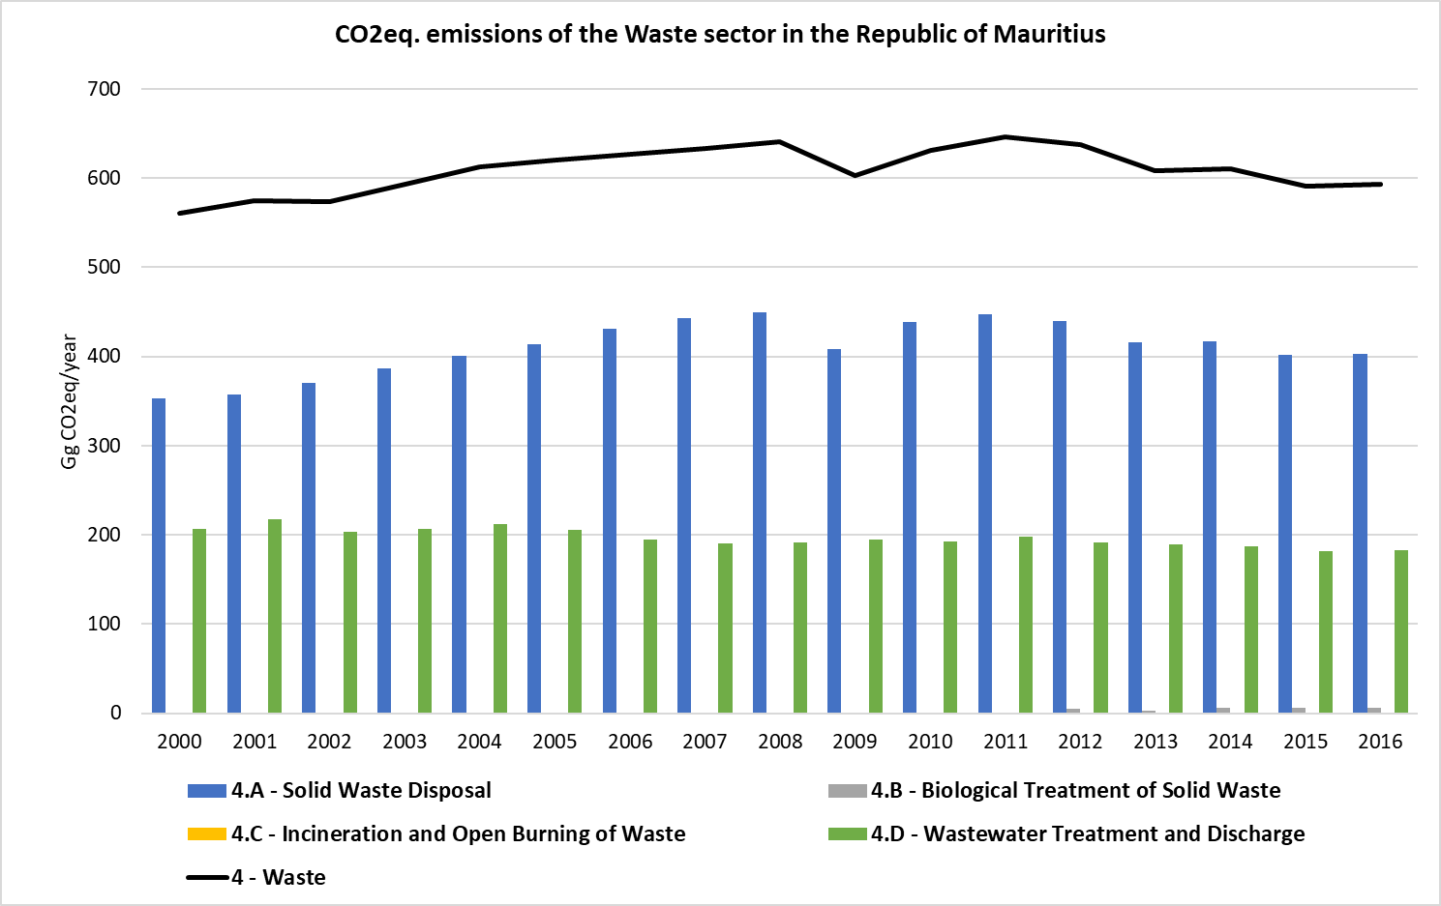

# Introduction

## National Circumstances

*To be developed by National Consultant*

## Commitment under UNFCCC for GHG Reporting

RoM submitted its first inventory of GHG as part of its Initial National Communication in April 1999. Then, an improved national GHG inventory was developed by RoM during the preparation of the Second and Third National Communications.

RoM has an obligation to submit its Biennial Update Report (BUR) as well as NC on a regular basis. It is vital that the process be strengthened, and a system is developed and maintained in a robust manner to ensure that it functions on a continuous basis to meet RoM reporting requirement. There is a need to strengthen the existing institutional arrangements or establish new ones to ensure that national capacity is available to yield more technically robust reports and meet the frequency of submissions. An attempt has been made to establish a sustainable team of experts and data flows in the context of the preparation of the BUR.

## Involvement and Participation of Stakeholders

### Climate Change Committee

The Climate Change Division leads the process of institutional reorganization.

These Ministries will be involved in the whole process of institutional arrangement to provide technical resources to shape the sectoral technical working groups.

Figure 6. Proposed sustained institutional arrangement for Biennial Update Report

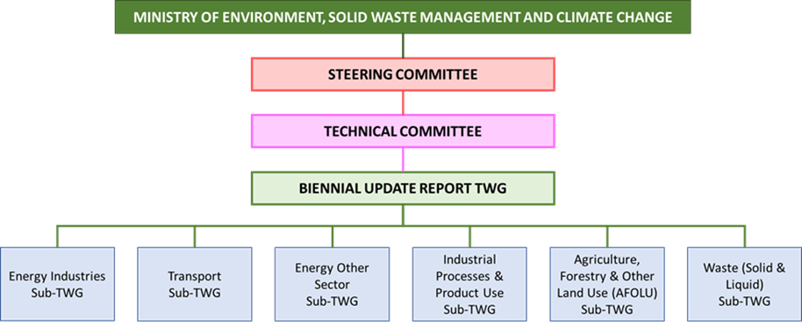

The Climate Change Division was established in March 2010 to lead efforts in response to the challenges of climate change faced by the country. Through its work. The Division aspires to enhance the country’s resilience to climate change.

The Division is responsible for the development, coordination and implementation of climate change adaptation and mitigation policies, programmes and initiatives. In addition to the above, the Division also follows regional and international climate negotiations and ensures compliance with international commitments taken by Mauritius under the United National Framework Convention on Climate Change and the Kyoto Protocol.

Some of the notable works undertaken by the Division include:

* Development of a National Climate Change Adaptation Policy Framework for the Republic of Mauritius
* Formulation of Technology Needs Assessment identifying and prioritizing relevant technologies for adaptation to and mitigation of climate change impacts
* Reporting on GHG emission
* Preparation and submission of the Intended Nationally Determined Contributions to the UNFCCC
* Preparation and submission of Third National Communication on climate change to UNFCCC
* Development of a Mauritius 2050 Pathways Calculator
* Development of user-friendly sector-wise excel based mitigation toolkits and accompanying manuals for the sectors such as energy, transport, solid and liquid wastes, agriculture including livestock and crop, and forestry
* Operationalization of a Climate Change Information Centre
* Promotion of research, capacity building and awareness raising

The Climate Change Division is also:

* Formulating a Low Carbon Development Strategy and Nationally Appropriate Mitigation Actions (NAMAs) for Mauritius
* Preparing the Biennial Update Report (BUR) for the RoM

The overall government structure regarding the responsibilities of reporting the BUR and NIR documents are shown in the figure below.

Figure 7. Government structure

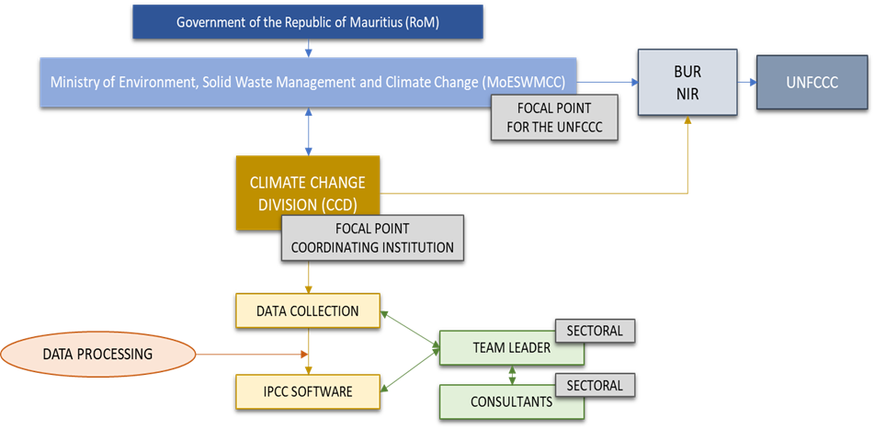

### Institutional Arrangements for GHG Inventory

CCD together with the support of the MoESWMCC, acting as the coordinating institution for GHG inventory, is responsible for coordinating the activities related to data collection, identification of relevant stakeholders, and the organisation of capacity building exercises. The data collection is led by the Team Leader (TL) of each sectoral working group, under the guidance of consultants.

The MoESWMCC is the focal point for the UNFCCC and is responsible for the coordination of the BUR and NIR development. The CCD, as responsible for the coordination of data collection and responsible for the formulation of Low Carbon Development Strategy and a Nationally Appropriate Mitigation Actions (NAMAs) for RoM, should support the MoESWMCC in the development of the documents to be reported to the UNFCCC.

Figure 8. Institutions involved in the preparation of NIR/BUR

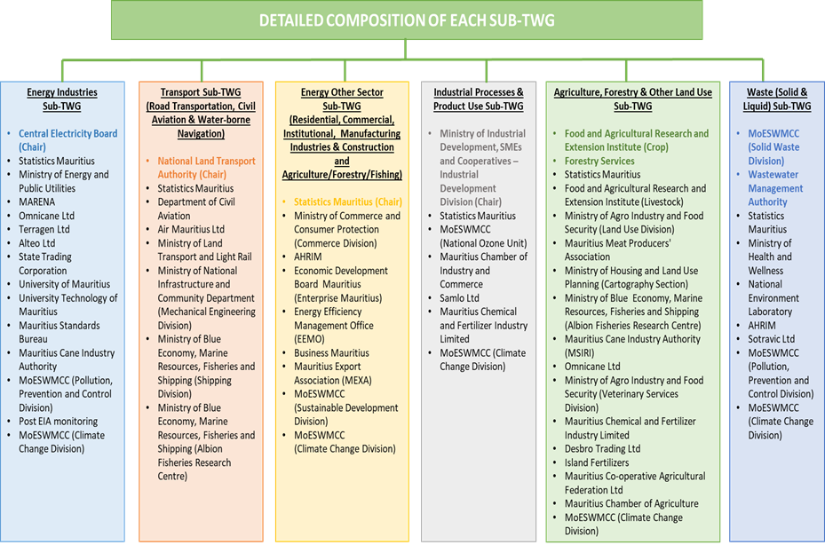

The CCD, as focal point of the data collection is responsible for the data gathering from the responsible data providers. For this request of information, it is necessary the development of a correct institutional arrangement. The institutional arrangement should assure the smooth and regular development of the GHG Inventory. In addition, it is recommendable to establish a responsible for each of the data that has to be collected for the development of the national inventory. This responsible should have identified the different responsible from whom data must be requested.

## Inventory Preparation

### Brief Description of Methodology

To meet the reporting requirements of UNFCCC the GHG national inventory is divided into 4 main sectors (Energy, IPPU, AFOLU and Waste) and each of which are further subdivided into sub-categories.

The methodology followed for the development of the national inventory is recommended by IPCC in their 2006 Guidelines for GHG emission estimation to be in line with Good Practices.

Generally, the methodology adopted for GHG emissions estimation consist on multiplying activity data (AD) by the relevant appropriate emission factor (EF).

Emissions (E) = Activity Data (AD) x Emission Factor (EF)

The methodology approach used for each of the sectors are outlined below, but 3 general levels of complexity and detail of methods are defined in IPCC 2006 Guidelines.

* **Tier 1:** the simplest approach and uses IPCC default values. This method is defined to be used where limited activity data is available.
* **Tier 2:** involves the simple methods but include the use of country specific emission factors
* **Tier 3:** the most complex and cover the use of models or plant specific data to generate accurate GHG emission estimates.

The specific methodology used for GHG emission estimation is detailed in each sectorial Chapters 3 to 6 of the IPCC 2006 Guidelines, and in the sections below.

To use a common unit for GEI emissions, the IPCC recommends the use of Global Warming Potentials (GWP) to convert GHG emissions other than CO2 to the latter equivalent, CO2 equivalent (CO2e). The GWP values used in the current inventory are those adopted from the Second Assessment Report (SAR) as collected in the following table for each GHG reported in the National Inventory.

Table 1. GWP values for 100-year time horizon according to the Second Assessment Report of IPCC

|  |  |  |
| --- | --- | --- |
| Common name | Chemical formula | Second Assessment Report (SAR) |
| Carbon dioxide | CO2 | 1 |
| Methane | CH4 | 21 |
| Nitrous oxide | N2O | 310 |
| HFC-23 | CHF3 | 11,700 |
| HFC-32 | CH2F2 | 650 |
| HFC-125 | CHF2CF3 | 2,800 |
| HFC-134a | CH2FCF3 | 1,300 |
| HFC-152a | CH3CHF2 | 140 |
| HFC-143a | CH3CF3 | 3,800 |
| HFC-227ea | CF3CHFCF3 | 2,900 |
| HFC-236fa | CF3CH2CF3 | 6,300 |

***Source:*** *Second Assessment Report (SAR,1995).*

### Methodology for Key Category Analysis and Trend Assessment

According to the *Good Practice Guidance and Uncertainty Management in National GHG Inventories*, key categories are those which contribute 95% of the cumulative emissions (Level Assessment) or contribute to significantly increasing or decreasing trends (Trend Assessment) (IPCC, 2000). It is considered a good practice to identify key categories, as it helps to prioritize efforts and improve the overall quality of the national inventory.

The category analysis was made using the equation for level 1 approach reported in the IPCC 2006 guidelines (Volume 1, Chapter 4).

Source Category Level Assessment = Source Category Estimate / Total Estimate

Lx.t = Ex.t / Et

The total contribution, which is the sum of the absolute values of emissions and removals in year t, calculated using the aggregation level chosen by the country for key category analysis. Because both emissions and removals are entered with positive sign, the total contribution/level can be larger than a country’s total emissions less removal.

The key category analysis was conducted using 2006 IPCC Software. The results from the software were interpreted as follow:

* The categories totalising the emission contribution thresholds of 95 are compared with the most recent key category analysis with the assessment for three or more previous years
* If a category has been key for all or most previous years according to the either level or trend assessments or both (two assessments should be considered separately), they should be identified as key in the latest year estimate except in cases where a clear explanation can be provided why a category may no longer be key in any future years.

The trend was assessed to identify categories that, although not large enough to be identified by the level assessment, their trend may be significantly increasing or decreasing to require particular attention, checking and possible improvement of methods. The trend assessment was calculated according to equation 4.2 of Volume 1, Chapter 4 of IPCC 2006 Guidelines (IPCC, 2006).

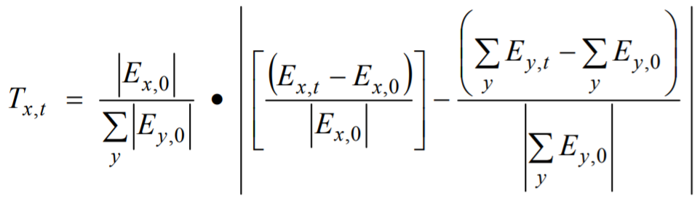

Where.

Tx.t = trend assessment of source or sink category x in year t as compared to the base year

│Ex.t│= absolute value of emission or removal estimate of source or sink category x in base year

Ex.t and Ex.0 = real values of estimates of source or sink category x in year t and base year, respectively

and = total inventory estimates in year t and base year, respectively

The results of this analysis are reported in the Appendix 1: Key Category Analysis.

### Quality Assurance and Quality Control (QA/QC)

The IPCC 2006 Guidelines recommend that quality control be exercised by comparing emission results using alternative approaches, comparing results and investigating anomalies. They also recommend that control include review of emission factors, verification of activity data to ascertain source of data, and distinction in use where applicable, and to ensure avoidance of double counting.

As an improvement of QA/QC, specific templates were developed for activity data collection based on the IPCC 2006 Guidelines.

### Uncertainty Assessment

IPCC 2006 Guidelines considers the Uncertainty Analysis an essential part of the GHG emission inventory. This Uncertainty Analysis should be considered to prioritize national efforts aimed to increase the accuracy and precision of future inventories and to guide decisions on the methodology selected.

Chapter 3, Volume 1 of the IPCC 2006 Guidelines defines uncertainty as the lack of knowledge of the true value of a variable by defining the possible range within a confidence level the value could be. Uncertainties are used to highlight where the real emissions/removals have the potential to be significantly different to estimate.

The uncertainty of the national GHG emission inventory of the Republic of Mauritius has been estimated for emission factors and activity data, and the method used for the calculation has been the Approach 1: Propagation of error. The uncertainty of each category is weighted by the emissions or removals in that category to obtain the contribution to the total combined uncertainty.

The last inventory period estimated by RoM was 2000-2013, where the base year considered was the year 2000. In some cases, the activity data for some of the new year’s included were not available, so these were estimated by using the best adjustment which best fits the trend, and these could lead to a bigger uncertainty of the data used. For that reason, two base years have been established, and two uncertainty analyses have been developed.

The Uncertainty Assessment developed for each category is collected in its corresponding section, and the results of the complete Uncertainty Assessment is available in the Appendix 2: Uncertainty Assessment.

### Completeness Assessment

The following table provides the completeness of the inventory.

Table 2. Completeness of the 2000-2016 National GHG Emission Inventory

| **Category** | **CO2** | **CH4** | **N2O** | **HFCs** | **PFCs** | **SF6** |
| --- | --- | --- | --- | --- | --- | --- |
| 1 - Energy |  |  |  |  |  |  |
| 1.A – Fuel Combustion Activities |  |  |  |  |  |  |
| 1.A.1 – Energy Industries | X | X | X |  |  |  |
| 1.A.2 – Manufacturing Industries and Construction | X | X | X |  |  |  |
| 1.A.3 – Transport | X | X | X |  |  |  |
| 1.A.4 – Other sectors | X | X | X |  |  |  |
| 1.A.5 – Non-specified | X | X | X |  |  |  |
| 1.B – Fugitive emissions from fuels |  |  |  |  |  |  |
| 1.B.1 – Solid Fuels | NA | NA | NA |  |  |  |
| 1.B.2 – Oil and Natural gas | NA | NA | NA |  |  |  |
| 1.B.3 – Other emissions from Energy production | NA | NA | NA |  |  |  |
| 1.C – Carbon dioxide Transport and Storage |  |  |  |  |  |  |
| 1.C.1 – Transport of CO2 | NO |  |  |  |  |  |
| 1.C.2 – Injection and Storage | NO |  |  |  |  |  |
| 1.C.3 – Other | NO |  |  |  |  |  |
| 2 – Industrial Processes and Product Use (IPPU) |  |  |  |  |  |  |
| 2.A – Mineral Industry |  |  |  |  |  |  |
| 2.A.1 – Cement production | NO |  |  |  |  |  |
| 2.A.2 – Lime production | X |  |  |  |  |  |
| 2.A.3 – Glass production | NO |  |  |  |  |  |
| 2.A.4 – Other process uses of carbonates | NO |  |  |  |  |  |
| 2.A.5 – Other | NO |  |  |  |  |  |
| 2.B – Chemical Industry |  |  |  |  |  |  |
| 2.B.1 – Ammonia production | NO | NO | NO |  |  |  |
| 2.B.2 – Nitric Acid production |  |  | NO |  |  |  |
| 2.B.3 – Adipic Acid production | NO |  | NO |  |  |  |
| 2.B.4 – Caprolactam. glyoxal and glyoxylic acid production | NO |  | NO |  |  |  |
| 2.B.6 – titanium dioxide production | NO |  |  |  |  |  |
| 2.B.7 – Soda ash production | NO |  |  |  |  |  |
| 2.B.8 – Petrochemical and carbon black production | NO | NO |  |  |  |  |
| 2.B.9 – Fluorochemical production |  |  |  | NO | NO | NO |
| 2.B.10 – Other | NO | NO | NO | NO | NO | NO |
| 2.C – Metal Industry |  |  |  |  |  |  |
| 2.C.1 – Iron and steel production | X | NA |  |  |  |  |
| 2.C.2 – Ferroalloys production | NO | NO |  |  |  |  |
| 2.C.3 – Aluminium production | NO |  |  |  | NO |  |
| 2.C.4 – Magnesium production | NO |  |  | NO | NO | NO |
| 2.C.5 – Lead production | NO |  |  |  |  |  |
| 2.C.6 – Zinc production | NO |  |  |  |  |  |
| 2.C.7 – Other | NO | NO | NO | NO | NO | NO |
| 2.D – Non-Energy products from Fuels and Solvent Use |  |  |  |  |  |  |
| 2.D.1 – Lubricant Use | X | NA | NA |  |  |  |
| 2.D.2 – Paraffin Wax Use | NO | NO | NO |  |  |  |
| 2.D.3 – Solvent Use | NO | NO | NO |  |  |  |
| 2.D.4 – Other | NO | NO | NO |  |  |  |
| 2.E – Electronics Industry |  |  |  |  |  |  |
| 2.E.1 – Integrated Circuit or Semiconductor |  |  |  | NO | NO | NO |
| 2.E.2 – TFT Flat Panel Display |  |  |  | NO | NO | NO |
| 2.E.3 – Photovoltaics |  |  |  | NO | NO | NO |
| 2.E.4 – Heat Transfer Fluid |  |  |  | NO | NO | NO |
| 2.E.5 - Other |  |  |  | NO | NO | NO |
| 2.F – Product Uses as Substitutes for Ozone Depleting Substances |  |  |  |  |  |  |
| 2.F.1 – Refrigeration and Air Conditioning |  |  |  | X | NO | NO |
| 2.F.2 – Foam Blowing Agents |  |  |  | NA | NA | NA |
| 2.F.3 – Fire Protection |  |  |  | NA | NA | NA |
| 2.F.4 – Aerosols |  |  |  | NA | NA | NA |
| 2.F.5 – Solvents |  |  |  | NA | NA | NA |
| 2.F.6 – Other |  |  |  | NO | NO | NO |
| 2.G – Other Product Manufacture and Use |  |  |  |  |  |  |
| 2.G.1 – Electrical Equipment |  |  |  |  | NA | NA |
| 2.G.2 – SF6 and PFCs from Other Product Uses |  |  |  |  | NA | NA |
| 2.G.3 – N2O from Product uses |  |  | NA |  |  |  |
| 2.G.4 – Other | NA | NA | NA | NA | NA | NA |
| 2.H – Other |  |  |  |  |  |  |
| 2.H.1 – Pulp and paper Industry | NO | NO | NO | NO | NO | NO |
| 2.H.2 – Food and Beverages Industry | NO | NO | NO | NO | NO | NO |
| 2.H.3 – Other | NO | NO | NO | NO | NO | NO |
| 3 – Agriculture. Forestry. and Other Land Use (AFOLU) |  |  |  |  |  |  |
| 3.A – Livestock |  |  |  |  |  |  |
| 3.A.1 – Enteric Fermentation |  | X |  |  |  |  |
| 3.A.2 – Manure Management |  | X | X |  |  |  |
| 3.B – Land |  |  |  |  |  |  |
| 3.B.1 – Forest land | NE |  |  |  |  |  |
| 3.B.2 – Cropland | NE |  |  |  |  |  |
| 3.B.3 – Grassland | NE |  |  |  |  |  |
| 3.B.4 – Wetlands | NE |  | NE |  |  |  |
| 3.B.5 – Settlements | NE |  |  |  |  |  |
| 3.B.6 – Other land | NE |  |  |  |  |  |
| 3.C – Aggregate sources and non-CO2 emissions sources on land |  |  |  |  |  |  |
| 3.C.1 – Emissions from biomass burning |  | NE | NE |  |  |  |
| 3.C.2 – Liming | NE |  |  |  |  |  |
| 3.C.3 – Urea application | X |  |  |  |  |  |
| 3.C.4 – Direct N2O emissions from managed soils |  |  | X |  |  |  |
| 3.C.5 – Indirect N2O emissions from managed soils |  |  | X |  |  |  |
| 3.C.6 – Indirect N2O emissions from Manure soils |  |  | NE |  |  |  |
| 3.C.7 – Rice Cultivations |  | NE |  |  |  |  |
| 3.C.8 – Other |  |  |  |  |  |  |
| 3.D – Other |  |  |  |  |  |  |
| 3.D.1 – Harvested Wood products | X | NO |  |  |  |  |
| 3.D.2 – Other |  | NO |  |  |  |  |
| 4 – Waste |  |  |  |  |  |  |
| 4.A – Solid Waste Disposal |  | X |  |  |  |  |
| 4.B – Biological Treatment of Solid Waste |  | X | X |  |  |  |
| 4.C – Incineration and Open Burning of Waste | X | NA | NA |  |  |  |
| 4.D – Wastewater Treatment and Discharge |  | X | X |  |  |  |
| 5 – Other |  |  |  |  |  |  |
| 5.A – Indirect N2O emissions from the atmospheric deposition of nitrogen in NOx and NH3 |  |  | NA |  |  |  |
| 5.B – Other | NA | NA | NA |  |  |  |

X = Estimated; NA = Not Applicable; NO = Not Occurring; NE = Not Estimated

# Trends of Greenhouse Gas (GHG) Emissions

This chapter summarises the emission trends from 2000 to 2016.The current inventory is based on the methodology contained in the 2006 IPCC Guidelines of National Greenhouse Gas Inventories.

## Emission trend by sector

The trends by sector for the GHG estimate 2000-2016 are tabulated in Table 4 and Figure 3 presents the emission share for each sector.

Table 3. Total GHG Emissions by Sector from 2000 to 2016 (Gg CO2eq)

|  |  |  |  |  |  |  |  |  |
| --- | --- | --- | --- | --- | --- | --- | --- | --- |
| Year | Energy | IPPU | Agriculture | LULUCF | Waste | Total GHG excluding sinks | Total GHG including sinks | Annual Change (%) |
| 2000 | 2,323.15 | 70.32 | 0.00 | -23.98 | 560.25 | 2,953.72 | 2,929.74 |  |
| 2001 | 2,492.10 | 73.46 | 0.00 | -30.57 | 574.81 | 3,140.36 | 3,109.79 | 6.32% |
| 2002 | 2,523.99 | 76.15 | 0.00 | -31.29 | 573.58 | 3,173.72 | 3,142.43 | 1.06% |
| 2003 | 2,678.11 | 78.88 | 0.00 | -30.68 | 593.24 | 3,350.24 | 3,319.55 | 5.56% |
| 2004 | 2,687.20 | 81.25 | 0.00 | -32.06 | 612.67 | 3,381.12 | 3,349.06 | 0.92% |
| 2005 | 2,874.17 | 113.16 | 0.00 | -34.11 | 619.70 | 3,607.02 | 3,572.92 | 6.68% |
| 2006 | 3,236.14 | 108.04 | 0.00 | -33.05 | 626.24 | 3,970.41 | 3,937.37 | 10.07% |
| 2007 | 3,403.21 | 103.25 | 0.00 | -33.56 | 633.45 | 4,139.91 | 4,106.34 | 4.27% |
| 2008 | 3,507.71 | 125.87 | 0.00 | -20.27 | 640.55 | 4,274.12 | 4,253.86 | 3.24% |
| 2009 | 3,457.07 | 139.56 | 0.00 | -20.84 | 603.15 | 4,199.78 | 4,178.94 | -1.74% |
| 2010 | 3,715.96 | 151.71 | 0.00 | -16.26 | 631.44 | 4,499.11 | 4,482.85 | 7.13% |
| 2011 | 3,727.56 | 193.95 | 0.00 | -2.12 | 646.12 | 4,567.63 | 4,565.52 | 1.52% |
| 2012 | 3,825.40 | 214.43 | 0.00 | -4.67 | 637.03 | 4,676.86 | 4,672.19 | 2.39% |
| 2013 | 3,935.07 | 300.00 | 0.00 | -2.07 | 608.45 | 4,843.52 | 4,841.45 | 3.56% |
| 2014 | 3,990.89 | 300.78 | 57.79 | -2.58 | 610.35 | 4,959.81 | 4,957.23 | 2.40% |
| 2015 | 4,043.99 | 300.96 | 20.50 | -2.51 | 590.73 | 4,956.19 | 4,953.67 | -0.07% |
| 2016 | 4,182.62 | 311.18 | 51.18 | 0.00 | 592.81 | 5,137.78 | 5,137.78 | 3.66% |

Figure 9. Total GHG Emissions by Sector from 2000 to 2016 (CO2eq)

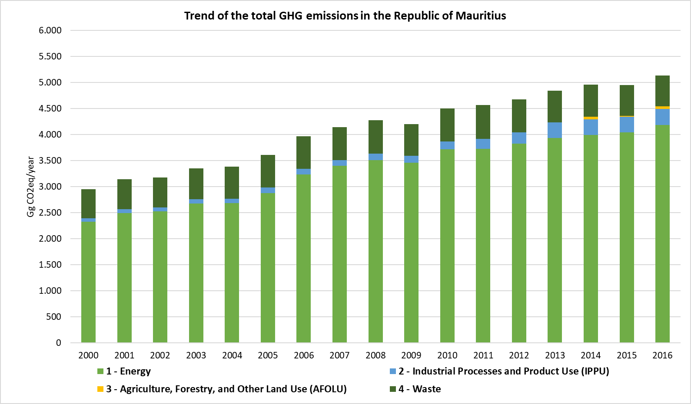

### Energy Sector

The trend of the CO2eq emissions is clearly rising along the last 17 years, from 2000 to 2016. The biggest emitter of the sector are the energy industries, which represent the 57.9% of the total emissions of the sector in 2016, followed by the transport sector, leaded by the road transport representing the 28.0%. Manufacturing industries and construction, and "Other sectors", represent the 8.2% and the 5.9% of the total emissions of the sector in 2016 respectively.

The total amount of GHG emissions increased in 80.0% from 2000 to 2016. Energy industries show a constant increase of CO2eq emissions from 2000 to 2016, specially motivated by the use of coal, the highest emitter of the energy industries category, responsible for the 37.5% of the sector’s emissions (2016). In terms of electricity generation by energy industries, the fuel that generates the highest amounts of electricity is the coal (corresponding to the highest amounts of CO2eq emissions), followed by fuel oil which is responsible for the 15.4% of the emissions of the sector. The third fuel that generates highest amounts of electricity is the bagasse, which is a renewable resource and so CO2 emission have not been accounted as it is a biogenic emissions source.

The transport category represents the second biggest emitter of the energy sector. This category is divided into civil aviation, road transport, and water-borne navigation. In 2016, transport represents the 28.0% of the total emissions of the energy sector, and the 93.6% of those emissions corresponds to the road transport category, while water-borne navigation represents the 5.6% of the category’s emissions and the civil aviation the remaining 0.8%. This category showed an exponential grow in terms of emissions all over the time analysed.

The emissions from manufacturing industries and construction experimented lots of variations. From 2000 to 2003, the trend of emissions was ascendant, from 2004 to 2009 the emissions varied a lot and, from 2010 to 2016, the emission decreased. The fluctuations in the period 2004-2009 were especially due to the variable use of coal.

Figure 10. GHG Emissions from Energy Sector 2000 – 2016 (Gg CO2eq)



Table 4. Total GHG Emissions for Energy Sector from 2000 to 2016 (Gg CO2eq)

| **Years** | **Total emissions for Energy** |
| --- | --- |
| 2000 | 2,323.15 |
| 2001 | 2,492.10 |
| 2002 | 2,523.99 |
| 2003 | 2,678.11 |
| 2004 | 2,687.20 |
| 2005 | 2,874.17 |
| 2006 | 3,236.14 |
| 2007 | 3,403.21 |
| 2008 | 3,507.71 |
| 2009 | 3,457.07 |
| 2010 | 3,715.96 |
| 2011 | 3,727.56 |
| 2012 | 3,825.40 |
| 2013 | 3,935.07 |
| 2014 | 3,990.89 |
| 2015 | 4,043.99 |
| 2016 | 4,182.62 |

Figure 11. Share of GHG Emissions for Energy Sector 2000, 2005, 2010 and 2016 (%CO2eq)

|  |  |
| --- | --- |
|  |  |
|  |  |
|  | |

#### Energy Industries

The biggest emitter of the energy sector is the energy industries category, responsible of the 57.9% of the total GHG Emission of the Energy sector in 2016.

As seen in the figure below, the trend of the energy industries emissions is ascendant, with a growth of 105.7% between 2000 and 2016.This general rising trend can be explained by the change in lifestyle and increased demand for electricity in household and commercial and institutional sectors.

Figure 12. GHG Emission trend for Energy Industry Category, 2000 – 2016 (Gg CO2eq/year)

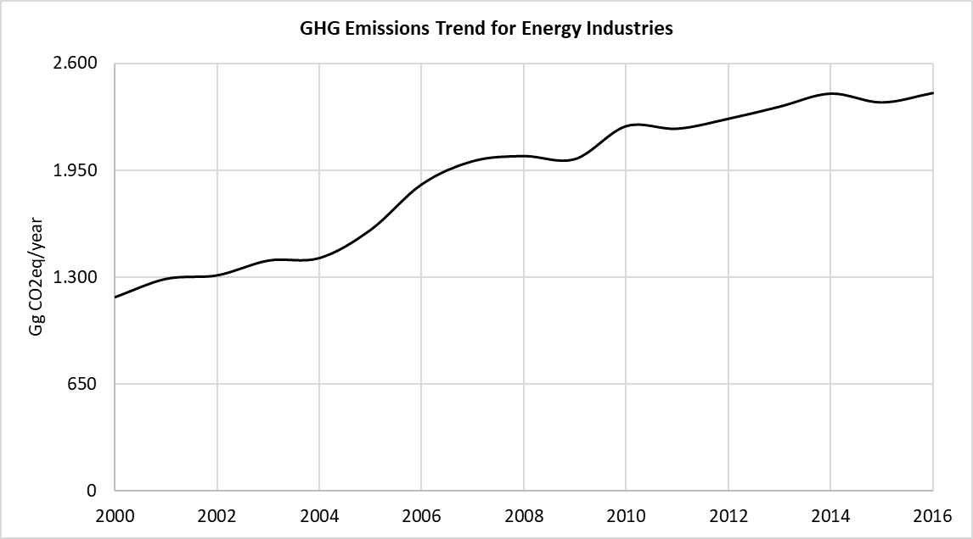

Table 5. Total GHG Emissions for Energy Industries, 2000 – 2016 (Gg GHG/year)

|  |  |  |  |  |
| --- | --- | --- | --- | --- |
| **Year** | **CO2** | **CH4** | **N2O** | **Total CO2eq** |
| 2000 | 1,159.26 | 0.25 | 0.04 | 1,177.61 |
| 2001 | 1,268.82 | 0.27 | 0.05 | 1,289.30 |
| 2002 | 1,289.42 | 0.29 | 0.05 | 1,310.80 |
| 2003 | 1,381.20 | 0.26 | 0.05 | 1,400.80 |
| 2004 | 1,396.03 | 0.27 | 0.05 | 1,416.17 |
| 2005 | 1,567.12 | 0.26 | 0.05 | 1,587.64 |
| 2006 | 1,843.79 | 0.26 | 0.05 | 1,865.46 |
| 2007 | 1,985.18 | 0.24 | 0.05 | 2,006.65 |
| 2008 | 2,011.06 | 0.32 | 0.06 | 2,037.72 |
| 2009 | 1,994.91 | 0.28 | 0.06 | 2,019.24 |
| 2010 | 2,194.94 | 0.29 | 0.06 | 2,220.34 |
| 2011 | 2,180.34 | 0.28 | 0.06 | 2,204.72 |
| 2012 | 2,240.87 | 0.27 | 0.06 | 2,265.14 |
| 2013 | 2,314.09 | 0.27 | 0.06 | 2,338.84 |
| 2014 | 2,393.79 | 0.27 | 0.06 | 2,418.53 |
| 2015 | 2,339.08 | 0.29 | 0.06 | 2,365.06 |
| 2016 | 2,397.16 | 0.27 | 0.06 | 2,422.16 |

#### Manufacturing Industries

Manufacturing Industries and Construction category is responsible of the 8.2% of the GHG emissions of the energy sector in 2016, being the third biggest emitter of the energy sector, after energy industries and transport categories.

From 2000 to 2016 the GHG emissions of the manufacturing industries experiment a decrease of 8.1%.

Figure 13. GHG Emission trend from Manufacturing Industry Category, 2000 – 2016 (Gg CO2eq/year)

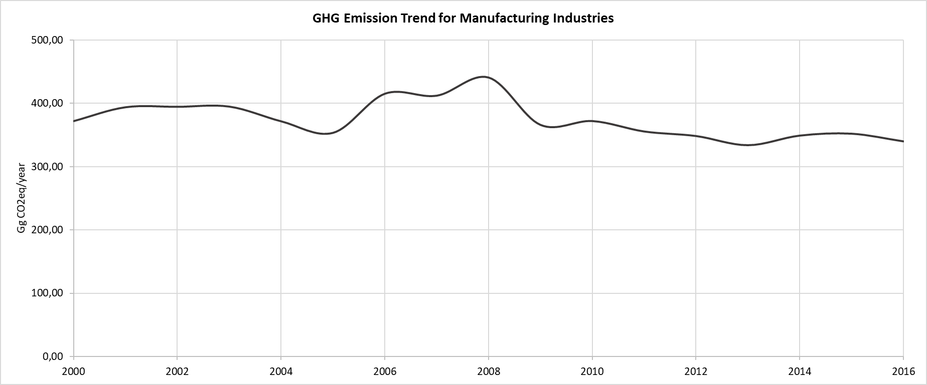

Table 6. Total GHG Emissions from Manufacturing Industries Category, 2000 – 2016 (Gg GHG/year)

|  |  |  |  |  |
| --- | --- | --- | --- | --- |
| **Year** | **CO2** | **CH4** | **N2O** | **Total CO2eq** |
| 2000 | 363.71 | 0.13 | 0.02 | 372.22 |
| 2001 | 393.06 | 0.13 | 0.02 | 401.62 |
| 2002 | 374.18 | 0.12 | 0.02 | 381.53 |
| 2003 | 393.68 | 0.13 | 0.02 | 402.04 |
| 2004 | 352.90 | 0.13 | 0.02 | 361.16 |
| 2005 | 336.09 | 0.12 | 0.02 | 343.71 |
| 2006 | 395.46 | 0.12 | 0.02 | 403.08 |
| 2007 | 393.19 | 0.10 | 0.01 | 399.53 |
| 2008 | 424.56 | 0.08 | 0.01 | 429.55 |
| 2009 | 351.90 | 0.07 | 0.01 | 356.32 |
| 2010 | 357.67 | 0.08 | 0.01 | 362.68 |
| 2011 | 341.86 | 0.07 | 0.01 | 346.40 |
| 2012 | 335.45 | 0.06 | 0.01 | 339.59 |
| 2013 | 320.97 | 0.06 | 0.01 | 325.04 |
| 2014 | 333.60 | 0.06 | 0.01 | 337.37 |
| 2015 | 339.89 | 0.06 | 0.01 | 343.79 |
| 2016 | 338.80 | 0.05 | 0.01 | 342.18 |

#### Transport

Road transport is the sector that consumes biggest amounts of fuels, after the electricity generation industries. Road transport represents the 26% of the total Energy emissions in 2016 and 93.6% of the total transport emissions. Fuel consumption from 2000 to 2016 has increased especially due to the increase in the consumption of diesel by buses and consumption of gasoline by cars, together with a decrease of gasoline consumption by dual purpose vehicles and diesel consumption by heavy duty trucks. The emissions of the road transport sector increased from 2000 to 2016 in 103%.

In terms of emissions, the air transport could be differenced into domestic and international aviation, and only domestic aviation is considered for the national inventory of GHG. In that sense, the emissions from this category also experienced an increase from 2000 to 2016 of 103.5%.

The fuels used in the water-borne category, is mainly fuel oil followed by gasoline and diesel. Sea transport corresponds to a 4.3% of the total energy consumption in transport sector by 2016 in the country. Regarding the overall time series, the GHG emissions increased along the time series from 30.83 Gg CO2eq in 2000 to 65.55 Gg CO2eq in 2016 (112.62%).

Transport category is the second most emitted category from energy sector, contributing to the 28.0% of the sector’s emissions in 2016. The GHG emissions increased from 2000 to 2016 in 103%.

Figure 14. GHG Emission trend from Transport Sector, 2000 – 2016 (Gg CO2eq/year)

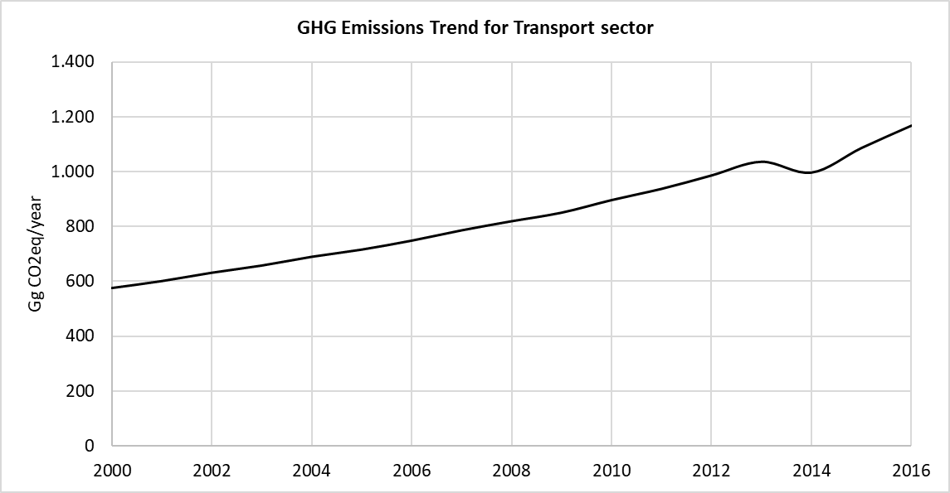

Table 7. Total GHG Emissions from Transport Sector, 2000 – 2016 (Gg GHG/year)

|  |  |  |  |  |
| --- | --- | --- | --- | --- |
| **Year** | **CO2** | **CH4** | **N2O** | **Total CO2eq** |
| 2000 | 563.74 | 0.13 | 0.03 | 574.91 |
| 2001 | 588.78 | 0.13 | 0.03 | 600.43 |
| 2002 | 618.63 | 0.14 | 0.03 | 630.83 |
| 2003 | 644.61 | 0.15 | 0.03 | 657.31 |
| 2004 | 675.86 | 0.15 | 0.03 | 689.22 |
| 2005 | 701.73 | 0.16 | 0.03 | 715.66 |
| 2006 | 733.94 | 0.17 | 0.04 | 748.51 |
| 2007 | 770.87 | 0.17 | 0.04 | 786.15 |
| 2008 | 803.47 | 0.18 | 0.04 | 819.46 |
| 2009 | 834.10 | 0.19 | 0.04 | 850.74 |
| 2010 | 879.36 | 0.20 | 0.04 | 896.85 |
| 2011 | 919.71 | 0.21 | 0.04 | 937.99 |
| 2012 | 967.88 | 0.22 | 0.05 | 987.12 |
| 2013 | 1,016.89 | 0.23 | 0.05 | 1,037.11 |
| 2014 | 978.15 | 0.21 | 0.05 | 997.44 |
| 2015 | 1,066.11 | 0.25 | 0.05 | 1,087.43 |
| 2016 | 1,146.34 | 0.28 | 0.06 | 1,169.30 |

Figure 15. GHG Emission share from Transport Sector 2000, 2010 and 2016 (Gg CO2eq)

|  |  |
| --- | --- |
|  |  |
|  | |

#### Energy Other Sectors

Those considered other sectors are commercial/institutional sector, residential, agriculture/forestry/fishing and others and contribute to the 5.5% of the total GHG emissions from Energy sector.

Between 2000 and 2016 the GHG emissions of the category increased in 25.04%.

Figure 16. GHG Emission trend from Other Sector, 2000 – 2016 (Gg CO2eq/year)

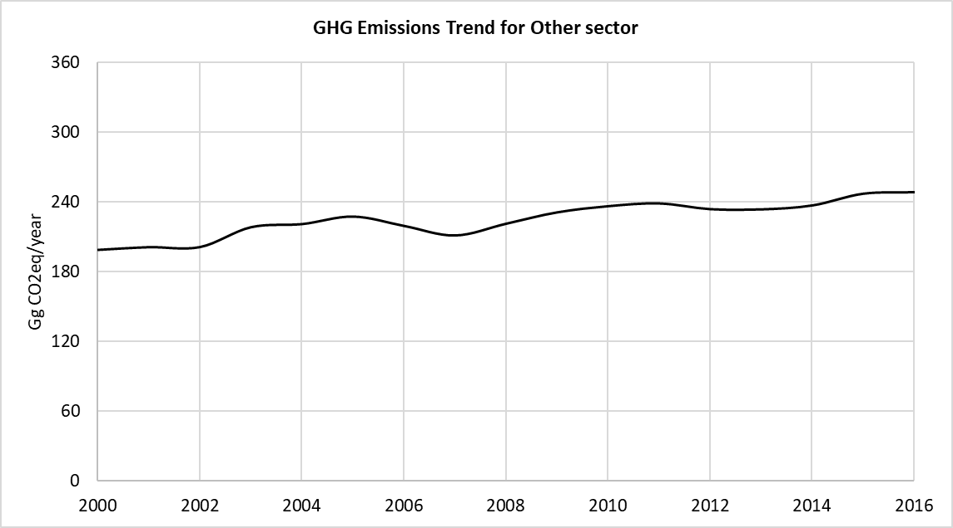

Table 8. Total GHG Emissions from Other Sectors, 2000 – 2016 (Gg GHG/year)

|  |  |  |  |  |
| --- | --- | --- | --- | --- |
| **Year** | **CO2** | **CH4** | **N2O** | **Total CO2eq** |
| 2000 | 195.82 | 0.1 | 0.001 | 198.41 |
| 2001 | 198.14 | 0.1 | 0.001 | 200.74 |
| 2002 | 198.24 | 0.1 | 0.001 | 200.83 |
| 2003 | 215.31 | 0.1 | 0.001 | 217.96 |
| 2004 | 218.00 | 0.1 | 0.001 | 220.65 |
| 2005 | 224.40 | 0.1 | 0.001 | 227.16 |
| 2006 | 216.30 | 0.11 | 0.001 | 219.09 |
| 2007 | 208.13 | 0.1 | 0.001 | 210.88 |
| 2008 | 218.25 | 0.1 | 0.001 | 220.97 |
| 2009 | 228.02 | 0.1 | 0.001 | 230.77 |
| 2010 | 233.32 | 0.1 | 0.001 | 236.09 |
| 2011 | 235.71 | 0.1 | 0.001 | 238.46 |
| 2012 | 230.88 | 0.1 | 0.001 | 233.54 |
| 2013 | 230.73 | 0.1 | 0.001 | 233.30 |
| 2014 | 234.28 | 0.09 | 0.001 | 236.75 |
| 2015 | 244.49 | 0.09 | 0.001 | 246.87 |
| 2016 | 245.73 | 0.09 | 0.001 | 248.10 |

Figure 17. GHG Emission share for Other Sectors 2000, 2010 and 2016 (Gg CO2eq)

|  |  |
| --- | --- |
|  |  |
|  | |

#### Non-Specified Sector

The Non-Specified sector contribute to the 0.02% of the total GHG emissions from Energy sector in 2016.

Consumptions in this category are reported since 2013. Between 2013 and 2016 the GHG emissions of the category increased in 13%.

Figure 18. GHG Emission trend from Non-Specified Sector, 2000 – 2016 (Gg CO2eq/year)

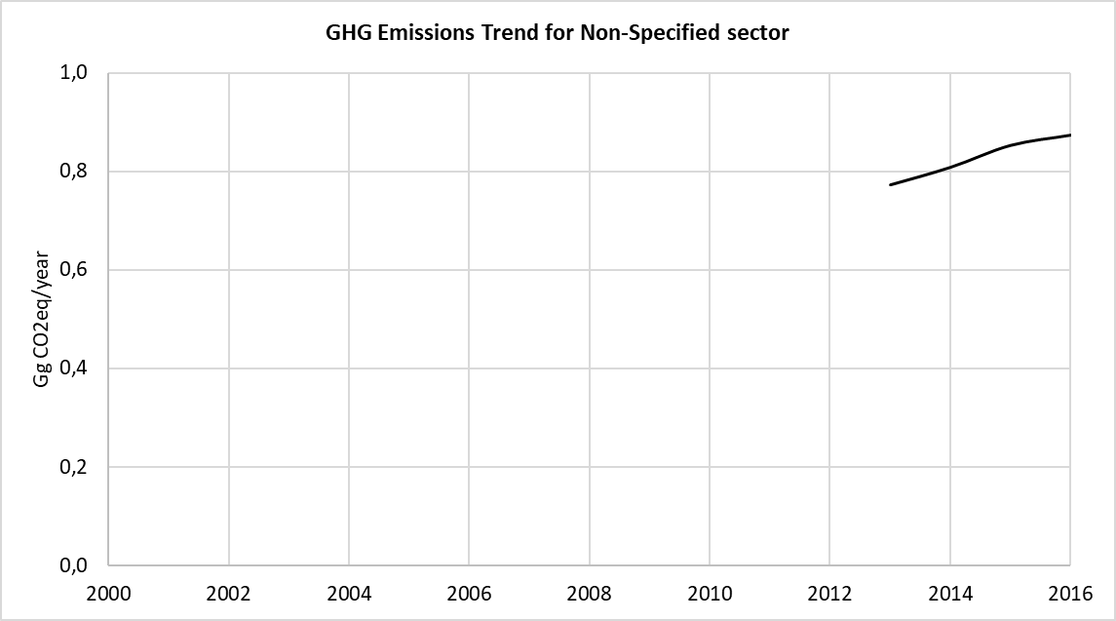

Table 9. Total GHG Emissions from Non-Specified Sectors, 2000 – 2016 (Gg GHG/year)

| **Year** | **CO2** | **CH4** | **N2O** | **Total CO2eq** |
| --- | --- | --- | --- | --- |
| 2000 | NO | NO | NO | NO |
| 2001 | NO | NO | NO | NO |
| 2002 | NO | NO | NO | NO |
| 2003 | NO | NO | NO | NO |
| 2004 | NO | NO | NO | NO |
| 2005 | NO | NO | NO | NO |
| 2006 | NO | NO | NO | NO |
| 2007 | NO | NO | NO | NO |
| 2008 | NO | NO | NO | NO |
| 2009 | NO | NO | NO | NO |
| 2010 | NO | NO | NO | NO |
| 2011 | NO | NO | NO | NO |
| 2012 | NO | NO | NO | NO |
| 2013 | 0.77 | 0.00 | 0.00 | 0.77 |
| 2014 | 0.81 | 0.00 | 0.00 | 0.81 |
| 2015 | 0.85 | 0.00 | 0.00 | 0.85 |
| 2016 | 0.87 | 0.00 | 0.00 | 0.87 |

#### Memo Items

Memo Item category is an additional category that includes the international aviation and navigation emissions. Although these emissions are estimated, they are excluded from national totals and are reported separately as memo items, following IPCC Guidelines.

The memo items are composed by International Aviation emissions and International Water-borne Navigation emissions. The fuel consumed in international aviation is Jet Kerosene while in international water-borne navigation diesel and fuel oil are used.

An increase of a 52.6% of the total GHG emissions considered in this category is observed between 2000 and 2016.

Figure 19. GHG Emission trend from Memo Items, 2000 – 2016 (Gg CO2eq/year)

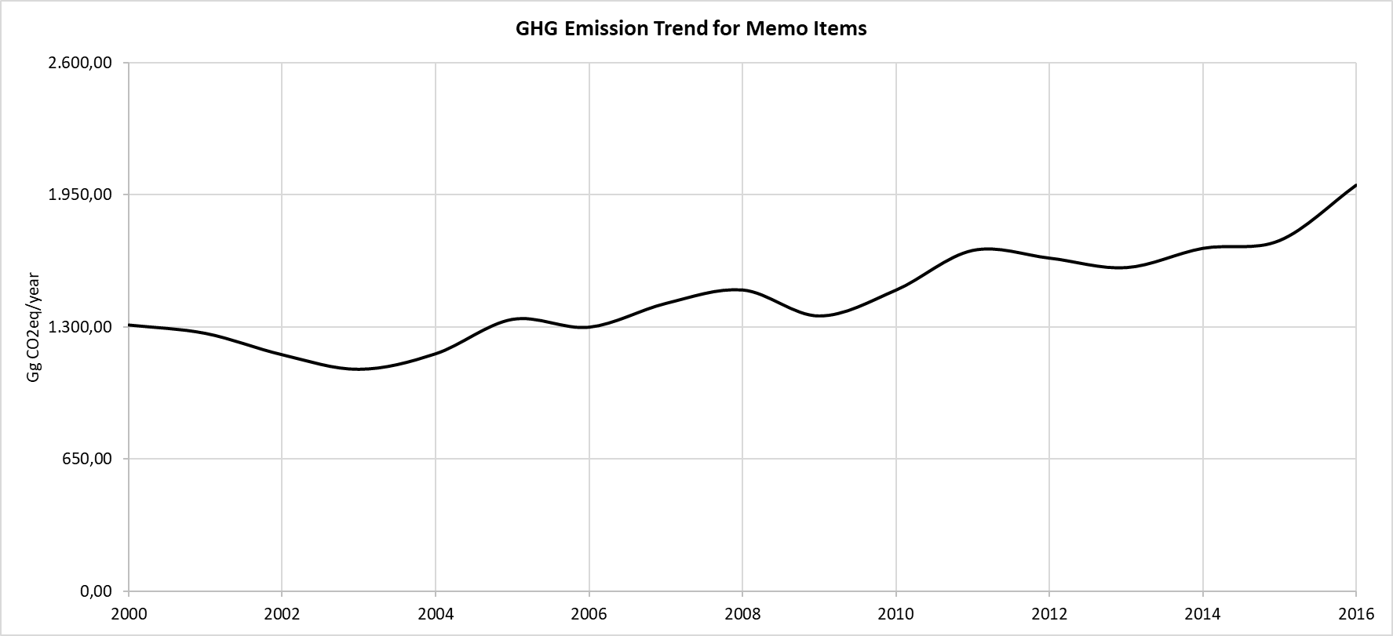

Table 10. Total GHG Emissions from Memo Items, 2000 – 2016 (Gg GHG/year)

| **Year** | **CO2** | **CH4** | **N2O** | **Total CO2eq** |
| --- | --- | --- | --- | --- |
| 2000 | 1,296.58 | 0.07 | 0.04 | 1,308.99 |
| 2001 | 1,255.85 | 0.06 | 0.03 | 1,267.84 |
| 2002 | 1,151.65 | 0.05 | 0.03 | 1,162.57 |
| 2003 | 1,080.71 | 0.04 | 0.03 | 1,090.84 |
| 2004 | 1,156.49 | 0.05 | 0.03 | 1,167.33 |
| 2005 | 1,324.20 | 0.06 | 0.04 | 1,336.73 |
| 2006 | 1,286.09 | 0.06 | 0.04 | 1,298.20 |
| 2007 | 1,401.92 | 0.06 | 0.04 | 1,415.12 |
| 2008 | 1,467.58 | 0.07 | 0.04 | 1,481.42 |
| 2009 | 1,340.87 | 0.07 | 0.04 | 1,353.60 |
| 2010 | 1,466.74 | 0.07 | 0.04 | 1,480.64 |
| 2011 | 1,660.18 | 0.09 | 0.04 | 1,675.94 |
| 2012 | 1,623.02 | 0.08 | 0.04 | 1,638.39 |
| 2013 | 1,576.27 | 0.08 | 0.04 | 1,591.26 |
| 2014 | 1,670.57 | 0.09 | 0.05 | 1,686.46 |
| 2015 | 1,708.48 | 0.09 | 0.05 | 1,724.68 |
| 2016 | 1,978.47 | 0.10 | 0.05 | 1,997.25 |

### Industrial Processes and Product Use (IPPU) Sector

As represented in the following figure and table, the GHG emissions from IPPU Sector has experiment an increase along the time series from 2000 to 2016.

The most significant category, in terms of GHG emissions, that represent the IPPU sector is the Product Use as Substitutes of Ozone Depleting Substances (ODS), represented by stationary refrigerant and air conditioning and mobile air conditioning.

GHG emissions of this sector have increase annually, more moderately between 2000 and 2004 (15.54%) and more pronounced from 2004 to 2016 (283%). The category that most contribute to the increase of the emissions in the last 10 years is the product uses as substitutes for ODS.

Product Uses as Substitutes for ODS represent the 90.7% of the total GHG emissions of the sector in 2016, corresponding to the Refrigeration and Air conditioning category, stationary and mobile. Stationary sources are responsible for the 97% of this category, while the mobile sources represent the remaining 3% by 2016. This category experienced an exponential increase throughout the studied 2000-2016 period of 90.7%, from 47.99 GgCO2eq in 2000 to 282.10 GgCO2eq in 2016.

In stationary air conditioning and refrigeration sub-category, the most used substances are HFC-125, HFC-134a, HFC-143a, HFC-32 and HFC-23 which correspond to the 43.2%,27.7%.27.4%,1.6% and 0.1% of the total amount of ODS substances used in the sub-category by 2016. For the mobile air conditioning sub-category, the only HFC substance used correspond to HFC-134a.

The Metal Industry, represented by the Iron and Steel Production Industries, contribute to the 6.9% of the total GHG emissions of the IPPU sector in 2016. The iron and steel production show some variations along the time series, increasing from 2000 to 2011 in a 89.6% and following decreasing until 2016. The decrease in the emissions from 2011 to 2016 is estimated in 42.3%. From 2000 to 2016 the sector experiments an overall increase of 9.4%.

GHG emissions from Mineral Industry, more specifically from Lime production, represent the 0.3% of the total GHG emissions of the IPPU sector in 2014 when the lime production stopped. The GHG emission trend in this category experiments variations along the time series but with a general decreasing trend of 70.9% between 2000 and 2014.

RoM also has emissions due to the use of lubricants in the industrial sector, as non-energy products, since 2011. The emissions from this category represent the 2.5% of the total emissions of IPPU sector. The emissions present a decrease of a 18% between 2011 and 2016.

Figure 20. GHG Emissions from IPPU Sector, 2000 – 2016 (Gg CO2eq/year)



Table 11. Total GHG Emissions from IPPU Sector, 2000 – 2016 (Gg CO2eq/year)

|  |  |
| --- | --- |
| **Years** | **Total emissions for IPPU** |
| 2000 | 70.32 |
| 2001 | 73.46 |
| 2002 | 76.15 |
| 2003 | 78.88 |
| 2004 | 81.25 |
| 2005 | 113.16 |
| 2006 | 108.04 |
| 2007 | 103.25 |
| 2008 | 125.87 |
| 2009 | 139.56 |
| 2010 | 151.71 |
| 2011 | 193.95 |
| 2012 | 214.43 |
| 2013 | 300.00 |
| 2014 | 300.78 |
| 2015 | 300.96 |
| 2016 | 311.18 |

Figure 21. Share of GHG Emissions from IPPU Sector 2000, 2005, 2010 and 2016 (%CO2eq)

|  |  |
| --- | --- |
|  |  |
|  |  |
|  | |

### Agriculture. Forestry and Other Land Use (AFOLU) Sector

Forestry sector is part of the AFOLU and particularly an important carbon sink and sequester carbon dioxide. The forests and a few other lands sequester carbon with an average of about 367 Gg yearly in total, with a contribution of 75.68 Gg from Rodrigues. Livestock, with enteric fermentation and manure management contributed in the emissions of CH4. Rodrigues, which has important livestock populations accounts for almost half of the total emissions. Total emission from agriculture and soil excluding forestry and other land use (that is source of carbon sinks) is 128 Gg CO2eq.

#### Livestock

The animal population as well as their housing system and waste management determine the amount of emissions. The GHG inventory in the livestock subsector considers only two of the six direct greenhouse gases, namely, methane and nitrous oxide emanating from Enteric Fermentation and Manure Management source categories.

Table 12. GHG emissions from enteric fermentation of Livestock and manure management, 2014 – 2016

|  |  |  |
| --- | --- | --- |
| **Year** | **CO2eq. emission from enteric fermentation of Livestock** | **CO2eq. emission from  manure management** |
| **2014** | 14.91 | 3.27 |
| **2015** | 14.88 | 3.31 |
| **2016** | 13.35 | 3.30 |

Figure 22. Emissions from enteric fermentation of livestock and manure management, 2014 – 2016

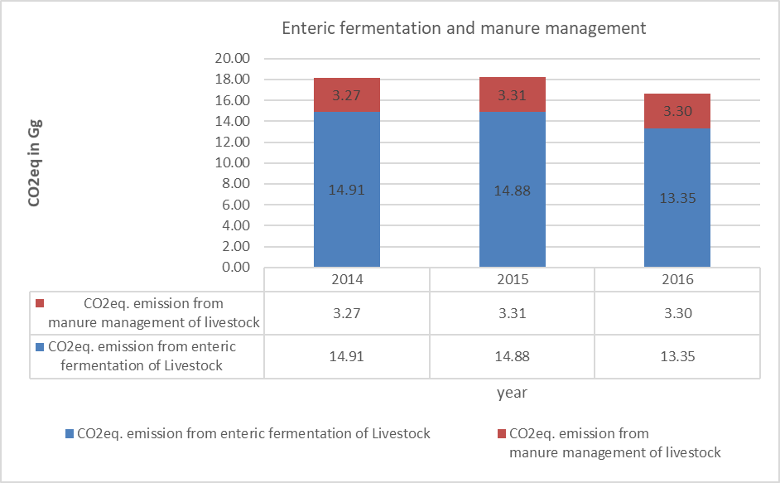

#### Lands

The Net CO2 emissions resulting from: (i) the land remaining the same and (ii) the land converted to other land use was estimated for the period 2006 to 2013. The land use sector represented a net removal of CO2 for the period 2013 to 2016. Forestland remaining forestland represented a net carbon sink form living biomass during the period 2013 – 2016. Very little variation in the total CO2 removal was observed for this land category with the average being -367 Gg CO2-eq.

Under the category forestland, CO2 removal is limited to the subcategory category forestland remaining forestland. Over the period 2013 to 2016, CO2 removal from forestland remaining forest land fluctuated very slightly. The total variation observed for 4 years was -1.18%.

These changes were attributed primarily to changes in the growing stock. The evolution of emissions/removals by the forest sector reported for the time period from 2013 through 2016 was influenced by the low rate of deforestation (average rate of 0.02%) and application of the principles of the National Forest Policy (2006). The Policy prescribes the management of Mauritian Forests for environmental and ecological functions rather than to produce timber. Timber exploitation is gradually being phased out on State Lands and exotic species are gradually being replaced by native species. The forest areas affected by disturbances (fire, pests and diseases) for the period 2013-2016 were negligible.

Table 13. GHG Sequestration by AFOLU sector (Gg CO2eq/year)

|  |  |
| --- | --- |
| **Year** | **AFOLU – GHG removals** |
| 2013 | -367.56 |
| 2014 | -366.90 |
| 2015 | -368.70 |
| 2016 | -363.30 |

Figure 23. GHG Trend of GHG Removals from Forest Land (Gg CO2eq)

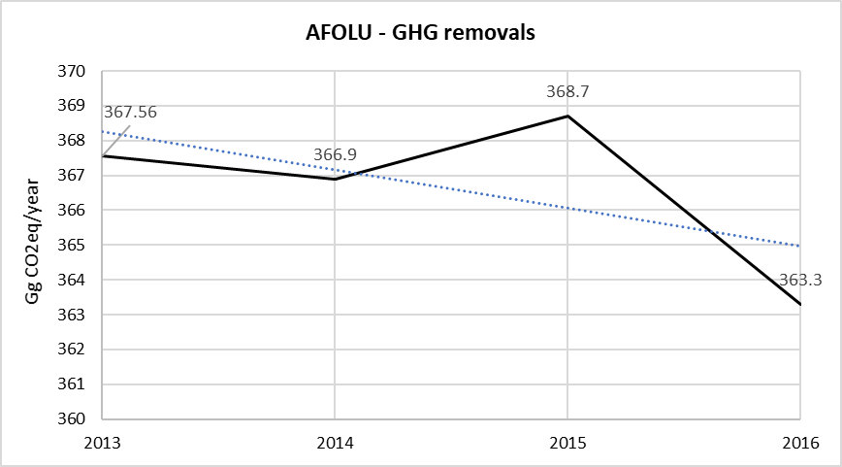

#### Agriculture Soils

Direct and indirect N2O emissions on land produced a total of 70 Gg CO2-eq in 2014. There has been a slight decrease in emission for this sector between 2014 and 2016 to 68.4 Gg CO2-eq. Overall, there has not been any significant variation in GHG emissions over the inventory years, attributed mainly to stable acreage of land under cultivation and amount of fertilizer use.

Table 14. Direct and indirect emissions of N2O (Gg N2O)

|  |  |  |
| --- | --- | --- |
| **Year** | **Direct N2O emissions from managed soils CO2eq.** | **Indirect Emission from managed soils CO2eq.** |
| **2014** | 52.28 | 17.4 |
| **2015** | 49.65 | 16.55 |
| **2016** | 51.33 | 17.11 |

### Waste Sector

As represented in the following figure and table, the GHG emissions from Waste Sector are relatively constant along the time series from 2000 to 2016, experiencing a slight increase of 5.8% from 2000 to 2016.

The most significant category, in terms of GHG emissions, for this sector is the solid waste disposal category, which represents the 68.03% of the total GHG emissions of this sector in 2016, and being the category that most contributes to the variations in the total sector’s emissions in the analysed period.

The following category that most contributes to the emissions in the sector is the wastewater treatment and discharge, responsible for the 30.82% of the total GHG emissions in the sector in the year 2016. These emissions have experienced a small decrease in the period 2000 – 2016 of 11.8%, from the 207.04 GgCO2eq estimated in 2000 to the 182.70 GgCO2eq estimated in 2016.

Emissions from biological treatment of solid waste represent the 1.02% of the total emissions in the waste sector in 2016. The emissions from biological treatment began to be estimated in 2011, with the entry of this type of aerobic waste management system. On the other hand, the incineration and open burning of waste represent the 0.12% of sector’s emissions in 2016.

Figure 24. GHG Emissions from Waste Sector, 2000 – 2016 (Gg CO2eq/year)

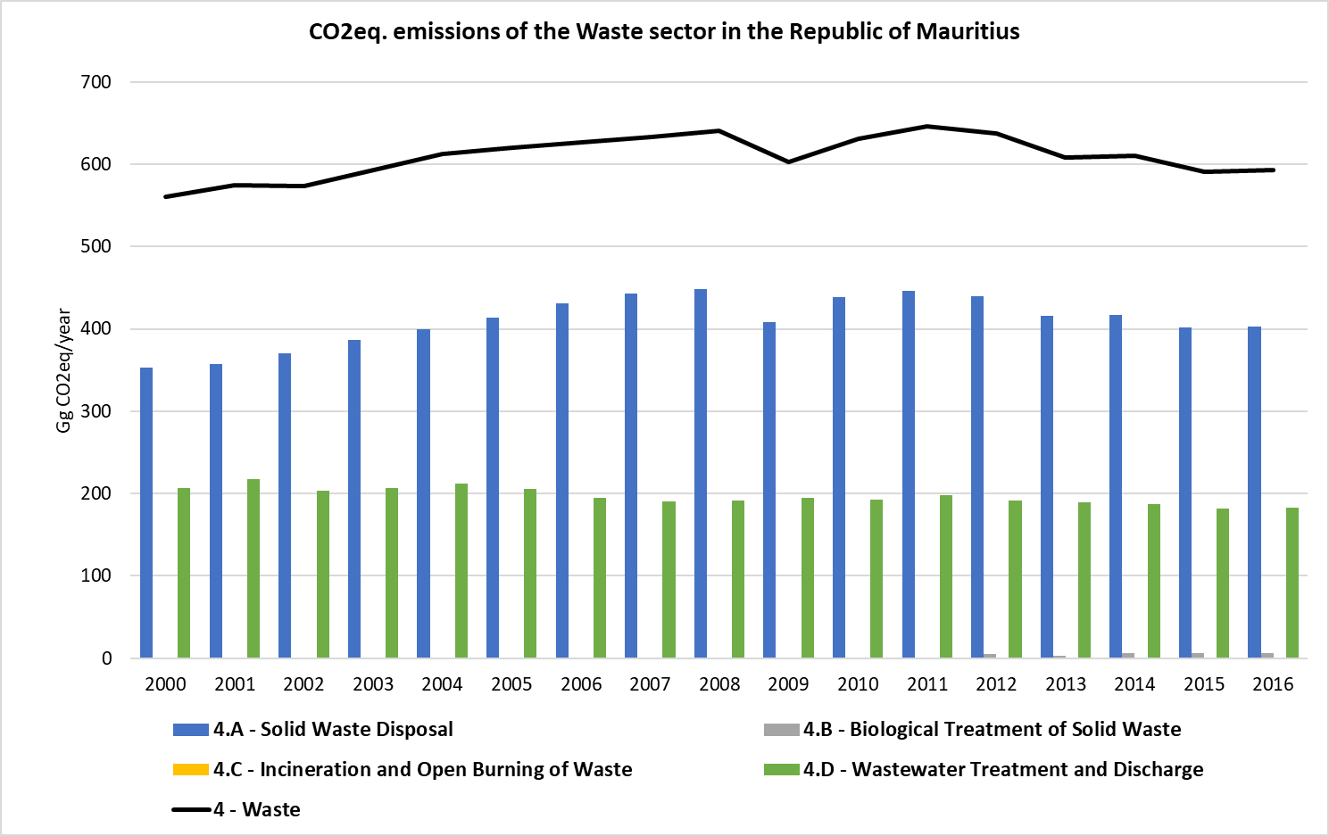

Table 15. Total GHG Emissions from Waste Sector, 2000 – 2016 (Gg CO2eq/year)

| **Years** | **Total emissions for Waste** |
| --- | --- |
| 2000 | 560.25 |
| 2001 | 574.81 |
| 2002 | 573.58 |
| 2003 | 593.24 |
| 2004 | 612.67 |
| 2005 | 619.70 |
| 2006 | 626.24 |
| 2007 | 633.45 |
| 2008 | 640.55 |
| 2009 | 603.15 |
| 2010 | 631.44 |
| 2011 | 646.12 |
| 2012 | 637.03 |
| 2013 | 608.45 |
| 2014 | 610.35 |
| 2015 | 590.73 |
| 2016 | 592.81 |

## Summary of GHG Emission Trends per Gas

### Carbon Dioxide

In the figure below the trend of CO2 emissions are represented for each of the sectors. As seen in the graph, the sector that most contribute to these emissions is the energy sector, which represents the 99.2% of the total CO2 emissions in the country. All the sectors present an increase in their CO2 emissions since the year 2000.

Figure 25. GHG Trend of CO2 emissions in the RoM (Gg CO2)

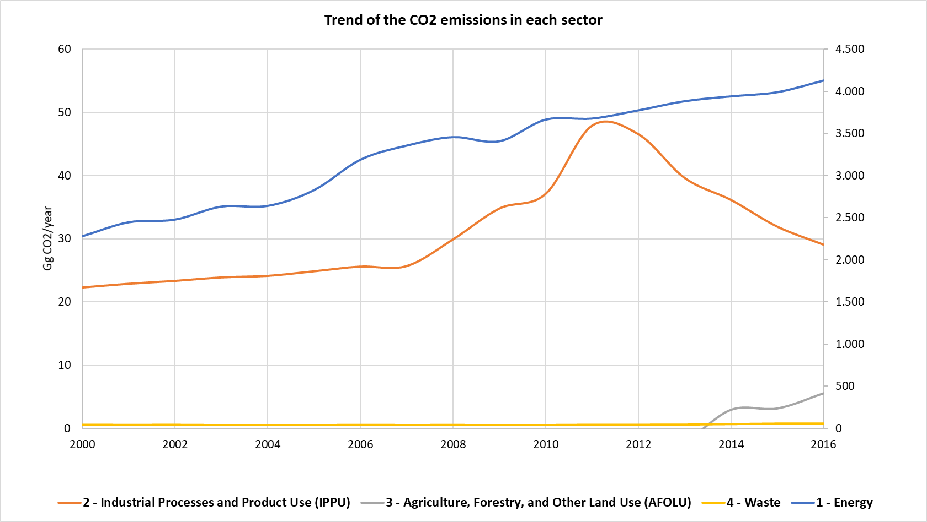

### Methane

The emissions of CH4 are represented in the figure below for each sector. The sector that most contribute to the emissions of these compound is the Waste sector, representing the 96.7% of the total CH4 emissions in the country. The energy sector does not present big variations in its CH4 emissions along the inventory period (2000 – 2016) as opposed to the waste and AFOLU sectors.

Figure 26. GHG Trend of CH4 emissions in the RoM (Gg CH4)

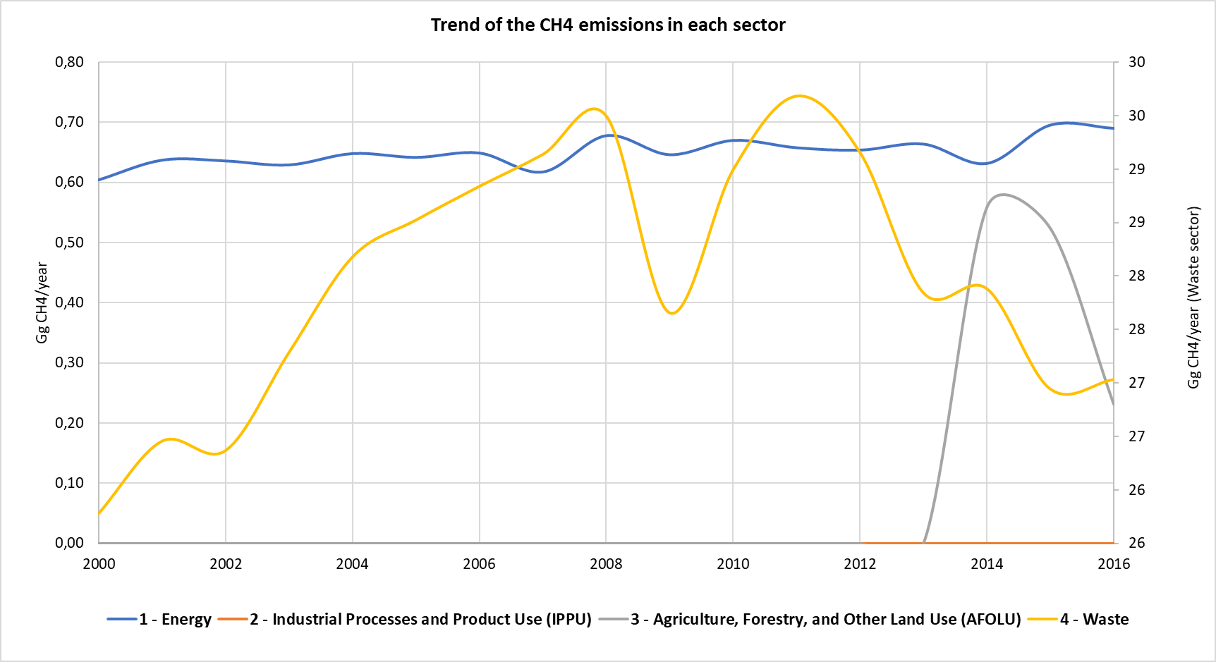

### Nitrous Oxide

In the figure below the trend of N2O emissions are represented for each of the sectors. As seen in the figure, the sector that most contribute to these emissions is the agriculture sector, which represents the 39.03% of the total N2O emissions in the country followed by the waste sector representing the 23.38% of the total emissions. The energy sector does not present big variations in its N2O emissions along the inventory period (2000 – 2016).

Figure 27. GHG Trend of N2O emissions in the RoM (Gg N2O)

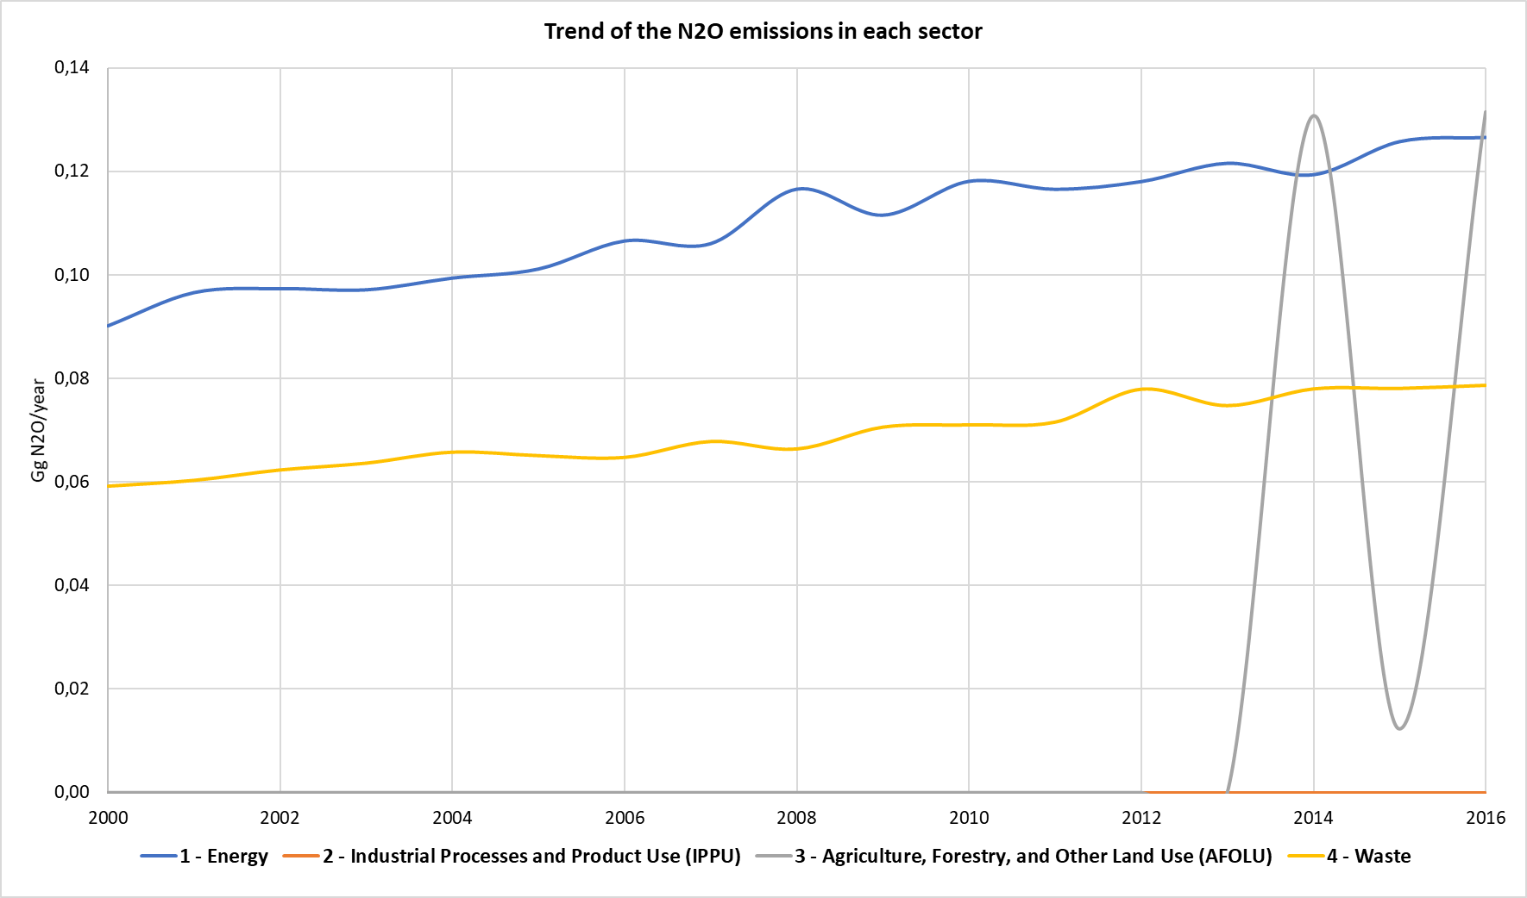

### Hydrofluorocarbons (HFCs)

The hydrofluorocarbons are emitted mainly from IPPU sector activities such as refrigerants and air conditioning. The emissions from these compounds are represented in the figure below as CO2eq emissions. The trend of the emissions represents an increase along the inventory time series (2000 – 2016), reaching the maximum in 2016.

Figure 28. GHG Trend of HFC emissions in the RoM (Gg CO2eq)

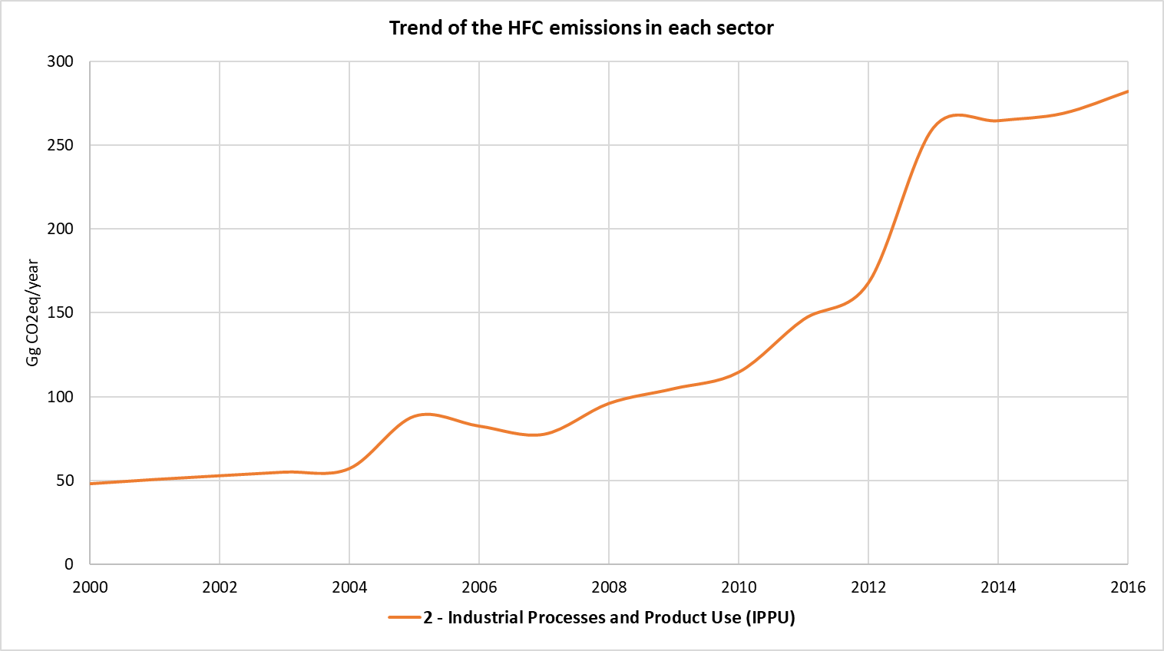

## Key Category Analysis

A Key Category Analysis (KCA) (refer to Table 16 and Table 17) was carried out to determine the categories, fuels and GHGs that are important (cumulatively make up more than 95% of the absolute emissions or have significant upward or downward trends) in the inventory and that needs more focus for accurate calculations.

The level and trend assessment for the period 2000-2016 resulted in the following gases and sectors as key sources/sinks of GHGs. The whole analysis is shown in the Appendix 1: Key Category Analysis:

Table 16. Key Categories analysis from 2016 IPCC Software – Level Assessment

|  |  |  |  |  |  |  |
| --- | --- | --- | --- | --- | --- | --- |
| IPCC Category code | IPCC Category | GHG | 2016 Ex,t (Gg CO2eq) | │Ex,t│ (Gg CO2eq) | Lx,t | Cumulative Total of Column Lx,t |
| 1.A.1 | Energy Industries - Solid Fuels | CO2 | 1694,13 | 1694,13 | 0,33 | 0,33 |
| 1.A.3.b | Road Transportation | CO2 | 1071,80 | 1071,80 | 0,21 | 0,54 |
| 1.A.1 | Energy Industries - Liquid Fuels | CO2 | 703,03 | 703,03 | 0,14 | 0,67 |
| 4.A | Solid Waste Disposal | CH4 | 403,30 | 403,30 | 0,08 | 0,75 |
| 2.F.1 | Refrigeration and Air Conditioning | HFCsPFCs | 282,10 | 282,10 | 0,05 | 0,81 |
| 1.A.2 | Manufacturing Industries and Construction - Liquid Fuels | CO2 | 261,45 | 261,45 | 0,05 | 0,86 |
| 1.A.4 | Other Sectors - Liquid Fuels | CO2 | 245,73 | 245,73 | 0,05 | 0,91 |
| 4.D | Wastewater Treatment and Discharge | CH4 | 161,14 | 161,14 | 0,03 | 0,94 |
| 1.A.2 | Manufacturing Industries and Construction - Solid Fuels | CO2 | 77,35 | 77,35 | 0,02 | 0,95 |

Table 17. Key Categories analysis from 2016 IPCC Software – Trend Assessment

|  |  |  |  |  |  |  |  |
| --- | --- | --- | --- | --- | --- | --- | --- |
| IPCC Category code | IPCC Category | GHG | 2000 Year Estimate Ex0 (Gg CO2eq) | 2016 Year Estimate Ext (Gg CO2eq) | Trend Assessment (Txt) | % Contribution to Trend | Cumulative Total |
| **1.A.1** | Energy Industries - Solid Fuels | CO2 | 561,54 | 1694,13 | 0,24 | 0,30 | 0,30 |
| **1.A.1** | Energy Industries - Liquid Fuels | CO2 | 597,72 | 703,03 | 0,12 | 0,15 | 0,45 |
| **1.A.2** | Manufacturing Industries and Construction - Liquid Fuels | CO2 | 303,60 | 261,45 | 0,09 | 0,12 | 0,57 |
| **4.A** | Solid Waste Disposal | CH4 | 352,65 | 403,30 | 0,07 | 0,09 | 0,66 |
| **2.F.1** | Refrigeration and Air Conditioning | HFCs, PFCs | 47,99 | 282,10 | 0,07 | 0,09 | 0,75 |
| **4.D** | Wastewater Treatment and Discharge | CH4 | 188,70 | 161,14 | 0,06 | 0,07 | 0,82 |
| **1.A.3.b** | Road Transportation | CO2 | 528,48 | 1071,80 | 0,05 | 0,06 | 0,88 |
| **1.A.4** | Other Sectors - Liquid Fuels | CO2 | 195,81 | 245,73 | 0,03 | 0,04 | 0,93 |
| **3.C.4** | Direct N2O Emissions from managed soils | N2O | 0,00 | 37,04 | 0,01 | 0,02 | 0,94 |
| **1.A.2** | Manufacturing Industries and Construction - Solid Fuels | CO2 | 60,11 | 77,35 | 0,01 | 0,01 | 0,95 |
| **1.A.1** | Energy Industries - Solid Fuels | CO2 | 561,54 | 1694,13 | 0,24 | 0,30 | 0,30 |

# Energy Sector

## Overview

Energy sector in the RoM corresponds to the highest GHG emission in the country. The industries for energy production are responsible for the 57.9% of the total amount of GHG emissions generated in the Energy sector by 2016 and is dominated by fuel combustion activities.

The primary energy supply in the country is led by fossil fuels which represent the 87.1% of the supply in the country, and the remaining 12.9% corresponding to local renewable sources such as hydro, wind, landfill gas, photovoltaic energy, bagasse and wood. Nevertheless, the country does not have any fossil fuel extraction sources, and for this reason, all the fossil fuels consumed in the country are imported. In the case of coal, this fuel is imported mainly from South Africa; gasoline, diesel, fuel oil and kerosene mainly from India; and Liquified Petroleum Gases (LPG) from different places such us United Arab Emirates, Singapore and/or Bahrain, among others.

Figure 29. Primary energy requirement in 2018 (% of required energy in terms of TJ) in the RoM

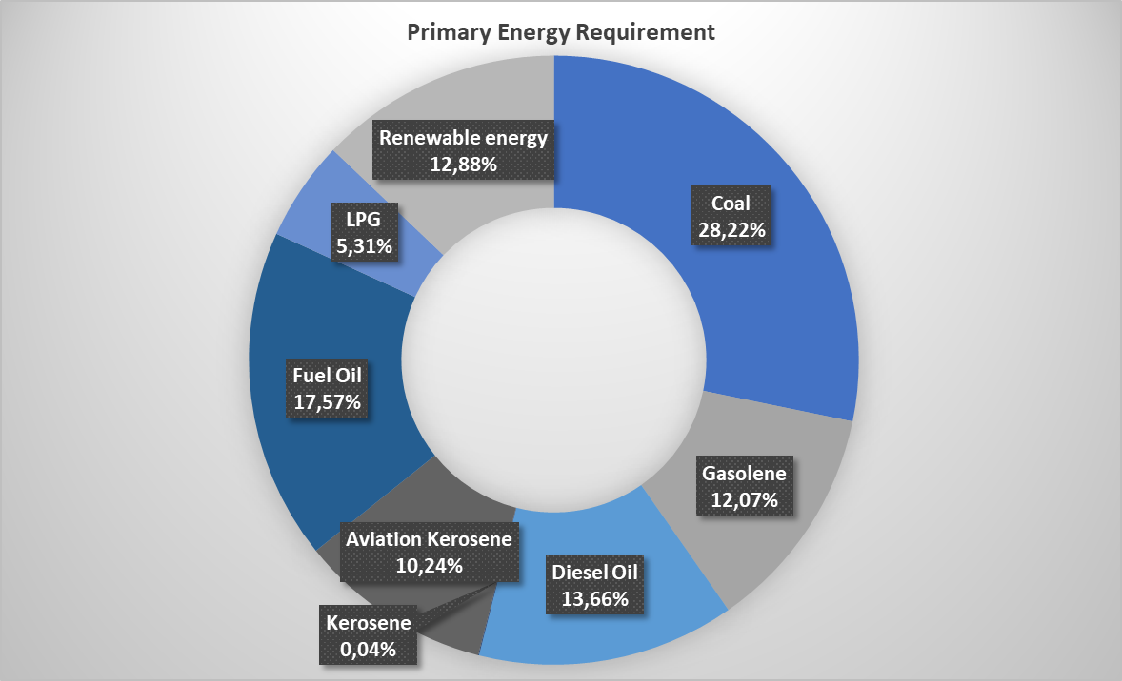

***Source****: Statistics Mauritius, Energy and Water.*

The primary energy supply in the country has increased 9% from 2013 to 2018, and so does the fossil fuel importations (increase of 11.9% between 2013 and 2018). In case of renewable energy sources, the variation between 2013 and 2018 has experienced fluctuations, considering an increase of 14.5% in 2013-2015 and a decrease of almost 19% in 2015-2018 (Energy Statistics, 2018).

The high dependence on the supply of fossil fuels has been a major concern for Mauritius due to the uncertainty in the price and supply of fossil fuels in the world market. In this regard, the Government of Mauritius had come up with an Outline Energy Policy (OEP) in 2007 to pave the road map for meeting the future energy demands for the country. The OEP focused on achieving sustainability in the energy sector and focused on the main drivers of the energy sector like electricity generation and transport. Much focus was laid on capturing the potential of renewable energy sources (CEB, 2019).

Figure 30. Percentage of primary energy requirement locally produced and imported in 2018 (% of TJ of energy required)

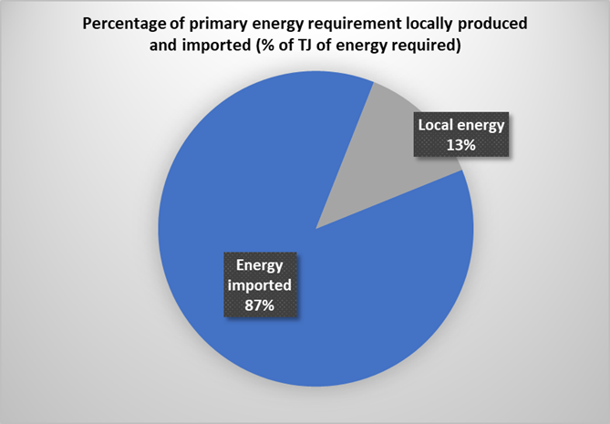

***Source****: Statistics Mauritius, Energy and Water.*

The total energy consumption in the RoM in 2018 was reported in 560.3 ktoe considering the different types of fuels supplied in the country (gasoline, diesel, LPG, kerosene, fuel oil, coal, and renewables such as wood, bagasse and charcoal). Electricity consumption in 2016 was 2,779.7 GWh. Transport sector is the sector with the highest energy consumption, representing a 54.6% of the total energy consumption in the country, and followed by the manufacturing sector with the 20.6% of the total consumption, households (14% of the total consumption), commercial sector and agriculture, with the 10.2% and 0.4% of total consumption respectively (Energy Statistics, 2018).

Figure 31. Distribution of Energy consumption by sector in 2018 (% of the total TJ of energy consumed)

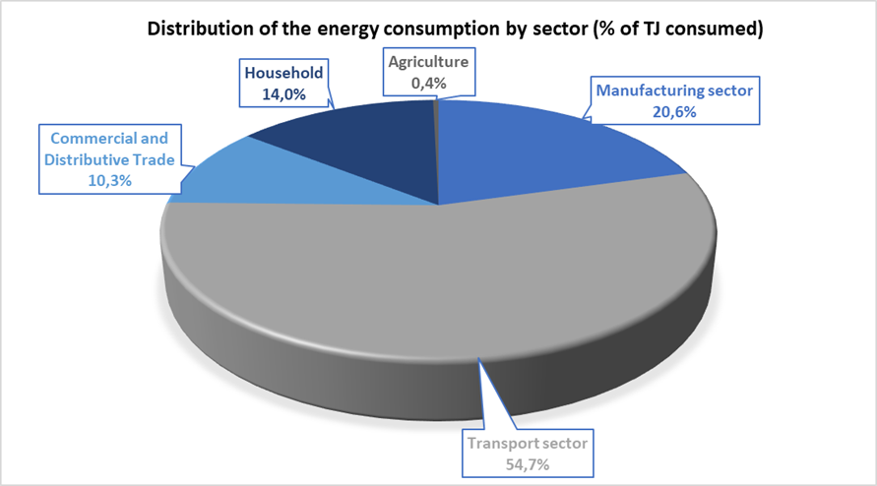

***Source****: Statistics Mauritius, Energy and Water.*

### General Methodology

The general methodology used in the energy sector is collected in the following table:

Table 18. Methodology used for the Energy sector

|  |  |  |  |  |
| --- | --- | --- | --- | --- |
| **Category** | **Activity Data** | **Emission Factor** | **Conversion Factor / NCV** | **Activity Data Source** |
| **1.A. Fuel Combustion Activities** | | | | |
| **1.A.1. Energy Industries** | | | | |
| 1.A.1.a.i. Electricity generation by Energy Industries | T1 | D/T1 | CS | Energy and Water Statistics Mauritius |
| **1.A.2. Manufacturing Industries and Construction** | | | | |
| 1.A.2. Manufacturing Industries and Construction | T1 | D/T1 | CS | ESDD, Commerce Division and Manufacturing Statistics Mauritius |
| **1.A.3. Transport Sector** | | | | |
| 1.A.3.a.i. International Aviation | T1 | D/T1 | D | International Energy Agency (IEA) |
| 1.A.3.a.ii. Civil Aviation | T1 | D/T1 | CS | Air Mauritius, Domestic flights |
| 1.A.3.b. Road Transport | T1 | D/T2 | CS | Transport Toolkit v17.1 |
| 1.A.3.d.i. International Water-borne Navigation | T1 | D/T1 | D | International Energy Agency (IEA) |
| 1.A.3.d.ii. Water-borne Navigation | T1 | D/T1 | CS | Tourism Authority, Water-borne navigation |
| **1.A.4. Other Sector** | | | | |
| 1.A.4.a. Commercial / Institutional | T1 | D/T1 | CS | Ministry of Environment. Data for Energy Other Sectors |
| 1.A.4.b. Residential | T1 | D/T1 | CS | Ministry of Environment, Data for Energy Other Sectors |
| 1.A.4.c. Agriculture | T1 | D/T1 | CS | Ministry of Environment, Data for Energy Other Sectors |
| 1.A.4.d. Other | T1 | D/T1 | CS | Ministry of Environment, Data for Energy Other Sectors |
| **1.B. Fugitive Emissions from Fuels** | | | | |
| 1.B. Fugitive Emissions from Fuels | NA | NA | NA | - |
| **1.C. Carbon Dioxide Transport and Storage** | | | | |
| 1.C. Carbon Dioxide Transport and Storage | NO | NO | NO | - |

T1: Tier 1; T2: Tier 2; D: Default; CS: Country Specific; NO: Not Occurring; NA: Not Applicable; NE: Not Estimated.

## Energy Industries (Category 1A1)

Energy Industries in RoM comprises principally of sub-category 1.A.1.a – Main activity Electricity and Heat Production. Within this category, Electricity Generation (1.A.1.a.i) is solely considered. The other sub-categories are not occurring.

### Source Category Description

The energy generation in the country is produced by the Central Electricity Board (CEB), supplying the 43.1% of the total electricity generated, and by the Independent Power Producers (IPPs) the remaining 56.9% of the total electricity generated in the country by 2018, where 3,129.82 GWh of electricity were generated (Energy Statistics, 2018).

Coal is the main fossil fuel used for electricity generation, reaching to produce 40.2% of the total electricity generated in the area, fossil fuel derived energy represents the 79,3% of the total energy generated, while renewable sources (bagasse, landfill gas, hydro, photovoltaic and wind) accounted for 20.8% of the total electricity generated by 2018. Since 2011 at Mare Chicose landfill the methane generated from the decomposition of the organic matter is being collected and use as renewable energy source (3.14 GWh in 2011), obtaining 22.6 GWh of electricity generation in 2018 (Energy Statistics, 2018). The electricity generation from landfill gas has vary during the years, increasing from 2011 to 2014 (579.3%), decreasing from 2014 to 2017 (20.8%) and increasing again in 2018, when the highest amount of electricity was generated from this source.

Figure 32. Distribution of the Primary Electricity Generation by Fuel type in 2018

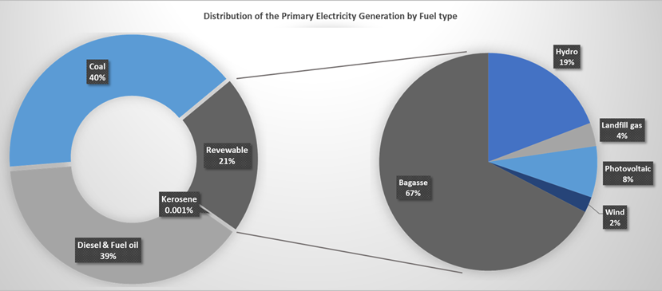

***Source****: Statistics Mauritius, Energy and Water.*

The electricity produced by CEB comes from their 4 thermal power plants named St Lois, Fort Victoria, Fort George and Nicolay, all located in Port Louis. CEB count on 10 hydroelectric plants and 2 photovoltaic facilities located in the Island of Mauritius, and a wind farm in Rodrigues island. IPPs, on their part, count on 2 photovoltaic facilities located in each island, a wind farm and six thermal plants, as well as an electricity generation plant from landfill gas produced in the Chicose landfill (Energy Statistics, 2018).

With a view to up-scale ocean energy in the energy mix, the Mauritius Research Council (MRC) has signed a Collaboration Agreement with the Carnegie Wave Energy Ltd. Australia in 2015. A project on Wave Resource Assessment and Wave – Integrated Micro grid Design in Mauritius – is currently being implemented[1].

Table 19. Effective Plant Capacity, Peak Demand and Electricity Generation 2000 – 2018

| **Year** | **Effective Plant Capacity (MW)** | **Peak Demand (MW)** | **Amount of Electricity Generated (GWh)** |
| --- | --- | --- | --- |
| 2000 | 1,226.6 | 283.9 | 1,777.5 |
| 2001 | 1,228.6 | 297.4 | 1,910.8 |
| 2002 | 1,220.6 | 308.6 | 1,948.9 |
| 2003 | 1,213.1 | 323.8 | 2,081.5 |
| 2004 | 1,194.4 | 332.6 | 2,165.2 |
| 2005 | 1,256.8 | 353.1 | 2,272.2 |
| 2006 | 1,310.1 | 367.3 | 2,350.2 |
| 2007 | 1,403.6 | 367.6 | 2,464.7 |
| 2008 | 1,333.2 | 378.1 | 2,557.2 |
| 2009 | 1,376.3 | 388.6 | 2,577.4 |
| 2010 | 1,384.3 | 404.1 | 2,688.7 |
| 2011 | 1,385.5 | 412.5 | 2,738.6 |
| 2012 | 1,450.2 | 430.1 | 2,797.1 |
| 2013 | 1,451.9 | 441.1 | 2,885.3 |
| 2014 | 1,465.5 | 446.2 | 2,936.9 |
| 2015 | 1,480.3 | 459.9 | 2,995.6 |
| 2016 | 1,515.5 | 467.9 | 3,042.2 |
| 2017 | 765.5 | 469.1 | 3,119.7 |
| 2018 | 814.6 | 476.3 | 3,131.6 |

***Source****: Statistics Mauritius, Energy and Water.*

Figure 33. Evolution of the Electricity Mix (2000 – 2018)

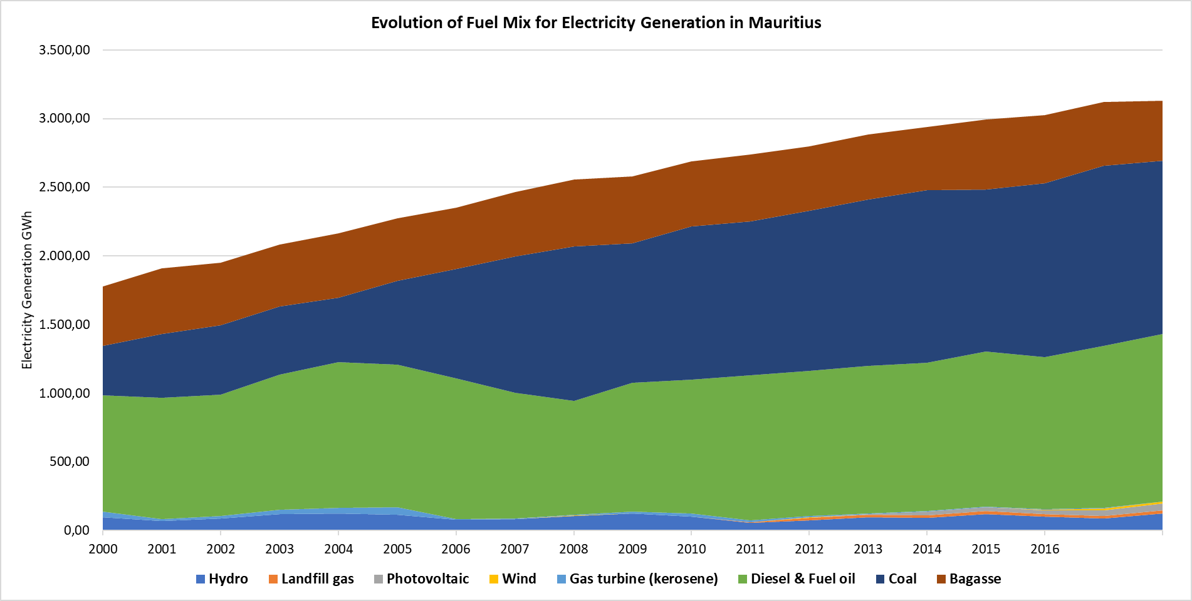

***Source****: Statistics Mauritius, Energy and Water.*

### Methodological Issues

The considered approach for the estimation of GHG Emissions for Energy Industries, was a Tier 1 but using Country Specific (CS) Net Calorific Values (NCV). In RoM different fuels are used for the electricity generation and the 79% of them are from fossil origin (coal, diesel, fuel oil and kerosene) where coal is the main fuel. The remaining 21% of the fuels are from renewable origin (bagasse, landfill gas, hydro, photovoltaic and wind) where bagasse is the renewable source with highest contribution.

As reported in the 2006 IPCC Guidelines, CO2 emissions from renewable energies do not have to be accounted with the rest of CO2 emissions from this category, in this case, they should be accounted as CO2 emissions from biomass and taken as a memo item. The non-CO2 emissions from renewables has to be accounted in the national totals.

To obtain the results of the GHG emissions from each fuel type used in the electricity generation of the country, each fuel’s activity data (AD). NCV and Emission Factor (EF) have been entered in the 2006 IPCC Inventory Software for the obtention of GHG emissions. The emission results for each fuel type have been aggregated to obtain the total amount of emissions.

#### Calculation

For the emission calculation, the equation 2.1 from Chapter 2, Volume 2 of the 2006 IPCC Guidelines was used.

*Emissions GHG.fuel = Fuel Consumption fuel x Emission Factor GHG.fuel*

Where:

|  |  |
| --- | --- |
| Emissions GHG.fuel = | emissions of a given GHG by type of fuel (kg GHG) |
| Fuel Consumption fuel = | amount of fuel consumed (TJ) |
| Emission Factor GHG.fuel = | default emission factor of a given GHG by type of fuel (kg gas/TJ). For CO2 it includes the carbon oxidation factor, assumed to be 1. |

To calculate the total emission by gas from the source category, the emissions as calculated in Equation 2.1 are summed over all fuels.

#### Activity Data

The activity data used for the estimation of GHG emissions for energy industries have been obtained from the amount of fuels consumed for the electricity generation in the country, published in the Statistics Mauritius under the aegis of the Ministry of Finance, Economic Planning and Development, Energy and Water.

The following table compiles the AD values used in the estimation of GHG emissions for the energy industries from 2000 to 2016.

Table 20. Fuel consumed for electricity generation, 2000 – 2016 (Gg Fuel)

|  |  |  |  |  |  |
| --- | --- | --- | --- | --- | --- |
| **Years** | **Kerosene** | **Fuel Oil** | **Diesel** | **Sub-Bituminous Coal** | **Bagasse** |
| 2000 | 13.08 | 175.52 | 3.36 | 228.52 | 1,021.50 |
| 2001 | 3.76 | 185.34 | 3.14 | 273.38 | 1,142.50 |
| 2002 | 5.44 | 179.62 | 3.48 | 286.89 | 1,202.10 |
| 2003 | 9.86 | 204.46 | 3.90 | 287.18 | 1,046.79 |
| 2004 | 16.56 | 220.07 | 3.97 | 265.13 | 1,092.82 |
| 2005 | 17.73 | 217.05 | 2.13 | 340.68 | 1,055.74 |
| 2006 | 1.85 | 226.54 | 2.53 | 462.78 | 1,036.60 |
| 2007 | 1.07 | 201.82 | 2.75 | 552.63 | 1,040.29 |
| 2008 | 2.10 | 167.55 | 1.90 | 609.75 | 1,300.94 |
| 2009 | 4.92 | 190.60 | 2.76 | 574.14 | 1,135.59 |
| 2010 | 6.01 | 196.88 | 2.00 | 643.05 | 1,140.38 |
| 2011 | 3.66 | 214.52 | 1.52 | 617.30 | 1,119.04 |
| 2012 | 3.44 | 213.03 | 1.86 | 649.16 | 1,077.79 |
| 2013 | 0.65 | 216.19 | 1.27 | 683.21 | 1,056.15 |
| 2014 | 0.68 | 221.35 | 1.23 | 711.24 | 1,030.56 |
| 2015 | 0.74 | 229.57 | 1.08 | 684.35 | 1,240.30 |
| 2016 | 0.73 | 224.21 | 1.03 | 701.23 | 1,129.55 |

***Source****: Statistics Mauritius, Digest of Energy and Water Statistics.*

The AD was provided in terms of Gg and then, using the NCV for each fuel type, this was converted to TJ. The NCV used in the national inventory are collected in the following table:

Table 21. Country Specific Net Calorific Values (NCV) for fuels consumed in Energy Industries (TJ/Gg)

|  |  |
| --- | --- |
| **Fuel type** | **Country Specific NCV** |
| Kerosene | 43.54 |
| Fuel Oil | 40.19 |
| Diesel | 43.3 |

***Source****: Statistics Mauritius,* *Digest of Energy and Water Statistics.*

**Table 22. Country Specific Net Calorific Values (NCV) for fuels consumed in Energy Industries (TJ/Gg)**

| **Year** | **Coal** | **Bagasse** |
| --- | --- | --- |
| 2000 | 25.57 | 7.11 |
| 2001 | 25.52 | 7.10 |
| 2002 | 25.48 | 7.09 |
| 2003 | 25.43 | 7.08 |
| 2004 | 25.39 | 7.07 |
| 2005 | 25.34 | 7.06 |
| 2006 | 25.30 | 7.05 |
| 2007 | 25.33 | 6.48 |
| 2008 | 25.21 | 7.18 |
| 2009 | 24.97 | 7.24 |
| 2010 | 25.20 | 7.25 |
| 2011 | 25.23 | 6.98 |
| 2012 | 25.03 | 7.04 |
| 2013 | 24.91 | 7.24 |
| 2014 | 24.86 | 7.22 |
| 2015 | 24.62 | 6.67 |
| 2016 | 25.14 | 6.71 |

***Source****: Omnicane Management and Consultancy Limited, 2019.*

#### Emission Factors

The Emission Factors used for the estimation of the GHG emissions of the energy industries are adopted from the default values proposed in the 2006 IPCC Guidelines, as shown in the table below:

Table 23. Emissions Factors for the fuel used for the energy industries (kg GHG/TJ)

|  |  |  |  |
| --- | --- | --- | --- |
| **Fuel type** | **EF CO2 (kg CO2/TJ)** | **EF CH4 (kg CH4/TJ)** | **EF N2O (kg N2O/TJ)** |
| Kerosene | 71,900 | 3 | 0.6 |
| Fuel Oil | 77,400 | 3 | 0.6 |
| Diesel | 74,100 | 3 | 0.6 |
| Sub-Bituminous Coal | 96,100 | 1 | 1.5 |
| Bagasse | 100,000 | 30 | 4 |

***Source****: Table 2.2, Chapter 2, Volume 2 of the 2006 IPCC Guidelines.*

### Results

Aggregated emissions from the Energy Industries (CEB and IPPs) increased from 1,177.61 Gg CO2eq in 2000 to 2,422.16 in 2016, which represent an increase of 105.68% from 2000 to 2016.

Figure 34. Evolution of the GHG Emissions from Energy Industries from 2000 to 2016 (Gg CO2eq)

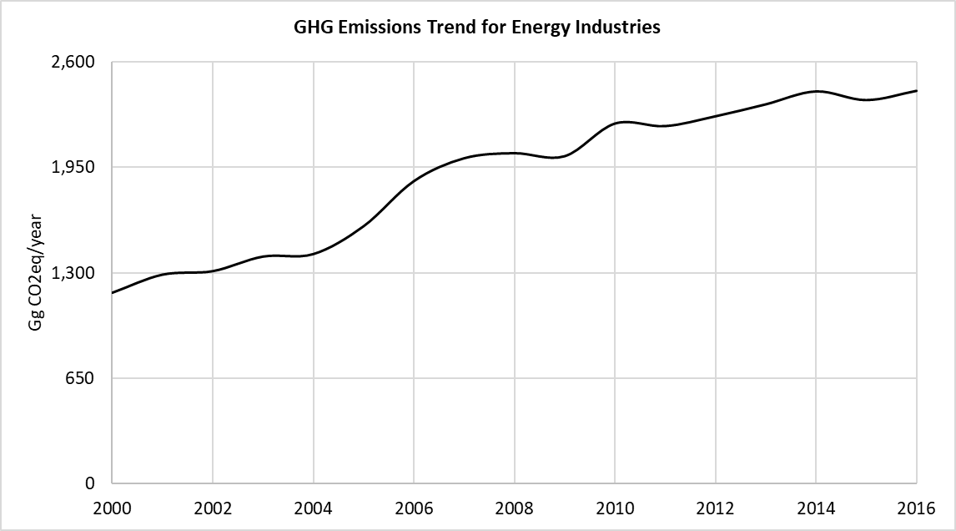

Table 24. GHG Emissions from Energy Industries from 2000 to 2016 (Gg CO2eq)

| **Year** | **Total GHG Emissions for Energy Sector** | **Total GHG Emissions for Energy Industries** | **GHG Emission Share for Energy Industries (%)** |
| --- | --- | --- | --- |
| 2000 | 2,323.15 | 1,177.61 | 50.7% |
| 2001 | 2,492.10 | 1,289.30 | 51.7% |
| 2002 | 2,523.99 | 1,310.80 | 51.9% |
| 2003 | 2,678.11 | 1,400.80 | 52.3% |
| 2004 | 2,687.20 | 1,416.17 | 52.7% |
| 2005 | 2,874.17 | 1,587.64 | 55.2% |
| 2006 | 3,236.14 | 1,865.46 | 57.6% |
| 2007 | 3,403.21 | 2,006.65 | 59.0% |
| 2008 | 3,507.71 | 2,037.72 | 58.1% |
| 2009 | 3,457.07 | 2,019.24 | 58.4% |
| 2010 | 3,715.96 | 2,220.34 | 59.8% |
| 2011 | 3,727.56 | 2,204.72 | 59.1% |
| 2012 | 3,825.40 | 2,265.14 | 59.2% |
| 2013 | 3,935.07 | 2,338.84 | 59.4% |
| 2014 | 3,990.89 | 2,418.53 | 60.6% |
| 2015 | 4,043.99 | 2,365.06 | 58.5% |
| 2016 | 4,182.62 | 2,422.16 | 57.9% |

### Quality Control

Most of the activity data for fuel consumption have been obtained from the respective power plants and sent on a monthly basis to the Statistics Mauritius. The Statistics Mauritius present these data annually in the Digest of Energy and Water Statistics published in their page. The values used in this inventory have been obtained from these annual statistics.

On the other hand, and in order to ensure the use of right data in the inventory, some of the QC implemented during the data collection and emission estimation is listed below:

* Cross verification between data provided via mail by the CEB and IPPs and data reported in the national Statistics Mauritius.
* Cross verification between EF values provided by institutional authorities and the default values proposed by the IPCC 2006 Guidelines for Energy Industries.
* Cross verification between country specific NCV provided by institutional authorities and the NCV range proposed by the IPCC 2006 Guidelines.
* Cross verification between the GHG emissions estimated in the current inventory for energy industries and the results obtained in the last reported national inventory of the RoM.

### Uncertainty Assessment and Time-series Consistency

The uncertainty analysis results for the Energy sector categories obtained from the IPCC software are reported in the following tables, for 2000 as base year:

Table 25. Uncertainty Analysis of the Energy Industry category (1.A.1) for the period 2000 – 2016

|  |  |  |  |  |
| --- | --- | --- | --- | --- |
| **IPCC Category** | **Gas** | **Activity Data Uncertainty (%)** | **Emission Factor Uncertainty (%)** | **Combined Uncertainty (%)** |
| 1.A.1 - Energy Industries - Liquid Fuels | CO2 | 5.00 | 6.14 | 7.92 |
| 1.A.1 - Energy Industries - Liquid Fuels | CH4 | 5.00 | 228.79 | 228.84 |
| 1.A.1 - Energy Industries - Liquid Fuels | N2O | 5.00 | 228.79 | 228.84 |
| 1.A.1 - Energy Industries - Solid Fuels | CO2 | 5.00 | 12.41 | 13.38 |
| 1.A.1 - Energy Industries - Solid Fuels | CH4 | 5.00 | 200.00 | 200.06 |
| 1.A.1 - Energy Industries - Solid Fuels | N2O | 5.00 | 222.22 | 222.28 |
| 1.A.1 - Energy Industries - Biomass | CO2 | 5.00 | 18.69 | 19.35 |
| 1.A.1 - Energy Industries - Biomass | CH4 | 5.00 | 245.45 | 245.51 |
| 1.A.1 - Energy Industries - Biomass | N2O | 5.00 | 304.55 | 304.59 |

It is concluded from the table above, that the greatest source of uncertainty corresponds to the emission factors due to the use of default factors and therefore to the absence of country specific factors.

### Recalculations

The recalculations carried out in the Energy Industries category consist on the improvement on the NCV data for coal and bagasse fuels. In the previous inventory developed in 2013, the NCV used for the fuels consumed in the category where country specific values set as a constant average value for the whole time series and each type of fuel. In this current inventory, the NCV for coal and bagasse was set annually.

The impact in emissions caused by these recalculations compared to the past inventory results in a decrease of a 2% of the emissions estimated from energy industries recorded in 2013, where emissions of 2,386 tCO2e where estimated in the national inventory in 2013, compared to 2,338.84 tCO2e emissions estimated in the current national inventory (2000-2016) for the same year.

### Planned Improvements

Fossil fuels consumed in the country are all imported from different countries, for this reason, the Net Calorific Value (NCV) for the same fossil fuel imported from different countries may vary slightly. This NCV could vary also annually so, for that reason, RoM is considering the recalculation of these NCV for each fossil fuel annually, not solely for coal and bagasse as it has done for this inventory edition.

The activity data used for this category are quite detailed and obtained at plant level, however, this is not the case for EFs. To achieve higher tier levels in the estimation of GHG emissions, it is necessary to obtain specific plant EF, RoM will work on this aspect for the future.

## Manufacturing Industries (Category 1A2)

Manufacturing Industries and Construction category is composed by the following sub-categories in the country:

* 1A2a Iron and Steel
* 1A2c Chemicals
* 1A2d Pulp. Paper and Print
* 1A2e Food processing. Beverages and Tobacco
* 1A2k Construction
* 1A2l Textile and Leather
* 1A2m Other

### Source Category Description

The manufacturing and construction activities are part of the secondary sector of the country that contribute to the 20.7% of the total Global Value Added (GVA) of the country. The manufacturing category and its sub-categories, are the largest sector in Mauritian economy, contributing the 13.9% of the GVA of the country in 2016 (NAI, 2016).

The fuel types used in the manufacturing industry are mainly diesel, fuel oil, liquified petroleum gases (LPG), coal, gasoline, and biomass fuels such as fuelwood and bagasse. The GHG emissions provided from this category result from the combustion of these fossil fuels.

### Methodological Issues

The considered approach for the estimation of GHG Emissions for Manufacturing Industries, was a Tier 1 but using CS NCV. In this category, as mentioned in the previous section, fossil and non-fossil fuels are used in the combustion activities of the manufacturing category. For that sense, and as reported in the 2006 IPCC Guidelines, CO2 emissions from non-fossil fuels do not have to be accounted with the rest of CO2 emissions from this category, in this case, they should be accounted as CO2 emissions from biomass and taken as a memo item. The non-CO2 emissions from non-fossil fuels has to be accounted in the national totals.

To obtain the results of the GHG emissions from each fuel type used in the energy combustion activities of the manufacturing industries of the country, each fuel’s activity data (AD). NCV and Emission Factor (EF) have been entered in the 2006 IPCC Inventory Software for the obtention of GHG emissions. The emission results for each fuel type have been aggregated to obtain the total amount of emissions.

#### Calculation

For the emission calculation, the equation 2.1 from Chapter 2, Volume 2 of the 2006 IPCC Guidelines was used.

*Emissions GHG.fuel = Fuel Consumption fuel x Emission Factor GHG.fuel*

Where:

|  |  |
| --- | --- |
| Emissions GHG.fuel = | emissions of a given GHG by type of fuel (kg GHG) |
| Fuel Consumption fuel = | amount of fuel consumed (TJ) |
| Emission Factor GHG.fuel = | default emission factor of a given GHG by type of fuel (kg gas/TJ). For CO2 it includes the carbon oxidation factor, assumed to be 1. |

To calculate the total emission by gas from the source category, the emissions as calculated in Equation 2.1 are summed over all fuels.

#### Activity Data

The activity data used for the estimation of GHG emissions for manufacturing industries have been estimated by the ESDD according to the data from the Ministry of Industrial Development, SMEs and Cooperatives (SMEs Division) and the Statistics Mauritius.

The total fuel consumption estimations are available for the period between 2000 and 2016, as well as the percentage of fuel consumed on each manufacturing industry (estimates made by the ESDD according to data from the Ministry of Industry). The multiplication between the total fuel consumption and the percentage provided by the ESDD was made to obtain the amount of fuel consumed in each manufacturing industry.

The following table compiles the AD values used in the estimation of GHG emissions for the manufacturing industries from 2000 to 2016.

Table 26. Fuel consumed by Manufacturing Industries and Construction, 2000 – 2016 (Gg Fuel)

| **Years** | **Diesel** | **Fuel Oil** | **LPG** | **Coal** | **Gasoline** | **Fuelwood** | **Bagasse** |
| --- | --- | --- | --- | --- | --- | --- | --- |
| 2000 | 41.60 | 44.77 | 4.27 | 29.72 | 0.55 | 1.50 | 531.80 |
| 2001 | 37.53 | 56.15 | 4.18 | 32.38 | 0.55 | 1.50 | 529.00 |
| 2002 | 37.41 | 56.90 | 4.03 | 32.57 | 0.55 | 1.45 | 442.72 |
| 2003 | 41.27 | 51.22 | 3.54 | 35.02 | 0.55 | 1.43 | 510.25 |
| 2004 | 43.37 | 45.92 | 3.36 | 29.61 | 0.55 | 1.42 | 518.38 |
| 2005 | 41.13 | 42.63 | 4.48 | 28.17 | 0.55 | 1.40 | 476.20 |
| 2006 | 49.77 | 53.82 | 4.66 | 27.99 | 0.55 | 1.43 | 463.56 |
| 2007 | 48.34 | 55.80 | 4.74 | 26.52 | 0.55 | 1.43 | 400.65 |
| 2008 | 46.30 | 50.36 | 5.57 | 47.58 | 0.55 | 1.43 | 239.28 |
| 2009 | 45.88 | 43.18 | 5.65 | 26.64 | 0.55 | 1.43 | 226.76 |
| 2010 | 46.54 | 41.57 | 5.77 | 29.66 | 0.55 | 1.43 | 265.99 |
| 2011 | 43.09 | 40.42 | 5.84 | 28.94 | 0.55 | 1.43 | 244.29 |
| 2012 | 41.31 | 39.06 | 6.04 | 30.20 | 0.55 | 1.41 | 213.12 |
| 2013 | 35.44 | 39.29 | 5.85 | 32.11 | 0.55 | 1.39 | 204.57 |
| 2014 | 36.10 | 40.58 | 5.93 | 36.01 | 0.55 | 1.34 | 177.97 |
| 2015 | 36.59 | 37.31 | 6.18 | 40.81 | 0.55 | 1.30 | 197.65 |
| 2016 | 35.31 | 36.90 | 6.10 | 37.52 | 0.55 | 1.26 | 158.43 |

***Source****: ESDD according to the data from the Ministry of Industrial Development, SMEs and Cooperatives (SMEs Division) and the Statistics Mauritius.*

The AD was provided in terms of Gg and then, using the NCV for each fuel type, this was converted to TJ. The NCV used in the national inventory are collected in the following table:

Table 27. Country Specific Net Calorific Values for fuel consumed in Manufacturing Industries and Construction (TJ/Gg)

|  |  |
| --- | --- |
| **Fuel type** | **Country Specific NCV** |
| Diesel | 43.3 |
| Fuel Oil | 40.19 |
| LPG | 47.3 |
| Gasoline | 44.8 |
| Fuelwood | 15.6 |

***Source****: Statistics Mauritius, Energy and Water.*

Table 28. Country Specific Net Calorific Values for fuel consumed (coal and bagasse) in Manufacturing Industries and Construction (TJ/Gg)

| **Fuel type** | **Coal** | **Bagasse** |
| --- | --- | --- |
| 2000 | 25.57 | 7.11 |
| 2001 | 25.52 | 7.10 |
| 2002 | 25.48 | 7.09 |
| 2003 | 25.43 | 7.08 |
| 2004 | 25.39 | 7.07 |
| 2005 | 25.34 | 7.06 |
| 2006 | 25.30 | 7.05 |
| 2007 | 25.33 | 6.48 |
| 2008 | 25.21 | 7.18 |
| 2009 | 24.97 | 7.24 |
| 2010 | 25.20 | 7.25 |
| 2011 | 25.23 | 6.98 |
| 2012 | 25.03 | 7.04 |
| 2013 | 24.91 | 7.24 |
| 2014 | 24.86 | 7.22 |
| 2015 | 24.62 | 6.67 |
| 2016 | 25.14 | 6.71 |

***Source****: Omnicane Management and Consultancy Limited, 2019.*

#### Emission Factors

The Emission Factors used for the estimation of the GHG emissions of the manufacturing industries are adopted from the default values proposed in the 2006 IPCC Guidelines, as shown in the table below:

Table 29. Emissions factors for the fuel used for the manufacturing industries (kg GHG/TJ)

|  |  |  |  |
| --- | --- | --- | --- |
| **Fuel type** | **EF CO2 (kg CO2/TJ)** | **EF CH4 (kg CH4/TJ)** | **EF N2O (kg N2O/TJ)** |
| Diesel | 74,100 | 3 | 0.6 |
| Fuel Oil | 77,400 | 3 | 0.6 |
| LPG | 63,100 | 1 | 0.1 |
| Coal | 96,100 | 10 | 1.5 |
| Fuelwood | 112,000 | 30 | 4 |
| Bagasse | 100,000 | 30 | 4 |

***Source****: Table 2.3, Chapter 2, Volume 2 of the 2006 IPCC Guidelines.*

### Results

Aggregated emissions from the Manufacturing Industries and Construction increased from 372.17 Gg CO2eq in 2000 to 429.55 Gg CO2eq in 2008 where the maximum emission value was reached, and then the GHG emissions decreased from 2008 to 342.18 Gg CO2eq in 2016. The emissions decreased in 8.1% from 2000 to 2016.

Figure 35. Evolution of the GHG Emissions from Manufacturing Industries and Construction, 2000 – 2016 (Gg CO2eq)

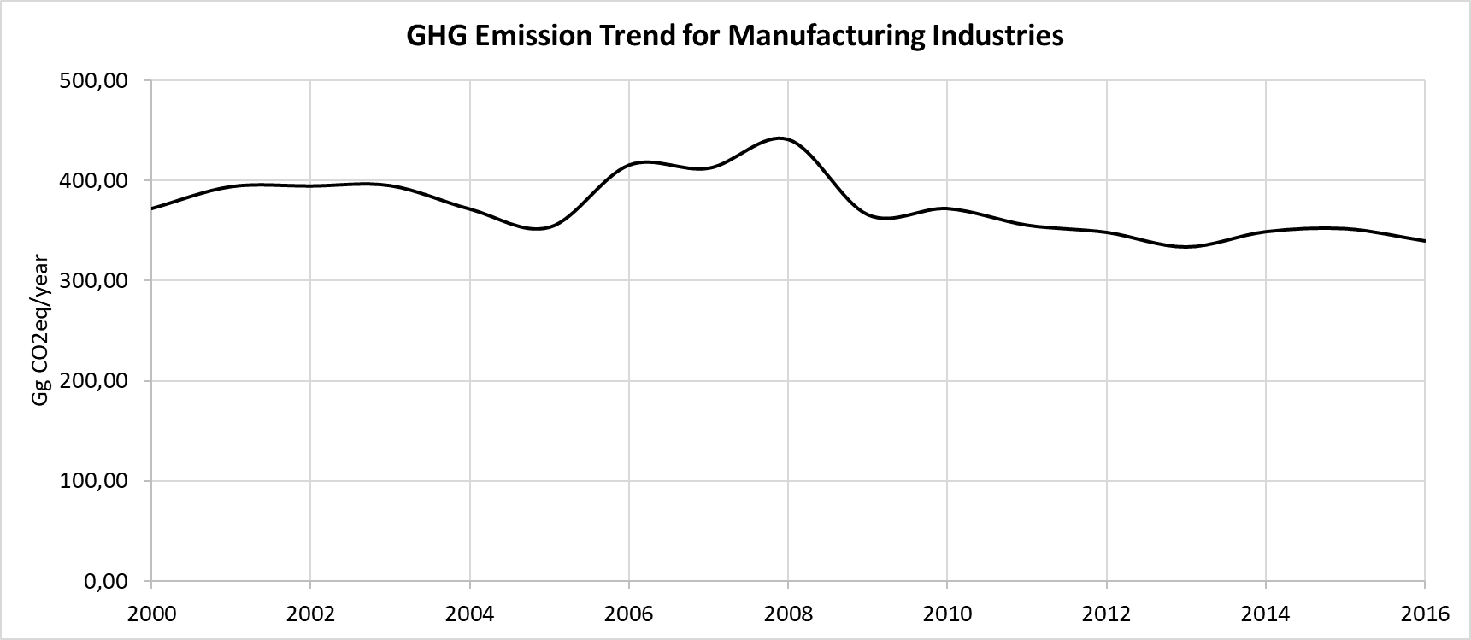

Table 30. GHG Emissions from Manufacturing Industries, 2000 – 2016 (Gg CO2eq)

|  |  |  |  |
| --- | --- | --- | --- |
| **Year** | **Total GHG Emissions for Energy Sector** | **Total GHG Emissions for Manufacturing Industries** | **GHG Emission Share for Manufacturing Industries (%)** |
| 2000 | 2,323.15 | 372.22 | 16.0% |
| 2001 | 2,492.10 | 401.62 | 16.1% |
| 2002 | 2,523.99 | 381.53 | 15.1% |
| 2003 | 2,678.11 | 402.04 | 15.0% |
| 2004 | 2,687.20 | 361.16 | 13.4% |
| 2005 | 2,874.17 | 343.71 | 12.0% |
| 2006 | 3,236.14 | 403.08 | 12.5% |
| 2007 | 3,403.21 | 399.53 | 11.7% |
| 2008 | 3,507.71 | 429.55 | 12.2% |
| 2009 | 3,457.07 | 356.32 | 10.3% |
| 2010 | 3,715.96 | 362.68 | 9.8% |
| 2011 | 3,727.56 | 346.40 | 9.3% |
| 2012 | 3,825.40 | 339.59 | 8.9% |
| 2013 | 3,935.07 | 325.04 | 8.3% |
| 2014 | 3,990.89 | 337.37 | 8.5% |
| 2015 | 4,043.99 | 343.79 | 8.5% |
| 2016 | 4,182.62 | 342.18 | 8.2% |

### Quality Control

The values used in this inventory have been obtained from the estimations elaborated by the ESDD according to the data from the Ministry of Industrial Development, SMEs and Cooperatives (SMEs Division) and the Statistics Mauritius.

On the other hand, and in order to ensure the use of right data in the inventory, some of the QC implemented during the data collection and emission estimation is listed below:

* Cross verification between EF values provided by institutional authorities and the default values proposed by the IPCC 2006 Guidelines for Manufacturing Industries.
* Cross verification between country specific NCV provided by institutional authorities and the NCV range proposed by the IPCC 2006 Guidelines.
* Cross verification between the GHG emissions estimated in the current inventory for manufacturing industries and the results obtained in the last reported national inventory of the RoM.

### Uncertainty Assessment and Time-series Consistency

The uncertainty analysis results for the Manufacturing Industry and Contruction sector categories obtained from the IPCC software are reported in the following table for 2000 as base year:

Table 31. Uncertainty Analysis from the Manufacturing Industry category (1.A.2) for the period 2000 – 2016

|  |  |  |  |  |
| --- | --- | --- | --- | --- |
| **IPCC Category** | **Gas** | **Activity Data Uncertainty (%)** | **Emission Factor Uncertainty (%)** | **Combined Uncertainty (%)** |
| 1.A.2.a - Iron and Steel - Liquid Fuels | CO2 | 5,00 | 6,14 | 7,92 |
| 1.A.2.a - Iron and Steel - Liquid Fuels | CH4 | 5,00 | 228,79 | 228,84 |
| 1.A.2.a - Iron and Steel - Liquid Fuels | N2O | 5,00 | 228,79 | 228,84 |
| 1.A.2.c - Chemicals - Liquid Fuels | CO2 | 5,00 | 6,14 | 7,92 |
| 1.A.2.c - Chemicals - Liquid Fuels | CH4 | 5,00 | 228,79 | 228,84 |
| 1.A.2.c - Chemicals - Liquid Fuels | N2O | 5,00 | 228,79 | 228,84 |
| 1.A.2.c - Chemicals - Solid Fuels | CO2 | 5,00 | 12,46 | 13,43 |
| 1.A.2.c - Chemicals - Solid Fuels | CH4 | 5,00 | 200,00 | 200,06 |
| 1.A.2.c - Chemicals - Solid Fuels | N2O | 5,00 | 222,22 | 222,28 |
| 1.A.2.d - Pulp, Paper and Print - Liquid Fuels | CO2 | 5,00 | 6,14 | 7,92 |
| 1.A.2.d - Pulp, Paper and Print - Liquid Fuels | CH4 | 5,00 | 228,79 | 228,84 |
| 1.A.2.d - Pulp, Paper and Print - Liquid Fuels | N2O | 5,00 | 228,79 | 228,84 |
| 1.A.2.e - Food Processing, Beverages and Tobacco - Liquid Fuels | CO2 | 5,00 | 6,14 | 7,92 |
| 1.A.2.e - Food Processing, Beverages and Tobacco - Liquid Fuels | CH4 | 5,00 | 228,79 | 228,84 |
| 1.A.2.e - Food Processing, Beverages and Tobacco - Liquid Fuels | N2O | 5,00 | 228,79 | 228,84 |
| 1.A.2.e - Food Processing, Beverages and Tobacco - Solid Fuels | CO2 | 5,00 | 12,46 | 13,43 |
| 1.A.2.e - Food Processing, Beverages and Tobacco - Solid Fuels | CH4 | 5,00 | 200,00 | 200,06 |
| 1.A.2.e - Food Processing, Beverages and Tobacco - Solid Fuels | N2O | 5,00 | 222,22 | 222,28 |
| 1.A.2.k - Construction - Liquid Fuels | CO2 | 5,00 | 6,14 | 7,92 |
| 1.A.2.k - Construction - Liquid Fuels | CH4 | 5,00 | 228,79 | 228,84 |
| 1.A.2.k - Construction - Liquid Fuels | N2O | 5,00 | 228,79 | 228,84 |
| 1.A.2.l - Textile and Leather - Liquid Fuels | CO2 | 5,00 | 6,14 | 7,92 |
| 1.A.2.l - Textile and Leather - Liquid Fuels | CH4 | 5,00 | 228,79 | 228,84 |
| 1.A.2.l - Textile and Leather - Liquid Fuels | N2O | 5,00 | 228,79 | 228,84 |
| 1.A.2.l - Textile and Leather - Solid Fuels | CO2 | 5,00 | 12,46 | 13,43 |
| 1.A.2.l - Textile and Leather - Solid Fuels | CH4 | 5,00 | 200,00 | 200,06 |
| 1.A.2.l - Textile and Leather - Solid Fuels | N2O | 5,00 | 222,22 | 222,28 |
| 1.A.2.m - Non-specified Industry - Liquid Fuels | CO2 | 5,00 | 6,14 | 7,92 |
| 1.A.2.m - Non-specified Industry - Liquid Fuels | CH4 | 5,00 | 228,79 | 228,84 |
| 1.A.2.m - Non-specified Industry - Liquid Fuels | N2O | 5,00 | 228,79 | 228,84 |
| 1.A.2.m - Non-specified Industry - Solid Fuels | CO2 | 5,00 | 12,46 | 13,43 |
| 1.A.2.m - Non-specified Industry - Solid Fuels | CH4 | 5,00 | 200,00 | 200,06 |
| 1.A.2.m - Non-specified Industry - Solid Fuels | N2O | 5,00 | 222,22 | 222,28 |
| 1.A.2.m - Non-specified Industry - Biomass | CO2 | 5,00 | 18,69 | 19,35 |
| 1.A.2.m - Non-specified Industry - Biomass | CH4 | 5,00 | 245,45 | 245,51 |
| 1.A.2.m - Non-specified Industry - Biomass | N2O | 5,00 | 281,82 | 281,86 |

It is concluded from the tables above, that the greatest source of uncertainty corresponds to the emission factors due to the use of default factors and therefore to the absence of country specific factors.

### Recalculations

The Manufacturing Industries and Construction category collects some recalculations in the activity data used for the estimation of the GHG emissions regarding the last national inventory edition (TNC). In this current inventory, the activity data used for the calculations has been disaggregated considering the fuel consumed in the specific activities in which the category is composed.

The Manufacturing Industry and Construction category presents a recalculation in the EF used for the GHG emission estimation. For last inventory edition (2000 – 2013), the EF reported for the estimation of CH4 emissions for coal and fuelwood combustion were reported as 1 kgCH4/TJ and 300 kgCH4/TJ respectively. Knowing that the EF used for the estimation of the GHG emissions are adopted from the default EF values proposed in the table 2.3 of the 2006 IPCC Guidelines, these values have been identified as errors. The values considered for this current inventory edition are 10 kgCH4/TJ (coal) and 30 kgCH4/TJ (fuelwood).

On the other hand, some improvements on the NCV data for coal and bagasse has been made. In the last inventory edition, the NCV used for the fuels consumed in the category where country specific values set as a constant average value for every year and each time of fuel. In this current inventory, the NCV for coal and bagasse was set annually.

As well as in the energy industry category, the recalculations made in the present inventory did not show major differences in terms of GHG emissions. In this sense, between the last inventory and the updated inventory for 2016, a decrease of a 2% has been recorded in the year 2013. In the last inventory 342,3 tCO2e where estimated in 2013 whilst 333,96 tCO2e have been estimated for the same year in the present inventory.

### Planned Improvements

The data desegregation available for each of the manufacturing industry and construction categories, is being estimated and not calculated. The country is working in the obtention of more accurate data for each sub-category specially for iron and steel and construction industries.

As for the energy industries, the fossil fuels consumed in these industries should have different NCV values and EF, for that reason, the country is considering the recalculation of these NCV for each fossil fuel annually, not solely for coal and bagasse as it has done for this inventory edition.

## Transport (Category 1A3)

The transport sector in the Country involves the Civil or Domestic Aviation (1A3a), Road Transportation (1A3b) and Water-borne navigation (1A3d). Rail transport does not apply by the moment since the country does not count on rail-based transport, nonetheless, a rail transport system is being made in the country currently, which means that for the next inventory. GHG emissions from this new transportation must be take into consideration.

### Source Category Description

Transport sector in the RoM is represented by the aviation, road transport and navigation transports. The transport consumed the 53.2% of the total energy consumption of the country in 2016, corresponding to 505.6 ktoe. The amount of energy consumed in the sector has increased 11.3% from 2014 to 2016 where the maximum amount of energy consumption is registered since 2000 (Energy Statistics, 2016).

The Republic of Mauritius has a well-developed road network of 2,686 km, 1,192 km of main roads,833 km of secondary roads,100 km of motorways and 561 km of other roads, as registered in 2017. The fleet of vehicles registered in the Republic is 571,122 (556,001 registered in the island of Mauritius and 15,121 in the island of Rodrigues) in 2018,20% higher than in 2014. The highest number of vehicles registered are passenger cars, corresponding to a 42% of the total amount of vehicles registered, autocycles and motorcycles corresponding to a 38.7%of total amount of vehicles registered. Car registration increased in 13% since 2014 and motorcycles and autocycles an 8% (National Land Transport Authority, NLTA).

Air transport in Mauritius currently has more than 20 scheduled airlines that serve some 30 destinations through our international airport. The passenger terminal handles around 1,640 passengers per hour (both arrivals and departures) and has a capacity of 4 million passengers per year. It is operating at 92 percent of its capacity. The country is implementing a series of measures to increase passenger handling capacity to 4.5 million by 2020 and to expand air freight traffic to 65,000 tonnes in 2020. In collaboration with private operators, Mauritius is developing a new Cargo, Freeport and Logistics zone in the airport area. In 2017, an increase in air freight traffic by 18 percent with a freight tonnage of 61,000 was noted.

Water-borne navigation in the Republic is considered as inter-island traffic transport, tugs used in port activities and pleasure crafts in the tourism industry. In 2017, Mauritius reviewed its Port Masterplan and has started work to cement our position as the preferred regional maritime gateway. We have invested in the extension of the Mauritius Container Terminal berths to 800 m thus strengthening the existing quay. We have deepened the navigational channel to 16.5 m, making Port Louis the deepest port in the region capable of accommodating very large vessels. Additional equipment, including seven cranes for loading and uploading of vessels, was also procured, thus improving port productivity. We have also expanded backup facilities to increase terminal capacity from 550,000 TEUs (Twenty-foot Equivalent Unit) to 750,000 TEUs. These improvements have allowed Port Louis to handle more transhipment traffic. The bunker traffic increased by almost 36 percent from 404,837 tonnes to 550,241 tonnes in the past three years. The number of cruising ships making calls to Port Louis increased from 24 to 37.

RoM does not have any railway transport facility, but it is planned to introduce a mass transit system (Mauritius Metro Express). Operations are due to begin in September 2019[2].

### Methodological Issues

The considered approach for the estimation of GHG Emissions for Civil aviation and Water-borne navigation in the Transport sector, was a Tier 1 but using CS NCVs. The methodological approach used for road transport was a Tier 1.

To obtain the results of the GHG emissions from each fuel type used in the transport sector of the country, each fuel’s activity data (AD) and Emission Factor (EF) have been entered in the 2006 IPCC Inventory Software for the obtention of GHG emissions. The emission results for each fuel type have been aggregated to obtain the total amount of emissions.

#### Calculation

For the emission calculation of **road transport**, the equation 3.2.1 and 3.2.3 from Chapter 3, Volume 2 of the 2006 IPCC Guidelines was used.

*Emissions GHG.fuel = Fuel Consumption fuel x Emission Factor GHG.fuel*

Where:

|  |  |
| --- | --- |
| Emissions GHG.fuel = | emissions of a given GHG by type of fuel (kg GHG) |
| Fuel Consumption fuel = | amount of fuel consumed (TJ) |
| Emission Factor GHG.fuel = | default emission factor of a given GHG by type of fuel (kg gas/TJ). |

The *Fuel Consumption fuel* parameter has been calculated using the 3.2.6 equation of the 2006 IPCC Guidelines, for each vehicle and fuel type.

*Fuel Consumption fuel= Vehicles type. fuel x Consumption vehicle type.fuel x Distance travelled*

Where:

|  |  |
| --- | --- |
| Fuel Consumption fuel = | amount of fuel consumed (TJ) |
| Vehicles type. fuel = | Number of vehicles by type and fuel used |
| Consumption vehicle type.fuel = | Average fuel consumption by vehicle type and fuel used |
| Distance travelled | Average distance travelled by each type of vehicle by fuel type (km) |

The emissions are calculated for each vehicle and fuel type and to calculate the total emission by gas the emissions calculated in the 3.2.1 and 3.2.3 equations are summed over all fuels.

For the emission calculation of **water-borne navigation**, the equation 3.5.1 from Chapter 3, Volume 2 of the 2006 IPCC Guidelines was used.

*Emissions GHG.fuel = Fuel Consumption fuel x Emission Factor GHG.fuel*

Where:

|  |  |
| --- | --- |
| Emissions GHG.fuel = | emissions of a given GHG by type of fuel (kg GHG) |
| Fuel Consumption fuel = | amount of fuel consumed (TJ) |
| Emission Factor GHG.fuel = | default emission factor of a given GHG by type of fuel (kg gas/TJ). |

To calculate the total emission by gas from the source category, the emissions as calculated in Equation 3.5.1 are summed over all fuels.

For the emission calculation of **civil aviation**, the equation 3.6.1 from Chapter 3, Volume 2 of the 2006 IPCC Guidelines was used.

*Emissions GHG.fuel = Fuel Consumption fuel x Emission Factor GHG.fuel*

Where:

|  |  |
| --- | --- |
| Emissions GHG.fuel = | emissions of a given GHG by type of fuel (kg GHG) |
| Fuel Consumption fuel = | amount of fuel consumed (TJ) |
| Emission Factor GHG.fuel = | default emission factor of a given GHG by type of fuel (kg gas/TJ). |

To calculate the total emission by gas from the source category, the emissions as calculated in Equation 3.6.1 are summed over all fuels.

#### Activity Data

For the **road transport**, the AD used differs depending on the time period. On one hand, the NLA facilitated the number of vehicles by type, technology and fuel consumed for the years 2014, 2015 and 2016, for both Mauritius and Rodrigues. In addition, the NLTA also facilitated the total amount of vehicles for the period 2000 – 2013 in Mauritius, and the total amount of vehicles for the period 2006 – 2013 in the island of Rodrigues. The completion of data about the total amount of vehicles in the island of Rodrigues for the period 2000-2005 has been estimated using the average inter-annual growth rate.

On the other hand, the estimation of vehicle by type of fuel for the period 2000 – 2013 has been carried out according to the average distribution of vehicle type by fuel obtained from 2014-2016 data received from NLTA for both islands.

Table 32. Number of vehicles by type and fuel used matriculated in the Island of Mauritius, 2014 – 2016

|  |  |  |  |  |  |  |
| --- | --- | --- | --- | --- | --- | --- |
| Vehicle type | Technology | Fuel | 2014 | 2015 | 2016 | Average |
| Passenger Cars and Taxis | 3 way catalyst | Gasoline | 71,092 | 82,072 | 97.940 | 17% |
| Diesel | 5,682 | 6,388 | 7.456 | 1% |
| LPG | 178 | 17 | 20 | 0% |
| Hybrid | 1,829 | 2,424 | 3.777 | 1% |
| Electric | 9 | 10 | 11 | 0% |
| Without 3 way catalyst | Gasoline | 101,023 | 96,804 | 97.411 | 20% |
| Diesel | 10,117 | 10,004 | 9.874 | 2% |
| LPG | 40 | 204 | 203 | 0% |
| Hybrid | 0 | 0 | 0 | 0% |
| Electric | 0 | 1 | 2 | 0% |
| Motorcycle | | Gasoline | 195.611 | 210,055 | 210,100 | 42% |
| Dual Purpose Vehicle (DPV) | 3 way catalyst | Gasoline | 659 | 692 | 732 | 0% |
| Diesel | 11,666 | 11,681 | 13.890 | 3% |
| LPG | 5 | 4 | 5 | 0% |
| Without 3 way catalyst | Gasoline | 5,836 | 5,656 | 5.413 | 1% |
| Diesel | 19,801 | 19,610 | 19.573 | 4% |
| LPG | 9 | 10 | 9 | 0% |
| Light Duty Trucks | 3 way catalyst | Diesel | 3,163 | 4,120 | 5.670 | 1% |
| Without 3 way catalyst | Diesel | 16,596 | 16,237 | 15.960 | 3% |
| Heavy Duty Trucks | | Diesel | 18.492 | 16,520 | 15,789 | 3% |
| Buses | | Diesel | 3.244 | 3,552 | 3,828 | 1% |
| TOTAL | | | 465,052 | 486,061 | 507,663 |  |

***Source****: National Land Transport Authority (NLTA).*

Table 33. Number of vehicles by type and fuel used matriculated in the Island of Rodrigues, 2014 – 2016

|  |  |  |  |  |  |  |
| --- | --- | --- | --- | --- | --- | --- |
| Vehicle type | Technology | Fuel | 2014 | 2015 | 2016 | Average |
| Passenger Cars and Taxis | 3 way catalyst | Gasoline | 169 | 129 | 276 | 2% |
| Diesel | 69 | 26 | 44 | 0% |
| LPG |  |  |  | 0% |
| Hybrid | 3 | 3 | 6 | 0% |
| Electric |  |  |  | 0% |
| Without 3 way catalyst | Gasoline | 525 | 677 | 677 | 5% |
| Diesel | 403 | 401 | 401 | 3% |
| LPG |  |  |  | 0% |
| Hybrid | 0 | 0 | 0 | 0% |
| Electric |  |  |  | 0% |
| Motorcycle | | Gasoline | 7.436 | 8.048 | 8.694 | 67% |
| Dual Purpose Vehicle (DPV) | 3 way catalyst | Gasoline | 6 | 6 | 12 | 0% |
| Diesel | 340 | 585 | 685 | 4% |
| LPG | 0 | 2 | 3 | 0% |
| Without 3 way catalyst | Gasoline | 14 | 14 | 14 | 0% |
| Diesel | 924 | 916 | 974 | 8% |
| LPG | 5 | 5 | 5 | 0% |
| Light Duty Trucks | 3 way catalyst | Diesel | 0 | 0 | 0 | 0% |
| Without 3 way catalyst | Diesel | 0 | 0 | 0 | 0% |
| Heavy Duty Trucks | | Diesel | 913 | 948 | 999 | 8% |
| Buses | | Diesel | 172 | 177 | 185 | 1% |
| TOTAL | | | 10,979 | 11,937 | 12,975 |  |

***Source****: National Land Transport Authority (NLTA).*

Table 34. Total number of vehicles in the RoM, 2000 – 2016

| **Year** | **Island of Mauritius** | **Island of Rodrigues** |
| --- | --- | --- |
| 2000 | 244,690 | 4,002 |
| 2001 | 255,149 | 4,324 |
| 2002 | 265,841 | 4,672 |
| 2003 | 276,371 | 5,048 |
| 2004 | 291,605 | 5,454 |
| 2005 | 305,496 | 5,894 |
| 2006 | 319,440 | 6,368 |
| 2007 | 334,145 | 6,725 |
| 2008 | 351,406 | 7,099 |
| 2009 | 366,520 | 7,359 |
| 2010 | 384,115 | 7,670 |
| 2011 | 400,919 | 8,083 |
| 2012 | 421,926 | 8,677 |
| 2013 | 443,495 | 9,332 |
| 2014 | 465,052 | 10,979 |
| 2015 | 486,144 | 11,937 |
| 2016 | 507,676 | 12,975 |

***Source****: National Land Transport Authority (NLTA).*

The fuel consumption data for years 2014, 2015 and 2016 has been provided by the NLTA using specific and disaggregated data regarding vehicle type, technology, vehicle year, fuel used, average distance travelled and fuel efficiency for each vehicle in both islands.

The parameters used to estimate the GHG emissions related to the road transport are reported in the following tables.

Table 35. Country Specific Density Values for fuels consumed in road transport (L fuel/ton fuel)

|  |  |  |  |
| --- | --- | --- | --- |
| **Parameter** | **Gasoline** | **Diesel** | **LPG** |
| **Density (L/ton)** | 1,384 | 1,174.24 | 1,769.9 |

***Source****: National Land Transport Authority (NLTA).*

The NCV used for the road transport in the national inventory are collected in the following table:

Table 36. Country Specific Net Calorific Values for fuels consumed in road transport (TJ/Gg)

|  |  |
| --- | --- |
| **Fuel type** | **Country Specific NCV (TJ/Gg)** |
| Gasoline | 44.8 |
| Diesel | 43.33 |
| LPG | 47.31 |

***Source****: National Land Transport Authority (NLTA).*

To estimate GHG emissions for 2000 – 2013 period, the main data used was provided by the NLTA: total number of vehicles, densities and NCV values.

On the other hand, to estimate the fuel consumption of road transport in the period 2000 – 2013, and to continue applying the same methodology used for 2014 – 2016, several average data have been used.

Table 37. Average distance travelled in the Road Transport for the period 2000 – 2013

| **Vehicle type** | **Fuel** | **Distance (km/year)** |
| --- | --- | --- |
| Passenger cars | Gasoline | 13,500 |
| Diesel | 13,500 |
| LPG | 13,500 |
| Autocycle and Motorcycle | Gasoline | 5,600 |
| Dual Purpose Vehicle | Gasoline | 13,500 |
| Diesel | 13,500 |
| LPG | 13,500 |
| Light Duty / Good vehicles | Diesel | 13,500 |
| Heavy Duty Trucks | Diesel | 13,500 |
| Buses | Diesel | 38,000 |

***Source****: Transport Toolkit*

Table 38. Average fuel consumption in the Road Transport for the period 2000 – 2013

|  |  |  |
| --- | --- | --- |
| **Vehicle type** | **Fuel** | **Fuel consumption (L/100km)** |
| Passenger cars | Gasoline | 6.5 |
| Diesel | 9 |
| LPG | 9 |
| Autocycle and Motorcycle | Gasoline | 2.75 |
| Dual Purpose Vehicle | Gasoline | 11.5 |
| Diesel | 11.5 |
| LPG | 11.5 |
| Light Duty / Good vehicles | Diesel | 11.5 |
| Heavy Duty Trucks | Diesel | 30.3 |
| Buses | Diesel | 30.3 |

***Source****: Transport Toolkit*

The methodology used to calculate the fuel consumption in the road transport of the Republic of Mauritius is shown in the following equation (Tier 1 methodology from the 2006 IPCC Guidelines).

Fuel consumption (Gg) = Number of vehicle by type, technology and fuel used (number) x Fuel Consumption by type of vehicle, technology and fuel used (L/km)) x Distance travelled by type of vehicle, technology and fuel used (km/year) x Fuel Density (Gg/L)

The following table reports the fuel consumption by vehicle type and type of fuel consumed.

Table 39. Total fuel consumption in road transport in the RoM, 2000 – 2016 (Gg fuel).

|  |  |  |  |  |  |  |  |  |  |  |  |  |  |
| --- | --- | --- | --- | --- | --- | --- | --- | --- | --- | --- | --- | --- | --- |
| **Year** | **Passenger Cars and Taxis** | | | | **Motorcycle** | **Dual Purpose Vehicle (DPV)** | | | | **Light Duty** | | **Heavy duty and Buses** | |
| **Gasoline** | **Diesel** | **LPG** | **Gasoline** | | **Gasoline** | **Diesel** | **LPG** | **Diesel** | | **Diesel** | |
| 2000 | 58.24 | 8.75 | 0.08 | 11.80 | | 3.59 | 22.00 | 0.01 | 13.69 | | 48.95 | |
| 2001 | 60.74 | 9.13 | 0.08 | 12.31 | | 3.74 | 22.96 | 0.01 | 14.28 | | 51.10 | |
| 2002 | 63.29 | 9.52 | 0.08 | 12.84 | | 3.90 | 23.95 | 0.01 | 14.88 | | 53.32 | |
| 2003 | 65.81 | 9.90 | 0.09 | 13.36 | | 4.05 | 24.93 | 0.01 | 15.46 | | 55.50 | |
| 2004 | 69.44 | 10.46 | 0.09 | 14.11 | | 4.28 | 26.33 | 0.01 | 16.32 | | 58.61 | |
| 2005 | 72.75 | 10.96 | 0.10 | 14.79 | | 4.48 | 27.61 | 0.01 | 17.10 | | 61.49 | |
| 2006 | 76.09 | 11.47 | 0.10 | 15.48 | | 4.69 | 28.90 | 0.01 | 17.88 | | 64.39 | |
| 2007 | 79.59 | 12.00 | 0.10 | 16.20 | | 4.90 | 30.24 | 0.01 | 18.70 | | 67.37 | |
| 2008 | 83.70 | 12.62 | 0.11 | 17.04 | | 5.16 | 31.81 | 0.01 | 19.67 | | 70.86 | |
| 2009 | 87.30 | 13.16 | 0.11 | 17.77 | | 5.38 | 33.17 | 0.01 | 20.51 | | 73.89 | |
| 2010 | 91.49 | 13.79 | 0.12 | 18.62 | | 5.64 | 34.76 | 0.01 | 21.50 | | 77.42 | |
| 2011 | 95.50 | 14.40 | 0.12 | 19.44 | | 5.88 | 36.29 | 0.01 | 22.44 | | 80.85 | |
| 2012 | 100.51 | 15.16 | 0.13 | 20.47 | | 6.19 | 38.22 | 0.01 | 23.61 | | 85.14 | |
| 2013 | 105.65 | 15.94 | 0.14 | 21.54 | | 6.51 | 40.21 | 0.02 | 24.82 | | 89.59 | |
| 2014 | 101.75 | 14.99 | 0.10 | 15.13 | | 4.59 | 33.80 | 0.01 | 25.25 | | 96.17 | |
| 2015 | 121.32 | 15.37 | 0.13 | 20.34 | | 6.34 | 33.88 | 0.02 | 30.34 | | 89.30 | |
| 2016 | 134.03 | 18.38 | 0.13 | 22.53 | | 6.37 | 36.32 | 0.02 | 32.24 | | 89.30 | |

The AD for **civil aviation** and **water-borne navigation** corresponds to the amount of fuel consumed by fuel type. Kerosene for civil aviation, and diesel and gasoline for water-borne navigation.

The following tables compiles the AD values used in the estimation of GHG emissions for the civil aviation and water-borne navigation from 2000 to 2016.

Table 40. Fuel consumed by Civil aviation, 2000 – 2016 (Gg fuel)

|  |  |
| --- | --- |
| **Years** | **Civil Aviation** |
| **Kerosene (Jet Fuel)** |
| 2000 | 1.50 |
| 2001 | 1.59 |
| 2002 | 1.85 |
| 2003 | 1.97 |
| 2004 | 1.89 |
| 2005 | 1.69 |
| 2006 | 1.75 |
| 2007 | 1.96 |
| 2008 | 1.75 |
| 2009 | 1.33 |
| 2010 | 1.82 |
| 2011 | 1.99 |
| 2012 | 2.11 |
| 2013 | 2.17 |
| 2014 | 2.24 |
| 2015 | 2.66 |
| 2016 | 3.04 |

***Source****: Air Mauritius, Domestic flights between Mauritius Island and Rodrigues Island.*

Table 41. Fuel consumed by Water-borne navigation, 2000 – 2016 (Gg fuel)

| **Years** | **Water-borne Navigation** | |
| --- | --- | --- |
| **Gasoline** | **Diesel** |
| 2000 | 9.46 | 0.35 |
| 2001 | 10.03 | 0.37 |
| 2002 | 11.73 | 0.43 |
| 2003 | 12.48 | 0.46 |
| 2004 | 11.93 | 0.43 |
| 2005 | 10.69 | 0.39 |
| 2006 | 11.08 | 0.40 |
| 2007 | 12.40 | 0.45 |
| 2008 | 11.09 | 0.40 |
| 2009 | 10.87 | 0.40 |
| 2010 | 12.63 | 0.46 |
| 2011 | 13.61 | 0.50 |
| 2012 | 14.19 | 0.52 |
| 2013 | 14.66 | 0.53 |
| 2014 | 14.61 | 0.53 |
| 2015 | 17.32 | 0.63 |
| 2016 | 20.12 | 0.73 |

***Source****: Tourism Authority, Water-borne navigation.*

The AD was provided in terms of ton and then, using the NCV for each fuel type, this was converted to TJ. The NCV used in the national inventory are collected in the following table:

Table 42. Country Specific Net Calorific Values for fuels consumed in aviation and water-borne navigation (TJ/Gg)

|  |  |  |
| --- | --- | --- |
| **Transport** | **Fuel type** | **Country Specific NCV** |
| Aviation | Kerosene (Jet Fuel) | 44.59 |
| Water-borne navigation | Gasoline | 44.8 |
| Diesel | 43.3 |

***Source****: Statistics Mauritius, Energy and Water.*

#### Emission Factors

Emission factors for the **road transport, civil aviation and water-borne navigation** are obtained from the proposed default values of the 2006IPCC Guidelines, as shown in the table below:

Table 43. Emissions factors for the fuel used for the road transport (kg GHG/TJ)

|  |  |  |  |
| --- | --- | --- | --- |
| **Fuel type** | **EF CO2 (kg CO2/TJ)** | **EF CH4 (kg CH4/TJ)** | **EF N2O (kg N2O/TJ)** |
| Gasoline | 69,300 | 33 | 3.2 |
| Diesel | 74,100 | 3.9 | 3.9 |
| LPG | 63,100 | 62 | 0.2 |

***Source****: Table 3.2.1 and 3.2.2, Chapter 3, Volume 2 of the 2006 IPCC Guidelines.*

Table 44. Emissions factors for the fuel used for civil aviation (kg GHG/TJ)

|  |  |  |  |
| --- | --- | --- | --- |
| **Fuel type** | **EF CO2 (kg CO2/TJ)** | **EF CH4 (kg CH4/TJ)** | **EF N2O (kg N2O/TJ)** |
| Kerosene (Jet fuel) | 71,500 | 0.5 | 2 |

***Source****: Table 3.6.4 and 3.6.5, Chapter 3, Volume 2 of the 2006 IPCC Guidelines.*

Table 45. Emissions factors for the fuel used for water-borne navigation (kg GHG/TJ)

|  |  |  |  |
| --- | --- | --- | --- |
| **Fuel type** | **EF CO2 (kg CO2/TJ)** | **EF CH4 (kg CH4/TJ)** | **EF N2O (kg N2O/TJ)** |
| Gasoline | 69,300 | 7 | 2 |
| Diesel | 74,100 | 7 | 2 |

***Source****: Table 3.5.2 and 3.5.3, Chapter 3, Volume 2 of the 2006 IPCC Guidelines.*

### Results

Aggregated emissions from the Transport Sector increased from 741,58 Gg CO2eq in 2000 to 1,533.56 Gg CO2eq in 2016. The emissions then, increased in 106.80% from 2000 to 2016.

Figure 36. Evolution of the GHG Emissions from Transport Sector, 2000 – 2016 (Gg CO2eq)

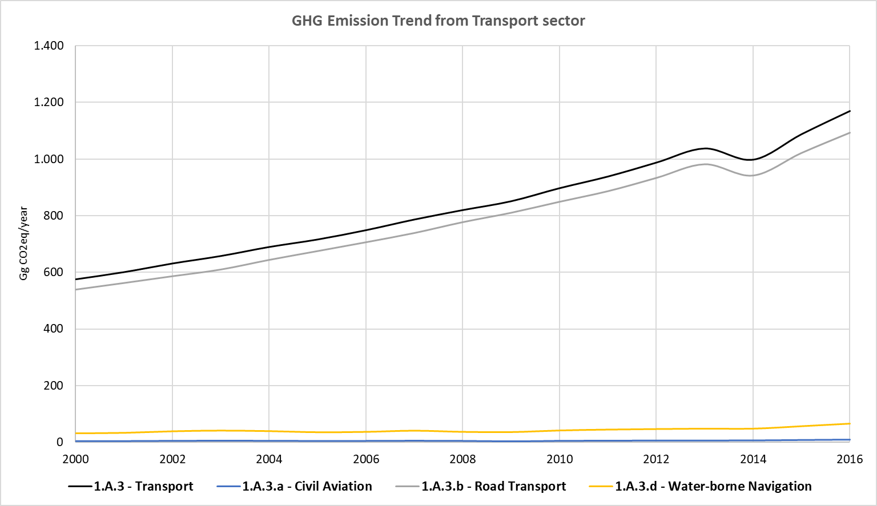

Table 46. GHG Emissions from Transport Sector, 2000 – 2016 (Gg CO2eq)

|  |  |  |  |  |  |  |
| --- | --- | --- | --- | --- | --- | --- |
| **Year** | **Total GHG Emissions for Energy Sector** | **Total GHG Emissions for Transport Sector** | **GHG Emissions for Civil Aviation** | **GHG Emissions for Road Transport** | **GHG Emissions for Water-borne Navigation** | **Emission Share for Transport (%)** |
| 2000 | 2,323.15 | 574.91 | 4.81 | 539.27 | 30.83 | 24.7% |
| 2001 | 2,492.10 | 600.43 | 5.10 | 562.67 | 32.66 | 24.1% |
| 2002 | 2,523.99 | 630.83 | 5.96 | 586.66 | 38.20 | 25.0% |
| 2003 | 2,678.11 | 657.31 | 6.35 | 610.31 | 40.65 | 24.5% |
| 2004 | 2,687.20 | 689.22 | 6.07 | 644.29 | 38.86 | 25.6% |
| 2005 | 2,874.17 | 715.66 | 5.43 | 675.42 | 34.81 | 24.9% |
| 2006 | 3,236.14 | 748.51 | 5.64 | 706.77 | 36.10 | 23.1% |
| 2007 | 3,403.21 | 786.15 | 6.31 | 739.45 | 40.39 | 23.1% |
| 2008 | 3,507.71 | 819.46 | 5.64 | 777.70 | 36.12 | 23.4% |
| 2009 | 3,457.07 | 850.74 | 4.29 | 811.05 | 35.39 | 24.6% |
| 2010 | 3,715.96 | 896.85 | 5.87 | 849.86 | 41.13 | 24.1% |
| 2011 | 3,727.56 | 937.99 | 6.39 | 887.27 | 44.33 | 25.2% |
| 2012 | 3,825.40 | 987.12 | 6.79 | 934.12 | 46.21 | 25.8% |
| 2013 | 3,935.07 | 1,037.11 | 6.97 | 982.40 | 47.74 | 26.4% |
| 2014 | 3,990.89 | 997.44 | 7.21 | 942.64 | 47.59 | 25.0% |
| 2015 | 4,043.99 | 1,087.43 | 8.56 | 1,022.44 | 56.42 | 26.9% |
| 2016 | 4,182.62 | 1,169.30 | 9.79 | 1,093.96 | 65.55 | 28.0% |

### Quality Control

To ensure the use of right data in the inventory, some of the QC implemented during the data collection and emission estimation are listed below:

* Cross verification between EF values provided by institutional authorities and the default values proposed by the IPCC 2006 Guidelines for Manufacturing Industries.
* Cross verification between country specific NCV provided by institutional authorities and the NCV range proposed by the IPCC 2006 Guidelines.
* Cross verification between the GHG emissions estimated in the current inventory for transport sector and the results obtained in the last reported national inventory of the RoM.
* Cross verification between the Energy Balance data from NLTA, data provided by the NLTA regarding road transport fuel consumption and the information contained in the transport toolkit.

### Uncertainty Assessment and Time-series Consistency

The uncertainty analysis results for the Transport sector categories obtained from the IPCC software are reported in the following table for 2000 as base year:

Table 47. Uncertainty Analysis of the Transport category (1.A.3) for the period 2000 – 2016

| **IPCC Category** | **Gas** | **Activity Data Uncertainty (%)** | **Emission Factor Uncertainty (%)** | **Combined Uncertainty (%)** |
| --- | --- | --- | --- | --- |
| 1.A.3.a.ii - Domestic Aviation - Liquid Fuels | CO2 | 5.00 | 4.17 | 6.51 |
| 1.A.3.a.ii - Domestic Aviation - Liquid Fuels | CH4 | 5.00 | 100.00 | 100.12 |
| 1.A.3.a.ii - Domestic Aviation - Liquid Fuels | N2O | 5.00 | 150.00 | 150.08 |
| 1.A.3.b.i.1 - Passenger cars with 3-way catalysts - Liquid Fuels | CO2 | 5.00 | 3.07 | 5.87 |
| 1.A.3.b.i.1 - Passenger cars with 3-way catalysts - Liquid Fuels | CH4 | 5.00 | 244.69 | 244.74 |
| 1.A.3.b.i.1 - Passenger cars with 3-way catalysts - Liquid Fuels | N2O | 5.00 | 209.94 | 210.00 |
| 1.A.3.b.ii.1 - Light-duty trucks with 3-way catalysts - Liquid Fuels | CO2 | 5.00 | 3.07 | 5.87 |
| 1.A.3.b.ii.1 - Light-duty trucks with 3-way catalysts - Liquid Fuels | CH4 | 5.00 | 244.69 | 244.74 |
| 1.A.3.b.ii.1 - Light-duty trucks with 3-way catalysts - Liquid Fuels | N2O | 5.00 | 209.94 | 210.00 |
| 1.A.3.b.ii.2 - Light-duty trucks without 3-way catalysts - Liquid Fuels | CO2 | 5.00 | 5.00 | 7.07 |
| 1.A.3.b.ii.2 - Light-duty trucks without 3-way catalysts - Liquid Fuels | CH4 | 5.00 | 25.00 | 25.50 |
| 1.A.3.b.ii.2 - Light-duty trucks without 3-way catalysts - Liquid Fuels | N2O | 5.00 | 60.00 | 60.21 |
| 1.A.3.b.iii - Heavy-duty trucks and buses - Liquid Fuels | CO2 | 5,00 | 5,00 | 7,07 |
| 1.A.3.b.iii - Heavy-duty trucks and buses - Liquid Fuels | CH4 | 5,00 | 5,00 | 7,07 |
| 1.A.3.b.iii - Heavy-duty trucks and buses - Liquid Fuels | N2O | 5,00 | 5,00 | 7,07 |
| 1.A.3.b.iv - Motorcycles - Liquid Fuels | CO2 | 5,00 | 3,07 | 5,87 |
| 1.A.3.b.iv - Motorcycles - Liquid Fuels | CH4 | 5,00 | 244,69 | 244,74 |
| 1.A.3.b.iv - Motorcycles - Liquid Fuels | N2O | 5,00 | 209,94 | 210,00 |
| 1.A.3.d.ii - Domestic Water-borne Navigation - Liquid Fuels | CO2 | 5.00 | 4.30 | 6.60 |
| 1.A.3.d.ii - Domestic Water-borne Navigation - Liquid Fuels | CH4 | 5.00 | 50.00 | 50.25 |
| 1.A.3.d.ii - Domestic Water-borne Navigation - Liquid Fuels | N2O | 5.00 | 140.00 | 140.09 |

It is concluded from the tables above, that the greatest source of uncertainty corresponds to the emission factors due to the use of default factors and therefore to the absence of country specific factors.

### Recalculations

For the road transport category, validated data on fuel consumption by each type of vehicle matriculated in the islands of Mauritius and Rodrigues for the years 2014, 2015 and 2016 was facilitated by the NLTA. For the rest of the time series (2000 – 2013) a recalculation has been made, maintaining a methodological consistency between the two time periods. For the 2000 – 2013 period, data on number of vehicles by type, technology and fuel used is available from the NLTA. The NLTA data completion has been made using the average parameter values reported in the Excel tool, named Transport Toolkit v17.1, has been used. This tool was developed by the Ministry of Environment, Solid Waste Management and Climate Change together with the UN Environment Programme (UNEP) and the Global Environment Facility (GEF). The tool was used for the GHG emission estimation in the TNC report, and for the calculation of different proposed scenarios in the road transport sector. The parameters used from this toolkit were the average fuel consumption by type of vehicle and the average distance travelled by vehicle type. Number of vehicles, NCV values and fuel density values were considered from NLTA data.

In order ensure a complete consistency between the time period with direct data provided by the NLTA and the time period projected and estimated, the data of total number of vehicles matriculated in each island (Mauritius and Rodrigues) available by NLTA, was disaggregated in the same vehicle type by technology and fuel used as reported in the data from NLTA for the period 2014 – 2016.

In order to project the desegregated values from 2000 to 2013 based on the real values of the period 2014-2016, these steps have been followed:

1. Projection of the total number of matriculated vehicles in each island from 2000 to 2016, using the best statistical adjustment which fit best considering data trend.
2. Calculating the average percentage by type of vehicle, technology and fuel consumption for years 2014, 2015 and 2016.
3. Multiplying each average percentage calculated in the above step by the total value of vehicles matriculated each year that was projected during the first step.
4. Multiplying number of vehicles matriculated by type of vehicle, technology and fuel used by the parameters collected in the tool for the period 2000 – 2013 (average distance travelled, and average consumed combustible by vehicle type) and the values provided by the NLTA such as NCV values for each fuel type and fuel densities, to obtain the total amount of combustible consumed by type of fuel.

The parameters considered for the estimates, disaggregated for each type of vehicle and fuel used (average fuel consumption for each vehicle and average distance travelled by each type of vehicle), have been obtained from the transport toolkit (this information is reported in detail in this section). Emission factors are obtained from the proposed default values of the IPCC Guidelines of 2006.

The activity data used for the estimation of GHG emissions of civil aviation has been re-estimated from the last inventory’s activity data. The activity data was obtained from Air Mauritius and was available from 2008 to 2016. The rest of data values to complete the time series from 2000 to 2016, was estimated using the inter annual variation data of tourist arrivals and departures available between 2000 and 2016, available by Statistics Mauritius, International Travel and Tourism. This inter annual variation was applied to their respective unknown jet fuel consumption year.

Activity data for water-borne navigation was recalculated too, considering the 2018 data reported by the Tourism Authority for Water-borne navigation. For the obtention of the rest of values of the time series (2000-2016) the tourism inter-annual variation has been used (same method used for civil aviation). Furthermore, another recalculation has been made regarding the EF established for CH4 and N2O emissions for gasoline and diesel consumed in water-borne navigation. The previous emission inventory sets the same EF values for fuels in road transport and in water-borne navigation, however, according to IPCC 2006 Guidelines, these values should be different. In that sense, the EF values for the water-borne navigation has been updated and default values proposed for this category in IPCC 2006 Guidelines has been used (Gasoline: 7 tons CH4/ton gasoline and 2 tons N2O/ton gasoline; Diesel: oil 7 tons CH4/ton diesel and 2 tons N2O/ton diesel).

All these recalculations made have had an impact in estimated emissions between the past inventory edition (2000-2013) and the current one (2000-2016). An increase of a 25% has been noticed between the last and current inventory for year 2013.

### Planned Improvements

In the transport sector, the country is working to obtain country specific EFs. This improvement could contribute to the achievement of a higher tier level. It will be necessary to recalculate the time series after the implementation of this new methodology to ensure the consistency of the time period.

On the other hand, it is planned to include data for number of vehicles matriculated in the Island of Rodrigues in the toolkit used to calculate and monitor the mitigation actions proposed in the transport sector.

It is planned to improve the accuracy of the activity data used for the transport sector in the country, especially for the road transport.

It is also planned to improve the data collection related to the domestic water-borne navigation sector and domestic aviation sector in the country, due to the lack of information concerning the energy consumption in this activity.

## Other Sectors (Category 1A4)

The Other Sector category involves 1A4a Commercial/Institutional sector, 1A4b Residential and 1A4c Agriculture/Forestry/Fishing, this one is divided into 1A4cii Off-road Vehicles, Other Machinery and 1A4ciii Fishing (mobile combustion).

### Source Category Description

Commercial or institutional activities use fossil fuel such as LPG and non-fossil fuels such as Charcoal for the development of their activities.

Residential sector use kerosene and LPG as fossil fuels and wood and charcoal as non-fossil fuels for cooking.

Agriculture/Forestry/Fishing category is divided into stationary and mobile combustion. Stationary combustion in this category is minimal and the mobile combustion uses diesel and gasoline as fossil fuels for field operations and fishing activities.

### Methodological Issues

The considered approach for the estimation of GHG Emissions for Other Sector, was a Tier 1 but using CS NCV. In this category, as mentioned in the previous section, fossil and non-fossil fuels are used in the combustion activities of this category. For that sense, and as reported in the 2006 IPCC Guidelines, CO2 emissions from non-fossil fuels do not have to be accounted with the rest of CO2 emissions from this category, in this case, they should be accounted as CO2 emissions from biomass and taken as a memo item. The non-CO2 emissions from non-fossil fuels has to be accounted in the national totals.

To obtain the results of the GHG emissions from each fuel type used in the energy combustion activities of energy other sectors of the country, each fuel’s activity data (AD). NCV and Emission Factor (EF) have been entered in the 2006 IPCC Inventory Software for the obtention of GHG emissions. The emission results for each fuel type have been aggregated to obtain the total amount of emissions.

#### Calculation

For the emission calculation, the equation 2.1 from Chapter 2. Volume 2 of the 2006 IPCC Guidelines was used.

*Emissions GHG.fuel = Fuel Consumption fuel x Emission Factor GHG.fuel*

Where:

|  |  |
| --- | --- |
| Emissions GHG.fuel = | emissions of a given GHG by type of fuel (kg GHG) |
| Fuel Consumption fuel = | amount of fuel consumed (TJ) |
| Emission Factor GHG.fuel = | default emission factor of a given GHG by type of fuel (kg gas/TJ). For CO2 it includes the carbon oxidation factor, assumed to be 1. |

To calculate the total emission by gas from the source category, the emissions as calculated in Equation 2.1 are summed over all fuels.

#### Activity Data

The activity data used for the estimation of GHG emissions for Energy Other Sectors have been obtained from the amount of fuels consumed for the Commercial/Institutional sector, Residential sector and Agriculture/Forestry/Fishing sector, obtained from the Ministry of Environment.

The amount of fuel consumed in those sectors, except in agriculture, are reported from 2000 to 2016 so no projections of the AD have been necessary for the estimation of the emissions for the inventory. For agriculture sector, the activity data was available from 2000 to 2006 and the projection was made considering the average inter-annual variation of the available activity data.

The following table compiles the AD values used in the estimation of GHG emissions for the Energy Other Sectors from 2000 to 2016.

Table 48. Fuel consumed by Energy Other Sectors, 2000 – 2016 (Gg Fuel)

|  |  |  |  |  |  |  |
| --- | --- | --- | --- | --- | --- | --- |
| **Years** | **Commercial / Institutional** | | **Residential** | | | |
| **LPG** | **Charcoal** | **Kerosene** | **LPG** | **Wood** | **Charcoal** |
| 2000 | 4.15 | 0.30 | 9.60 | 37.71 | 16.00 | 0.15 |
| 2001 | 4.45 | 0.33 | 9.48 | 37.85 | 15.90 | 0.15 |
| 2002 | 4.56 | 0.34 | 8.41 | 39.02 | 15.85 | 0.13 |
| 2003 | 5.75 | 0.35 | 8.27 | 40.56 | 15.78 | 0.13 |
| 2004 | 6.37 | 0.36 | 8.73 | 42.86 | 15.94 | 0.12 |
| 2005 | 6.99 | 0.38 | 9.77 | 43.21 | 16.54 | 0.13 |
| 2006 | 11.44 | 0.39 | 3.92 | 41.60 | 17.47 | 0.12 |
| 2007 | 10.93 | 0.41 | 1.24 | 42.09 | 17.50 | 0.13 |
| 2008 | 10.09 | 0.42 | 1.77 | 42.39 | 16.73 | 0.12 |
| 2009 | 10.58 | 0.44 | 1.48 | 43.24 | 16.62 | 0.12 |
| 2010 | 10.93 | 0.45 | 1.73 | 44.06 | 16.60 | 0.12 |
| 2011 | 11.26 | 0.47 | 0.52 | 44.64 | 16.34 | 0.12 |
| 2012 | 11.92 | 0.47 | 0.24 | 45.33 | 16.00 | 0.11 |
| 2013 | 13.29 | 0.48 | 0.20 | 46.36 | 15.47 | 0.11 |
| 2014 | 14.03 | 0.50 | 0.15 | 47.57 | 14.53 | 0.10 |
| 2015 | 15.10 | 0.45 | 0.13 | 49.09 | 13.63 | 0.10 |
| 2016 | 16.08 | 0.42 | 0.07 | 49.46 | 13.56 | 0.10 |

|  |  |  |  |
| --- | --- | --- | --- |
| **Years** | **Agriculture** | **Fishing** | |
| **Diesel** | **Gasoline** | **Diesel** |
| 2000 | 2.46 | 8.93 | 1.63 |
| 2001 | 2.79 | 9.04 | 1.62 |
| 2002 | 2.75 | 9.10 | 1.49 |
| 2003 | 2.93 | 11.64 | 1.78 |
| 2004 | 3.15 | 8.91 | 1.87 |
| 2005 | 3.00 | 9.36 | 1.67 |
| 2006 | 3.05 | 10.01 | 1.52 |
| 2007 | 3.10 | 9.85 | 1.71 |
| 2008 | 3.16 | 12.54 | 2.17 |
| 2009 | 3.22 | 14.33 | 2.48 |
| 2010 | 3.27 | 14.56 | 2.52 |
| 2011 | 3.33 | 15.45 | 2.68 |
| 2012 | 3.39 | 13.21 | 2.29 |
| 2013 | 3.46 | 11.20 | 1.94 |
| 2014 | 2.28 | 11.65 | 2.02 |
| 2015 | 2.31 | 12.32 | 2.13 |
| 2016 | 2.27 | 11.65 | 2.02 |

***Source****: Ministry of Environment, Government of Mauritius.*

The AD was provided in terms of Gg and then, using the NCV for each fuel type, this was converted to TJ. The NCV used in the national inventory are collected in the following table:

Table 49. Country Specific Net Calorific Values for fuels consumed in Energy Other Sectors (TJ/Gg)

| **Fuel type** | **Country Specific NCV** |
| --- | --- |
| Diesel | 43.3 |
| Gasoline | 44.8 |
| LPG | 47.3 |
| Charcoal | 29.5 |
| Wood | 15.6 |
| Kerosene | 43.54 |

***Source****: Statistics Mauritius, Energy and Water.*

#### Emission Factors

The Emission Factors used for the estimation of the GHG emissions of the energy other sectors are adopted from the default values proposed in the 2006 IPCC Guidelines, as shown in the table below:

Table 50. Emissions factors for the fuel used for the Commercial/Institutional sector from Energy Other Sectors (kg GHG/TJ)

|  |  |  |  |
| --- | --- | --- | --- |
| **Fuel type** | **EF CO2 (kg CO2/TJ)** | **EF CH4 (kg CH4/TJ)** | **EF N2O (kg N2O/TJ)** |
| LPG | 63,100 | 5 | 0.1 |
| Charcoal | 112,000 | 200 | 1 |

***Source****: Table 2.4, Chapter 2, Volume 2 of the 2006 IPCC Guidelines.*

Table 51. Emissions factors for the fuel used for the Residential (kg GHG/TJ)

|  |  |  |  |
| --- | --- | --- | --- |
| **Fuel type** | **EF CO2 (kg CO2/TJ)** | **EF CH4 (kg CH4/TJ)** | **EF N2O (kg N2O/TJ)** |
| Kerosene | 71,900 | 10 | 0.6 |
| LPG | 63,100 | 5 | 0.1 |
| Charcoal | 112,000 | 200 | 1 |
| Wood | 112,000 | 300 | 4 |

***Source****: Table 2.5, Chapter 2, Volume 2 of the 2006 IPCC Guidelines.*

Table 52. Emissions factors for the fuel used for the Agriculture/Forestry/Fishing sector from Energy Other Sectors (kg GHG/TJ)

|  |  |  |  |
| --- | --- | --- | --- |
| **Fuel type** | **EF CO2 (kg CO2/TJ)** | **EF CH4 (kg CH4/TJ)** | **EF N2O (kg N2O/TJ)** |
| Diesel | 74,100 | 10 | 0.6 |
| Gasoline | 69,300 | 10 | 0.6 |
| LPG | 63,100 | 5 | 0.1 |

***Source****: Table 2.5, Chapter 2, Volume 2 of the 2006 IPCC Guidelines.*

### Results

Aggregated emissions from Other Sectors increased from 198.41 Gg CO2eq in 2000 to 248.10 Gg CO2eq in 2016. The emissions then, increased in 25.04% from 2000 to 2016.

Figure 37. Evolution of the GHG Emissions from Other Sectors, 2000 – 2016 (Gg CO2eq)

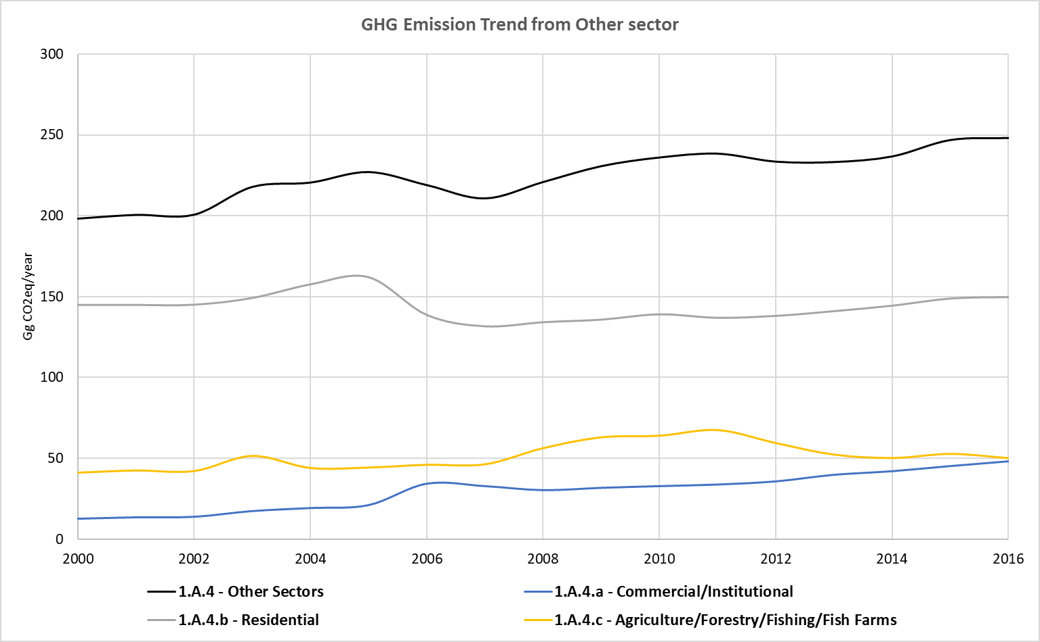

Table 53. GHG Emissions from Energy Other sectors, 2000 – 2016 (Gg CO2eq)

|  |  |  |  |  |  |  |
| --- | --- | --- | --- | --- | --- | --- |
| **Year** | **Total GHG Emissions for Energy Sector** | **Total GHG Emissions for Other Sectors** | **GHG Emissions for Commercial** | **GHG Emissions for Residential** | **GHG Emissions for Agriculture / Fishing** | **Emission Share for Other sectors (%)** |
| 2000 | 2,323.15 | 198.41 | 12.45 | 144.91 | 41.05 | 8.5% |
| 2001 | 2,492.10 | 200.74 | 13.35 | 144.94 | 42.45 | 8.1% |
| 2002 | 2,523.99 | 200.83 | 13.68 | 145.07 | 42.08 | 8.0% |
| 2003 | 2,678.11 | 217.96 | 17.24 | 149.20 | 51.52 | 8.1% |
| 2004 | 2,687.20 | 220.65 | 19.11 | 157.54 | 44.00 | 8.2% |
| 2005 | 2,874.17 | 227.16 | 20.94 | 161.93 | 44.28 | 7.9% |
| 2006 | 3,236.14 | 219.09 | 34.26 | 138.85 | 45.99 | 6.8% |
| 2007 | 3,403.21 | 210.88 | 32.74 | 131.86 | 46.29 | 6.2% |
| 2008 | 3,507.71 | 220.97 | 30.25 | 134.36 | 56.36 | 6.3% |
| 2009 | 3,457.07 | 230.77 | 31.69 | 135.94 | 63.14 | 6.7% |
| 2010 | 3,715.96 | 236.09 | 32.74 | 139.20 | 64.15 | 6.4% |
| 2011 | 3,727.56 | 238.46 | 33.74 | 137.08 | 67.64 | 6.4% |
| 2012 | 3,825.40 | 233.54 | 35.71 | 138.24 | 59.59 | 6.1% |
| 2013 | 3,935.07 | 233.30 | 39.80 | 141.14 | 52.37 | 5.9% |
| 2014 | 3,990.89 | 236.75 | 42.02 | 144.49 | 50.23 | 5.9% |
| 2015 | 4,043.99 | 246.87 | 45.22 | 148.87 | 52.78 | 6.1% |
| 2016 | 4,182.62 | 248.10 | 48.16 | 149.75 | 50.18 | 5.9% |

### Quality Control

In order to ensure the use of right data in the inventory. some of the QC implemented during the data collection and emission estimation is listed below:

* Cross verification between data provided via mail by institutional authorities and data reported in the national Statistics Mauritius.
* Cross verification between EF values provided by institutional authorities and the default values proposed by the IPCC 2006 Guidelines for energy other sectors.
* Cross verification between country specific NCV provided by institutional authorities and the NCV range proposed by the IPCC 2006 Guidelines.
* Cross verification between the GHG emissions estimated in the current inventory for energy other sectors and the results obtained in the last reported national inventory of the RoM.

### Uncertainty Assessment and Time-series Consistency

The uncertainty analysis results for the Other sector categories obtained from the IPCC software are reported in the following table for 2000 as base year:

Table 54. Uncertainty Analysis of Other sectors category (1.A.4) for the period 2000 – 2016

| **IPCC Category** | **Gas** | **Activity Data Uncertainty (%)** | **Emission Factor Uncertainty (%)** | **Combined Uncertainty (%)** |
| --- | --- | --- | --- | --- |
| 1.A.4.a - Commercial/Institutional - Liquid Fuels | CO2 | 5.00 | 6.14 | 7.92 |
| 1.A.4.a - Commercial/Institutional - Liquid Fuels | CH4 | 5.00 | 200.00 | 200.06 |
| 1.A.4.a - Commercial/Institutional - Liquid Fuels | N2O | 5.00 | 228.79 | 228.84 |
| 1.A.4.a - Commercial/Institutional - Biomass | CO2 | 5.00 | 18.69 | 19.35 |
| 1.A.4.a - Commercial/Institutional - Biomass | CH4 | 5.00 | 227.27 | 227.33 |
| 1.A.4.a - Commercial/Institutional - Biomass | N2O | 5.00 | 297.73 | 297.77 |
| 1.A.4.b - Residential - Liquid Fuels | CO2 | 5.00 | 6.14 | 7.92 |
| 1.A.4.b - Residential - Liquid Fuels | CH4 | 5.00 | 200.00 | 200.06 |
| 1.A.4.b - Residential - Liquid Fuels | N2O | 5.00 | 236.36 | 236.42 |
| 1.A.4.b - Residential - Biomass | CO2 | 5.00 | 18.69 | 19.35 |
| 1.A.4.b - Residential - Biomass | CH4 | 5.00 | 227.27 | 227.33 |
| 1.A.4.b - Residential - Biomass | N2O | 5.00 | 297.73 | 297.77 |
| 1.A.4.c.ii - Off-road Vehicles and Other Machinery - Liquid Fuels | CO2 | 5.00 | 6.14 | 7.92 |
| 1.A.4.c.ii - Off-road Vehicles and Other Machinery - Liquid Fuels | CH4 | 5.00 | 200.00 | 200.06 |
| 1.A.4.c.ii - Off-road Vehicles and Other Machinery - Liquid Fuels | N2O | 5.00 | 236.36 | 236.42 |
| 1.A.4.c.iii - Fishing (mobile combustion) - Liquid Fuels | CO2 | 5.00 | 6.14 | 7.92 |
| 1.A.4.c.iii - Fishing (mobile combustion) - Liquid Fuels | CH4 | 5.00 | 200.00 | 200.06 |
| 1.A.4.c.iii - Fishing (mobile combustion) - Liquid Fuels | N2O | 5.00 | 236.36 | 236.42 |

It is concluded from the tables above, that the greatest source of uncertainty corresponds to the emission factors due to the use of default factors and therefore to the absence of country specific factors.

### Recalculations

Unlike the previous inventory, the activity data used in this sector has been disaggregated into different activities (commercial/institutional, residential and agriculture/forestry/fishing). Besides, the activity data used for considering agriculture/forestry/fishing has been recalculated using values from the Ministry of Environment and Statistics Mauritius. In the last developed inventory, the activities considered in this sector were commercial/institutional and residential activities, in this current inventory besides these activities others such as agriculture and fishing have been considered. For this reason, the GHG emissions have increased compared to the previous inventory edition.

The recalculation made in the Energy Other Sector category corresponds to the modification of the CH4 EF used for the kerosene in the residential sector, which was considered as 3 kg CH4/TJ. Knowing that the EF used for the estimation of the GHG emissions were adopted from the default EF values proposed in the IPCC 2006 Guidelines, it was decided to change that value for the correct one of 10 kgCH4/TJ.

Before these recalculations, no big differences have been observed with the last developed inventory in terms of GHG emissions estimations. In this sense, an increase of a 2% of the emissions estimated in the year 2013 has been noticed.

### Planned Improvements

A potential improvement regarding this category could be encouraging the suppliers to keep track of fuel sales for monitoring the GHG emissions.

The fossil fuels consumed in this category could be improved by having different NCV values every year.

## Non-Specified Sector (Category 1A5)

The Other Sector category considers the non-specified fuel consumptions within the Energy sector in the country. These fuel consumptions are considered to be consumed in stationary combustion (1A5a).

### Source Category Description

The Ministry of Environment reports a use of LPG fuel as Other quantities consumed since 2013. Nevertheless, not enough information is collected in the Energy reports published yearly by the Ministry of Environment. For that reason, the amount of fuel consumed in this category has been considered as non-specified sector.

The following figure is obtained from the Energy and Water report of the Statistics Mauritius for the year 2016. As it is shown in the figure, a small quantity of fuel is consumed in Other sector, which is not specified.

Figure 38. Final Energy consumption by sector in 2016.

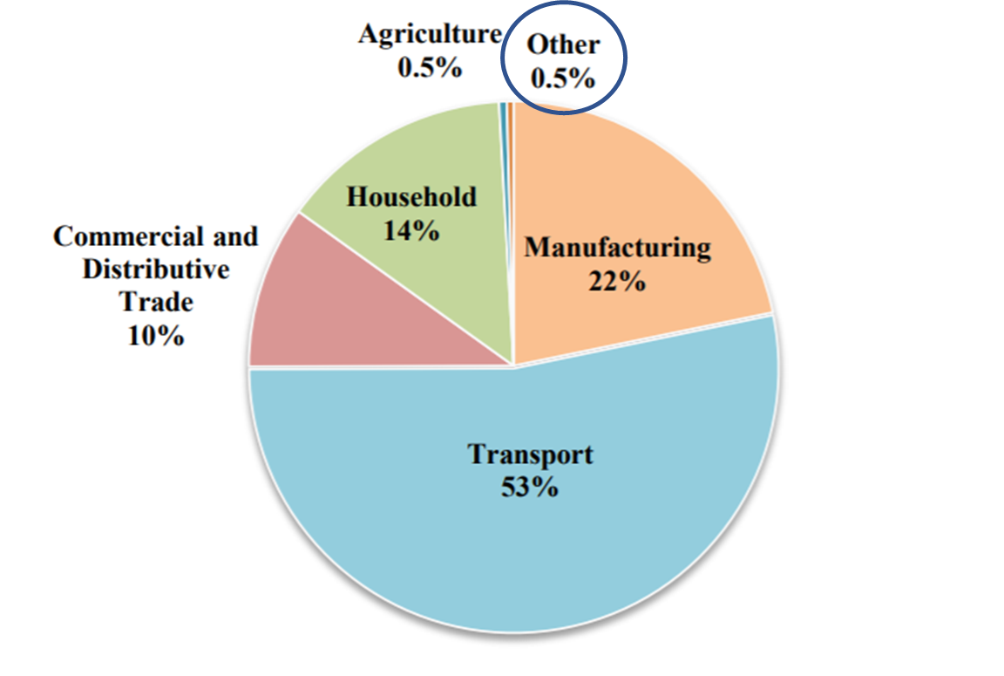

***Source****: Statistics Mauritius, Digest of Energy and Water Statistics.*

### Methodological Issues

The considered approach for the estimation of GHG Emissions for Non-Specified Sector, was a Tier 1 but using CS NCV.

#### Calculation

For the emission calculation, the equation 2.1 from Chapter 2. Volume 2 of the 2006 IPCC Guidelines was used.

*Emissions GHG.fuel = Fuel Consumption fuel x Emission Factor GHG.fuel*

Where:

|  |  |
| --- | --- |
| Emissions GHG.fuel = | emissions of a given GHG by type of fuel (kg GHG) |
| Fuel Consumption fuel = | amount of fuel consumed (TJ) |
| Emission Factor GHG.fuel = | default emission factor of a given GHG by type of fuel (kg gas/TJ). For CO2 it includes the carbon oxidation factor, assumed to be 1. |

To calculate the total emission by gas from the source category, the emissions as calculated in Equation 2.1 are summed over all fuels.

#### Activity Data

The activity data used for the estimation of GHG emissions for Non-Specified Sector have been obtained from the amount of fuels consumed for Other categories, obtained from the Ministry of Environment.

The amount of fuel consumed in this sector is reported since 2013, reporting that before 2013 no fuel consumed in this category was identified.

The following table compiles the AD values used in the estimation of GHG emissions for the Non-Specified Sector from 2000 to 2016.

Table 55. Fuel consumed by Non-Specified Sectors, 2000 – 2016 (Gg Fuel)

|  |  |
| --- | --- |
| **Years** | **LPG** |
| 2000 | NO |
| 2001 | NO |
| 2002 | NO |
| 2003 | NO |
| 2004 | NO |
| 2005 | NO |
| 2006 | NO |
| 2007 | NO |
| 2008 | NO |
| 2009 | NO |
| 2010 | NO |
| 2011 | NO |
| 2012 | NO |
| 2013 | 0.26 |
| 2014 | 0.27 |
| 2015 | 0.29 |
| 2016 | 0.29 |

***Source****: Ministry of Environment, Government of Mauritius.*

The AD was provided in terms of Gg and then, using the NCV for LPG, this was converted to TJ. The NCV used in the national inventory are collected in the following table:

Table 56. Country Specific Net Calorific Values for fuels consumed in Non-Specified Sector (TJ/Gg)

| **Fuel type** | **Country Specific NCV** |
| --- | --- |
| LPG | 47.3 |

***Source****: Statistics Mauritius, Energy and Water.*

#### Emission Factors

The Emission Factors used for the estimation of the GHG emissions of the non-specified sector are adopted from the default values proposed in the 2006 IPCC Guidelines, as shown in the table below:

Table 57. Emissions factors for the fuel used for Non-Specified Sectors (kg GHG/TJ)

|  |  |  |  |
| --- | --- | --- | --- |
| **Fuel type** | **EF CO2 (kg CO2/TJ)** | **EF CH4 (kg CH4/TJ)** | **EF N2O (kg N2O/TJ)** |
| LPG | 63,100 | 5 | 0.1 |

***Source****: Table 2.4, Chapter 2, Volume 2 of the 2006 IPCC Guidelines.*

### Results

Aggregated emissions from Non-Specified Sectors start occurring in 2013. Emissions increased from 0.77 Gg CO2eq in 2013 to 0.87 Gg CO2eq in 2016. The emissions then, increased in 13% from 2013 to 2016.

Figure 39. Evolution of the GHG Emissions from Non-Specified Sectors, 2000 – 2016 (Gg CO2eq)



Table 58. GHG Emissions from Non-Specified Sector, 2000 – 2016 (Gg CO2eq)

|  |  |  |  |
| --- | --- | --- | --- |
| **Year** | **Total GHG Emissions for Energy Sector** | **GHG Emissions for Non-Specified sector** | **Emission Share for Other sectors (%)** |
| 2000 | 2,323.15 | NO | NO |
| 2001 | 2,492.10 | NO | NO |
| 2002 | 2,523.99 | NO | NO |
| 2003 | 2,678.11 | NO | NO |
| 2004 | 2,687.20 | NO | NO |
| 2005 | 2,874.17 | NO | NO |
| 2006 | 3,236.14 | NO | NO |
| 2007 | 3,403.21 | NO | NO |
| 2008 | 3,507.71 | NO | NO |
| 2009 | 3,457.07 | NO | NO |
| 2010 | 3,715.96 | NO | NO |
| 2011 | 3,727.56 | NO | NO |
| 2012 | 3,825.40 | NO | NO |
| 2013 | 3,935.07 | 0.77 | 0.02% |
| 2014 | 3,990.89 | 0.81 | 0.02% |
| 2015 | 4,043.99 | 0.85 | 0.02% |
| 2016 | 4,182.62 | 0.87 | 0.02% |

### Quality Control

In order to ensure the use of right data in the inventory. some of the QC implemented during the data collection and emission estimation is listed below:

* Cross verification between data provided via mail by institutional authorities and data reported in the national Statistics Mauritius.
* Cross verification between EF values provided by institutional authorities and the default values proposed by the IPCC 2006 Guidelines for energy other sectors.
* Cross verification between country specific NCV provided by institutional authorities and the NCV range proposed by the IPCC 2006 Guidelines.

### Uncertainty Assessment and Time-series Consistency

The uncertainty analysis results for the Other sector categories obtained from the IPCC software are reported in the following table for 2000 as base year:

Table 59. Uncertainty Analysis of Non-Specified sector category (1.A.5) for the period 2000 – 2016

| **IPCC Category** | **Gas** | **Activity Data Uncertainty (%)** | **Emission Factor Uncertainty (%)** | **Combined Uncertainty (%)** |
| --- | --- | --- | --- | --- |
| 1.A.5.a - Stationary - Liquid Fuels | CO2 | 5.00 | 5.00 | 7.07 |
| 1.A.5.a - Stationary - Liquid Fuels | CH4 | 5.00 | 5.00 | 7.07 |
| 1.A.5.a - Stationary - Liquid Fuels | N2O | 5.00 | 5.00 | 7.07 |

It is concluded from the tables above, that not great uncertainty is obtained from the category, probably due to the non-significant amount of fuel consumed.

### Recalculations

Unlike the previous inventory, the activity data used in this sector has been considered for the first time. This activity data has been reported in the Energy and Water Statistics since 2013 but it has not been included in the GHG National Inventory since now.

The amount of fuel consumed in this category is insignificant compared to the quantities consumed in the rest of categories of the energy sector. Nevertheless, it is necessary to consider this fuel quantities properly in the GHG inventory in order to ensure the completeness of the Inventory.

### Planned Improvements

A potential improvement regarding this category could be the information gathering, in order to determine the type of activities where this fuel has been consumed.

The fossil fuel consumed in this category could be improved by having different NCV values every year.

## Memo Items

The Memo Items category comprises two main categories:

* Category 1.A.3.a.i. International Aviation
* Category 1.A.3.d.i. International Water-borne Navigation

All emissions from fuels used for international aviation (bunkers) and multilateral operations pursuant to the Charter of UN are to be excluded from national totals and reported separately as memo items.

### Source Category Description

The information for international travels by air and water-borne navigation has been gathered from the International Energy Agency due to a lack of specific information in the national statistics.

Energy consumption in international aviation consist on jet kerosene consumption, while in international water-borne navigation comprises diesel and fuel oil consumption.

### Methodological Issues

The considered approach for the estimation of GHG Emissions for International aviation and water-borne navigation, was a Tier 1.

#### Calculation

For the emission calculation, the equation 2.1 from Chapter 2. Volume 2 of the 2006 IPCC Guidelines has been used.

*Emissions GHG.fuel = Fuel Consumption fuel x Emission Factor GHG.fuel*

Where:

|  |  |
| --- | --- |
| Emissions GHG.fuel = | emissions of a given GHG by type of fuel (kg GHG) |
| Fuel Consumption fuel = | amount of fuel consumed (TJ) |
| Emission Factor GHG.fuel = | default emission factor of a given GHG by type of fuel (kg gas/TJ). For CO2 it includes the carbon oxidation factor, assumed to be 1. |

To calculate the total emissions by gas, the emissions calculated with Equation 2.1 are summed over all fuels.

#### Activity Data

The activity data used for the estimation of GHG emissions for Memo Items have been obtained from the International Energy Agency (IEA)[3].

The amount of fuel consumed in this sector is reported for the whole period, from 2000 to 2016.

The following table compiles the AD values used in the estimation of GHG emissions for the Memo Items from 2000 to 2016.

Table 60. Fuel consumed by Memo Items (International Aviation and Water-borne Navigation, 2000 – 2016 (Gg Fuel)

| **Years** | **International Aviation** | **International Water-borne Navigation** | |
| --- | --- | --- | --- |
| **Jet Kerosene** | **Diesel** | **Fuel Oil** |
| 2000 | 192 | 160 | 58 |
| 2001 | 196 | 157 | 44 |
| 2002 | 198 | 139 | 27 |
| 2003 | 209 | 98 | 35 |
| 2004 | 221 | 105 | 40 |
| 2005 | 229 | 135 | 55 |
| 2006 | 236 | 122 | 49 |
| 2007 | 250 | 118 | 76 |
| 2008 | 252 | 117 | 96 |
| 2009 | 208 | 109 | 108 |
| 2010 | 229 | 113 | 123 |
| 2011 | 242 | 100 | 185 |
| 2012 | 249 | 103 | 163 |
| 2013 | 230 | 114 | 156 |
| 2014 | 242 | 117 | 171 |
| 2015 | 259 | 116 | 167 |
| 2016 | 291 | 120 | 217 |

***Source****: International Energy Agency (IEA).*

The AD was provided in terms of Gg and then, using the NCV default values for jet kerosene, diesel and fuel oil, this was converted to TJ.

The NCV used in the national inventory are collected in the following table:

Table 61. Country Specific Net Calorific Values for fuels consumed in aviation and water-borne navigation (TJ/Gg)

|  |  |  |
| --- | --- | --- |
| **Transport** | **Fuel type** | **Country Specific NCV** |
| International Aviation | Kerosene (Jet Fuel) | 40.1 |
| International Water-borne navigation | Fuel oil | 40.4 |
| Diesel | 43 |

***Source****: Statistics Mauritius, Energy and Water.*

#### Emission Factors

Emission factors for the international aviation and international water-borne navigation are obtained from the default values of the 2006IPCC Guidelines, as shown in the table below:

Table 62. Emissions factors for the fuel used for civil aviation (kg GHG/TJ)

|  |  |  |  |
| --- | --- | --- | --- |
| **Fuel type** | **EF CO2 (kg CO2/TJ)** | **EF CH4 (kg CH4/TJ)** | **EF N2O (kg N2O/TJ)** |
| Kerosene (Jet fuel) | 71,500 | 0.5 | 2 |

***Source****: Table 3.6.4 and 3.6.5, Chapter 3, Volume 2 of the 2006 IPCC Guidelines.*

Table 63. Emissions factors for the fuel used for water-borne navigation (kg GHG/TJ)

|  |  |  |  |
| --- | --- | --- | --- |
| **Fuel type** | **EF CO2 (kg CO2/TJ)** | **EF CH4 (kg CH4/TJ)** | **EF N2O (kg N2O/TJ)** |
| Fuel oil | 77,400 | 7 | 2 |
| Diesel | 74,100 | 7 | 2 |

***Source****: Table 3.5.2 and 3.5.3, Chapter 3, Volume 2 of the 2006 IPCC Guidelines.*

### Results

Emissions from Memo items increased from 1,308.99 Gg CO2eq in 2000 to 1,997.25 Gg CO2eq in 2016. The emissions then, increased in 52.6% from 2000 to 2016.

Figure 40. Evolution of the GHG Emissions from Non-Specified Sectors, 2000 – 2016 (Gg CO2eq)

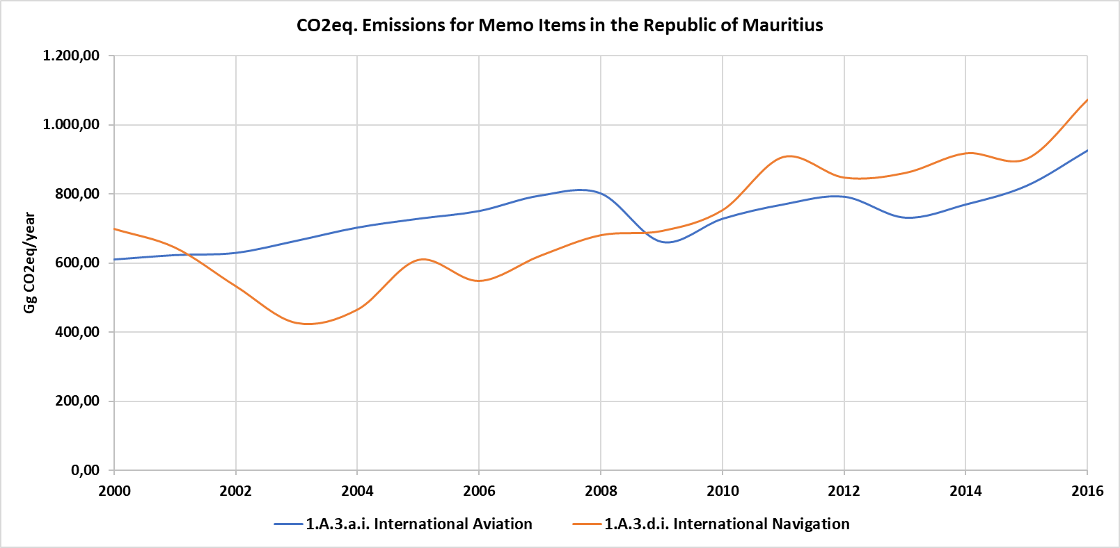

Table 64. GHG Emissions from Memo Items, 2000 – 2016 (Gg CO2eq)

|  |  |  |  |
| --- | --- | --- | --- |
| **Year** | **Total GHG Emissions for International Aviation** | **GHG Emissions for International Navigation** | **Total GHG Emissions for Memo Items** |
| 2000 | 610.74 | 698.25 | 1,308.99 |
| 2001 | 623.47 | 644.38 | 1,267.84 |
| 2002 | 629.83 | 532.74 | 1,162.57 |
| 2003 | 664.82 | 426.02 | 1,090.84 |
| 2004 | 702.99 | 464.34 | 1,167.33 |
| 2005 | 728.44 | 608.29 | 1,336.73 |
| 2006 | 750.71 | 547.49 | 1,298.20 |
| 2007 | 795.24 | 619.88 | 1,415.12 |
| 2008 | 801.60 | 679.82 | 1,481.42 |
| 2009 | 661.64 | 691.96 | 1,353.60 |
| 2010 | 728.44 | 752.21 | 1,480.64 |
| 2011 | 769.79 | 906.15 | 1,675.94 |
| 2012 | 792.06 | 846.33 | 1,638.39 |
| 2013 | 731.62 | 859.64 | 1,591.26 |
| 2014 | 769.79 | 916.66 | 1,686.46 |
| 2015 | 823.87 | 900.81 | 1,724.68 |
| 2016 | 925.66 | 1071.59 | 1,997.25 |

### Quality Control

The information has been obtained from the IEA and is not available as part of the national statistics (national energy balance), for that reason, no Quality Controls have been possible to be carried out.

### Uncertainty Assessment and Time-series Consistency

The uncertainty analysis results for the Memo Item categories obtained from the IPCC software are reported in the following table for 2000 as base year:

Table 65. Uncertainty Analysis of Memo Item category (1.A.3.a.i and 1.A.3.d.i) for the period 2000 – 2016

| **IPCC Category** | **Gas** | **Activity Data Uncertainty (%)** | **Emission Factor Uncertainty (%)** | **Combined Uncertainty (%)** |
| --- | --- | --- | --- | --- |
| 1.A.3.a.i - International Aviation (International Bunkers) – Liquid Fuels | CO2 | 5.00 | 4.17 | 6.51 |
| 1.A.3.a.i - International Aviation (International Bunkers) – Liquid Fuels | CH4 | 5.00 | 100 | 100.12 |
| 1.A.3.a.i - International Aviation (International Bunkers) – Liquid Fuels | N2O | 5.00 | 150 | 150.08 |
| 1.A.3.d.i – International water-borne navigation (International bunkers) – Liquid Fuels | CO2 | 5.00 | 4.30 | 6.60 |
| 1.A.3.d.i – International water-borne navigation (International bunkers) – Liquid Fuels | CH4 | 5.00 | 50 | 50.25 |
| 1.A.3.d.i – International water-borne navigation (International bunkers) – Liquid Fuels | N2O | 5.00 | 140 | 140.09 |

It is concluded from the table above, that the greatest source of uncertainty corresponds to the emission factors due to the use of default factors.

### Recalculations

Only GHG emissions from international aviation sector were considered in the last national inventory developed for the Third National Communication.

For the current national inventory, emissions from memo items have been estimated considering data reported in the International Energy Agency.

### Planned Improvements

As it has previously mentioned, data for these activities are not available in national statistics nor through the national energy balance. The improvement for next inventory cycle would be the analysis and study about how to achieve the data from national statistics and include them as part of the national energy balance. This information should be aligned with the information reported by the IEA.

## Reference Approach

### Description

The reference approach is a top-down approach carried out using country’s energy balance data to calculate the GHG emissions related to the consumption of fossil fuels. This analysis allows the production of a second independent estimate of CO2 emissions from fuel combustion with limited additional effort and data requirements.

As detailed in the 2006 IPCC Guidelines, it is a good practice to apply both the sectoral and reference approach to estimate a country’s CO2 emissions from fuel combustion and to compare the results of these two independent estimates. Significant differences may indicate possible problems with the energy balance, activity data, net calorific values, carbon content, excluded carbon calculation, etc.

The 2006 IPCC Guidelines consider that for countries with a well-developed statistical system the comparison between sectoral and reference approach could be in range of ±5% for a given fuel. For countries with a less well-developed energy data system, this could be considerably larger, probably about ±10%.

### Methodological Issues

For the calculation of reference approach emissions, the equation 6.1 from Chapter 6. Volume 2 of the 2006 IPCC Guidelines was used.

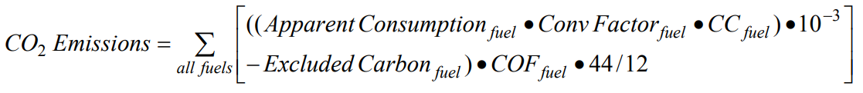

Where:

The apparent consumption is calculated following the equation 6.2 from Chapter 6, Volume 2 of the 2006 IPCC Guidelines.

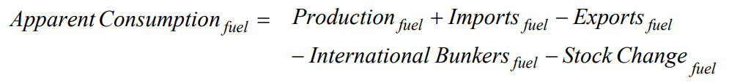

The conversion factors used in the reference approach are the same factors used in the sectoral approach. For carbon content and fraction of carbon oxidized, default factors proposed by 2006 IPCC Guidelines have been used.

No production of fuels is recorded in the country, and the imports of fuels reported in the energy balance of the country only includes the imports related to the local consumption. Some re-exports and stock change of fuel are reported in the country every year regarding the information available in the energy balance.

### Results

The IPCC software has been used to estimate and develop the reference approach. Regarding the results obtained, some possible improvements could be considered.

A summary of the results obtained from the reference approach is reported in the following table.

|  |  |  |  |  |
| --- | --- | --- | --- | --- |
|  | 2000 | 2006 | 2010 | 2016 |
| Total difference for Energy Consumption | 23.0% | -7.7% | 10.7% | 9.0% |
| Total difference for CO2 emissions | 21.2% | -6.6% | 9.4% | 8.0% |

The percentage of comparison between sectoral and reference approach for the period between 2007 and 2016 is within the range proposed in the IPCC Guidelines. On the other hand, the previous years present comparison percentages of ±10-25%. Several considerations have been identified that could explain the comparison percentages obtained in the reference approach analysis:

* The data obtained, for the manufacturing and construction industry from the country considered several fuel consumptions that were not identified in the energy balance of the country. It It is recommended to check the energy balance with the responsible authority in the information gathering and the responsible authority for the manufacturing and construction industry, in order to report the more accurate data.
* Same happened with several fuel consumptions in the Energy Other Sectors category, due to the obtention of more updated data from Agriculture, Forestry and Fishing.
* It will be therefore necessary to review and update the information contained in the energy balance.

# Industrial Processes and Product Use (IPPU)

## Overview

Greenhouse gas emissions are produced from a wide variety of industrial activities. The main emission sources are releases from industrial processes that chemically or physically transform materials. During these processes, many different greenhouse gases, including carbon dioxide (CO2), methane (CH4), nitrous oxide (N2O), hydrofluorocarbons (HFCs), perfluorocarbons (PFCs), and other fluorinated compounds such as trifluoromethyl sulphur pentafluoride (SF5CF3) can be produced and emitted.

In addition, greenhouse gases often are used in products such as refrigerators, foams or aerosol cans. For example, HFCs are used as alternatives to ozone depleting substances (ODS) in various types of product applications. Similarly, sulphur hexafluoride (SF6) and N2O are used in a number of products used in industry or by end-consumers.

The main emission sources for the IPPU sector in RoM are the Product Uses as Substitutes for Ozone Depleting Substances (90.7%), followed by the Metal Industry, constituted by iron and steel production industries, construction iron and steel bars (6.9%), Non-Energy products from fuels and solvent use which represent a 2.5% of the emissions of the sector and lime production (0.3% in 2014, 0% in 2016). The main GHG emitted in this sector is carbon dioxide (CO2). A summary of the trends for this category is included in Chapter 2.

### General Methodology

The methodology used to estimate the GHG emissions of the IPPU sector are highlighted in the table below. This table contains information about the tier level used in each IPPU sector category, conversion factor used, and the source of activity data used for the development of the National Inventory.

Table 66. Methodology used for the IPPU sector

|  |  |  |  |
| --- | --- | --- | --- |
| **Category** | **Activity Data** | **Emission Factor** | **Activity Data Source** |
| **2.A. Mineral Industry** | | | |
| 2.A.2. Lime production | T2 | D (CO2) | Statistics Unit of the ESDD[4] facilitated by the institutional authority via mail |
| **2.B. Chemical Industry** | | | |
| 2.B. Chemical Industry | NO | NO | - |
| **2.C. Metal Industry** | | | |
| 2.C.1. Iron and Steel production | T2 | D (CO2) | Statistics Unit of the ESDD facilitated by the institutional authority via mail |
| **2.D. Non-Energy Products from Fuels and Solvent Use** | | | |
| 2.D. Non-Energy Products from Fuels and Solvent Use | X | D (CO2) | International Energy Agency (IEA) |
| **2.E. Electronics Industry** | | | |
| 2.E. Electronics Industry | NO | NO | - |
| **2.F. Product Uses as Substitutes for Ozone Depleting Substances (ODS)** | | | |
| 2.F.1. Refrigeration and Air Conditioning | | | |
| 2.F.1.a. Refrigeration and Stationary Air Conditioning | T1 | D (HFCs) | Statistics Unit of the ESDD facilitated by the institutional authority via mail |
| 2.F.1.b. Mobile Air Conditioning | T1 | D (HFCs) | Statistics Unit of the ESDD facilitated by the institutional authority via mail |
| **2.G. Other Product Manufacture and Use** | | | |
| 2.G. Other Product Manufacture and Use | NO | NO | - |
| **2.H. Other** | | | |
| 2.H. Other | NO | NO | - |

## Mineral Industry – Lime Production (Category 2A2)

In the category of mineral industry, only lime production activities were carried out in RoM. The lime production involving a series of steps, including the quarrying of raw materials, crushing and sizing, calcining the raw materials to produce lime, and (if required) hydrating the lime to calcium hydroxide. Shafts or rotary kilns are used to heat limestone at high temperatures in order to decompose the carbonates. Calcium oxide (CaO) or quick lime is formed. This process releases carbon dioxide (CO2).

### Source Category Description

During the inventory period (2000 – 2016), there was only one manufacturer, which does the quarrying of the raw material and processing it into hydrated lime. This manufacture ceased its operation in 2014, so in 2015 and 2016 the emissions from this category are null. In RoM, lime is mainly used in the sugar factories to remove impurities from the raw cane juice. Any excess lime is then removed through carbonation.

### Methodological Issues

#### Calculation

There are 3 general levels of complexity and detail of methods defined in IPCC 2006 Guidelines.

* **Tier 1:** the simplest approach and uses IPCC default values. This method is defined to be used where limited activity data is available.
* **Tier 2:** involves the simple methods but include the use of country specific emission factors
* **Tier 3:** the most complex and cover the use of models or plant specific data to generate accurate GHG emission estimates.

According to the 2006 IPCC Guidelines, the Tier 1 method is based on applying default emission factor to national level lime production data.

The methodology adopted for GHG emissions estimation consist on multiplying activity data (AD) by the relevant appropriate emission factor (EF).

Emissions (E) = Activity Data (AD) x Emission Factor (EF)

To use a common unit for GEI emissions. the IPCC recommends the use of Global Warming Potentials (GWP) to convert GHG emissions other than CO2 to the latter equivalent, CO2 equivalent (CO2e). The GWP values used in the current inventory are those adopted from the Second Assessment Report (SAR) as collected in the following table for each GHG reported in the National Inventory.

#### Activity Data

Activity data for years 2000-2016 were obtained from the Ministry of Environment, Solid Waste Management and Climate Change.

Table 67. Lime production in RoM (2000 – 2016)

| **Years** | **Lime produced (tons)** |
| --- | --- |
| 2000 | 4,669 |
| 2001 | 4,573 |
| 2002 | 4,190 |
| 2003 | 3,981 |
| 2004 | 3,249 |
| 2005 | 3,340 |
| 2006 | 3,450 |
| 2007 | 2,441 |
| 2008 | 2,309 |
| 2009 | 3,298 |
| 2010 | 3,654 |
| 2011 | 2,315 |
| 2012 | 3,037 |
| 2013 | 2,188 |
| 2014 | 1,360 |
| 2015 | NO |
| 2016 | NO |

***Source****: Ministry of Environment, Solid Waste Management and Climate Change.*

#### Emission Factors

Tier 1 method, being an output-based method, applies an emission factor to the total quantity of lime produced. Based on information obtained from the lime manufacturer, the type of lime produced is hydrated lime and the EF adopted from the 2006 IPCC Guidelines is 0.59.

### Results

GHG emissions from the Lime Production decreased from 2.75 Gg CO2-eq in the year 2000 to 0.80 Gg CO2-eq in 2014, which represented a decrease of 70.91%. This was mainly due to a significant decrease in the production of hydrated lime as most of the sugar indurates in RoM import lime from other countries to refine their sugar produced. The share for Lime Production decreased from 3.0% to 0.4% in the IPPU Sector during the same period.

Figure 41. Evolution of the GHG Emissions from Lime Production, 2000 – 2016 (Gg CO2eq)

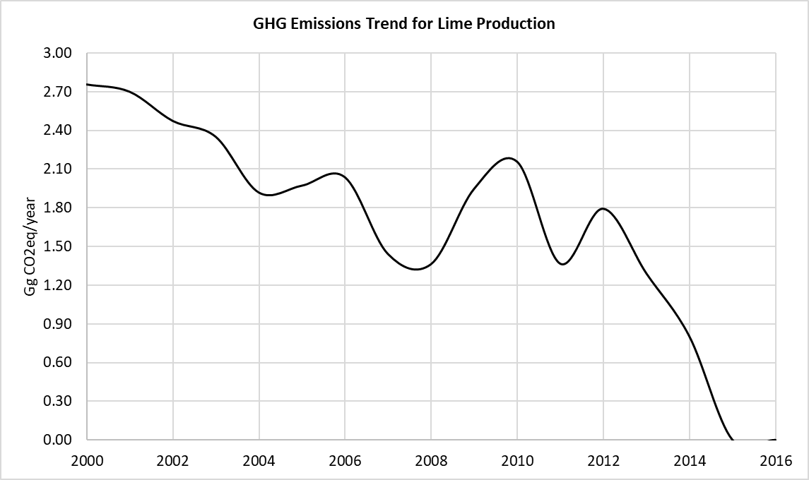

Table 68. GHG Emissions (Gg CO2-eq) from Lime Production, 2000 – 2016.

|  |  |  |  |
| --- | --- | --- | --- |
| **Years** | **Total emissions for IPPU** | **Lime production emissions** | **Share for Lime Production (%)** |
| 2000 | 70.32 | 2.75 | 3.92% |
| 2001 | 73.46 | 2.70 | 3.67% |
| 2002 | 76.15 | 2.47 | 3.25% |
| 2003 | 78.88 | 2.35 | 2.98% |
| 2004 | 81.25 | 1.92 | 2.36% |
| 2005 | 113.16 | 1.97 | 1.74% |
| 2006 | 108.04 | 2.04 | 1.88% |
| 2007 | 103.25 | 1.44 | 1.39% |
| 2008 | 125.87 | 1.36 | 1.08% |
| 2009 | 139.56 | 1.95 | 1.39% |
| 2010 | 151.71 | 2.16 | 1.42% |
| 2011 | 193.95 | 1.37 | 0.70% |
| 2012 | 214.43 | 1.79 | 0.84% |
| 2013 | 300.00 | 1.29 | 0.43% |
| 2014 | 300.78 | 0.80 | 0.27% |
| 2015 | 300.96 | 0.00 | 0.00% |
| 2016 | 311.18 | 0.00 | 0.00% |

### Quality Control

Some quality control activities were implemented in order to ensure the use of right data in the inventory. The QC implemented during the data collection and GHG emission estimation is listed below:

* Cross verification between data provided via mail by institutional authorities and data reported in the national Statistics Mauritius.
* Cross verification between EF values provided by institutional authorities and the default values proposed by the IPCC 2006 Guidelines for IPPU sector.
* Cross verification between the GHG emissions estimated in the current inventory for IPPU sector and the results obtained in the las reported national inventory of the RoM.

### Uncertainty Assessment and Time-series Consistency

The uncertainty analysis results for the Mineral Industry sector categories obtained from the IPCC software are reported in the following table for 2000 as base year:

Table 69. Uncertainty Analysis of Lime Production category (2.A.2) for the period 2000 – 2016

|  |  |  |  |  |
| --- | --- | --- | --- | --- |
| **IPCC Category** | **Gas** | **Activity Data Uncertainty (%)** | **Emission Factor Uncertainty (%)** | **Combined Uncertainty (%)** |
| 2.A.2 - Lime production | CO2 | 15.00 | 0.00 | 15.00 |

### Recalculations

The activity data used in this sector regarding the amount of lime production in the country has been improved using more accurate data from the Ministry of Environment, Solid Waste Management and Climate Change.

Due to the improvement related to the accuracy of the activity data used for the present inventory, a decrease of a 16% of the emissions estimated in the year 2013 has been reported, compared to the emissions reported in the last inventory (from the 1.5 tCO2e emissions estimated in the last inventory for the year 2013, to the 1,29 tCO2e emissions reported in the current inventory for the same year).

### Planned Improvements

Considering this activity does not occur since 2014, there are no planned improvements. If this activity starts again at some point in the future, and in order to achieve a best approach (higher tier) for the GHG emissions estimates, RoM would continue working to determine country specific information (Tier 2) and plant level information (Tier 3).

## Metal Industry – Iron and Steel Production (Category 2C1)

In this category, only the iron and steel manufacturing (2C1) was occurring in RoM. According to Volume 3 of the 2006 IPCC Guidelines, the iron and steel industry broadly consist of: primary facilities that produce both iron and steel; secondary steelmaking facilities; iron production facilities; and offsite production of metallurgical coke.

### Source Category Description

In RoM, all iron and steel production are manufactured from the recycling of ferrous scrap metals. The scrap metals are firstly segregated by magnets in a shed and then sent to a furnace operating at 1,800ºC to be melted. High quality fluxes, imported by the manufacturer, are used to purify the melt. High strength and superior quality steel ingots are produced. These steel ingots are then used as raw material in the steel rolling mill to finally produce steel construction bars.

According to the information facilitated from the Ministry of Environment, Solid Waste Management and Climate Change, there are 4 industries under operation for iron production and 2 others that stopped their production between 2015 and 2016.

Table 70. Metal Industry Companies

| **Company name** | **Description** | **Status** |
| --- | --- | --- |
| SAMLO – KOYENCO STEEL LTD | Manufacture of iron bars | Operational as at June 2019 |
| MRC WIRE PRODUCTIS LTD | Manufacture of welded mesh | Operational as at June 2019 |
| KOSTO LTD | Cut and bend iron bars for reinforcement concrete | Operational as at June 2019 |
| METAL SHEETS INDUSTRIES LTD | Manufacture of corrugated iron sheets | Operational as at June 2019 |
| SAMLO & SONS CO. LTD | Processing and export of scrap metals | Dormant as from 2015 |
| APPOLLO TUBES | Manufacture of steel tubes, pipes, open door profile and nails | Winding up as from 2016 |

***Source****: Ministry of Environment, Solid Waste Management and Climate Change.*

### Methodological Issues

#### Calculation

Emissions per unit of steel production varied widely, depending on the method of steel production. According to the 2006 IPCC Guidelines, it is good practice to determine the share of steel produced in different types of steel making processes.

According to the 2006 IPCC Guidelines, the Tier 1 approach for emissions from iron and steel production was adopted.

The methodology adopted for GHG emissions estimation consist of multiplying activity data (AD) by the relevant appropriate emission factor (EF).

*Emissions (E) = Activity Data (AD) x Emission Factor (EF)*

To use a common unit for GEI emissions, the IPCC recommends the use of Global Warming Potentials (GWP) to convert GHG emissions other than CO2 to the latter equivalent. CO2 equivalent (CO2e). The GWP values used in the current inventory are those adopted from the Second Assessment Report (SAR) as collected in the following table for each GHG reported in the National Inventory.

#### Activity Data

Activity data. as shown in table below, for 2009 – 2016 was obtained from the Ministry of Industrial Development, SMEs and Cooperatives. To complete the data for the whole time series, the best adjust has been used to estimate data from 2000 to 2008 according to the Gross Output Value (GOV) from the metal industry. This GOV is available for the years 2002, 2007 and 2013, in this way, the rest of the values are obtained interpolating the iron and steel production values for the years 2007 and 2002 (according to the GOV values for those years and the known value for 2013).

Table 71. Iron and Steel Production (2000 – 2016)

|  |  |
| --- | --- |
| **Years** | **Iron and Steel**  **Produced (tons)** |
| 2000 | 18,462.80 |
| 2001 | 19,079.13 |
| 2002 | 19,716.04 |
| 2003 | 20,352.95 |
| 2004 | 20,989.86 |
| 2005 | 21,626.77 |
| 2006 | 22,263.68 |
| 2007 | 22,900.58 |
| 2008 | 26,950.29 |
| 2009 | 31,000.00 |
| 2010 | 33,000.00 |
| 2011 | 35,000.00 |
| 2012 | 32,200.00 |
| 2013 | 26,700.00 |
| 2014 | 25,000.00 |
| 2015 | 24,000.00 |
| 2016 | 20,200.00 |

#### Emission Factor

Mauritius has several facilities to produce iron and steel, not all having the same type of production technology. It has been identified that some of them have EAE electric ovens, others have a process called Direct Forming Technology (DTF), which is a combination of several technologies. At the time of preparation of the Inventory, the information necessary to apply a Tier 2 is not available, that is, the amount of iron and steel produced by each different and specific type of technology, which would allow assigning each technology the corresponding emission factor. Mauritius continues working to have this disaggregated information for the next Inventory, which is included as part of the improvement plan. For this edition of Inventory, it has been chosen to use a Tier 1 and make use of the emission factor that best represents the technological situation of the country, that is, an average value that considers different types of production technologies.

Mauritius has several facilities to produce iron and steel, not all having the same type of production technology. It has been identified that some of them have EAE electric ovens, others have a process called Direct Forming Technology (DTF), which is a combination of several technologies. At the time of preparation of the Inventory, the information necessary to apply a Tier 2 is not available, that is, the amount of iron and steel produced by each different and specific type of technology, which would allow assigning each technology the corresponding emission factor. Mauritius continues working to have this information for the next Inventory, which is included as part of the improvement plan. For this edition of Inventory, it has been chosen to use a Tier 1 and make use of the emission factor that best represents the technological situation of the country, that is, an average value that considers different types of production technologies.

The emission factor (EF) considered is 1.06 tons of CO2 per ton of steel produced, according to the Table 4.1 from Volume 3, Chapter 4 from 2006 IPCC Guideline. This emission factor represents a global average factor for different types of technologies for the iron and steel production, which considers an average value for EF of these technologies 65% of Basic Oxygen Furnace (BOF), 30% of Electric Arc Furnace (EAF) and 5% of Open-Hearth Furnace (OHF).

### Results

GHG emissions from the Iron and Steel Production increased from 19.57 Gg CO2eq in the year 2000 to 21.41 Gg CO2eq in 2016, which represented an increase of 9.4%.

Figure 42. Evolution of the GHG Emissions from Iron and Steel Production (Gg CO2eq)

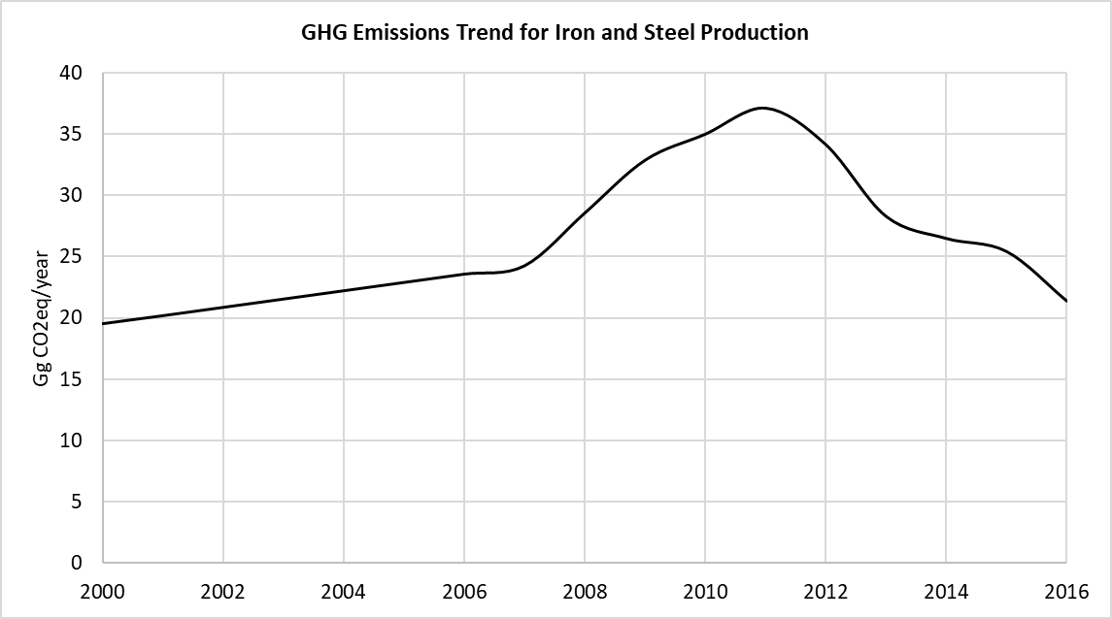

Table 72. GHG Emissions (Gg CO2-eq) from Iron and Steel Production

|  |  |  |  |
| --- | --- | --- | --- |
| **Years** | **Total emissions for IPPU** | **Iron and Steel Production** | **Share for Iron and Steel Production (%)** |
| 2000 | 70.32 | 19.57 | 27.83% |
| 2001 | 73.46 | 20.22 | 27.53% |
| 2002 | 76.15 | 20.90 | 27.44% |
| 2003 | 78.88 | 21.57 | 27.35% |
| 2004 | 81.25 | 22.25 | 27.38% |
| 2005 | 113.16 | 22.92 | 20.26% |
| 2006 | 108.04 | 23.60 | 21.84% |
| 2007 | 103.25 | 24.27 | 23.51% |
| 2008 | 125.87 | 28.57 | 22.70% |
| 2009 | 139.56 | 32.86 | 23.55% |
| 2010 | 151.71 | 34.98 | 23.06% |
| 2011 | 193.95 | 37.10 | 19.13% |
| 2012 | 214.43 | 34.13 | 15.92% |
| 2013 | 300.00 | 28.30 | 9.43% |
| 2014 | 300.78 | 26.50 | 8.81% |
| 2015 | 300.96 | 25.44 | 8.45% |
| 2016 | 311.18 | 21.41 | 6.88% |

### Quality Control

Some quality control activities were implemented in order to ensure the use of right data in the inventory. The QC implemented during the data collection and GHG emission estimation is listed below:

* Cross verification between data provided via mail by institutional authorities and data reported in the national Statistics Mauritius.
* Cross verification between EF values provided by institutional authorities and the default values proposed by the IPCC 2006 Guidelines for IPPU sector.
* Cross verification between the GHG emissions estimated in the current inventory for IPPU sector and the results obtained in the last reported national inventory of the RoM.

### Uncertainty Assessment and Time-series Consistency

The uncertainty analysis results for the Metal Industry sector categories obtained from the IPCC software are reported in the following table for 2000 as base year:

Table 73. Uncertainty Analysis of Iron and Steel Production category (2.C.1) for the period 2000 – 2016

|  |  |  |  |  |
| --- | --- | --- | --- | --- |
| **IPCC Category** | **Gas** | **Activity Data Uncertainty (%)** | **Emission Factor Uncertainty (%)** | **Combined Uncertainty (%)** |
| 2.C.1 - Iron and Steel Production | CO2 | 10.00 | 0.00 | 10.00 |

### Recalculations

The recalculations implemented in this category consist on the improvement of the activity data used.

On the other hand, the EF previously used in last inventory has been changed in order to reflect real national circumstances in terms of the technology used. For last inventory, the EF used was for pig iron production, but this EF didn´t exactly reflect the technology used by this sector. However, the specific production method used by each company is not known so, for that reason, the global average factor used for this inventory edition has been 1.06 tCO2/ton steel production, based on IPCC 2006 Guidelines.

A bigger difference with the previous inventory is noticed in this category due to the recalculations made for this inventory. After the improvements on the activity data and modifications in the factors used, a decrease of a 27% of the emissions estimated in the year 2013 have been calculated between the last inventory and the current one. That is, in the last inventory, 36 tCO2e of emissions were estimated for the year 2013 and in the current inventory 28.3 tCO2e of emissions have been estimated for the same year.

### Planned Improvements

In order to improve the accuracy of the inventory, the country is working on collecting all the information regarding the technology that every industry in the country is using. In line with this improvement, the activity data should be collected split by each technology. RoM will continue working to determine plant level information for every year.

## Non-Energy Products from Fuels and Solvent Use as Lubricant Use (Category 2D1)

According to 2006 IPCC Guidelines, the products covered here comprise lubricants, paraffin waxes, bitumen/asphalt, and solvents. Information about this consumption is not currently available through national statistics, however, there is relevant information in the International Energy Agency[5], which reports some fuel consumption as non-energy use. Due to the lack of more detailed information, this fuel has been assumed as lubricants, however, this is something to be checked for next inventory cycle in order to align the information reported by the IEA and the national statistics. Source Category Description

Lubricants are mostly used in industrial and transportation applications. The most common use of these lubricants could be their use as lubricants in engines and their emissions should be consider as non-combustion emissions in the IPPU sector. The use of lubricants is susceptible to emit CO2.

### Methodological Issues

#### Calculation

For the emission estimation of this category, a Tier 1 approach has been used according to the 2006 IPCC Guidelines methodology.

CO2 emissions = Consumption of lubricant (TJ) x Carbon content of lubricant (t C/TJ) x Oxidised During Use (ODU) Factor x 44/12

As a Tier 1 approach has been used, the carbon content and ODU factor values are obtained from the default values proposed in the 2006 IPCC Guidelines.

#### Activity Data

The activity data values used are obtained from the International Energy Agency (IEA) for the lubricant use in the RoM. It is noticed that consumption of lubricants is only reported from 2011, while from 2000 to 2010 no consumption of lubricants was reported for the country.

Table 74. Consumption (Gg) of lubricants in RoM (2011 – 2016)

|  |  |
| --- | --- |
| **Years** | **HFC-134a** |
| 2011 | 16 |
| 2012 | 18 |
| 2013 | 17 |
| 2014 | 15 |
| 2015 | 11 |
| 2016 | 13 |

***Source****: International Energy Agency.*

#### Emission Factor

The emission and conversion factors used in this category are the default values proposed by the 2006 IPCC Guidelines.

Table 75. Parameters used for the estimation of CO2 emissions from lubricant use

|  |  |  |
| --- | --- | --- |
|  | **Carbon content of lubricant (tC/TJ)** | **Oxidised During Use (ODU) factor for lubricant** |
| **Factor** | 20 | 0.2 |

***Source****: Default values from 2006 IPCC Guidelines, Volume 3, Chapter 5.*

### Results

GHG emissions from the Non-Energy Products from fuels and solvents use are null until year 2011. From 2011 to 2016 a decrease in the emissions reported in this category are observed (from 9.43 Gg CO2eq in 2011 to 7.66 Gg CO2eq in 2016) representing a decrease of a 18.8% between 2011 and 2016.

Figure 43. Evolution of the GHG Emissions from Non-Energy Products (Gg CO2eq)

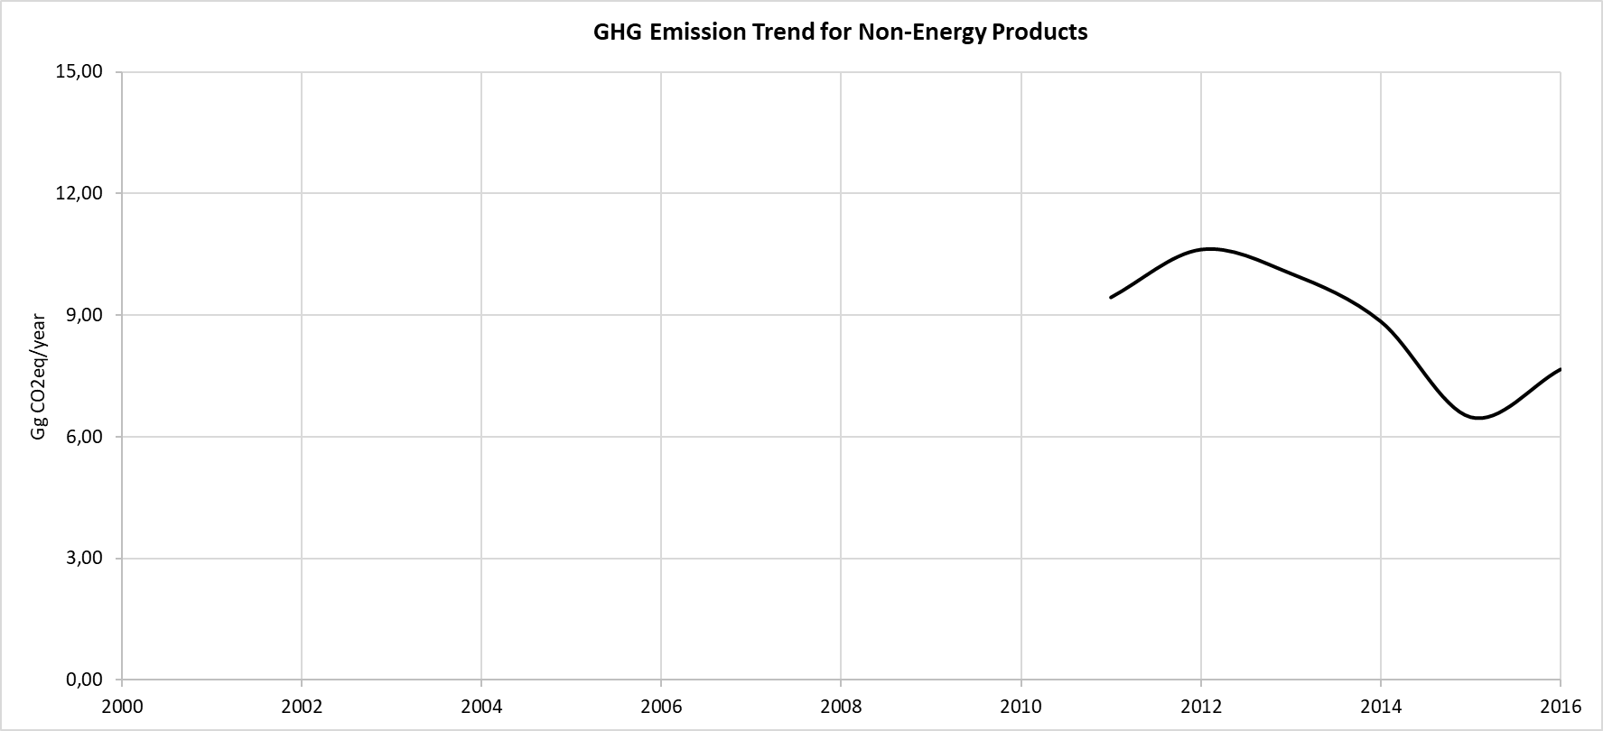

Table 76. GHG Emissions (Gg CO2-eq) from Non-Energy Products

|  |  |  |  |
| --- | --- | --- | --- |
| **Years** | **Total emissions for IPPU** | **Non-Energy Products** | **Share for Non-Energy Products (%)** |
| 2000 | 70.32 | NO |  |
| 2001 | 73.46 | NO |  |
| 2002 | 76.15 | NO |  |
| 2003 | 78.88 | NO |  |
| 2004 | 81.25 | NO |  |
| 2005 | 113.16 | NO |  |
| 2006 | 108.04 | NO |  |
| 2007 | 103.25 | NO |  |
| 2008 | 125.87 | NO |  |
| 2009 | 139.56 | NO |  |
| 2010 | 151.71 | NO |  |
| 2011 | 193.95 | 9.43 | 4.86% |
| 2012 | 214.43 | 10.61 | 4.95% |
| 2013 | 300.00 | 10.02 | 3.34% |
| 2014 | 300.78 | 8.84 | 2.94% |
| 2015 | 300.96 | 6.49 | 2.15% |
| 2016 | 311.18 | 7.66 | 2.46% |

### Quality Control

It is proposed as an improvement for the next inventory cycle, the cross verification of the activity data reported in the International Energy Agency with the data reported by national authorities. Uncertainty Assessment and Time-series Consistency.

The uncertainty analysis results for the Non-Energy Products category obtained from the IPCC software are reported in the following table for 2000 as base year:

Table 77. Uncertainty Analysis of Non-Energy Products category (2.D.1) for the period 2000 – 2016

|  |  |  |  |  |
| --- | --- | --- | --- | --- |
| **IPCC Category** | **Gas** | **Activity Data Uncertainty (%)** | **Emission Factor Uncertainty (%)** | **Combined Uncertainty (%)** |
| 2.D.1 - Lubricant Use | CO2 | 10.00 | 0.00 | 10.00 |

### Recalculations

The previous inventory developed for the Third National Communication of the RoM did not report the emissions from this category. The oil consumption as lubricant use in this category is not reported at national level but it is reported in the International Energy Agency (IEA). For that reason, the emissions from the category are included in the inventory for the first time.

### Planned Improvements

In order to improve the accuracy of the inventory, the country will work to align its national statistics with the IEA.

## Product Uses as Substitutes for Ozone Depleting Substances (Category 2F)

According to 2006 IPCC Guidelines, HFCs are serving as alternatives to ODS substitute being phased out under the Montreal Protocol. Current application areas of HFCs in RoM include refrigeration and air conditioning systems (stationary and mobile) as well as in fire extinguishers. These appliances and refrigerants are not produced locally and are all imported. This sub-sector will therefore concentrate on emissions of the use of these appliances. These substances are not produced in the country, so they are all imported.

Sulphur hexafluoride (SF6) is used in electrical equipment such as gas insulated switchgear and substations and in gas circuit breakers.

This sector is divided into 2 sub-categories, 2F1a Refrigeration and Stationary Air Conditioning, and 2F1b Mobile Air Conditioning.

### Source Category Description

In RoM, SF6 are mostly used in breakers, which are categorised as Sealed Pressure Systems or Sealed-for-life Equipment. This type of equipment does not require any refilling with gas during its lifetime and generally contains less than 5 kg of gas per functional unit. Emissions of SF6 have therefore been assumed to be insignificant as the breakers have been installed since the 1990s and have not exceeded their lifetime during the inventory period.

### Methodological Issues

#### Calculation

According to the 2006 IPCC Guidelines, the Tier 1a approach (emission-factor approach) relies on the availability of basic activity data at application level, rather than at the level of equipment or product type. According to these guidelines, for the GHG emission estimations, despite being the time series from 2000 to 2016, the data in this category has to be introduced from 1990 (if applicable).

The calculation formula for Net Consumption with this approach is as follows:

Net Consumption = Production + Imports – Exports

Net consumption values for each HFC are then used to calculate annual emissions for applications exhibiting prompt emissions as follows:

*Annual Emissions = Net Consumption × Composite EF + Total Banked Chemical × Composite EF*

Where,

Net Consumption = net consumption for the application

Composite EF = composite emission factor for the application

Total Banked Chemical = bank of the chemical for the application

#### Activity Data

Activity data, collected in table below, were obtained from the National Ozone Unit of the Ministry of Environment, Solid Waste Management and Climate Change. and represent the net consumption of the ODS in the country, calculated as importations – exportations, considering that the production of these substances in the country is null.

Table 78. Net Consumption (ton) of ODS Substitute in RoM for Refrigeration and Stationary Air Conditioning (1990 – 2016)

| **Years** | **HFC-23** | **HFC-32** | **HFC-125** | **HFC-134a** | **HFC-143a** | **HFC-227a** |
| --- | --- | --- | --- | --- | --- | --- |
| 1990 | 0.00 | 0.99 | 5.64 | 15.19 | 5.47 | 0.00 |
| 1991 | 0.00 | 0.93 | 5.31 | 15.23 | 5.16 | 0.00 |
| 1992 | 0.00 | 0.92 | 5.25 | 15.24 | 5.10 | 0.00 |
| 1993 | 0.00 | 0.94 | 5.34 | 15.23 | 5.19 | 0.00 |
| 1994 | 0.00 | 0.92 | 5.26 | 15.24 | 5.10 | 0.00 |
| 1995 | 0.00 | 0.95 | 5.44 | 15.21 | 5.28 | 0.00 |
| 1996 | 0.00 | 0.99 | 5.64 | 15.19 | 5.48 | 0.00 |
| 1997 | 0.00 | 1.02 | 5.83 | 15.16 | 5.66 | 0.00 |
| 1998 | 0.00 | 1.06 | 6.03 | 15.14 | 5.85 | 0.00 |
| 1999 | 0.00 | 1.08 | 6.18 | 15.12 | 6.00 | 0.00 |
| 2000 | 0.00 | 1.18 | 6.70 | 12.82 | 6.51 | 0.00 |
| 2001 | 0.00 | 1.21 | 6.89 | 12.80 | 6.69 | 0.00 |
| 2002 | 0.00 | 1.22 | 6.95 | 12.70 | 6.75 | 0.00 |
| 2003 | 0.00 | 1.27 | 7.25 | 12.56 | 7.04 | 0.00 |
| 2004 | 0.00 | 1.32 | 7.53 | 12.48 | 7.31 | 0.00 |
| 2005 | 0.00 | 1.38 | 7.84 | 12.36 | 7.62 | 0.00 |
| 2006 | 0.00 | 1.30 | 7.42 | 12.37 | 7.21 | 0.00 |
| 2007 | 0.21 | 3.01 | 14.85 | 22.51 | 13.03 | 0.00 |
| 2008 | 0.00 | 5.57 | 14.97 | 79.65 | 10.95 | 0.00 |
| 2009 | 0.00 | 15.16 | 27.27 | 33.99 | 13.68 | 0.00 |
| 2010 | 0.00 | 6.98 | 22.36 | 23.74 | 17.97 | 0.00 |
| 2011 | 0.00 | 12.85 | 45.65 | 41.25 | 36.68 | 0.00 |
| 2012 | 0.05 | 16.73 | 45.45 | 32.20 | 33.54 | 0.00 |
| 2013 | 0.26 | 12.01 | 52.73 | 23.74 | 164.40 | 0.78 |
| 2014 | 0.26 | 17.46 | 65.33 | 27.82 | 22.79 | 0.00 |
| 2015 | 0.00 | 22.38 | 51.10 | 31.43 | 32.06 | 0.00 |
| 2016 | 0.09 | 2.40 | 64.94 | 41.72 | 41.25 | 0.00 |

***Source****: Ministry of Environment, Solid Waste Management and Climate Change, National Ozone Unit.*

Table 79. Net Consumption (ton) of ODS Substitute in RoM for Mobile Air Conditioning (1990 – 2016)

|  |  |
| --- | --- |
| **Years** | **HFC-134a** |
| 1990 | 0.00 |
| 1991 | 0.00 |
| 1992 | 0.00 |
| 1993 | 0.00 |
| 1994 | 0.00 |
| 1995 | 0.00 |
| 1996 | 0.00 |
| 1997 | 0.00 |
| 1998 | 0.00 |
| 1999 | 0.00 |
| 2000 | 2.23 |
| 2001 | 2.23 |
| 2002 | 2.31 |
| 2003 | 2.41 |
| 2004 | 2.46 |
| 2005 | 2.54 |
| 2006 | 2.59 |
| 2007 | 4.45 |
| 2008 | 17.04 |
| 2009 | 5.94 |
| 2010 | 4.90 |
| 2011 | 9.23 |
| 2012 | 5.74 |
| 2013 | 4.99 |
| 2014 | 5.45 |
| 2015 | 6.67 |
| 2016 | 8.55 |

***Source****: Ministry of Environment, Solid Waste Management and Climate Change, National Ozone Unit.*

#### Emission Factor

A composite emission factor is required to complete a Tier 1 method, as well as some necessary parameters. All these parameters and factors are estimated from the default factors proposed in the 7.5.2.1 section of 2006 IPCC Guidelines.

Table 80. Parameters for GHG Emission estimation for Product Uses as Substitutes for ODS

|  |  |  |
| --- | --- | --- |
| **Parameter** | **Unit** | **Value** |
| Lifetime | years | 15 |
| Composite Emission Factor (EF) | % | 15 |
| Destruction | % | 25 |

|  |  |  |  |  |
| --- | --- | --- | --- | --- |
| **2.F.1.a Category** | **Introduction year** |  | **2.F.1.b Category** | **Introduction year** |
| HFC-23 | 2007 |  | HFC-134a | 2000 |
| HFC-32 | 1990 |  |  |  |
| HFC-125 | 1990 |  |  |  |
| HFC-134a | 1990 |  |  |  |
| HFC-143a | 1990 |  |  |  |
| HFC-227ea | 2013 |  |  |  |

***Source****: Ministry of Environment, Solid Waste Management and Climate Change, National Ozone Unit and Default values from 2006 IPCC Guidelines.*

### Results

HFCs emissions from Product Uses as Substitutes to ODS increased from 48.81 Gg CO2-eq in the year 2000 to 299.21 Gg CO2-eq in 2016 which consist in an increase of 513.01%. A complete explanation on the reasons for the large increase in emissions are included in the section 4.4.6 below.

Figure 44. Evolution of the GHG Emissions from Product Uses as ODS (Gg CO2eq)

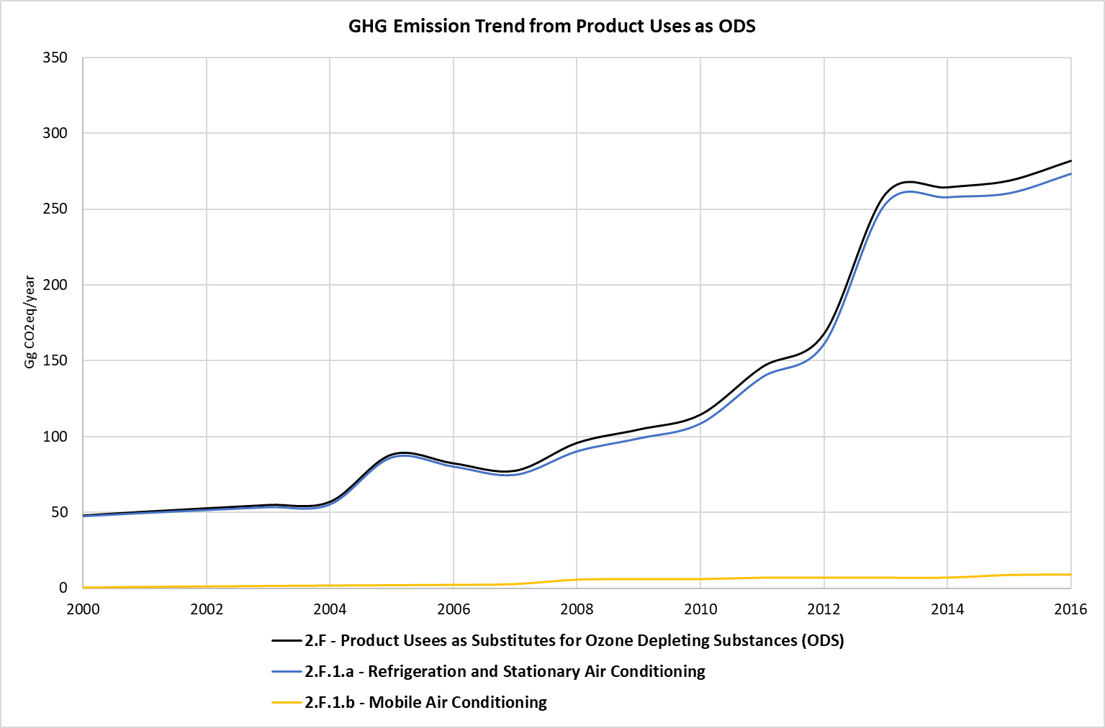

Table 81. GHG Emissions (Gg CO2eq) from Product Uses as Substitutes to ODS

|  |  |  |  |
| --- | --- | --- | --- |
| **Years** | **Total emissions for IPPU** | **Product Uses as Substitutes to ODS** | **Share for Product Uses as Substitutes to ODS (%)** |
| 2000 | 70.32 | 47.99 | 68.25% |
| 2001 | 73.46 | 50.54 | 68.80% |
| 2002 | 76.15 | 52.78 | 69.31% |
| 2003 | 78.88 | 54.96 | 69.67% |
| 2004 | 81.25 | 57.08 | 70.26% |
| 2005 | 113.16 | 88.26 | 78.00% |
| 2006 | 108.04 | 82.40 | 76.27% |
| 2007 | 103.25 | 77.54 | 75.10% |
| 2008 | 125.87 | 95.94 | 76.22% |
| 2009 | 139.56 | 104.75 | 75.06% |
| 2010 | 151.71 | 114.58 | 75.52% |
| 2011 | 193.95 | 146.05 | 75.30% |
| 2012 | 214.43 | 167.89 | 78.30% |
| 2013 | 300.00 | 260.38 | 86.79% |
| 2014 | 300.78 | 264.64 | 87.98% |
| 2015 | 300.96 | 269.03 | 89.39% |
| 2016 | 311.18 | 282.10 | 90.66% |

### Quality Control

Some quality control activities were implemented in order to ensure the use of right data in the inventory. The QC implemented during the data collection and GHG emission estimation is listed below:

* Cross verification between data provided via mail by institutional authorities and data reported in the national Statistics Mauritius.
* Cross verification between EF values provided by institutional authorities and the default values proposed by the IPCC 2006 Guidelines for IPPU sector.
* Cross verification between the GHG emissions estimated in the current inventory for IPPU sector and the results obtained in the las reported national inventory of the RoM.

### Uncertainty Assessment and Time-series Consistency

The uncertainty analysis results for the Product Uses as Substitutes for ODS sector categories obtained from the IPCC software are reported in the following table for 2000 as base year:

Table 82. Uncertainty Analysis of Product Uses as Substitutes for ODS category (2.F.1) for the period 2000 – 2016

|  |  |  |  |  |
| --- | --- | --- | --- | --- |
| **IPCC Category** | **Gas** | **Activity Data Uncertainty (%)** | **Emission Factor Uncertainty (%)** | **Combined Uncertainty (%)** |
| 2.F.1.a - Refrigeration and Stationary Air Conditioning | CHF3 | 0.00 | 0.00 | 0.00 |
| 2.F.1.a - Refrigeration and Stationary Air Conditioning | CH2F2 | 0.00 | 0.00 | 0.00 |
| 2.F.1.a - Refrigeration and Stationary Air Conditioning | CHF2CF3 | 0.00 | 0.00 | 0.00 |
| 2.F.1.a - Refrigeration and Stationary Air Conditioning | CH2FCF3 | 0.00 | 0.00 | 0.00 |
| 2.F.1.a - Refrigeration and Stationary Air Conditioning | CF3CH3 | 0.00 | 0.00 | 0.00 |
| 2.F.1.b - Mobile Air Conditioning | CH2FCF3 | 5.00 | 0.00 | 5.00 |

### Recalculations

A total recalculation for the "2.F – Product Uses as Substitutes for ODS" category has been carried out to be aligned with the IPCC 2006 Guidelines. To date, for the calculation of the category’s emissions, it was not taken into consideration the emissions related to banks. GHG emissions that have to be taken into account specially if a time series estimate is being developed, as in this case, Bank emissions represent the amount of chemical that have been accumulated throughout the lifecycle that as of the end of the most recent year has not been emitted. Considering that the average lifetime exceeds the time series period considered in the national inventory (2000-2016) it is necessary to consider these bank emissions.

Necessary parameters and factors have been taken from default factors proposed by IPCC 2006 Guidelines, and the methodology and calculation method has been taken from the "Calculation Example for 2F1" worksheet, available in the IPCC website[6].

Comparing the emissions estimated in the last inventory and the current one for the year 2013, an increase of the 98% of the emissions have been noticed. In the last inventory the emissions estimated in this category accounted in 6.2 tCO2e, while emissions estimated in the current inventory are reported at 260.38 tCO2e for the year 2013.

### Planned Improvements

RoM will continue working to obtain the information for the missing years, since the first year of data available is 2006. Furthermore, a mass balance and a determination of country specific EFs will be another aspect in which RoM will focus its future efforts.

In addition, during the QA analysis of the national inventory, it was observed that the data regarding the Product uses as substitutes for ozone depleting substances sector should be checked with the National Ozone Unit (competent authority) to confirm whether HFC compounds are used in firefighting activities in the country, in order to know if this activity is occurring or not. The information obtained should be considered in the next inventory cycle.

# Agriculture, Forestry and Other Land Use (AFOLU)

## Overview

AFOLU sector plays a vital role in the economy of RoM for ensuring food and nutritional security. The country’s economy closely tied to its natural resource base and climate-sensitive sectors such as agriculture, water and forestry. Though the GHG emissions from agriculture sector is less when compared to other sectors but the overall impact of climate change on agriculture is high. Mauritian agriculture is dependent on many climatic factors such as temperature, rainfall, humidity, and sunshine duration. Climatic variations may impact crops both positively and negatively depending on the nature of crop and the ecosystems they are grown.

In 2015, the land area occupied by agriculture was around 41.87% of the total land area of Mauritius. The agricultural sector is considered to be of significant importance to the Mauritian economy, employing some 7.3% of total working population and representing 38% of overall exported commodities, but contributing only 3.5% to national GDP in 2017. Nonetheless, the sector still plays a vital, multi-functional role within the economy. It contributes significantly to GDP in absolute terms, and has significant economic, social and environmental impacts. In addition, agriculture provides direct employment to some 45,300 people. Land under agriculture is mainly used for sugarcane, tea, food crops and fruit production (Litchi & Mango Banana and pineapple) and other crops.

Six land-use categories (i.e., Forest Land, Cropland, Grassland, Wetlands, Settlements, and Other Land) are considered and these land categories are further sub-divided into land remaining in the same category and land converted from one category to another. The land-use categories are designed to enable inclusion of all managed land area within a country, and this approach follows the most up to date guidance published by the IPCC.

In view of the small size of RoM, land is a prized asset for food production and economic development. Intensive agriculture and grazing land occupy 52% of the land surface, Forestland 25%, built up areas 17% and other land 6%.

In RoM, most of the GHG emissions/removals from AFOLU sector are generated by Forestland (which is a key category), enteric fermentation, manure management, agricultural soils and field burning.

In the AFOLU sector, there is more carbon sequestered than emitted. The forests are the largest component of the AFOLU sector and are net carbon sinks. Agricultural emission sources include the livestock sector where enteric fermentation and manure management emit CH4 and some N2O, and from direct and indirect N2O on managed soils.

Figure 45. Share of Agriculture in the Economy in the Republic of Mauritius, 2016

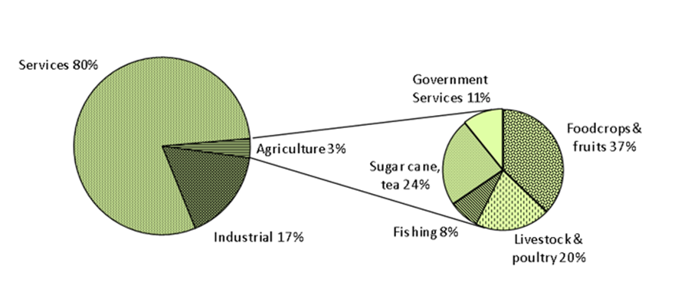

**Non-sugar sector**

Food crop production is dominated by small scale farming and covers a wide range of crops including potatoes, onion, tomatoes, chillies, crucifers, cucurbits, leafy vegetables, garlic and ginger which are cultivated on commercial scale whereas fruits come mainly from backyard production. Over the last decade, production of selected crops namely tomato, green pepper and cucumber have started under soil-less, protected structures. Generally, some 8,000 small producers cultivating about 8,200 hectares of land produce on average some 110,000 tonnes of food crops annually. Except in cases of drought, cyclones and heavy rains, fresh vegetable production amply satisfies the local consumption.

However, Mauritius imports its entire requirement in terms of the main staples, namely some 166,000 tonnes of wheat and 66,000 tonnes of rice. Fruit production which consists of mainly banana, pineapple, and seasonal fruits such as litchi and mangoes is estimated at 42,660 tonnes annually, over an equivalent of 3,065 ha of land. Fruits are produced mainly in backyards. Moreover, there is some corporate sector involvement in the production of pitaya, litchi, jujube and citrus. Among the backyard fruits, litchi has achieved some prominence. Exports draw heavily on backyard production and some existing or newly established orchards.

Since the 1990’s the area under tea production has wound down from 3,028 ha due to lack of competitiveness and quality for the export market, to reach 622 ha for season 2016/2017, with a production of around 7,309 tonnes of green leaf. There were around 1,205 registered tea growers in 2017 and 3 major tea factories in the country. With recent favourable economic situation of the tea sector Government policy is now to revive this sector, and some 600 acres of land has been earmarked for new plantations.

An annual food crop production of 102,633 tonnes was harvested in 2015 over a harvest area of 8,077 ha. Table indicates, the annually production and area harvested for sugarcane, tea, food crops and fruits.

Table 83. Area harvested and production in agricultural crops, 2014 – 2016

|  |  |  |  |  |  |  |
| --- | --- | --- | --- | --- | --- | --- |
| **Agricultural crops** | **2014** | | **2015** | | **2016** | |
| **Area harvested (ha)** | **Production (tons)** | **Area harvested (ha)** | **Production (tons)** | **Area harvested (ha)** | **Production (tons)** |
| Sugarcane | 50,694 | 4,044,422 | 52,387 | 4,009,232 | 51,477 | 3,798,448 |
| Tea | 672 | 7,607 | 574 | 6,732 | 622 | 7,301 |
| Potato | 821 | 19,404 | 707 | 16,427 | 765 | 16,236 |
| Pumpkin | 477 | 6,980 | 423 | 5,713 | 526 | 7,002 |
| Rice (paddy) | 412 | 1,186 | 340 | 657 | 161 | 352 |
| Squash | 79 | 659 | 92 | 702 | 76 | 554 |
| Sweet potato | 59 | 780 | 52 | 686 | 35 | 446 |
| Tomato | 857 | 10,997 | 740 | 8,525 | 730 | 10,137 |
| Pineapple | 450 | 10,788 | 523 | 11,693 | 417 | 9,707 |

***Source:*** *Digest of Agriculture and Environment 2014, 2015, and 2016*

Present policy is to develop bio-farming activities in the food crop and fruit production, and several schemes are in place to support such initiatives. Agroforestry systems are also being encouraged and pilot/demonstration plots are being developed.

In 2015, 21.8% of agricultural land was provided with irrigation facility to sustain crop production during the whole year. The area of land area under irrigation facility has, however decreased from 17,183 ha to 16,455 ha in 2017, respectively.

### General Methodology

The general methodology and data sources used in AFOLU category is mentioned below provides the activity data sources, method to subcategories.

Table 84. Methodology used in the AFOLU sector

| **Category** | **Activity Data** | **Emission Factor** | **Activity Data Source** |
| --- | --- | --- | --- |
| **3 – Agriculture, Forestry and Other Land Use** | | | |
| **3.A – Livestock** | | | |
| **3.A.1 – Enteric Fermentation** | | | |
| 3.A.1.a – Cattle | T1 | D | Digest of Agricultural statistics / FAREI / Mauritius Meat Authority |
| 3.A.1.a.i – Dairy Cows | T1 | D | Digest of Agricultural statistics / FAREI |
| 3.A.1.a.ii – Other Cattle | T1 | D | Digest of Agricultural statistics / FAREI / Mauritius Meat Authority |
| 3.A.1.b – Buffalo | NA | NA | NA |
| 3.A.1.c – Sheep | T1 | D | Digest of Agricultural statistics / FAREI |
| 3.A.1.d – Goats | T1 | D | Digest of Agricultural statistics / FAREI |
| 3.A.1.e – Camels | NA | NA | NA |
| 3.A.1.f – Horses | T1 | D | Statistical Office |
| 3.A.1.g – Mules and Asses | NA | NA | NA |
| 3.A.1.h – Swine | T1 | D | Digest of Agricultural statistics / FAREI |
| 3.A.1.i – Poultry | T1 | D | Digest Agricultural statistics / FAREI estimates |
| 3.A.1.j – Other – Deer | T1 | D | FAREI estimates |
| **3.A.2 – Manure Management (1)** | | | |
| 3.A.2.a - Cattle | T2 | D | Digest of Agricultural statistics / FAREI / Mauritius Meat Authority |
| 3.A.2.a.i – Dairy cows | T2 | D | Digest of Agricultural statistics / FAREI |
| 3.A.2.a.ii – Other cattle | T1 | D | Digest of Agricultural statistics / FAREI / Mauritius Meat Authority |
| 3.A.2.b - Buffalo | NA | NA | NA |
| 3.A.1.c – Sheep | T1 | D | Digest of Agricultural statistics / FAREI |
| 3.A.1.d – Goats | T1 | D | Digest of Agricultural statistics / FAREI |
| 3.A.1.e – Camels | NA | NA | NA |
| 3.A.1.f – Horses | T1 | D | Statistical Office |
| 3.A.1.g – Mules and Asses | NA | NA | NA |
| 3.A.1.h – Swine | T1 | D | Digest of Agricultural statistics / FAREI |
| 3.A.1.i – Poultry | T1 | D | Digest Agricultural statistics / FAREI estimates |
| 3.A.1.j – Other – Deer | T1 | D | FAREI estimates |
| **3.B – Land** | | | |
| **3.B.1 – Forest land** | | | |
| 3.B.1.a – Forest land remaining forest land | T2 | D | Forestry Services |
| 3.B.1.b – Land converted to Forest land | T1 | D, CS | Forestry Services |
| 3.B.1.b.i – Cropland converted to Forest land | T1 | D | Forestry Services |
| 3.B.1.b.ii – Grassland converted to Forest land | T1 | D | Forestry Services |
| **3.B.2 – Cropland** | | | |
| 3.B.2.a – Cropland remaining cropland | T1 | D | MSIRI/MCIA |
| 3.B.2.b – Land converted to Cropland | T1 | D |  |
| 3.B.2.b.i – Forest land converted to Cropland | T1 | D |  |
| **3.B.3 – Grassland** | | | |
| 3.B.3.a – Grassland remaining grassland | T1 | D |  |
| 3.B.3.b – Land converted to grassland | T1 | D |  |
| 3.B.3.i – Forest land converted to grassland | T1 | D |  |
| **3.B.4 – Wetland** | | | |
| 3.B.4.a – Wetlands remaining wetlands | T1 | D |  |
| 3.B.4.a.i – Peatlands remaining peatlands | T1 | D |  |
| 3.B.4.a.ii – Flooded land remaining flooded land | T1 | D |  |
| **3.B.5 – Settlements** | | | |
| 3.B.5.a – Settlements remaining settlements | T1 | D |  |
| 3.B.5.b – Land converted to settlements | T1 | D |  |
| 3.B.5.b.i – Forest land converted to settlements | T1 | D |  |
| 3.B.5.b.ii – Cropland converted to settlements | T1 | D |  |
| **3.B.6 – Other land** | | | |
| 3.B.6.a – Other land remaining other land | T1 | D |  |
| 3.B.6.b – Land converted to other land | T1 | D |  |
| 3.B.6.b.i – Forest land converted to other land | T1 | D |  |
| 3.B.6.b.ii – Cropland converted to other land | T1 | D |  |
| **3.C – Aggregate sources and non-CO2 emissions sources on land (2)** | | | |
| 3.C.1.b – Biomass burning in croplands | T1 | D | MSIRI/MCIA |
| **3.C.3 – Urea application** | | | |
| 3.C.3 – Urea application | T1 | D | FAREI |
| 3.C.4 - Direct N2O Emissions from managed soils (3) | T2 | D | FAREI |

T1 -Tier 1 and Tier 2 Methods; CS – Country Specific Emission; D –Default Emission Factors; NA: Not Applicable

### Source Category Description

Agriculture contributes to greenhouse gas emission primarily through the emission and consumption of GHGs such as methane (CH4), nitrous oxide (N2O) and carbon dioxide (CO2). Enteric fermentation in ruminants is a major source of methane emission. Methane is also produced in soil during microbial decomposition of organic matter under anaerobic conditions. Crop fields, which are submerged under water are the potential source of methane production. Nitrous oxide is produced in soils through the processes of nitrification and denitrification. Nitrification is the aerobic microbial oxidation of ammonium to nitrate, and denitrification is the anaerobic microbial reduction of nitrate to nitrogen gas. Nitrous oxide is a gaseous intermediate in the reaction sequence of denitrification and a by-product of nitrification that leaks from microbial cells into the soil and ultimately into the atmosphere. One of the main controlling factors in this reaction is the availability of inorganic N in soil through additions of synthetic or organic fertilizers, manure, crop residues, sewage sludge or mineralization of N in soil organic matter following drainage/management of organic soils and cultivation/land-use change on mineral soils.

The main source of carbon dioxide in agriculture is the soil management practices. Use of fuel for various agricultural operations and burning of crop residues are the other sources of carbon dioxide emission. An off-site source is the manufacturing of farm implements, fertilizers and pesticides. In general, GHG emissions from the agricultural sector are generally linked to the management of agricultural soils, livestock, crop production and biomass burning.

The main agricultural sources of GHG emissions considered for inventory preparation are the following:

* enteric fermentation, part of the digestive process for many ruminants such as cattle, sheep and goats, which produces methane;
* application of N in soil, which produces nitrous oxide;
* manure decomposition, which produces both methane and nitrous oxide.

The GHG emissions from agriculture are influenced by a number of factors such as farm management practices, amount and type of fertilizer, amount and nutrient content of manure applied, number of ruminant animals, etc.

**Enteric fermentation**

Methane is produced in herbivores animals as a by-product of enteric fermentation, a digestive process by which carbohydrates are broken down by microorganisms into simple molecules for absorption into the bloodstream. The amount of methane that is released depends on the type of digestive tract, age, and weight of the animal, and the quality and quantity of the feed consumed. Ruminant livestock (e.g., cattle, sheep) are major sources of methane and moderate amounts produced from non-ruminant livestock (e.g., pigs, horses).

Manure Management under enteric fermentation: The CH4 and N2O produced during the storage and treatment of manure, and from manure deposited on pasture were calculated. The term ‘manure’ is used here collectively to include both dung and urine (i.e. the solids and the liquids) produced by livestock.

**Agriculture soils**

There are two pathways of N2O emissions from soils-direct and indirect. Direct N2O emission was estimated using net N additions to soils (synthetic or organic fertilizers, deposited manure, crop residues) and mineralization of N in soil due to cultivation/land-use change on mineral soils. The indirect N2O emission was estimated from volatilization of NH3 and NOx from managed soils and the subsequent re-deposition of these gases and their products (NH4 and NO3) to soils and after leaching and runoff of N, mainly as NO3 from managed soils. Total emissions of N2O from managed soils have been estimated.

**Field burning of agricultural residue**

Non-CO2 emissions associated with burning of agriculture residues is reported. Crop residue is burning in the fields produces CO, CH4, N2O, NOx, NMHCs, SO2 and many other gases. Generally, residues from crops are burned in field. The field burning is accounted to be nil as there is continuous cane plantation in the same field and same amount of CO2 is sequester, thus net result is zero.

**Forestry and Other Land Use (FOLU)**

Forestry and Other Land Use (FOLU) part of the AFOLU sector is an important carbon sink. The forests and a few other lands sequester carbon with an average of about 366 Gg yearly in total, with a contribution of 32 Gg from Rodrigues. The emissions occur most importantly from the soils (as N2O) in the Agriculture sector as use of fertilisers are very common, especially in the sugarcane cultivations, from where on average 83 Gg CO2eq were emitted yearly. Livestock, with enteric fermentation and manure management contributed in the emissions of CH4. Rodrigues, which has important livestock populations accounts for almost half of the total emissions.

### Methodological Issues

For comprehensive, complete, comparable, transparent and accurate (CCCTA) reporting, the 2006 IPCC Guidelines for National GHG Inventories were followed. However, the basis of reporting remains as per the requirements of decision 17/CP.8 i.e. the IPCC Revised Guidelines 1996. Both default and country specific emission factors have been used in this report.

#### Calculations

**For Enteric Fermentation**

The calculations involve simply multiplying the number of animals (as AD) by the respective EF:



Where,

Emissions = methane emissions from Enteric Fermentation, Gg CH4 yr-1

EF(T) = emission factor for the defined livestock population, kg CH4 head-1 yr-1

N(T) = the number of head of livestock species / category T in the country

T = species/category of livestock



Where,

Total CH4 Enteric = total methane emissions from Enteric Fermentation, Gg CH4 yr-1

Ei = is the emissions for the livestock categories and subcategories

This means that for each animal type, its population in a particular year is multiplied by its EF to obtain its emissions. The emissions for each animal types are then added together to get the emissions for enteric fermentation.

**For Manure Management System**

Methane production depends on the type of manure management system, which can be broadly divided into “liquid” and “dry” systems. Dry systems include solid storage, dry feedlots, deep pit stacks, and daily spreading of the manure. In addition, unmanaged manure from animals grazing on pasture falls into this category. Liquid management systems often use water to facilitate manure handling. These systems include tanks and lagoons which store manure until it is applied to cropland. Liquid systems create the ideal anaerobic environment for methane production.

CH4 emission from manure management



Where:

CH4Manure = CH4 emissions from manure management, for a defined population, Gg CH4 yr-1

EF(T) = emission factor for the defined livestock population, kg CH4 head-1 yr-1

N(T) = the number of head of livestock species/category T in the country

T = species/category of livestock

#### Activity Data

**Primary activity data**

* Livestock population data for 2014 to 2016 were compiled and scrutinized to check conformity as follows:

|  |  |
| --- | --- |
| **Species** | **Source** |
| Cattle | Digest of Agricultural Statistics Mauritius, FAREI and MMA Annual Report Importation (2014-2016)  **Data for imported animals have been annualised** |
| Goat | Digest of Agricultural Statistics Mauritius and MMA Annual Report Importation (2014-2016)  **Data for imported animals have been annualised** |
| Sheep | Digest of Agricultural Statistics Mauritius and MMA Annual Report Importation. (2014-2016)  **Data for imported animals have been annualised** |
| Pig | Digest of Agricultural Statistics Mauritius (2014-2016) |
| Chicken meat | Food Balance Sheets 2014-2016 (Raw data for local production from Food balance sheet in Digest of Agricultural Statistic converted to total broilers and parent stock) |
| Eggs | Food Balance Sheets 2014-2016 (Raw data for local production converted to total layers and parent stock) |
| Duck | FAREI (estimation) |
| Horse | Statistic Office |
| Deer | FAREI (estimation) |

* Imported sheep, goats and cattle figures were obtained from MMA slaughter statistic; the data was annualized by dividing by 4 (assuming the animals are reared over a period of 3 months). The imported data figure excludes animals slaughtered on religious purposes or home consumption.
* The data for poultry was deduced from production data quoted from Food Balance sheet of the Digest of Agricultural statistic and formulated production technical assumptions. For annualized broilers estimation, the yearly production data was divided by 1.5 kg carcass weight and by 6 (representing minimum production cycles per year). The broiler parent stock was deduced by dividing the estimated yearly broiler production by 300 (maximum eggs per bird).
* The layer population was estimated by dividing the yearly production by 300 (maximum eggs per bird). The layer parent stock was estimated by dividing the layer population by 300 (maximum eggs per bird).
* The data for duck was from FAREI estimation.
* The total poultry population included the total estimates for broiler, layers, broiler parent stocks, layer parent stocks and ducks.

**Secondary Activity Data**

The live weight of poultry, pigs, cattle, goat and sheep were agreed by livestock expert from FAREI based on weighing data collected at FAREI Curepipe Livestock Research Station (CLRS) and on farms. Data for feeding situation and manure management system was gathered from a survey carried out by FAREI, resource profile data and expert knowledge. Also, some default EFs have to be chosen using expert knowledge.

Table 85. Livestock population

| **Inventory Year** | **2014** | **2015** | **2016** |
| --- | --- | --- | --- |
| **Subcategories** | **Activity Data** | | |
| **Number of Animals** | **Number of Animals** | **Number of Animals** |
| 3.A.1 - Enteric Fermentation | 0 | 0 | 0 |
| 3.A.1.a - Cattle | 7,949 | 7,911 | 6,233 |
| 3.A.1.a.i - Dairy Cows | 0 | 0 | 0 |
| 3.A.1.a.ii - Imported Cattle | 7,949 | 7,911 | 6,233 |
| 3.A.1.b - Buffalo | 0 | 0 | 0 |
| 3.A.1.c - Sheep | 3,513 | 2,760 | 2,874 |
| 3.A.1.d - Goats | 26,723 | 26,835 | 26,990 |
| 3.A.1.e - Camels | 0 | 0 | 0 |
| 3.A.1.f - Horses | 873 | 824 | 855 |
| 3.A.1.g - Mules and Asses | NA | NA | NA |
| 3.A.1.h - Swine | 17,511 | 21,964 | 24,161 |
| 3.A.1.j - Deer (from paddock) | 8,000 | 8,000 | 8,000 |
| 3.A.2 - Manure Management (1) | 0 | 0 | 0 |
| 3.A.2.a - Cattle | 7,949 | 7,911 | 6,233 |
| 3.A.2.a.i - Dairy cows | 2,368 | 1,997 | 1,736 |
| 3.A.2.a.ii - Other cattle | 5,581 | 5,914 | 4,497 |
| 3.A.2.b - Buffalo | 0 | 0 | 0 |
| 3.A.2.c - Sheep | 3,513 | 2,760 | 2,874 |
| 3.A.2.d - Goats | 26,723 | 26,835 | 26,990 |
| 3.A.2.e - Camels | 0 | 0 | 0 |
| 3.A.2.f - Horses | 873 | 824 | 855 |
| 3.A.2.g - Mules and Asses | NA | NA | NA |
| 3.A.2.h - Swine | 17,511 | 21,964 | 24,161 |
| 3.A.2.i - Poultry | 6,102,657 | 5,977,990 | 5,928,050 |
| 3.A.2.j - Deer (from paddock) | 8,000 | 8,000 | 8,000 |

#### Emission Factors

The Emission Factors used for the estimation of the GHG emissions of the AFLOU sector are adopted from the default values proposed in the 2006 IPCC Guidelines, as shown in the table below:

Table 86. Default emissions factors for Livestock sub-category as per IPCC 2006

| **Livestock subcategory** | **Typical animal mass (kg)** | **CH4 Emission factor from enteric fermentation (kgCH4/head/year)** | **CH4 Emission factor from manure management (kgCH4/head/year)** | **Excretion rate/mass/day** |
| --- | --- | --- | --- | --- |
| Dairy cow | 400 | 46 | 1 | 0.73 |
| Bull | 200 | 31 | 1 | 0.73 |
| Calf | 75 | 31 | 1 | 0.73 |
| Heifer | 150 | 31 | 1 | 0.73 |
| Imported bull | 500 | 31 | 1 | 0.73 |
| Sheep | 45 | 5 | 0.15 | 1.17 |
| Goat | 30 | 5 | 0.17 | 1.37 |
| Horse[7] | 377 | 18 | 1.64 | 0.46 |
| Mule and Asses |  | 10 | 0.9 | 0.46 |
| Boar | 150 | 1 | 1 | 0.55 |
| Fattener | 90 | 1 | 1 | 1.57 |
| Piglet | 13 | 1 | 1 | 1.57 |
| sow/gilt | 125 | 1 | 1 | 0.55 |
| Broiler | 1.8 |  | 0.02 | 1.1 |
| Broiler parent | 2.1 |  | 0.03 | 0.82 |
| Layer/Parent | 1.8 |  | 0.03 | 0.82 |
| Duck | 2.5 |  | 0.03 | 0.83 |
| Deer | 60 | 20 | 0.22 | 1.17 |

### Results

**GHG Emission in Agriculture sector**

Emissions from the Agriculture sector amounted to 128 GgCO2eq in 2016, a decrease of 14 GgCO2eq (10%) when compared with the year 2013.

Figure 46. GHG emissions from AFOLU sector, 2013 – 2016

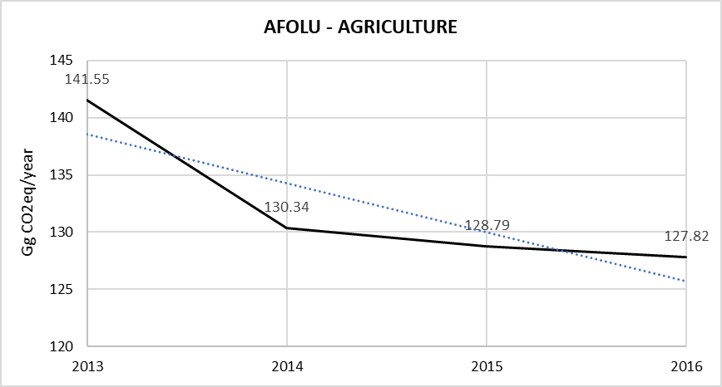

**Source :** Analysis using IPCC tier 1 & 2

Table 87. Methane Emission from Livestock for the period 2014 – 2016

|  |  |  |  |
| --- | --- | --- | --- |
| **Year** | **CO2eq. emission from enteric fermentation of Livestock** | **CO2eq. emission from  manure management** | **Total** |
| **2014** | 14.91 | 3.27 | 18.18 |
| **2015** | 14.88 | 3.31 | 18.19 |
| **2016** | 13.35 | 3.30 | 16.65 |

Figure 47. CO2 emission from Manure management and enteric fermentation

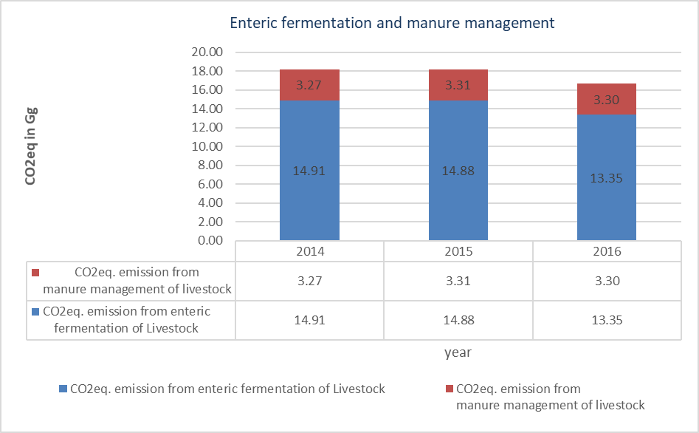

### Quality Control

Most of the data have been obtained from Statistics Mauritius and which shows the reliability and authenticity of the data base. The Statistics Mauritius present these data annually in the Digest of Agriculture and Environment Statistics as published in their page. The values used in this inventory have been obtained from these annual statistics.

On the other hand, and in order to ensure the use of right data in the inventory, some of the QC implemented during the data collection and emission estimation is listed below:

* Cross verification between data provided via mail by the Climate Change Division (CCD), FAREI and data reported in the national Statistics Mauritius.
* Cross verification between data provided by institutional authorities (MCIA) and the default values proposed by the IPCC 2006 Guidelines for AFOLU sector.
* Cross verification between the GHG emissions estimated in the current inventory for AFOLU sector and the results obtained in the last reported national inventory of the RoM.

**Activity data check:** The livestock data collection methods were reviewed, in particular checking that livestock for each species/sub species data were collected and aggregated correctly with consideration for the duration of production cycles and for imported animals. The data were cross-checked with previous years to ensure the data were reasonable and consistent with the expected trend. As the emission in AFOLU sector is mostly from direct and indirect emission N2O emission on land and livestock in Republic of Mauritius.

**Source specific verification (Quality control):** The Principal Research Scientist (Animal Production) from FAREI assessed the quality of the data, determined the conformity of the procedures which were followed for the compilation of this inventory and to identify areas of improvement.

**Quality and reliability of data:** All data collected was done using local expertise, experience in this sector and to the best of knowledge.

### Uncertainty Assessment and Time-series Consistency

The method used was that from the 2006 IPCC guideline and software. Uncertainties have not been considered in this National GHG Emission Inventory for activity data used. Despite this, activity data used for the inventory are obtained from the same information sources used in the last national inventory, for that reason, uncertainties for activity data would be in line with the results for uncertainties calculated and reported in the 2013 Inventory. However, as per IPCC 2006 guidelines, Ch10 TABLE 10.15 and 10.19, the combined uncertainty in the AD and in EF is +30% for methane emission and the uncertainty in N2O estimates is +50% from manure management of livestock respectively.

### Recalculations

No recalculations have been carried out in AFLOU sector during the elaboration of this inventory for the period from 2014, 2015 and 2016. However, recalculation is required for pre-2014 period up till TNC. Over/under estimations can be seen with various lowered calculations. Time series data for AFOLU sector is required for actual estimations of GHG emissions.

### Planned Improvements

* Primary data are collected by FAREI extension services and compiled by the Biometry Division for submission to the Statistic Mauritius.
* Application of GIS and remote sensing for data capture for land acreage under food crops, tea and fruits is required for the latest assessment.
* Tier 1 methodology and default EF have been used for the agricultural sector that may not be appropriate for local conditions and carry large uncertainties as RoM being a SIDS country. It is therefore important to develop local EF so the GHG emissions from agriculture can be accurately assessed as possible.
* The potential of GHG sequestration in tea plantation and orchards have not been adequately accounted for in the GHG inventory and new approach need to be developed to assess the tea plantation and other orchards GHG sequestration.

## Land (Category 3B)

The land use category is subdivided into the six IPCC land subcategories, namely: Forestland, Cropland, Grassland, Settlements, Wetlands and Other lands. Each of the 2006 IPCC categories is briefly described below.

**Forestland (Sub-category 3B1)**

Greenhouse gas emissions and removals per hectare vary according to site factors, forest or plantation types, stages of stand development and management practices. It is good practice to stratify Forest Land into various subcategories to reduce the variation in growth rate and other forest parameters and to reduce uncertainty.

In RoM, there is no legal definition for forestland. However, any land area of 0.5 ha or more and having a natural or planted forest tree canopy cover of 30% or more is considered as forestland. Forestland includes plantations and natural forest. This category covers estimation of CO2 removals and includes above-ground biomass and the soil carbon pool. There has been very little change in the forested areas across the time series. However, the reason that remaining forestland is a net sink is because there is an increase in the standing biomass per hectare.

The total extent of forest cover in Mauritius is estimated at 47066 Hectares representing about 25% of the total land area. There are only two types of forest ownership: public and private.

Total forest area decreased by 3 hectares from 47,069 hectares in 2015 to 47,066 hectares in 2016. Some 22,066 hectares (47%) of the total forest area in 2016 was state-owned and the remaining 25,000 hectares (53%) was privately-owned.

Out of the 22,066 hectares of state-owned forest area, 12012 hectares (54.4%) were planted areas while the Black River Gorges National Park and the nature reserves accounted for 6,574 (29.8%) and 799 (3.6%) hectares respectively. “Pas Geometriques” covered about 623 hectares (2.8%), other nature parks, 906 hectares (4.1%) and other forest lands, 1,366 hectares (6.2%).

Rodrigues’ island has more than 4,000 ha of forest area (out of a total of 10,500 ha). The forest formations are all composed of fast growing "exotic" species: *Acacia nilotica, Casuarina equisetifolia, Eucalyptus tereticornis, Terminalia catappa,Syzygium jambos, Pongamia pinnata*. For this NIR, almost all forestlands have been considered as Forest Land Remaining Forest Land when compiling the inventory. The detailed assessment of other lands in Rodrigues will be conducted in future inventory planned during the development of Fourth National Communication.

Both the native and planted forests are considered, as they are all managed. They have been classified according to types and ecological zone to be used in the 2006 IPCC Inventory Software. Timber exploitation is carried out mainly in planted forests under Pine and Eucalyptus species. Both these species are moderately resistant to cyclones and suffer substantial damage during their passages. The amount of carbon stored through biomass increment exceeds by far the amount lost through commercial felling, fuel wood gathering and disturbances such as cyclones and fires.

Timber exploitation is limited and there has been decreasing trend in timber local production.

Figure 48. Timber local production

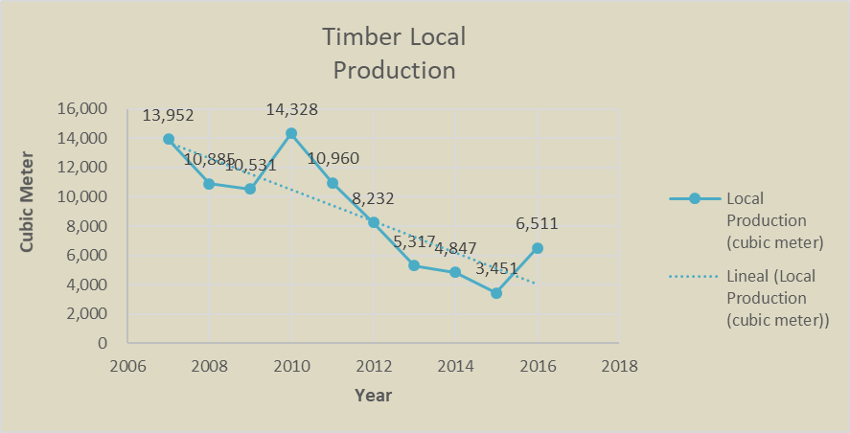

The sub classes include:

* Dry land (*Araucaria columnaris, Araucaria cunninghamii Casuarina equisetifolia, Eucalyptus tereticornis, Tabebuia pallida*, Scrubland forest);
* Mangrove forest;
* Moist Forest (*Araucaria columnaris, Eucalyptus tereticornis, Eucalyptus robusta, Tabebuia pallida*, amongst others, Scrubland forest, Natural forest);
* Wet upland forest (*Eucalyptus robusta, Cryptomeria japonica, Pinuselliottii, Araucaria columnaris*, amongst others); and
* Natural Forest.

**Cropland (Sub-category 3B2)**

Cropland includes arable and tillable land, rice fields, and agroforestry systems where the vegetation structure falls below the thresholds used for the Forest Land category and is not expected to exceed those thresholds at a later time. Cropland includes all annual and perennial crops as well as temporary fallow land (i.e., land set at rest for one or several years before being cultivated again). Annual crops include cereals, oils seeds, vegetables, root crops and forages. Perennial crops include trees and shrubs, in combination with herbaceous crops (e.g., agroforestry) or as orchards, vineyards and plantations such as cocoa, coffee, tea, oil palm, coconut, rubber trees, and bananas, except where these lands meet the criteria for categorisation as Forest Land. Arable land, which is normally used for cultivation of annual crops, but which is temporarily used for forage crops or grazing as part of an annual crop-pasture rotation (mixed system) is included under cropland.

In Republic of Mauritius Cropland comprises mostly sugarcane cultivation which covers about 51476 ha (2016) or 26% of the total surface area (Statistics Mauritius 2016). Since the late 1990s, cropland has been declining due to abandonment and conversion of sugarcane lands to other crop activities and conversion to habitat. The sub classes considered are:

* Fruits;
* Mixed Cropping;
* Orchard;
* Sugarcane;
* Tea; and
* Cropland Trees.

**Grassland (Sub-category 3B3)**

Grasslands are generally distinguished from “forest” as ecosystems having a tree canopy cover of less than a certain threshold, which varies from region to region. Below-ground carbon dominates in grassland and is mainly contained in roots and soil organic matter. The transition along rainfall or soil gradients from grassland to forest is often gradual. Many shrublands with high proportions of perennial woody biomass may be considered to be a type of grassland and countries may elect to account for some or all of these shrublands in the Grassland category.

According to 2006 IPCC Guidelines, this category includes range lands and pastureland that are not considered Cropland. It also includes systems with woody vegetation and other non-grass vegetation such as herbs and brushes that fall below the threshold values used in the Forest Land category. The category also includes all grassland from wild lands to recreational areas as well as agricultural and silvi-pastural systems, consistent with national definitions.

In RoM, this category includes land that are left as unoccupied that are invaded by bushes and a few patches of trees, part of hunting areas in private forests and along mountain sides. Since they include some woody biomass, they have been accounted for.

**Wetlands (Sub-category 3B4)**

Wetlands include any land that is covered or saturated by water for all or part of the year, and that does not fall into the Forest Land, Cropland, or Grassland categories. Managed wetlands will be restricted to wetlands where the water table is artificially changed (e.g., drained or raised) or those created through human activity (e.g., damming a river). Emissions from unmanaged wetlands are not estimated.

This category in RoM is considered to be managed as reservoirs and rivers and their surrounding areas. Hence, the trees around them have been considered. However, the 2006 IPCC Guidelines does not provide methods to account for these sinks and therefore the calculations have been included in forests. This also includes mangroves which are classified in the forest’s categorisation.

**Settlements (Sub-category 3B5)**

Settlements are defined as including all developed land -- i.e., residential, transportation, commercial, and production (commercial, manufacturing) infrastructure of any size, unless it is already included under other land-use categories. The land-use category Settlements includes soils, herbaceous perennial vegetation such as turf grass and garden plants, trees in rural settlements, homestead gardens and urban areas. Examples of settlements include land along streets, in residential (rural and urban) and commercial lawns, in public and private gardens, in golf courses and athletic fields, and in parks, provided such land is functionally or administratively associated with particular cities, villages or other settlement types and is not accounted for in another land-use category.

The trees within the compounds of houses, along roads, parks and others within settlements form an additional sink of carbon in Republic of Mauritius.

**Other Land (Sub-category 3B6)**

Other Land includes bare soil, rock and all land areas that do not fall into any of the other five land-use categories. Other Land is often unmanaged, and in that case changes in carbon stocks and non-CO2 emissions and removals are not estimated. This is because the conversion is associated with changes in carbon stocks or non-CO2 emissions, most importantly those associated with conversions from Forest Land. According to the 2006 IPCC Guidelines, this land‐use category is included to allow the total of identified land areas to match the national area and there is no need to estimate emissions from it.

***The Land Cover and Use***

Figure 49. Land Cover of Mauritius (Circa 2010)

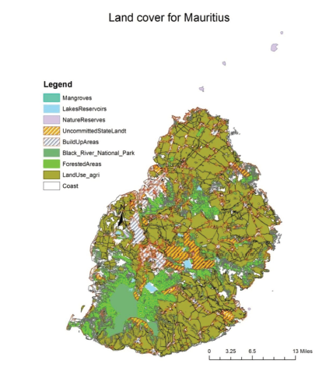

The land cover in RoM has been classified according to ecological zones and these include climate type. The different land classes considered, as described above, is presented in Figure below.

Figure 50. Portion of the scanned 1:25,000 scale map. Circled area shows mountains and wasteland (see text)

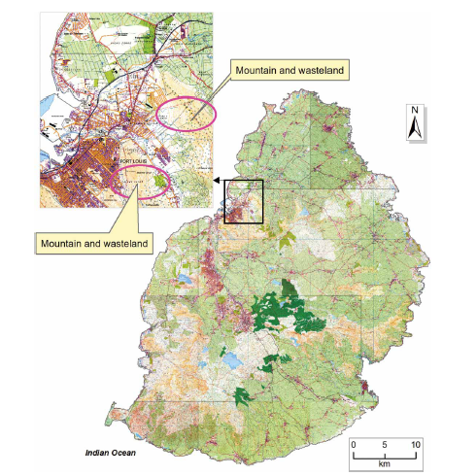

***Source:*** Journal of Maps (2014) <https://www.tandfonline.com/doi/pdf/10.1080/17445647.2014.926297?needAccess=true>

***Land Cover Change Assessment***

According to the GIS data base used in the recent study by International Institute for Applied Systems Analysis (IIASA), Mauritius has a total land surface area of 186,540 ha. The cultivated land is 99,580ha, or 53percent of the total area of the island. Around 8percent is occupied by built-up areas. The remaining land consists of forests (11%), scrub land, grassland, woodland (27%), and reservoirs and other inland water (0.6%).

An assessment of land use change was made using a national methodology, which is still under development. The methodology uses satellite imagery from online sources as developed by the US Forest Department (USDA 2014) and has been used in a few studies (e.g. Song et al. 2012). Since longer time slots change are not available a 10 to 12 years change is adopted. The estimates are as presented in table below:

Table 88. Land Cover Change of RoM



The above estimates were verified against other publications such as Digest of Agriculture and Environment, Statistics of Mauritius, study by Fischer et al. (2013), MSIRI map and others to calibrate the land classifications and their proportions. However, the latest land classification which uses FAO forest classes is not applicable in Mauritius being a SIDS.

**Forest Land (Category 3B1)**

Greenhouse gas emissions and removals per hectare vary according to site factors, forest or plantation types, stages of stand development and management practices. It is good practice to stratify Forest Land into various sub-categories to reduce the variation in growth rate and other forest parameters and to reduce uncertainty

* The carbon stock in forests changes is due to:
* biomass increments in forests;
* losses from deforestation;
* harvesting of round wood and fuel wood;
* disturbances such as fires;
* cyclones; and
* Pests and diseases.

Greenhouse gas inventory for Forest Land remaining Forest Land (FF)involves estimation of changes in carbon stock from five carbon pools (i.e., above-ground biomass, below ground biomass, dead wood, litter, and soil organic matter), as well as emissions of non-CO2 gases.

The 2006 IPCC Guidelines were used for the estimation of the emissions of the forest sector.CO2 emissions from living biomass, dead organic matter and soil were calculated using a Tier 1approach. In accordance with this approach, net change of CO2 for dead organic matter is equal to zero as it is assumed that the average transfer rate of CO2 into the dead wood pool is equal to transfer rate out of the dead wood pool.

### Source Category Description

The forestry sector includes all activities dependent on forests, trees and other woody vegetation, and all industries based on them. It has numerous interactions and linkages with other sectors, such as agriculture, water, environment, tourism and communications.

The native forests which originally covered most of the island have almost completely disappeared except for a few inaccessible areas, which have been spared the onslaught of deforestation. These areas have now been converted to national parks, nature reserves or other protected areas. Large areas of degraded, upland native forests have since been re-afforested with fast growing exotics that form the bulk of the forest plantations.

The total extent of forest cover in Mauritius is estimated at 47,066 Hectares representing about 25% of the total land area. There are only two types of forest ownership: public and private.

Total forest area decreased by 3 hectares from 47,069 hectares in 2015 to 47,066 hectares in 2016. Some 22,066 hectares (47%) of the total forest area in 2016 was state-owned and the remaining 25,000 hectares (53%) was privately-owned.

Out of the 22,066 hectares of state-owned forest area, 12,012 hectares (54.4%) were planted areas while the Black River Gorges National Park and the nature reserves accounted for 6,574 (29.8%) and 799 (3.6%) hectares respectively. “Pas Geometriques” covered about 623 hectares (2.8%), other nature parks, 906 hectares (4.1%) and other forest lands, 1,366 hectares (6.2%).

Approximately 14605 ha of land, including some 2593 ha of privately-owned land, are covered with planted forests. The remaining are natural forests, most of which are badly degraded. Only around 2% of the land area of Mauritius is considered to be covered with good quality native forests.

A mangrove rehabilitation and propagation programme were initiated in 1995 by the Albion Fisheries Research Centre of the then Ministry of Fisheries and Co-operatives and is still ongoing with the active involvement of NGOs. As a result, the mangrove area has increased from 14.8 ha in 2012 to 19.8 ha in 2016 and there has been significant increase in mangrove plantation to the level of 33%.

Native species are not commercially logged in RoM and are now legally protected by the Native Terrestrial Biodiversity and National Parks Act (2015). Only exotic plantation is commercially harvested in RoM. However, in line with the National Forest Policy (2006), timber exploitation is gradually being phased out and exotic species are gradually being replaced by native species.

As a result, the harvested round wood and firewood has steadily decreased from 5,332 m3/year and 7,067 m3/year respectively in the inventory year 2007 to 1,155 m3/year and 5178 m3/year respectively in the inventory year 2016.

Table 89. Harvest of Round Wood and Fuel Wood Gathering

|  |  |  |  |  |
| --- | --- | --- | --- | --- |
| **Year** | **Total Local  Production (cubic meter)** | **Timber (cub. Meter)** | **Fuelwood  (cub. Meter)** | **Poles** |
| 2007 | 13,952 | 5,332 | 7,067 | 1,553 |
| 2008 | 10,885 | 4,330 | 5,271 | 1,284 |
| 2009 | 10,531 | 3,807 | 5,482 | 1,242 |
| 2010 | 14,328 | 3,696 | 9,412 | 1,220 |
| 2011 | 10,960 | 3,207 | 6,472 | 1,281 |
| 2012 | 8,232 | 2,354 | 5,077 | 801 |
| 2013 | 5,317 | 948 | 3,885 | 484 |
| 2014 | 4,847 | 976 | 3,611 | 260 |
| 2015 | 3,451 | 598 | 2,685 | 168 |
| 2016 | 6,511 | 1,155 | 5,178 | 178 |

### Methodological Issues

All forest data are available at the Forestry Service. The growing stock data were obtained from Global Forest Resource Assessment for RoM (2005, 2010 and 2015). The growing stock data were available for the following species: *Pinus elliottii*, *Eucalyptus sp*, *Araucaria sp*, *Tabebuia pallida*, *Cryptomeria japonica* and *Casuarina equisetifolia*. Forest coverage data harvested wood and area affected by disturbances were available in Forestry Service Annual Reports till 2016.

The methodologies and equations used are those available in the 2006 IPCC Guidelines. Most of the country specific factors were not available (basic wood density, biomass expansion factors, root-to-shoot ratio, amongst others). The removal factors utilised were mostly default values.

**Estimating Change in Carbon Stocks in Biomass on Forestlands**

The annual increase in biomass carbon stock is estimated using Equation 2.9, where area under each forest sub-category is multiplied by mean annual increment in tonnes of dry matter per hectare per year.

* Since the biomass growth is usually in terms of merchantable volume or above-ground biomass, the belowground biomass is estimated with a below-ground biomass to above-ground biomass ratio (Equation 2.10). Alternatively, merchantable volume (m3) can be converted directly to total biomass using biomass conversion and expansion factors (BCEFI), (Equation 2.10).
* If BCEFI values are not available and if the biomass expansion factor (BEF) and basic wood density (D) values are separately estimated, then the following conversion can be used:

BCEFI = BEFI ● D

#### Calculations

Annual increase in biomass carbon stocks (Gain-Loss Method), ΔCG – (Land remaining in same land use category):

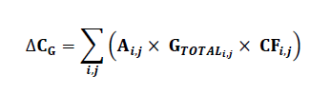

Where,

* ΔCG = annual increase in biomass carbon stocks due to biomass growth in land remaining in the same
* land-use category by vegetation type and climatic zone, tonnes C yr-1
* A = area of land remaining in the same land-use category, ha
* GTOTAL= mean annual biomass growth, tonnes d. m. ha-1 yr-1
* *i* = ecological zone (*i* = 1 to *n*)
* *j* = climate domain (*j* = 1 to *m)*
* CF = carbon fraction of dry matter, tonne C (tonne d.m.)-1

Equation 2.9 page, 2.15, Vol 4, 2006 IPCC Guidelines

**Average annual increment in biomass (GTOTAL):**

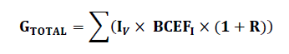

Where,

* GTOTAL = average annual biomass growth above and below-ground, tonnes d. m. ha-1 yr-1
* R = ratio of below-ground biomass to above-ground biomass for a specific vegetation type, in tonne d.m. below-ground biomass (tonne d.m. above-ground biomass)-1. R must be set to zero if assuming no changes of below-ground biomass allocation patterns (Tier 1).
* IV = average net annual increment for specific vegetation type, m3 ha-1 yr-1
* BCEFI = biomass conversion and expansion factor for conversion of net annual increment in volume (including bark) to above-ground biomass growth for specific vegetation type, tonnes above-ground biomass growth (m3 net annual increment)-1

(Equation 2.10- page, 2.15, Vol 4, 2006 IPCC Guidelines).

**Biomass carbon stocks losses (Gain-Loss Method), ΔCL**

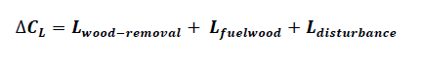

Where,

* Δ CL = annual decrease in carbon stocks due to biomass loss in land remaining in the same land-use category, tonnes C yr-1
* Lwood-removals = annual carbon loss due to wood removals, tonnes C yr-1
* L fuelwood = annual biomass carbon loss due to fuelwood removals, tonnes C yr-1
* L disturbance = annual biomass carbon losses due to disturbances, tonnes C yr-1

(Equation 2.11, Vol 4, Page 2.16, 2006 IPCC Guidelines)

Note: for equations Lwood-removals, Lfuelwood and Ldisturbance (Equation 2.12, 2.13 and 2.14 pg 2.17-2.18, 2006 IPCC Guidelines)

***Biomass: Land Converted to Other Land-Use Category***



Where,

* ΔCB = annual change in carbon stocks in biomass on land converted to other land-use category, in tonnes C yr-1
* ΔCG = annual increase in carbon stocks in biomass due to growth on land converted to another land-use
* category, in tonnes C yr-1
* ΔCCONVERSION = initial change in carbon stocks in biomass on land converted to other land-use category, in tonnes C yr-1
* ΔCL = annual decrease in biomass carbon stocks due to losses from harvesting, fuel wood gathering and disturbances on land converted to other land-use category, in tonnes C yr-1

(Equation.2.15, page 2.20, Vol 4, 2006 IPCC Guidelines)

Initial change in biomass carbon stocks in Land Converted to Other Land-Use Category *

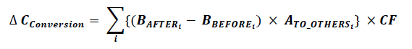

Where,

* ΔCCONVERSION = initial change in biomass carbon stocks on land converted to another land category, tonnes C yr-1
* BAFTERi= biomass stocks on land type immediately after conversion, t d.m.ha-1
* BBEFOREi= biomass stocks on land type before conversion, t d.m. ha-1
* ΔATO_OTHERSi= area of land use converted to another land-use category in a certain year, ha yr-1
* CF = carbon fraction of dry matter, tonne C (t d.m.)-1
* i= type of land use converted to another land-use category

(Equation 2.16, Page 2.20, Vol 4, 2006 IPCC Guidelines)

**Change in C stocks in DOM: Land Remaining in the Same Land Use**

* Tier 2 methods for estimation of carbon stock changes in DOM pools calculate the changes in dead wood and litter carbon pools by Gain-Loss Method (GPG LULUCF provides guidance on DOM only for FL)
* These estimates require either detailed inventories that include repeated measurements of dead wood and litter pools, or models that simulate dead wood and litter dynamics.



Where,

* A = area of managed land, ha
* DOMin = average annual transfer into DW/litter pool (due to mortality, slash due to harvest and natural disturbance),t d.m./ha/yr
* DOMout = average annual transfer out of DW/litter pool, t d.m./ha/yr
* CF = carbon fraction of dry matter, tC/(t d.m.)

(Equation 2.18, page 2.23, Vol 4, 2006 IPCC Guidelines)

### Results

The Net CO2 emissions resulting from: (i) the land remaining the same and (ii) the land converted to other land use was estimated for the period 2013 to 2016. The land use sector represented a net removal of CO2 for the period 2013 to 2016. Forestland remaining forestland represented a net carbon sink form living biomass during the period 2006-2013, as shown in the table below. Very little variation in the total CO2 removal was observed for this land category with the average being -367 Gg CO2-eq.

Table 90. GHG removals in AFOLU sector

|  |  |
| --- | --- |
| **Year** | **FOLU - GHG removals** |
| 2013 | -367.56 |
| 2014 | -366.90 |
| 2015 | -368.70 |
| 2016 | -363.30 |

Figure 51. GHG removals in AFOLU sector, 2013 – 2016

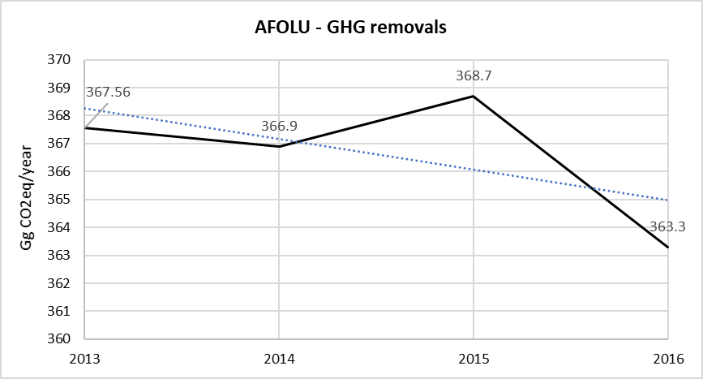

***Source:*** *Digest Env, Statistics Mauritius*

### Quality Control

All the field data collected (e.g. Plantation sites, area, silvicultural practices, dbh, tree height, volume of forest produce harvested, among others) are verified at every stages by the Forestry Service of Mauritius and the same is reported regularly to the Statistics of Mauritius which then reports the total amount of emission reduction, harvesting of wood, plantation details in Digest of Environment which is published annually by the Statistics of Mauritius. The values used in this inventory have been obtained from these annual statistics.

On the other hand, and in order to ensure the use of right data in the inventory, some of the QC implemented during the data collection and emission estimation is listed below:

* Cross verification between data provided via mail by institutional authorities and data reported in the national statistics of Mauritius.
* Cross verification between the GHG emissions and removals estimated in the current inventory for AFLOU sectors and the results obtained in the last reported national inventory of the RoM.

### Uncertainty Assessment

Uncertainties as identified during the process of BUR and 2nd NIR development are as follows:

* Land use, land use changes and latest data on conversion of land and its GIS mapping
* Uncertainty in the stock change/emission factors for Tier 1 or 2 approaches (carbon increase and loss, carbon stocks, and expansion factor terms); and
* Uncertainty in model structure/parameter error for Tier 3 model-based approaches, or measurement error/sampling variability associated with a measurement-based inventories.
* Data validation and ground truthing is essential to have proper estimation.

It is concluded from the tables above, that the greatest source of uncertainty corresponds to the emission factors due to the use of default factors and therefore to the absence of country specific factors.

### Recalculations

Major recalculation is required for pre-2014 period up till TNC. Over/under estimations can be seen with various lowered calculations. This calls for a humungous re-assessment (beyond the scope of ToR) of previous work for proper estimation of GHG emissions from the AFLOU sector

### Planned Improvements

During the development process of Biennial Update Report and 2nd NIR, the major data gaps identified were lack of data and maps for general land cover changes and land uses for the past ten years and lack of data on private forests lands. Proper estimation of private forest needs to be assessed for estimation of exact carbon dioxide sequestration from the private forests.

To address some of these gaps the adoption of GIS and remote sensing with complementary ground truthing exercise is essential. However, because of the untimely acquisition of historical and current high-resolution satellite imagery, new land cover and time series of land use maps could not be produced for the current NIR.

Land cover maps produced will have to be overlaid with climatic and soil maps and data reprocessed to produce a time series of land use maps.

In order to move to a higher tier approach for future NIRs, the whole forest inventory system will have to be reviewed. Improved data collection and record keeping including distribution of forest by species, age class distribution and biomass estimates is essential for both natural and plantations. Actions aimed at simulations, creation and verification of country specific emissions/removals factors (annual net increment in volume, basic wood density, biomass expansion factors, root-to-shoot ratio, amongst others) will be having to be explored.

Data on mangrove plantation and carbon sequestration from the same need to be assessed with appropriate methodology and country specific carbon sequestration approach.

## Aggregate Sources and non-CO2 Emissions Sources on Land (3.C)

Agriculture occupied around 30% of the land area of RoM in 2016. There has been ongoing decrease of agricultural land over the years, mainly due to a decrease in the area under sugar cane for economic reasons, and the expansion of settlements and infrastructures.

The agricultural sector is dominated by sugar cane, which is planted on around 87 % of the arable land, the rest being used for food crops (general vegetables and ornamentals), fruits, tea and livestock production. The extent of land under the different agricultural land use in 2016 is given in table below.

Table 91. Harvested Area and Production in 2016

| **Crops** | **Area harvested (hectares)** | **Production (tons)** |
| --- | --- | --- |
| Sugarcane | 51,476 | 3,798,448 |
| Tea | 622 | 7,301 |
| Potato | 789 | 16,854 |
| Pumpkin | 526 | 7,002 |
| Rice (paddy) | 161 | 352 |
| Squash | 76 | 554 |
| Sweet potato | 41 | 471 |
| Tomato | 730 | 10,137 |
| Pineapple | 417 | 9,707 |

**Source:** Digest of Agricultural Statistics 2016

Synthetic fertilisers are extensively used in the production of sugar cane and food crops. In addition, compost and manure from the livestock sector and scum are also used as organic fertilisers in sugar cane and food crop production.

This category combines 3.C.4 and 3.C.5.

### Source Category Description

In most soils, an increase in available N enhances nitrification and denitrification rates which then increase the production of N2O. Increases in available N can occur through human-induced N additions or change of land-use and/or management practices that mineralize soil organic N. In Republic of Mauritius the contribution to direct emissions from the agricultural soils occur mainly from the use of synthetic N fertiliser, recycling of crop residues and organic N applied as fertiliser (e.g., animal manure, compost, sewage sludge, rendering waste).

Emissions also occur from soil organic matter mineralisation during such practices like ploughing and tillage. The indirect emissions of nitrous oxide arise mainly from atmospheric of N deposition and from leaching and surface runoff of applied N mineralised into groundwater and surface water.

Rice cultivation is undertaken over a limited area without flooding, and therefore, has been included as a normal crop.

### Methodological Issues

Nitrous oxide (N2O) is produced naturally in soils through the microbial processes of nitrification and denitrification. A number of agricultural activities add nitrogen (N) to soils, increasing the amount of nitrogen available for nitrification and denitrification, and ultimately the amount of N2O emitted. The emissions of N2O that result from anthropogenic N inputs occur through both a direct pathway (i.e. directly from the soils to which the N is added), and through two indirect pathways (i.e. through volatilisation as NH3 and NOx and subsequent redeposition, and through leaching and runoff). In the 2006 IPCC Guidelines, direct and indirect emissions of N2O from agricultural soils are estimated separately.

The 2006 IPCC Guidelines method for estimating direct N2O emissions from agricultural soils has two parts: (i) estimation of direct N2O emissions due to N-inputs to soils (excluding N-inputs from animals on pasture, range, and paddock); and (ii) estimation of direct N2O emissions from unmanaged animal manure (i.e. manure deposited by animals on pasture, range, and paddock).

The 2006 IPCC Guidelines were used to estimate emissions from agricultural soils. The guidelines divide the Agricultural Soil Management source category into five components:

* direct emissions due to N additions to cropland and grassland mineral soils, including synthetic fertilisers, sewage sludge applications, crop residues, organic amendments, and biological N fixation associated with planting of legumes on cropland and grassland soils;
* direct emissions from soil organic matter mineralisation due to land use and management change;
* direct emissions from drainage of organic soils in croplands and grasslands;
* direct emissions from soils due to the deposition of manure by livestock on grasslands; and
* indirect emissions from soils and water due to N additions and manure deposition to soils that lead to volatilisation, leaching, or runoff of N and subsequent conversion to N2O.

In RoM, emissions were estimated for direct N2O emissions from synthetic N fertilisers and manure/compost application, indirect N2O emissions from leaching and runoff, indirect N2O emission from atmospheric N deposition and direct N2O from crop residues. A Tier 1 methodology was applied to the extent that only few country specific emission factors were used in the inventory.

Direct and indirect N2O emissions were estimated using the 2006 IPCC Inventory Software Version 2.17 (2016) which is based on the 2006 IPCC Guidelines.

#### Calculations

Emissions from managed soils were calculated using a Tier 1 method according to the IPCC Inventory Software which is based on the 2006 IPCC Guidelines. The equation 11.1, from Chapter 11, 2006 IPCC Guidelines, was however adapted to local conditions, as far as certain activities were excluded from it because of their limited extent in the local context. For instance, no flooded rice is practiced, and the use of carbonated lime is not occurring.

The equation for direct N2O emission is as follows:



Where,

N2O – NN inputs = [(FSN + FON + FCR) × EFl]

N2O – NPRP = [FPRP,CPP × EF3PRP,CPP) + ( FPRP,SO × EFPRP,SO)]

Where,

N2ODirect– N = annual direct N2O – N emissions produced from managed soils (kg N2O – N yr-1);

N2O – NN inputs = annual direct N2O – N emissions from N inputs to managed soils (kg N2O– N yr-1)

N2O – NPRP= annual direct N2O – N emissions from urine and dung inputs to grazed soils (kg N2O – N yr-1)

FSN = annual amount of synthetic fertiliser N applied to soils (kg N yr-1)

FON = annual amount of animal manure, compost, sewage sludge and other organic N additions applied to soil (kg N yr-1)

FCR = annual amount of N in crop residues, including N- fixing crops, and forage/pasture renewal, returned to soils (kg N yr-1)

FPRP = annual amount of urine and dung N deposited by grazing animals on pasture, range and paddock (kg N yr-1)

CPP = Cattle, Poultry and Pigs, SO = Sheep and Other;

EFl = emission factor for N2O emissions from N inputs (kg N2O – N (kg N input)-1);

EF3PRP = emission factor for N2O emissions from urine and dung N deposited on pasture, range and paddock by grazing animals (kg N2O – N (kg N input)-1), CPP = Cattle, Poultry and Pigs, SO = Sheep and Other.

#### Activity Data

To estimate direct and indirect N2O emissions from managed soils, the 2006 IPCC Guidelines encourage, as far as possible, detailed activity data collection, in order to generate good estimate of emissions from agricultural soils. In this context the following activity data were collected locally:

* Application rates of nitrogenous fertilisers and national consumption;

The nitrogen was estimated by considering both local production and imports in estimating the amount of fertiliser applied to land (i.e., data from Statistics Mauritius and FAREI). Crop area data for food crop were obtained from Digest of Agricultural Statistic 2017.

Data on the areas harvested and the yield for some thirty crops cultivated as well as areas under some common fruits, like banana and pineapple was available from the Biometry Division of FAREI and Statistics Mauritius.

Data on the use of compost, animal manure and other organic input on soil were based on an estimate of the annual number of heads available at the Livestock Department of FAREI as well as from Statistics Mauritius.

The activity data for determining emission from managed soils summarised in the tables below.

Table 92. Agricultural crops – Area harvested and production, 2014 – 2016

|  |  |  |  |  |  |  |
| --- | --- | --- | --- | --- | --- | --- |
| **Years** | **2014** | | **2015** | | **2016** | |
| **Area harvested (ha)** | **Production (tons)** | **Area harvested (ha)** | **Production (tons)** | **Area harvested (ha)** | **Production (tons)** |
| Sugarcane | 50,694 | 4,044,422 | 52,387 | 4,009,232 | 51,477 | 3,798,448 |
| Tea | 672 | 7,607 | 574 | 6,732 | 622 | 7,301 |
| Potato | 821 | 19,404 | 707 | 16,427 | 789 | 16,854 |
| Pumpkin | 477 | 6,980 | 423 | 5,713 | 526 | 7,002 |
| Rice (paddy) | 412 | 1,186 | 340 | 657 | 161 | 352 |
| Squash | 79 | 659 | 92 | 702 | 76 | 554 |
| Sweet potato | 59 | 780 | 52 | 686 | 41 | 471 |
| Tomato | 857 | 10,997 | 740 | 8,525 | 730 | 10,137 |
| Pineapple | 450 | 10,788 | 523 | 11,693 | 417 | 9,707 |

***Source:*** *Digest of Agriculture 2016, RoM*

Table 93. Summary N Inorganic Fertiliser used on Cropland for the whole Island[8]

| **Year** | **Cropping Area (ha)** | **Average N application kg N/ha** | **Total N consumption *kg N/yr** |
| --- | --- | --- | --- |
|
| 2006 | 79,255 | 95 | 7,529,225 |
| 2007 | 76,533 | 95 | 7,270,635 |
| 2008 | 72,981 | 93 | 6,807,140 |
| 2009 | 74,171 | 89 | 6,616,456 |
| 2010 | 72,927 | 102 | 7,468,310 |
| 2011 | 70,531 | 111 | 7,834,140 |
| 2012 | 66,765 | 145 | 9,700,004 |
| 2013 | 65,967 | 151 | 9,967,255 |
| 2014 | 59,525 | 127 | 7,559,675 |
| 2015 | 61,038 | 127 | 7,751,826 |
| 2016 | 59,864 | 127 | 7,602,728 |
| 2017 | 58,375 | 127 | 7,413,625 |

#### Emission Factors

The choice of emission factors for direct and indirect N2O emissions used are enumerated in the table below.

Table 94. Emission Factors used to calculate Direct and Indirect N2O Emissions from Managed Soil

| **Source of Emission** | **Parameter** | **Unit** | **EF** | **Source** |
| --- | --- | --- | --- | --- |
| **Direct N2O  emission from managed soil** | N in synthetic fertilizer | Kg N2O-N/kg N input | 0.01 | As per IPCC 2006 |
| N in animal manure, compost,  sewage sludge and other | Kg N2O-N/kg N input | 0.01 | As per IPCC 2006 |
| N in mineralized soil that is  mineralized in association with loss of soil C from soil organic matter as result of changes to land use or management | Kg N2O-N/kg N input | 0.01 | As per IPCC 2006 |
| N in crop residues | Kg N2O-N/kg N input | 0.01 | As per IPCC 2006 |
| **Indirect N2O  emission from managed soil** | Fraction of synthetic fertilizers that volatizes frac (GASF) | Kg NH3-N + NOx-N | 0.1 | As per IPCC 2006 |
| Fraction of applied organic N  fertilizer, urine and dung N deposited by grazing animal that volatilizes | Kg NH3-N + NOx-N | 0.2 | As per IPCC 2006 |
| Fraction of all N addition that is loss through leaching and run-off | Kg N/kg N additions | 0.3 | As per IPCC 2006 |
| N2O from N leaching/ run-off | Kg N2O -N/kg N  leaching / run-off | 0.0075 | As per IPCC 2006 |

### Results

Aggregated emissions from Agricultural Soils is 70 Gg CO2-eq in 2014.There has been a slight decrease in emission for this sector between 2014 and 2016 to 68.4 Gg CO2-eq. Overall, there has not been any significant variation in GHG emissions over the inventory years, attributed mainly to stable acreage of land under cultivation and amount of fertiliser use. The following tableshows the GHG Emissions in Gg CO2-eq, from Agricultural Soils.

Table 95. GHG Emissions (Gg CO2eq) from Agricultural Soils

|  |  |  |
| --- | --- | --- |
| **Year** | **Direct N2O emissions from managed soils CO2eq.** | **Indirect Emission from managed soils CO2eq.** |
| **2014** | 52.28 | 17.4 |
| **2015** | 49.65 | 16.55 |
| **2016** | 51.33 | 17.11 |

### Quality Control

The activity data were gathered mainly from officially published national documents such as Digest of Agricultural Statistics and FAREI. All the data appearing in these official documents were further cross checked with relevant institutions working in their respective sectors.

All calculations made during the exercise used approved standardised procedures for emissions calculations, measurements and documentations as per the 2006 IPCC Guidelines. Furthermore, the inventory process was carried out under close supervision of the local and international consultants to ensure compliance with the 2006 IPCC Guidelines.

### Uncertainty Assessment

Uncertainties have not been considered in this National GHG Emission Inventory for activity data used. Despite this, activity data used for the inventory are obtained from the same information sources used in the last national inventory, for that reason, uncertainties for activity data would be in line with the results for uncertainties calculated and reported in the 2013 Inventory. In addition, the following major uncertainties were identified:

* Areas under the non-sugar crop were based on estimates due to lack of a comprehensive survey;
* Default IPCC emission factors were used, and this carried large variations which may not reflect local circumstances;
* In some cases, the use of expert judgement may not reflect the local situations;
* Some minor source categories have not been considered in the inventory calculation due to lack of data; and
* The emission inventory considers a single climatic and soil condition for the island, which therefore does not reflect the diverse conditions prevailing.

Uncertainty is a parameter which depends on many different factors, is the sum of the uncertainty of multiple factors (emission trend, activity data, emission factors, other parameters). In addition, this uncertainty is automatically estimated by the IPCC software, and this software is only capable to estimate using a Tier 1, no Tier 2. This is one of the inconveniences of using this software for the emission inventories.

The uncertainty can be improved, but it is required more detailed data for the activity data, emission factors and any other parameters involved in the emission estimates (not using defaults values from IPCC), and applying the Tier 2, that is, not using the IPCC software.

### Planned Improvements

In the AFOLU sector, the institution FAREI is working on developing country specific emission factor and this improvement could contribute to the achievement of higher tier level.

Forestry services is working on the forest data and in the near future data on private forests land will be available with State Forest department and thus the accurate carbon sequestration could be assessed for further improvement. Land use and land change need to be assessed through GIS and remote sensing to arrive at accurate information on cropping pattern and other plantation activities on the island. The GHG inventory in the future can also be improved by providing further capacity building to the inventory team. Data control, management, regular flow and verification at all level will ensure data accuracy.

# Waste

## Overview

Waste management is a major challenge faced worldwide, with this issue being even more pressing in small island developing states like Mauritius. Economic growth, urbanization, improvement of living standards, coupled with change in consumption patterns, create an exponential growth in waste generation.

CH4 emissions from SWDS are the largest source of greenhouse gas emissions in the Waste Sector, and CH4 emissions from wastewater treatment and discharge may also be important. On the other hand, incineration and open burning of waste containing fossil carbon are the most important sources of CO2 emissions in the Waste Sector.

It is important to mention that:

* CO2 is also produced in SWDS, wastewater treatment and burning of non-fossil waste, but this CO2 is of biogenic origin and is therefore not included as a reporting item in this sector.
* All greenhouse gas emissions from waste-to-energy, where waste material is used directly as fuel or converted into a fuel (biogas), have been estimated and reported under the Energy Sector.

### General Methodology

The general methodology used in the waste sector is collected in the following table:

Table 96. Methodology used for the Waste sector

|  |  |  |  |
| --- | --- | --- | --- |
| **Category** | **Activity Data** | **Emission Factor** | **Activity Data Source** |
| **4.A - Solid Waste Disposal** | | | |
| 4.A.1 - Managed Waste Disposal Sites | T2 | D, CS | Solid Waste Management Division, Statistics Mauritius |
| **4.B - Biological Treatment of Solid Waste** | T1 | D | Solid Waste Management Division, Statistics Mauritius |
| **4.C - Incineration and Open Burning of Waste** | | | |
| 4.C.1 - Waste Incineration | T1 | D | Solid Waste Management Division, Statistics Mauritius |
| **4.D – Wastewater Treatment and Discharge** | | | |
| 4.D.1 - Domestic Wastewater Treatment and Discharge | T1/T2 | D, CS | Wastewater Management Authority, Statistics Mauritius |
| 4.D.2 - Industrial Wastewater Treatment and Discharge | T1/T2 | D, CS | Wastewater Management Authority, Statistics Mauritius |

T1: Tier 1; T2: Tier 2; D: Default; CS: Country Specific; NO: Not Occurring; NA: Not Applicable; NE: Not Estimated

## Solid Waste Disposal – Managed Waste Disposal Sites (Category 4A1)

Treatment and disposal of municipal, industrial, and other solid waste produces significant amounts of methane (CH4). Decomposition of organic material derived from biomass sources (e.g., crops, wood) is the primary source of CO2 released from waste. These CO2 emissions are not included in national totals, because the carbon is of biogenic origin.

The IPCC methodology for estimating CH4 emissions from SWDS is based on the First Order Decay (FOD) method. This method assumes that the degradable organic component (degradable organic carbon, DOC) in waste decays slowly throughout a few decades, during which CH4 and CO2 are formed. If conditions are constant, the rate of CH4 production depends solely on the amount of carbon remaining in the waste. As a result, emissions of CH4 from waste deposited in a disposal site are highest in the first few years after deposition, then gradually decline as the degradable carbon in the waste is consumed by the bacteria responsible for the decay.

The FOD method requires data to be collected or estimated for historical disposals of waste over a period of 3 to 5 half-lives to achieve an acceptably accurate result. It is therefore good practice to use disposal data for at least 50 years as this time frame provides an acceptably accurate result for most typical disposal practices and conditions.

### Source Category Description

The Solid Waste Management Division is responsible for the setting up and operation of waste management facilities, including landfill and transfer stations whilst Local Authorities, which operate under the aegis of the Ministry of Local Government, are responsible for the collection and conveyance of domestic wastes to the five transfer stations across the Mauritius island. Domestic wastes are stored in appropriate storage receptacles by households.

With increasing population and change in lifestyle of Mauritians, the number of solid wastes landfilled has increased. In the year 2000, the Government Policy on solid waste management primarily focused on the closure of open dump sites and on regular collection of municipal solid wastes for landfilling.

According to the Solid Waste Management Division, the sanitary landfill in RoM is modern and well managed, with capping works to minimise methane emissions and engineering installations to abstract landfill gas (methane) for flaring and power generation.

### Methodological Issues

#### Calculation

The method presented in the 2006 IPCC Guidelines for calculation of CH4 emissions from landfills is based on the "first order decay" method (FOD method). The IPCC software has been used, so all required data and parameters have been included here to obtain the final CH4 emissions. As it was previously mentioned, it is therefore good practice to use disposal data for at least 50 years as this time frame, so activity data since 1960 have been considered.

The FOD method is described below, as well as the relevant activity data and parameters used for determining methane formation in landfills.

*CH4 Emissions = [Σ CH4 generatedx,T - RT] • [1-OXT]*

Where:

* CH4 Emissions = CH4 emitted in year T, Gg
* T = inventory year
* x = waste category or type/material
* RT = recovered CH4 in year T, Gg
* OXT = oxidation factor in year T, (fraction)

The amount of CH4 formed from decomposable material is found by multiplying the CH4 fraction in generated landfill gas and the CH4 /C molecular weight ratio.

*CH4 generatedT = DDOCm decompT • F •16 /12*

Where:

* CH4 generatedT = amount of CH4 generated from decomposable material
* DDOCm decompT = DDOCm decomposed in year *T*, Gg
* F = fraction of CH4, by volume, in generated landfill gas (fraction)
* 16/12 = molecular weight ratio CH4/C (ratio)

The CH4 potential that is generated throughout the years can be estimated based on the amounts and composition of the waste disposed into SWDS and the waste management practices at the disposal sites. The basis for the calculation is the amount of Decomposable Degradable Organic Carbon (DDOCm) as defined in next equation:

*DDOCm =W • DOC • DOCf •MCF*

Where:

* DDOCm = mass of decomposable DOC deposited, Gg
* W = mass of waste deposited, Gg
* DOC = degradable organic carbon in the year of deposition, fraction, Gg C/Gg waste
* DOCf = fraction of DOC that can decompose (fraction)
* MCF = CH4 correction factor for aerobic decomposition in the year of deposition (fraction)

With a first order reaction, the amount of product is always proportional to the amount of reactive material. This means that the year in which the waste material was deposited in the SWDS is irrelevant to the amount of CH4 generated each year. It is only the total mass of decomposing material currently in the site that matters.

This also means that when we know the amount of decomposing material in the SWDS at the start of the year, every year can be regarded as year number 1 in the estimation method, and the basic first order calculations can be done by these two simple equations, with the decay reaction beginning on the 1st of January the year after deposition.

For more detailed information about the FOD methodology, please refer to 2006 IPCC Guidelines, Vol 5, chapter 3.

#### Activity Data and parameters required

Table 97. Activity data for Solid waste disposal in Mauritius

| **Year** | **Population (capita)** | **Waste per capita (kg/capita)** | **Sludge - Landfill (t)** | **MSW - Landfill (t)** |
| --- | --- | --- | --- | --- |
| 1960 | 652,703 | 261.5 | 0 | 170,687 |
| 1961 | 667,161 | 261.5 | 0 | 174,468 |
| 1962 | 681,619 | 261.5 | 0 | 178,249 |
| 1963 | 696,077 | 261.5 | 0 | 182,030 |
| 1964 | 710,535 | 261.5 | 0 | 185,811 |
| 1965 | 724,993 | 261.5 | 0 | 189,592 |
| 1966 | 739,451 | 261.5 | 0 | 193,373 |
| 1967 | 753,909 | 261.5 | 0 | 197,154 |
| 1968 | 768,367 | 261.5 | 0 | 200,934 |
| 1969 | 782,825 | 261.5 | 0 | 204,715 |
| 1970 | 797,283 | 261.5 | 0 | 208,496 |
| 1971 | 811,741 | 261.5 | 0 | 212,277 |
| 1972 | 826,199 | 261.5 | 0 | 216,058 |
| 1973 | 838,987 | 261.5 | 0 | 219,402 |
| 1974 | 851,774 | 261.5 | 0 | 222,746 |
| 1975 | 864,562 | 261.5 | 0 | 226,090 |
| 1976 | 877,350 | 261.5 | 0 | 229,434 |
| 1977 | 890,137 | 261.5 | 0 | 232,778 |
| 1978 | 902,925 | 261.5 | 0 | 236,122 |
| 1979 | 915,712 | 261.5 | 0 | 239,467 |
| 1980 | 928,500 | 261.5 | 0 | 242,811 |
| 1981 | 941,288 | 261.5 | 0 | 246,155 |
| 1982 | 954,075 | 261.5 | 0 | 249,499 |
| 1983 | 966,863 | 261.5 | 0 | 252,843 |
| 1984 | 974,805 | 261.5 | 0 | 254,920 |
| 1985 | 982,747 | 261.5 | 0 | 256,997 |
| 1986 | 990,689 | 261.5 | 0 | 259,073 |
| 1987 | 998,630 | 261.5 | 0 | 261,150 |
| 1988 | 1,006,572 | 261.5 | 0 | 263,227 |
| 1989 | 1,014,514 | 261.5 | 0 | 265,304 |
| 1990 | 1,022,456 | 261.5 | 0 | 267,381 |
| 1991 | 1,036,041 | 261.5 | 0 | 270,933 |
| 1992 | 1,049,626 | 261.5 | 0 | 274,486 |
| 1993 | 1,063,211 | 261.5 | 0 | 278,039 |
| 1994 | 1,076,796 | 261.5 | 0 | 281,591 |
| 1995 | 1,090,381 | 261.5 | 0 | 285,144 |
| 1996 | 1,103,966 | 261.5 | 0 | 288,696 |
| 1997 | 1,117,551 | 261.5 | 0 | 292,249 |
| 1998 | 1,131,136 | 261.5 | 0 | 295,802 |
| 1999 | 1,144,721 | 261.5 | 0 | 299,354 |
| 2000 | 1,157,290 | 261.5 | 0 | 302,000 |
| 2001 | 1,160,083 | 299.1 | 0 | 346,300 |
| 2002 | 1,167,995 | 320.9 | 0 | 374,200 |
| 2003 | 1,176,323 | 320.3 | 0 | 376,200 |
| 2004 | 1,183,533 | 326.6 | 0 | 386,000 |
| 2005 | 1,190,361 | 351.4 | 0 | 417,700 |
| 2006 | 1,195,676 | 340.9 | 8,056 | 407,039 |
| 2007 | 1,200,887 | 322.8 | 13,077 | 387,075 |
| 2008 | 1,204,955 | 332.0 | 12,148 | 399,488 |
| 2009 | 1,207,842 | 344.9 | 9,126 | 415,948 |
| 2010 | 1,210,391 | 353.9 | 10,949 | 427,802 |
| 2011 | 1,211,970 | 346.8 | 10,402 | 414,543 |
| 2012 | 1,214,987 | 348.4 | 7,370 | 387,926 |
| 2013 | 1,217,341 | 369.5 | 6,963 | 429,935 |
| 2014 | 1,219,265 | 376.7 | 5,191 | 417,478 |
| 2015 | 1,220,663 | 399.2 | 4,692 | 448,476 |
| 2016 | 1,221,213 | 396.2 | 4,280 | 444,695 |

Data sources:

* Population: Only direct information is available for years 1962, 1972, 1983, 1990, and 1998-2016 in Statistics Mauritius (Digest of Demographic 2018. Tables 1.3 and 1.19). Population data for the rest of the years have been estimated by interpolation.
* Waste per capita: This parameter was estimated for 2000-2016 based on direct population and waste landfilled data (sludge+MSW). The value obtained for year 2000 has been replicated for the rest of the years.
* Sludge: Activity data have been obtained from the Solid Waste Management Division for 2000-2014 period. Data for 2015-2016 have been obtained from Statistic Mauritius. Data for the rest of the years have been assumed to be zero.
* MSW: Activity data have been obtained from the Solid Waste Management Division for 2000-2016 period. Based on data from year 2000, a waste per capita ratio was obtained. This value has been maintained constant for the 1960-1999 period and has been used in conjunction with the population to determine the amount of solid waste landfilled for 1960-1999 period.

Table 98. Activity data for Solid waste disposal in Rodrigues

| **Year** | **Population (capita)** | **Waste per capita (kg/capita)** | **Sludge - Landfill (t)** | **MSW - Landfill (t)** |
| --- | --- | --- | --- | --- |
| 1960 | 17,048 | 261.5 | 0 | 4,458 |
| 1961 | 17,692 | 261.5 | 0 | 4,627 |
| 1962 | 18,335 | 261.5 | 0 | 4,795 |
| 1963 | 18,978 | 261.5 | 0 | 4,963 |
| 1964 | 19,622 | 261.5 | 0 | 5,131 |
| 1965 | 20,265 | 261.5 | 0 | 5,300 |
| 1966 | 20,909 | 261.5 | 0 | 5,468 |
| 1967 | 21,552 | 261.5 | 0 | 5,636 |
| 1968 | 22,195 | 261.5 | 0 | 5,804 |
| 1969 | 22,839 | 261.5 | 0 | 5,973 |
| 1970 | 23,482 | 261.5 | 0 | 6,141 |
| 1971 | 24,126 | 261.5 | 0 | 6,309 |
| 1972 | 24,769 | 261.5 | 0 | 6,477 |
| 1973 | 25,525 | 261.5 | 0 | 6,675 |
| 1974 | 26,280 | 261.5 | 0 | 6,873 |
| 1975 | 27,036 | 261.5 | 0 | 7,070 |
| 1976 | 27,792 | 261.5 | 0 | 7,268 |
| 1977 | 28,548 | 261.5 | 0 | 7,465 |
| 1978 | 29,303 | 261.5 | 0 | 7,663 |
| 1979 | 30,059 | 261.5 | 0 | 7,861 |
| 1980 | 30,815 | 261.5 | 0 | 8,058 |
| 1981 | 31,571 | 261.5 | 0 | 8,256 |
| 1982 | 32,326 | 261.5 | 0 | 8,454 |
| 1983 | 33,082 | 261.5 | 0 | 8,651 |
| 1984 | 33,242 | 261.5 | 0 | 8,693 |
| 1985 | 33,403 | 261.5 | 0 | 8,735 |
| 1986 | 33,563 | 261.5 | 0 | 8,777 |
| 1987 | 33,723 | 261.5 | 0 | 8,819 |
| 1988 | 33,883 | 261.5 | 0 | 8,861 |
| 1989 | 34,044 | 261.5 | 0 | 8,903 |
| 1990 | 34,204 | 261.5 | 0 | 8,945 |
| 1991 | 34,355 | 261.5 | 0 | 8,984 |
| 1992 | 34,506 | 261.5 | 0 | 9,024 |
| 1993 | 34,657 | 261.5 | 0 | 9,063 |
| 1994 | 34,808 | 261.5 | 0 | 9,102 |
| 1995 | 34,958 | 261.5 | 0 | 9,142 |
| 1996 | 35,109 | 261.5 | 0 | 9,181 |
| 1997 | 35,260 | 261.5 | 0 | 9,221 |
| 1998 | 35,411 | 261.5 | 0 | 9,260 |
| 1999 | 35,640 | 261.5 | 0 | 9,320 |
| 2000 | 35,992 | 261.5 | 0 | 9,412 |
| 2001 | 36,414 | 299.1 | 0 | 10,890 |
| 2002 | 36,837 | 320.9 | 0 | 11,822 |
| 2003 | 37,258 | 320.3 | 0 | 11,934 |
| 2004 | 37,681 | 326.6 | 0 | 12,308 |
| 2005 | 38,106 | 351.4 | 0 | 13,390 |
| 2006 | 38,531 | 340.9 | 0 | 13,137 |
| 2007 | 38,954 | 322.8 | 0 | 12,575 |
| 2008 | 39,376 | 332.0 | 0 | 13,075 |
| 2009 | 39,798 | 344.9 | 0 | 13,725 |
| 2010 | 40,221 | 353.9 | 0 | 14,236 |
| 2011 | 40,663 | 346.8 | 0 | 14,103 |
| 2012 | 41,083 | 348.4 | 0 | 14,315 |
| 2013 | 41,504 | 369.5 | 0 | 15,338 |
| 2014 | 41,788 | 376.7 | 0 | 15,740 |
| 2015 | 42,058 | 399.2 | 0 | 16,790 |
| 2016 | 42,396 | 396.2 | 0 | 16,797 |

Data sources:

* Population: Only direct information is available for years 1962, 1972, 1983, 1990, and 1998-2016 in Digest of Statistics on Rodrigues 2018, tables 1.2 and 1.6. Population data for the rest of the years have been estimated by interpolation.
* Waste per capita: Same values for Mauritius have been assumed for Rodrigues
* Sludge: No sludge in landfills has been considered for Rodrigues.
* MSW: No direct data are available, so the values have been estimated my multiplying the population and the waste per capita.

Table 99. Total activity data for Solid waste disposal in RoM

| **Year** | **Population (capita)** | **Waste per capita (kg/capita)** | **Sludge - Landfill (t)** | **MSW - Landfill (t)** |
| --- | --- | --- | --- | --- |
| 1960 | 669,751 | 261.5 | 0 | 175,146 |
| 1961 | 684,853 | 261.5 | 0 | 179,095 |
| 1962 | 699,954 | 261.5 | 0 | 183,044 |
| 1963 | 715,055 | 261.5 | 0 | 186,993 |
| 1964 | 730,157 | 261.5 | 0 | 190,942 |
| 1965 | 745,258 | 261.5 | 0 | 194,891 |
| 1966 | 760,360 | 261.5 | 0 | 198,840 |
| 1967 | 775,461 | 261.5 | 0 | 202,790 |
| 1968 | 790,562 | 261.5 | 0 | 206,739 |
| 1969 | 805,664 | 261.5 | 0 | 210,688 |
| 1970 | 820,765 | 261.5 | 0 | 214,637 |
| 1971 | 835,867 | 261.5 | 0 | 218,586 |
| 1972 | 850,968 | 261.5 | 0 | 222,535 |
| 1973 | 864,511 | 261.5 | 0 | 226,077 |
| 1974 | 878,055 | 261.5 | 0 | 229,619 |
| 1975 | 891,598 | 261.5 | 0 | 233,160 |
| 1976 | 905,141 | 261.5 | 0 | 236,702 |
| 1977 | 918,685 | 261.5 | 0 | 240,244 |
| 1978 | 932,228 | 261.5 | 0 | 243,786 |
| 1979 | 945,772 | 261.5 | 0 | 247,327 |
| 1980 | 959,315 | 261.5 | 0 | 250,869 |
| 1981 | 972,858 | 261.5 | 0 | 254,411 |
| 1982 | 986,402 | 261.5 | 0 | 257,952 |
| 1983 | 999,945 | 261.5 | 0 | 261,494 |
| 1984 | 1,008,047 | 261.5 | 0 | 263,613 |
| 1985 | 1,016,149 | 261.5 | 0 | 265,732 |
| 1986 | 1,024,251 | 261.5 | 0 | 267,850 |
| 1987 | 1,032,354 | 261.5 | 0 | 269,969 |
| 1988 | 1,040,456 | 261.5 | 0 | 272,088 |
| 1989 | 1,048,558 | 261.5 | 0 | 274,207 |
| 1990 | 1,056,660 | 261.5 | 0 | 276,325 |
| 1991 | 1,070,396 | 261.5 | 0 | 279,918 |
| 1992 | 1,084,132 | 261.5 | 0 | 283,510 |
| 1993 | 1,097,868 | 261.5 | 0 | 287,102 |
| 1994 | 1,111,604 | 261.5 | 0 | 290,694 |
| 1995 | 1,125,339 | 261.5 | 0 | 294,286 |
| 1996 | 1,139,075 | 261.5 | 0 | 297,878 |
| 1997 | 1,152,811 | 261.5 | 0 | 301,470 |
| 1998 | 1,166,547 | 261.5 | 0 | 305,062 |
| 1999 | 1,180,361 | 261.5 | 0 | 308,674 |
| 2000 | 1,193,282 | 261.5 | 0 | 311,412 |
| 2001 | 1,196,497 | 299.1 | 0 | 357,190 |
| 2002 | 1,204,832 | 320.9 | 0 | 386,022 |
| 2003 | 1,213,581 | 320.3 | 0 | 388,134 |
| 2004 | 1,221,214 | 326.6 | 0 | 398,308 |
| 2005 | 1,228,467 | 351.4 | 0 | 431,090 |
| 2006 | 1,234,207 | 340.9 | 8,056 | 420,176 |
| 2007 | 1,239,841 | 322.8 | 13,077 | 399,650 |
| 2008 | 1,244,331 | 332.0 | 12,148 | 412,563 |
| 2009 | 1,247,640 | 344.9 | 9,126 | 429,673 |
| 2010 | 1,250,612 | 353.9 | 10,949 | 442,038 |
| 2011 | 1,252,633 | 346.8 | 10,402 | 428,646 |
| 2012 | 1,256,070 | 348.4 | 7,370 | 402,241 |
| 2013 | 1,258,845 | 369.5 | 6,963 | 445,273 |
| 2014 | 1,261,053 | 376.7 | 5,191 | 433,218 |
| 2015 | 1,262,721 | 399.2 | 4,692 | 465,266 |
| 2016 | 1,263,609 | 396.2 | 4,280 | 461,492 |

The following composition data has been applied for both islands, Mauritius and Rodrigues, since there are no specific values for the Rodrigues island.

Table 100. Composition of Solid waste disposed at landfills in RoM. Data in percentage (%)

| **Year** | **Food** | **Garden** | **Paper** | **Wood** | **Textile** | **Nappies** | **Plastics, other inert** | **Total** |
| --- | --- | --- | --- | --- | --- | --- | --- | --- |
| 1960 | 25 | 43 | 12 | 0 | 3 | 0 | 17 | 100 |
| 1961 | 25 | 43 | 12 | 0 | 3 | 0 | 17 | 100 |
| 1962 | 25 | 43 | 12 | 0 | 3 | 0 | 17 | 100 |
| 1963 | 25 | 43 | 12 | 0 | 3 | 0 | 17 | 100 |
| 1964 | 25 | 43 | 12 | 0 | 3 | 0 | 17 | 100 |
| 1965 | 25 | 43 | 12 | 0 | 3 | 0 | 17 | 100 |
| 1966 | 25 | 43 | 12 | 0 | 3 | 0 | 17 | 100 |
| 1967 | 25 | 43 | 12 | 0 | 3 | 0 | 17 | 100 |
| 1968 | 25 | 43 | 12 | 0 | 3 | 0 | 17 | 100 |
| 1969 | 25 | 43 | 12 | 0 | 3 | 0 | 17 | 100 |
| 1970 | 25 | 43 | 12 | 0 | 3 | 0 | 17 | 100 |
| 1971 | 25 | 43 | 12 | 0 | 3 | 0 | 17 | 100 |
| 1972 | 25 | 43 | 12 | 0 | 3 | 0 | 17 | 100 |
| 1973 | 25 | 43 | 12 | 0 | 3 | 0 | 17 | 100 |
| 1974 | 25 | 43 | 12 | 0 | 3 | 0 | 17 | 100 |
| 1975 | 25 | 43 | 12 | 0 | 3 | 0 | 17 | 100 |
| 1976 | 25 | 43 | 12 | 0 | 3 | 0 | 17 | 100 |
| 1977 | 25 | 43 | 12 | 0 | 3 | 0 | 17 | 100 |
| 1978 | 25 | 43 | 12 | 0 | 3 | 0 | 17 | 100 |
| 1979 | 25 | 43 | 12 | 0 | 3 | 0 | 17 | 100 |
| 1980 | 25 | 43 | 12 | 0 | 3 | 0 | 17 | 100 |
| 1981 | 25 | 43 | 12 | 0 | 3 | 0 | 17 | 100 |
| 1982 | 25 | 43 | 12 | 0 | 3 | 0 | 17 | 100 |
| 1983 | 25 | 43 | 12 | 0 | 3 | 0 | 17 | 100 |
| 1984 | 25 | 43 | 12 | 0 | 3 | 0 | 17 | 100 |
| 1985 | 25 | 43 | 12 | 0 | 3 | 0 | 17 | 100 |
| 1986 | 25 | 43 | 12 | 0 | 3 | 0 | 17 | 100 |
| 1987 | 25 | 43 | 12 | 0 | 3 | 0 | 17 | 100 |
| 1988 | 25 | 43 | 12 | 0 | 3 | 0 | 17 | 100 |
| 1989 | 25 | 43 | 12 | 0 | 3 | 0 | 17 | 100 |
| 1990 | 25 | 43 | 12 | 0 | 3 | 0 | 17 | 100 |
| 1991 | 25 | 43 | 12 | 0 | 3 | 0 | 17 | 100 |
| 1992 | 25 | 43 | 12 | 0 | 3 | 0 | 17 | 100 |
| 1993 | 25 | 43 | 12 | 0 | 3 | 0 | 17 | 100 |
| 1994 | 25 | 43 | 12 | 0 | 3 | 0 | 17 | 100 |
| 1995 | 25 | 43 | 12 | 0 | 3 | 0 | 17 | 100 |
| 1996 | 25 | 43 | 12 | 0 | 3 | 0 | 17 | 100 |
| 1997 | 25 | 43 | 12 | 0 | 3 | 0 | 17 | 100 |
| 1998 | 25 | 43 | 12 | 0 | 3 | 0 | 17 | 100 |
| 1999 | 25 | 43 | 12 | 0 | 3 | 0 | 17 | 100 |
| 2000 | 25 | 43 | 12 | 0 | 3 | 0 | 17 | 100 |
| 2001 | 25 | 43 | 12 | 0 | 3 | 0 | 17 | 100 |
| 2002 | 25 | 43 | 12 | 0 | 3 | 0 | 17 | 100 |
| 2003 | 25 | 43 | 12 | 0 | 3 | 0 | 17 | 100 |
| 2004 | 25 | 43 | 12 | 0 | 3 | 0 | 17 | 100 |
| 2005 | 25 | 43 | 12 | 0 | 3 | 0 | 17 | 100 |
| 2006 | 25 | 43 | 12 | 0 | 3 | 0 | 17 | 100 |
| 2007 | 25 | 43 | 12 | 0 | 3 | 0 | 17 | 100 |
| 2008 | 25 | 43 | 12 | 0 | 3 | 0 | 17 | 100 |
| 2009 | 45 | 25 | 10 | 0 | 4 | 0 | 16 | 100 |
| 2010 | 45 | 25 | 10 | 0 | 4 | 0 | 16 | 100 |
| 2011 | 45 | 25 | 10 | 0 | 4 | 0 | 16 | 100 |
| 2012 | 45 | 25 | 10 | 0 | 4 | 0 | 16 | 100 |
| 2013 | 45 | 25 | 10 | 0 | 4 | 0 | 16 | 100 |
| 2014 | 27 | 27 | 14 | 0 | 6 | 0 | 26 | 100 |
| 2015 | 27 | 27 | 14 | 0 | 6 | 0 | 26 | 100 |
| 2016 | 27 | 27 | 14 | 0 | 6 | 0 | 26 | 100 |

Data sources: composition data for 2000-2016 has been provided by the Solid Waste Management Division. There are no composition data for 1960-1999 period, so same composition data for 2000 has been assumed for that 1960-1999 period.

Figure 52. Solid waste composition over the Inventory period

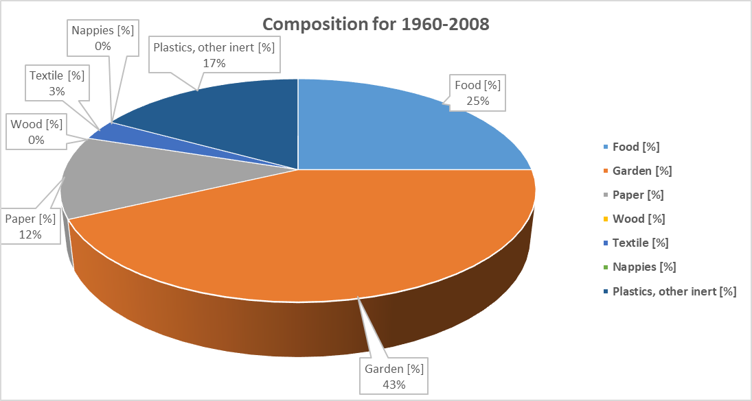

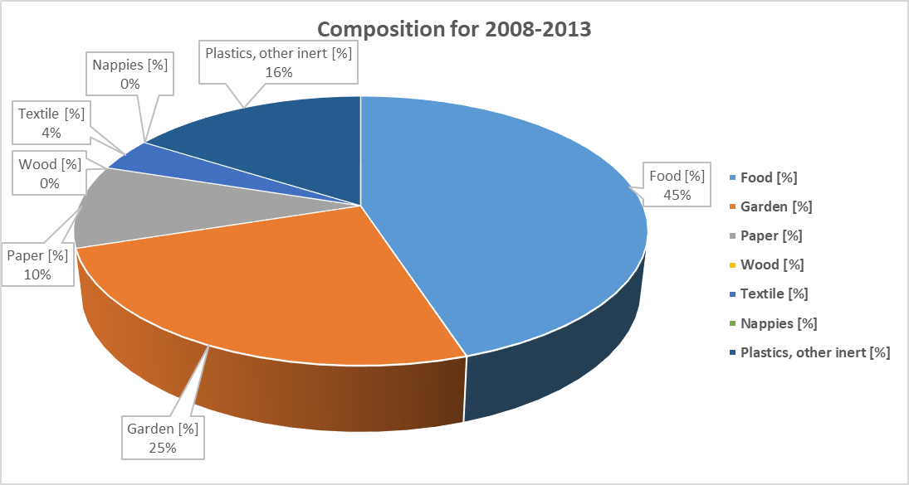

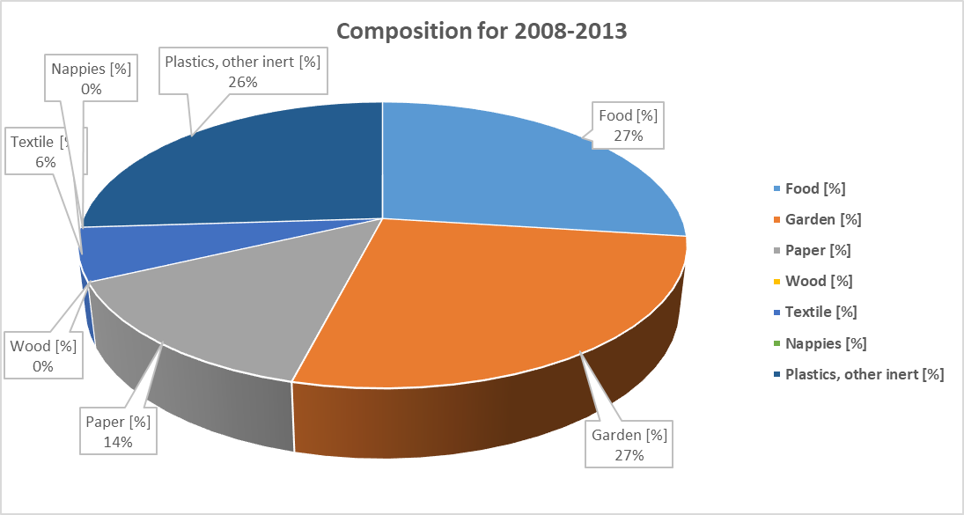

Table 101. DOC values

|  |  |  |  |  |  |  |  |
| --- | --- | --- | --- | --- | --- | --- | --- |
| **Food** | **Garden** | **Paper** | **Wood** | **Textile** | **Nappies** | **Sewage sludge** | **Plastics, other inert** |
| 0.15 | 0.20 | 0.40 | 0.43 | 0.24 | 0.24 | 0.05 | 0 |

***Source****: Default values provided by 2006 IPCC Guidelines, table 2.4, Vol 5, chapter 2.*

Table 102. Other parameters assumed for solid waste disposal emissions estimates

|  |  |  |
| --- | --- | --- |
| **Parameter** | **Value** | **Unit** |
| OXT | 0 | Fraction |
| DOCF | 0.5 | Fraction |
| Delay time | 6 | Months |
| F | 0.5 | fraction |

***Source****: Default values proposed by 2006 IPCC Guidelines, Vol 5, chapter 3.*

For the emissions estimated from landfills, a default MCF value of 1 (managed – aerobic) has been considered for all inventory period.

The half-life value, t1/2 is the time taken for the DOCm in waste to decay to half its initial mass. In the FOD model, the reaction constant k is used. The relationship between k and t1/2 is k = ln (2)/t1/2.

The half-life is affected by a wide variety of factors related with the composition of the waste, climatic conditions at the site where the SWDS is located, characteristics of the SWDS, waste disposal practices and others.

For the emissions estimates it is necessary to determine the climate zone, which will determine the k values to be considered for the estimates. For landfills in RoM the climate zone “Tropical wet” has been assumed, and default *k* values associated to this climate zone are presented in table below.

Table 103. Methane generation rate (*k*) values considered

|  |  |  |  |  |  |  |  |
| --- | --- | --- | --- | --- | --- | --- | --- |
| **Food** | **Garden** | **Paper** | **Wood** | **Textile** | **Nappies** | **Sewage sludge** | **Plastics, other inert** |
| 0.40 | 0.17 | 0.07 | 0.035 | 0.07 | 0.05 | 0.40 | 0 |

***Source****: Default values provided by 2006 IPCC Guidelines, table 3.3, Vol 5, chapter 3.*

Table 104. Landfill gas (LFG) and CH4 data from solid waste disposal sites (2000 – 2016)

|  |  |  |  |  |  |  |
| --- | --- | --- | --- | --- | --- | --- |
| **Year** | **LFG flared (Nm3/year)** | **LFG to electricity (Nm3/year)** | **TOTAL LFG Abstracted (Nm3/year)** | **Total CH4 abstracted (Nm3/year)[9]** | **Total CH4 abstracted (kg/year)[10]** | **Total CH4 abstracted (Gg/year)** |
| 2009 | 7,060,962 | 0 | 7,060,962 | 3,530,481 | 2,315,996 | 2.32 |
| 2010 | 5,809,655 | 0 | 5,809,655 | 2,904,828 | 1,905,567 | 1.91 |
| 2011 | 6,977,828 (Incl. flaring and LGTE) | | 6,977,828 | 3,488,914 | 2,288,728 | 2.29 |
| 2012 | 507,495 | 8,510,785 | 9,018,280 | 4,509,140 | 2,957,996 | 2.96 |
| 2013 | 318,685 | 11,707,785 | 12,026,470 | 6,013,235 | 3,944,682 | 3.94 |
| 2014 | 26,632 | 12,846,801 | 12,873,433 | 6,436,717 | 4,222,486 | 4.22 |
| 2015 | 97,341 | 12,014,370 | 12,111,711 | 6,055,856 | 3,972,641 | 3.97 |
| 2016 | 50,324 | 11,004,192 | 11,054,516 | 5,527,258 | 3,625,881 | 3.63 |

***Source****: Data provided by the Solid Waste Management Division*

Table 105. CH4 recovered, flared and energy recovery data from solid waste disposal sites (2000 – 2016)

| **Year** | **CH4 recovered (t)** | **CH4 flared (t)** | **CH4 energy recovery (t)** |
| --- | --- | --- | --- |
| 2000 | 0 | 0 | 0 |
| 2001 | 0 | 0 | 0 |
| 2002 | 0 | 0 | 0 |
| 2003 | 0 | 0 | 0 |
| 2004 | 0 | 0 | 0 |
| 2005 | 0 | 0 | 0 |
| 2006 | 0 | 0 | 0 |
| 2007 | 0 | 0 | 0 |
| 2008 | 0 | 0 | 0 |
| 2009 | 2,316 | 2,316 | 0 |
| 2010 | 1,906 | 1,906 | 0 |
| 2011 | 2,289 | 64 | 2,224 |
| 2012 | 2,958 | 166 | 2,792 |
| 2013 | 3,945 | 105 | 3,840 |
| 2014 | 4,222 | 9 | 4,214 |
| 2015 | 3,973 | 32 | 3,941 |
| 2016 | 3,626 | 17 | 3,609 |

### Results

CH4 emissions from solid waste disposal increased from 352.65 Gg CO2-eq in the year 2000 to 404.37 Gg CO2-eq in 2016 which consist in an increase of 14.7%.

Figure 53. Evolution of the GHG Emissions from Solid waste disposal (Gg CO2eq)

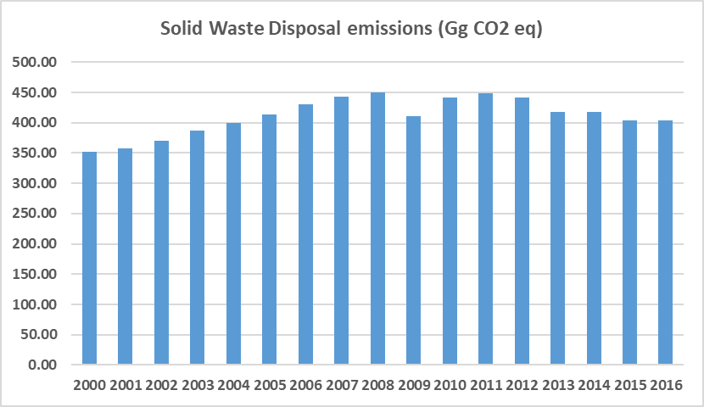

Table 106. GHG Emissions from solid waste disposal (Gg CO2eq)

|  |  |  |  |
| --- | --- | --- | --- |
| Years | Total emissions from Waste | Solid waste disposal | Share for solid waste disposal (%) |
| 2000 | 560.2 | 352.65 | 62.94% |
| 2001 | 574.8 | 356.95 | 62.10% |
| 2002 | 573.6 | 370.03 | 64.51% |
| 2003 | 593.2 | 386.47 | 65.15% |
| 2004 | 612.7 | 400.10 | 65.30% |
| 2005 | 619.7 | 413.28 | 66.69% |
| 2006 | 628.4 | 430.85 | 68.56% |
| 2007 | 634.2 | 443.77 | 69.97% |
| 2008 | 642.3 | 450.69 | 70.17% |
| 2009 | 605.4 | 410.48 | 67.80% |
| 2010 | 633.7 | 440.99 | 69.59% |
| 2011 | 648.5 | 449.12 | 69.25% |
| 2012 | 639.4 | 441.59 | 69.06% |
| 2013 | 610.5 | 417.60 | 68.40% |
| 2014 | 612.1 | 418.27 | 68.33% |
| 2015 | 592.1 | 403.60 | 68.16% |
| 2016 | 593.9 | 404.37 | 68.09% |

### Quality Control

Some quality control activities were implemented to ensure the use of right data in the inventory. The QC implemented during the data collection and GHG emission estimation is listed below:

* Cross verification between data provided via mail by institutional authorities (Solid Waste Management Division) and data reported in the national Statistics Mauritius.
* Consistency of the overall generating waste balance
* Cross verification between the GHG emissions estimated in the current inventory for solid waste disposal activity and the results obtained in the las reported national inventory of the RoM.

### Uncertainty Assessment and Time-series Consistency

The uncertainty analysis results for solid waste disposal category obtained from the IPCC software are reported in the following table for 2000 as base year:

Table 107. Uncertainty Analysis of Solid waste disposal category (4.A) for the period 2000 – 2016

|  |  |  |  |  |
| --- | --- | --- | --- | --- |
| IPCC Category | Gas | Activity Data Uncertainty (%) | Emission Factor Uncertainty (%) | Combined Uncertainty (%) |
| 4.A – Solid Waste Disposal | CH4 | 0.0 | 0.0 | 0.0 |

### Recalculations

FOD method, applied through the IPCC software, has been applied, including data since 1960. This aspect has improved the accuracy of the emissions but has also entails a notably CH4 emissions update.

### Planned Improvements

There are no composition data for 1960-1999 period, and it has been assumed constant and equal to the composition in 2000. RoM will continue working to review and update these values to improve the accuracy of the estimates.

Based on data from year 2000, a waste per capita ratio was obtained. This value has been maintained constant for the 1960-1999 period and has been used in conjunction with the population to determine the amount of solid waste landfilled. This population has also been estimated for some of the inventory years, applying interpolation methods, since only direct information at Statistics Mauritius is available for years 1962, 1972, 1983, 1990, and 1998-2016. RoM will continue working to review and update these values to improve the accuracy of the estimates.

For Rodrigues, no direct data are available regarding waste landfilled so these values have estimated for this inventory. RoM will continue working to improve the estimates by obtaining direct data.

## Biological Treatment of Solid Waste (Category 4B)

This activity includes the emissions deriving from the composting of organic waste. In urban centres of population with advanced treatments for municipal waste, the organic component of the waste is separated for its treatment in composting, which gives rise to a product that may be used again.

The waste streams that may potentially be used for this type of treatment include: a) municipal waste, excluding garden or green waste, b) garden waste; and c) sewage sludge from waste water treatment plants. The main advantages provided by this type of treatment are: 1) the reduction in the bulk of the waste to be stored or processed using other techniques with a greater or smaller environmental impact; and 2) the production, as the outcome of the process, of a product known as compost with added value in several applications such as fertilization or soil amendments.

### Source Category Description

A large-scale compost plant has been operational since October 2011. It is important to mention that, since November 2015, composting has started at Petit Verger Prison and to date nearly ten tons has been produced and used for organic gardening by the Ministry of Environment and other government agencies, in addition to use by Petit Verger Prison.

RoM is moving toward this biological waste treatment to reduce the amount of organic matter disposed at landfills, so it is expected that emissions from this activity continue increasing in the future years, but with the consequent emissions reduction from landfills.

### Methodological Issues

#### Calculation

According to the 2006 IPCC Guidelines, the Tier 1 approach for emissions from compost production was adopted.

The methodology adopted for GHG emissions estimation consist of multiplying activity data (AD) by the relevant appropriate emission factor (EF).

*Emissions (E) = Activity Data (AD) x Emission Factor (EF)*

To use a common unit for GEI emissions, the IPCC recommends the use of Global Warming Potentials (GWP) to convert GHG emissions other than CO2 to the latter equivalent. CO2 equivalent (CO2e). The GWP values used in the current inventory are those adopted from the Second Assessment Report (SAR) as collected in the following table for each GHG reported in the National Inventory.

#### Activity Data

This activity started at RoM in 2011, and activity data, as shown in table below, has been obtained from the Solid Waste Management Division. All data are directly received from the plant, there is not any data gap so estimates have not been required.

Table 108. Activity data for composting

| **Years** | **Compost (tons)** |
| --- | --- |
| 2000 | NO |
| 2001 | NO |
| 2002 | NO |
| 2003 | NO |
| 2004 | NO |
| 2005 | NO |
| 2006 | NO |
| 2007 | NO |
| 2008 | NO |
| 2009 | NO |
| 2010 | NO |
| 2011 | 5,154 |
| 2012 | 34,785 |
| 2013 | 19,257 |
| 2014 | 41,032 |
| 2015 | 37,979 |
| 2016 | 38,308 |

NO: Not Occurring

#### Emission Factor

Emission factors for composting category were taken from 2006 IPCC Guidelines default emission factors.CO2, in line with the IPCC methodology, is not included in the Inventory calculation as it comes from a renewable source of organic matter.

The emission factors (EF) considered are 4 g CH4/kg waste treated (wet weight basis) and 0.24 g N2O/kg waste treated (wet weight basis), according to the Table 4.1 from Volume 5, Chapter 4 from 2006 IPCC Guidelines.

### Results

CH4 and N2O emissions from composting increased from 0.82 Gg CO2-eq in the year 2011 to 6.07 Gg CO2-eq in 2016 which consist in an increase of 643.3%.

Figure 54. Evolution of the GHG Emissions from Composting (Gg CO2eq)

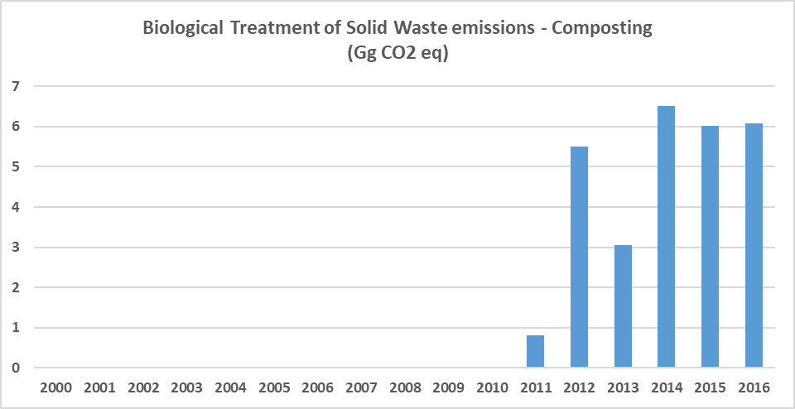

Table 109. GHG Emissions from composting (Gg CO2eq)

|  |  |  |  |
| --- | --- | --- | --- |
| **Years** | **Total emissions from Waste** | **Composting** | **Share for composting (%)** |
| 2011 | 648.5 | 0.82 | 0.13% |
| 2012 | 639.4 | 5.51 | 0.86% |
| 2013 | 610.5 | 3.05 | 0.50% |
| 2014 | 612.1 | 6.50 | 1.06% |
| 2015 | 592.1 | 6.02 | 1.02% |
| 2016 | 593.9 | 6.07 | 1.02% |

### Quality Control

Some quality control activities were implemented to ensure the use of right data in the inventory. The QC implemented during the data collection and GHG emission estimation is listed below:

* Cross verification between data provided via mail by institutional authorities (Solid Waste Management Division) and data reported in the national Statistics Mauritius.
* Consistency of the overall generating waste balance
* Cross verification between the GHG emissions estimated in the current inventory for composting activity and the results obtained in the las reported national inventory of the RoM.

### Uncertainty Assessment and Time-series Consistency

The uncertainty analysis results for biological treatment of solid waste (composting) category obtained from the IPCC software are reported in the following table for 2000 as base year:

Table 110. Uncertainty Analysis of Biological treatment of solid waste category (4.B) for the period 2000 – 2016

|  |  |  |  |  |
| --- | --- | --- | --- | --- |
| **IPCC Category** | **Gas** | **Activity Data Uncertainty (%)** | **Emission Factor Uncertainty (%)** | **Combined Uncertainty (%)** |
| 4.B – Biological treatment of solid waste | CH4 | 0.0 | 0.0 | 0.0 |
| N2O | 0.0 | 0.0 | 0.0 |

### Recalculations

No recalculations have been implemented for this category. Only new data have been incorporated for 2014-2016 period.

### Planned Improvements

Since activity data are directly receive from plant, to improve the accuracy of the inventory RoM could studies the possibility to move to a Tier 2 by an emission factors country-specific determination. RoM will continue working to obtains/determine plant level information for every year.

## Incineration and Open Burning of Waste – Waste Incineration (Category 4C1)

Waste incineration is defined as the combustion of solid and liquid waste in controlled incineration facilities. Modern refuse combustors have tall stacks and specially designed combustion chambers, which provide high combustion temperatures, long residence times, and efficient waste agitation while introducing air for more complete combustion. Types of waste incinerated include municipal solid waste (MSW), industrial waste, hazardous waste, clinical waste, and sewage sludge.

Relevant gases emitted include CO2, CH4 and N2O. Normally, emissions of CO2 from waste incineration are more significant than CH4 and N2O emissions.

Emissions from waste incineration without energy recovery are reported in the Waste Sector, while emissions from incineration with energy recovery are reported in the Energy Sector, both with a distinction between fossil and biogenic carbon dioxide (CO2) emissions.

### Source Category Description

Based on information provided by relevant stakeholders from RoM, only clinical waste are incinerated in the country. These incinerators are placed at the hospitals[11] (Flacq, SSRN, A.G. Jeetoo, Victoria, Poudre D’or, Brown Sequard), and it is important to mention that very often, these facilities are in operational due to break down and poor maintenance.

Open burning of wastes is not permitted by law in RoM. Henceforth, GHG emissions from open burning of solid waste are considered negligible and have not been accounted for.

### Methodological Issues

#### Calculation

According to the 2006 IPCC Guidelines, the Tier 1 approach for emissions from clinical waste incineration was adopted (Equation 5.1, Vol 5, chapter 5).

The methodology adopted for GHG emissions estimation consist of multiplying activity data (AD) by the relevant appropriate emission factor (EF).

*CO2 Emissions (E) = Σ (SWi x dmi x CFi x FCFi x OFi) * 44/12*

Where:

* CO2 Emissions = CO2 emissions in inventory year, Gg/yr
* SWi = total amount of solid waste of type i (wet weight) incinerated or open-burned, Gg/yr
* dmi = dry matter content in the waste (wet weight) incinerated or open-burned, (fraction)
* CFi = fraction of carbon in the dry matter (total carbon content), (fraction)
* FCFi = fraction of fossil carbon in the total carbon, (fraction)
* OFi = oxidation factor, (fraction)
* 44/12 = conversion factor from C to CO2
* i = type of waste incinerated

To use a common unit for GEI emissions, the IPCC recommends the use of Global Warming Potentials (GWP) to convert GHG emissions other than CO2 to the latter equivalent. CO2 equivalent (CO2e). The GWP values used in the current inventory are those adopted from the Second Assessment Report (SAR) as collected in the following table for each GHG reported in the National Inventory.

#### Activity Data

Activity data for 2000-2013 and 2015 were directly received from the incinerators, so activity data for 2014 and 2016 have been estimated to solve the data gaps for that years.

Table 111. Activity data for clinical waste incineration

|  |  |
| --- | --- |
| **Years** | **Clinical waste (tons)** |
| 2000 | 641.09 |
| 2001 | 627.36 |
| 2002 | 635.10 |
| 2003 | 589.55 |
| 2004 | 594.66 |
| 2005 | 593.78 |
| 2006 | 622.98 |
| 2007 | 601.64 |
| 2008 | 611.09 |
| 2009 | 589.04 |
| 2010 | 598.49 |
| 2011 | 645.74 |
| 2012 | 645.74 |
| 2013 | 667.79 |
| 2014 | 753.90 |
| 2015 | 840.00 |
| 2016 | 840.38 |

#### Emission Factor

CO2 emission factor for waste incineration category was taken from 2006 IPCC Guidelines default emission factors. CH4 emissions have not been included in the Inventory calculation as only emissions factors for MSW are available at 2006 IPCC Guidelines. N2O emissions have not been included in the Inventory calculation as only emissions factors for MSW, industrial waste, and sewage sludge are available at 2006 IPCC Guidelines.

The CO2 emission factor (EF) parameters considered are from 2006 IPCC Guidelines, table 5.2, Vol 5, Chapter 5.

Table 112. CO2 emission factor parameters for clinical waste incineration

|  |  |
| --- | --- |
| **Parameters** | **Value (%)** |
| Dry matter content in % of wet weight | NA |
| Total carbon content in % of dry weight | 60 |
| Fossil carbon fraction in % of total carbon content | 40 |
| Oxidation factor in % of carbon input | 100 |

### Results

CO2 emissions from clinical waste incineration increased from 0.56 Gg CO2-eq in the year 2000 to 0.74 Gg CO2-eq in 2016 which consist in an increase of 31%.

Figure 55. Evolution of the GHG Emissions from clinical waste incineration (Gg CO2eq)

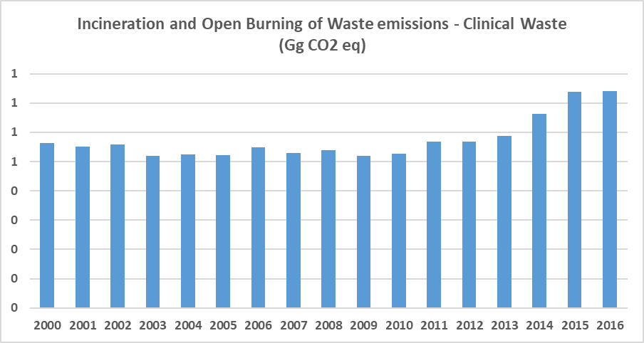

Table 113. GHG Emissions from clinical waste incineration (Gg CO2eq)

|  |  |  |  |
| --- | --- | --- | --- |
| **Years** | **Total emissions from Waste** | **Clinical waste incineration** | **Share for Waste incineration (%)** |
| 2000 | 560.2 | 0.564 | 0.10% |
| 2001 | 574.8 | 0.552 | 0.10% |
| 2002 | 573.6 | 0.559 | 0.10% |
| 2003 | 593.2 | 0.519 | 0.09% |
| 2004 | 612.7 | 0.523 | 0.09% |
| 2005 | 619.7 | 0.523 | 0.08% |
| 2006 | 628.4 | 0.548 | 0.09% |
| 2007 | 634.2 | 0.529 | 0.08% |
| 2008 | 642.3 | 0.538 | 0.08% |
| 2009 | 605.4 | 0.518 | 0.09% |
| 2010 | 633.7 | 0.527 | 0.08% |
| 2011 | 648.5 | 0.568 | 0.09% |
| 2012 | 639.4 | 0.568 | 0.09% |
| 2013 | 610.5 | 0.588 | 0.10% |
| 2014 | 612.1 | 0.663 | 0.11% |
| 2015 | 592.1 | 0.739 | 0.12% |
| 2016 | 593.9 | 0.740 | 0.12% |

### Quality Control

Some quality control activities were implemented to ensure the use of right data in the inventory. The QC implemented during the data collection and GHG emission estimation is listed below:

* Consistency of the overall generating waste balance
* Cross verification between the GHG emissions estimated in the current inventory for clinical waste incineration activity and the results obtained in the las reported national inventory of the RoM.

### Uncertainty Assessment and Time-series Consistency

The uncertainty analysis results for waste incineration category obtained from the IPCC software are reported in the following table for 2000 as base year:

Table 114. Uncertainty Analysis of Waste Incineration category (4.C) for the period 2000 – 2016

|  |  |  |  |  |
| --- | --- | --- | --- | --- |
| **IPCC Category** | **Gas** | **Activity Data Uncertainty (%)** | **Emission Factor Uncertainty (%)** | **Combined Uncertainty (%)** |
| 4.C – Waste Incineration | CO2 | 0.0 | 0.0 | 0.0 |

### Recalculations

No recalculations have been implemented for this category. Only new data have been incorporated for 2014-2016 period.

### Planned Improvements

To improve the accuracy of the inventory, RoM will gather the activity data for 2014 and 2016. In addition, RoM will continue working on collecting all the information regarding the technology that every incinerator uses. In line with this improvement, the activity data should be collected split by each technology.

## Wastewater Treatment and Discharge (Category 4D)

Wastewater originates from a variety of domestic, commercial, and industrial sources and may be treated on site (uncollected), sewered to a centralized plant (collected) or disposed untreated nearby or via an outfall. Domestic wastewater is defined as wastewater from household water use, while industrial wastewater is from industrial practices only.

Wastewater can be a source of methane (CH4) when treated or disposed anaerobically. It can also be a source of nitrous oxide (N2O) emissions. Carbon dioxide (CO2) emissions from wastewater are not considered because these are of biogenic origin and should not be included in national total emissions.

### Source Category Description

Wastewater Management Authority (WMA) manages the public wastewater system, which consists of 591 km of sewer network, 72 pumping stations and 10 treatment plants, including 4 main treatment plants which are located at St. Martin, Grand-Baie, Baie-du-Tombeau, and Montagne Jacquot.

At the St. Martin WWTP, all primary and secondary sludge produced is anaerobically digested and the resulting methane is recovered and used for generating about 25% of the plant’s requirement in electricity. Apart from the St. Martin wastewater treatment plant, the methane produced from other wastewater treatment plants is not recovered.

### Methodological Issues

#### Domestic/Commercial wastewater

**CH4 emissions**

Emissions are a function of the amount of organic waste generated and an emission factor that characterises the extent to which this waste generates CH4.

The general equation to estimate CH4 emissions from industrial wastewater is as follows:

*CH4 Emissions = [ Σ [(Ui • Ti,j • EFj)] • (TOW – S) – R*

Where:

* CH4 Emissions = CH4 emissions in inventory year, kg CH4/yr
* TOW = total organics in wastewater in inventory year, kg BOD/yr
* S = organic component removed as sludge in inventory year, kg BOD/yr
* Ui = fraction of population in income group *i* in inventory year
* Ti,j = degree of utilization of treatment/discharge pathway or system, *j*, for each income group
* fraction *i* in inventory year.
* i = income group: rural, urban high income and urban low income
* j = each treatment/discharge pathway or system
* EFj = emission factor, kg CH4 / kg BOD
* R = amount of CH4 recovered in inventory year, kg CH4/yr

The activity data for this source category is the total amount of organically degradable material in the wastewater (TOW). This parameter is a function of human population and BOD generation per person. It is expressed in terms of biochemical oxygen demand (kg BOD/year). The equation for TOW is:

*TOW = P • BOD • 0.001 • I • 365*

Where:

* TOW = total organics in wastewater in inventory year, kg BOD/yr
* P = country population in inventory year, (person)
* BOD = country-specific per capita BOD in inventory year, g/person/day (a default value of 0.6 kg CH4/kg BOD has been assumed)
* 0.001 = conversion from grams BOD to kg BOD
* I = correction factor for additional industrial BOD discharged into sewers (it has been assumed a default value of 1.00.)

The emission factor for a wastewater treatment and discharge pathway and system is a function of the maximum CH4 producing potential (B0) and the methane correction factor (MCF) for the wastewater treatment and discharge system.

*EFj* = *B0 •* *MCFj*

Where:

* EFj = emission factor, kg CH4/kg BOD,
* j = each treatment/discharge pathway or system
* B0 = maximum CH4 producing capacity, kg CH4/kg BOD
* MCFj = methane correction factor (fraction)

Table 115. Activity data for wastewater treatment in RoM

|  |  |  |  |
| --- | --- | --- | --- |
| **Years** | **Population (person)** | **BOD (kg/person/year)** | **TOW (kg BOD/yr)** |
| 2000 | 1,193,282 | 13.505 | 15,629,201 |
| 2001 | 1,196,497 | 13.505 | 15,666,921 |
| 2002 | 1,204,832 | 13.505 | 15,773,772 |
| 2003 | 1,213,581 | 13.505 | 15,886,242 |
| 2004 | 1,221,214 | 13.505 | 15,983,613 |
| 2005 | 1,228,467 | 13.505 | 16,075,825 |
| 2006 | 1,234,207 | 13.505 | 16,147,604 |
| 2007 | 1,239,841 | 13.505 | 16,217,979 |
| 2008 | 1,244,331 | 13.505 | 16,272,917 |
| 2009 | 1,247,640 | 13.505 | 16,311,906 |
| 2010 | 1,250,612 | 13.505 | 16,346,330 |
| 2011 | 1,252,633 | 13.505 | 16,367,655 |
| 2012 | 1,256,070 | 13.505 | 16,408,399 |
| 2013 | 1,258,845 | 13.505 | 16,440,190 |
| 2014 | 1,261,053 | 13.505 | 16,466,174 |
| 2015 | 1,262,721 | 13.505 | 16,485,054 |
| 2016 | 1,263,609 | 13.505 | 16,492,482 |

Data sources:

* Population: This population is from RoM (Mauritius + Rodrigues). Population has been obtained from Statistics Mauritius, including population from Rodrigues[12]
* BOD: a default value from 2006 IPCC Guidelines has been assumed (table 6.4, Vol 5, chapter 6). The BOD value to be considered here is the organic load contained into the wastewater, that is, the value at the entrance of the WWTP. This value depends on the population and the use of the water, but not on the treatment applied.

Table 116. Disaggregation of domestic/commercial wastewater by type of treatment in Mauritius (data in %)

| **Year** | **Centralized, aerobic treatment plant. Must be well managed** | **Anaerobic digester for sludge** | **Septic system** | **Latrine** | **TOTAL** |
| --- | --- | --- | --- | --- | --- |
| 2000 | 20.49 | 65.19 | 3.48 | 10.85 | 100 |
| 2001 | 20.49 | 65.19 | 3.48 | 10.85 | 100 |
| 2002 | 20.49 | 65.19 | 3.48 | 10.85 | 100 |
| 2003 | 20.49 | 65.19 | 3.48 | 10.85 | 100 |
| 2004 | 20.49 | 65.19 | 3.48 | 10.85 | 100 |
| 2005 | 20.49 | 65.19 | 3.48 | 10.85 | 100 |
| 2006 | 20.49 | 65.19 | 3.48 | 10.85 | 100 |
| 2007 | 20.75 | 64.98 | 3.47 | 10.81 | 100 |
| 2008 | 21.01 | 64.75 | 3.46 | 10.77 | 100 |
| 2009 | 21.28 | 64.54 | 3.45 | 10.74 | 100 |
| 2010 | 21.37 | 64.46 | 3.44 | 10.73 | 100 |
| 2011 | 21.65 | 68.17 | 6.66 | 3.51 | 100 |
| 2012 | 22.75 | 67.22 | 6.57 | 3.46 | 100 |
| 2013 | 23.84 | 66.27 | 6.48 | 3.41 | 100 |
| 2014 | 25.10 | 65.32 | 6.39 | 3.18 | 100 |
| 2015 | 25.80 | 64.72 | 6.33 | 3.15 | 100 |
| 2016 | 27.10 | 63.59 | 6.22 | 3.10 | 100 |

Data sources: 2006-2016 data have been provided by the Wastewater Management Authority. 2000-2005 data are not available and have been considered equal to data for 2006.

Table 117. Disaggregation of domestic/commercial wastewater by type of treatment in Rodrigues (data in %)

|  |  |  |  |  |  |
| --- | --- | --- | --- | --- | --- |
| **Year** | **Untreated. Sea, river and lake discharge** | **Anaerobic digester for sludge** | **Septic system** | **Latrine** | **TOTAL** |
| 2000 | 3.4 | 43.61 | 6.79 | 46.2 | 100 |
| 2001 | 3.4 | 43.61 | 6.79 | 46.2 | 100 |
| 2002 | 3.4 | 43.61 | 6.79 | 46.2 | 100 |
| 2003 | 3.4 | 43.61 | 6.79 | 46.2 | 100 |
| 2004 | 3.4 | 43.61 | 6.79 | 46.2 | 100 |
| 2005 | 3.4 | 43.61 | 6.79 | 46.2 | 100 |
| 2006 | 3.4 | 43.61 | 6.79 | 46.2 | 100 |
| 2007 | 3.4 | 43.61 | 6.79 | 46.2 | 100 |
| 2008 | 3.4 | 43.61 | 6.79 | 46.2 | 100 |
| 2009 | 3.4 | 43.61 | 6.79 | 46.2 | 100 |
| 2010 | 3.4 | 43.61 | 6.79 | 46.2 | 100 |
| 2011 | 3.4 | 43.61 | 6.79 | 46.2 | 100 |
| 2012 | 3.4 | 43.61 | 6.79 | 46.2 | 100 |
| 2013 | 3.4 | 43.61 | 6.79 | 46.2 | 100 |
| 2014 | 3.4 | 43.61 | 6.79 | 46.2 | 100 |
| 2015 | 3.4 | 43.61 | 6.79 | 46.2 | 100 |
| 2016 | 3.4 | 43.61 | 6.79 | 46.2 | 100 |

Data sources: Data extracted from Housing Census 2011, Table HDU07 (page 198). No public information available for the rest of the years, so values for 2011 has been replicated for the rest of the inventory years.

Table 118. Disaggregation of domestic/commercial wastewater by type of treatment in RoM (data in %)

| **Year** | **Untreated. Sea, river and lake discharge** | **Centralized, aerobic treatment plant. Must be well managed** | **Anaerobic digester for sludge** | **Septic system** | **Latrine** | **TOTAL** |
| --- | --- | --- | --- | --- | --- | --- |
| 2000 | 0.10 | 19.87 | 64.53 | 3.58 | 11.91 | 100 |
| 2001 | 0.10 | 19.86 | 64.53 | 3.58 | 11.92 | 100 |
| 2002 | 0.10 | 19.86 | 64.53 | 3.58 | 11.93 | 100 |
| 2003 | 0.10 | 19.86 | 64.52 | 3.59 | 11.93 | 100 |
| 2004 | 0.10 | 19.85 | 64.52 | 3.59 | 11.94 | 100 |
| 2005 | 0.11 | 19.85 | 64.52 | 3.59 | 11.94 | 100 |
| 2006 | 0.11 | 19.85 | 64.51 | 3.59 | 11.95 | 100 |
| 2007 | 0.11 | 20.09 | 64.30 | 3.58 | 11.92 | 100 |
| 2008 | 0.11 | 20.35 | 64.08 | 3.57 | 11.90 | 100 |
| 2009 | 0.11 | 20.60 | 63.87 | 3.56 | 11.87 | 100 |
| 2010 | 0.11 | 20.68 | 63.79 | 3.55 | 11.87 | 100 |
| 2011 | 0.11 | 20.95 | 67.38 | 6.67 | 4.90 | 100 |
| 2012 | 0.11 | 22.01 | 66.45 | 6.58 | 4.86 | 100 |
| 2013 | 0.11 | 23.06 | 65.52 | 6.49 | 4.82 | 100 |
| 2014 | 0.11 | 24.27 | 64.60 | 6.40 | 4.61 | 100 |
| 2015 | 0.11 | 24.94 | 64.02 | 6.34 | 4.59 | 100 |
| 2016 | 0.11 | 26.19 | 62.92 | 6.24 | 4.54 | 100 |

Data sources: these data have been estimated as weighted average percentage from Mauritius and Rodrigues data.

Table 119. MCF values considered for domestic/commercial wastewater treatments

|  |  |  |  |  |  |
| --- | --- | --- | --- | --- | --- |
| **Year** | **Untreated. Sea, river and lake discharge** | **Centralized, aerobic treatment plant. Must be well managed** | **Anaerobic digester for sludge** | **Septic system** | **Latrine** |
| 2000-2016 | 0.1 | 0 | 0.8 | 0.5 | 0.1 |

***Source:*** *2006 IPCC Guidelines. Table 6.3. Vol 5, Chapter 6.*

Table 120. Amount of CH4 recovered and flared in RoM

|  |  |  |  |
| --- | --- | --- | --- |
| **Year** | **CH4 produced (t)** | **CH4 recovered (t)** | **CH4 flared (t)** |
| 2000 | 5,155.2 | 0 | 0 |
| 2001 | 5,167.7 | 0 | 0 |
| 2002 | 5,202.9 | 0 | 0 |
| 2003 | 5,240.0 | 0 | 0 |
| 2004 | 5,272.1 | 0 | 0 |
| 2005 | 5,302.6 | 0 | 0 |
| 2006 | 5,326.2 | 354.37 | 354.37 |
| 2007 | 5,332.2 | 354.37 | 354.37 |
| 2008 | 5,332.0 | 354.37 | 354.37 |
| 2009 | 5,326.9 | 354.37 | 354.37 |
| 2010 | 5,331.8 | 397.26 | 397.26 |
| 2011 | 5,717.7 | 395.26 | 395.26 |
| 2012 | 5,651.7 | 460.97 | 460.97 |
| 2013 | 5,582.4 | 489.14 | 489.14 |
| 2014 | 5,510.0 | 482.80 | 482.81 |
| 2015 | 5,465.4 | 478.89 | 478.89 |
| 2016 | 5,372.0 | 470.71 | 470.71 |

Data sources: 2006-2013 CH4 recovered and flared data have been obtained from TNC. 2013-2016 data have been estimated keeping the proportion between CH4 produced and flared in 2013. CH4 produced data (obtained from IPCC software) have been reported here to show how CH4 recovered and flared data for 2014-2016 period have been estimated.

*Hotel sector*

Tourism in RoM is a truly relevant sector for the economy and general lifestyle in the country. This tourism produces, due to a large amount of people arriving the country, and among other things, an important volume of wastewater which need to be treated.

Table 121. Amount of tourist visiting RoM

|  |  |
| --- | --- |
| **Year** | **Tourists (person)** |
| 2000 | 656,453 |
| 2001 | 660,318 |
| 2002 | 681,648 |
| 2003 | 702,018 |
| 2004 | 718,861 |
| 2005 | 761,063 |
| 2006 | 788,276 |
| 2007 | 906,971 |
| 2008 | 930,456 |
| 2009 | 871,356 |
| 2010 | 934,827 |
| 2011 | 964,642 |
| 2012 | 965,441 |
| 2013 | 992,503 |
| 2014 | 1,038,334 |
| 2015 | 1,151,252 |
| 2016 | 1,275,227 |

Data sources: Statistics Mauritius. Data are for RoM (Mauritius + Rodrigues), but disaggregated data by islands are not available.

This wastewater, due to the characteristics of its origin, has a different BOD value. In addition, the methodology to be used to estimate CH4 emissions must be different to the wastewater produced by people from RoM who lives the whole year in the country. In this sense, specific methodology was described in previous inventory as follows:

* The total water consumption for the tourist hotels was computed as follows (Source: SNC):

(1.72 m3/room per day) x (365 days/year) x (total number of hotel rooms in year) x 0.66

The annual tourist nights, and numbers of tourists were obtained from Statistics Mauritius.

* The average raw BOD value for wastewater from tourist hotels was calculated from actual data for the 5 hotels referred to in the report of the Ministry of Environment and NDU (these values were obtained from the report on wastewater from the Hotel Sector prepared by the Ministry of Environment & NDU in 2004). The average raw BOD was computed as 187 mg/l. (Source: SNC)

It is important to consider this sector in the Inventory, however, it has been assumed that all wastewater produced at hotels where tourist stay is treated at centralized and well-managed aerobic treatment plants. This means that MCF to be applied is 0, so the emissions produced due to the treatment of this wastewater are 0.

**N2O emissions**

In keeping with the method proposed by the 2006 IPCC Guidelines, the total emissions of nitrous oxide that are produced via domestic/commercial wastewater are determined as a combination of the direct nitrous oxide emissions (N2OPlants) and indirect nitrous oxide emissions (N2OEffluent).

Currently, RoM only has indirect emissions, so following equations proposed by 2006 IPCC Guidelines have been applied:

*N2O Emissions = NEFFLUENT • EFEFFLUENT • 44 / 28*

Where:

* N2O emissions = N2O emissions in inventory year, kg N2O/yr
* NEFFLUENT = nitrogen in the effluent discharged to aquatic environments, kg N/yr
* EFEFFLUENT = emission factor for N2O emissions from discharged to wastewater, kg N2O-N/kg N
* The factor 44/28 is the conversion of kg N2O-N into kg N2O

*NEFFLUENT = P • Protein • FNPR • FNON −CON • FIND−COM − NSLUDGE*

Where:

* NEFFLUENT = total annual amount of nitrogen in the wastewater effluent, kg N/yr
* P = human population
* Protein = annual per capita protein consumption, kg/person/yr
* FNPR = fraction of nitrogen in protein, default = 0.16, kg N/kg protein
* FNON-CON = factor for non-consumed protein added to the wastewater
* FIND-COM = factor for industrial and commercial co-discharged protein into the sewer system
* NSLUDGE = nitrogen removed with sludge (default = zero), kg N/yr

Table 122. RoM population and annual per capita protein consumption (kg/person/year)

|  |  |  |
| --- | --- | --- |
| **Years** | **Population** | **Protein consumption** |
| 2000 | 1,193,282 | 28.67 |
| 2001 | 1,196,497 | 29.15 |
| 2002 | 1,204,832 | 29.92 |
| 2003 | 1,213,581 | 30.33 |
| 2004 | 1,221,214 | 31.15 |
| 2005 | 1,228,467 | 30.65 |
| 2006 | 1,234,207 | 30.35 |
| 2007 | 1,239,841 | 31.65 |
| 2008 | 1,244,331 | 30.86 |
| 2009 | 1,247,640 | 32.75 |
| 2010 | 1,250,612 | 32.87 |
| 2011 | 1,252,633 | 32.50 |
| 2012 | 1,256,070 | 32.08 |
| 2013 | 1,258,845 | 32.25 |
| 2014 | 1,261,053 | 31.29 |
| 2015 | 1,262,721 | 31.62 |
| 2016 | 1,263,609 | 31.84 |

Data sources:

* Population: This population is from RoM (Mauritius + Rodrigues). Population has been obtained from Statistics Mauritius, including population from Rodrigues[13]
* Protein consumption: <http://www.fao.org/faostat/en/#data/FBS/visualize>

Table 123. Parameters assumed for N2O emissions estimates (default values)

|  |  |  |
| --- | --- | --- |
| **Parameter** | **Value** | **Unit** |
| EFEFFLUENT | 0.005 | kg N2O-N/kg N |
| FNPR | 0.16 | kg N/kg protein |
| FNON-CON | 1.1 | Fraction |
| FIND-COM | 1.25 | Fraction |
| NSLUDGE | 0 | kg N/yr |

***Source:*** *2006 IPCC Guidelines*

#### Industrial wastewater

The general equation to estimate CH4 emissions from industrial wastewater is as follows:

*CH4 Emissions = Σ [(TOWi – Si) • EFi – Ri]*

Where:

* CH4 Emissions = CH4 emissions in inventory year, kg CH4/yr
* TOWi = total organically degradable material in wastewater from industry I in inventory year, kg COD/yr
* i = industrial sector
* Si = organic component removed as sludge in inventory year, kg COD/yr
* EFi = emission factor for industry i, kg CH4/kg COD for treatment/discharge pathway or system(s) used in inventory year
* Ri = amount of CH4 recovered in inventory year, kg CH4/yr

The activity data for this source category is the amount of organically degradable material in the wastewater (TOW).

*TOWi = Pi •Wi • CODi*

Where:

* TOWi = total organically degradable material in wastewater for industry i, kg COD/yr
* i = industrial sector
* Pi = total industrial product for industrial sector i, t/yr
* Wi = wastewater generated, m3/t product
* CODi = chemical oxygen demand (industrial degradable organic component in wastewater),
* kg COD/m3

There are significant differences in the CH4 emitting potential of different types of industrial wastewater. To the extent possible, data should be collected to determine the maximum CH4 producing capacity (B0) in each industry. The MCF indicates the extent to which the CH4 producing potential (B0) is realized in each type of treatment method. Thus, it is an indication of the degree to which the system is anaerobic

*EFj* = *Bo* • *MCFj*

Where:

* EFj = emission factor for each treatment/discharge pathway or system, kg CH4/kg COD,
* j = each treatment/discharge pathway or system
* B0 = maximum CH4 producing capacity, kg CH4/kg COD (a default value of 0.25 kg CH4/kg COD has been assumed)
* MCFj = methane correction factor (fraction)

Table 124. Activity data for sugar industry

|  |  |  |  |  |  |
| --- | --- | --- | --- | --- | --- |
| **Years** | **P (t)** | **W (m3/t produced)** | **Wastewater produced (m3)** | **COD (kg/m3)** | **TOW (kg COD/yr)** |
| 2000 | 569,289 | 8 | 4,554,312 | 5 | 22,771,560 |
| 2001 | 645,597 | 8 | 5,164,776 | 5 | 25,823,880 |
| 2002 | 520,887 | 8 | 4,167,096 | 5 | 20,835,480 |
| 2003 | 537,155 | 8 | 4,297,240 | 5 | 21,486,200 |
| 2004 | 572,316 | 8 | 4,578,528 | 5 | 22,892,640 |
| 2005 | 519,816 | 8 | 4,158,528 | 5 | 20,792,640 |
| 2006 | 504,857 | 8 | 4,038,856 | 5 | 20,194,280 |
| 2007 | 435,972 | 8 | 3,487,776 | 5 | 17,438,880 |
| 2008 | 452,062 | 8 | 3,616,496 | 5 | 18,082,480 |
| 2009 | 467,234 | 8 | 3,737,872 | 5 | 18,689,360 |
| 2010 | 452,473 | 8 | 3,619,784 | 5 | 18,098,920 |
| 2011 | 435,310 | 8 | 3,482,480 | 5 | 17,412,400 |
| 2012 | 409,200 | 8 | 3,273,600 | 5 | 16,368,000 |
| 2013 | 404,713 | 8 | 3,237,704 | 5 | 16,188,520 |
| 2014 | 400,173 | 8 | 3,201,384 | 5 | 16,006,920 |
| 2015 | 366,070 | 8 | 2,928,559 | 5 | 14,642,795 |
| 2016 | 386,277 | 8 | 3,090,218 | 5 | 15,451,090 |

Data sources:

* P: Statistics Mauritius (2000-2016)
* W: This figure was obtained from a report entitled “Implementation of the Multi-Annual Adaptation Strategy for the Mauritian Sugar Cane Cluster (2006-2015) – Strategic Environmental Assessment – Final Draft Report” (Agreco Consortium, 2006).
* COD: This was obtained from EIA report for production of granulated refined sugar (Arup SIGMA 2004).

Table 125. Activity data for poultry industry

|  |  |  |  |  |  |
| --- | --- | --- | --- | --- | --- |
| **Years** | **P (t)** | **W (m3/t produced)** | **Wastewater produced (m3)** | **COD (kg/m3)** | **TOW (kg COD/yr)** |
| 2000 | 41,276 | 8.60 | 354,974 | 3.5 | 1,242,407.6 |
| 2001 | 41,276 | 8.60 | 354,974 | 3.5 | 1,242,407.6 |
| 2002 | 41,276 | 8.60 | 354,974 | 3.5 | 1,242,407.6 |
| 2003 | 41,276 | 8.60 | 354,974 | 3.5 | 1,242,407.6 |
| 2004 | 41,276 | 8.60 | 354,974 | 3.5 | 1,242,407.6 |
| 2005 | 41,276 | 8.60 | 354,974 | 3.5 | 1,242,407.6 |
| 2006 | 41,276 | 8.60 | 354,974 | 3.5 | 1,242,407.6 |
| 2007 | 46,700 | 8.60 | 401,620 | 3.5 | 1,405,670.0 |
| 2008 | 42,000 | 8.60 | 361,200 | 3.5 | 1,264,200.0 |
| 2009 | 44,000 | 8.60 | 378,400 | 3.5 | 1,324,400.0 |
| 2010 | 46,600 | 8.60 | 400,760 | 3.5 | 1,402,660.0 |
| 2011 | 47,000 | 8.60 | 404,200 | 3.5 | 1,414,700.0 |
| 2012 | 47,200 | 8.60 | 405,920 | 3.5 | 1,420,720.0 |
| 2013 | 46,700 | 8.60 | 401,620 | 3.5 | 1,405,670.0 |
| 2014 | 46,550 | 8.60 | 400,330 | 3.5 | 1,401,155.0 |
| 2015 | 46,400 | 8.60 | 399,040 | 3.5 | 1,396,640.0 |
| 2016 | 45,800 | 8.60 | 393,880 | 3.5 | 1,378,580.0 |

Data sources:

* P: TNC (2006-2013) and Statistics Mauritius (2000-2016). For 2000-2005 period, same value than 2006 has been considered, and data for 2014 has been estimated as the average value from 2013 and 2015.
* W: The volume of wastewater per tonne of poultry processed was obtained from the two largest poultry processing plants in RoM
* COD: This figure was obtained from actual test results reported for the design of a wastewater treatment plant for one major poultry processing plant

Table 126. Activity data for beer industry

| **Years** | **P (t)** | **W (m3/t produced)** | **Wastewater produced (m3)** | **COD (kg/m3)** | **TOW (kg COD/yr)** |
| --- | --- | --- | --- | --- | --- |
| 2000 | 37,370 | 6.3 | 235,431 | 2.9 | 682,749.9 |
| 2001 | 37,370 | 6.3 | 235,431 | 2.9 | 682,749.9 |
| 2002 | 37,370 | 6.3 | 235,431 | 2.9 | 682,749.9 |
| 2003 | 37,370 | 6.3 | 235,431 | 2.9 | 682,749.9 |
| 2004 | 37,370 | 6.3 | 235,431 | 2.9 | 682,749.9 |
| 2005 | 37,370 | 6.3 | 235,431 | 2.9 | 682,749.9 |
| 2006 | 37,370 | 6.3 | 235,431 | 2.9 | 682,749.9 |
| 2007 | 37,370 | 6.3 | 235,431 | 2.9 | 682,749.9 |
| 2008 | 37,370 | 6.3 | 235,431 | 2.9 | 682,749.9 |
| 2009 | 37,370 | 6.3 | 235,431 | 2.9 | 682,749.9 |
| 2010 | 37,370 | 6.3 | 235,431 | 2.9 | 682,749.9 |
| 2011 | 37,370 | 6.3 | 235,431 | 2.9 | 682,749.9 |
| 2012 | 36,855 | 6.3 | 232,187 | 2.9 | 673,340.9 |
| 2013 | 36,340 | 6.3 | 228,942 | 2.9 | 663,931.8 |
| 2014 | 35,825 | 6.3 | 225,698 | 2.9 | 654,522.8 |
| 2015 | 35,310 | 6.3 | 222,453 | 2.9 | 645,113.7 |
| 2016 | 36,070 | 6.3 | 227,241 | 2.9 | 658,998.9 |

Data sources:

* P: Statistics Mauritius (2011, 2015, 2016). Data in Statistics Mauritius are in m3, but a density value like water has been used to convert data into tonnes. For 2000-2010 period, same value from 2011 has been assumed, and for 2012-2014 an interpolation has been applied.
* W: Default values from 2006 IPCC Guidelines (table 6.9, Vol5, chapter 6)
* COD: Default values from 2006 IPCC Guidelines (table 6.9, Vol5, chapter 6)

Table 127. Disaggregation of industrial wastewater treated by type of treatment

|  |  |  |  |  |
| --- | --- | --- | --- | --- |
| **Years** | **Industry sector** | **Aerobic treatment plant (%)** | **Anaerobic digester for sludge (%)** | **TOTAL (%)** |
| 2000-2016 | Sugar | 25 | 75 | 100 |
| Poultry | 25 | 75 | 100 |
| Beer | 25 | 75 | 100 |

Based on 2006 IPCC Guidelines (Vol 5, chapter 6), other default values considered for the emissions estimates:

* Aerobic treatment plant: MCF = 0
* Anaerobic digester for sludge: MCF = 0.8
* Si: 0 kg COD/yr (all years)
* Ri: 0 kg CH4/yr (all years)

### Results

Regarding domestic/commercial wastewater, CH4 emissions decreased from 110.9 Gg CO2-eq in the year 2000 to 106.0 Gg CO2-eq in 2016, which consist in a decrease of 4.3%. In addition, N2O emissions increase from 18.3 Gg CO2-eq in the year 2000 to 21.6 Gg CO2-eq in 2016, which consist in an increase of 17.6%.

Regarding industrial wastewater, CH4 emissions decreased from 77.8 Gg CO2-eq in the year 2000 to 55.1 Gg CO2-eq in 2016, which consist in a decrease of 29.2%.

Figure 56. Evolution of the GHG Emissions from domestic/commercial wastewater (Gg CO2eq)

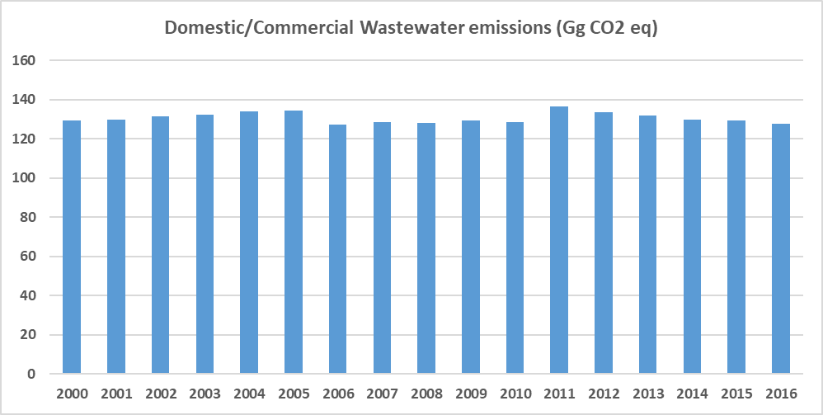

Figure 57. Evolution of the GHG Emissions from industrial wastewater (Gg CO2eq)

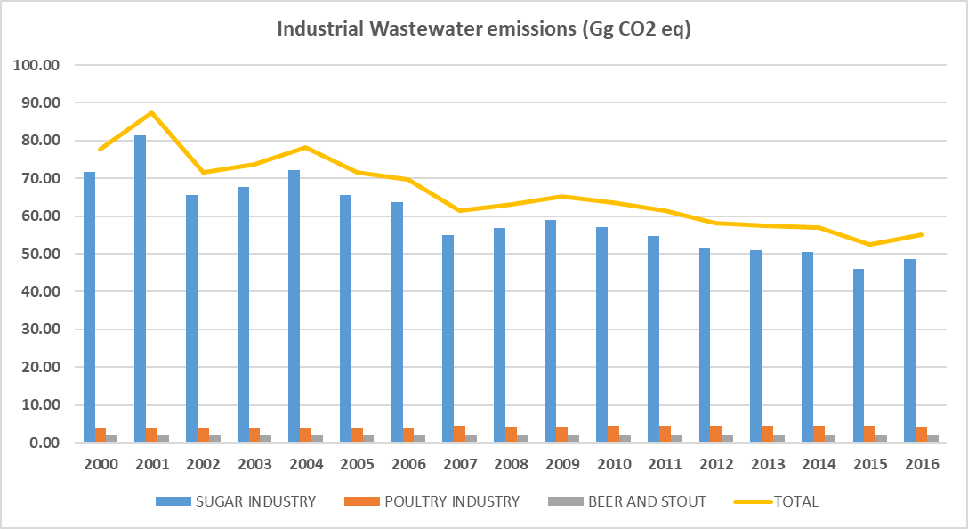

Table 128. GHG Emissions from domestic/commercial wastewater (Gg CO2eq)

| **Years** | **CH4 (Gg CO2 eq)** | **N2O (Gg CO2 eq)** | **TOTAL** |
| --- | --- | --- | --- |
| 2000 | 110.9 | 18.3 | 129.2 |
| 2001 | 111.2 | 18.7 | 129.9 |
| 2002 | 112.0 | 19.3 | 131.3 |
| 2003 | 112.8 | 19.7 | 132.5 |
| 2004 | 113.5 | 20.4 | 133.9 |
| 2005 | 114.2 | 20.2 | 134.3 |
| 2006 | 107.2 | 20.1 | 127.3 |
| 2007 | 107.4 | 21.0 | 128.4 |
| 2008 | 107.4 | 20.6 | 128.0 |
| 2009 | 107.4 | 21.9 | 129.2 |
| 2010 | 106.6 | 22.0 | 128.6 |
| 2011 | 114.8 | 21.8 | 136.6 |
| 2012 | 112.0 | 21.6 | 133.6 |
| 2013 | 110.0 | 21.8 | 131.8 |
| 2014 | 108.6 | 21.1 | 129.8 |
| 2015 | 107.8 | 21.4 | 129.2 |
| 2016 | 106.0 | 21.6 | 127.6 |

Table 129. GHG Emissions from industrial wastewater (Gg CO2eq)

| **Years** | **Sugar industry** | **Poultry industry** | **Beer industry** | **TOTAL** |
| --- | --- | --- | --- | --- |
| 2000 | 71.73 | 3.91 | 2.15 | 77.79 |
| 2001 | 81.35 | 3.91 | 2.15 | 87.41 |
| 2002 | 65.63 | 3.91 | 2.15 | 71.70 |
| 2003 | 67.68 | 3.91 | 2.15 | 73.75 |
| 2004 | 72.11 | 3.91 | 2.15 | 78.18 |
| 2005 | 65.50 | 3.91 | 2.15 | 71.56 |
| 2006 | 63.61 | 3.91 | 2.15 | 69.68 |
| 2007 | 54.93 | 4.43 | 2.15 | 61.51 |
| 2008 | 56.96 | 3.98 | 2.15 | 63.09 |
| 2009 | 58.87 | 4.17 | 2.15 | 65.19 |
| 2010 | 57.01 | 4.42 | 2.15 | 63.58 |
| 2011 | 54.85 | 4.46 | 2.15 | 61.46 |
| 2012 | 51.56 | 4.48 | 2.12 | 58.16 |
| 2013 | 50.99 | 4.43 | 2.09 | 57.51 |
| 2014 | 50.42 | 4.41 | 2.06 | 56.90 |
| 2015 | 46.12 | 4.40 | 2.03 | 52.56 |
| 2016 | 48.67 | 4.34 | 2.08 | 55.09 |

Table 130. GHG Emissions from total wastewater (domestic/commercial + industrial) (Gg CO2eq)

|  |  |  |  |
| --- | --- | --- | --- |
| **Years** | **Total emissions from Waste** | **Total wastewater** | **Share for total wastewater (%)** |
| 2000 | 560.2 | 207.04 | 36.95% |
| 2001 | 574.8 | 217.30 | 37.80% |
| 2002 | 573.6 | 202.98 | 35.39% |
| 2003 | 593.2 | 206.25 | 34.77% |
| 2004 | 612.7 | 212.05 | 34.61% |
| 2005 | 619.7 | 205.89 | 33.23% |
| 2006 | 628.4 | 196.99 | 31.35% |
| 2007 | 634.2 | 189.94 | 29.95% |
| 2008 | 642.3 | 191.10 | 29.75% |
| 2009 | 605.4 | 194.44 | 32.12% |
| 2010 | 633.7 | 192.19 | 30.33% |
| 2011 | 648.5 | 198.03 | 30.53% |
| 2012 | 639.4 | 191.78 | 29.99% |
| 2013 | 610.5 | 189.28 | 31.00% |
| 2014 | 612.1 | 186.69 | 30.50% |
| 2015 | 592.1 | 181.76 | 30.70% |
| 2016 | 593.9 | 182.70 | 30.76% |

### Quality Control

Some quality control activities were implemented to ensure the use of right data in the inventory. The QC implemented during the data collection and GHG emission estimation is listed below:

* Cross verification between data provided via mail by institutional authorities (Wastewater Management Authority) and data reported in the national Statistics Mauritius.
* Cross verification between the GHG emissions estimated in the current inventory for wastewater activity and the results obtained in the las reported national inventory of the RoM.

### Uncertainty Assessment and Time-series Consistency

The uncertainty analysis results for wastewater treatment and discharge category obtained from the IPCC software are reported in the following table for 2000 as base year:

Table 131. Uncertainty Analysis of Wastewater Treatment and Discharge category (4.D) for the period 2000 – 2016

|  |  |  |  |  |
| --- | --- | --- | --- | --- |
| **IPCC Category** | **Gas** | **Activity Data Uncertainty (%)** | **Emission Factor Uncertainty (%)** | **Combined Uncertainty (%)** |
| 4.D – Wastewater Treatment and Discharge | CH4 | 0.0 | 0.0 | 0.0 |
| N2O | 0.0 | 0.0 | 0.0 |

### Recalculations

#### Domestic/Commercial wastewater

Wastewater emissions from Rodrigues have been included for this Inventory. These emissions (CH4 and N2O) have supposed an increase regarding previous Inventory edition.

A recalculation related to N2O emissions has been implemented as the protein consumption values used for previous inventory were not found at FAO Statistics, and a slightly update has been implemented with the new values found at FAO database statistics[14].

#### Industrial wastewater

For this inventory edition (2000-2016), a new type of industry (beer production) has been considered due to the relevancy in the country. The emissions estimated from this new industry have produced a recalculation in this category.

In addition, the MCF value considered for all the wastewater treated in previous inventory (0.5) has been reviewed and updated. For this inventory edition, two different types of treatments have been considered based on information provided by stakeholders so 25% of wastewater has been treated at aerobic treatment plants (MCF value = 0) and 75% of wastewater has been treated by anaerobic digester for sludge (MCF = 0.8).

### Planned Improvements

#### Domestic/Commercial wastewater

For Mauritius, data for distribution of wastewater by treatments for 2000-2005 period are not available and have been considered equal to data for 2006. RoM will continue working to obtained more accurate data for 2000-2005 period.

Additionally, the amounts of CH4 captured and flared for 2014-2016 period have not been available for this inventory edition and has had to be estimated. RoM will continue working to obtain more accurate data for next inventory cycle.

For Rodrigues, only wastewater distribution data for 2011 is available, so the data for the rest of the inventory period has been replicated. RoM will continue working to obtained more accurate data for 2000-2005 period.

BOD value considered is a default value from 2006 IPCC Guidelines. It is known that the Wastewater Management Authority has worked to get a country-specific value, however, the current available information cannot be included as part of the inventory due to some formatting and conceptual aspects to be solve and be aligned with 2006 IPCC Guidelines. The Wastewater Management Authority will continue actively working with the Inventory team for next Inventory cycle, and a country-specific BOD value will be considered.

#### Industrial wastewater

RoM will continue working on improving the information related to the amount of wastewater treated under each type of treatment for every year, and for every type of industry. For this inventory it has been assumed that the percentage of wastewater treated by each treatment has been the same for all the years of the inventory period, but it is possible that the industries have upgraded their processes and technologies over the years.

Regarding the poultry industry, activity data from 2006-2013 were obtained from the TNC, and from 2015-2016 from Statistics Mauritius. The activity data for the rest of the inventory period have been estimated, that is, for 2000-2005 period same value than 2006 and data for 2014 has been estimated as the average value from 2013 and 2015. RoM will continue working on reviewing and updating the estimated data through a closer collaboration with industrial facilities and/or with industry associations.

Regarding beer production, only data for 2011, 2015 and 2016 were available from Statistics Mauritius. For 2000-2010 period same value from 2011 has been assumed, and for 2012-2014 an interpolation has been applied. RoM will continue working on reviewing and improving the estimated data through a closer collaboration with industrial facilities and/or with industry associations.

Additionally, for the beer production industry, default IPCC values have been considered (m3 wastewater /t produced and kg COD/m3 wastewater). RoM will work to determine country-specific values for these parameters as already has for the sugar and poultry industries.

# Improvement Plan

This Chapter highlights the plan of improvement not indicated in specific sectoral chapters of this report. For sectoral plan of improvement, please refer to the end of each sectoral chapter or in its parts (sub-chapters). The National GHG inventory requires continuous improvement, GHG inventory reporting requires detailed activity data collection and estimation of country-specific emission factors.

## Strategies for Long Term Improvement in the National Inventory System

The Republic of Mauritius has an obligation to submit BUR as well as NC on a regular basis. It is vital that the process be strengthened, and a system is developed and maintained in a robust manner to ensure that it functions on a continuous basis to meet RoM reporting requirement. There is a need to strengthen the existing institutional arrangements.

It is recommended that, during the upcoming development of future Biennial Update Reports (BURs) and National Communications, the methodology is improved further, considering the development of national emissions factors in key sectors for GHG emissions and use of data from the emissions monitoring systems. In addition, the development of a sustainable national inventory system involving key organisations, in the regular update and improvement of the GHG inventory be established.

### Institutional Arrangements

The National Inventory Report (NIR) was coordinated as a component under the BUR1 project by the Climate Change Division.

According to Article 4 of UNFCCC, Parties are committed to communicate regularly the following information:

* Anthropogenic emissions and removals;
* Established measures and related policies to mitigate climate change;
* Established measures and related policies to adapt to climate change impacts;
* Existing and planned research and systematic observation; and
* Existing and planned programmes of education, training and public awareness.

These institutional arrangements (via a National Systems) should ensure that the GHG inventory is continuously improved and that institutional memory is retained and developed.

### Capacity Building & Development of Technical Know-how and Institutional Memory

Despite the knowledge acquired during the preparation of the BUR1, there are still need for more capacity building and empowerment of staff and institutions. The training could include theoretical training and practical exercises and could cover, amongst others:

* Data collection;
* Methodology development, including for deriving EFs;
* Use of software, including IPCC, GIS and others; and
* Report writing.

Concerning the information sharing it is recommended to:

* Create national registry/website/database or clearinghouse for the GHG inventory with tools, among others; and
* Open website for gathering public and private reviews.

### Quality Control

It is recommended that. as part of the National System, Mauritius develops an efficient, transparent and pragmatic QC and verification system. For upcoming Greenhouse gases inventory, it is recommended for RoM to develop a detailed QA and QC. Therefore, required information for QC and QA shall be recorded in templates located in Appendix 4 and 5 accordingly.

## Planned Improvement on the Methodology

The level of inventory reporting depends on the data quality and methodology employed. This is indicated as the Tier used (e.g. 1 = simplest and least accurate, 2 or 3 as the most complex and accurate) as per the IPCC 2006 Guidelines. Despite the comprehensive initiation of activities under the BUR1 project, there is considerable scope for improvement. Where possible, and for key categories as a priority, GHG estimates should be made at Tier 2 or 3 levels.

To achieve this, sub-sectoral level estimates of activity data and emission factors (EF) must be developed. Similar and consistent formats must be adopted for data reporting and ensuring consistency in generating activity data by organisations for collation of the GHG inventory into a centralised system.

Considering that the country counts on its own NCV values for several fuels, it is recommendable including as part of the NIR the methodology considered to determine those NCV values as well as to determine the country specific NCV value of the rest of fuels consumed in the country.

A recommendation has been obtained, in line with the comment above, in the QA analysis developed to the inventory. , Considering that Mauritius has determined its own NCV values for all fuels, the measured programme could be extended to include the measurement of carbon content of the fuels. In this manner, the country-specific CO2 emission factor could be obtained for all fuels assuming a 100% oxidation of the fuels (in line with the assumptions of the default EF taken in the 2006 IPCC guidelines).

During the QA analysis, it was also detected the necessity of the Republic of Mauritius to improve the completeness of the inventory by investigating the use of lubricants as additives to gasoline in the other sectors. It is also stated that this investigation must also consider the non-energy use of feedstocks for reporting in the IPPU sector.

In order to improve the accuracy and completeness of the information, the Republic of Mauritius must work on the comparison and consolidation of all the available information from different sources. This activity should ensure the identification of all the energy consumptions in the country and all the emitting activities, in order to achieve a complete and accurate inventory report.

In line with the comment above, the RoM must work in the data gathering of those categories that are not reported in their national statistics, such as International water-borne navigation, international aviation and non-energy product consumption, among others.

The detailed planned improvements on data collection, research and emission factors with priority action, responsibility and expected timeframe are detailed in sectoral chapters of the National Inventory Report (above).

For future improvement, a full recalculation staring from 1990 using 2006 IPCC Guidelines and its 2019 refinement will be conducted.

# References

* Energy Statistics (2018). Digest of Energy and Water Statistics. Statistics Mauritius: <http://statsmauritius.govmu.org/English/StatsbySubj/Pages/Energy-and-Water.aspx>
* Transport OpenData (2016). Transport Statistics from Open Data: <https://data.govmu.org/dkan/?q=search/field_topic/transport-40>
* TNC Report (2016). Third National Communication Report of Mauritius: <https://unfccc.int/files/national_reports/non-annex_i_natcom/application/pdf/nc3_republic_of_mauritius_20jan17.pdf>
* CEB (2019). Letter to Ministry of Social Security – Data requirement for GHG inventory. mitigation assessment and MRV for the preparation of the First BUR.
* WB (2018). GNI per capita. Atlas method in current USD for Mauritius published by the World Bank Group: <https://data.worldbank.org/indicator/NY.GNP.PCAP.CD?locations=MU>
* Census (2013). Census and Economic Activities for small and large establishments in Mauritius published by the Statistics Mauritius: <http://statsmauritius.govmu.org/English/StatsbySubj/Pages/SME.aspx>
* NAM (2013). National Accounts of Mauritius published by the Statistics Mauritius: <http://statsmauritius.govmu.org/English/StatsbySubj/Pages/National-Accounts.aspx>
* IPCC (2006). IPCC 2006 Guidelines: <https://www.ipcc-nggip.iges.or.jp/public/2006gl/>
* Transport Toolkit (2017). Transport Toolkit developed for the estimation of GHG emissions derived from road transport in Mauritius.
* NIR (2017). National Inventory Report of Mauritius 2000 – 2013: <https://unfccc.int/resource/docs/natc/ghg_mauritius.pdf>
* SAR (1995). Second Assessment Report of IPCC: <https://www.ipcc.ch/report/ipcc-second-assessment-full-report/>
* International Energy Agency (IEA) <https://www.iea.org/data-and-statistics/data-tables?country=MAURITIUS>

# Appendix 1: Key Category Analysis

Table 132. Key Category Analysis using Approach 1 Trend Assessment method from IPCC 2006 Guidelines for the National Inventory for the period 2000 – 2016.

| **IPCC Category code** | **IPCC Category** | **GHG** | **2000 Year Estimate Ex0 (Gg CO2 Eq)** | **2016 Year Estimate Ext (Gg CO2 Eq)** | **Trend Assessment (Txt)** | **% Contribution to Trend** | **Cumulative Total of Column G** |
| --- | --- | --- | --- | --- | --- | --- | --- |
| **1.A.1** | **Energy Industries - Solid Fuels** | **CO2** | **561,54** | **1694,13** | **0,24** | **0,30** | **0,30** |
| **1.A.1** | **Energy Industries - Liquid Fuels** | **CO2** | **597,72** | **703,03** | **0,12** | **0,15** | **0,45** |
| **1.A.2** | **Manufacturing Industries and Construction - Liquid Fuels** | **CO2** | **303,60** | **261,45** | **0,09** | **0,12** | **0,57** |
| **4.A** | **Solid Waste Disposal** | **CH4** | **352,65** | **403,30** | **0,07** | **0,09** | **0,66** |
| **2.F.1** | **Refrigeration and Air Conditioning** | **HFCs, PFCs** | **47,99** | **282,10** | **0,07** | **0,09** | **0,75** |
| **4.D** | **Wastewater Treatment and Discharge** | **CH4** | **188,70** | **161,14** | **0,06** | **0,07** | **0,82** |
| **1.A.3.b** | **Road Transportation** | **CO2** | **528,48** | **1071,80** | **0,05** | **0,06** | **0,88** |
| **1.A.4** | **Other Sectors - Liquid Fuels** | **CO2** | **195,81** | **245,73** | **0,03** | **0,04** | **0,93** |
| **3.C.4** | **Direct N2O Emissions from managed soils** | **N2O** | **0,00** | **37,04** | **0,01** | **0,02** | **0,94** |
| **1.A.2** | **Manufacturing Industries and Construction - Solid Fuels** | **CO2** | **60,11** | **77,35** | **0,01** | **0,01** | **0,95** |
| 2.C.1 | Iron and Steel Production | CO2 | 19,57 | 21,41 | 0,00 | 0,01 | 0,96 |
| 1.A.3.d | Water-borne Navigation - Liquid Fuels | CO2 | 30,49 | 64,83 | 0,00 | 0,00 | 0,96 |
| 4.D | Wastewater Treatment and Discharge | N2O | 18,34 | 21,56 | 0,00 | 0,00 | 0,97 |
| 2.D | Non-Energy Products from Fuels and Solvent Use | CO2 | 0,00 | 7,66 | 0,00 | 0,00 | 0,97 |
| 1.A.2 | Manufacturing Industries and Construction - Biomass | N2O | 4,72 | 1,34 | 0,00 | 0,00 | 0,97 |
| 3.A.1 | Enteric Fermentation | CH4 | 0,00 | 6,50 | 0,00 | 0,00 | 0,98 |
| 1.A.1 | Energy Industries - Biomass | N2O | 9,01 | 9,40 | 0,00 | 0,00 | 0,98 |
| 3.D.1 | Harvested Wood Products | CO2 | -23,98 | 0,00 | 0,00 | 0,00 | 0,98 |
| 3.C.3 | Urea application | CO2 | 0,00 | 5,58 | 0,00 | 0,00 | 0,98 |
| 2.A.2 | Lime production | CO2 | 2,75 | 0,00 | 0,00 | 0,00 | 0,99 |
| 3.C.5 | Indirect N2O Emissions from managed soils | N2O | 0,00 | 3,70 | 0,00 | 0,00 | 0,99 |
| 1.A.2 | Manufacturing Industries and Construction - Biomass | CH4 | 2,40 | 0,68 | 0,00 | 0,00 | 0,99 |
| 1.A.1 | Energy Industries - Solid Fuels | N2O | 2,72 | 8,20 | 0,00 | 0,00 | 0,99 |
| 1.A.1 | Energy Industries - Biomass | CH4 | 4,58 | 4,77 | 0,00 | 0,00 | 0,99 |
| 4.B | Biological Treatment of Solid Waste | CH4 | 0,00 | 3,22 | 0,00 | 0,00 | 0,99 |
| 4.B | Biological Treatment of Solid Waste | N2O | 0,00 | 2,85 | 0,00 | 0,00 | 1,00 |
| 1.A.3.b | Road Transportation | N2O | 8,16 | 16,47 | 0,00 | 0,00 | 1,00 |
| 1.A.4 | Other Sectors - Biomass | CH4 | 1,63 | 1,40 | 0,00 | 0,00 | 1,00 |
| 1.A.3.a | Civil Aviation | CO2 | 4,77 | 9,71 | 0,00 | 0,00 | 1,00 |
| 1.A.3.b | Road Transportation | CH4 | 2,62 | 5,69 | 0,00 | 0,00 | 1,00 |
| 1.A.5 | Non-Specified - Liquid Fuels | CO2 | 0,00 | 0,87 | 0,00 | 0,00 | 1,00 |
| 1.A.1 | Energy Industries - Liquid Fuels | N2O | 1,45 | 1,69 | 0,00 | 0,00 | 1,00 |
| 1.A.2 | Manufacturing Industries and Construction - Liquid Fuels | N2O | 0,72 | 0,61 | 0,00 | 0,00 | 1,00 |
| 1.A.1 | Energy Industries - Liquid Fuels | CH4 | 0,49 | 0,57 | 0,00 | 0,00 | 1,00 |
| 1.A.4 | Other Sectors - Biomass | N2O | 0,31 | 0,27 | 0,00 | 0,00 | 1,00 |
| 1.A.4 | Other Sectors - Liquid Fuels | CH4 | 0,42 | 0,47 | 0,00 | 0,00 | 1,00 |
| 4.C | Incineration and Open Burning of Waste | CO2 | 0,56 | 0,74 | 0,00 | 0,00 | 1,00 |
| 1.A.2 | Manufacturing Industries and Construction - Liquid Fuels | CH4 | 0,25 | 0,21 | 0,00 | 0,00 | 1,00 |
| 1.A.4 | Other Sectors - Liquid Fuels | N2O | 0,25 | 0,23 | 0,00 | 0,00 | 1,00 |
| 1.A.1 | Energy Industries - Solid Fuels | CH4 | 0,12 | 0,37 | 0,00 | 0,00 | 1,00 |
| 1.A.2 | Manufacturing Industries and Construction - Solid Fuels | N2O | 0,29 | 0,37 | 0,00 | 0,00 | 1,00 |
| 1.A.3.d | Water-borne Navigation - Liquid Fuels | N2O | 0,27 | 0,58 | 0,00 | 0,00 | 1,00 |
| 1.A.2 | Manufacturing Industries and Construction - Solid Fuels | CH4 | 0,13 | 0,17 | 0,00 | 0,00 | 1,00 |
| 1.A.3.d | Water-borne Navigation - Liquid Fuels | CH4 | 0,06 | 0,14 | 0,00 | 0,00 | 1,00 |
| 1.A.3.a | Civil Aviation | N2O | 0,04 | 0,08 | 0,00 | 0,00 | 1,00 |
| 1.A.5 | Non-Specified - Liquid Fuels | CH4 | 0,00 | 0,00 | 0,00 | 0,00 | 1,00 |
| 1.A.5 | Non-Specified - Liquid Fuels | N2O | 0,00 | 0,00 | 0,00 | 0,00 | 1,00 |
| 1.A.3.a | Civil Aviation | CH4 | 0,00 | 0,00 | 0,00 | 0,00 | 1,00 |
| 1.A.1 | Energy Industries - Gaseous Fuels | CO2 | 0,00 | 0,00 | 0,00 | 0,00 | 1,00 |
| 1.A.1 | Energy Industries - Gaseous Fuels | CH4 | 0,00 | 0,00 | 0,00 | 0,00 | 1,00 |
| 1.A.1 | Energy Industries - Gaseous Fuels | N2O | 0,00 | 0,00 | 0,00 | 0,00 | 1,00 |
| 1.A.1 | Energy Industries - Other Fossil Fuels | CO2 | 0,00 | 0,00 | 0,00 | 0,00 | 1,00 |
| 1.A.1 | Energy Industries - Other Fossil Fuels | CH4 | 0,00 | 0,00 | 0,00 | 0,00 | 1,00 |
| 1.A.1 | Energy Industries - Other Fossil Fuels | N2O | 0,00 | 0,00 | 0,00 | 0,00 | 1,00 |
| 1.A.1 | Energy Industries - Peat | CO2 | 0,00 | 0,00 | 0,00 | 0,00 | 1,00 |
| 1.A.1 | Energy Industries - Peat | CH4 | 0,00 | 0,00 | 0,00 | 0,00 | 1,00 |
| 1.A.1 | Energy Industries - Peat | N2O | 0,00 | 0,00 | 0,00 | 0,00 | 1,00 |
| 1.A.1 | Energy Industries - Biomass | CO2 | 0,00 | 0,00 | 0,00 | 0,00 | 1,00 |
| 1.A.2 | Manufacturing Industries and Construction - Gaseous Fuels | CO2 | 0,00 | 0,00 | 0,00 | 0,00 | 1,00 |
| 1.A.2 | Manufacturing Industries and Construction - Gaseous Fuels | CH4 | 0,00 | 0,00 | 0,00 | 0,00 | 1,00 |
| 1.A.2 | Manufacturing Industries and Construction - Gaseous Fuels | N2O | 0,00 | 0,00 | 0,00 | 0,00 | 1,00 |
| 1.A.2 | Manufacturing Industries and Construction - Other Fossil Fuels | CO2 | 0,00 | 0,00 | 0,00 | 0,00 | 1,00 |
| 1.A.2 | Manufacturing Industries and Construction - Other Fossil Fuels | CH4 | 0,00 | 0,00 | 0,00 | 0,00 | 1,00 |
| 1.A.2 | Manufacturing Industries and Construction - Other Fossil Fuels | N2O | 0,00 | 0,00 | 0,00 | 0,00 | 1,00 |
| 1.A.2 | Manufacturing Industries and Construction - Peat | CO2 | 0,00 | 0,00 | 0,00 | 0,00 | 1,00 |
| 1.A.2 | Manufacturing Industries and Construction - Peat | CH4 | 0,00 | 0,00 | 0,00 | 0,00 | 1,00 |
| 1.A.2 | Manufacturing Industries and Construction - Peat | N2O | 0,00 | 0,00 | 0,00 | 0,00 | 1,00 |
| 1.A.2 | Manufacturing Industries and Construction - Biomass | CO2 | 0,00 | 0,00 | 0,00 | 0,00 | 1,00 |
| 1.A.3.c | Railways | CO2 | 0,00 | 0,00 | 0,00 | 0,00 | 1,00 |
| 1.A.3.c | Railways | CH4 | 0,00 | 0,00 | 0,00 | 0,00 | 1,00 |
| 1.A.3.c | Railways | N2O | 0,00 | 0,00 | 0,00 | 0,00 | 1,00 |
| 1.A.3.d | Water-borne Navigation - Solid Fuels | CO2 | 0,00 | 0,00 | 0,00 | 0,00 | 1,00 |
| 1.A.3.d | Water-borne Navigation - Solid Fuels | CH4 | 0,00 | 0,00 | 0,00 | 0,00 | 1,00 |
| 1.A.3.d | Water-borne Navigation - Solid Fuels | N2O | 0,00 | 0,00 | 0,00 | 0,00 | 1,00 |
| 1.A.3.d | Water-borne Navigation - Gaseous Fuels | CO2 | 0,00 | 0,00 | 0,00 | 0,00 | 1,00 |
| 1.A.3.d | Water-borne Navigation - Gaseous Fuels | CH4 | 0,00 | 0,00 | 0,00 | 0,00 | 1,00 |
| 1.A.3.d | Water-borne Navigation - Gaseous Fuels | N2O | 0,00 | 0,00 | 0,00 | 0,00 | 1,00 |
| 1.A.3.d | Water-borne Navigation - Other Fossil Fuels | CO2 | 0,00 | 0,00 | 0,00 | 0,00 | 1,00 |
| 1.A.3.d | Water-borne Navigation - Other Fossil Fuels | CH4 | 0,00 | 0,00 | 0,00 | 0,00 | 1,00 |
| 1.A.3.d | Water-borne Navigation - Other Fossil Fuels | N2O | 0,00 | 0,00 | 0,00 | 0,00 | 1,00 |
| 1.A.3.d | Water-borne Navigation - Peat | CO2 | 0,00 | 0,00 | 0,00 | 0,00 | 1,00 |
| 1.A.3.d | Water-borne Navigation - Peat | CH4 | 0,00 | 0,00 | 0,00 | 0,00 | 1,00 |
| 1.A.3.d | Water-borne Navigation - Peat | N2O | 0,00 | 0,00 | 0,00 | 0,00 | 1,00 |
| 1.A.3.d | Water-borne Navigation - Biomass | CO2 | 0,00 | 0,00 | 0,00 | 0,00 | 1,00 |
| 1.A.3.d | Water-borne Navigation - Biomass | CH4 | 0,00 | 0,00 | 0,00 | 0,00 | 1,00 |
| 1.A.3.d | Water-borne Navigation - Biomass | N2O | 0,00 | 0,00 | 0,00 | 0,00 | 1,00 |
| 1.A.3.e | Other Transportation | CO2 | 0,00 | 0,00 | 0,00 | 0,00 | 1,00 |
| 1.A.3.e | Other Transportation | CH4 | 0,00 | 0,00 | 0,00 | 0,00 | 1,00 |
| 1.A.3.e | Other Transportation | N2O | 0,00 | 0,00 | 0,00 | 0,00 | 1,00 |
| 1.A.4 | Other Sectors - Solid Fuels | CO2 | 0,00 | 0,00 | 0,00 | 0,00 | 1,00 |
| 1.A.4 | Other Sectors - Solid Fuels | CH4 | 0,00 | 0,00 | 0,00 | 0,00 | 1,00 |
| 1.A.4 | Other Sectors - Solid Fuels | N2O | 0,00 | 0,00 | 0,00 | 0,00 | 1,00 |
| 1.A.4 | Other Sectors - Gaseous Fuels | CO2 | 0,00 | 0,00 | 0,00 | 0,00 | 1,00 |
| 1.A.4 | Other Sectors - Gaseous Fuels | CH4 | 0,00 | 0,00 | 0,00 | 0,00 | 1,00 |
| 1.A.4 | Other Sectors - Gaseous Fuels | N2O | 0,00 | 0,00 | 0,00 | 0,00 | 1,00 |
| 1.A.4 | Other Sectors - Other Fossil Fuels | CO2 | 0,00 | 0,00 | 0,00 | 0,00 | 1,00 |
| 1.A.4 | Other Sectors - Other Fossil Fuels | CH4 | 0,00 | 0,00 | 0,00 | 0,00 | 1,00 |
| 1.A.4 | Other Sectors - Other Fossil Fuels | N2O | 0,00 | 0,00 | 0,00 | 0,00 | 1,00 |
| 1.A.4 | Other Sectors - Peat | CO2 | 0,00 | 0,00 | 0,00 | 0,00 | 1,00 |
| 1.A.4 | Other Sectors - Peat | CH4 | 0,00 | 0,00 | 0,00 | 0,00 | 1,00 |
| 1.A.4 | Other Sectors - Peat | N2O | 0,00 | 0,00 | 0,00 | 0,00 | 1,00 |
| 1.A.4 | Other Sectors - Biomass | CO2 | 0,00 | 0,00 | 0,00 | 0,00 | 1,00 |
| 1.A.5 | Non-Specified - Solid Fuels | CO2 | 0,00 | 0,00 | 0,00 | 0,00 | 1,00 |
| 1.A.5 | Non-Specified - Solid Fuels | CH4 | 0,00 | 0,00 | 0,00 | 0,00 | 1,00 |
| 1.A.5 | Non-Specified - Solid Fuels | N2O | 0,00 | 0,00 | 0,00 | 0,00 | 1,00 |
| 1.A.5 | Non-Specified - Gaseous Fuels | CO2 | 0,00 | 0,00 | 0,00 | 0,00 | 1,00 |
| 1.A.5 | Non-Specified - Gaseous Fuels | CH4 | 0,00 | 0,00 | 0,00 | 0,00 | 1,00 |
| 1.A.5 | Non-Specified - Gaseous Fuels | N2O | 0,00 | 0,00 | 0,00 | 0,00 | 1,00 |
| 1.A.5 | Non-Specified - Other Fossil Fuels | CO2 | 0,00 | 0,00 | 0,00 | 0,00 | 1,00 |
| 1.A.5 | Non-Specified - Other Fossil Fuels | CH4 | 0,00 | 0,00 | 0,00 | 0,00 | 1,00 |
| 1.A.5 | Non-Specified - Other Fossil Fuels | N2O | 0,00 | 0,00 | 0,00 | 0,00 | 1,00 |
| 1.A.5 | Non-Specified - Peat | CO2 | 0,00 | 0,00 | 0,00 | 0,00 | 1,00 |
| 1.A.5 | Non-Specified - Peat | CH4 | 0,00 | 0,00 | 0,00 | 0,00 | 1,00 |
| 1.A.5 | Non-Specified - Peat | N2O | 0,00 | 0,00 | 0,00 | 0,00 | 1,00 |
| 1.A.5 | Non-Specified - Biomass | CO2 | 0,00 | 0,00 | 0,00 | 0,00 | 1,00 |
| 1.A.5 | Non-Specified - Biomass | CH4 | 0,00 | 0,00 | 0,00 | 0,00 | 1,00 |
| 1.A.5 | Non-Specified - Biomass | N2O | 0,00 | 0,00 | 0,00 | 0,00 | 1,00 |
| 1.B.1 | Solid Fuels | CO2 | 0,00 | 0,00 | 0,00 | 0,00 | 1,00 |
| 1.B.1 | Solid Fuels | CH4 | 0,00 | 0,00 | 0,00 | 0,00 | 1,00 |
| 1.B.1 | Solid Fuels | N2O | 0,00 | 0,00 | 0,00 | 0,00 | 1,00 |
| 1.B.2.a | Oil | CO2 | 0,00 | 0,00 | 0,00 | 0,00 | 1,00 |
| 1.B.2.a | Oil | CH4 | 0,00 | 0,00 | 0,00 | 0,00 | 1,00 |
| 1.B.2.a | Oil | N2O | 0,00 | 0,00 | 0,00 | 0,00 | 1,00 |
| 1.B.2.b | Natural Gas | CO2 | 0,00 | 0,00 | 0,00 | 0,00 | 1,00 |
| 1.B.2.b | Natural Gas | CH4 | 0,00 | 0,00 | 0,00 | 0,00 | 1,00 |
| 1.B.2.b | Natural Gas | N2O | 0,00 | 0,00 | 0,00 | 0,00 | 1,00 |
| 1.C | Carbon dioxide Transport and Storage | CO2 | 0,00 | 0,00 | 0,00 | 0,00 | 1,00 |
| 2.A.1 | Cement production | CO2 | 0,00 | 0,00 | 0,00 | 0,00 | 1,00 |
| 2.A.3 | Glass Production | CO2 | 0,00 | 0,00 | 0,00 | 0,00 | 1,00 |
| 2.A.4 | Other Process Uses of Carbonates | CO2 | 0,00 | 0,00 | 0,00 | 0,00 | 1,00 |
| 2.B.1 | Ammonia Production | CO2 | 0,00 | 0,00 | 0,00 | 0,00 | 1,00 |
| 2.B.2 | Nitric Acid Production | N2O | 0,00 | 0,00 | 0,00 | 0,00 | 1,00 |
| 2.B.3 | Adipic Acid Production | N2O | 0,00 | 0,00 | 0,00 | 0,00 | 1,00 |
| 2.B.4 | Caprolactam, Glyoxal and Glyoxylic Acid Production | N2O | 0,00 | 0,00 | 0,00 | 0,00 | 1,00 |
| 2.B.5 | Carbide Production | CO2 | 0,00 | 0,00 | 0,00 | 0,00 | 1,00 |
| 2.B.5 | Carbide Production | CH4 | 0,00 | 0,00 | 0,00 | 0,00 | 1,00 |
| 2.B.6 | Titanium Dioxide Production | CO2 | 0,00 | 0,00 | 0,00 | 0,00 | 1,00 |
| 2.B.7 | Soda Ash Production | CO2 | 0,00 | 0,00 | 0,00 | 0,00 | 1,00 |
| 2.B.8 | Petrochemical and Carbon Black Production | CO2 | 0,00 | 0,00 | 0,00 | 0,00 | 1,00 |
| 2.B.8 | Petrochemical and Carbon Black Production | CH4 | 0,00 | 0,00 | 0,00 | 0,00 | 1,00 |
| 2.B.9 | Fluorochemical Production | SF6, PFCs, HFCs and other | 0,00 | 0,00 | 0,00 | 0,00 | 1,00 |
| 2.C.1 | Iron and Steel Production | CH4 | 0,00 | 0,00 | 0,00 | 0,00 | 1,00 |
| 2.C.2 | Ferroalloys Production | CO2 | 0,00 | 0,00 | 0,00 | 0,00 | 1,00 |
| 2.C.2 | Ferroalloys Production | CH4 | 0,00 | 0,00 | 0,00 | 0,00 | 1,00 |
| 2.C.3 | Aluminium production | CO2 | 0,00 | 0,00 | 0,00 | 0,00 | 1,00 |
| 2.C.3 | Aluminium production | PFCs | 0,00 | 0,00 | 0,00 | 0,00 | 1,00 |
| 2.C.4 | Magnesium production | CO2 | 0,00 | 0,00 | 0,00 | 0,00 | 1,00 |
| 2.C.4 | Magnesium production | SF6 | 0,00 | 0,00 | 0,00 | 0,00 | 1,00 |
| 2.C.5 | Lead Production | CO2 | 0,00 | 0,00 | 0,00 | 0,00 | 1,00 |
| 2.C.6 | Zinc Production | CO2 | 0,00 | 0,00 | 0,00 | 0,00 | 1,00 |
| 2.E | Electronics Industry | SF6, PFCs, HFCs and other | 0,00 | 0,00 | 0,00 | 0,00 | 1,00 |
| 2.F.2 | Foam Blowing Agents | HFCs | 0,00 | 0,00 | 0,00 | 0,00 | 1,00 |
| 2.F.3 | Fire Protection | HFCs, PFCs | 0,00 | 0,00 | 0,00 | 0,00 | 1,00 |
| 2.F.4 | Aerosols | HFCs, PFCs | 0,00 | 0,00 | 0,00 | 0,00 | 1,00 |
| 2.F.5 | Solvents | HFCs, PFCs | 0,00 | 0,00 | 0,00 | 0,00 | 1,00 |
| 2.F.6 | Other Applications (please specify) | HFCs, PFCs | 0,00 | 0,00 | 0,00 | 0,00 | 1,00 |
| 2.G | Other Product Manufacture and Use | SF6, PFCs | 0,00 | 0,00 | 0,00 | 0,00 | 1,00 |
| 2.G | Other Product Manufacture and Use | N2O | 0,00 | 0,00 | 0,00 | 0,00 | 1,00 |
| 3.A.2 | Manure Management | CH4 | 0,00 | 0,00 | 0,00 | 0,00 | 1,00 |
| 3.A.2 | Manure Management | N2O | 0,00 | 0,00 | 0,00 | 0,00 | 1,00 |
| 3.B.1.a | Forest land Remaining Forest land | CO2 | 0,00 | 0,00 | 0,00 | 0,00 | 1,00 |
| 3.B.1.b | Land Converted to Forest land | CO2 | 0,00 | 0,00 | 0,00 | 0,00 | 1,00 |
| 3.B.2.a | Cropland Remaining Cropland | CO2 | 0,00 | 0,00 | 0,00 | 0,00 | 1,00 |
| 3.B.2.b | Land Converted to Cropland | CO2 | 0,00 | 0,00 | 0,00 | 0,00 | 1,00 |
| 3.B.3.a | Grassland Remaining Grassland | CO2 | 0,00 | 0,00 | 0,00 | 0,00 | 1,00 |
| 3.B.3.b | Land Converted to Grassland | CO2 | 0,00 | 0,00 | 0,00 | 0,00 | 1,00 |
| 3.B.4.a.i | Peatlands remaining peatlands | CO2 | 0,00 | 0,00 | 0,00 | 0,00 | 1,00 |
| 3.B.4.a.i | Peatlands remaining peatlands | N2O | 0,00 | 0,00 | 0,00 | 0,00 | 1,00 |
| 3.B.4.b | Land Converted to Wetlands | N2O | 0,00 | 0,00 | 0,00 | 0,00 | 1,00 |
| 3.B.4.b | Land Converted to Wetlands | CO2 | 0,00 | 0,00 | 0,00 | 0,00 | 1,00 |
| 3.B.5.a | Settlements Remaining Settlements | CO2 | 0,00 | 0,00 | 0,00 | 0,00 | 1,00 |
| 3.B.5.b | Land Converted to Settlements | CO2 | 0,00 | 0,00 | 0,00 | 0,00 | 1,00 |
| 3.B.6.b | Land Converted to Other land | CO2 | 0,00 | 0,00 | 0,00 | 0,00 | 1,00 |
| 3.C.1 | Emissions from biomass burning | CH4 | 0,00 | 0,00 | 0,00 | 0,00 | 1,00 |
| 3.C.1 | Emissions from biomass burning | N2O | 0,00 | 0,00 | 0,00 | 0,00 | 1,00 |
| 3.C.2 | Liming | CO2 | 0,00 | 0,00 | 0,00 | 0,00 | 1,00 |
| 3.C.6 | Indirect N2O Emissions from manure management | N2O | 0,00 | 0,00 | 0,00 | 0,00 | 1,00 |
| 3.C.7 | Rice cultivation | CH4 | 0,00 | 0,00 | 0,00 | 0,00 | 1,00 |
| 4.C | Incineration and Open Burning of Waste | CH4 | 0,00 | 0,00 | 0,00 | 0,00 | 1,00 |
| 4.C | Incineration and Open Burning of Waste | N2O | 0,00 | 0,00 | 0,00 | 0,00 | 1,00 |
| **Total** | | | | | | | |
|  |  |  | 2,929.73 | 5,139.42 | 0.78 | 1 |  |

Table 133. Key Category Analysis using Approach 1 Level Assessment method from IPCC 2006 Guidelines for the National Inventory for the period 2000 – 2016.

| **IPCC Category code** | **IPCC Category** | **GHG** | **2016 Ex,t (Gg CO2 Eq)** | **|Ex,t| (Gg CO2 Eq)** | **Lx,t** | **Cumulative Total of Column F** |
| --- | --- | --- | --- | --- | --- | --- |
| **1.A.1** | **Energy Industries - Solid Fuels** | **CO2** | **1694,13** | **1694,13** | **0,33** | **0,33** |
| **1.A.3.b** | **Road Transportation** | **CO2** | **1071,80** | **1071,80** | **0,21** | **0,54** |
| **1.A.1** | **Energy Industries - Liquid Fuels** | **CO2** | **703,03** | **703,03** | **0,14** | **0,67** |
| **4.A** | **Solid Waste Disposal** | **CH4** | **403,30** | **403,30** | **0,08** | **0,75** |
| **2.F.1** | **Refrigeration and Air Conditioning** | **HFCs, PFCs** | **282,10** | **282,10** | **0,05** | **0,81** |
| **1.A.2** | **Manufacturing Industries and Construction - Liquid Fuels** | **CO2** | **261,45** | **261,45** | **0,05** | **0,86** |
| **1.A.4** | **Other Sectors - Liquid Fuels** | **CO2** | **245,73** | **245,73** | **0,05** | **0,91** |
| **4.D** | **Wastewater Treatment and Discharge** | **CH4** | **161,14** | **161,14** | **0,03** | **0,94** |
| **1.A.2** | **Manufacturing Industries and Construction - Solid Fuels** | **CO2** | **77,35** | **77,35** | **0,02** | **0,95** |
| 1.A.3.d | Water-borne Navigation - Liquid Fuels | CO2 | 64,83 | 64,83 | 0,01 | 0,97 |
| 3.C.4 | Direct N2O Emissions from managed soils | N2O | 37,04 | 37,04 | 0,01 | 0,97 |
| 4.D | Wastewater Treatment and Discharge | N2O | 21,56 | 21,56 | 0,00 | 0,98 |
| 2.C.1 | Iron and Steel Production | CO2 | 21,41 | 21,41 | 0,00 | 0,98 |
| 1.A.3.b | Road Transportation | N2O | 16,47 | 16,47 | 0,00 | 0,98 |
| 1.A.3.a | Civil Aviation | CO2 | 9,71 | 9,71 | 0,00 | 0,99 |
| 1.A.1 | Energy Industries - Biomass | N2O | 9,40 | 9,40 | 0,00 | 0,99 |
| 1.A.1 | Energy Industries - Solid Fuels | N2O | 8,20 | 8,20 | 0,00 | 0,99 |
| 2.D | Non-Energy Products from Fuels and Solvent Use | CO2 | 7,66 | 7,66 | 0,00 | 0,99 |
| 3.A.1 | Enteric Fermentation | CH4 | 6,50 | 6,50 | 0,00 | 0,99 |
| 1.A.3.b | Road Transportation | CH4 | 5,69 | 5,69 | 0,00 | 0,99 |
| 3.C.3 | Urea application | CO2 | 5,58 | 5,58 | 0,00 | 1,00 |
| 1.A.1 | Energy Industries - Biomass | CH4 | 4,77 | 4,77 | 0,00 | 1,00 |
| 3.C.5 | Indirect N2O Emissions from managed soils | N2O | 3,70 | 3,70 | 0,00 | 1,00 |
| 4.B | Biological Treatment of Solid Waste | CH4 | 3,22 | 3,22 | 0,00 | 1,00 |
| 4.B | Biological Treatment of Solid Waste | N2O | 2,85 | 2,85 | 0,00 | 1,00 |
| 1.A.1 | Energy Industries - Liquid Fuels | N2O | 1,69 | 1,69 | 0,00 | 1,00 |
| 1.A.4 | Other Sectors - Biomass | CH4 | 1,40 | 1,40 | 0,00 | 1,00 |
| 1.A.2 | Manufacturing Industries and Construction - Biomass | N2O | 1,34 | 1,34 | 0,00 | 1,00 |
| 1.A.5 | Non-Specified - Liquid Fuels | CO2 | 0,87 | 0,87 | 0,00 | 1,00 |
| 4.C | Incineration and Open Burning of Waste | CO2 | 0,74 | 0,74 | 0,00 | 1,00 |
| 1.A.2 | Manufacturing Industries and Construction - Biomass | CH4 | 0,68 | 0,68 | 0,00 | 1,00 |
| 1.A.2 | Manufacturing Industries and Construction - Liquid Fuels | N2O | 0,61 | 0,61 | 0,00 | 1,00 |
| 1.A.3.d | Water-borne Navigation - Liquid Fuels | N2O | 0,58 | 0,58 | 0,00 | 1,00 |
| 1.A.1 | Energy Industries - Liquid Fuels | CH4 | 0,57 | 0,57 | 0,00 | 1,00 |
| 1.A.4 | Other Sectors - Liquid Fuels | CH4 | 0,47 | 0,47 | 0,00 | 1,00 |
| 1.A.2 | Manufacturing Industries and Construction - Solid Fuels | N2O | 0,37 | 0,37 | 0,00 | 1,00 |
| 1.A.1 | Energy Industries - Solid Fuels | CH4 | 0,37 | 0,37 | 0,00 | 1,00 |
| 1.A.4 | Other Sectors - Biomass | N2O | 0,27 | 0,27 | 0,00 | 1,00 |
| 1.A.4 | Other Sectors - Liquid Fuels | N2O | 0,23 | 0,23 | 0,00 | 1,00 |
| 1.A.2 | Manufacturing Industries and Construction - Liquid Fuels | CH4 | 0,21 | 0,21 | 0,00 | 1,00 |
| 1.A.2 | Manufacturing Industries and Construction - Solid Fuels | CH4 | 0,17 | 0,17 | 0,00 | 1,00 |
| 1.A.3.d | Water-borne Navigation - Liquid Fuels | CH4 | 0,14 | 0,14 | 0,00 | 1,00 |
| 1.A.3.a | Civil Aviation | N2O | 0,08 | 0,08 | 0,00 | 1,00 |
| 1.A.5 | Non-Specified - Liquid Fuels | CH4 | 0,00 | 0,00 | 0,00 | 1,00 |
| 1.A.3.a | Civil Aviation | CH4 | 0,00 | 0,00 | 0,00 | 1,00 |
| 1.A.5 | Non-Specified - Liquid Fuels | N2O | 0,00 | 0,00 | 0,00 | 1,00 |
| 1.A.1 | Energy Industries - Gaseous Fuels | CO2 | 0,00 | 0,00 | 0,00 | 1,00 |
| 1.A.1 | Energy Industries - Gaseous Fuels | CH4 | 0,00 | 0,00 | 0,00 | 1,00 |
| 1.A.1 | Energy Industries - Gaseous Fuels | N2O | 0,00 | 0,00 | 0,00 | 1,00 |
| 1.A.1 | Energy Industries - Other Fossil Fuels | CO2 | 0,00 | 0,00 | 0,00 | 1,00 |
| 1.A.1 | Energy Industries - Other Fossil Fuels | CH4 | 0,00 | 0,00 | 0,00 | 1,00 |
| 1.A.1 | Energy Industries - Other Fossil Fuels | N2O | 0,00 | 0,00 | 0,00 | 1,00 |
| 1.A.1 | Energy Industries - Peat | CO2 | 0,00 | 0,00 | 0,00 | 1,00 |
| 1.A.1 | Energy Industries - Peat | CH4 | 0,00 | 0,00 | 0,00 | 1,00 |
| 1.A.1 | Energy Industries - Peat | N2O | 0,00 | 0,00 | 0,00 | 1,00 |
| 1.A.1 | Energy Industries - Biomass | CO2 | 0,00 | 0,00 | 0,00 | 1,00 |
| 1.A.2 | Manufacturing Industries and Construction - Gaseous Fuels | CO2 | 0,00 | 0,00 | 0,00 | 1,00 |
| 1.A.2 | Manufacturing Industries and Construction - Gaseous Fuels | CH4 | 0,00 | 0,00 | 0,00 | 1,00 |
| 1.A.2 | Manufacturing Industries and Construction - Gaseous Fuels | N2O | 0,00 | 0,00 | 0,00 | 1,00 |
| 1.A.2 | Manufacturing Industries and Construction - Other Fossil Fuels | CO2 | 0,00 | 0,00 | 0,00 | 1,00 |
| 1.A.2 | Manufacturing Industries and Construction - Other Fossil Fuels | CH4 | 0,00 | 0,00 | 0,00 | 1,00 |
| 1.A.2 | Manufacturing Industries and Construction - Other Fossil Fuels | N2O | 0,00 | 0,00 | 0,00 | 1,00 |
| 1.A.2 | Manufacturing Industries and Construction - Peat | CO2 | 0,00 | 0,00 | 0,00 | 1,00 |
| 1.A.2 | Manufacturing Industries and Construction - Peat | CH4 | 0,00 | 0,00 | 0,00 | 1,00 |
| 1.A.2 | Manufacturing Industries and Construction - Peat | N2O | 0,00 | 0,00 | 0,00 | 1,00 |
| 1.A.2 | Manufacturing Industries and Construction - Biomass | CO2 | 0,00 | 0,00 | 0,00 | 1,00 |
| 1.A.3.c | Railways | CO2 | 0,00 | 0,00 | 0,00 | 1,00 |
| 1.A.3.c | Railways | CH4 | 0,00 | 0,00 | 0,00 | 1,00 |
| 1.A.3.c | Railways | N2O | 0,00 | 0,00 | 0,00 | 1,00 |
| 1.A.3.d | Water-borne Navigation - Solid Fuels | CO2 | 0,00 | 0,00 | 0,00 | 1,00 |
| 1.A.3.d | Water-borne Navigation - Solid Fuels | CH4 | 0,00 | 0,00 | 0,00 | 1,00 |
| 1.A.3.d | Water-borne Navigation - Solid Fuels | N2O | 0,00 | 0,00 | 0,00 | 1,00 |
| 1.A.3.d | Water-borne Navigation - Gaseous Fuels | CO2 | 0,00 | 0,00 | 0,00 | 1,00 |
| 1.A.3.d | Water-borne Navigation - Gaseous Fuels | CH4 | 0,00 | 0,00 | 0,00 | 1,00 |
| 1.A.3.d | Water-borne Navigation - Gaseous Fuels | N2O | 0,00 | 0,00 | 0,00 | 1,00 |
| 1.A.3.d | Water-borne Navigation - Other Fossil Fuels | CO2 | 0,00 | 0,00 | 0,00 | 1,00 |
| 1.A.3.d | Water-borne Navigation - Other Fossil Fuels | CH4 | 0,00 | 0,00 | 0,00 | 1,00 |
| 1.A.3.d | Water-borne Navigation - Other Fossil Fuels | N2O | 0,00 | 0,00 | 0,00 | 1,00 |
| 1.A.3.d | Water-borne Navigation - Peat | CO2 | 0,00 | 0,00 | 0,00 | 1,00 |
| 1.A.3.d | Water-borne Navigation - Peat | CH4 | 0,00 | 0,00 | 0,00 | 1,00 |
| 1.A.3.d | Water-borne Navigation - Peat | N2O | 0,00 | 0,00 | 0,00 | 1,00 |
| 1.A.3.d | Water-borne Navigation - Biomass | CO2 | 0,00 | 0,00 | 0,00 | 1,00 |
| 1.A.3.d | Water-borne Navigation - Biomass | CH4 | 0,00 | 0,00 | 0,00 | 1,00 |
| 1.A.3.d | Water-borne Navigation - Biomass | N2O | 0,00 | 0,00 | 0,00 | 1,00 |
| 1.A.3.e | Other Transportation | CO2 | 0,00 | 0,00 | 0,00 | 1,00 |
| 1.A.3.e | Other Transportation | CH4 | 0,00 | 0,00 | 0,00 | 1,00 |
| 1.A.3.e | Other Transportation | N2O | 0,00 | 0,00 | 0,00 | 1,00 |
| 1.A.4 | Other Sectors - Solid Fuels | CO2 | 0,00 | 0,00 | 0,00 | 1,00 |
| 1.A.4 | Other Sectors - Solid Fuels | CH4 | 0,00 | 0,00 | 0,00 | 1,00 |
| 1.A.4 | Other Sectors - Solid Fuels | N2O | 0,00 | 0,00 | 0,00 | 1,00 |
| 1.A.4 | Other Sectors - Gaseous Fuels | CO2 | 0,00 | 0,00 | 0,00 | 1,00 |
| 1.A.4 | Other Sectors - Gaseous Fuels | CH4 | 0,00 | 0,00 | 0,00 | 1,00 |
| 1.A.4 | Other Sectors - Gaseous Fuels | N2O | 0,00 | 0,00 | 0,00 | 1,00 |
| 1.A.4 | Other Sectors - Other Fossil Fuels | CO2 | 0,00 | 0,00 | 0,00 | 1,00 |
| 1.A.4 | Other Sectors - Other Fossil Fuels | CH4 | 0,00 | 0,00 | 0,00 | 1,00 |
| 1.A.4 | Other Sectors - Other Fossil Fuels | N2O | 0,00 | 0,00 | 0,00 | 1,00 |
| 1.A.4 | Other Sectors - Peat | CO2 | 0,00 | 0,00 | 0,00 | 1,00 |
| 1.A.4 | Other Sectors - Peat | CH4 | 0,00 | 0,00 | 0,00 | 1,00 |
| 1.A.4 | Other Sectors - Peat | N2O | 0,00 | 0,00 | 0,00 | 1,00 |
| 1.A.4 | Other Sectors - Biomass | CO2 | 0,00 | 0,00 | 0,00 | 1,00 |
| 1.A.5 | Non-Specified - Solid Fuels | CO2 | 0,00 | 0,00 | 0,00 | 1,00 |
| 1.A.5 | Non-Specified - Solid Fuels | CH4 | 0,00 | 0,00 | 0,00 | 1,00 |
| 1.A.5 | Non-Specified - Solid Fuels | N2O | 0,00 | 0,00 | 0,00 | 1,00 |
| 1.A.5 | Non-Specified - Gaseous Fuels | CO2 | 0,00 | 0,00 | 0,00 | 1,00 |
| 1.A.5 | Non-Specified - Gaseous Fuels | CH4 | 0,00 | 0,00 | 0,00 | 1,00 |
| 1.A.5 | Non-Specified - Gaseous Fuels | N2O | 0,00 | 0,00 | 0,00 | 1,00 |
| 1.A.5 | Non-Specified - Other Fossil Fuels | CO2 | 0,00 | 0,00 | 0,00 | 1,00 |
| 1.A.5 | Non-Specified - Other Fossil Fuels | CH4 | 0,00 | 0,00 | 0,00 | 1,00 |
| 1.A.5 | Non-Specified - Other Fossil Fuels | N2O | 0,00 | 0,00 | 0,00 | 1,00 |
| 1.A.5 | Non-Specified - Peat | CO2 | 0,00 | 0,00 | 0,00 | 1,00 |
| 1.A.5 | Non-Specified - Peat | CH4 | 0,00 | 0,00 | 0,00 | 1,00 |
| 1.A.5 | Non-Specified - Peat | N2O | 0,00 | 0,00 | 0,00 | 1,00 |
| 1.A.5 | Non-Specified - Biomass | CO2 | 0,00 | 0,00 | 0,00 | 1,00 |
| 1.A.5 | Non-Specified - Biomass | CH4 | 0,00 | 0,00 | 0,00 | 1,00 |
| 1.A.5 | Non-Specified - Biomass | N2O | 0,00 | 0,00 | 0,00 | 1,00 |
| 1.B.1 | Solid Fuels | CO2 | 0,00 | 0,00 | 0,00 | 1,00 |
| 1.B.1 | Solid Fuels | CH4 | 0,00 | 0,00 | 0,00 | 1,00 |
| 1.B.1 | Solid Fuels | N2O | 0,00 | 0,00 | 0,00 | 1,00 |
| 1.B.2.a | Oil | CO2 | 0,00 | 0,00 | 0,00 | 1,00 |
| 1.B.2.a | Oil | CH4 | 0,00 | 0,00 | 0,00 | 1,00 |
| 1.B.2.a | Oil | N2O | 0,00 | 0,00 | 0,00 | 1,00 |
| 1.B.2.b | Natural Gas | CO2 | 0,00 | 0,00 | 0,00 | 1,00 |
| 1.B.2.b | Natural Gas | CH4 | 0,00 | 0,00 | 0,00 | 1,00 |
| 1.B.2.b | Natural Gas | N2O | 0,00 | 0,00 | 0,00 | 1,00 |
| 1.C | Carbon dioxide Transport and Storage | CO2 | 0,00 | 0,00 | 0,00 | 1,00 |
| 2.A.1 | Cement production | CO2 | 0,00 | 0,00 | 0,00 | 1,00 |
| 2.A.2 | Lime production | CO2 | 0,00 | 0,00 | 0,00 | 1,00 |
| 2.A.3 | Glass Production | CO2 | 0,00 | 0,00 | 0,00 | 1,00 |
| 2.A.4 | Other Process Uses of Carbonates | CO2 | 0,00 | 0,00 | 0,00 | 1,00 |
| 2.B.1 | Ammonia Production | CO2 | 0,00 | 0,00 | 0,00 | 1,00 |
| 2.B.2 | Nitric Acid Production | N2O | 0,00 | 0,00 | 0,00 | 1,00 |
| 2.B.3 | Adipic Acid Production | N2O | 0,00 | 0,00 | 0,00 | 1,00 |
| 2.B.4 | Caprolactam, Glyoxal and Glyoxylic Acid Production | N2O | 0,00 | 0,00 | 0,00 | 1,00 |
| 2.B.5 | Carbide Production | CO2 | 0,00 | 0,00 | 0,00 | 1,00 |
| 2.B.5 | Carbide Production | CH4 | 0,00 | 0,00 | 0,00 | 1,00 |
| 2.B.6 | Titanium Dioxide Production | CO2 | 0,00 | 0,00 | 0,00 | 1,00 |
| 2.B.7 | Soda Ash Production | CO2 | 0,00 | 0,00 | 0,00 | 1,00 |
| 2.B.8 | Petrochemical and Carbon Black Production | CO2 | 0,00 | 0,00 | 0,00 | 1,00 |
| 2.B.8 | Petrochemical and Carbon Black Production | CH4 | 0,00 | 0,00 | 0,00 | 1,00 |
| 2.B.9 | Fluorochemical Production | SF6, PFCs, HFCs and other | 0,00 | 0,00 | 0,00 | 1,00 |
| 2.C.1 | Iron and Steel Production | CH4 | 0,00 | 0,00 | 0,00 | 1,00 |
| 2.C.2 | Ferroalloys Production | CO2 | 0,00 | 0,00 | 0,00 | 1,00 |
| 2.C.2 | Ferroalloys Production | CH4 | 0,00 | 0,00 | 0,00 | 1,00 |
| 2.C.3 | Aluminium production | CO2 | 0,00 | 0,00 | 0,00 | 1,00 |
| 2.C.3 | Aluminium production | PFCs | 0,00 | 0,00 | 0,00 | 1,00 |
| 2.C.4 | Magnesium production | CO2 | 0,00 | 0,00 | 0,00 | 1,00 |
| 2.C.4 | Magnesium production | SF6 | 0,00 | 0,00 | 0,00 | 1,00 |
| 2.C.5 | Lead Production | CO2 | 0,00 | 0,00 | 0,00 | 1,00 |
| 2.C.6 | Zinc Production | CO2 | 0,00 | 0,00 | 0,00 | 1,00 |
| 2.E | Electronics Industry | SF6, PFCs, HFCs and other | 0,00 | 0,00 | 0,00 | 1,00 |
| 2.F.2 | Foam Blowing Agents | HFCs | 0,00 | 0,00 | 0,00 | 1,00 |
| 2.F.3 | Fire Protection | HFCs | 0,00 | 0,00 | 0,00 | 1,00 |
| 2.F.4 | Aerosols | HFCs | 0,00 | 0,00 | 0,00 | 1,00 |
| 2.F.5 | Solvents | HFCs | 0,00 | 0,00 | 0,00 | 1,00 |
| 2.F.6 | Other Applications (please specify) | HFCs | 0,00 | 0,00 | 0,00 | 1,00 |
| 2.G | Other Product Manufacture and Use | SF6, PFCs | 0,00 | 0,00 | 0,00 | 1,00 |
| 2.G | Other Product Manufacture and Use | N2O | 0,00 | 0,00 | 0,00 | 1,00 |
| 3.A.2 | Manure Management | CH4 | 0,00 | 0,00 | 0,00 | 1,00 |
| 3.A.2 | Manure Management | N2O | 0,00 | 0,00 | 0,00 | 1,00 |
| 3.B.1.a | Forest land Remaining Forest land | CO2 | 0,00 | 0,00 | 0,00 | 1,00 |
| 3.B.1.b | Land Converted to Forest land | CO2 | 0,00 | 0,00 | 0,00 | 1,00 |
| 3.B.2.a | Cropland Remaining Cropland | CO2 | 0,00 | 0,00 | 0,00 | 1,00 |
| 3.B.2.b | Land Converted to Cropland | CO2 | 0,00 | 0,00 | 0,00 | 1,00 |
| 3.B.3.a | Grassland Remaining Grassland | CO2 | 0,00 | 0,00 | 0,00 | 1,00 |
| 3.B.3.b | Land Converted to Grassland | CO2 | 0,00 | 0,00 | 0,00 | 1,00 |
| 3.B.4.a.i | Peatlands remaining peatlands | CO2 | 0,00 | 0,00 | 0,00 | 1,00 |
| 3.B.4.a.i | Peatlands remaining peatlands | N2O | 0,00 | 0,00 | 0,00 | 1,00 |
| 3.B.4.b | Land Converted to Wetlands | N2O | 0,00 | 0,00 | 0,00 | 1,00 |
| 3.B.4.b | Land Converted to Wetlands | CO2 | 0,00 | 0,00 | 0,00 | 1,00 |
| 3.B.5.a | Settlements Remaining Settlements | CO2 | 0,00 | 0,00 | 0,00 | 1,00 |
| 3.B.5.b | Land Converted to Settlements | CO2 | 0,00 | 0,00 | 0,00 | 1,00 |
| 3.B.6.b | Land Converted to Other land | CO2 | 0,00 | 0,00 | 0,00 | 1,00 |
| 3.C.1 | Emissions from biomass burning | CH4 | 0,00 | 0,00 | 0,00 | 1,00 |
| 3.C.1 | Emissions from biomass burning | N2O | 0,00 | 0,00 | 0,00 | 1,00 |
| 3.C.2 | Liming | CO2 | 0,00 | 0,00 | 0,00 | 1,00 |
| 3.C.6 | Indirect N2O Emissions from manure management | N2O | 0,00 | 0,00 | 0,00 | 1,00 |
| 3.C.7 | Rice cultivation | CH4 | 0,00 | 0,00 | 0,00 | 1,00 |
| 3.D.1 | Harvested Wood Products | CO2 | 0,00 | 0,00 | 0,00 | 1,00 |
| 4.C | Incineration and Open Burning of Waste | CH4 | 0,00 | 0,00 | 0,00 | 1,00 |
| 4.C | Incineration and Open Burning of Waste | N2O | 0,00 | 0,00 | 0,00 | 1,00 |
| **Total** | | | | | | |
|  |  |  | **5,139.42** | **5,139.42** | **1** |  |

# Appendix 2: Uncertainty Assessment

Table 134. Uncertainty Assessment in trend 2000 – 2016 of the National Inventory

| **2006 IPCC Categories** | **Gas** | **Base Year emissions or removals (Gg CO2eq)** | **Year T emissions or removals (Gg CO2eq)** | **Activity Data Uncertainty (%)** | **Emission Factor Uncertainty (%)** | **Combined Uncertainty (%)** | **Contribution to Variance by Category in Year T** | **Type A Sensitivity (%)** | **Type B Sensitivity (%)** | **Uncertainty in trend in national emissions introduced by emission factor uncertainty (%)** | **Uncertainty in trend in national emissions introduced by activity data uncertainty (%)** | **Uncertainty introduced into the trend in total national emissions (%)** |
| --- | --- | --- | --- | --- | --- | --- | --- | --- | --- | --- | --- | --- |
| **1.A - Fuel Combustion Activities** |  |  |  |  |  |  |  |  |  |  |  |  |
| 1.A.1.a.i - Electricity Generation - Liquid Fuels | CO2 | 597,72 | 703,03 | 5,00 | 6,14 | 7,92 | 0,48 | 0,04 | 0,13 | 0,22 | 0,92 | 0,90 |
| 1.A.1.a.i - Electricity Generation - Liquid Fuels | CH4 | 0,49 | 0,57 | 5,00 | 228,79 | 228,84 | 0,00 | 0,00 | 0,00 | 0,01 | 0,00 | 0,00 |
| 1.A.1.a.i - Electricity Generation - Liquid Fuels | N2O | 1,45 | 1,69 | 5,00 | 228,79 | 228,84 | 0,00 | 0,00 | 0,00 | 0,02 | 0,00 | 0,00 |
| 1.A.1.a.i - Electricity Generation - Solid Fuels | CO2 | 561,54 | 1694,13 | 5,00 | 12,41 | 13,38 | 7,97 | 0,16 | 0,32 | 1,97 | 2,23 | 8,86 |
| 1.A.1.a.i - Electricity Generation - Solid Fuels | CH4 | 0,12 | 0,37 | 5,00 | 200,00 | 200,06 | 0,00 | 0,00 | 0,00 | 0,01 | 0,00 | 0,00 |
| 1.A.1.a.i - Electricity Generation - Solid Fuels | N2O | 2,72 | 8,20 | 5,00 | 222,22 | 222,28 | 0,05 | 0,00 | 0,00 | 0,17 | 0,01 | 0,03 |
| 1.A.1.a.i - Electricity Generation - Biomass | CO2 | 726,29 | 757,92 | 5,00 | 18,69 | 19,35 | 3,34 | 0,06 | 0,14 | 1,14 | 1,00 | 2,28 |
| 1.A.1.a.i - Electricity Generation - Biomass | CH4 | 4,58 | 4,77 | 5,00 | 245,45 | 245,51 | 0,02 | 0,00 | 0,00 | 0,09 | 0,01 | 0,01 |
| 1.A.1.a.i - Electricity Generation - Biomass | N2O | 9,01 | 9,40 | 5,00 | 304,55 | 304,59 | 0,13 | 0,00 | 0,00 | 0,23 | 0,01 | 0,05 |
| 1.A.2.a - Iron and Steel - Liquid Fuels | CO2 | 1,77 | 1,78 | 5,00 | 6,14 | 7,92 | 0,00 | 0,00 | 0,00 | 0,00 | 0,00 | 0,00 |
| 1.A.2.a - Iron and Steel - Liquid Fuels | CH4 | 0,00 | 0,00 | 5,00 | 228,79 | 228,84 | 0,00 | 0,00 | 0,00 | 0,00 | 0,00 | 0,00 |
| 1.A.2.a - Iron and Steel - Liquid Fuels | N2O | 0,00 | 0,00 | 5,00 | 228,79 | 228,84 | 0,00 | 0,00 | 0,00 | 0,00 | 0,00 | 0,00 |
| 1.A.2.c - Chemicals - Liquid Fuels | CO2 | 13,88 | 11,93 | 5,00 | 6,14 | 7,92 | 0,00 | 0,00 | 0,00 | 0,01 | 0,02 | 0,00 |
| 1.A.2.c - Chemicals - Liquid Fuels | CH4 | 0,01 | 0,01 | 5,00 | 228,79 | 228,84 | 0,00 | 0,00 | 0,00 | 0,00 | 0,00 | 0,00 |
| 1.A.2.c - Chemicals - Liquid Fuels | N2O | 0,03 | 0,03 | 5,00 | 228,79 | 228,84 | 0,00 | 0,00 | 0,00 | 0,00 | 0,00 | 0,00 |
| 1.A.2.c - Chemicals - Solid Fuels | CO2 | 8,59 | 8,61 | 5,00 | 12,46 | 13,43 | 0,00 | 0,00 | 0,00 | 0,01 | 0,01 | 0,00 |
| 1.A.2.c - Chemicals - Solid Fuels | CH4 | 0,02 | 0,02 | 5,00 | 200,00 | 200,06 | 0,00 | 0,00 | 0,00 | 0,00 | 0,00 | 0,00 |
| 1.A.2.c - Chemicals - Solid Fuels | N2O | 0,04 | 0,04 | 5,00 | 222,22 | 222,28 | 0,00 | 0,00 | 0,00 | 0,00 | 0,00 | 0,00 |
| 1.A.2.d - Pulp, Paper and Print - Liquid Fuels | CO2 | 1,68 | 1,38 | 5,00 | 6,14 | 7,92 | 0,00 | 0,00 | 0,00 | 0,00 | 0,00 | 0,00 |
| 1.A.2.d - Pulp, Paper and Print - Liquid Fuels | CH4 | 0,00 | 0,00 | 5,00 | 228,79 | 228,84 | 0,00 | 0,00 | 0,00 | 0,00 | 0,00 | 0,00 |
| 1.A.2.d - Pulp, Paper and Print - Liquid Fuels | N2O | 0,00 | 0,00 | 5,00 | 228,79 | 228,84 | 0,00 | 0,00 | 0,00 | 0,00 | 0,00 | 0,00 |
| 1.A.2.e - Food Processing, Beverages and Tobacco - Liquid Fuels | CO2 | 47,16 | 39,98 | 5,00 | 6,14 | 7,92 | 0,00 | 0,01 | 0,01 | 0,03 | 0,05 | 0,00 |
| 1.A.2.e - Food Processing, Beverages and Tobacco - Liquid Fuels | CH4 | 0,04 | 0,03 | 5,00 | 228,79 | 228,84 | 0,00 | 0,00 | 0,00 | 0,00 | 0,00 | 0,00 |
| 1.A.2.e - Food Processing, Beverages and Tobacco - Liquid Fuels | N2O | 0,12 | 0,10 | 5,00 | 228,79 | 228,84 | 0,00 | 0,00 | 0,00 | 0,00 | 0,00 | 0,00 |
| 1.A.2.e - Food Processing, Beverages and Tobacco - Solid Fuels | CO2 | 8,59 | 11,46 | 5,00 | 12,46 | 13,43 | 0,00 | 0,00 | 0,00 | 0,00 | 0,02 | 0,00 |
| 1.A.2.e - Food Processing, Beverages and Tobacco - Solid Fuels | CH4 | 0,02 | 0,03 | 5,00 | 200,00 | 200,06 | 0,00 | 0,00 | 0,00 | 0,00 | 0,00 | 0,00 |
| 1.A.2.e - Food Processing, Beverages and Tobacco - Solid Fuels | N2O | 0,04 | 0,06 | 5,00 | 222,22 | 222,28 | 0,00 | 0,00 | 0,00 | 0,00 | 0,00 | 0,00 |
| 1.A.2.k - Construction - Liquid Fuels | CO2 | 35,94 | 30,23 | 5,00 | 6,14 | 7,92 | 0,00 | 0,00 | 0,01 | 0,03 | 0,04 | 0,00 |
| 1.A.2.k - Construction - Liquid Fuels | CH4 | 0,03 | 0,03 | 5,00 | 228,79 | 228,84 | 0,00 | 0,00 | 0,00 | 0,00 | 0,00 | 0,00 |
| 1.A.2.k - Construction - Liquid Fuels | N2O | 0,09 | 0,07 | 5,00 | 228,79 | 228,84 | 0,00 | 0,00 | 0,00 | 0,00 | 0,00 | 0,00 |
| 1.A.2.l - Textile and Leather - Liquid Fuels | CO2 | 173,45 | 149,53 | 5,00 | 6,14 | 7,92 | 0,02 | 0,02 | 0,03 | 0,12 | 0,20 | 0,05 |
| 1.A.2.l - Textile and Leather - Liquid Fuels | CH4 | 0,14 | 0,12 | 5,00 | 228,79 | 228,84 | 0,00 | 0,00 | 0,00 | 0,00 | 0,00 | 0,00 |
| 1.A.2.l - Textile and Leather - Liquid Fuels | N2O | 0,41 | 0,34 | 5,00 | 228,79 | 228,84 | 0,00 | 0,00 | 0,00 | 0,01 | 0,00 | 0,00 |
| 1.A.2.l - Textile and Leather - Solid Fuels | CO2 | 25,76 | 34,37 | 5,00 | 12,46 | 13,43 | 0,00 | 0,00 | 0,01 | 0,01 | 0,05 | 0,00 |
| 1.A.2.l - Textile and Leather - Solid Fuels | CH4 | 0,06 | 0,08 | 5,00 | 200,00 | 200,06 | 0,00 | 0,00 | 0,00 | 0,00 | 0,00 | 0,00 |
| 1.A.2.l - Textile and Leather - Solid Fuels | N2O | 0,12 | 0,17 | 5,00 | 222,22 | 222,28 | 0,00 | 0,00 | 0,00 | 0,00 | 0,00 | 0,00 |
| 1.A.2.m - Non-specified Industry - Liquid Fuels | CO2 | 29,72 | 26,63 | 5,00 | 6,14 | 7,92 | 0,00 | 0,00 | 0,00 | 0,02 | 0,04 | 0,00 |
| 1.A.2.m - Non-specified Industry - Liquid Fuels | CH4 | 0,02 | 0,02 | 5,00 | 228,79 | 228,84 | 0,00 | 0,00 | 0,00 | 0,00 | 0,00 | 0,00 |
| 1.A.2.m - Non-specified Industry - Liquid Fuels | N2O | 0,07 | 0,06 | 5,00 | 228,79 | 228,84 | 0,00 | 0,00 | 0,00 | 0,00 | 0,00 | 0,00 |
| 1.A.2.m - Non-specified Industry - Solid Fuels | CO2 | 17,18 | 22,91 | 5,00 | 12,46 | 13,43 | 0,00 | 0,00 | 0,00 | 0,01 | 0,03 | 0,00 |
| 1.A.2.m - Non-specified Industry - Solid Fuels | CH4 | 0,04 | 0,05 | 5,00 | 200,00 | 200,06 | 0,00 | 0,00 | 0,00 | 0,00 | 0,00 | 0,00 |
| 1.A.2.m - Non-specified Industry - Solid Fuels | N2O | 0,08 | 0,11 | 5,00 | 222,22 | 222,28 | 0,00 | 0,00 | 0,00 | 0,00 | 0,00 | 0,00 |
| 1.A.2.m - Non-specified Industry - Biomass | CO2 | 380,73 | 108,48 | 5,00 | 18,69 | 19,35 | 0,07 | 0,09 | 0,02 | 1,60 | 0,14 | 2,58 |
| 1.A.2.m - Non-specified Industry - Biomass | CH4 | 2,40 | 0,68 | 5,00 | 245,45 | 245,51 | 0,00 | 0,00 | 0,00 | 0,13 | 0,00 | 0,02 |
| 1.A.2.m - Non-specified Industry - Biomass | N2O | 4,72 | 1,34 | 5,00 | 281,82 | 281,86 | 0,00 | 0,00 | 0,00 | 0,30 | 0,00 | 0,09 |
| 1.A.3.a.i - International Aviation (International Bunkers) - Liquid Fuels | CO2 | 605,40 | 917,57 | 5,00 | 4,17 | 6,51 | 0,55 | 0,00 | 0,17 | 0,01 | 1,21 | 1,46 |
| 1.A.3.a.i - International Aviation (International Bunkers) - Liquid Fuels | CH4 | 0,09 | 0,13 | 5,00 | 100,00 | 100,12 | 0,00 | 0,00 | 0,00 | 0,00 | 0,00 | 0,00 |
| 1.A.3.a.i - International Aviation (International Bunkers) - Liquid Fuels | N2O | 5,25 | 7,96 | 5,00 | 150,00 | 150,08 | 0,02 | 0,00 | 0,00 | 0,00 | 0,01 | 0,00 |
| 1.A.3.a.ii - Domestic Aviation - Liquid Fuels | CO2 | 4,77 | 9,71 | 5,00 | 4,17 | 6,51 | 0,00 | 0,00 | 0,00 | 0,00 | 0,01 | 0,00 |
| 1.A.3.a.ii - Domestic Aviation - Liquid Fuels | CH4 | 0,00 | 0,00 | 5,00 | 100,00 | 100,12 | 0,00 | 0,00 | 0,00 | 0,00 | 0,00 | 0,00 |
| 1.A.3.a.ii - Domestic Aviation - Liquid Fuels | N2O | 0,04 | 0,08 | 5,00 | 150,00 | 150,08 | 0,00 | 0,00 | 0,00 | 0,00 | 0,00 | 0,00 |
| 1.A.3.b.i.1 - Passenger cars with 3-way catalysts - Liquid Fuels | CO2 | 93,72 | 230,20 | 5,00 | 3,07 | 5,87 | 0,03 | 0,02 | 0,04 | 0,05 | 0,30 | 0,09 |
| 1.A.3.b.i.1 - Passenger cars with 3-way catalysts - Liquid Fuels | CH4 | 0,84 | 2,10 | 5,00 | 244,69 | 244,74 | 0,00 | 0,00 | 0,00 | 0,04 | 0,00 | 0,00 |
| 1.A.3.b.i.1 - Passenger cars with 3-way catalysts - Liquid Fuels | N2O | 1,36 | 3,34 | 5,00 | 209,94 | 210,00 | 0,01 | 0,00 | 0,00 | 0,05 | 0,00 | 0,00 |
| 1.A.3.b.ii.1 - Light-duty trucks with 3-way catalysts - Liquid Fuels | CO2 | 115,40 | 245,30 | 5,00 | 3,07 | 5,87 | 0,03 | 0,01 | 0,05 | 0,04 | 0,32 | 0,11 |
| 1.A.3.b.ii.1 - Light-duty trucks with 3-way catalysts - Liquid Fuels | CH4 | 1,00 | 2,14 | 5,00 | 244,69 | 244,74 | 0,00 | 0,00 | 0,00 | 0,03 | 0,00 | 0,00 |
| 1.A.3.b.ii.1 - Light-duty trucks with 3-way catalysts - Liquid Fuels | N2O | 1,68 | 3,58 | 5,00 | 209,94 | 210,00 | 0,01 | 0,00 | 0,00 | 0,04 | 0,00 | 0,00 |
| 1.A.3.b.ii.2 - Light-duty trucks without 3-way catalysts - Liquid Fuels | CO2 | 37,60 | 78,42 | 5,00 | 5,00 | 7,07 | 0,00 | 0,00 | 0,01 | 0,02 | 0,10 | 0,01 |
| 1.A.3.b.ii.2 - Light-duty trucks without 3-way catalysts - Liquid Fuels | CH4 | 0,05 | 0,11 | 5,00 | 25,00 | 25,50 | 0,00 | 0,00 | 0,00 | 0,00 | 0,00 | 0,00 |
| 1.A.3.b.ii.2 - Light-duty trucks without 3-way catalysts - Liquid Fuels | N2O | 0,61 | 1,27 | 5,00 | 60,00 | 60,21 | 0,00 | 0,00 | 0,00 | 0,00 | 0,00 | 0,00 |
| 1.A.3.b.iii - Heavy-duty trucks and buses - Liquid Fuels | CO2 | 88,09 | 161,39 | 5,00 | 5,00 | 7,07 | 0,02 | 0,01 | 0,03 | 0,03 | 0,21 | 0,05 |
| 1.A.3.b.iii - Heavy-duty trucks and buses - Liquid Fuels | CH4 | 0,19 | 0,33 | 5,00 | 25,00 | 25,50 | 0,00 | 0,00 | 0,00 | 0,00 | 0,00 | 0,00 |
| 1.A.3.b.iii - Heavy-duty trucks and buses - Liquid Fuels | N2O | 1,42 | 2,60 | 5,00 | 60,00 | 60,21 | 0,00 | 0,00 | 0,00 | 0,01 | 0,00 | 0,00 |
| 1.A.3.b.iv - Motorcycles - Liquid Fuels | CO2 | 157,05 | 286,54 | 5,00 | 5,00 | 7,07 | 0,06 | 0,01 | 0,05 | 0,05 | 0,38 | 0,14 |
| 1.A.3.b.iv - Motorcycles - Liquid Fuels | CH4 | 0,17 | 0,32 | 5,00 | 5,00 | 7,07 | 0,00 | 0,00 | 0,00 | 0,00 | 0,00 | 0,00 |
| 1.A.3.b.iv - Motorcycles - Liquid Fuels | N2O | 2,56 | 4,68 | 5,00 | 5,00 | 7,07 | 0,00 | 0,00 | 0,00 | 0,00 | 0,01 | 0,00 |
| 1.A.3.d.i - International water-borne navigation (International bunkers) - Liquid Fuels | CO2 | 36,62 | 69,96 | 5,00 | 3,07 | 5,87 | 0,00 | 0,00 | 0,01 | 0,01 | 0,09 | 0,01 |
| 1.A.3.d.i - International water-borne navigation (International bunkers) - Liquid Fuels | CH4 | 0,37 | 0,70 | 5,00 | 244,69 | 244,74 | 0,00 | 0,00 | 0,00 | 0,01 | 0,00 | 0,00 |
| 1.A.3.d.i - International water-borne navigation (International bunkers) - Liquid Fuels | N2O | 0,52 | 1,00 | 5,00 | 209,94 | 210,00 | 0,00 | 0,00 | 0,00 | 0,01 | 0,00 | 0,00 |
| 1.A.3.d.ii - Domestic Water-borne Navigation - Liquid Fuels | CO2 | 691,17 | 1060,91 | 5,00 | 4,30 | 6,60 | 0,76 | 0,01 | 0,20 | 0,02 | 1,40 | 1,95 |
| 1.A.3.d.ii - Domestic Water-borne Navigation - Liquid Fuels | CH4 | 1,36 | 2,05 | 5,00 | 50,00 | 50,25 | 0,00 | 0,00 | 0,00 | 0,00 | 0,00 | 0,00 |
| 1.A.3.d.ii - Domestic Water-borne Navigation - Liquid Fuels | N2O | 5,72 | 8,63 | 5,00 | 140,00 | 140,09 | 0,02 | 0,00 | 0,00 | 0,00 | 0,01 | 0,00 |
| 1.A.4.a - Commercial/Institutional - Liquid Fuels | CO2 | 30,49 | 64,83 | 5,00 | 4,30 | 6,60 | 0,00 | 0,00 | 0,01 | 0,02 | 0,09 | 0,01 |
| 1.A.4.a - Commercial/Institutional - Liquid Fuels | CH4 | 0,06 | 0,14 | 5,00 | 50,00 | 50,25 | 0,00 | 0,00 | 0,00 | 0,00 | 0,00 | 0,00 |
| 1.A.4.a - Commercial/Institutional - Liquid Fuels | N2O | 0,27 | 0,58 | 5,00 | 140,00 | 140,09 | 0,00 | 0,00 | 0,00 | 0,00 | 0,00 | 0,00 |
| 1.A.4.a - Commercial/Institutional - Biomass | CO2 | 12,39 | 48,00 | 5,00 | 6,14 | 7,92 | 0,00 | 0,01 | 0,01 | 0,03 | 0,06 | 0,01 |
| 1.A.4.a - Commercial/Institutional - Biomass | CH4 | 0,02 | 0,08 | 5,00 | 200,00 | 200,06 | 0,00 | 0,00 | 0,00 | 0,00 | 0,00 | 0,00 |
| 1.A.4.a - Commercial/Institutional - Biomass | N2O | 0,01 | 0,02 | 5,00 | 228,79 | 228,84 | 0,00 | 0,00 | 0,00 | 0,00 | 0,00 | 0,00 |
| 1.A.4.b - Residential - Liquid Fuels | CO2 | 0,99 | 1,39 | 5,00 | 18,69 | 19,35 | 0,00 | 0,00 | 0,00 | 0,00 | 0,00 | 0,00 |
| 1.A.4.b - Residential - Liquid Fuels | CH4 | 0,04 | 0,05 | 5,00 | 227,27 | 227,33 | 0,00 | 0,00 | 0,00 | 0,00 | 0,00 | 0,00 |
| 1.A.4.b - Residential - Liquid Fuels | N2O | 0,00 | 0,00 | 5,00 | 297,73 | 297,77 | 0,00 | 0,00 | 0,00 | 0,00 | 0,00 | 0,00 |
| 1.A.4.b - Residential - Biomass | CO2 | 142,60 | 147,83 | 5,00 | 6,14 | 7,92 | 0,02 | 0,01 | 0,03 | 0,07 | 0,19 | 0,04 |
| 1.A.4.b - Residential - Biomass | CH4 | 0,28 | 0,25 | 5,00 | 200,00 | 200,06 | 0,00 | 0,00 | 0,00 | 0,01 | 0,00 | 0,00 |
| 1.A.4.b - Residential - Biomass | N2O | 0,13 | 0,07 | 5,00 | 236,36 | 236,42 | 0,00 | 0,00 | 0,00 | 0,01 | 0,00 | 0,00 |
| 1.A.4.c.ii - Off-road Vehicles and Other Machinery - Liquid Fuels | CO2 | 28,45 | 24,01 | 5,00 | 18,69 | 19,35 | 0,00 | 0,00 | 0,00 | 0,06 | 0,03 | 0,01 |
| 1.A.4.c.ii - Off-road Vehicles and Other Machinery - Liquid Fuels | CH4 | 1,59 | 1,34 | 5,00 | 227,27 | 227,33 | 0,00 | 0,00 | 0,00 | 0,04 | 0,00 | 0,00 |
| 1.A.4.c.ii - Off-road Vehicles and Other Machinery - Liquid Fuels | N2O | 0,31 | 0,26 | 5,00 | 297,73 | 297,77 | 0,00 | 0,00 | 0,00 | 0,01 | 0,00 | 0,00 |
| 1.A.4.c.iii - Fishing (mobile combustion) - Liquid Fuels | CO2 | 7,88 | 7,27 | 5,00 | 6,14 | 7,92 | 0,00 | 0,00 | 0,00 | 0,01 | 0,01 | 0,00 |
| 1.A.4.c.iii - Fishing (mobile combustion) - Liquid Fuels | CH4 | 0,02 | 0,02 | 5,00 | 200,00 | 200,06 | 0,00 | 0,00 | 0,00 | 0,00 | 0,00 | 0,00 |
| 1.A.4.c.iii - Fishing (mobile combustion) - Liquid Fuels | N2O | 0,02 | 0,02 | 5,00 | 236,36 | 236,42 | 0,00 | 0,00 | 0,00 | 0,00 | 0,00 | 0,00 |
| 1.A.5.a - Stationary - Liquid Fuels | CO2 | 32,94 | 42,63 | 5,00 | 6,14 | 7,92 | 0,00 | 0,00 | 0,01 | 0,01 | 0,06 | 0,00 |
| 1.A.5.a - Stationary - Liquid Fuels | CH4 | 0,10 | 0,13 | 5,00 | 200,00 | 200,06 | 0,00 | 0,00 | 0,00 | 0,00 | 0,00 | 0,00 |
| 1.A.5.a - Stationary - Liquid Fuels | N2O | 0,09 | 0,11 | 5,00 | 236,36 | 236,42 | 0,00 | 0,00 | 0,00 | 0,00 | 0,00 | 0,00 |
| 1.A.3.b.vi - Urea-based catalysts | CO2 | 0,00 | 0,87 | 5,00 | 5,00 | 7,07 | 0,00 | 0,00 | 0,00 | 0,00 | 0,00 | 0,00 |
| **1.B.1 - Fugitive Emissions from Fuels - Solid Fuels** |  |  |  |  |  |  |  |  |  |  |  |  |
| 1.B.1.a.i.1 - Mining | CO2 | 0,00 | 0,00 | 0,00 | 0,00 | 0,00 | 0,00 | 0,00 | 0,00 | 0,00 | 0,00 | 0,00 |
| 1.B.1.a.i.1 - Mining | CH4 | 0,00 | 0,00 | 0,00 | 0,00 | 0,00 | 0,00 | 0,00 | 0,00 | 0,00 | 0,00 | 0,00 |
| 1.B.1.a.i.2 - Post-mining seam gas emissions | CO2 | 0,00 | 0,00 | 0,00 | 0,00 | 0,00 | 0,00 | 0,00 | 0,00 | 0,00 | 0,00 | 0,00 |
| 1.B.1.a.i.2 - Post-mining seam gas emissions | CH4 | 0,00 | 0,00 | 0,00 | 0,00 | 0,00 | 0,00 | 0,00 | 0,00 | 0,00 | 0,00 | 0,00 |
| 1.B.1.a.i.3 - Abandoned underground mines | CH4 | 0,00 | 0,00 | 5,00 | 0,00 | 5,00 | 0,00 | 0,00 | 0,00 | 0,00 | 0,00 | 0,00 |
| 1.B.1.a.i.4 - Flaring of drained methane or conversion of methane to CO2 | CH4 | 0,00 | 0,00 | 5,00 | 0,00 | 5,00 | 0,00 | 0,00 | 0,00 | 0,00 | 0,00 | 0,00 |
| 1.B.1.a.i.4 - Flaring of drained methane or conversion of methane to CO2 | CO2 | 0,00 | 0,00 | 5,00 | 0,00 | 5,00 | 0,00 | 0,00 | 0,00 | 0,00 | 0,00 | 0,00 |
| 1.B.1.a.ii.1 - Mining | CO2 | 0,00 | 0,00 | 0,00 | 0,00 | 0,00 | 0,00 | 0,00 | 0,00 | 0,00 | 0,00 | 0,00 |
| 1.B.1.a.ii.1 - Mining | CH4 | 0,00 | 0,00 | 0,00 | 0,00 | 0,00 | 0,00 | 0,00 | 0,00 | 0,00 | 0,00 | 0,00 |
| 1.B.1.a.ii.2 - Post-mining seam gas emissions | CO2 | 0,00 | 0,00 | 0,00 | 0,00 | 0,00 | 0,00 | 0,00 | 0,00 | 0,00 | 0,00 | 0,00 |
| 1.B.1.a.ii.2 - Post-mining seam gas emissions | CH4 | 0,00 | 0,00 | 0,00 | 0,00 | 0,00 | 0,00 | 0,00 | 0,00 | 0,00 | 0,00 | 0,00 |
| **1.B.2 - Fugitive Emissions from Fuels - Oil and Natural Gas** |  |  |  |  |  |  |  |  |  |  |  |  |
| **1.C - CO2 Transport Injection and Storage** |  |  |  |  |  |  |  |  |  |  |  |  |
| 1.C.1.a - Pipelines | CO2 | 0,00 | 0,00 | 5,00 | 0,00 | 5,00 | 0,00 | 0,00 | 0,00 | 0,00 | 0,00 | 0,00 |
| 1.C.1.b - Ships | CO2 | 0,00 | 0,00 | 5,00 | 0,00 | 5,00 | 0,00 | 0,00 | 0,00 | 0,00 | 0,00 | 0,00 |
| 1.C.1.c - Other (please specify) | CO2 | 0,00 | 0,00 | 5,00 | 0,00 | 5,00 | 0,00 | 0,00 | 0,00 | 0,00 | 0,00 | 0,00 |
| 1.C.2.a - Injection | CO2 | 0,00 | 0,00 | 5,00 | 0,00 | 5,00 | 0,00 | 0,00 | 0,00 | 0,00 | 0,00 | 0,00 |
| 1.C.2.b - Storage | CO2 | 0,00 | 0,00 | 5,00 | 0,00 | 5,00 | 0,00 | 0,00 | 0,00 | 0,00 | 0,00 | 0,00 |
| 1.C.3 - Other | CO2 | 0,00 | 0,00 | 5,00 | 0,00 | 5,00 | 0,00 | 0,00 | 0,00 | 0,00 | 0,00 | 0,00 |
| **2.A - Mineral Industry** |  |  |  |  |  |  |  |  |  |  |  |  |
| 2.A.1 - Cement production | CO2 | 0,00 | 0,00 | 35,00 | 0,00 | 35,00 | 0,00 | 0,00 | 0,00 | 0,00 | 0,00 | 0,00 |
| 2.A.2 - Lime production | CO2 | 2,75 | 0,00 | 15,00 | 0,00 | 15,00 | 0,00 | 0,00 | 0,00 | 0,00 | 0,00 | 0,00 |
| 2.A.3 - Glass Production | CO2 | 0,00 | 0,00 | 5,00 | 0,00 | 5,00 | 0,00 | 0,00 | 0,00 | 0,00 | 0,00 | 0,00 |
| 2.A.4.a - Ceramics | CO2 | 0,00 | 0,00 | 0,00 | 0,00 | 0,00 | 0,00 | 0,00 | 0,00 | 0,00 | 0,00 | 0,00 |
| 2.A.4.b - Other Uses of Soda Ash | CO2 | 0,00 | 0,00 | 0,00 | 0,00 | 0,00 | 0,00 | 0,00 | 0,00 | 0,00 | 0,00 | 0,00 |
| 2.A.4.c - Non Metallurgical Magnesia Production | CO2 | 0,00 | 0,00 | 0,00 | 0,00 | 0,00 | 0,00 | 0,00 | 0,00 | 0,00 | 0,00 | 0,00 |
| 2.A.4.d - Other (please specify) | CO2 | 0,00 | 0,00 | 0,00 | 0,00 | 0,00 | 0,00 | 0,00 | 0,00 | 0,00 | 0,00 | 0,00 |
| **2.B - Chemical Industry** |  |  |  |  |  |  |  |  |  |  |  |  |
| 2.B.1 - Ammonia Production | CO2 | 0,00 | 0,00 | 5,00 | 0,00 | 5,00 | 0,00 | 0,00 | 0,00 | 0,00 | 0,00 | 0,00 |
| 2.B.2 - Nitric Acid Production | N2O | 0,00 | 0,00 | 2,00 | 0,00 | 2,00 | 0,00 | 0,00 | 0,00 | 0,00 | 0,00 | 0,00 |
| 2.B.3 - Adipic Acid Production | N2O | 0,00 | 0,00 | 5,00 | 0,00 | 5,00 | 0,00 | 0,00 | 0,00 | 0,00 | 0,00 | 0,00 |
| 2.B.4 - Caprolactam, Glyoxal and Glyoxylic Acid Production | N2O | 0,00 | 0,00 | 10,00 | 0,00 | 10,00 | 0,00 | 0,00 | 0,00 | 0,00 | 0,00 | 0,00 |
| 2.B.5 - Carbide Production | CO2 | 0,00 | 0,00 | 5,00 | 10,00 | 11,18 | 0,00 | 0,00 | 0,00 | 0,00 | 0,00 | 0,00 |
| 2.B.5 - Carbide Production | CH4 | 0,00 | 0,00 | 5,00 | 10,00 | 11,18 | 0,00 | 0,00 | 0,00 | 0,00 | 0,00 | 0,00 |
| 2.B.6 - Titanium Dioxide Production | CO2 | 0,00 | 0,00 | 5,00 | 0,00 | 5,00 | 0,00 | 0,00 | 0,00 | 0,00 | 0,00 | 0,00 |
| 2.B.7 - Soda Ash Production | CO2 | 0,00 | 0,00 | 5,00 | 0,00 | 5,00 | 0,00 | 0,00 | 0,00 | 0,00 | 0,00 | 0,00 |
| 2.B.8.a - Methanol | CO2 | 0,00 | 0,00 | 10,00 | 0,00 | 10,00 | 0,00 | 0,00 | 0,00 | 0,00 | 0,00 | 0,00 |
| 2.B.8.a - Methanol | CH4 | 0,00 | 0,00 | 10,00 | 0,00 | 10,00 | 0,00 | 0,00 | 0,00 | 0,00 | 0,00 | 0,00 |
| 2.B.8.b - Ethylene | CO2 | 0,00 | 0,00 | 10,00 | 0,00 | 10,00 | 0,00 | 0,00 | 0,00 | 0,00 | 0,00 | 0,00 |
| 2.B.8.b - Ethylene | CH4 | 0,00 | 0,00 | 10,00 | 0,00 | 10,00 | 0,00 | 0,00 | 0,00 | 0,00 | 0,00 | 0,00 |
| 2.B.8.c - Ethylene Dichloride and Vinyl Chloride Monomer | CO2 | 0,00 | 0,00 | 10,00 | 0,00 | 10,00 | 0,00 | 0,00 | 0,00 | 0,00 | 0,00 | 0,00 |
| 2.B.8.c - Ethylene Dichloride and Vinyl Chloride Monomer | CH4 | 0,00 | 0,00 | 10,00 | 0,00 | 10,00 | 0,00 | 0,00 | 0,00 | 0,00 | 0,00 | 0,00 |
| 2.B.8.d - Ethylene Oxide | CO2 | 0,00 | 0,00 | 10,00 | 0,00 | 10,00 | 0,00 | 0,00 | 0,00 | 0,00 | 0,00 | 0,00 |
| 2.B.8.d - Ethylene Oxide | CH4 | 0,00 | 0,00 | 10,00 | 0,00 | 10,00 | 0,00 | 0,00 | 0,00 | 0,00 | 0,00 | 0,00 |
| 2.B.8.e - Acrylonitrile | CO2 | 0,00 | 0,00 | 10,00 | 0,00 | 10,00 | 0,00 | 0,00 | 0,00 | 0,00 | 0,00 | 0,00 |
| 2.B.8.e - Acrylonitrile | CH4 | 0,00 | 0,00 | 10,00 | 0,00 | 10,00 | 0,00 | 0,00 | 0,00 | 0,00 | 0,00 | 0,00 |
| 2.B.8.f - Carbon Black | CO2 | 0,00 | 0,00 | 10,00 | 0,00 | 10,00 | 0,00 | 0,00 | 0,00 | 0,00 | 0,00 | 0,00 |
| 2.B.8.f - Carbon Black | CH4 | 0,00 | 0,00 | 10,00 | 0,00 | 10,00 | 0,00 | 0,00 | 0,00 | 0,00 | 0,00 | 0,00 |
| 2.B.9.a - By-product emissions | CHF3 | 0,00 | 0,00 | 1,00 | 0,00 | 1,00 | 0,00 | 0,00 | 0,00 | 0,00 | 0,00 | 0,00 |
| 2.B.9.a - By-product emissions | CH2F2 | 0,00 | 0,00 | 1,00 | 0,00 | 1,00 | 0,00 | 0,00 | 0,00 | 0,00 | 0,00 | 0,00 |
| 2.B.9.a - By-product emissions | CH3F | 0,00 | 0,00 | 1,00 | 0,00 | 1,00 | 0,00 | 0,00 | 0,00 | 0,00 | 0,00 | 0,00 |
| 2.B.9.a - By-product emissions | CF3CHFCHFCF2CF3 | 0,00 | 0,00 | 1,00 | 0,00 | 1,00 | 0,00 | 0,00 | 0,00 | 0,00 | 0,00 | 0,00 |
| 2.B.9.a - By-product emissions | CHF2CF3 | 0,00 | 0,00 | 1,00 | 0,00 | 1,00 | 0,00 | 0,00 | 0,00 | 0,00 | 0,00 | 0,00 |
| 2.B.9.a - By-product emissions | CHF2CHF2 | 0,00 | 0,00 | 1,00 | 0,00 | 1,00 | 0,00 | 0,00 | 0,00 | 0,00 | 0,00 | 0,00 |
| 2.B.9.a - By-product emissions | CH2FCF3 | 0,00 | 0,00 | 1,00 | 0,00 | 1,00 | 0,00 | 0,00 | 0,00 | 0,00 | 0,00 | 0,00 |
| 2.B.9.a - By-product emissions | CH3CHF2 | 0,00 | 0,00 | 1,00 | 0,00 | 1,00 | 0,00 | 0,00 | 0,00 | 0,00 | 0,00 | 0,00 |
| 2.B.9.a - By-product emissions | CHF2CH2F | 0,00 | 0,00 | 1,00 | 0,00 | 1,00 | 0,00 | 0,00 | 0,00 | 0,00 | 0,00 | 0,00 |
| 2.B.9.a - By-product emissions | CF3CH3 | 0,00 | 0,00 | 1,00 | 0,00 | 1,00 | 0,00 | 0,00 | 0,00 | 0,00 | 0,00 | 0,00 |
| 2.B.9.a - By-product emissions | CF3CHFCF3 | 0,00 | 0,00 | 1,00 | 0,00 | 1,00 | 0,00 | 0,00 | 0,00 | 0,00 | 0,00 | 0,00 |
| 2.B.9.a - By-product emissions | CF3CH2CF3 | 0,00 | 0,00 | 1,00 | 0,00 | 1,00 | 0,00 | 0,00 | 0,00 | 0,00 | 0,00 | 0,00 |
| 2.B.9.a - By-product emissions | CH2FCF2CHF2 | 0,00 | 0,00 | 1,00 | 0,00 | 1,00 | 0,00 | 0,00 | 0,00 | 0,00 | 0,00 | 0,00 |
| 2.B.9.a - By-product emissions | CF4 | 0,00 | 0,00 | 1,00 | 0,00 | 1,00 | 0,00 | 0,00 | 0,00 | 0,00 | 0,00 | 0,00 |
| 2.B.9.a - By-product emissions | C2F6 | 0,00 | 0,00 | 1,00 | 0,00 | 1,00 | 0,00 | 0,00 | 0,00 | 0,00 | 0,00 | 0,00 |
| 2.B.9.a - By-product emissions | C3F8 | 0,00 | 0,00 | 1,00 | 0,00 | 1,00 | 0,00 | 0,00 | 0,00 | 0,00 | 0,00 | 0,00 |
| 2.B.9.a - By-product emissions | C4F10 | 0,00 | 0,00 | 1,00 | 0,00 | 1,00 | 0,00 | 0,00 | 0,00 | 0,00 | 0,00 | 0,00 |
| 2.B.9.a - By-product emissions | c-C4F8 | 0,00 | 0,00 | 1,00 | 0,00 | 1,00 | 0,00 | 0,00 | 0,00 | 0,00 | 0,00 | 0,00 |
| 2.B.9.a - By-product emissions | C5F12 | 0,00 | 0,00 | 1,00 | 0,00 | 1,00 | 0,00 | 0,00 | 0,00 | 0,00 | 0,00 | 0,00 |
| 2.B.9.a - By-product emissions | C6F14 | 0,00 | 0,00 | 1,00 | 0,00 | 1,00 | 0,00 | 0,00 | 0,00 | 0,00 | 0,00 | 0,00 |
| 2.B.9.a - By-product emissions | SF6 | 0,00 | 0,00 | 1,00 | 0,00 | 1,00 | 0,00 | 0,00 | 0,00 | 0,00 | 0,00 | 0,00 |
| 2.B.9.a - By-product emissions | CHCl3 | 0,00 | 0,00 | 1,00 | 0,00 | 1,00 | 0,00 | 0,00 | 0,00 | 0,00 | 0,00 | 0,00 |
| 2.B.9.a - By-product emissions | CH2Cl2 | 0,00 | 0,00 | 1,00 | 0,00 | 1,00 | 0,00 | 0,00 | 0,00 | 0,00 | 0,00 | 0,00 |
| 2.B.9.a - By-product emissions | CF3 I | 0,00 | 0,00 | 1,00 | 0,00 | 1,00 | 0,00 | 0,00 | 0,00 | 0,00 | 0,00 | 0,00 |
| **2.C - Metal Industry** |  |  |  |  |  |  |  |  |  |  |  |  |
| 2.C.1 - Iron and Steel Production | CO2 | 19,57 | 21,41 | 10,00 | 0,00 | 10,00 | 0,00 | 0,00 | 0,00 | 0,00 | 0,06 | 0,00 |
| 2.C.1 - Iron and Steel Production | CH4 | 0,00 | 0,00 | 10,00 | 0,00 | 10,00 | 0,00 | 0,00 | 0,00 | 0,00 | 0,00 | 0,00 |
| 2.C.2 - Ferroalloys Production | CO2 | 0,00 | 0,00 | 5,00 | 0,00 | 5,00 | 0,00 | 0,00 | 0,00 | 0,00 | 0,00 | 0,00 |
| 2.C.2 - Ferroalloys Production | CH4 | 0,00 | 0,00 | 5,00 | 0,00 | 5,00 | 0,00 | 0,00 | 0,00 | 0,00 | 0,00 | 0,00 |
| 2.C.3 - Aluminium production | CO2 | 0,00 | 0,00 | 2,00 | 0,00 | 2,00 | 0,00 | 0,00 | 0,00 | 0,00 | 0,00 | 0,00 |
| 2.C.3 - Aluminium production | CF4 | 0,00 | 0,00 | 2,00 | 0,00 | 2,00 | 0,00 | 0,00 | 0,00 | 0,00 | 0,00 | 0,00 |
| 2.C.3 - Aluminium production | C2F6 | 0,00 | 0,00 | 2,00 | 0,00 | 2,00 | 0,00 | 0,00 | 0,00 | 0,00 | 0,00 | 0,00 |
| 2.C.4 - Magnesium production | CO2 | 0,00 | 0,00 | 5,00 | 0,00 | 5,00 | 0,00 | 0,00 | 0,00 | 0,00 | 0,00 | 0,00 |
| 2.C.4 - Magnesium production | SF6 | 0,00 | 0,00 | 5,00 | 0,00 | 5,00 | 0,00 | 0,00 | 0,00 | 0,00 | 0,00 | 0,00 |
| 2.C.5 - Lead Production | CO2 | 0,00 | 0,00 | 10,00 | 0,00 | 10,00 | 0,00 | 0,00 | 0,00 | 0,00 | 0,00 | 0,00 |
| 2.C.6 - Zinc Production | CO2 | 0,00 | 0,00 | 10,00 | 0,00 | 10,00 | 0,00 | 0,00 | 0,00 | 0,00 | 0,00 | 0,00 |
| **2.D - Non-Energy Products from Fuels and Solvent Use** |  |  |  |  |  |  |  |  |  |  |  |  |
| 2.D.1 - Lubricant Use | CO2 | 0,00 | 7,66 | 10,00 | 0,00 | 10,00 | 0,00 | 0,00 | 0,00 | 0,00 | 0,02 | 0,00 |
| 2.D.2 - Paraffin Wax Use | CO2 | 0,00 | 0,00 | 10,00 | 0,00 | 10,00 | 0,00 | 0,00 | 0,00 | 0,00 | 0,00 | 0,00 |
| **2.E - Electronics Industry** |  |  |  |  |  |  |  |  |  |  |  |  |
| 2.E.1 - Integrated Circuit or Semiconductor | C2F6 | 0,00 | 0,00 | 10,00 | 0,00 | 10,00 | 0,00 | 0,00 | 0,00 | 0,00 | 0,00 | 0,00 |
| 2.E.1 - Integrated Circuit or Semiconductor | CF4 | 0,00 | 0,00 | 10,00 | 0,00 | 10,00 | 0,00 | 0,00 | 0,00 | 0,00 | 0,00 | 0,00 |
| 2.E.1 - Integrated Circuit or Semiconductor | CHF3 | 0,00 | 0,00 | 10,00 | 0,00 | 10,00 | 0,00 | 0,00 | 0,00 | 0,00 | 0,00 | 0,00 |
| 2.E.1 - Integrated Circuit or Semiconductor | C3F8 | 0,00 | 0,00 | 10,00 | 0,00 | 10,00 | 0,00 | 0,00 | 0,00 | 0,00 | 0,00 | 0,00 |
| 2.E.1 - Integrated Circuit or Semiconductor | SF6 | 0,00 | 0,00 | 10,00 | 0,00 | 10,00 | 0,00 | 0,00 | 0,00 | 0,00 | 0,00 | 0,00 |
| 2.E.2 - TFT Flat Panel Display | CF4 | 0,00 | 0,00 | 10,00 | 0,00 | 10,00 | 0,00 | 0,00 | 0,00 | 0,00 | 0,00 | 0,00 |
| 2.E.2 - TFT Flat Panel Display | SF6 | 0,00 | 0,00 | 10,00 | 0,00 | 10,00 | 0,00 | 0,00 | 0,00 | 0,00 | 0,00 | 0,00 |
| 2.E.3 - Photovoltaics | CF4 | 0,00 | 0,00 | 10,00 | 0,00 | 10,00 | 0,00 | 0,00 | 0,00 | 0,00 | 0,00 | 0,00 |
| 2.E.3 - Photovoltaics | C2F6 | 0,00 | 0,00 | 10,00 | 0,00 | 10,00 | 0,00 | 0,00 | 0,00 | 0,00 | 0,00 | 0,00 |
| 2.E.4 - Heat Transfer Fluid | C6F14 | 0,00 | 0,00 | 10,00 | 0,00 | 10,00 | 0,00 | 0,00 | 0,00 | 0,00 | 0,00 | 0,00 |
| **2.F - Product Uses as Substitutes for Ozone Depleting Substances** |  |  |  |  |  |  |  |  |  |  |  |  |
| 2.F.1.a - Refrigeration and Stationary Air Conditioning | CHF3 | 0,00 | 0,90 | 0,00 | 0,00 | 0,00 | 0,00 | 0,00 | 0,00 | 0,00 | 0,00 | 0,00 |
| 2.F.1.a - Refrigeration and Stationary Air Conditioning | CH2F2 | 0,56 | 6,48 | 0,00 | 0,00 | 0,00 | 0,00 | 0,00 | 0,00 | 0,00 | 0,00 | 0,00 |
| 2.F.1.a - Refrigeration and Stationary Air Conditioning | CHF2CF3 | 13,73 | 108,56 | 0,00 | 0,00 | 0,00 | 0,00 | 0,02 | 0,02 | 0,00 | 0,00 | 0,00 |
| 2.F.1.a - Refrigeration and Stationary Air Conditioning | CH2FCF3 | 15,15 | 19,21 | 0,00 | 0,00 | 0,00 | 0,00 | 0,00 | 0,00 | 0,00 | 0,00 | 0,00 |
| 2.F.1.a - Refrigeration and Stationary Air Conditioning | CF3CH3 | 18,11 | 137,80 | 0,00 | 0,00 | 0,00 | 0,00 | 0,02 | 0,03 | 0,00 | 0,00 | 0,00 |
| 2.F.1.b - Mobile Air Conditioning | CH2FCF3 | 0,43 | 8,95 | 5,00 | 0,00 | 5,00 | 0,00 | 0,00 | 0,00 | 0,00 | 0,01 | 0,00 |
| 2.F.4 - Aerosols | CH2FCF3 | 0,00 | 0,00 | 10,00 | 10,00 | 14,14 | 0,00 | 0,00 | 0,00 | 0,00 | 0,00 | 0,00 |
| 2.F.4 - Aerosols | CH3CHF2 | 0,00 | 0,00 | 10,00 | 10,00 | 14,14 | 0,00 | 0,00 | 0,00 | 0,00 | 0,00 | 0,00 |
| 2.F.4 - Aerosols | CF3CHFCF3 | 0,00 | 0,00 | 10,00 | 10,00 | 14,14 | 0,00 | 0,00 | 0,00 | 0,00 | 0,00 | 0,00 |
| 2.F.4 - Aerosols | CF3CHFCHFCF2CF3 | 0,00 | 0,00 | 10,00 | 10,00 | 14,14 | 0,00 | 0,00 | 0,00 | 0,00 | 0,00 | 0,00 |
| 2.F.5 - Solvents | CF3CHFCHFCF2CF3 | 0,00 | 0,00 | 10,00 | 50,00 | 50,99 | 0,00 | 0,00 | 0,00 | 0,00 | 0,00 | 0,00 |
| 2.F.5 - Solvents | C6F14 | 0,00 | 0,00 | 10,00 | 50,00 | 50,99 | 0,00 | 0,00 | 0,00 | 0,00 | 0,00 | 0,00 |
| 2.F.6 - Other Applications (please specify) | CHF3 | 0,00 | 0,00 | 10,00 | 0,00 | 10,00 | 0,00 | 0,00 | 0,00 | 0,00 | 0,00 | 0,00 |
| 2.F.6 - Other Applications (please specify) | CH2F2 | 0,00 | 0,00 | 10,00 | 0,00 | 10,00 | 0,00 | 0,00 | 0,00 | 0,00 | 0,00 | 0,00 |
| 2.F.6 - Other Applications (please specify) | CH3F | 0,00 | 0,00 | 10,00 | 0,00 | 10,00 | 0,00 | 0,00 | 0,00 | 0,00 | 0,00 | 0,00 |
| 2.F.6 - Other Applications (please specify) | CF3CHFCHFCF2CF3 | 0,00 | 0,00 | 10,00 | 0,00 | 10,00 | 0,00 | 0,00 | 0,00 | 0,00 | 0,00 | 0,00 |
| 2.F.6 - Other Applications (please specify) | CHF2CF3 | 0,00 | 0,00 | 10,00 | 0,00 | 10,00 | 0,00 | 0,00 | 0,00 | 0,00 | 0,00 | 0,00 |
| 2.F.6 - Other Applications (please specify) | CHF2CHF2 | 0,00 | 0,00 | 10,00 | 0,00 | 10,00 | 0,00 | 0,00 | 0,00 | 0,00 | 0,00 | 0,00 |
| 2.F.6 - Other Applications (please specify) | CH2FCF3 | 0,00 | 0,00 | 10,00 | 50,00 | 50,99 | 0,00 | 0,00 | 0,00 | 0,00 | 0,00 | 0,00 |
| 2.F.6 - Other Applications (please specify) | CH3CHF2 | 0,00 | 0,00 | 10,00 | 0,00 | 10,00 | 0,00 | 0,00 | 0,00 | 0,00 | 0,00 | 0,00 |
| 2.F.6 - Other Applications (please specify) | CHF2CH2F | 0,00 | 0,00 | 10,00 | 0,00 | 10,00 | 0,00 | 0,00 | 0,00 | 0,00 | 0,00 | 0,00 |
| 2.F.6 - Other Applications (please specify) | CF3CH3 | 0,00 | 0,00 | 10,00 | 0,00 | 10,00 | 0,00 | 0,00 | 0,00 | 0,00 | 0,00 | 0,00 |
| 2.F.6 - Other Applications (please specify) | CF3CHFCF3 | 0,00 | 0,00 | 10,00 | 50,00 | 50,99 | 0,00 | 0,00 | 0,00 | 0,00 | 0,00 | 0,00 |
| 2.F.6 - Other Applications (please specify) | CF3CH2CF3 | 0,00 | 0,00 | 10,00 | 0,00 | 10,00 | 0,00 | 0,00 | 0,00 | 0,00 | 0,00 | 0,00 |
| 2.F.6 - Other Applications (please specify) | CH2FCF2CHF2 | 0,00 | 0,00 | 10,00 | 0,00 | 10,00 | 0,00 | 0,00 | 0,00 | 0,00 | 0,00 | 0,00 |
| 2.F.6 - Other Applications (please specify) | CF4 | 0,00 | 0,00 | 10,00 | 0,00 | 10,00 | 0,00 | 0,00 | 0,00 | 0,00 | 0,00 | 0,00 |
| 2.F.6 - Other Applications (please specify) | C2F6 | 0,00 | 0,00 | 10,00 | 50,00 | 50,99 | 0,00 | 0,00 | 0,00 | 0,00 | 0,00 | 0,00 |
| 2.F.6 - Other Applications (please specify) | C3F8 | 0,00 | 0,00 | 10,00 | 0,00 | 10,00 | 0,00 | 0,00 | 0,00 | 0,00 | 0,00 | 0,00 |
| 2.F.6 - Other Applications (please specify) | C4F10 | 0,00 | 0,00 | 10,00 | 0,00 | 10,00 | 0,00 | 0,00 | 0,00 | 0,00 | 0,00 | 0,00 |
| 2.F.6 - Other Applications (please specify) | c-C4F8 | 0,00 | 0,00 | 10,00 | 0,00 | 10,00 | 0,00 | 0,00 | 0,00 | 0,00 | 0,00 | 0,00 |
| 2.F.6 - Other Applications (please specify) | C5F12 | 0,00 | 0,00 | 10,00 | 0,00 | 10,00 | 0,00 | 0,00 | 0,00 | 0,00 | 0,00 | 0,00 |
| 2.F.6 - Other Applications (please specify) | C6F14 | 0,00 | 0,00 | 10,00 | 0,00 | 10,00 | 0,00 | 0,00 | 0,00 | 0,00 | 0,00 | 0,00 |
| **2.G - Electrical Equipment** |  |  |  |  |  |  |  |  |  |  |  |  |
| 2.G.1.a - Manufacture of Electrical Equipment | SF6 | 0,00 | 0,00 | 30,00 | 30,00 | 42,43 | 0,00 | 0,00 | 0,00 | 0,00 | 0,00 | 0,00 |
| 2.G.1.a - Manufacture of Electrical Equipment | CF4 | 0,00 | 0,00 | 30,00 | 30,00 | 42,43 | 0,00 | 0,00 | 0,00 | 0,00 | 0,00 | 0,00 |
| 2.G.1.a - Manufacture of Electrical Equipment | C2F6 | 0,00 | 0,00 | 30,00 | 30,00 | 42,43 | 0,00 | 0,00 | 0,00 | 0,00 | 0,00 | 0,00 |
| 2.G.1.a - Manufacture of Electrical Equipment | C3F8 | 0,00 | 0,00 | 30,00 | 30,00 | 42,43 | 0,00 | 0,00 | 0,00 | 0,00 | 0,00 | 0,00 |
| 2.G.1.a - Manufacture of Electrical Equipment | C4F10 | 0,00 | 0,00 | 30,00 | 30,00 | 42,43 | 0,00 | 0,00 | 0,00 | 0,00 | 0,00 | 0,00 |
| 2.G.1.a - Manufacture of Electrical Equipment | c-C4F8 | 0,00 | 0,00 | 30,00 | 30,00 | 42,43 | 0,00 | 0,00 | 0,00 | 0,00 | 0,00 | 0,00 |
| 2.G.1.a - Manufacture of Electrical Equipment | C5F12 | 0,00 | 0,00 | 30,00 | 30,00 | 42,43 | 0,00 | 0,00 | 0,00 | 0,00 | 0,00 | 0,00 |
| 2.G.1.a - Manufacture of Electrical Equipment | C6F14 | 0,00 | 0,00 | 30,00 | 30,00 | 42,43 | 0,00 | 0,00 | 0,00 | 0,00 | 0,00 | 0,00 |
| 2.G.1.b - Use of Electrical Equipment | SF6 | 0,00 | 0,00 | 30,00 | 30,00 | 42,43 | 0,00 | 0,00 | 0,00 | 0,00 | 0,00 | 0,00 |
| 2.G.1.b - Use of Electrical Equipment | CF4 | 0,00 | 0,00 | 30,00 | 30,00 | 42,43 | 0,00 | 0,00 | 0,00 | 0,00 | 0,00 | 0,00 |
| 2.G.1.b - Use of Electrical Equipment | C2F6 | 0,00 | 0,00 | 30,00 | 30,00 | 42,43 | 0,00 | 0,00 | 0,00 | 0,00 | 0,00 | 0,00 |
| 2.G.1.b - Use of Electrical Equipment | C3F8 | 0,00 | 0,00 | 30,00 | 30,00 | 42,43 | 0,00 | 0,00 | 0,00 | 0,00 | 0,00 | 0,00 |
| 2.G.1.b - Use of Electrical Equipment | C4F10 | 0,00 | 0,00 | 30,00 | 30,00 | 42,43 | 0,00 | 0,00 | 0,00 | 0,00 | 0,00 | 0,00 |
| 2.G.1.b - Use of Electrical Equipment | c-C4F8 | 0,00 | 0,00 | 30,00 | 30,00 | 42,43 | 0,00 | 0,00 | 0,00 | 0,00 | 0,00 | 0,00 |
| 2.G.1.b - Use of Electrical Equipment | C5F12 | 0,00 | 0,00 | 30,00 | 30,00 | 42,43 | 0,00 | 0,00 | 0,00 | 0,00 | 0,00 | 0,00 |
| 2.G.1.b - Use of Electrical Equipment | C6F14 | 0,00 | 0,00 | 30,00 | 30,00 | 42,43 | 0,00 | 0,00 | 0,00 | 0,00 | 0,00 | 0,00 |
| 2.G.1.c - Disposal of Electrical Equipment | SF6 | 0,00 | 0,00 | 40,00 | 40,00 | 56,57 | 0,00 | 0,00 | 0,00 | 0,00 | 0,00 | 0,00 |
| 2.G.1.c - Disposal of Electrical Equipment | CF4 | 0,00 | 0,00 | 40,00 | 40,00 | 56,57 | 0,00 | 0,00 | 0,00 | 0,00 | 0,00 | 0,00 |
| 2.G.1.c - Disposal of Electrical Equipment | C2F6 | 0,00 | 0,00 | 40,00 | 40,00 | 56,57 | 0,00 | 0,00 | 0,00 | 0,00 | 0,00 | 0,00 |
| 2.G.1.c - Disposal of Electrical Equipment | C3F8 | 0,00 | 0,00 | 40,00 | 40,00 | 56,57 | 0,00 | 0,00 | 0,00 | 0,00 | 0,00 | 0,00 |
| 2.G.1.c - Disposal of Electrical Equipment | C4F10 | 0,00 | 0,00 | 40,00 | 40,00 | 56,57 | 0,00 | 0,00 | 0,00 | 0,00 | 0,00 | 0,00 |
| 2.G.1.c - Disposal of Electrical Equipment | c-C4F8 | 0,00 | 0,00 | 40,00 | 40,00 | 56,57 | 0,00 | 0,00 | 0,00 | 0,00 | 0,00 | 0,00 |
| 2.G.1.c - Disposal of Electrical Equipment | C5F12 | 0,00 | 0,00 | 40,00 | 40,00 | 56,57 | 0,00 | 0,00 | 0,00 | 0,00 | 0,00 | 0,00 |
| 2.G.1.c - Disposal of Electrical Equipment | C6F14 | 0,00 | 0,00 | 40,00 | 40,00 | 56,57 | 0,00 | 0,00 | 0,00 | 0,00 | 0,00 | 0,00 |
| 2.G.2.a - Military Applications | SF6 | 0,00 | 0,00 | 10,00 | 0,00 | 10,00 | 0,00 | 0,00 | 0,00 | 0,00 | 0,00 | 0,00 |
| 2.G.2.a - Military Applications | CF4 | 0,00 | 0,00 | 10,00 | 0,00 | 10,00 | 0,00 | 0,00 | 0,00 | 0,00 | 0,00 | 0,00 |
| 2.G.2.a - Military Applications | C2F6 | 0,00 | 0,00 | 10,00 | 0,00 | 10,00 | 0,00 | 0,00 | 0,00 | 0,00 | 0,00 | 0,00 |
| 2.G.2.a - Military Applications | C3F8 | 0,00 | 0,00 | 10,00 | 0,00 | 10,00 | 0,00 | 0,00 | 0,00 | 0,00 | 0,00 | 0,00 |
| 2.G.2.a - Military Applications | C4F10 | 0,00 | 0,00 | 10,00 | 0,00 | 10,00 | 0,00 | 0,00 | 0,00 | 0,00 | 0,00 | 0,00 |
| 2.G.2.a - Military Applications | c-C4F8 | 0,00 | 0,00 | 10,00 | 0,00 | 10,00 | 0,00 | 0,00 | 0,00 | 0,00 | 0,00 | 0,00 |
| 2.G.2.a - Military Applications | C5F12 | 0,00 | 0,00 | 10,00 | 0,00 | 10,00 | 0,00 | 0,00 | 0,00 | 0,00 | 0,00 | 0,00 |
| 2.G.2.a - Military Applications | C6F14 | 0,00 | 0,00 | 10,00 | 0,00 | 10,00 | 0,00 | 0,00 | 0,00 | 0,00 | 0,00 | 0,00 |
| 2.G.2.b - Accelerators | SF6 | 0,00 | 0,00 | 10,00 | 0,00 | 10,00 | 0,00 | 0,00 | 0,00 | 0,00 | 0,00 | 0,00 |
| 2.G.2.b - Accelerators | CF4 | 0,00 | 0,00 | 10,00 | 0,00 | 10,00 | 0,00 | 0,00 | 0,00 | 0,00 | 0,00 | 0,00 |
| 2.G.2.b - Accelerators | C2F6 | 0,00 | 0,00 | 10,00 | 0,00 | 10,00 | 0,00 | 0,00 | 0,00 | 0,00 | 0,00 | 0,00 |
| 2.G.2.b - Accelerators | C3F8 | 0,00 | 0,00 | 10,00 | 0,00 | 10,00 | 0,00 | 0,00 | 0,00 | 0,00 | 0,00 | 0,00 |
| 2.G.2.b - Accelerators | C4F10 | 0,00 | 0,00 | 10,00 | 0,00 | 10,00 | 0,00 | 0,00 | 0,00 | 0,00 | 0,00 | 0,00 |
| 2.G.2.b - Accelerators | c-C4F8 | 0,00 | 0,00 | 10,00 | 0,00 | 10,00 | 0,00 | 0,00 | 0,00 | 0,00 | 0,00 | 0,00 |
| 2.G.2.b - Accelerators | C5F12 | 0,00 | 0,00 | 10,00 | 0,00 | 10,00 | 0,00 | 0,00 | 0,00 | 0,00 | 0,00 | 0,00 |
| 2.G.2.b - Accelerators | C6F14 | 0,00 | 0,00 | 10,00 | 0,00 | 10,00 | 0,00 | 0,00 | 0,00 | 0,00 | 0,00 | 0,00 |
| 2.G.2.c - Other (please specify) | SF6 | 0,00 | 0,00 | 0,00 | 0,00 | 0,00 | 0,00 | 0,00 | 0,00 | 0,00 | 0,00 | 0,00 |
| 2.G.2.c - Other (please specify) | CF4 | 0,00 | 0,00 | 0,00 | 0,00 | 0,00 | 0,00 | 0,00 | 0,00 | 0,00 | 0,00 | 0,00 |
| 2.G.2.c - Other (please specify) | C2F6 | 0,00 | 0,00 | 0,00 | 0,00 | 0,00 | 0,00 | 0,00 | 0,00 | 0,00 | 0,00 | 0,00 |
| 2.G.2.c - Other (please specify) | C3F8 | 0,00 | 0,00 | 0,00 | 0,00 | 0,00 | 0,00 | 0,00 | 0,00 | 0,00 | 0,00 | 0,00 |
| 2.G.2.c - Other (please specify) | C4F10 | 0,00 | 0,00 | 0,00 | 0,00 | 0,00 | 0,00 | 0,00 | 0,00 | 0,00 | 0,00 | 0,00 |
| 2.G.2.c - Other (please specify) | c-C4F8 | 0,00 | 0,00 | 0,00 | 0,00 | 0,00 | 0,00 | 0,00 | 0,00 | 0,00 | 0,00 | 0,00 |
| 2.G.2.c - Other (please specify) | C5F12 | 0,00 | 0,00 | 0,00 | 0,00 | 0,00 | 0,00 | 0,00 | 0,00 | 0,00 | 0,00 | 0,00 |
| 2.G.2.c - Other (please specify) | C6F14 | 0,00 | 0,00 | 0,00 | 0,00 | 0,00 | 0,00 | 0,00 | 0,00 | 0,00 | 0,00 | 0,00 |
| 2.G.3.a - Medical Applications | N2O | 0,00 | 0,00 | 0,00 | 0,00 | 0,00 | 0,00 | 0,00 | 0,00 | 0,00 | 0,00 | 0,00 |
| 2.G.3.b - Propellant for pressure and aerosol products | N2O | 0,00 | 0,00 | 0,00 | 0,00 | 0,00 | 0,00 | 0,00 | 0,00 | 0,00 | 0,00 | 0,00 |
| 2.G.3.c - Other (Please specify) | N2O | 0,00 | 0,00 | 0,00 | 0,00 | 0,00 | 0,00 | 0,00 | 0,00 | 0,00 | 0,00 | 0,00 |
| **2.H - Other** |  |  |  |  |  |  |  |  |  |  |  |  |
| **3.A - Livestock** |  |  |  |  |  |  |  |  |  |  |  |  |
| 3.A.1.a.i - Dairy Cows | CH4 | 0,00 | 0,00 | 0,00 | 0,00 | 0,00 | 0,00 | 0,00 | 0,00 | 0,00 | 0,00 | 0,00 |
| 3.A.1.a.ii - Other Cattle | CH4 | 0,00 | 6,02 | 0,00 | 0,00 | 0,00 | 0,00 | 0,00 | 0,00 | 0,00 | 0,00 | 0,00 |
| 3.A.1.b - Buffalo | CH4 | 0,00 | 0,00 | 0,00 | 0,00 | 0,00 | 0,00 | 0,00 | 0,00 | 0,00 | 0,00 | 0,00 |
| 3.A.1.c - Sheep | CH4 | 0,00 | 0,48 | 0,00 | 0,00 | 0,00 | 0,00 | 0,00 | 0,00 | 0,00 | 0,00 | 0,00 |
| 3.A.1.d - Goats | CH4 | 0,00 | 0,00 | 0,00 | 0,00 | 0,00 | 0,00 | 0,00 | 0,00 | 0,00 | 0,00 | 0,00 |
| 3.A.1.e - Camels | CH4 | 0,00 | 0,00 | 0,00 | 0,00 | 0,00 | 0,00 | 0,00 | 0,00 | 0,00 | 0,00 | 0,00 |
| 3.A.1.f - Horses | CH4 | 0,00 | 0,00 | 0,00 | 0,00 | 0,00 | 0,00 | 0,00 | 0,00 | 0,00 | 0,00 | 0,00 |
| 3.A.1.g - Mules and Asses | CH4 | 0,00 | 0,00 | 0,00 | 0,00 | 0,00 | 0,00 | 0,00 | 0,00 | 0,00 | 0,00 | 0,00 |
| 3.A.1.h - Swine | CH4 | 0,00 | 0,00 | 0,00 | 0,00 | 0,00 | 0,00 | 0,00 | 0,00 | 0,00 | 0,00 | 0,00 |
| 3.A.1.j - Other (please specify) | CH4 | 0,00 | 0,00 | 0,00 | 0,00 | 0,00 | 0,00 | 0,00 | 0,00 | 0,00 | 0,00 | 0,00 |
| 3.A.2.a.i - Dairy cows | N2O | 0,00 | 0,00 | 0,00 | 0,00 | 0,00 | 0,00 | 0,00 | 0,00 | 0,00 | 0,00 | 0,00 |
| 3.A.2.a.ii - Other cattle | N2O | 0,00 | 0,00 | 0,00 | 0,00 | 0,00 | 0,00 | 0,00 | 0,00 | 0,00 | 0,00 | 0,00 |
| 3.A.2.b - Buffalo | N2O | 0,00 | 0,00 | 0,00 | 0,00 | 0,00 | 0,00 | 0,00 | 0,00 | 0,00 | 0,00 | 0,00 |
| 3.A.2.c - Sheep | N2O | 0,00 | 0,00 | 0,00 | 0,00 | 0,00 | 0,00 | 0,00 | 0,00 | 0,00 | 0,00 | 0,00 |
| 3.A.2.d - Goats | N2O | 0,00 | 0,00 | 0,00 | 0,00 | 0,00 | 0,00 | 0,00 | 0,00 | 0,00 | 0,00 | 0,00 |
| 3.A.2.e - Camels | N2O | 0,00 | 0,00 | 0,00 | 0,00 | 0,00 | 0,00 | 0,00 | 0,00 | 0,00 | 0,00 | 0,00 |
| 3.A.2.f - Horses | N2O | 0,00 | 0,00 | 0,00 | 0,00 | 0,00 | 0,00 | 0,00 | 0,00 | 0,00 | 0,00 | 0,00 |
| 3.A.2.g - Mules and Asses | N2O | 0,00 | 0,00 | 0,00 | 0,00 | 0,00 | 0,00 | 0,00 | 0,00 | 0,00 | 0,00 | 0,00 |
| 3.A.2.h - Swine | N2O | 0,00 | 0,00 | 0,00 | 0,00 | 0,00 | 0,00 | 0,00 | 0,00 | 0,00 | 0,00 | 0,00 |
| 3.A.2.i - Poultry | N2O | 0,00 | 0,00 | 0,00 | 0,00 | 0,00 | 0,00 | 0,00 | 0,00 | 0,00 | 0,00 | 0,00 |
| 3.A.2.j - Other (please specify) | N2O | 0,00 | 0,00 | 0,00 | 0,00 | 0,00 | 0,00 | 0,00 | 0,00 | 0,00 | 0,00 | 0,00 |
| 3.A.2.a.i - Dairy cows | CH4 | 0,00 | 0,00 | 0,00 | 0,00 | 0,00 | 0,00 | 0,00 | 0,00 | 0,00 | 0,00 | 0,00 |
| 3.A.2.a.ii - Other cattle | CH4 | 0,00 | 0,00 | 0,00 | 0,00 | 0,00 | 0,00 | 0,00 | 0,00 | 0,00 | 0,00 | 0,00 |
| 3.A.2.b - Buffalo | CH4 | 0,00 | 0,00 | 0,00 | 0,00 | 0,00 | 0,00 | 0,00 | 0,00 | 0,00 | 0,00 | 0,00 |
| 3.A.2.c - Sheep | CH4 | 0,00 | 0,00 | 0,00 | 0,00 | 0,00 | 0,00 | 0,00 | 0,00 | 0,00 | 0,00 | 0,00 |
| 3.A.2.d - Goats | CH4 | 0,00 | 0,00 | 0,00 | 0,00 | 0,00 | 0,00 | 0,00 | 0,00 | 0,00 | 0,00 | 0,00 |
| 3.A.2.e - Camels | CH4 | 0,00 | 0,00 | 0,00 | 0,00 | 0,00 | 0,00 | 0,00 | 0,00 | 0,00 | 0,00 | 0,00 |
| 3.A.2.f - Horses | CH4 | 0,00 | 0,00 | 0,00 | 0,00 | 0,00 | 0,00 | 0,00 | 0,00 | 0,00 | 0,00 | 0,00 |
| 3.A.2.g - Mules and Asses | CH4 | 0,00 | 0,00 | 0,00 | 0,00 | 0,00 | 0,00 | 0,00 | 0,00 | 0,00 | 0,00 | 0,00 |
| 3.A.2.h - Swine | CH4 | 0,00 | 0,00 | 0,00 | 0,00 | 0,00 | 0,00 | 0,00 | 0,00 | 0,00 | 0,00 | 0,00 |
| 3.A.2.i - Poultry | CH4 | 0,00 | 0,00 | 0,00 | 0,00 | 0,00 | 0,00 | 0,00 | 0,00 | 0,00 | 0,00 | 0,00 |
| 3.A.2.j - Other (please specify) | CH4 | 0,00 | 0,00 | 0,00 | 0,00 | 0,00 | 0,00 | 0,00 | 0,00 | 0,00 | 0,00 | 0,00 |
| **3.B - Land** |  |  |  |  |  |  |  |  |  |  |  |  |
| 3.B.1.a - Forest land Remaining Forest land | CO2 | 0,00 | 0,00 | 0,00 | 0,00 | 0,00 | 0,00 | 0,00 | 0,00 | 0,00 | 0,00 | 0,00 |
| 3.B.1.b.i - Cropland converted to Forest Land | CO2 | 0,00 | 0,00 | 0,00 | 0,00 | 0,00 | 0,00 | 0,00 | 0,00 | 0,00 | 0,00 | 0,00 |
| 3.B.1.b.ii - Grassland converted to Forest Land | CO2 | 0,00 | 0,00 | 0,00 | 0,00 | 0,00 | 0,00 | 0,00 | 0,00 | 0,00 | 0,00 | 0,00 |
| 3.B.1.b.iii - Wetlands converted to Forest Land | CO2 | 0,00 | 0,00 | 0,00 | 0,00 | 0,00 | 0,00 | 0,00 | 0,00 | 0,00 | 0,00 | 0,00 |
| 3.B.1.b.iv - Settlements converted to Forest Land | CO2 | 0,00 | 0,00 | 0,00 | 0,00 | 0,00 | 0,00 | 0,00 | 0,00 | 0,00 | 0,00 | 0,00 |
| 3.B.1.b.v - Other Land converted to Forest Land | CO2 | 0,00 | 0,00 | 0,00 | 0,00 | 0,00 | 0,00 | 0,00 | 0,00 | 0,00 | 0,00 | 0,00 |
| 3.B.2.a - Cropland Remaining Cropland | CO2 | 0,00 | 0,00 | 0,00 | 0,00 | 0,00 | 0,00 | 0,00 | 0,00 | 0,00 | 0,00 | 0,00 |
| 3.B.2.b.i - Forest Land converted to Cropland | CO2 | 0,00 | 0,00 | 0,00 | 0,00 | 0,00 | 0,00 | 0,00 | 0,00 | 0,00 | 0,00 | 0,00 |
| 3.B.2.b.ii - Grassland converted to Cropland | CO2 | 0,00 | 0,00 | 0,00 | 0,00 | 0,00 | 0,00 | 0,00 | 0,00 | 0,00 | 0,00 | 0,00 |
| 3.B.2.b.iii - Wetlands converted to Cropland | CO2 | 0,00 | 0,00 | 0,00 | 0,00 | 0,00 | 0,00 | 0,00 | 0,00 | 0,00 | 0,00 | 0,00 |
| 3.B.2.b.iv - Settlements converted to Cropland | CO2 | 0,00 | 0,00 | 0,00 | 0,00 | 0,00 | 0,00 | 0,00 | 0,00 | 0,00 | 0,00 | 0,00 |
| 3.B.2.b.v - Other Land converted to Cropland | CO2 | 0,00 | 0,00 | 0,00 | 0,00 | 0,00 | 0,00 | 0,00 | 0,00 | 0,00 | 0,00 | 0,00 |
| 3.B.3.a - Grassland Remaining Grassland | CO2 | 0,00 | 0,00 | 0,00 | 0,00 | 0,00 | 0,00 | 0,00 | 0,00 | 0,00 | 0,00 | 0,00 |
| 3.B.3.b.i - Forest Land converted to Grassland | CO2 | 0,00 | 0,00 | 0,00 | 0,00 | 0,00 | 0,00 | 0,00 | 0,00 | 0,00 | 0,00 | 0,00 |
| 3.B.3.b.ii - Cropland converted to Grassland | CO2 | 0,00 | 0,00 | 0,00 | 0,00 | 0,00 | 0,00 | 0,00 | 0,00 | 0,00 | 0,00 | 0,00 |
| 3.B.3.b.iii - Wetlands converted to Grassland | CO2 | 0,00 | 0,00 | 0,00 | 0,00 | 0,00 | 0,00 | 0,00 | 0,00 | 0,00 | 0,00 | 0,00 |
| 3.B.3.b.iv - Settlements converted to Grassland | CO2 | 0,00 | 0,00 | 0,00 | 0,00 | 0,00 | 0,00 | 0,00 | 0,00 | 0,00 | 0,00 | 0,00 |
| 3.B.3.b.v - Other Land converted to Grassland | CO2 | 0,00 | 0,00 | 0,00 | 0,00 | 0,00 | 0,00 | 0,00 | 0,00 | 0,00 | 0,00 | 0,00 |
| 3.B.4.a.i - Peatlands remaining peatlands | CO2 | 0,00 | 0,00 | 0,00 | 0,00 | 0,00 | 0,00 | 0,00 | 0,00 | 0,00 | 0,00 | 0,00 |
| 3.B.4.a.i - Peatlands remaining peatlands | N2O | 0,00 | 0,00 | 0,00 | 0,00 | 0,00 | 0,00 | 0,00 | 0,00 | 0,00 | 0,00 | 0,00 |
| 3.B.4.b.i - Land converted for peat extraction | N2O | 0,00 | 0,00 | 0,00 | 0,00 | 0,00 | 0,00 | 0,00 | 0,00 | 0,00 | 0,00 | 0,00 |
| 3.B.4.b.ii - Land converted to flooded land | CO2 | 0,00 | 0,00 | 0,00 | 0,00 | 0,00 | 0,00 | 0,00 | 0,00 | 0,00 | 0,00 | 0,00 |
| 3.B.5.a - Settlements Remaining Settlements | CO2 | 0,00 | 0,00 | 0,00 | 0,00 | 0,00 | 0,00 | 0,00 | 0,00 | 0,00 | 0,00 | 0,00 |
| 3.B.5.b.i - Forest Land converted to Settlements | CO2 | 0,00 | 0,00 | 0,00 | 0,00 | 0,00 | 0,00 | 0,00 | 0,00 | 0,00 | 0,00 | 0,00 |
| 3.B.5.b.ii - Cropland converted to Settlements | CO2 | 0,00 | 0,00 | 0,00 | 0,00 | 0,00 | 0,00 | 0,00 | 0,00 | 0,00 | 0,00 | 0,00 |
| 3.B.5.b.iii - Grassland converted to Settlements | CO2 | 0,00 | 0,00 | 0,00 | 0,00 | 0,00 | 0,00 | 0,00 | 0,00 | 0,00 | 0,00 | 0,00 |
| 3.B.5.b.iv - Wetlands converted to Settlements | CO2 | 0,00 | 0,00 | 0,00 | 0,00 | 0,00 | 0,00 | 0,00 | 0,00 | 0,00 | 0,00 | 0,00 |
| 3.B.5.b.v - Other Land converted to Settlements | CO2 | 0,00 | 0,00 | 0,00 | 0,00 | 0,00 | 0,00 | 0,00 | 0,00 | 0,00 | 0,00 | 0,00 |
| 3.B.6.b.i - Forest Land converted to Other Land | CO2 | 0,00 | 0,00 | 0,00 | 0,00 | 0,00 | 0,00 | 0,00 | 0,00 | 0,00 | 0,00 | 0,00 |
| 3.B.6.b.ii - Cropland converted to Other Land | CO2 | 0,00 | 0,00 | 0,00 | 0,00 | 0,00 | 0,00 | 0,00 | 0,00 | 0,00 | 0,00 | 0,00 |
| 3.B.6.b.iii - Grassland converted to Other Land | CO2 | 0,00 | 0,00 | 0,00 | 0,00 | 0,00 | 0,00 | 0,00 | 0,00 | 0,00 | 0,00 | 0,00 |
| 3.B.6.b.iv - Wetlands converted to Other Land | CO2 | 0,00 | 0,00 | 0,00 | 0,00 | 0,00 | 0,00 | 0,00 | 0,00 | 0,00 | 0,00 | 0,00 |
| 3.B.6.b.v - Settlements converted to Other Land | CO2 | 0,00 | 0,00 | 0,00 | 0,00 | 0,00 | 0,00 | 0,00 | 0,00 | 0,00 | 0,00 | 0,00 |
| **3.C - Aggregate sources and non-CO2 emissions sources on land** |  |  |  |  |  |  |  |  |  |  |  |  |
| 3.C.1.a - Biomass burning in forest lands | CH4 | 0,00 | 0,00 | 0,00 | 0,00 | 0,00 | 0,00 | 0,00 | 0,00 | 0,00 | 0,00 | 0,00 |
| 3.C.1.a - Biomass burning in forest lands | N2O | 0,00 | 0,00 | 0,00 | 0,00 | 0,00 | 0,00 | 0,00 | 0,00 | 0,00 | 0,00 | 0,00 |
| 3.C.1.b - Biomass burning in croplands | CH4 | 0,00 | 0,00 | 0,00 | 0,00 | 0,00 | 0,00 | 0,00 | 0,00 | 0,00 | 0,00 | 0,00 |
| 3.C.1.b - Biomass burning in croplands | N2O | 0,00 | 0,00 | 0,00 | 0,00 | 0,00 | 0,00 | 0,00 | 0,00 | 0,00 | 0,00 | 0,00 |
| 3.C.1.c - Biomass burning in grasslands | CH4 | 0,00 | 0,00 | 0,00 | 0,00 | 0,00 | 0,00 | 0,00 | 0,00 | 0,00 | 0,00 | 0,00 |
| 3.C.1.c - Biomass burning in grasslands | N2O | 0,00 | 0,00 | 0,00 | 0,00 | 0,00 | 0,00 | 0,00 | 0,00 | 0,00 | 0,00 | 0,00 |
| 3.C.1.d - Biomass burning in all other land | CH4 | 0,00 | 0,00 | 0,00 | 0,00 | 0,00 | 0,00 | 0,00 | 0,00 | 0,00 | 0,00 | 0,00 |
| 3.C.1.d - Biomass burning in all other land | N2O | 0,00 | 0,00 | 0,00 | 0,00 | 0,00 | 0,00 | 0,00 | 0,00 | 0,00 | 0,00 | 0,00 |
| 3.C.2 - Liming | CO2 | 0,00 | 0,00 | 0,00 | 0,00 | 0,00 | 0,00 | 0,00 | 0,00 | 0,00 | 0,00 | 0,00 |
| 3.C.3 - Urea application | CO2 | 0,00 | 5,58 | 0,00 | 0,00 | 0,00 | 0,00 | 0,00 | 0,00 | 0,00 | 0,00 | 0,00 |
| 3.C.4 - Direct N2O Emissions from managed soils | N2O | 0,00 | 37,04 | 0,00 | 0,00 | 0,00 | 0,00 | 0,01 | 0,01 | 0,00 | 0,00 | 0,00 |
| 3.C.5 - Indirect N2O Emissions from managed soils | N2O | 0,00 | 3,70 | 0,00 | 0,00 | 0,00 | 0,00 | 0,00 | 0,00 | 0,00 | 0,00 | 0,00 |
| 3.C.6 - Indirect N2O Emissions from manure management | N2O | 0,00 | 0,00 | 0,00 | 0,00 | 0,00 | 0,00 | 0,00 | 0,00 | 0,00 | 0,00 | 0,00 |
| 3.C.7 - Rice cultivations | CH4 | 0,00 | 0,00 | 0,00 | 0,00 | 0,00 | 0,00 | 0,00 | 0,00 | 0,00 | 0,00 | 0,00 |
| **3.D - Other** |  |  |  |  |  |  |  |  |  |  |  |  |
| 3.D.1 - Harvested Wood Products | CO2 | -23,98 | 0,00 | 0,00 | 0,00 | 0,00 | 0,00 | 0,01 | 0,00 | 0,00 | 0,00 | 0,00 |
| **4.A - Solid Waste Disposal** |  |  |  |  |  |  |  |  |  |  |  |  |
| 4.A - Solid Waste Disposal | CH4 | 352,65 | 403,30 | 0,00 | 0,00 | 0,00 | 0,00 | 0,02 | 0,08 | 0,00 | 0,00 | 0,00 |
| **4.B - Biological Treatment of Solid Waste** |  |  |  |  |  |  |  |  |  |  |  |  |
| 4.B - Biological Treatment of Solid Waste | CH4 | 0,00 | 3,22 | 0,00 | 0,00 | 0,00 | 0,00 | 0,00 | 0,00 | 0,00 | 0,00 | 0,00 |
| 4.B - Biological Treatment of Solid Waste | N2O | 0,00 | 2,85 | 0,00 | 0,00 | 0,00 | 0,00 | 0,00 | 0,00 | 0,00 | 0,00 | 0,00 |
| **4.C - Incineration and Open Burning of Waste** |  |  |  |  |  |  |  |  |  |  |  |  |
| 4.C.1 - Waste Incineration | CO2 | 0,56 | 0,74 | 0,00 | 0,00 | 0,00 | 0,00 | 0,00 | 0,00 | 0,00 | 0,00 | 0,00 |
| 4.C.1 - Waste Incineration | CH4 | 0,00 | 0,00 | 0,00 | 0,00 | 0,00 | 0,00 | 0,00 | 0,00 | 0,00 | 0,00 | 0,00 |
| 4.C.1 - Waste Incineration | N2O | 0,00 | 0,00 | 0,00 | 0,00 | 0,00 | 0,00 | 0,00 | 0,00 | 0,00 | 0,00 | 0,00 |
| 4.C.2 - Open Burning of Waste | CO2 | 0,00 | 0,00 | 0,00 | 0,00 | 0,00 | 0,00 | 0,00 | 0,00 | 0,00 | 0,00 | 0,00 |
| 4.C.2 - Open Burning of Waste | CH4 | 0,00 | 0,00 | 0,00 | 0,00 | 0,00 | 0,00 | 0,00 | 0,00 | 0,00 | 0,00 | 0,00 |
| 4.C.2 - Open Burning of Waste | N2O | 0,00 | 0,00 | 0,00 | 0,00 | 0,00 | 0,00 | 0,00 | 0,00 | 0,00 | 0,00 | 0,00 |
| **4.D - Wastewater Treatment and Discharge** |  |  |  |  |  |  |  |  |  |  |  |  |
| 4.D.1 - Domestic Wastewaster Treatment and Discharge | CH4 | 18,34 | 21,56 | 0,00 | 0,00 | 0,00 | 0,00 | 0,00 | 0,00 | 0,00 | 0,00 | 0,00 |
| 4.D.1 - Domestic Wastewaster Treatment and Discharge | N2O | 110,91 | 106,05 | 0,00 | 0,00 | 0,00 | 0,00 | 0,01 | 0,02 | 0,00 | 0,00 | 0,00 |
| 4.D.2 - Industrial Wastewater Treatment and Discharge | CH4 | 77,79 | 55,09 | 0,00 | 0,00 | 0,00 | 0,00 | 0,01 | 0,01 | 0,00 | 0,00 | 0,00 |
| **4.E - Other (please specify)** |  |  |  |  |  |  |  |  |  |  |  |  |
| **5.A - Indirect N2O emissions from the atmospheric deposition of nitrogen in NOx and NH3** |  |  |  |  |  |  |  |  |  |  |  |  |
| **5.B - Other (please specify)** |  |  |  |  |  |  |  |  |  |  |  |  |
| **Total** | | | | | | | | | | | | |
|  |  | **Sum(C): 5,375.18** | **Sum(D): 8,028.27** |  |  |  | **Sum(H): 13.67** |  |  |  |  | **Sum(M): 18.78** |
|  |  |  |  |  |  |  | **Uncertainty in total inventory: 3.70** |  |  |  |  | **Trend uncertainty: 4.33** |

# Appendix 3: National Inventory

## Appendix 3.1: GHG Emissions Inventory for the Time Series 2000 – 2016

Table 135. GHG Emissions Inventory (Gg CO2eq). time series 2000 – 2007

| Categories | 2000 | 2001 | 2002 | 2003 | 2004 | 2005 | 2006 | 2007 |
| --- | --- | --- | --- | --- | --- | --- | --- | --- |
| 1 - Energy | **2,323.15** | **2,492.10** | **2,523.99** | **2,678.11** | **2,687.20** | **2,874.17** | **3,236.14** | **3,403.21** |
| 1.A - Fuel Combustion Activities | **2,323.15** | **2,492.10** | **2,523.99** | **2,678.11** | **2,687.20** | **2,874.17** | **3,236.14** | **3,403.21** |
| 1.A.1 - Energy Industries | **1,177.61** | **1,289.30** | **1,310.80** | **1,400.80** | **1,416.17** | **1,587.64** | **1,865.46** | **2,006.65** |
| 1.A.1.a - Main Activity Electricity and Heat Production | 1,177.61 | 1,289.30 | 1,310.80 | 1,400.80 | 1,416.17 | 1,587.64 | 1,865.46 | 2,006.65 |
| 1.A.1.a.i - Electricity Generation | 1,177.61 | 1,289.30 | 1,310.80 | 1,400.80 | 1,416.17 | 1,587.64 | 1,865.46 | 2,006.65 |
| 1.A.1.a.ii - Combined Heat and Power Generation (CHP) | - | - | - | - | - | - | - | - |
| 1.A.1.a.iii - Heat Plants | - | - | - | - | - | - | - | - |
| 1.A.1.b - Petroleum Refining | - | - | - | - | - | - | - | - |
| 1.A.1.c - Manufacture of Solid Fuels and Other Energy Industries | - | - | - | - | - | - | - | - |
| 1.A.1.c.i - Manufacture of Solid Fuels | - | - | - | - | - | - | - | - |
| 1.A.1.c.ii - Other Energy Industries | - | - | - | - | - | - | - | - |
| 1.A.2 - Manufacturing Industries and Construction | 372.17 | 401.57 | 381.53 | 402.04 | 361.16 | 343.71 | 403.08 | 399.53 |
| 1.A.2.a - Iron and Steel | 1.78 | 1.78 | 1.78 | 1.78 | 1.78 | 1.78 | 1.78 | 1.78 |
| 1.A.2.b - Non-Ferrous Metals | - | - | - | - | - | - | - | - |
| 1.A.2.c - Chemicals | 22.57 | 23.47 | 23.54 | 24.70 | 22.81 | 21.72 | 24.21 | 23.57 |
| 1.A.2.d - Pulp. Paper and Print | 1.68 | 2.11 | 2.14 | 1.92 | 1.72 | 1.60 | 2.02 | 2.10 |
| 1.A.2.e - Food Processing. Beverages and Tobacco | 55.97 | 58.36 | 58.58 | 59.84 | 57.34 | 54.26 | 64.22 | 63.50 |
| 1.A.2.f - Non-Metallic Minerals | - | - | - | - | - | - | - | - |
| 1.A.2.g - Transport Equipment | - | - | - | - | - | - | - | - |
| 1.A.2.h - Machinery | - | - | - | - | - | - | - | - |
| 1.A.2.i - Mining (excluding fuels) and Quarrying | - | - | - | - | - | - | - | - |
| 1.A.2.j - Wood and wood products | - | - | - | - | - | - | - | - |
| 1.A.2.k - Construction | 36.01 | 38.33 | 17.69 | 38.24 | 20.43 | 19.45 | 23.49 | 22.82 |
| 1.A.2.l - Textile and Leather | 199.94 | 221.04 | 222.34 | 217.45 | 203.04 | 193.12 | 230.62 | 231.40 |
| 1.A.2.m - Non-specified Industry | 54.23 | 56.52 | 55.47 | 58.11 | 54.04 | 51.78 | 56.74 | 54.36 |
| 1.A.3 - Transport | 574.91 | 600.43 | 630.83 | 657.31 | 689.22 | 715.66 | 748.51 | 786.15 |
| 1.A.3.a - Civil Aviation | 4.81 | 5.10 | 5.96 | 6.35 | 6.07 | 5.43 | 5.64 | 6.31 |
| 1.A.3.a.i - International Aviation (International Bunkers) | - | - | - | - | - | - | - | - |
| 1.A.3.a.ii - Domestic Aviation | 4.81 | 5.10 | 5.96 | 6.35 | 6.07 | 5.43 | 5.64 | 6.31 |
| 1.A.3.b - Road Transportation | 539.27 | 562.67 | 586.66 | 610.31 | 644.29 | 675.42 | 706.77 | 739.45 |
| 1.A.3.b.i - Cars |  |  |  |  |  |  |  |  |
| 1.A.3.b.i.1 - Passenger cars with 3-way catalysts |  |  |  |  |  |  |  |  |
| 1.A.3.b.i.2 - Passenger cars without 3-way catalysts |  |  |  |  |  |  |  |  |
| 1.A.3.b.ii - Light-duty trucks |  |  |  |  |  |  |  |  |
| 1.A.3.b.ii.1 - Light-duty trucks with 3-way catalysts |  |  |  |  |  |  |  |  |
| 1.A.3.b.ii.2 - Light-duty trucks without 3-way catalysts |  |  |  |  |  |  |  |  |
| 1.A.3.b.iii - Heavy-duty trucks and buses |  |  |  |  |  |  |  |  |
| 1.A.3.b.iv - Motorcycles |  |  |  |  |  |  |  |  |
| 1.A.3.b.v - Evaporative emissions from vehicles | - | - | - | - | - | - | - | - |
| 1.A.3.b.vi - Urea-based catalysts | - | - | - | - | - | - | - | - |
| 1.A.3.c - Railways | - | - | - | - | - | - | - | - |
| 1.A.3.d - Water-borne Navigation | 30.83 | 32.66 | 38.20 | 40.65 | 38.86 | 34.81 | 36.10 | 40.39 |
| 1.A.3.d.i - International water-borne navigation (International bunkers) | - | - | - | - | - | - | - | - |
| 1.A.3.d.ii - Domestic Water-borne Navigation | 30.83 | 32.66 | 38.20 | 40.65 | 38.86 | 34.81 | 36.10 | 40.39 |
| 1.A.3.e - Other Transportation | - | - | - | - | - | - | - | - |
| 1.A.3.e.i - Pipeline Transport | - | - | - | - | - | - | - | - |
| 1.A.3.e.ii - Off-road | - | - | - | - | - | - | - | - |
| 1.A.4 - Other Sectors | **198.41** | **200.74** | **200.83** | **217.96** | **220.65** | **227.16** | **219.09** | **210.88** |
| 1.A.4.a - Commercial/Institutional | 12.45 | 13.35 | 13.68 | 17.24 | 19.11 | 20.94 | 34.26 | 32.74 |
| 1.A.4.b - Residential | 144.91 | 144.94 | 145.07 | 149.20 | 157.54 | 161.93 | 138.85 | 131.86 |
| 1.A.4.c - Agriculture/Forestry/Fishing/Fish Farms | 41.05 | 42.45 | 42.08 | 51.52 | 44.00 | 44.28 | 45.99 | 46.29 |
| 1.A.4.c.i - Stationary | - | - | - | - | - | - | - | - |
| 1.A.4.c.ii - Off-road Vehicles and Other Machinery | 7.92 | 9.00 | 8.87 | 9.45 | 10.15 | 9.66 | 9.84 | 10.01 |
| 1.A.4.c.iii - Fishing (mobile combustion) | 33.13 | 33.44 | 33.21 | 42.07 | 33.85 | 34.62 | 36.15 | 36.27 |
| 1.A.5 - Non-Specified | **NA** | **NA** | **NA** | **NA** | **NA** | **NA** | **NA** | **NA** |
| 1.A.5.a - Stationary | NA | NA | NA | NA | NA | NA | NA | NA |
| 1.A.5.b - Mobile | - | - | - | - | - | - | - | - |
| 1.A.5.b.i - Mobile (aviation component) | - | - | - | - | - | - | - | - |
| 1.A.5.b.ii - Mobile (water-borne component) | - | - | - | - | - | - | - | - |
| 1.A.5.b.iii - Mobile (Other) | - | - | - | - | - | - | - | - |
| 1.A.5.c - Multilateral Operations | - | - | - | - | - | - | - | - |
| 1.B - Fugitive emissions from fuels | - | - | - | - | - | - | - | - |
| 1.B.1 - Solid Fuels | - | - | - | - | - | - | - | - |
| 1.B.1.a - Coal mining and handling | - | - | - | - | - | - | - | - |
| 1.B.1.a.i - Underground mines | - | - | - | - | - | - | - | - |
| 1.B.1.a.i.1 - Mining | - | - | - | - | - | - | - | - |
| 1.B.1.a.i.2 - Post-mining seam gas emissions | - | - | - | - | - | - | - | - |
| 1.B.1.a.i.3 - Abandoned underground mines | - | - | - | - | - | - | - | - |
| 1.B.1.a.i.4 - Flaring of drained methane or conversion of methane to CO2 | - | - | - | - | - | - | - | - |
| 1.B.1.a.ii - Surface mines | - | - | - | - | - | - | - | - |
| 1.B.1.a.ii.1 - Mining | - | - | - | - | - | - | - | - |
| 1.B.1.a.ii.2 - Post-mining seam gas emissions | - | - | - | - | - | - | - | - |
| 1.B.1.b - Uncontrolled combustion and burning coal dumps | - | - | - | - | - | - | - | - |
| 1.B.1.c - Solid fuel transformation | - | - | - | - | - | - | - | - |
| 1.B.2 - Oil and Natural Gas | - | - | - | - | - | - | - | - |
| 1.B.2.a - Oil | - | - | - | - | - | - | - | - |
| 1.B.2.a.i - Venting | - | - | - | - | - | - | - | - |
| 1.B.2.a.ii - Flaring | - | - | - | - | - | - | - | - |
| 1.B.2.a.iii - All Other | - | - | - | - | - | - | - | - |
| 1.B.2.a.iii.1 - Exploration | - | - | - | - | - | - | - | - |
| 1.B.2.a.iii.2 - Production and Upgrading | - | - | - | - | - | - | - | - |
| 1.B.2.a.iii.3 - Transport | - | - | - | - | - | - | - | - |
| 1.B.2.a.iii.4 - Refining | - | - | - | - | - | - | - | - |
| 1.B.2.a.iii.5 - Distribution of oil products | - | - | - | - | - | - | - | - |
| 1.B.2.a.iii.6 - Other | - | - | - | - | - | - | - | - |
| 1.B.2.b - Natural Gas | - | - | - | - | - | - | - | - |
| 1.B.2.b.i - Venting | - | - | - | - | - | - | - | - |
| 1.B.2.b.ii - Flaring | - | - | - | - | - | - | - | - |
| 1.B.2.b.iii - All Other | - | - | - | - | - | - | - | - |
| 1.B.2.b.iii.1 - Exploration | - | - | - | - | - | - | - | - |
| 1.B.2.b.iii.2 - Production | - | - | - | - | - | - | - | - |
| 1.B.2.b.iii.3 - Processing | - | - | - | - | - | - | - | - |
| 1.B.2.b.iii.4 - Transmission and Storage | - | - | - | - | - | - | - | - |
| 1.B.2.b.iii.5 - Distribution | - | - | - | - | - | - | - | - |
| 1.B.2.b.iii.6 - Other | - | - | - | - | - | - | - | - |
| 1.B.3 - Other emissions from Energy Production | - | - | - | - | - | - | - | - |
| 1.C - Carbon dioxide Transport and Storage | - | - | - | - | - | - | - | - |
| 1.C.1 - Transport of CO2 | - | - | - | - | - | - | - | - |
| 1.C.1.a - Pipelines | - | - | - | - | - | - | - | - |
| 1.C.1.b - Ships | - | - | - | - | - | - | - | - |
| 1.C.1.c - Other (please specify) | - | - | - | - | - | - | - | - |
| 1.C.2 - Injection and Storage | - | - | - | - | - | - | - | - |
| 1.C.2.a - Injection | - | - | - | - | - | - | - | - |
| 1.C.2.b - Storage | - | - | - | - | - | - | - | - |
| 1.C.3 - Other | - | - | - | - | - | - | - | - |
| 2 - Industrial Processes and Product Use | **70.32** | **73.46** | **76.15** | **78.88** | **81.25** | **113.16** | **108.04** | **103.25** |
| 2.A - Mineral Industry | **2.75** | **2.70** | **2.47** | **2.35** | **1.92** | **1.97** | **2.04** | **1.44** |
| 2.A.1 - Cement production | - | - | - | - | - | - | - | - |
| 2.A.2 - Lime production | 2.75 | 2.70 | 2.47 | 2.35 | 1.92 | 1.97 | 2.04 | 1.44 |
| 2.A.3 - Glass Production | - | - | - | - | - | - | - | - |
| 2.A.4 - Other Process Uses of Carbonates | - | - | - | - | - | - | - | - |
| 2.A.4.a - Ceramics | - | - | - | - | - | - | - | - |
| 2.A.4.b - Other Uses of Soda Ash | - | - | - | - | - | - | - | - |
| 2.A.4.c - Non Metallurgical Magnesia Production | - | - | - | - | - | - | - | - |
| 2.A.4.d - Other (please specify) | - | - | - | - | - | - | - | - |
| 2.A.5 - Other (please specify) | - | - | - | - | - | - | - | - |
| 2.B - Chemical Industry | - | - | - | - | - | - | - | - |
| 2.B.1 - Ammonia Production | - | - | - | - | - | - | - | - |
| 2.B.2 - Nitric Acid Production | - | - | - | - | - | - | - | - |
| 2.B.3 - Adipic Acid Production | - | - | - | - | - | - | - | - |
| 2.B.4 - Caprolactam. Glyoxal and Glyoxylic Acid Production | - | - | - | - | - | - | - | - |
| 2.B.5 - Carbide Production | - | - | - | - | - | - | - | - |
| 2.B.6 - Titanium Dioxide Production | - | - | - | - | - | - | - | - |
| 2.B.7 - Soda Ash Production | - | - | - | - | - | - | - | - |
| 2.B.8 - Petrochemical and Carbon Black Production | - | - | - | - | - | - | - | - |
| 2.B.8.a - Methanol | - | - | - | - | - | - | - | - |
| 2.B.8.b - Ethylene | - | - | - | - | - | - | - | - |
| 2.B.8.c - Ethylene Dichloride and Vinyl Chloride Monomer | - | - | - | - | - | - | - | - |
| 2.B.8.d - Ethylene Oxide | - | - | - | - | - | - | - | - |
| 2.B.8.e - Acrylonitrile | - | - | - | - | - | - | - | - |
| 2.B.8.f - Carbon Black | - | - | - | - | - | - | - | - |
| 2.B.9 - Fluorochemical Production | - | - | - | - | - | - | - | - |
| 2.B.9.a - By-product emissions | - | - | - | - | - | - | - | - |
| 2.B.9.b - Fugitive Emissions | - | - | - | - | - | - | - | - |
| 2.B.10 - Other (Please specify) | - | - | - | - | - | - | - | - |
| 2.C - Metal Industry | **2.75** | **2.70** | **2.47** | **2.35** | **1.92** | **1.97** | **2.04** | **1.44** |
| 2.C.1 - Iron and Steel Production | 2.75 | 2.70 | 2.47 | 2.35 | 1.92 | 1.97 | 2.04 | 1.44 |
| 2.C.2 - Ferroalloys Production | - | - | - | - | - | - | - | - |
| 2.C.3 - Aluminium production | - | - | - | - | - | - | - | - |
| 2.C.4 - Magnesium production | - | - | - | - | - | - | - | - |
| 2.C.5 - Lead Production | - | - | - | - | - | - | - | - |
| 2.C.6 - Zinc Production | - | - | - | - | - | - | - | - |
| 2.C.7 - Other (please specify) | - | - | - | - | - | - | - | - |
| 2.D - Non-Energy Products from Fuels and Solvent Use | **NO** | **NO** | **NO** | **NO** | **NO** | **NO** | **NO** | **NO** |
| 2.D.1 - Lubricant Use | NO | NO | NO | NO | NO | NO | NO | NO |
| 2.D.2 - Paraffin Wax Use | - | - | - | - | - | - | - | - |
| 2.D.3 - Solvent Use | - | - | - | - | - | - | - | - |
| 2.D.4 - Other (please specify) | - | - | - | - | - | - | - | - |
| 2.E - Electronics Industry | - | - | - | - | - | - | - | - |
| 2.E.1 - Integrated Circuit or Semiconductor | - | - | - | - | - | - | - | - |
| 2.E.2 - TFT Flat Panel Display | - | - | - | - | - | - | - | - |
| 2.E.3 - Photovoltaics | - | - | - | - | - | - | - | - |
| 2.E.4 - Heat Transfer Fluid | - | - | - | - | - | - | - | - |
| 2.E.5 - Other (please specify) | - | - | - | - | - | - | - | - |
| 2.F - Product Uses as Substitutes for Ozone Depleting Substances | **47.99** | **50.54** | **52.78** | **54.96** | **57.08** | **88.26** | **82.40** | **77.54** |
| 2.F.1 - Refrigeration and Air Conditioning | 47.99 | 50.54 | 52.78 | 54.96 | 57.08 | 88.26 | 82.40 | 77.54 |
| 2.F.1.a - Refrigeration and Stationary Air Conditioning | 47.56 | 49.74 | 51.64 | 53.53 | 55.38 | 86.32 | 80.25 | 74.84 |
| 2.F.1.b - Mobile Air Conditioning | 0.43 | 0.80 | 1.13 | 1.43 | 1.70 | 1.94 | 2.15 | 2.70 |
| 2.F.2 - Foam Blowing Agents | - | - | - | - | - | - | - | - |
| 2.F.3 - Fire Protection | - | - | - | - | - | - | - | - |
| 2.F.4 - Aerosols | - | - | - | - | - | - | - | - |
| 2.F.5 - Solvents | - | - | - | - | - | - | - | - |
| 2.F.6 - Other Applications (please specify) | - | - | - | - | - | - | - | - |
| 2.G - Other Product Manufacture and Use | - | - | - | - | - | - | - | - |
| 2.G.1 - Electrical Equipment | - | - | - | - | - | - | - | - |
| 2.G.1.a - Manufacture of Electrical Equipment | - | - | - | - | - | - | - | - |
| 2.G.1.b - Use of Electrical Equipment | - | - | - | - | - | - | - | - |
| 2.G.1.c - Disposal of Electrical Equipment | - | - | - | - | - | - | - | - |
| 2.G.2 - SF6 and PFCs from Other Product Uses | - | - | - | - | - | - | - | - |
| 2.G.2.a - Military Applications | - | - | - | - | - | - | - | - |
| 2.G.2.b - Accelerators | - | - | - | - | - | - | - | - |
| 2.G.2.c - Other (please specify) | - | - | - | - | - | - | - | - |
| 2.G.3 - N2O from Product Uses | - | - | - | - | - | - | - | - |
| 2.G.3.a - Medical Applications | - | - | - | - | - | - | - | - |
| 2.G.3.b - Propellant for pressure and aerosol products | - | - | - | - | - | - | - | - |
| 2.G.3.c - Other (Please specify) | - | - | - | - | - | - | - | - |
| 2.G.4 - Other (Please specify) | - | - | - | - | - | - | - | - |
| 2.H - Other | - | - | - | - | - | - | - | - |
| 3 - Agriculture, Forestry, and Other Land Use (AFOLU) | **-23.98** | **-30.57** | **-31.29** | **-30.68** | **-32.06** | **-34.11** | **-33.05** | **-33.56** |
| 3.A - Livestock | **0.00** | **0.00** | **0.00** | **0.00** | **0.00** | **0.00** | **0.00** | **0.00** |
| 3.A.1 - Enteric Fermentation | 0.00 | 0.00 | 0.00 | 0.00 | 0.00 | 0.00 | 0.00 | 0.00 |
| 3.A.2 - Manure Management | 0.00 | 0.00 | 0.00 | 0.00 | 0.00 | 0.00 | 0.00 | 0.00 |
| 3.B - Land | **0.00** | **0.00** | **0.00** | **0.00** | **0.00** | **0.00** | **0.00** | **0.00** |
| 3.B.1 - Forest land | 0.00 | 0.00 | 0.00 | 0.00 | 0.00 | 0.00 | 0.00 | 0.00 |
| 3.B.2 - Cropland | 0.00 | 0.00 | 0.00 | 0.00 | 0.00 | 0.00 | 0.00 | 0.00 |
| 3.B.3 - Grassland | 0.00 | 0.00 | 0.00 | 0.00 | 0.00 | 0.00 | 0.00 | 0.00 |
| 3.B.4 - Wetlands | 0.00 | 0.00 | 0.00 | 0.00 | 0.00 | 0.00 | 0.00 | 0.00 |
| 3.B.5 - Settlements | 0.00 | 0.00 | 0.00 | 0.00 | 0.00 | 0.00 | 0.00 | 0.00 |
| 3.B.6 - Other land | 0.00 | 0.00 | 0.00 | 0.00 | 0.00 | 0.00 | 0.00 | 0.00 |
| 3.C - Aggregate sources and non-CO2 emissions sources on land | **0.00** | **0.00** | **0.00** | **0.00** | **0.00** | **0.00** | **0.00** | **0.00** |
| 3.C.1 - Emissions from biomass burning | 0.00 | 0.00 | 0.00 | 0.00 | 0.00 | 0.00 | 0.00 | 0.00 |
| 3.C.2 - Liming | 0.00 | 0.00 | 0.00 | 0.00 | 0.00 | 0.00 | 0.00 | 0.00 |
| 3.C.3 - Urea application | 0.00 | 0.00 | 0.00 | 0.00 | 0.00 | 0.00 | 0.00 | 0.00 |
| 3.C.4 - Direct N2O Emissions from managed soils | 0.00 | 0.00 | 0.00 | 0.00 | 0.00 | 0.00 | 0.00 | 0.00 |
| 3.C.5 - Indirect N2O Emissions from managed soils | 0.00 | 0.00 | 0.00 | 0.00 | 0.00 | 0.00 | 0.00 | 0.00 |
| 3.C.6 - Indirect N2O Emissions from manure management | 0.00 | 0.00 | 0.00 | 0.00 | 0.00 | 0.00 | 0.00 | 0.00 |
| 3.C.7 - Rice cultivations | 0.00 | 0.00 | 0.00 | 0.00 | 0.00 | 0.00 | 0.00 | 0.00 |
| 3.C.8 - Other | 0.00 | 0.00 | 0.00 | 0.00 | 0.00 | 0.00 | 0.00 | 0.00 |
| 3.D - Other | **-23.98** | **-30.57** | **-31.29** | **-30.68** | **-32.06** | **-34.11** | **-33.05** | **-33.56** |
| 3.D.1 - Harvested Wood Products | -23.98 | -30.57 | -31.29 | -30.68 | -32.06 | -34.11 | -33.05 | -33.56 |
| 3.D.2 - Other | 0.00 | 0.00 | 0.00 | 0.00 | 0.00 | 0.00 | 0.00 | 0.00 |
| 4 - Waste | **560.25** | **574.81** | **573.58** | **593.24** | **612.67** | **619.70** | **626.24** | **633.45** |
| 4.A - Solid Waste Disposal | **352.65** | **356.95** | **370.03** | **386.47** | **400.09** | **413.28** | **430.85** | **442.98** |
| 4.B - Biological Treatment of Solid Waste | **0.00** | **0.00** | **0.00** | **0.00** | **0.00** | **0.00** | **0.00** | **0.00** |
| 4.C - Incineration and Open Burning of Waste | **0.56** | **0.55** | **0.56** | **0.52** | **0.52** | **0.52** | **0.55** | **0.53** |
| 4.C.1 - Waste Incineration | 0.56 | 0.55 | 0.56 | 0.52 | 0.52 | 0.52 | 0.55 | 0.53 |
| 4.C.2 - Open Burning of Waste | 0.00 | 0.00 | 0.00 | 0.00 | 0.00 | 0.00 | 0.00 | 0.00 |
| 4.D - Wastewater Treatment and Discharge | **207.04** | **217.30** | **202.98** | **206.25** | **212.05** | **205.89** | **194.84** | **189.94** |
| 4.D.1 - Domestic Wastewater Treatment and Discharge | 129.24 | 129.89 | 131.29 | 132.50 | 133.87 | 134.33 | 127.31 | 128.43 |
| 4.D.2 - Industrial Wastewater Treatment and Discharge | 77.79 | 87.41 | 71.70 | 73.75 | 78.18 | 71.56 | 67.53 | 61.51 |
| 4.E - Other | **0.00** | **0.00** | **0.00** | **0.00** | **0.00** | **0.00** | **0.00** | **0.00** |
| 5 - Other | **0.00** | **0.00** | **0.00** | **0.00** | **0.00** | **0.00** | **0.00** | **0.00** |
| 5.A - Indirect N2O emissions from the atmospehric deposition of nitrogen in Nox and NH3 | **0.00** | **0.00** | **0.00** | **0.00** | **0.00** | **0.00** | **0.00** | **0.00** |
| 5.B - Other | **0.00** | **0.00** | **0.00** | **0.00** | **0.00** | **0.00** | **0.00** | **0.00** |
| Memo Items | **1,308.99** | **1,267.84** | **1,162.57** | **1,090.84** | **1,167.33** | **1,336.73** | **1,298.20** | **1,415.12** |
| 1.A.3.a.i – International Aviation | 610.74 | 623.47 | 629.83 | 664.82 | 702.99 | 728.44 | 750.71 | 795.24 |
| 1.A.3.d.i -International Water-borne Navigation | 698.25 | 644.38 | 532.74 | 426.02 | 464.34 | 608.29 | 547.49 | 619.88 |
| TOTAL excluding LULUCF | **2,953.72** | **3,140.36** | **3,173.72** | **3,350.24** | **3,381.12** | **3,607.02** | **3,970.41** | **4,139.91** |
| TOTAL including LULUCF | **2,929.74** | **3,109.79** | **3,142.43** | **3,319.55** | **3,349.06** | **3,572.92** | **3,937.37** | **4,106.34** |

Table 136. GHG Emissions Inventory (Gg CO2eq). time series 2008 – 2016

| Categories | 2008 | 2009 | 2010 | 2011 | 2012 | 2013 | 2014 | 2015 | 2016 |
| --- | --- | --- | --- | --- | --- | --- | --- | --- | --- |
| 1 - Energy | **3,507.71** | **3,457.07** | **3,715.96** | **3,727.56** | **3,825.40** | **3,935.07** | **3,990.89** | **4,043.99** | **4,182.62** |
| 1.A - Fuel Combustion Activities | **3,507.71** | **3,457.07** | **3,715.96** | **3,727.56** | **3,825.40** | **3,935.07** | **3,990.89** | **4,043.99** | **4,182.62** |
| 1.A.1 - Energy Industries | **2,037.72** | **2,019.24** | **2,220.34** | **2,204.72** | **2,265.14** | **2,338.84** | **2,418.53** | **2,365.06** | **2,422.16** |
| 1.A.1.a - Main Activity Electricity and Heat Production | 2,037.72 | 2,019.24 | 2,220.34 | 2,204.72 | 2,265.14 | 2,338.84 | 2,418.53 | 2,365.06 | 2,422.16 |
| 1.A.1.a.i - Electricity Generation | 2,037.72 | 2,019.24 | 2,220.34 | 2,204.72 | 2,265.14 | 2,338.84 | 2,418.53 | 2,365.06 | 2,422.16 |
| 1.A.1.a.ii - Combined Heat and Power Generation (CHP) | - | - | - | - | - | - | - | - | - |
| 1.A.1.a.iii - Heat Plants | - | - | - | - | - | - | - | - | - |
| 1.A.1.b - Petroleum Refining | - | - | - | - | - | - | - | - | - |
| 1.A.1.c - Manufacture of Solid Fuels and Other Energy Industries | - | - | - | - | - | - | - | - | - |
| 1.A.1.c.i - Manufacture of Solid Fuels | - | - | - | - | - | - | - | - | - |
| 1.A.1.c.ii - Other Energy Industries | - | - | - | - | - | - | - | - | - |
| 1.A.2 - Manufacturing Industries and Construction | 429.55 | 356.32 | 362.68 | 346.40 | 339.59 | 325.04 | 337.37 | 343.78 | 342.18 |
| 1.A.2.a - Iron and Steel | 1.78 | 1.78 | 1.78 | 1.78 | 1.78 | 1.78 | 1.78 | 1.78 | 1.78 |
| 1.A.2.b - Non-Ferrous Metals | - | - | - | - | - | - | - | - | - |
| 1.A.2.c - Chemicals | 30.17 | 22.21 | 23.36 | 22.35 | 22.29 | 21.71 | 20.69 | 24.69 | 20.64 |
| 1.A.2.d - Pulp. Paper and Print | 1.89 | 1.61 | 1.56 | 1.52 | 1.46 | 1.47 | 1.52 | 1.40 | 1.38 |
| 1.A.2.e - Food Processing. Beverages and Tobacco | 67.54 | 57.22 | 58.21 | 55.22 | 53.92 | 50.62 | 52.88 | 53.57 | 51.65 |
| 1.A.2.f - Non-Metallic Minerals | - | - | - | - | - | - | - | - | - |
| 1.A.2.g - Transport Equipment | - | - | - | - | - | - | - | - | - |
| 1.A.2.h - Machinery | - | - | - | - | - | - | - | - | - |
| 1.A.2.i - Mining (excluding fuels) and Quarrying | - | - | - | - | - | - | - | - | - |
| 1.A.2.j - Wood and wood products | - | - | - | - | - | - | - | - | - |
| 1.A.2.k - Construction | 21.92 | 21.73 | 22.05 | 20.44 | 19.62 | 16.88 | 17.18 | 17.43 | 30.33 |
| 1.A.2.l - Textile and Leather | 240.06 | 201.87 | 203.00 | 194.68 | 190.53 | 183.61 | 191.53 | 190.27 | 184.60 |
| 1.A.2.m - Non-specified Industry | 66.18 | 49.90 | 52.71 | 50.40 | 49.99 | 48.97 | 51.77 | 54.65 | 51.80 |
| 1.A.3 - Transport | 819.46 | 850.74 | 896.85 | 937.99 | 987.12 | 1,037.11 | 997.44 | 1,087.43 | 1,169.30 |
| 1.A.3.a - Civil Aviation | 5.64 | 4.29 | 5.87 | 6.39 | 6.79 | 6.97 | 7.21 | 8.56 | 9.79 |
| 1.A.3.a.i - International Aviation (International Bunkers) | - | - | - | - | - | - | - | - | - |
| 1.A.3.a.ii - Domestic Aviation | 5.64 | 4.29 | 5.87 | 6.39 | 6.79 | 6.97 | 7.21 | 8.56 | 9.79 |
| 1.A.3.b - Road Transportation | 777.70 | 811.05 | 849.86 | 887.27 | 934.12 | 982.40 | 942.64 | 1,022.44 | 1,093.96 |
| 1.A.3.b.i - Cars |  |  |  |  |  |  |  |  |  |
| 1.A.3.b.i.1 - Passenger cars with 3-way catalysts |  |  |  |  |  |  |  |  |  |
| 1.A.3.b.i.2 - Passenger cars without 3-way catalysts |  |  |  |  |  |  |  |  |  |
| 1.A.3.b.ii - Light-duty trucks |  |  |  |  |  |  |  |  |  |
| 1.A.3.b.ii.1 - Light-duty trucks with 3-way catalysts |  |  |  |  |  |  |  |  |  |
| 1.A.3.b.ii.2 - Light-duty trucks without 3-way catalysts |  |  |  |  |  |  |  |  |  |
| 1.A.3.b.iii - Heavy-duty trucks and buses |  |  |  |  |  |  |  |  |  |
| 1.A.3.b.iv - Motorcycles |  |  |  |  |  |  |  |  |  |
| 1.A.3.b.v - Evaporative emissions from vehicles | - | - | - | - | - | - | - | - | - |
| 1.A.3.b.vi - Urea-based catalysts | - | - | - | - | - | - | - | - | - |
| 1.A.3.c - Railways | - | - | - | - | - | - | - | - | - |
| 1.A.3.d - Water-borne Navigation | 36.12 | 35.39 | 41.13 | 44.33 | 46.21 | 47.74 | 47.59 | 56.42 | 65.55 |
| 1.A.3.d.i - International water-borne navigation (International bunkers) | - | - | - | - | - | - | - | - | - |
| 1.A.3.d.ii - Domestic Water-borne Navigation | 36.12 | 35.39 | 41.13 | 44.33 | 46.21 | 47.74 | 47.59 | 56.42 | 65.55 |
| 1.A.3.e - Other Transportation | - | - | - | - | - | - | - | - | - |
| 1.A.3.e.i - Pipeline Transport | - | - | - | - | - | - | - | - | - |
| 1.A.3.e.ii - Off-road | - | - | - | - | - | - | - | - | - |
| 1.A.4 - Other Sectors | **220.97** | **230.77** | **236.09** | **238.46** | **233.54** | **233.30** | **236.75** | **246.87** | **248.10** |
| 1.A.4.a - Commercial/Institutional | 30.25 | 31.69 | 32.74 | 33.74 | 35.71 | 39.80 | 42.02 | 45.22 | 48.16 |
| 1.A.4.b - Residential | 134.36 | 135.94 | 139.20 | 137.08 | 138.24 | 141.14 | 144.49 | 148.87 | 149.75 |
| 1.A.4.c - Agriculture/Forestry/Fishing/Fish Farms | 56.36 | 63.14 | 64.15 | 67.64 | 59.59 | 52.37 | 50.23 | 52.78 | 50.18 |
| 1.A.4.c.i - Stationary | - | - | - | - | - | - | - | - | - |
| 1.A.4.c.ii - Off-road Vehicles and Other Machinery | 10.19 | 10.38 | 10.56 | 10.75 | 10.95 | 11.15 | 7.36 | 7.44 | 7.31 |
| 1.A.4.c.iii - Fishing (mobile combustion) | 46.17 | 52.76 | 53.59 | 56.88 | 48.64 | 41.22 | 42.87 | 45.34 | 42.87 |
| 1.A.5 - Non-Specified | **NA** | **NA** | **NA** | **NA** | **NA** | **0.77** | **0.81** | **0.85** | **0.87** |
| 1.A.5.a - Stationary | NA | NA | NA | NA | NA | 0.77 | 0.81 | 0.85 | 0.87 |
| 1.A.5.b - Mobile | - | - | - | - | - | - | - | - | - |
| 1.A.5.b.i - Mobile (aviation component) | - | - | - | - | - | - | - | - | - |
| 1.A.5.b.ii - Mobile (water-borne component) | - | - | - | - | - | - | - | - | - |
| 1.A.5.b.iii - Mobile (Other) | - | - | - | - | - | - | - | - | - |
| 1.A.5.c - Multilateral Operations | - | - | - | - | - | - | - | - | - |
| 1.B - Fugitive emissions from fuels | - | - | - | - | - | - | - | - | - |
| 1.B.1 - Solid Fuels | - | - | - | - | - | - | - | - | - |
| 1.B.1.a - Coal mining and handling | - | - | - | - | - | - | - | - | - |
| 1.B.1.a.i - Underground mines | - | - | - | - | - | - | - | - | - |
| 1.B.1.a.i.1 - Mining | - | - | - | - | - | - | - | - | - |
| 1.B.1.a.i.2 - Post-mining seam gas emissions | - | - | - | - | - | - | - | - | - |
| 1.B.1.a.i.3 - Abandoned underground mines | - | - | - | - | - | - | - | - | - |
| 1.B.1.a.i.4 - Flaring of drained methane or conversion of methane to CO2 | - | - | - | - | - | - | - | - | - |
| 1.B.1.a.ii - Surface mines | - | - | - | - | - | - | - | - | - |
| 1.B.1.a.ii.1 - Mining | - | - | - | - | - | - | - | - | - |
| 1.B.1.a.ii.2 - Post-mining seam gas emissions | - | - | - | - | - | - | - | - | - |
| 1.B.1.b - Uncontrolled combustion and burning coal dumps | - | - | - | - | - | - | - | - | - |
| 1.B.1.c - Solid fuel transformation | - | - | - | - | - | - | - | - | - |
| 1.B.2 - Oil and Natural Gas | - | - | - | - | - | - | - | - | - |
| 1.B.2.a - Oil | - | - | - | - | - | - | - | - | - |
| 1.B.2.a.i - Venting | - | - | - | - | - | - | - | - | - |
| 1.B.2.a.ii - Flaring | - | - | - | - | - | - | - | - | - |
| 1.B.2.a.iii - All Other | - | - | - | - | - | - | - | - | - |
| 1.B.2.a.iii.1 - Exploration | - | - | - | - | - | - | - | - | - |
| 1.B.2.a.iii.2 - Production and Upgrading | - | - | - | - | - | - | - | - | - |
| 1.B.2.a.iii.3 - Transport | - | - | - | - | - | - | - | - | - |
| 1.B.2.a.iii.4 - Refining | - | - | - | - | - | - | - | - | - |
| 1.B.2.a.iii.5 - Distribution of oil products | - | - | - | - | - | - | - | - | - |
| 1.B.2.a.iii.6 - Other | - | - | - | - | - | - | - | - | - |
| 1.B.2.b - Natural Gas | - | - | - | - | - | - | - | - | - |
| 1.B.2.b.i - Venting | - | - | - | - | - | - | - | - | - |
| 1.B.2.b.ii - Flaring | - | - | - | - | - | - | - | - | - |
| 1.B.2.b.iii - All Other | - | - | - | - | - | - | - | - | - |
| 1.B.2.b.iii.1 - Exploration | - | - | - | - | - | - | - | - | - |
| 1.B.2.b.iii.2 - Production | - | - | - | - | - | - | - | - | - |
| 1.B.2.b.iii.3 - Processing | - | - | - | - | - | - | - | - | - |
| 1.B.2.b.iii.4 - Transmission and Storage | - | - | - | - | - | - | - | - | - |
| 1.B.2.b.iii.5 - Distribution | - | - | - | - | - | - | - | - | - |
| 1.B.2.b.iii.6 - Other | - | - | - | - | - | - | - | - | - |
| 1.B.3 - Other emissions from Energy Production | - | - | - | - | - | - | - | - | - |
| 1.C - Carbon dioxide Transport and Storage | - | - | - | - | - | - | - | - | - |
| 1.C.1 - Transport of CO2 | - | - | - | - | - | - | - | - | - |
| 1.C.1.a - Pipelines | - | - | - | - | - | - | - | - | - |
| 1.C.1.b - Ships | - | - | - | - | - | - | - | - | - |
| 1.C.1.c - Other (please specify) | - | - | - | - | - | - | - | - | - |
| 1.C.2 - Injection and Storage | - | - | - | - | - | - | - | - | - |
| 1.C.2.a - Injection | - | - | - | - | - | - | - | - | - |
| 1.C.2.b - Storage | - | - | - | - | - | - | - | - | - |
| 1.C.3 - Other | - | - | - | - | - | - | - | - | - |
| 2 - Industrial Processes and Product Use | **125.87** | **139.56** | **151.71** | **193.95** | **214.43** | **300.00** | **300.78** | **300.96** | **311.18** |
| 2.A - Mineral Industry | **1.36** | **1.95** | **2.16** | **1.37** | **1.79** | **1.29** | **0.80** | **0.00** | **0.00** |
| 2.A.1 - Cement production | - | - | - | - | - | - | - | - | - |
| 2.A.2 - Lime production | 1.36 | 1.95 | 2.16 | 1.37 | 1.79 | 1.29 | 0.80 | 0.00 | 0.00 |
| 2.A.3 - Glass Production | - | - | - | - | - | - | - | - | - |
| 2.A.4 - Other Process Uses of Carbonates | - | - | - | - | - | - | - | - | - |
| 2.A.4.a - Ceramics | - | - | - | - | - | - | - | - | - |
| 2.A.4.b - Other Uses of Soda Ash | - | - | - | - | - | - | - | - | - |
| 2.A.4.c - Non Metallurgical Magnesia Production | - | - | - | - | - | - | - | - | - |
| 2.A.4.d - Other (please specify) | - | - | - | - | - | - | - | - | - |
| 2.A.5 - Other (please specify) | - | - | - | - | - | - | - | - | - |
| 2.B - Chemical Industry | - | - | - | - | - | - | - | - | - |
| 2.B.1 - Ammonia Production | - | - | - | - | - | - | - | - | - |
| 2.B.2 - Nitric Acid Production | - | - | - | - | - | - | - | - | - |
| 2.B.3 - Adipic Acid Production | - | - | - | - | - | - | - | - | - |
| 2.B.4 - Caprolactam. Glyoxal and Glyoxylic Acid Production | - | - | - | - | - | - | - | - | - |
| 2.B.5 - Carbide Production | - | - | - | - | - | - | - | - | - |
| 2.B.6 - Titanium Dioxide Production | - | - | - | - | - | - | - | - | - |
| 2.B.7 - Soda Ash Production | - | - | - | - | - | - | - | - | - |
| 2.B.8 - Petrochemical and Carbon Black Production | - | - | - | - | - | - | - | - | - |
| 2.B.8.a - Methanol | - | - | - | - | - | - | - | - | - |
| 2.B.8.b - Ethylene | - | - | - | - | - | - | - | - | - |
| 2.B.8.c - Ethylene Dichloride and Vinyl Chloride Monomer | - | - | - | - | - | - | - | - | - |
| 2.B.8.d - Ethylene Oxide | - | - | - | - | - | - | - | - | - |
| 2.B.8.e - Acrylonitrile | - | - | - | - | - | - | - | - | - |
| 2.B.8.f - Carbon Black | - | - | - | - | - | - | - | - | - |
| 2.B.9 - Fluorochemical Production | - | - | - | - | - | - | - | - | - |
| 2.B.9.a - By-product emissions | - | - | - | - | - | - | - | - | - |
| 2.B.9.b - Fugitive Emissions | - | - | - | - | - | - | - | - | - |
| 2.B.10 - Other (Please specify) | - | - | - | - | - | - | - | - | - |
| 2.C - Metal Industry | **28.57** | **32.86** | **34.98** | **37.10** | **34.13** | **28.30** | **26.50** | **25.44** | **21.41** |
| 2.C.1 - Iron and Steel Production | 28.57 | 32.86 | 34.98 | 37.10 | 34.13 | 28.30 | 26.50 | 25.44 | 21.41 |
| 2.C.2 - Ferroalloys Production | - | - | - | - | - | - | - | - | - |
| 2.C.3 - Aluminium production | - | - | - | - | - | - | - | - | - |
| 2.C.4 - Magnesium production | - | - | - | - | - | - | - | - | - |
| 2.C.5 - Lead Production | - | - | - | - | - | - | - | - | - |
| 2.C.6 - Zinc Production | - | - | - | - | - | - | - | - | - |
| 2.C.7 - Other (please specify) | - | - | - | - | - | - | - | - | - |
| 2.D - Non-Energy Products from Fuels and Solvent Use | **NO** | **NO** | **NO** | **9.43** | **10.61** | **10.02** | **8.84** | **6.49** | **7.66** |
| 2.D.1 - Lubricant Use | - | - | - | - | - | - | - | - | - |
| 2.D.2 - Paraffin Wax Use | - | - | - | - | - | - | - | - | - |
| 2.D.3 - Solvent Use | - | - | - | - | - | - | - | - | - |
| 2.D.4 - Other (please specify) | - | - | - | - | - | - | - | - | - |
| 2.E - Electronics Industry | - | - | - | - | - | - | - | - | - |
| 2.E.1 - Integrated Circuit or Semiconductor | - | - | - | - | - | - | - | - | - |
| 2.E.2 - TFT Flat Panel Display | - | - | - | - | - | - | - | - | - |
| 2.E.3 - Photovoltaics | - | - | - | - | - | - | - | - | - |
| 2.E.4 - Heat Transfer Fluid | - | - | - | - | - | - | - | - | - |
| 2.E.5 - Other (please specify) | - | - | - | - | - | - | - | - | - |
| 2.F - Product Uses as Substitutes for Ozone Depleting Substances | **95.94** | **104.75** | **114.58** | **146.05** | **167.89** | **260.38** | **264.64** | **269.03** | **282.10** |
| 2.F.1 - Refrigeration and Air Conditioning | 95.94 | 104.75 | 114.58 | 146.05 | 167.89 | 260.38 | 264.64 | 269.03 | 282.10 |
| 2.F.1.a - Refrigeration and Stationary Air Conditioning | 90.32 | 98.82 | 108.58 | 139.15 | 160.91 | 253.48 | 257.70 | 260.36 | 273.16 |
| 2.F.1.b - Mobile Air Conditioning | 5.62 | 5.93 | 6.00 | 6.90 | 6.98 | 6.91 | 6.93 | 8.67 | 8.95 |
| 2.F.2 - Foam Blowing Agents | - | - | - | - | - | - | - | - | - |
| 2.F.3 - Fire Protection | - | - | - | - | - | - | - | - | - |
| 2.F.4 - Aerosols | - | - | - | - | - | - | - | - | - |
| 2.F.5 - Solvents | - | - | - | - | - | - | - | - | - |
| 2.F.6 - Other Applications (please specify) | - | - | - | - | - | - | - | - | - |
| 2.G - Other Product Manufacture and Use | - | - | - | - | - | - | - | - | - |
| 2.G.1 - Electrical Equipment | - | - | - | - | - | - | - | - | - |
| 2.G.1.a - Manufacture of Electrical Equipment | - | - | - | - | - | - | - | - | - |
| 2.G.1.b - Use of Electrical Equipment | - | - | - | - | - | - | - | - | - |
| 2.G.1.c - Disposal of Electrical Equipment | - | - | - | - | - | - | - | - | - |
| 2.G.2 - SF6 and PFCs from Other Product Uses | - | - | - | - | - | - | - | - | - |
| 2.G.2.a - Military Applications | - | - | - | - | - | - | - | - | - |
| 2.G.2.b - Accelerators | - | - | - | - | - | - | - | - | - |
| 2.G.2.c - Other (please specify) | - | - | - | - | - | - | - | - | - |
| 2.G.3 - N2O from Product Uses | - | - | - | - | - | - | - | - | - |
| 2.G.3.a - Medical Applications | - | - | - | - | - | - | - | - | - |
| 2.G.3.b - Propellant for pressure and aerosol products | - | - | - | - | - | - | - | - | - |
| 2.G.3.c - Other (Please specify) | - | - | - | - | - | - | - | - | - |
| 2.G.4 - Other (Please specify) | - | - | - | - | - | - | - | - | - |
| 2.H - Other | - | - | - | - | - | - | - | - | - |
| 3 - Agriculture, Forestry, and Other Land Use (AFOLU) | **-20.27** | **-20.84** | **-16.26** | **-2.12** | **-4.67** | **-2.07** | **55.20** | **17.99** | **55.18** |
| 3.A - Livestock | **0.00** | **0.00** | **0.00** | **0.00** | **0.00** | **0.00** | **11.74** | **11.00** | **4.86** |
| 3.A.1 - Enteric Fermentation | 0.00 | 0.00 | 0.00 | 0.00 | 0.00 | 0.00 | 11.74 | 11.00 | 4.86 |
| 3.A.2 - Manure Management | 0.00 | 0.00 | 0.00 | 0.00 | 0.00 | 0.00 | 0.00 | 0.00 | 0.00 |
| 3.B - Land | **0.00** | **0.00** | **0.00** | **0.00** | **0.00** | **0.00** | **0.00** | **0.00** | **0.00** |
| 3.B.1 - Forest land | 0.00 | 0.00 | 0.00 | 0.00 | 0.00 | 0.00 | 0.00 | 0.00 | 0.00 |
| 3.B.2 - Cropland | 0.00 | 0.00 | 0.00 | 0.00 | 0.00 | 0.00 | 0.00 | 0.00 | 0.00 |
| 3.B.3 - Grassland | 0.00 | 0.00 | 0.00 | 0.00 | 0.00 | 0.00 | 0.00 | 0.00 | 0.00 |
| 3.B.4 - Wetlands | 0.00 | 0.00 | 0.00 | 0.00 | 0.00 | 0.00 | 0.00 | 0.00 | 0.00 |
| 3.B.5 - Settlements | 0.00 | 0.00 | 0.00 | 0.00 | 0.00 | 0.00 | 0.00 | 0.00 | 0.00 |
| 3.B.6 - Other land | 0.00 | 0.00 | 0.00 | 0.00 | 0.00 | 0.00 | 0.00 | 0.00 | 0.00 |
| 3.C - Aggregate sources and non-CO2 emissions sources on land | **0.00** | **0.00** | **0.00** | **0.00** | **0.00** | **0.00** | **46.05** | **9.50** | **46.32** |
| 3.C.1 - Emissions from biomass burning | 0.00 | 0.00 | 0.00 | 0.00 | 0.00 | 0.00 | 0.00 | 0.00 | 0.00 |
| 3.C.2 - Liming | 0.00 | 0.00 | 0.00 | 0.00 | 0.00 | 0.00 | 0.00 | 0.00 | 0.00 |
| 3.C.3 - Urea application | 0.00 | 0.00 | 0.00 | 0.00 | 0.00 | 0.00 | 5.54 | 5.68 | 5.58 |
| 3.C.4 - Direct N2O Emissions from managed soils | 0.00 | 0.00 | 0.00 | 0.00 | 0.00 | 0.00 | 36.83 | 0.04 | 37.04 |
| 3.C.5 - Indirect N2O Emissions from managed soils | 0.00 | 0.00 | 0.00 | 0.00 | 0.00 | 0.00 | 3.68 | 3.78 | 3.70 |
| 3.C.6 - Indirect N2O Emissions from manure management | 0.00 | 0.00 | 0.00 | 0.00 | 0.00 | 0.00 | 0.00 | 0.00 | 0.00 |
| 3.C.7 - Rice cultivations | 0.00 | 0.00 | 0.00 | 0.00 | 0.00 | 0.00 | 0.00 | 0.00 | 0.00 |
| 3.C.8 - Other | 0.00 | 0.00 | 0.00 | 0.00 | 0.00 | 0.00 | 0.00 | 0.00 | 0.00 |
| 3.D - Other | **-20.27** | **-20.84** | **-16.26** | **-2.12** | **-4.67** | **-2.07** | **-2.58** | **-2.51** | **0.00** |
| 3.D.1 - Harvested Wood Products | -20.27 | -20.84 | -16.26 | -2.12 | -4.67 | -2.07 | -2.58 | -2.51 | 0.00 |
| 3.D.2 - Other | 0.00 | 0.00 | 0.00 | 0.00 | 0.00 | 0.00 | 0.00 | 0.00 | 0.00 |
| 4 - Waste | **640.55** | **603.15** | **631.44** | **646.12** | **637.03** | **608.45** | **610.35** | **590.73** | **592.81** |
| 4.A - Solid Waste Disposal | **448.91** | **408.19** | **438.72** | **446.71** | **439.18** | **415.53** | **416.50** | **402.22** | **403.30** |
| 4.B - Biological Treatment of Solid Waste | **0.00** | **0.00** | **0.00** | **0.82** | **5.51** | **3.05** | **6.50** | **6.02** | **6.07** |
| 4.C - Incineration and Open Burning of Waste | **0.54** | **0.52** | **0.53** | **0.57** | **0.57** | **0.59** | **0.66** | **0.74** | **0.74** |
| 4.C.1 - Waste Incineration | 0.54 | 0.52 | 0.53 | 0.57 | 0.57 | 0.59 | 0.66 | 0.74 | 0.74 |
| 4.C.2 - Open Burning of Waste | 0.00 | 0.00 | 0.00 | 0.00 | 0.00 | 0.00 | 0.00 | 0.00 | 0.00 |
| 4.D - Wastewater Treatment and Discharge | **191.10** | **194.44** | **192.19** | **198.03** | **191.78** | **189.28** | **186.69** | **181.76** | **182.70** |
| 4.D.1 - Domestic Wastewater Treatment and Discharge | 128.00 | 129.25 | 128.61 | 136.57 | 133.62 | 131.77 | 129.79 | 129.21 | 127.61 |
| 4.D.2 - Industrial Wastewater Treatment and Discharge | 63.09 | 65.19 | 63.58 | 61.46 | 58.16 | 57.51 | 56.90 | 52.56 | 55.09 |
| 4.E - Other | **0.00** | **0.00** | **0.00** | **0.00** | **0.00** | **0.00** | **0.00** | **0.00** | **0.00** |
| 5 - Other | **0.00** | **0.00** | **0.00** | **0.00** | **0.00** | **0.00** | **0.00** | **0.00** | **0.00** |
| 5.A - Indirect N2O emissions from the atmospehric deposition of nitrogten in Nox and NH3 | **0.00** | **0.00** | **0.00** | **0.00** | **0.00** | **0.00** | **0.00** | **0.00** | **0.00** |
| 5.B - Other | **0.00** | **0.00** | **0.00** | **0.00** | **0.00** | **0.00** | **0.00** | **0.00** | **0.00** |
| Memo Items | **1.481.42** | **1.353.60** | **1.480.64** | **1.675.94** | **1.638.39** | **1.591.26** | **1.686.46** | **1.724.68** | **1.997.25** |
| 1.A.3.a.i – International Aviation | 801.60 | 661.64 | 728.44 | 769.79 | 792.06 | 731.62 | 769.79 | 823.87 | 925.66 |
| 1.A.3.d.i – International Water-borne Navigation | 679.82 | 691.96 | 752.21 | 906.15 | 846.33 | 859.64 | 916.66 | 900.81 | 1.071.59 |
| TOTAL excluding LULUCF | **4,274.12** | **4,199.78** | **4,499.11** | **4,567.63** | **4,676.86** | **4,843.52** | **4,959.81** | **4,956.19** | **5,137.78** |
| TOTAL including LULUCF | **4,253.86** | **4,178.94** | **4,482.85** | **4,565.52** | **4,672.19** | **4,841.45** | **4,957.23** | **4,953.67** | **5,137.78** |

## Appendix 3.2: Summary report for GHG emissions inventory

Table 137. Summary Report for GHG Emissions Inventory. Year 2000

| **Categories** | **Emissions (Gg)** | | | **Emissions CO2 Equivalents (Gg)** | | | |
| --- | --- | --- | --- | --- | --- | --- | --- |
| **Net CO2** | **CH4** | **N2O** | **HFCs** | **PFCs** | **SF6** | **Other halogenated gases with CO2 equivalent conversion factors** |
| **Total National Emissions and Removals** | 2,281.43 | 26.38 | 0.15 | 47.99 | 0.00 | 0.00 | 0.00 |
| **1 - Energy** | 2,282.52 | 0.60 | 0.09 | 0.00 | 0.00 | 0.00 | 0.00 |
| **1.A - Fuel Combustion Activities** | 2,282.52 | 0.60 | 0.09 | 0.00 | 0.00 | 0.00 | 0.00 |
| 1.A.1 - Energy Industries | 1,159.26 | 0.25 | 0.04 |  |  |  |  |
| 1.A.2 - Manufacturing Industries and Construction | 363.71 | 0.13 | 0.02 |  |  |  |  |
| 1.A.3 - Transport | 563.74 | 0.13 | 0.03 |  |  |  |  |
| 1.A.4 - Other Sectors | 195.81 | 0.10 | 0.00 |  |  |  |  |
| 1.A.5 - Non-Specified | 0.00 | 0.00 | 0.00 |  |  |  |  |
| **1.B - Fugitive emissions from fuels** | 0.00 | 0.00 | 0.00 | 0.00 | 0.00 | 0.00 | 0.00 |
| 1.B.1 - Solid Fuels | 0.00 | 0.00 | 0.00 |  |  |  |  |
| 1.B.2 - Oil and Natural Gas | 0.00 | 0.00 | 0.00 |  |  |  |  |
| 1.B.3 - Other emissions from Energy Production | 0.00 | 0.00 | 0.00 |  |  |  |  |
| **1.C - Carbon dioxide Transport and Storage** | 0.00 | 0.00 | 0.00 | 0.00 | 0.00 | 0.00 | 0.00 |
| 1.C.1 - Transport of CO2 | 0.00 |  |  |  |  |  |  |
| 1.C.2 - Injection and Storage | 0.00 |  |  |  |  |  |  |
| 1.C.3 - Other | 0.00 |  |  |  |  |  |  |
| **2 - Industrial Processes and Product Use** | 22.33 | 0.00 | 0.00 | 47.99 | 0.00 | 0.00 | 0.00 |
| **2.A - Mineral Industry** | 2.75 | 0.00 | 0.00 | 0.00 | 0.00 | 0.00 | 0.00 |
| 2.A.1 - Cement production | 0.00 |  |  |  |  |  |  |
| 2.A.2 - Lime production | 2.75 |  |  |  |  |  |  |
| 2.A.3 - Glass Production | 0.00 |  |  |  |  |  |  |
| 2.A.4 - Other Process Uses of Carbonates | 0.00 |  |  |  |  |  |  |
| 2.A.5 - Other (please specify) | 0.00 | 0.00 | 0.00 |  |  |  |  |
| **2.B - Chemical Industry** | 0.00 | 0.00 | 0.00 | 0.00 | 0.00 | 0.00 | 0.00 |
| 2.B.1 - Ammonia Production | 0.00 |  |  |  |  |  |  |
| 2.B.2 - Nitric Acid Production |  |  | 0.00 |  |  |  |  |
| 2.B.3 - Adipic Acid Production |  |  | 0.00 |  |  |  |  |
| 2.B.4 - Caprolactam, Glyoxal and Glyoxylic Acid Production |  |  | 0.00 |  |  |  |  |
| 2.B.5 - Carbide Production | 0.00 | 0.00 |  |  |  |  |  |
| 2.B.6 - Titanium Dioxide Production | 0.00 |  |  |  |  |  |  |
| 2.B.7 - Soda Ash Production | 0.00 |  |  |  |  |  |  |
| 2.B.8 - Petrochemical and Carbon Black Production | 0.00 | 0.00 |  |  |  |  |  |
| 2.B.9 - Fluorochemical Production |  |  |  | 0.00 | 0.00 | 0.00 | 0.00 |
| 2.B.10 - Other (Please specify) | 0.00 | 0.00 | 0.00 | 0.00 | 0.00 | 0.00 | 0.00 |
| **2.C - Metal Industry** | 19.57 | 0.00 | 0.00 | 0.00 | 0.00 | 0.00 | 0.00 |
| 2.C.1 - Iron and Steel Production | 19.57 | 0.00 |  |  |  |  |  |
| 2.C.2 - Ferroalloys Production | 0.00 | 0.00 |  |  |  |  |  |
| 2.C.3 - Aluminium production | 0.00 |  |  |  | 0.00 |  |  |
| 2.C.4 - Magnesium production | 0.00 |  |  |  |  | 0.00 |  |
| 2.C.5 - Lead Production | 0.00 |  |  |  |  |  |  |
| 2.C.6 - Zinc Production | 0.00 |  |  |  |  |  |  |
| 2.C.7 - Other (please specify) | 0.00 | 0.00 | 0.00 | 0.00 | 0.00 | 0.00 | 0.00 |
| **2.D - Non-Energy Products from Fuels and Solvent Use** | 0.00 | 0.00 | 0.00 | 0.00 | 0.00 | 0.00 | 0.00 |
| 2.D.1 - Lubricant Use | 0.00 |  |  |  |  |  |  |
| 2.D.2 - Paraffin Wax Use | 0.00 |  |  |  |  |  |  |
| 2.D.3 - Solvent Use |  |  |  |  |  |  |  |
| 2.D.4 - Other (please specify) | 0.00 | 0.00 | 0.00 |  |  |  |  |
| **2.E - Electronics Industry** | 0.00 | 0.00 | 0.00 | 0.00 | 0.00 | 0.00 | 0.00 |
| 2.E.1 - Integrated Circuit or Semiconductor |  |  |  | 0.00 | 0.00 | 0.00 | 0.00 |
| 2.E.2 - TFT Flat Panel Display |  |  |  |  | 0.00 | 0.00 | 0.00 |
| 2.E.3 - Photovoltaics |  |  |  |  | 0.00 |  |  |
| 2.E.4 - Heat Transfer Fluid |  |  |  |  | 0.00 |  |  |
| 2.E.5 - Other (please specify) | 0.00 | 0.00 | 0.00 | 0.00 | 0.00 | 0.00 | 0.00 |
| **2.F - Product Uses as Substitutes for Ozone Depleting Substances** | 0.00 | 0.00 | 0.00 | 47.99 | 0.00 | 0.00 | 0.00 |
| 2.F.1 - Refrigeration and Air Conditioning |  |  |  | 47.99 |  |  |  |
| 2.F.2 - Foam Blowing Agents |  |  |  | 0.00 |  |  |  |
| 2.F.3 - Fire Protection |  |  |  | 0.00 | 0.00 |  |  |
| 2.F.4 - Aerosols |  |  |  | 0.00 |  |  |  |
| 2.F.5 - Solvents |  |  |  | 0.00 | 0.00 |  |  |
| 2.F.6 - Other Applications (please specify) |  |  |  | 0.00 | 0.00 |  |  |
| **2.G - Other Product Manufacture and Use** | 0.00 | 0.00 | 0.00 | 0.00 | 0.00 | 0.00 | 0.00 |
| 2.G.1 - Electrical Equipment |  |  |  |  | 0.00 | 0.00 |  |
| 2.G.2 - SF6 and PFCs from Other Product Uses |  |  |  |  | 0.00 | 0.00 |  |
| 2.G.3 - N2O from Product Uses |  |  | 0.00 |  |  |  |  |
| 2.G.4 - Other (Please specify) | 0.00 | 0.00 | 0.00 | 0.00 | 0.00 | 0.00 | 0.00 |
| **2.H - Other** | 0.00 | 0.00 | 0.00 | 0.00 | 0.00 | 0.00 | 0.00 |
| 2.H.1 - Pulp and Paper Industry | 0.00 | 0.00 |  |  |  |  |  |
| 2.H.2 - Food and Beverages Industry | 0.00 | 0.00 |  |  |  |  |  |
| 2.H.3 - Other (please specify) | 0.00 | 0.00 | 0.00 |  |  |  |  |
| **3 - Agriculture, Forestry, and Other Land Use** | -23.98 | 0.00 | 0.00 | 0.00 | 0.00 | 0.00 | 0.00 |
| **3.A - Livestock** | 0.00 | 0.00 | 0.00 | 0.00 | 0.00 | 0.00 | 0.00 |
| 3.A.1 - Enteric Fermentation |  | 0.00 |  |  |  |  |  |
| 3.A.2 - Manure Management |  | 0.00 | 0.00 |  |  |  |  |
| **3.B - Land** | 0.00 | 0.00 | 0.00 | 0.00 | 0.00 | 0.00 | 0.00 |
| 3.B.1 - Forest land | 0.00 |  |  |  |  |  |  |
| 3.B.2 - Cropland | 0.00 |  |  |  |  |  |  |
| 3.B.3 - Grassland | 0.00 |  |  |  |  |  |  |
| 3.B.4 - Wetlands | 0.00 |  | 0.00 |  |  |  |  |
| 3.B.5 - Settlements | 0.00 |  |  |  |  |  |  |
| 3.B.6 - Other Land | 0.00 |  |  |  |  |  |  |
| **3.C - Aggregate sources and non-CO2 emissions sources on land** | 0.00 | 0.00 | 0.00 | 0.00 | 0.00 | 0.00 | 0.00 |
| 3.C.1 - Emissions from biomass burning |  | 0.00 | 0.00 |  |  |  |  |
| 3.C.2 - Liming | 0.00 |  |  |  |  |  |  |
| 3.C.3 - Urea application | 0.00 |  |  |  |  |  |  |
| 3.C.4 - Direct N2O Emissions from managed soils |  |  | 0.00 |  |  |  |  |
| 3.C.5 - Indirect N2O Emissions from managed soils |  |  | 0.00 |  |  |  |  |
| 3.C.6 - Indirect N2O Emissions from manure management |  |  | 0.00 |  |  |  |  |
| 3.C.7 - Rice cultivations |  | 0.00 |  |  |  |  |  |
| 3.C.8 - Other (please specify) |  | 0.00 | 0.00 |  |  |  |  |
| **3.D - Other** | -23.98 | 0.00 | 0.00 | 0.00 | 0.00 | 0.00 | 0.00 |
| 3.D.1 - Harvested Wood Products | -23.98 |  |  |  |  |  |  |
| 3.D.2 - Other (please specify) | 0.00 | 0.00 | 0.00 |  |  |  |  |
| **4 - Waste** | 0.56 | 25.78 | 0.06 | 0.00 | 0.00 | 0.00 | 0.00 |
| **4.A - Solid Waste Disposal** | 0.00 | 16.79 | 0.00 | 0.00 | 0.00 | 0.00 | 0.00 |
| **4.B - Biological Treatment of Solid Waste** | 0.00 | 0.00 | 0.00 | 0.00 | 0.00 | 0.00 | 0.00 |
| **4.C - Incineration and Open Burning of Waste** | 0.56 | 0.00 | 0.00 | 0.00 | 0.00 | 0.00 | 0.00 |
| **4.D - Wastewater Treatment and Discharge** | 0.00 | 8.99 | 0.06 | 0.00 | 0.00 | 0.00 | 0.00 |
| **4.E - Other (please specify)** | 0.00 | 0.00 | 0.00 | 0.00 | 0.00 | 0.00 | 0.00 |
| **5 - Other** | 0.00 | 0.00 | 0.00 | 0.00 | 0.00 | 0.00 | 0.00 |
| **5.A - Indirect N2O emissions from the atmospheric deposition of nitrogen in NOx and NH3** | 0.00 | 0.00 | 0.00 | 0.00 | 0.00 | 0.00 | 0.00 |
| **5.B - Other (please specify)** | 0.00 | 0.00 | 0.00 | 0.00 | 0.00 | 0.00 | 0.00 |
|  |  |  |  |  |  |  |  |
| **Memo Items (5)** |  |  |  |  |  |  |  |
| **International Bunkers** | 1,296.58 | 0.07 | 0.04 | 0.00 | 0.00 | 0.00 | 0.00 |
| 1.A.3.a.i - International Aviation (International Bunkers) | 605.40 | 0.00 | 0.02 |  |  |  |  |
| 1.A.3.d.i - International water-borne navigation (International bunkers) | 691.17 | 0.06 | 0.02 |  |  |  |  |
| **1.A.5.c - Multilateral Operations** | 0.00 | 0.00 | 0.00 | 0.00 | 0.00 | 0.00 | 0.00 |

Table 138. Summary Report for GHG Emissions Inventory. Year 2005

| **Categories** | **Emissions (Gg)** | | | **Emissions CO2 Equivalents (Gg)** | | | |
| --- | --- | --- | --- | --- | --- | --- | --- |
| **Net CO2** | **CH4** | **N2O** | **HFCs** | **PFCs** | **SF6** | **Other halogenated gases with CO2 equivalent conversion factors** |
| **Total National Emissions and Removals** | 2,820.66 | 29.17 | 0.17 | 88.26 | 0.00 | 0.00 | 0.00 |
| **1 - Energy** | 2,829.35 | 0.64 | 0.10 | 0.00 | 0.00 | 0.00 | 0.00 |
| **1.A - Fuel Combustion Activities** | 2,829.35 | 0.64 | 0.10 | 0.00 | 0.00 | 0.00 | 0.00 |
| 1.A.1 - Energy Industries | 1,567.12 | 0.26 | 0.05 |  |  |  |  |
| 1.A.2 - Manufacturing Industries and Construction | 336.09 | 0.12 | 0.02 |  |  |  |  |
| 1.A.3 - Transport | 701.73 | 0.16 | 0.03 |  |  |  |  |
| 1.A.4 - Other Sectors | 224.40 | 0.10 | 0.00 |  |  |  |  |
| 1.A.5 - Non-Specified | 0.00 | 0.00 | 0.00 |  |  |  |  |
| **1.B - Fugitive emissions from fuels** | 0.00 | 0.00 | 0.00 | 0.00 | 0.00 | 0.00 | 0.00 |
| 1.B.1 - Solid Fuels | 0.00 | 0.00 | 0.00 |  |  |  |  |
| 1.B.2 - Oil and Natural Gas | 0.00 | 0.00 | 0.00 |  |  |  |  |
| 1.B.3 - Other emissions from Energy Production | 0.00 | 0.00 | 0.00 |  |  |  |  |
| **1.C - Carbon dioxide Transport and Storage** | 0.00 | 0.00 | 0.00 | 0.00 | 0.00 | 0.00 | 0.00 |
| 1.C.1 - Transport of CO2 | 0.00 |  |  |  |  |  |  |
| 1.C.2 - Injection and Storage | 0.00 |  |  |  |  |  |  |
| 1.C.3 - Other | 0.00 |  |  |  |  |  |  |
| **2 - Industrial Processes and Product Use** | 24.89 | 0.00 | 0.00 | 88.26 | 0.00 | 0.00 | 0.00 |
| **2.A - Mineral Industry** | 1.97 | 0.00 | 0.00 | 0.00 | 0.00 | 0.00 | 0.00 |
| 2.A.1 - Cement production | 0.00 |  |  |  |  |  |  |
| 2.A.2 - Lime production | 1.97 |  |  |  |  |  |  |
| 2.A.3 - Glass Production | 0.00 |  |  |  |  |  |  |
| 2.A.4 - Other Process Uses of Carbonates | 0.00 |  |  |  |  |  |  |
| 2.A.5 - Other (please specify) | 0.00 | 0.00 | 0.00 |  |  |  |  |
| **2.B - Chemical Industry** | 0.00 | 0.00 | 0.00 | 0.00 | 0.00 | 0.00 | 0.00 |
| 2.B.1 - Ammonia Production | 0.00 |  |  |  |  |  |  |
| 2.B.2 - Nitric Acid Production |  |  | 0.00 |  |  |  |  |
| 2.B.3 - Adipic Acid Production |  |  | 0.00 |  |  |  |  |
| 2.B.4 - Caprolactam, Glyoxal and Glyoxylic Acid Production |  |  | 0.00 |  |  |  |  |
| 2.B.5 - Carbide Production | 0.00 | 0.00 |  |  |  |  |  |
| 2.B.6 - Titanium Dioxide Production | 0.00 |  |  |  |  |  |  |
| 2.B.7 - Soda Ash Production | 0.00 |  |  |  |  |  |  |
| 2.B.8 - Petrochemical and Carbon Black Production | 0.00 | 0.00 |  |  |  |  |  |
| 2.B.9 - Fluorochemical Production |  |  |  | 0.00 | 0.00 | 0.00 | 0.00 |
| 2.B.10 - Other (Please specify) | 0.00 | 0.00 | 0.00 | 0.00 | 0.00 | 0.00 | 0.00 |
| **2.C - Metal Industry** | 22.92 | 0.00 | 0.00 | 0.00 | 0.00 | 0.00 | 0.00 |
| 2.C.1 - Iron and Steel Production | 22.92 | 0.00 |  |  |  |  |  |
| 2.C.2 - Ferroalloys Production | 0.00 | 0.00 |  |  |  |  |  |
| 2.C.3 - Aluminium production | 0.00 |  |  |  | 0.00 |  |  |
| 2.C.4 - Magnesium production | 0.00 |  |  |  |  | 0.00 |  |
| 2.C.5 - Lead Production | 0.00 |  |  |  |  |  |  |
| 2.C.6 - Zinc Production | 0.00 |  |  |  |  |  |  |
| 2.C.7 - Other (please specify) | 0.00 | 0.00 | 0.00 | 0.00 | 0.00 | 0.00 | 0.00 |
| **2.D - Non-Energy Products from Fuels and Solvent Use** | 0.00 | 0.00 | 0.00 | 0.00 | 0.00 | 0.00 | 0.00 |
| 2.D.1 - Lubricant Use | 0.00 |  |  |  |  |  |  |
| 2.D.2 - Paraffin Wax Use | 0.00 |  |  |  |  |  |  |
| 2.D.3 - Solvent Use |  |  |  |  |  |  |  |
| 2.D.4 - Other (please specify) | 0.00 | 0.00 | 0.00 |  |  |  |  |
| **2.E - Electronics Industry** | 0.00 | 0.00 | 0.00 | 0.00 | 0.00 | 0.00 | 0.00 |
| 2.E.1 - Integrated Circuit or Semiconductor |  |  |  | 0.00 | 0.00 | 0.00 | 0.00 |
| 2.E.2 - TFT Flat Panel Display |  |  |  |  | 0.00 | 0.00 | 0.00 |
| 2.E.3 - Photovoltaics |  |  |  |  | 0.00 |  |  |
| 2.E.4 - Heat Transfer Fluid |  |  |  |  | 0.00 |  |  |
| 2.E.5 - Other (please specify) | 0.00 | 0.00 | 0.00 | 0.00 | 0.00 | 0.00 | 0.00 |
| **2.F - Product Uses as Substitutes for Ozone Depleting Substances** | 0.00 | 0.00 | 0.00 | 88.26 | 0.00 | 0.00 | 0.00 |
| 2.F.1 - Refrigeration and Air Conditioning |  |  |  | 88.26 |  |  |  |
| 2.F.2 - Foam Blowing Agents |  |  |  | 0.00 |  |  |  |
| 2.F.3 - Fire Protection |  |  |  | 0.00 | 0.00 |  |  |
| 2.F.4 - Aerosols |  |  |  | 0.00 |  |  |  |
| 2.F.5 - Solvents |  |  |  | 0.00 | 0.00 |  |  |
| 2.F.6 - Other Applications (please specify) |  |  |  | 0.00 | 0.00 |  |  |
| **2.G - Other Product Manufacture and Use** | 0.00 | 0.00 | 0.00 | 0.00 | 0.00 | 0.00 | 0.00 |
| 2.G.1 - Electrical Equipment |  |  |  |  | 0.00 | 0.00 |  |
| 2.G.2 - SF6 and PFCs from Other Product Uses |  |  |  |  | 0.00 | 0.00 |  |
| 2.G.3 - N2O from Product Uses |  |  | 0.00 |  |  |  |  |
| 2.G.4 - Other (Please specify) | 0.00 | 0.00 | 0.00 | 0.00 | 0.00 | 0.00 | 0.00 |
| **2.H - Other** | 0.00 | 0.00 | 0.00 | 0.00 | 0.00 | 0.00 | 0.00 |
| 2.H.1 - Pulp and Paper Industry | 0.00 | 0.00 |  |  |  |  |  |
| 2.H.2 - Food and Beverages Industry | 0.00 | 0.00 |  |  |  |  |  |
| 2.H.3 - Other (please specify) | 0.00 | 0.00 | 0.00 |  |  |  |  |
| **3 - Agriculture, Forestry, and Other Land Use** | -34.11 | 0.00 | 0.00 | 0.00 | 0.00 | 0.00 | 0.00 |
| **3.A - Livestock** | 0.00 | 0.00 | 0.00 | 0.00 | 0.00 | 0.00 | 0.00 |
| 3.A.1 - Enteric Fermentation |  | 0.00 |  |  |  |  |  |
| 3.A.2 - Manure Management |  | 0.00 | 0.00 |  |  |  |  |
| **3.B - Land** | 0.00 | 0.00 | 0.00 | 0.00 | 0.00 | 0.00 | 0.00 |
| 3.B.1 - Forest land | 0.00 |  |  |  |  |  |  |
| 3.B.2 - Cropland | 0.00 |  |  |  |  |  |  |
| 3.B.3 - Grassland | 0.00 |  |  |  |  |  |  |
| 3.B.4 - Wetlands | 0.00 |  | 0.00 |  |  |  |  |
| 3.B.5 - Settlements | 0.00 |  |  |  |  |  |  |
| 3.B.6 - Other Land | 0.00 |  |  |  |  |  |  |
| **3.C - Aggregate sources and non-CO2 emissions sources on land** | 0.00 | 0.00 | 0.00 | 0.00 | 0.00 | 0.00 | 0.00 |
| 3.C.1 - Emissions from biomass burning |  | 0.00 | 0.00 |  |  |  |  |
| 3.C.2 - Liming | 0.00 |  |  |  |  |  |  |
| 3.C.3 - Urea application | 0.00 |  |  |  |  |  |  |
| 3.C.4 - Direct N2O Emissions from managed soils |  |  | 0.00 |  |  |  |  |
| 3.C.5 - Indirect N2O Emissions from managed soils |  |  | 0.00 |  |  |  |  |
| 3.C.6 - Indirect N2O Emissions from manure management |  |  | 0.00 |  |  |  |  |
| 3.C.7 - Rice cultivations |  | 0.00 |  |  |  |  |  |
| 3.C.8 - Other (please specify) |  | 0.00 | 0.00 |  |  |  |  |
| **3.D - Other** | -34.11 | 0.00 | 0.00 | 0.00 | 0.00 | 0.00 | 0.00 |
| 3.D.1 - Harvested Wood Products | -34.11 |  |  |  |  |  |  |
| 3.D.2 - Other (please specify) | 0.00 | 0.00 | 0.00 |  |  |  |  |
| **4 - Waste** | 0.52 | 28.52 | 0.07 | 0.00 | 0.00 | 0.00 | 0.00 |
| **4.A - Solid Waste Disposal** | 0.00 | 19.68 | 0.00 | 0.00 | 0.00 | 0.00 | 0.00 |
| **4.B - Biological Treatment of Solid Waste** | 0.00 | 0.00 | 0.00 | 0.00 | 0.00 | 0.00 | 0.00 |
| **4.C - Incineration and Open Burning of Waste** | 0.52 | 0.00 | 0.00 | 0.00 | 0.00 | 0.00 | 0.00 |
| **4.D - Wastewater Treatment and Discharge** | 0.00 | 8.84 | 0.07 | 0.00 | 0.00 | 0.00 | 0.00 |
| **4.E - Other (please specify)** | 0.00 | 0.00 | 0.00 | 0.00 | 0.00 | 0.00 | 0.00 |
| **5 - Other** | 0.00 | 0.00 | 0.00 | 0.00 | 0.00 | 0.00 | 0.00 |
| **5.A - Indirect N2O emissions from the atmospheric deposition of nitrogen in NOx and NH3** | 0.00 | 0.00 | 0.00 | 0.00 | 0.00 | 0.00 | 0.00 |
| **5.B - Other (please specify)** | 0.00 | 0.00 | 0.00 | 0.00 | 0.00 | 0.00 | 0.00 |
|  |  |  |  |  |  |  |  |
| **Memo Items (5)** |  |  |  |  |  |  |  |
| **International Bunkers** | 1,324.20 | 0.06 | 0.04 | 0.00 | 0.00 | 0.00 | 0.00 |
| 1.A.3.a.i - International Aviation (International Bunkers) | 722.07 | 0.01 | 0.02 |  |  |  |  |
| 1.A.3.d.i - International water-borne navigation (International bunkers) | 602.13 | 0.06 | 0.02 |  |  |  |  |
| **1.A.5.c - Multilateral Operations** | 0.00 | 0.00 | 0.00 | 0.00 | 0.00 | 0.00 | 0.00 |

Table 139. Summary Report for GHG Emissions Inventory. Year 2010

| **Categories** | **Emissions (Gg)** | | | **Emissions CO2 Equivalents (Gg)** | | | |
| --- | --- | --- | --- | --- | --- | --- | --- |
| **Net CO2** | **CH4** | **N2O** | **HFCs** | **PFCs** | **SF6** | **Other halogenated gases with CO2 equivalent conversion factors** |
| **Total National Emissions and Removals** | 3,686.70 | 29.66 | 0.19 | 114.58 | 0.00 | 0.00 | 0.00 |
| **1 - Energy** | 3,665.29 | 0.67 | 0.12 | 0.00 | 0.00 | 0.00 | 0.00 |
| **1.A - Fuel Combustion Activities** | 3,665.29 | 0.67 | 0.12 | 0.00 | 0.00 | 0.00 | 0.00 |
| 1.A.1 - Energy Industries | 2,194.94 | 0.29 | 0.06 |  |  |  |  |
| 1.A.2 - Manufacturing Industries and Construction | 357.67 | 0.08 | 0.01 |  |  |  |  |
| 1.A.3 - Transport | 879.36 | 0.20 | 0.04 |  |  |  |  |
| 1.A.4 - Other Sectors | 233.32 | 0.10 | 0.00 |  |  |  |  |
| 1.A.5 - Non-Specified | 0.00 | 0.00 | 0.00 |  |  |  |  |
| **1.B - Fugitive emissions from fuels** | 0.00 | 0.00 | 0.00 | 0.00 | 0.00 | 0.00 | 0.00 |
| 1.B.1 - Solid Fuels | 0.00 | 0.00 | 0.00 |  |  |  |  |
| 1.B.2 - Oil and Natural Gas | 0.00 | 0.00 | 0.00 |  |  |  |  |
| 1.B.3 - Other emissions from Energy Production | 0.00 | 0.00 | 0.00 |  |  |  |  |
| **1.C - Carbon dioxide Transport and Storage** | 0.00 | 0.00 | 0.00 | 0.00 | 0.00 | 0.00 | 0.00 |
| 1.C.1 - Transport of CO2 | 0.00 |  |  |  |  |  |  |
| 1.C.2 - Injection and Storage | 0.00 |  |  |  |  |  |  |
| 1.C.3 - Other | 0.00 |  |  |  |  |  |  |
| **2 - Industrial Processes and Product Use** | 37.14 | 0.00 | 0.00 | 114.58 | 0.00 | 0.00 | 0.00 |
| **2.A - Mineral Industry** | 2.16 | 0.00 | 0.00 | 0.00 | 0.00 | 0.00 | 0.00 |
| 2.A.1 - Cement production | 0.00 |  |  |  |  |  |  |
| 2.A.2 - Lime production | 2.16 |  |  |  |  |  |  |
| 2.A.3 - Glass Production | 0.00 |  |  |  |  |  |  |
| 2.A.4 - Other Process Uses of Carbonates | 0.00 |  |  |  |  |  |  |
| 2.A.5 - Other (please specify) | 0.00 | 0.00 | 0.00 |  |  |  |  |
| **2.B - Chemical Industry** | 0.00 | 0.00 | 0.00 | 0.00 | 0.00 | 0.00 | 0.00 |
| 2.B.1 - Ammonia Production | 0.00 |  |  |  |  |  |  |
| 2.B.2 - Nitric Acid Production |  |  | 0.00 |  |  |  |  |
| 2.B.3 - Adipic Acid Production |  |  | 0.00 |  |  |  |  |
| 2.B.4 - Caprolactam, Glyoxal and Glyoxylic Acid Production |  |  | 0.00 |  |  |  |  |
| 2.B.5 - Carbide Production | 0.00 | 0.00 |  |  |  |  |  |
| 2.B.6 - Titanium Dioxide Production | 0.00 |  |  |  |  |  |  |
| 2.B.7 - Soda Ash Production | 0.00 |  |  |  |  |  |  |
| 2.B.8 - Petrochemical and Carbon Black Production | 0.00 | 0.00 |  |  |  |  |  |
| 2.B.9 - Fluorochemical Production |  |  |  | 0.00 | 0.00 | 0.00 | 0.00 |
| 2.B.10 - Other (Please specify) | 0.00 | 0.00 | 0.00 | 0.00 | 0.00 | 0.00 | 0.00 |
| **2.C - Metal Industry** | 34.98 | 0.00 | 0.00 | 0.00 | 0.00 | 0.00 | 0.00 |
| 2.C.1 - Iron and Steel Production | 34.98 | 0.00 |  |  |  |  |  |
| 2.C.2 - Ferroalloys Production | 0.00 | 0.00 |  |  |  |  |  |
| 2.C.3 - Aluminium production | 0.00 |  |  |  | 0.00 |  |  |
| 2.C.4 - Magnesium production | 0.00 |  |  |  |  | 0.00 |  |
| 2.C.5 - Lead Production | 0.00 |  |  |  |  |  |  |
| 2.C.6 - Zinc Production | 0.00 |  |  |  |  |  |  |
| 2.C.7 - Other (please specify) | 0.00 | 0.00 | 0.00 | 0.00 | 0.00 | 0.00 | 0.00 |
| **2.D - Non-Energy Products from Fuels and Solvent Use** | 0.00 | 0.00 | 0.00 | 0.00 | 0.00 | 0.00 | 0.00 |
| 2.D.1 - Lubricant Use | 0.00 |  |  |  |  |  |  |
| 2.D.2 - Paraffin Wax Use | 0.00 |  |  |  |  |  |  |
| 2.D.3 - Solvent Use |  |  |  |  |  |  |  |
| 2.D.4 - Other (please specify) | 0.00 | 0.00 | 0.00 |  |  |  |  |
| **2.E - Electronics Industry** | 0.00 | 0.00 | 0.00 | 0.00 | 0.00 | 0.00 | 0.00 |
| 2.E.1 - Integrated Circuit or Semiconductor |  |  |  | 0.00 | 0.00 | 0.00 | 0.00 |
| 2.E.2 - TFT Flat Panel Display |  |  |  |  | 0.00 | 0.00 | 0.00 |
| 2.E.3 - Photovoltaics |  |  |  |  | 0.00 |  |  |
| 2.E.4 - Heat Transfer Fluid |  |  |  |  | 0.00 |  |  |
| 2.E.5 - Other (please specify) | 0.00 | 0.00 | 0.00 | 0.00 | 0.00 | 0.00 | 0.00 |
| **2.F - Product Uses as Substitutes for Ozone Depleting Substances** | 0.00 | 0.00 | 0.00 | 114.58 | 0.00 | 0.00 | 0.00 |
| 2.F.1 - Refrigeration and Air Conditioning |  |  |  | 114.58 |  |  |  |
| 2.F.2 - Foam Blowing Agents |  |  |  | 0.00 |  |  |  |
| 2.F.3 - Fire Protection |  |  |  | 0.00 | 0.00 |  |  |
| 2.F.4 - Aerosols |  |  |  | 0.00 |  |  |  |
| 2.F.5 - Solvents |  |  |  | 0.00 | 0.00 |  |  |
| 2.F.6 - Other Applications (please specify) |  |  |  | 0.00 | 0.00 |  |  |
| **2.G - Other Product Manufacture and Use** | 0.00 | 0.00 | 0.00 | 0.00 | 0.00 | 0.00 | 0.00 |
| 2.G.1 - Electrical Equipment |  |  |  |  | 0.00 | 0.00 |  |
| 2.G.2 - SF6 and PFCs from Other Product Uses |  |  |  |  | 0.00 | 0.00 |  |
| 2.G.3 - N2O from Product Uses |  |  | 0.00 |  |  |  |  |
| 2.G.4 - Other (Please specify) | 0.00 | 0.00 | 0.00 | 0.00 | 0.00 | 0.00 | 0.00 |
| **2.H - Other** | 0.00 | 0.00 | 0.00 | 0.00 | 0.00 | 0.00 | 0.00 |
| 2.H.1 - Pulp and Paper Industry | 0.00 | 0.00 |  |  |  |  |  |
| 2.H.2 - Food and Beverages Industry | 0.00 | 0.00 |  |  |  |  |  |
| 2.H.3 - Other (please specify) | 0.00 | 0.00 | 0.00 |  |  |  |  |
| **3 - Agriculture, Forestry, and Other Land Use** | -16.26 | 0.00 | 0.00 | 0.00 | 0.00 | 0.00 | 0.00 |
| **3.A - Livestock** | 0.00 | 0.00 | 0.00 | 0.00 | 0.00 | 0.00 | 0.00 |
| 3.A.1 - Enteric Fermentation |  | 0.00 |  |  |  |  |  |
| 3.A.2 - Manure Management |  | 0.00 | 0.00 |  |  |  |  |
| **3.B - Land** | 0.00 | 0.00 | 0.00 | 0.00 | 0.00 | 0.00 | 0.00 |
| 3.B.1 - Forest land | 0.00 |  |  |  |  |  |  |
| 3.B.2 - Cropland | 0.00 |  |  |  |  |  |  |
| 3.B.3 - Grassland | 0.00 |  |  |  |  |  |  |
| 3.B.4 - Wetlands | 0.00 |  | 0.00 |  |  |  |  |
| 3.B.5 - Settlements | 0.00 |  |  |  |  |  |  |
| 3.B.6 - Other Land | 0.00 |  |  |  |  |  |  |
| **3.C - Aggregate sources and non-CO2 emissions sources on land** | 0.00 | 0.00 | 0.00 | 0.00 | 0.00 | 0.00 | 0.00 |
| 3.C.1 - Emissions from biomass burning |  | 0.00 | 0.00 |  |  |  |  |
| 3.C.2 - Liming | 0.00 |  |  |  |  |  |  |
| 3.C.3 - Urea application | 0.00 |  |  |  |  |  |  |
| 3.C.4 - Direct N2O Emissions from managed soils |  |  | 0.00 |  |  |  |  |
| 3.C.5 - Indirect N2O Emissions from managed soils |  |  | 0.00 |  |  |  |  |
| 3.C.6 - Indirect N2O Emissions from manure management |  |  | 0.00 |  |  |  |  |
| 3.C.7 - Rice cultivations |  | 0.00 |  |  |  |  |  |
| 3.C.8 - Other (please specify) |  | 0.00 | 0.00 |  |  |  |  |
| **3.D - Other** | -16.26 | 0.00 | 0.00 | 0.00 | 0.00 | 0.00 | 0.00 |
| 3.D.1 - Harvested Wood Products | -16.26 |  |  |  |  |  |  |
| 3.D.2 - Other (please specify) | 0.00 | 0.00 | 0.00 |  |  |  |  |
| **4 - Waste** | 0.53 | 28.99 | 0.07 | 0.00 | 0.00 | 0.00 | 0.00 |
| **4.A - Solid Waste Disposal** | 0.00 | 20.89 | 0.00 | 0.00 | 0.00 | 0.00 | 0.00 |
| **4.B - Biological Treatment of Solid Waste** | 0.00 | 0.00 | 0.00 | 0.00 | 0.00 | 0.00 | 0.00 |
| **4.C - Incineration and Open Burning of Waste** | 0.53 | 0.00 | 0.00 | 0.00 | 0.00 | 0.00 | 0.00 |
| **4.D - Wastewater Treatment and Discharge** | 0.00 | 8.10 | 0.07 | 0.00 | 0.00 | 0.00 | 0.00 |
| **4.E - Other (please specify)** | 0.00 | 0.00 | 0.00 | 0.00 | 0.00 | 0.00 | 0.00 |
| **5 - Other** | 0.00 | 0.00 | 0.00 | 0.00 | 0.00 | 0.00 | 0.00 |
| **5.A - Indirect N2O emissions from the atmospheric deposition of nitrogen in NOx and NH3** | 0.00 | 0.00 | 0.00 | 0.00 | 0.00 | 0.00 | 0.00 |
| **5.B - Other (please specify)** | 0.00 | 0.00 | 0.00 | 0.00 | 0.00 | 0.00 | 0.00 |
|  |  |  |  |  |  |  |  |
| **Memo Items (5)** |  |  |  |  |  |  |  |
| **International Bunkers** | 1,466.74 | 0.07 | 0.04 | 0.00 | 0.00 | 0.00 | 0.00 |
| 1.A.3.a.i - International Aviation (International Bunkers) | 722.07 | 0.01 | 0.02 |  |  |  |  |
| 1.A.3.d.i - International water-borne navigation (International bunkers) | 744.67 | 0.07 | 0.02 |  |  |  |  |
| **1.A.5.c - Multilateral Operations** | 0.00 | 0.00 | 0.00 | 0.00 | 0.00 | 0.00 | 0.00 |

Table 140. Summary Report for GHG Emissions Inventory. Year 2014

| **Categories** | **Emissions (Gg)** | | | **Emissions CO2 Equivalents (Gg)** | | | |
| --- | --- | --- | --- | --- | --- | --- | --- |
| **Net CO2** | **CH4** | **N2O** | **HFCs** | **PFCs** | **SF6** | **Other halogenated gases with CO2 equivalent conversion factors** |
| **Total National Emissions and Removals** | 3,980.40 | 29.07 | 0.33 | 264.64 | 0.00 | 0.00 | 0.00 |
| **1 - Energy** | 3,940.63 | 0.63 | 0.12 | 0.00 | 0.00 | 0.00 | 0.00 |
| **1.A - Fuel Combustion Activities** | 3,940.63 | 0.63 | 0.12 | 0.00 | 0.00 | 0.00 | 0.00 |
| 1.A.1 - Energy Industries | 2,393.79 | 0.27 | 0.06 |  |  |  |  |
| 1.A.2 - Manufacturing Industries and Construction | 333.60 | 0.06 | 0.01 |  |  |  |  |
| 1.A.3 - Transport | 978.15 | 0.21 | 0.05 |  |  |  |  |
| 1.A.4 - Other Sectors | 234.28 | 0.09 | 0.00 |  |  |  |  |
| 1.A.5 - Non-Specified | 0.81 | 0.00 | 0.00 |  |  |  |  |
| **1.B - Fugitive emissions from fuels** | 0.00 | 0.00 | 0.00 | 0.00 | 0.00 | 0.00 | 0.00 |
| 1.B.1 - Solid Fuels | 0.00 | 0.00 | 0.00 |  |  |  |  |
| 1.B.2 - Oil and Natural Gas | 0.00 | 0.00 | 0.00 |  |  |  |  |
| 1.B.3 - Other emissions from Energy Production | 0.00 | 0.00 | 0.00 |  |  |  |  |
| **1.C - Carbon dioxide Transport and Storage** | 0.00 | 0.00 | 0.00 | 0.00 | 0.00 | 0.00 | 0.00 |
| 1.C.1 - Transport of CO2 | 0.00 |  |  |  |  |  |  |
| 1.C.2 - Injection and Storage | 0.00 |  |  |  |  |  |  |
| 1.C.3 - Other | 0.00 |  |  |  |  |  |  |
| **2 - Industrial Processes and Product Use** | 36.15 | 0.00 | 0.00 | 264.64 | 0.00 | 0.00 | 0.00 |
| **2.A - Mineral Industry** | 0.80 | 0.00 | 0.00 | 0.00 | 0.00 | 0.00 | 0.00 |
| 2.A.1 - Cement production | 0.00 |  |  |  |  |  |  |
| 2.A.2 - Lime production | 0.80 |  |  |  |  |  |  |
| 2.A.3 - Glass Production | 0.00 |  |  |  |  |  |  |
| 2.A.4 - Other Process Uses of Carbonates | 0.00 |  |  |  |  |  |  |
| 2.A.5 - Other (please specify) | 0.00 | 0.00 | 0.00 |  |  |  |  |
| **2.B - Chemical Industry** | 0.00 | 0.00 | 0.00 | 0.00 | 0.00 | 0.00 | 0.00 |
| 2.B.1 - Ammonia Production | 0.00 |  |  |  |  |  |  |
| 2.B.2 - Nitric Acid Production |  |  | 0.00 |  |  |  |  |
| 2.B.3 - Adipic Acid Production |  |  | 0.00 |  |  |  |  |
| 2.B.4 - Caprolactam, Glyoxal and Glyoxylic Acid Production |  |  | 0.00 |  |  |  |  |
| 2.B.5 - Carbide Production | 0.00 | 0.00 |  |  |  |  |  |
| 2.B.6 - Titanium Dioxide Production | 0.00 |  |  |  |  |  |  |
| 2.B.7 - Soda Ash Production | 0.00 |  |  |  |  |  |  |
| 2.B.8 - Petrochemical and Carbon Black Production | 0.00 | 0.00 |  |  |  |  |  |
| 2.B.9 - Fluorochemical Production |  |  |  | 0.00 | 0.00 | 0.00 | 0.00 |
| 2.B.10 - Other (Please specify) | 0.00 | 0.00 | 0.00 | 0.00 | 0.00 | 0.00 | 0.00 |
| **2.C - Metal Industry** | 26.50 | 0.00 | 0.00 | 0.00 | 0.00 | 0.00 | 0.00 |
| 2.C.1 - Iron and Steel Production | 26.50 | 0.00 |  |  |  |  |  |
| 2.C.2 - Ferroalloys Production | 0.00 | 0.00 |  |  |  |  |  |
| 2.C.3 - Aluminium production | 0.00 |  |  |  | 0.00 |  |  |
| 2.C.4 - Magnesium production | 0.00 |  |  |  |  | 0.00 |  |
| 2.C.5 - Lead Production | 0.00 |  |  |  |  |  |  |
| 2.C.6 - Zinc Production | 0.00 |  |  |  |  |  |  |
| 2.C.7 - Other (please specify) | 0.00 | 0.00 | 0.00 | 0.00 | 0.00 | 0.00 | 0.00 |
| **2.D - Non-Energy Products from Fuels and Solvent Use** | 8.84 | 0.00 | 0.00 | 0.00 | 0.00 | 0.00 | 0.00 |
| 2.D.1 - Lubricant Use | 8.84 |  |  |  |  |  |  |
| 2.D.2 - Paraffin Wax Use | 0.00 |  |  |  |  |  |  |
| 2.D.3 - Solvent Use |  |  |  |  |  |  |  |
| 2.D.4 - Other (please specify) | 0.00 | 0.00 | 0.00 |  |  |  |  |
| **2.E - Electronics Industry** | 0.00 | 0.00 | 0.00 | 0.00 | 0.00 | 0.00 | 0.00 |
| 2.E.1 - Integrated Circuit or Semiconductor |  |  |  | 0.00 | 0.00 | 0.00 | 0.00 |
| 2.E.2 - TFT Flat Panel Display |  |  |  |  | 0.00 | 0.00 | 0.00 |
| 2.E.3 - Photovoltaics |  |  |  |  | 0.00 |  |  |
| 2.E.4 - Heat Transfer Fluid |  |  |  |  | 0.00 |  |  |
| 2.E.5 - Other (please specify) | 0.00 | 0.00 | 0.00 | 0.00 | 0.00 | 0.00 | 0.00 |
| **2.F - Product Uses as Substitutes for Ozone Depleting Substances** | 0.00 | 0.00 | 0.00 | 264.64 | 0.00 | 0.00 | 0.00 |
| 2.F.1 - Refrigeration and Air Conditioning |  |  |  | 264.64 |  |  |  |
| 2.F.2 - Foam Blowing Agents |  |  |  | 0.00 |  |  |  |
| 2.F.3 - Fire Protection |  |  |  | 0.00 | 0.00 |  |  |
| 2.F.4 - Aerosols |  |  |  | 0.00 |  |  |  |
| 2.F.5 - Solvents |  |  |  | 0.00 | 0.00 |  |  |
| 2.F.6 - Other Applications (please specify) |  |  |  | 0.00 | 0.00 |  |  |
| **2.G - Other Product Manufacture and Use** | 0.00 | 0.00 | 0.00 | 0.00 | 0.00 | 0.00 | 0.00 |
| 2.G.1 - Electrical Equipment |  |  |  |  | 0.00 | 0.00 |  |
| 2.G.2 - SF6 and PFCs from Other Product Uses |  |  |  |  | 0.00 | 0.00 |  |
| 2.G.3 - N2O from Product Uses |  |  | 0.00 |  |  |  |  |
| 2.G.4 - Other (Please specify) | 0.00 | 0.00 | 0.00 | 0.00 | 0.00 | 0.00 | 0.00 |
| **2.H - Other** | 0.00 | 0.00 | 0.00 | 0.00 | 0.00 | 0.00 | 0.00 |
| 2.H.1 - Pulp and Paper Industry | 0.00 | 0.00 |  |  |  |  |  |
| 2.H.2 - Food and Beverages Industry | 0.00 | 0.00 |  |  |  |  |  |
| 2.H.3 - Other (please specify) | 0.00 | 0.00 | 0.00 |  |  |  |  |
| **3 - Agriculture, Forestry, and Other Land Use** | 2.96 | 0.56 | 0.13 | 0.00 | 0.00 | 0.00 | 0.00 |
| **3.A - Livestock** | 0.00 | 0.56 | 0.00 | 0.00 | 0.00 | 0.00 | 0.00 |
| 3.A.1 - Enteric Fermentation |  | 0.56 |  |  |  |  |  |
| 3.A.2 - Manure Management |  | 0.00 | 0.00 |  |  |  |  |
| **3.B - Land** | 0.00 | 0.00 | 0.00 | 0.00 | 0.00 | 0.00 | 0.00 |
| 3.B.1 - Forest land | 0.00 |  |  |  |  |  |  |
| 3.B.2 - Cropland | 0.00 |  |  |  |  |  |  |
| 3.B.3 - Grassland | 0.00 |  |  |  |  |  |  |
| 3.B.4 - Wetlands | 0.00 |  | 0.00 |  |  |  |  |
| 3.B.5 - Settlements | 0.00 |  |  |  |  |  |  |
| 3.B.6 - Other Land | 0.00 |  |  |  |  |  |  |
| **3.C - Aggregate sources and non-CO2 emissions sources on land** | 5.54 | 0.00 | 0.13 | 0.00 | 0.00 | 0.00 | 0.00 |
| 3.C.1 - Emissions from biomass burning |  | 0.00 | 0.00 |  |  |  |  |
| 3.C.2 - Liming | 0.00 |  |  |  |  |  |  |
| 3.C.3 - Urea application | 5.54 |  |  |  |  |  |  |
| 3.C.4 - Direct N2O Emissions from managed soils |  |  | 0.12 |  |  |  |  |
| 3.C.5 - Indirect N2O Emissions from managed soils |  |  | 0.01 |  |  |  |  |
| 3.C.6 - Indirect N2O Emissions from manure management |  |  | 0.00 |  |  |  |  |
| 3.C.7 - Rice cultivations |  | 0.00 |  |  |  |  |  |
| 3.C.8 - Other (please specify) |  | 0.00 | 0.00 |  |  |  |  |
| **3.D - Other** | -2.58 | 0.00 | 0.00 | 0.00 | 0.00 | 0.00 | 0.00 |
| 3.D.1 - Harvested Wood Products | -2.58 |  |  |  |  |  |  |
| 3.D.2 - Other (please specify) | 0.00 | 0.00 | 0.00 |  |  |  |  |
| **4 - Waste** | 0.66 | 27.88 | 0.08 | 0.00 | 0.00 | 0.00 | 0.00 |
| **4.A - Solid Waste Disposal** | 0.00 | 19.83 | 0.00 | 0.00 | 0.00 | 0.00 | 0.00 |
| **4.B - Biological Treatment of Solid Waste** | 0.00 | 0.16 | 0.01 | 0.00 | 0.00 | 0.00 | 0.00 |
| **4.C - Incineration and Open Burning of Waste** | 0.66 | 0.00 | 0.00 | 0.00 | 0.00 | 0.00 | 0.00 |
| **4.D - Wastewater Treatment and Discharge** | 0.00 | 7.88 | 0.07 | 0.00 | 0.00 | 0.00 | 0.00 |
| **4.E - Other (please specify)** | 0.00 | 0.00 | 0.00 | 0.00 | 0.00 | 0.00 | 0.00 |
| **5 - Other** | 0.00 | 0.00 | 0.00 | 0.00 | 0.00 | 0.00 | 0.00 |
| **5.A - Indirect N2O emissions from the atmospheric deposition of nitrogen in NOx and NH3** | 0.00 | 0.00 | 0.00 | 0.00 | 0.00 | 0.00 | 0.00 |
| **5.B - Other (please specify)** | 0.00 | 0.00 | 0.00 | 0.00 | 0.00 | 0.00 | 0.00 |
|  |  |  |  |  |  |  |  |
| **Memo Items (5)** |  |  |  |  |  |  |  |
| **International Bunkers** | 1,670.57 | 0.09 | 0.05 | 0.00 | 0.00 | 0.00 | 0.00 |
| 1.A.3.a.i - International Aviation (International Bunkers) | 763.06 | 0.01 | 0.02 |  |  |  |  |
| 1.A.3.d.i - International water-borne navigation (International bunkers) | 907.51 | 0.08 | 0.02 |  |  |  |  |
| **1.A.5.c - Multilateral Operations** | 0.00 | 0.00 | 0.00 | 0.00 | 0.00 | 0.00 | 0.00 |

Table 141. Summary Report for GHG Emissions Inventory. Year 2015

| **Categories** | **Emissions (Gg)** | | | **Emissions CO2 Equivalents (Gg)** | | | |
| --- | --- | --- | --- | --- | --- | --- | --- |
| **Net CO2** | **CH4** | **N2O** | **HFCs** | **PFCs** | **SF6** | **Other halogenated gases with CO2 equivalent conversion factors** |
| **Total National Emissions and Removals** | 4,026.25 | 28.16 | 0.22 | 269.03 | 0.00 | 0.00 | 0.00 |
| **1 - Energy** | 3,990.42 | 0.69 | 0.13 | 0.00 | 0.00 | 0.00 | 0.00 |
| **1.A - Fuel Combustion Activities** | 3,990.42 | 0.69 | 0.13 | 0.00 | 0.00 | 0.00 | 0.00 |
| 1.A.1 - Energy Industries | 2,339.08 | 0.29 | 0.06 |  |  |  |  |
| 1.A.2 - Manufacturing Industries and Construction | 339.89 | 0.06 | 0.01 |  |  |  |  |
| 1.A.3 - Transport | 1,066.11 | 0.25 | 0.05 |  |  |  |  |
| 1.A.4 - Other Sectors | 244.49 | 0.09 | 0.00 |  |  |  |  |
| 1.A.5 - Non-Specified | 0.85 | 0.00 | 0.00 |  |  |  |  |
| **1.B - Fugitive emissions from fuels** | 0.00 | 0.00 | 0.00 | 0.00 | 0.00 | 0.00 | 0.00 |
| 1.B.1 - Solid Fuels | 0.00 | 0.00 | 0.00 |  |  |  |  |
| 1.B.2 - Oil and Natural Gas | 0.00 | 0.00 | 0.00 |  |  |  |  |
| 1.B.3 - Other emissions from Energy Production | 0.00 | 0.00 | 0.00 |  |  |  |  |
| **1.C - Carbon dioxide Transport and Storage** | 0.00 | 0.00 | 0.00 | 0.00 | 0.00 | 0.00 | 0.00 |
| 1.C.1 - Transport of CO2 | 0.00 |  |  |  |  |  |  |
| 1.C.2 - Injection and Storage | 0.00 |  |  |  |  |  |  |
| 1.C.3 - Other | 0.00 |  |  |  |  |  |  |
| **2 - Industrial Processes and Product Use** | 31.93 | 0.00 | 0.00 | 269.03 | 0.00 | 0.00 | 0.00 |
| **2.A - Mineral Industry** | 0.00 | 0.00 | 0.00 | 0.00 | 0.00 | 0.00 | 0.00 |
| 2.A.1 - Cement production | 0.00 |  |  |  |  |  |  |
| 2.A.2 - Lime production | 0.00 |  |  |  |  |  |  |
| 2.A.3 - Glass Production | 0.00 |  |  |  |  |  |  |
| 2.A.4 - Other Process Uses of Carbonates | 0.00 |  |  |  |  |  |  |
| 2.A.5 - Other (please specify) | 0.00 | 0.00 | 0.00 |  |  |  |  |
| **2.B - Chemical Industry** | 0.00 | 0.00 | 0.00 | 0.00 | 0.00 | 0.00 | 0.00 |
| 2.B.1 - Ammonia Production | 0.00 |  |  |  |  |  |  |
| 2.B.2 - Nitric Acid Production |  |  | 0.00 |  |  |  |  |
| 2.B.3 - Adipic Acid Production |  |  | 0.00 |  |  |  |  |
| 2.B.4 - Caprolactam, Glyoxal and Glyoxylic Acid Production |  |  | 0.00 |  |  |  |  |
| 2.B.5 - Carbide Production | 0.00 | 0.00 |  |  |  |  |  |
| 2.B.6 - Titanium Dioxide Production | 0.00 |  |  |  |  |  |  |
| 2.B.7 - Soda Ash Production | 0.00 |  |  |  |  |  |  |
| 2.B.8 - Petrochemical and Carbon Black Production | 0.00 | 0.00 |  |  |  |  |  |
| 2.B.9 - Fluorochemical Production |  |  |  | 0.00 | 0.00 | 0.00 | 0.00 |
| 2.B.10 - Other (Please specify) | 0.00 | 0.00 | 0.00 | 0.00 | 0.00 | 0.00 | 0.00 |
| **2.C - Metal Industry** | 25.44 | 0.00 | 0.00 | 0.00 | 0.00 | 0.00 | 0.00 |
| 2.C.1 - Iron and Steel Production | 25.44 | 0.00 |  |  |  |  |  |
| 2.C.2 - Ferroalloys Production | 0.00 | 0.00 |  |  |  |  |  |
| 2.C.3 - Aluminium production | 0.00 |  |  |  | 0.00 |  |  |
| 2.C.4 - Magnesium production | 0.00 |  |  |  |  | 0.00 |  |
| 2.C.5 - Lead Production | 0.00 |  |  |  |  |  |  |
| 2.C.6 - Zinc Production | 0.00 |  |  |  |  |  |  |
| 2.C.7 - Other (please specify) | 0.00 | 0.00 | 0.00 | 0.00 | 0.00 | 0.00 | 0.00 |
| **2.D - Non-Energy Products from Fuels and Solvent Use** | 6.49 | 0.00 | 0.00 | 0.00 | 0.00 | 0.00 | 0.00 |
| 2.D.1 - Lubricant Use | 6.49 |  |  |  |  |  |  |
| 2.D.2 - Paraffin Wax Use | 0.00 |  |  |  |  |  |  |
| 2.D.3 - Solvent Use |  |  |  |  |  |  |  |
| 2.D.4 - Other (please specify) | 0.00 | 0.00 | 0.00 |  |  |  |  |
| **2.E - Electronics Industry** | 0.00 | 0.00 | 0.00 | 0.00 | 0.00 | 0.00 | 0.00 |
| 2.E.1 - Integrated Circuit or Semiconductor |  |  |  | 0.00 | 0.00 | 0.00 | 0.00 |
| 2.E.2 - TFT Flat Panel Display |  |  |  |  | 0.00 | 0.00 | 0.00 |
| 2.E.3 - Photovoltaics |  |  |  |  | 0.00 |  |  |
| 2.E.4 - Heat Transfer Fluid |  |  |  |  | 0.00 |  |  |
| 2.E.5 - Other (please specify) | 0.00 | 0.00 | 0.00 | 0.00 | 0.00 | 0.00 | 0.00 |
| **2.F - Product Uses as Substitutes for Ozone Depleting Substances** | 0.00 | 0.00 | 0.00 | 269.03 | 0.00 | 0.00 | 0.00 |
| 2.F.1 - Refrigeration and Air Conditioning |  |  |  | 269.03 |  |  |  |
| 2.F.2 - Foam Blowing Agents |  |  |  | 0.00 |  |  |  |
| 2.F.3 - Fire Protection |  |  |  | 0.00 | 0.00 |  |  |
| 2.F.4 - Aerosols |  |  |  | 0.00 |  |  |  |
| 2.F.5 - Solvents |  |  |  | 0.00 | 0.00 |  |  |
| 2.F.6 - Other Applications (please specify) |  |  |  | 0.00 | 0.00 |  |  |
| **2.G - Other Product Manufacture and Use** | 0.00 | 0.00 | 0.00 | 0.00 | 0.00 | 0.00 | 0.00 |
| 2.G.1 - Electrical Equipment |  |  |  |  | 0.00 | 0.00 |  |
| 2.G.2 - SF6 and PFCs from Other Product Uses |  |  |  |  | 0.00 | 0.00 |  |
| 2.G.3 - N2O from Product Uses |  |  | 0.00 |  |  |  |  |
| 2.G.4 - Other (Please specify) | 0.00 | 0.00 | 0.00 | 0.00 | 0.00 | 0.00 | 0.00 |
| **2.H - Other** | 0.00 | 0.00 | 0.00 | 0.00 | 0.00 | 0.00 | 0.00 |
| 2.H.1 - Pulp and Paper Industry | 0.00 | 0.00 |  |  |  |  |  |
| 2.H.2 - Food and Beverages Industry | 0.00 | 0.00 |  |  |  |  |  |
| 2.H.3 - Other (please specify) | 0.00 | 0.00 | 0.00 |  |  |  |  |
| **3 - Agriculture, Forestry, and Other Land Use** | 3.17 | 0.52 | 0.01 | 0.00 | 0.00 | 0.00 | 0.00 |
| **3.A - Livestock** | 0.00 | 0.52 | 0.00 | 0.00 | 0.00 | 0.00 | 0.00 |
| 3.A.1 - Enteric Fermentation |  | 0.52 |  |  |  |  |  |
| 3.A.2 - Manure Management |  | 0.00 | 0.00 |  |  |  |  |
| **3.B - Land** | 0.00 | 0.00 | 0.00 | 0.00 | 0.00 | 0.00 | 0.00 |
| 3.B.1 - Forest land | 0.00 |  |  |  |  |  |  |
| 3.B.2 - Cropland | 0.00 |  |  |  |  |  |  |
| 3.B.3 - Grassland | 0.00 |  |  |  |  |  |  |
| 3.B.4 - Wetlands | 0.00 |  | 0.00 |  |  |  |  |
| 3.B.5 - Settlements | 0.00 |  |  |  |  |  |  |
| 3.B.6 - Other Land | 0.00 |  |  |  |  |  |  |
| **3.C - Aggregate sources and non-CO2 emissions sources on land** | 5.68 | 0.00 | 0.01 | 0.00 | 0.00 | 0.00 | 0.00 |
| 3.C.1 - Emissions from biomass burning |  | 0.00 | 0.00 |  |  |  |  |
| 3.C.2 - Liming | 0.00 |  |  |  |  |  |  |
| 3.C.3 - Urea application | 5.68 |  |  |  |  |  |  |
| 3.C.4 - Direct N2O Emissions from managed soils |  |  | 0.00 |  |  |  |  |
| 3.C.5 - Indirect N2O Emissions from managed soils |  |  | 0.01 |  |  |  |  |
| 3.C.6 - Indirect N2O Emissions from manure management |  |  | 0.00 |  |  |  |  |
| 3.C.7 - Rice cultivations |  | 0.00 |  |  |  |  |  |
| 3.C.8 - Other (please specify) |  | 0.00 | 0.00 |  |  |  |  |
| **3.D - Other** | -2.51 | 0.00 | 0.00 | 0.00 | 0.00 | 0.00 | 0.00 |
| 3.D.1 - Harvested Wood Products | -2.51 |  |  |  |  |  |  |
| 3.D.2 - Other (please specify) | 0.00 | 0.00 | 0.00 |  |  |  |  |
| **4 - Waste** | 0.74 | 26.94 | 0.08 | 0.00 | 0.00 | 0.00 | 0.00 |
| **4.A - Solid Waste Disposal** | 0.00 | 19.15 | 0.00 | 0.00 | 0.00 | 0.00 | 0.00 |
| **4.B - Biological Treatment of Solid Waste** | 0.00 | 0.15 | 0.01 | 0.00 | 0.00 | 0.00 | 0.00 |
| **4.C - Incineration and Open Burning of Waste** | 0.74 | 0.00 | 0.00 | 0.00 | 0.00 | 0.00 | 0.00 |
| **4.D - Wastewater Treatment and Discharge** | 0.00 | 7.64 | 0.07 | 0.00 | 0.00 | 0.00 | 0.00 |
| **4.E - Other (please specify)** | 0.00 | 0.00 | 0.00 | 0.00 | 0.00 | 0.00 | 0.00 |
| **5 - Other** | 0.00 | 0.00 | 0.00 | 0.00 | 0.00 | 0.00 | 0.00 |
| **5.A - Indirect N2O emissions from the atmospheric deposition of nitrogen in NOx and NH3** | 0.00 | 0.00 | 0.00 | 0.00 | 0.00 | 0.00 | 0.00 |
| **5.B - Other (please specify)** | 0.00 | 0.00 | 0.00 | 0.00 | 0.00 | 0.00 | 0.00 |
|  |  |  |  |  |  |  |  |
| **Memo Items (5)** |  |  |  |  |  |  |  |
| **International Bunkers** | 1,708.48 | 0.09 | 0.05 | 0.00 | 0.00 | 0.00 | 0.00 |
| 1.A.3.a.i - International Aviation (International Bunkers) | 816.67 | 0.01 | 0.02 |  |  |  |  |
| 1.A.3.d.i - International water-borne navigation (International bunkers) | 891.81 | 0.08 | 0.02 |  |  |  |  |
| **1.A.5.c - Multilateral Operations** | 0.00 | 0.00 | 0.00 | 0.00 | 0.00 | 0.00 | 0.00 |

Table 142. Summary Report for GHG Emissions Inventory. Year 2016

| **Categories** | **Emissions (Gg)** | | | **Emissions CO2 Equivalents (Gg)** | | | |
| --- | --- | --- | --- | --- | --- | --- | --- |
| **Net CO2** | **CH4** | **N2O** | **HFCs** | **PFCs** | **SF6** | **Other halogenated gases with CO2 equivalent conversion factors** |
| **Total National Emissions and Removals** | 4,164.29 | 28.03 | 0.34 | 282.10 | 0.00 | 0.00 | 0.00 |
| **1 - Energy** | 4,128.90 | 0.69 | 0.13 | 0.00 | 0.00 | 0.00 | 0.00 |
| **1.A - Fuel Combustion Activities** | 4,128.90 | 0.69 | 0.13 | 0.00 | 0.00 | 0.00 | 0.00 |
| 1.A.1 - Energy Industries | 2,397.16 | 0.27 | 0.06 |  |  |  |  |
| 1.A.2 - Manufacturing Industries and Construction | 338.80 | 0.05 | 0.01 |  |  |  |  |
| 1.A.3 - Transport | 1,146.34 | 0.28 | 0.06 |  |  |  |  |
| 1.A.4 - Other Sectors | 245.73 | 0.09 | 0.00 |  |  |  |  |
| 1.A.5 - Non-Specified | 0.87 | 0.00 | 0.00 |  |  |  |  |
| **1.B - Fugitive emissions from fuels** | 0.00 | 0.00 | 0.00 | 0.00 | 0.00 | 0.00 | 0.00 |
| 1.B.1 - Solid Fuels | 0.00 | 0.00 | 0.00 |  |  |  |  |
| 1.B.2 - Oil and Natural Gas | 0.00 | 0.00 | 0.00 |  |  |  |  |
| 1.B.3 - Other emissions from Energy Production | 0.00 | 0.00 | 0.00 |  |  |  |  |
| **1.C - Carbon dioxide Transport and Storage** | 0.00 | 0.00 | 0.00 | 0.00 | 0.00 | 0.00 | 0.00 |
| 1.C.1 - Transport of CO2 | 0.00 |  |  |  |  |  |  |
| 1.C.2 - Injection and Storage | 0.00 |  |  |  |  |  |  |
| 1.C.3 - Other | 0.00 |  |  |  |  |  |  |
| **2 - Industrial Processes and Product Use** | 29.08 | 0.00 | 0.00 | 282.10 | 0.00 | 0.00 | 0.00 |
| **2.A - Mineral Industry** | 0.00 | 0.00 | 0.00 | 0.00 | 0.00 | 0.00 | 0.00 |
| 2.A.1 - Cement production | 0.00 |  |  |  |  |  |  |
| 2.A.2 - Lime production | 0.00 |  |  |  |  |  |  |
| 2.A.3 - Glass Production | 0.00 |  |  |  |  |  |  |
| 2.A.4 - Other Process Uses of Carbonates | 0.00 |  |  |  |  |  |  |
| 2.A.5 - Other (please specify) | 0.00 | 0.00 | 0.00 |  |  |  |  |
| **2.B - Chemical Industry** | 0.00 | 0.00 | 0.00 | 0.00 | 0.00 | 0.00 | 0.00 |
| 2.B.1 - Ammonia Production | 0.00 |  |  |  |  |  |  |
| 2.B.2 - Nitric Acid Production |  |  | 0.00 |  |  |  |  |
| 2.B.3 - Adipic Acid Production |  |  | 0.00 |  |  |  |  |
| 2.B.4 - Caprolactam, Glyoxal and Glyoxylic Acid Production |  |  | 0.00 |  |  |  |  |
| 2.B.5 - Carbide Production | 0.00 | 0.00 |  |  |  |  |  |
| 2.B.6 - Titanium Dioxide Production | 0.00 |  |  |  |  |  |  |
| 2.B.7 - Soda Ash Production | 0.00 |  |  |  |  |  |  |
| 2.B.8 - Petrochemical and Carbon Black Production | 0.00 | 0.00 |  |  |  |  |  |
| 2.B.9 - Fluorochemical Production |  |  |  | 0.00 | 0.00 | 0.00 | 0.00 |
| 2.B.10 - Other (Please specify) | 0.00 | 0.00 | 0.00 | 0.00 | 0.00 | 0.00 | 0.00 |
| **2.C - Metal Industry** | 21.41 | 0.00 | 0.00 | 0.00 | 0.00 | 0.00 | 0.00 |
| 2.C.1 - Iron and Steel Production | 21.41 | 0.00 |  |  |  |  |  |
| 2.C.2 - Ferroalloys Production | 0.00 | 0.00 |  |  |  |  |  |
| 2.C.3 - Aluminium production | 0.00 |  |  |  | 0.00 |  |  |
| 2.C.4 - Magnesium production | 0.00 |  |  |  |  | 0.00 |  |
| 2.C.5 - Lead Production | 0.00 |  |  |  |  |  |  |
| 2.C.6 - Zinc Production | 0.00 |  |  |  |  |  |  |
| 2.C.7 - Other (please specify) | 0.00 | 0.00 | 0.00 | 0.00 | 0.00 | 0.00 | 0.00 |
| **2.D - Non-Energy Products from Fuels and Solvent Use** | 7.66 | 0.00 | 0.00 | 0.00 | 0.00 | 0.00 | 0.00 |
| 2.D.1 - Lubricant Use | 7.66 |  |  |  |  |  |  |
| 2.D.2 - Paraffin Wax Use | 0.00 |  |  |  |  |  |  |
| 2.D.3 - Solvent Use |  |  |  |  |  |  |  |
| 2.D.4 - Other (please specify) | 0.00 | 0.00 | 0.00 |  |  |  |  |
| **2.E - Electronics Industry** | 0.00 | 0.00 | 0.00 | 0.00 | 0.00 | 0.00 | 0.00 |
| 2.E.1 - Integrated Circuit or Semiconductor |  |  |  | 0.00 | 0.00 | 0.00 | 0.00 |
| 2.E.2 - TFT Flat Panel Display |  |  |  |  | 0.00 | 0.00 | 0.00 |
| 2.E.3 - Photovoltaics |  |  |  |  | 0.00 |  |  |
| 2.E.4 - Heat Transfer Fluid |  |  |  |  | 0.00 |  |  |
| 2.E.5 - Other (please specify) | 0.00 | 0.00 | 0.00 | 0.00 | 0.00 | 0.00 | 0.00 |
| **2.F - Product Uses as Substitutes for Ozone Depleting Substances** | 0.00 | 0.00 | 0.00 | 282.10 | 0.00 | 0.00 | 0.00 |
| 2.F.1 - Refrigeration and Air Conditioning |  |  |  | 282.10 |  |  |  |
| 2.F.2 - Foam Blowing Agents |  |  |  | 0.00 |  |  |  |
| 2.F.3 - Fire Protection |  |  |  | 0.00 | 0.00 |  |  |
| 2.F.4 - Aerosols |  |  |  | 0.00 |  |  |  |
| 2.F.5 - Solvents |  |  |  | 0.00 | 0.00 |  |  |
| 2.F.6 - Other Applications (please specify) |  |  |  | 0.00 | 0.00 |  |  |
| **2.G - Other Product Manufacture and Use** | 0.00 | 0.00 | 0.00 | 0.00 | 0.00 | 0.00 | 0.00 |
| 2.G.1 - Electrical Equipment |  |  |  |  | 0.00 | 0.00 |  |
| 2.G.2 - SF6 and PFCs from Other Product Uses |  |  |  |  | 0.00 | 0.00 |  |
| 2.G.3 - N2O from Product Uses |  |  | 0.00 |  |  |  |  |
| 2.G.4 - Other (Please specify) | 0.00 | 0.00 | 0.00 | 0.00 | 0.00 | 0.00 | 0.00 |
| **2.H - Other** | 0.00 | 0.00 | 0.00 | 0.00 | 0.00 | 0.00 | 0.00 |
| 2.H.1 - Pulp and Paper Industry | 0.00 | 0.00 |  |  |  |  |  |
| 2.H.2 - Food and Beverages Industry | 0.00 | 0.00 |  |  |  |  |  |
| 2.H.3 - Other (please specify) | 0.00 | 0.00 | 0.00 |  |  |  |  |
| **3 - Agriculture, Forestry, and Other Land Use** | 5.58 | 0.31 | 0.13 | 0.00 | 0.00 | 0.00 | 0.00 |
| **3.A - Livestock** | 0.00 | 0.31 | 0.00 | 0.00 | 0.00 | 0.00 | 0.00 |
| 3.A.1 - Enteric Fermentation |  | 0.31 |  |  |  |  |  |
| 3.A.2 - Manure Management |  | 0.00 | 0.00 |  |  |  |  |
| **3.B - Land** | 0.00 | 0.00 | 0.00 | 0.00 | 0.00 | 0.00 | 0.00 |
| 3.B.1 - Forest land | 0.00 |  |  |  |  |  |  |
| 3.B.2 - Cropland | 0.00 |  |  |  |  |  |  |
| 3.B.3 - Grassland | 0.00 |  |  |  |  |  |  |
| 3.B.4 - Wetlands | 0.00 |  | 0.00 |  |  |  |  |
| 3.B.5 - Settlements | 0.00 |  |  |  |  |  |  |
| 3.B.6 - Other Land | 0.00 |  |  |  |  |  |  |
| **3.C - Aggregate sources and non-CO2 emissions sources on land** | 5.58 | 0.00 | 0.13 | 0.00 | 0.00 | 0.00 | 0.00 |
| 3.C.1 - Emissions from biomass burning |  | 0.00 | 0.00 |  |  |  |  |
| 3.C.2 - Liming | 0.00 |  |  |  |  |  |  |
| 3.C.3 - Urea application | 5.58 |  |  |  |  |  |  |
| 3.C.4 - Direct N2O Emissions from managed soils |  |  | 0.12 |  |  |  |  |
| 3.C.5 - Indirect N2O Emissions from managed soils |  |  | 0.01 |  |  |  |  |
| 3.C.6 - Indirect N2O Emissions from manure management |  |  | 0.00 |  |  |  |  |
| 3.C.7 - Rice cultivations |  | 0.00 |  |  |  |  |  |
| 3.C.8 - Other (please specify) |  | 0.00 | 0.00 |  |  |  |  |
| **3.D - Other** | 0.00 | 0.00 | 0.00 | 0.00 | 0.00 | 0.00 | 0.00 |
| 3.D.1 - Harvested Wood Products | 0.00 |  |  |  |  |  |  |
| 3.D.2 - Other (please specify) | 0.00 | 0.00 | 0.00 |  |  |  |  |
| **4 - Waste** | 0.74 | 27.03 | 0.08 | 0.00 | 0.00 | 0.00 | 0.00 |
| **4.A - Solid Waste Disposal** | 0.00 | 19.20 | 0.00 | 0.00 | 0.00 | 0.00 | 0.00 |
| **4.B - Biological Treatment of Solid Waste** | 0.00 | 0.15 | 0.01 | 0.00 | 0.00 | 0.00 | 0.00 |
| **4.C - Incineration and Open Burning of Waste** | 0.74 | 0.00 | 0.00 | 0.00 | 0.00 | 0.00 | 0.00 |
| **4.D - Wastewater Treatment and Discharge** | 0.00 | 7.67 | 0.07 | 0.00 | 0.00 | 0.00 | 0.00 |
| **4.E - Other (please specify)** | 0.00 | 0.00 | 0.00 | 0.00 | 0.00 | 0.00 | 0.00 |
| **5 - Other** | 0.00 | 0.00 | 0.00 | 0.00 | 0.00 | 0.00 | 0.00 |
| **5.A - Indirect N2O emissions from the atmospheric deposition of nitrogen in NOx and NH3** | 0.00 | 0.00 | 0.00 | 0.00 | 0.00 | 0.00 | 0.00 |
| **5.B - Other (please specify)** | 0.00 | 0.00 | 0.00 | 0.00 | 0.00 | 0.00 | 0.00 |
|  |  |  |  |  |  |  |  |
| **Memo Items (5)** |  |  |  |  |  |  |  |
| **International Bunkers** | 1,978.47 | 0.10 | 0.05 | 0.00 | 0.00 | 0.00 | 0.00 |
| 1.A.3.a.i - International Aviation (International Bunkers) | 917.57 | 0.01 | 0.03 |  |  |  |  |
| 1.A.3.d.i - International water-borne navigation (International bunkers) | 1,060.91 | 0.10 | 0.03 |  |  |  |  |
| **1.A.5.c - Multilateral Operations** | 0.00 | 0.00 | 0.00 | 0.00 | 0.00 | 0.00 | 0.00 |

# Appendix 4: QC Category-specific Procedures

Table 143. QC Procedures

|  |  |  |  |  |  |  |
| --- | --- | --- | --- | --- | --- | --- |
| Nº | QC Activity | Procedures | Task Completed | | Corrective Measure Taken | |
| **Name/ Initials** | **Date** | **Supporting Documents (List Document Name)** | **Date** |
| 1 | Assess the applicability of IPCC default factors | * Evaluate whether national conditions are similar to those used to develop the IPCC default factors * Compare default factors to site or plant-level factors * Consider options for obtaining country-specific factors * Document results of this assessment |  |  |  |  |
| 2 | Review measurements | * Determine if national or international (e.g. ISO) standards were used in measurements * Ensure measurement equipment is calibrated and maintained properly * Compare direct measurements with estimates using a factor; document any significant discrepancies |  |  |  |  |
| 3 | Check that parameters and units are correctly recorded and that appropriate conversion factors are used. | * Check that units are properly labelled in calculation sheets. * Check that units are correctly carried through from beginning to end of calculations. * Check that conversion factors are correct. * Check that temporal and spatial adjustment factors are used correctly. |  |  |  |  |
| 4 | Check the integrity of database files. | Examine the included intrinsic documentation to:   * Confirm that the appropriate data processing steps are correctly represented in the database; * Confirm that data relationships are correctly represented in the database; * Ensure that data fields are properly labelled and have the correct design specifications; * Ensure that adequate documentation of database and model structure and operation are archived. |  |  |  |  |
| 5 | Check for consistency in data between categories. | Identify parameters (e.g. activity data. constants) that are common to multiple categories and confirm that there is consistency in the values used for these parameters in the emission/removal calculations. |  |  |  |  |
| 6 | Check that the inventory data among processing steps is correct. | * Check that emissions and removals data are correctly aggregated from lower reporting levels to higher reporting levels when preparing summaries * Check that emissions and removals data are correctly transcribed between different intermediate products. |  |  |  |  |
| 7 | Check completeness. | * Confirm that estimates are reported for all categories and for all years from the appropriate base year to the period of the current inventory. * For subcategories. confirm that entire category is being covered. * Provide clear definition of „Other‟ type categories. * Check that known data gaps that result in incomplete estimates are documented. including a qualitative evaluation of the importance of the estimate in relation to total emissions |  |  |  |  |
| 8 | QC uncertainty estimates | * Apply QC techniques to uncertainty estimates * Review uncertainty calculations * Document uncertainty assumptions and qualifications of any experts consulted |  |  |  |  |

# Appendix 5: Quality Assurance Procedures

Following is the checklist used by the external experts to review the whole process of GHG inventory. These checklists can be used to develop the Terms of reference to hire the external consultant (s) to conduct QA procedures.

Table 144. Cross-Cutting Checks for Overall Inventory Quality

|  |  |  |  |
| --- | --- | --- | --- |
| Activities | Task Completed | | Recommendation |
| **Findings** | **Date** |
| 1.Emission Calculations Across GHG Emission and Removal Categories | | | |
| Identify parameters that are common across categories (e.g. conversion factors. carbon content coefficients. etc.) and check for consistency |  |  |  |
| Check that using same data inputs (e.g. animal population data) report comparable values (i.e. analogous in magnitude) |  |  |  |
| Check across categories that same electronic data set is used for common data (e.g. linking animal population data to the enteric fermentation and manure management calculations) |  |  |  |
| Check that the number of significant digits or decimal places for common parameters. conversion factors. emission factors. or activity data is consistent across categories |  |  |  |
| Check that total emissions are reported consistently (in terms of significant digits or decimal places) across categories |  |  |  |
| Check that emissions data are correctly aggregated from lower reporting levels to higher reporting levels |  |  |  |
| Other (specify): |  |  |  |
| 2. Documentation | | | |
| Check if internal documentation practices are consistent across categories |  |  |  |
| Other (specify): |  |  |  |
| 3. Completeness | | | |
| Check for completeness across categories and years |  |  |  |
| Check that data gaps are identified and reported as required |  |  |  |
| Compare current national inventory estimates with previous years |  |  |  |
| Other (specify): |  |  |  |
| 4. Maintaining Master Inventory File: Spreadsheets and Inventory Document | | | |
| Have file control procedures been followed? |  |  |  |
| Other (specify): |  |  |  |

Table 145. Detailed Checklist for Inventory Document

|  |  |  |  |
| --- | --- | --- | --- |
| Activities | Task Completed | | Recommendation |
| **Findings** | **Date** |
| 1. Front Section | | | |
| Cover page has correct date. title. and contact address |  |  |  |
| Tables of contents/tables/figures are accurate: titles match document. page #s match; numbers run consecutively and have correct punctuation |  |  |  |
| The Executive Summary and Introduction are updated with appropriate years and discussion of trends |  |  |  |
| Other (specify): |  |  |  |
| 2. Tables and Figures | | | |
| All numbers in tables match numbers in spreadsheets |  |  |  |
| Check that all tables have correct number of significant digits |  |  |  |
| Check alignment in columns and labels |  |  |  |
| Check that table formatting is consistent |  |  |  |
| Check that all figures are updated with new data and referenced in the text |  |  |  |
| Check table and figure titles for accuracy and consistency with content |  |  |  |
| Other (specify): |  |  |  |
| 3. Equations | | | |
| Check for consistency in equations |  |  |  |
| Check that variables used in equations are defined following the equation |  |  |  |
| Other (specify): |  |  |  |
| 4. References | | | |
| Check consistency of references. and that in text citations and references match |  |  |  |
| Other (specify): |  |  |  |
| 5. General Format | | | |
| All fonts in text. headings. titles. and subheadings are consistent |  |  |  |
| All highlighting. notes. and comments are removed from document |  |  |  |
| Size. style. and indenting of bullets are consistent |  |  |  |
| Spell check is complete |  |  |  |
| Other (specify): |  |  |  |
| 6. Other Issues | | | |
| Check that each section is updated with current year (or most recent year that inventory report includes) |  |  |  |
| Other (specify): |  |  |  |

1. More information about the project can be consulted in the following link <http://www.mrc.org.mu/English/Pages/High-Penetration-.aspx>
2. More information about the Metro Express Project can be consulted in the next link <https://www.railway-technology.com/projects/metro-express-project/>
3. Information available in the following link: <https://www.iea.org/data-and-statistics/data-tables?country=MAURITIUS>
4. Environmental and Sustainable Development Division
5. <https://www.iea.org/data-and-statistics/data-tables?country=MAURITIUS&energy=Balances&year=2018>
6. Link to the calculation worksheet <https://www.ipcc-nggip.iges.or.jp/public/2006gl/vol3.html>
7. IPCC 2006, page 10.28 Table 10.10 (Default for Development countries)
8. For the year 2006-2013: As per TNC (figures obtained from local manufactures and importers of fertilisers),

   For the year 2014-2017: Total N consumption is based on the average N application for the year 2010-2013 and the cropping area, Cropping area source: Digest of Agricultural Statistic 2017
9. Assuming a methane content of 50.0% in landfill gas (LFG)
10. Assuming a methane density of 0.656 kg/m3
11. https://environment.govmu.org/Documents/eia/eiareports/2019/3005%20-%20VEOLIA/chap%204.pdf
12. DIGEST OF STATISTICS ON RODRIGUES 2018. Tables 1.2 and 1.6
13. DIGEST OF STATISTICS ON RODRIGUES 2018. Tables 1.2 and 1.6
14. <http://www.fao.org/faostat/en/#data/FBS/visualize>